Chapter Four- Analyse

4.1 – Introduction

The previous chapter of this dissertation explored the methods and methodologies used to carry out primary research. Chapter four of this will be analysing the findings from the research. The findings will show trends and patterns which can either support or disagree with the secondary research in Chapter two, or on the other hand can show that the ever-developing youth crimes needs extensive research to develop a partnership between the police service and education system to help reduce youth crimes.

4.1.2- Aims and Objectives
As stated in the previous chapters the overall aim of this dissertation is to gain a ‘professional perspective on the support from the police in the education system to reduce young people from committing crime’
This chapter will achieve the objective to ‘analyse statistics and highlight any trends which could be occurring within youth crime’.

4.1.3- The results
The researcher carried out a questionnaire to achieve both quantitative and qualitative data, also known as a mixed method approach. The questionnaire entailed 15 questions with the use of both open and closed-ended questions, to ensure the respondent were engaged at all times. Furthermore, the researcher published the research on social media and through personal contacts in the education system and youth justice. The link to the questionnaire was active for 2 weeks, this allowed the researcher enough time to gather respondents.

Overall, the research achieved 50 responses, this chapter will allow the researcher to code the questions together. It will code the questions into groups to offer the data to be presented clearly and will permit for the researcher to give reference to the literature review to compare findings.

4.2- Demographics
4.2.1 - Gender
The first three questions of the questionnaire can be considered as demographic questions. The term demographic is described as ‘particular characteristics of a population’ for example; gender, race, age and employment (Lee & Schuele, 2012).
Question one explored the gender of the respondents. Overall, 69.4% of all respondents were female, with the remaining 30.6% being male; as shown in the graph below.
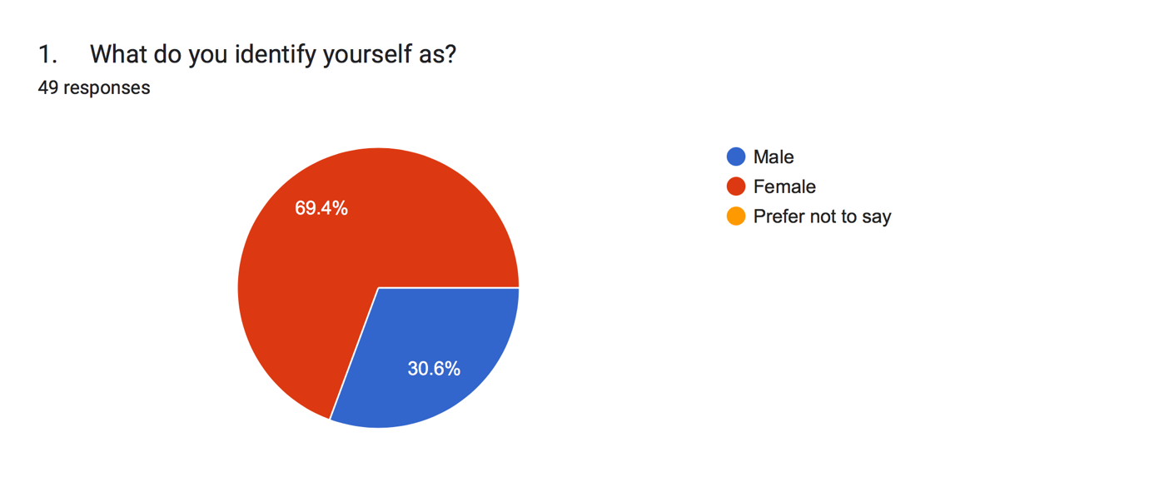

Does a larger female proportion impact the research in a different manner compared to when there are an equal number of males and females in a research?
When identifying any issues with an overrepresentation of females in the research, gender bias can be explored. This is due to the fact that additional researcher has found that women are underrepresented in high positions, authorities and in formal power (Tirmmers, et al 2010, cited in Besselaar & Sandstrom, 2015).

When one gender is overrepresented in a research study compared to the other it can cause a ‘gender imbalance’ (Dickinson, Adelson & Owen, 2012). Since the research has been completed; a way in which the researcher could have improved the research is by using different techniques to gather a response from the male population; as a number of the researcher personal contacts were women. However, the questions used in the research, were not impacted by gender. The overall aim of the research was to gain a personal opinion on youth crime.

4.2.2 – Age Range
The Second question entails the age range of the respondent, these was spilt into seven different categories; the youngest age to participant due to ethical issues and constant purposed were 18-24 year olds; this age range made up 38 percent of participant, this can be due to the fact that the researcher has used personal contacts and social media. However, on the other hand the second largest proportion was the 45 to 54 year olds, this accounted for 22 percent of responses, the questionnaire was forwarded to a number of lectures and teacher in colleges across wales. This can benefit the data, as there are a number of different age ranges which can offered a wide range of opinion on the serious questions in the questionnaire.

4.2.3 - Employment
The final demographic question posed in the questionnaire; was asking the participants their current occupation; to gain a professional perspective the researcher wanted to gain a representative sample of those in full time employment, part time employment or retired. Overall, 56 percent of the participants at the time of completing the questionnaire were in full- time employment, with 24 percent in part time employment. Overall, 80 percent of participants were employed, with 6 percent in their retirement. Furthermore, the final 14 percent were unemployed. The graph which shows the data from question three can be found in Appendix four.

4.3 – Is Youth Crime a growing concern?
The fourth question asked the participant a closed-ended question, this is due to the fact that the researcher did not want to start with the long open-ended questions; due to the time it can take to write and wanted to keep the participants interacted.
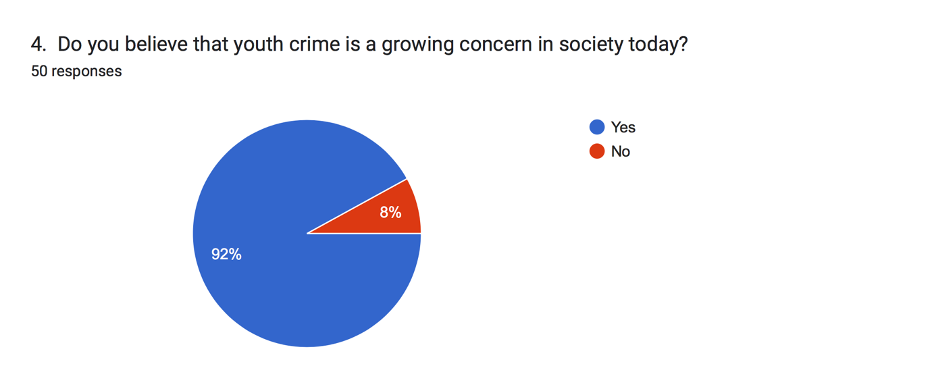

The graph above shows the results of the fourth question, which asked whether the participants believed that youth crime is a growing concern today. The results show that 92 percent of participants believe that youth crime is a growing concern. When analysing the data, it would be easy to suggest that youth crime must be on the increase. However, when compared to the national statistics, they suggest that youth crime are overall on the decrease (Ministry of Justice, 2022); this can be supported with the official statistics that suggest that during the year ending march 2021 first time entries had declined by 20 percent of the previous year (Ministry of Justice, 2022).
Furthermore, many of the respondents could be influences by external influences such as the media. For example, it has been stated that children growing up today can be labelled as deviant or troublesome by carrying out acts that were once seen as ‘normal and ‘part of growing up’ (Jewkes, 2015, page 116).
Additionally, the media can have an impact on many people’s opinions on youth crime, as through the decades they labelled young people as folk devils in the 1960’s.During the 1990’s and early 20’s there was regularly reports of young people committed serious crimes, for example; the branding of two ten year old boys as ‘evil monsters’ for the murder of James Bulger (Jewkes, 2015, page 116).

4.4- Youth crime
During this section of the chapter the researcher will be coding the questions which are suitable to be linked to the education system.
Question six asked the participants what age range they believe are more likely to be a victim of knife crime; the questionnaire offered a multiple choice; the three options included 11-14, 15-19 and, 20-24. The graph below shows the 50 responses;

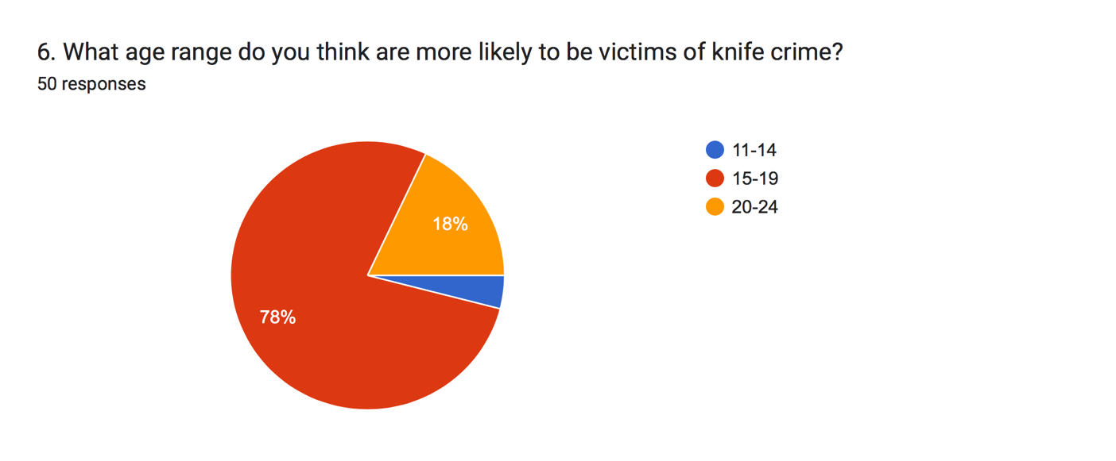
Overall, 78 percent of participants believed that the age range 15 to 19 year-olds were more likely to become victims of knife crime; compared with just 18 percent believing it was 20 to 24 year olds. Finally, only 4 percent believe that the age range 11 to 14 are more likely to be victims. This question can be linked back to chapter two, where the research found that children under the age of 16 were more likely to become victims of knife crime (Mayor, 2016). The secondary evidence suggests that people under 16 are more likely to be stabbed walking home from school compared to any other age range.

4.4.1- The dangers of walking home from school
The researcher posed the question to the participants; this is where question seven asked the participants whether they knew that ‘statistically, a young person is more likely to be stabbed walking home from school?’.
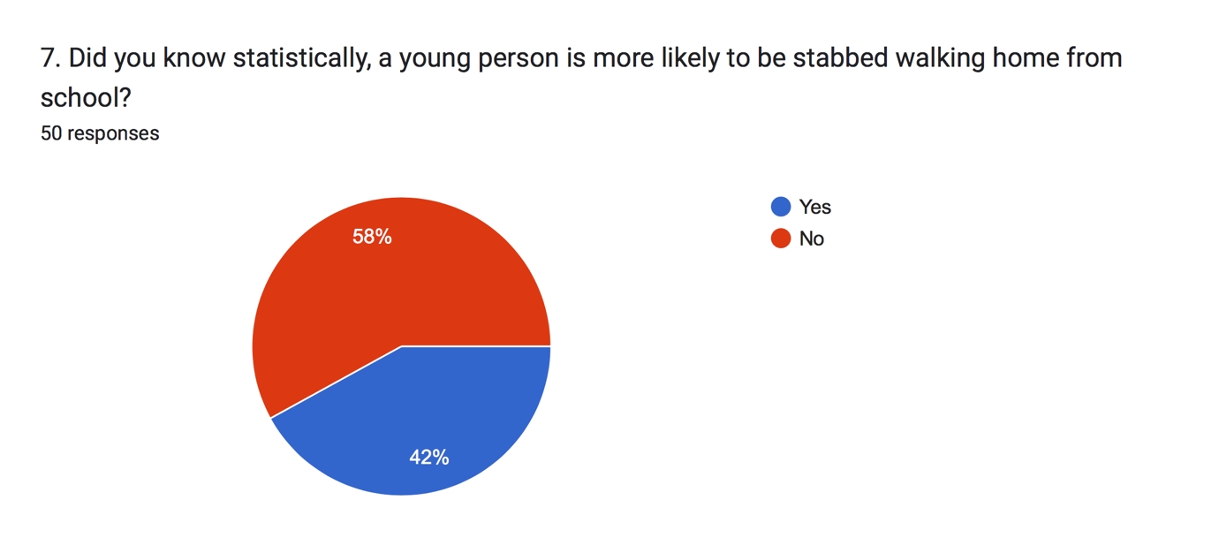

The graph above shows that 53 percent of participants where unfamiliar with this statistic. Therefore, can be more carried out to identify the dangers of children being unsupervised walking home from school. For example; could the local councils work with the education system to run free school transport for children over the age of 8; and living within three miles of the school.
At this current period of time, school pupils who live under 3 miles from their schools, either have to pay a fee to use school transport or; must use additional mode of transport such as walking (Childcare and Parenting, 2022). All children should be safe when walking to and from school, no matter how close they live. The schools and the local councils should work in partnership to identify whether it is in the student best interests to run free school transport.
The second part to the question was in question eight which asked for an explanation on whether school could do more to prevent stabbing from occurring when walking to and from school, or whether it was a police problem, when analysing the data, it has found that the majority of people believe it is both an issue for the education system and the police service; as the education system should have a responsibility to protect the pupils and educating children on real life issues, and the police should have more footfall on the grounds being used as an deterrent. The graph can be found in appendix.

On the other hand, 10 percent of respondents suggested that the issues are not in fact down to the schools or the police but the parents. This can be linked back to evidence found in the literature review surrounding ‘blaming the parent’.
It has been suggested by McLaughlin & Muncie (2013, page 144), that children which come from a single parent family and tend to grow up without a father figure, tend to be reckless and ‘run free’, and it turn are more likely to commit criminal activity.
Furthermore, one respondent believes is a non-partisan issue; their full response is as followed: ‘I believe it is a non-partisan issue. Local police and school boards should work in collaboration to mitigate the risks of knife crime and to safeguard pupils from the moment they leave home in the morning, to go to school, to the moment they return’.
Safeguarding in the education system should be a main priority.

4.5- The Education System
For this section of chapter four, the researcher has grouped together all the questions which include the education system. Firstly, question five, asked the respondents ‘in their own opinion, do you feel that the education system should be teaching children the dangers of criminal activities’.

The researcher has grouped the commonly used responses into the diagram above, the most common answer from the respondents was the word ‘Yes’, followed by the term ‘definitely’ and then ‘absolutely’. Overall, 100 percent of the respondents believe that there should be a form of lesson in the education system on the dangers of criminal activities. As a result of carrying out a lesson, it could benefit the children as it would give an insight into what could happen if faced with the criminal justice system. Additionally, information regarding the youth justice board could also be an advantage for young people; as they are the non-departmental organisation that overlooks the youth justice system (Youth Justice Board,2022).

Moreover, it is not just about classroom learning from teachers to pupils, it can also involve police officers being guest speakers. Question ten in the questionnaire asked whether the respondents had ‘heard of the worked carried out by the Welsh Police Forces to help reduce youth crime in Wales’
The graph in appendix six shows the response of 48 out of 50 respondents, overall 28 percent have not heard of the work carried out by the Welsh Police Forces. This can be seen as a negative in terms of; if children and teachers are not liaising with parents or other professionals, as a result the effect the speeches and classroom discussions with police officers have with the children could be unsatisfactory, and not teaching children the consequences of criminal activity. On the other hand, when looking into the work carried out by South Wales Police Service in the education system, with regards to the ‘Police School Programme’, the welsh government and police service investing £2 million into the programme (South Wales Police, 2022). The aim of the programme is to overall reduce the rate of young offending (South Wales Police, 2022).
However, although it could be said that the programme and all other methods of reducing youth crime are working. We must take into account that the corona-virus pandemic has had an impact on the low levels of youth crime. According to Webster (2022) due to the restrictions in place, courts were unable to proceed with hearing, leaving long delays with a number of trails. It is believed that next years statistics will also not be a true and accurate picture of society, due to having to ‘catch up’ (Webster, 2022).

4.5.1- Police Liaison Officer
Question 13 of the questionnaire asked the respondents if they thought ‘having a police liaison officer can act like a deterrent in schools?’ the results shown in appendix seven, found that 40 percent of participants believed that a police liaison officer can act as a deterrent in helping to reduce youth crime, this is supported by the research carried out by Dyfed Powys Police; the research saw many opinions arise of the work carried out by the police liaison officers, which includes
“I think an early education programme of awareness and dealing with a variety of threatening situations is extremely important in today’s society’ (Dyfed Powys Police, 2022).
Additionally, an estimated 20 percent of participants believed that the use of a Police Liaison Officer would not act as a deterrent within larger school such as, comprehensive schools. Furthermore, the remaining 40 percent of participants believed that can be useful in certain situations, but other forms of deterrent are available. For example, one participant states
“The presence of a police liaison officer would reduce this risk, however there are many other deterrents that would also be effective. E.g the presence of an officer at the end of the school day, Security at all gates for the schools”. This can lead onto question nine regarding security within the education system.

4.5.2- Security
As stated above; question nine investigates whether there should be more security when entering a school premises, the results show 80 percent of respondents believe that there should be an increase in security; the graph below shows the following results.

When the researcher explored the use of security gates in the education system in the United Kingdom; there is little evidence to suggest the use of them. However; this could be due to the fact that local authorities do not want the public to understand the procedures of trying to reduce knife crime. The only evidence found was carried out by the BBC (2010) which briefly states that under the ‘Violent Crime Reduction Act’, secondary schools and further education premisses, can have the authority to search pupils for weapons. On the contrary, this can be seen as an unreliable source.

Additionally, in countries such as New Zealand, the partnership work between the education system and the police is discussed openly including; the use of security guards and other security methods within schools (New Zealand Police, 2022). For example, the issue of young people stealing item’s such as bikes from school premisses become an issues dealt with by the New Zealand Police force, teachers and parents. This can be linked back to question 8, where many responses identified that youth crime is a problem for the police, education and parents. The partnership worked together to gather prevention techniques such as security; where local officer carried out patrols on foot prior to the beginning of school, and after school (New Zealand Police, 2022).
This shows that an increase in police presence in the education system can act as a deterrent for young people committing crime.

Furthermore, in the United Kingdom the reduction of police officers since 2010 has seen less officers patrolling the streets on foot. This could have a knock-on effect on how young people can feel protected when walking to and from school. Question 12, asked the respondents whether they thought that ‘young people carry sharp objects to protect themselves’, the findings are shown in appendix eight.
All 50 participants responded to the question where 55 percent of people believed that young people do carry sharp objects and weapons as a form of protect; some have expanded on their response explaining that they think it is because young people feel unsafe in society, due to gangs and an increase in violence on the streets.
Whereas, 15 percent asked the question saying ‘no’.
Finally, 30 percent of people explored the possibilities that it can be a range of reasons from; ‘showing off to their friends’, ‘accessory for social status’, finally, an expanded explanation with a mixed review on the opinion;
‘it is too vast a generalisation to make. I think many will use that as an excuse when surveyed or caught carrying sharp objects, and I have no doubt that some believe what they are saying. Others may be carrying sharp objects to impress peers or because they have been conditioned to believe that it makes them tougher or more masculine’.

A report carried out by the UK Government and charity ‘Barnardos’ (2019) surrounding ‘knife crime and young people’s perspective' found that many young people carried knives as a form of protection; this is supported by the research which interviewed a young person who said;
“I don’t feel protected; when I’m out I don’t feel protected. Nothing’s protecting me, if someone came up to me and started fighting me, what am I going to do?” (Jones et al, 2019).

A young person who felt strongly about the issue of knife crimes was Ben Kinsella. Unfortunately, he was stabbed to death in 2008, from a mis-identity (Ben Kinsella Trust, 2022). Question 11 asked the participants if they have heard of Ben’s law?
The graph below shows that only 32 percent of the respondents have heard of the law, compared to 68 percent who have not. This can be seen in the graph below.

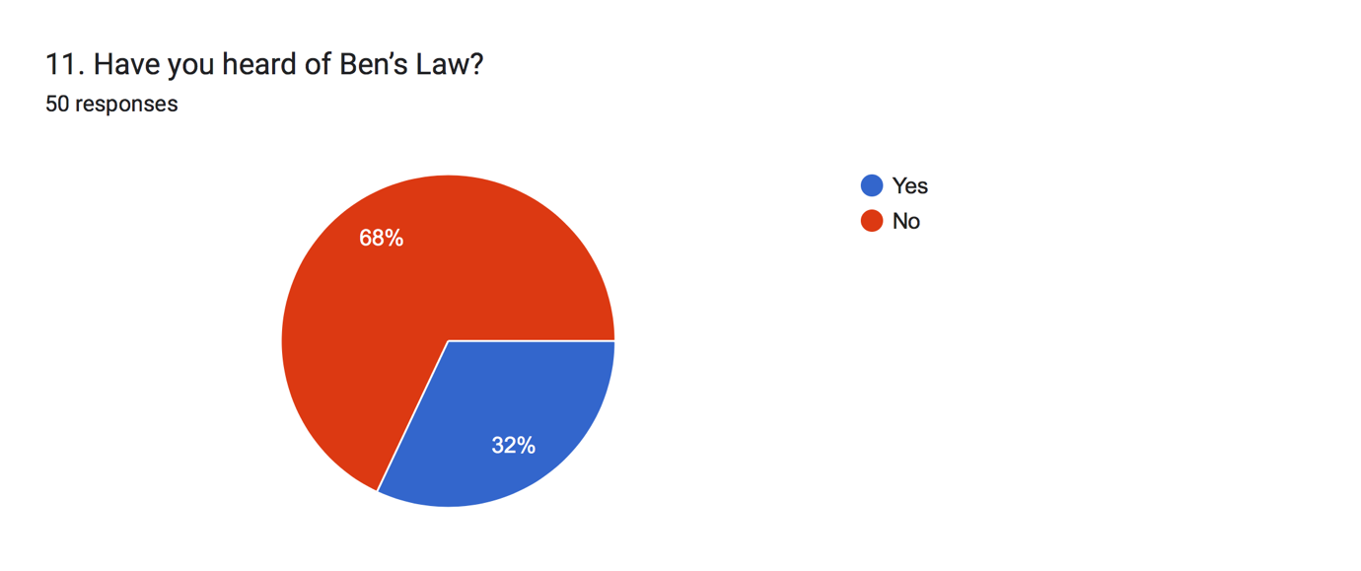

Prior to his murder, ben raised his concern by writing a letter to the Prime Minister calling for the government to carry out prevention methods to tackle knife crime. However, his family have campaign for a change in the law; this has had an effect on the sentencing length (Ben Kinsella Trust, 2022). The campaign had an impact on changing the mandatory life sentencing for a murder carried out with a sharp object from 15 years to 25 years (Ben Kinsella Trust, 2022).
This can be seen as a step in the right direction in terms of sentencing and knife crime. On the other hand, it should not take for a family to lose a son and campaign tiredlessly for the government to consider the issues regarding young people.

4.6 The Criminal Justice System
Prior to analysing question 14 it is important to understand the reasoning behind why the researchers decided to ask the question, when a young person commits a crime it can have an impact on their future, this can be a positive or negative way. Therefore, question 14 asked the participants ‘in their opinion, do they feel that a child should be punished in a education system setting rather than going through the Criminal Justice System?’
For this question there was overall 49 responses; there were a range of different opinion on this topic; including the use of rehabilitation in the education system for first time young offenders. However, there were lot of participants against the idea of punishing children in the education system, has it could give other pupils a negative experience in a school setting; the data can be shown in appendix nine.

Furthermore, a partnership between the education system and the youth offending team should be working together to prevent children from committing crimes; on the contrary if a young person commits a crime they will be supported by the youth offending team. Therefore, allowing for the children to build a rapport with the youth offending team can act as a prevention technique.
Although, there is little research to suggest whether young offenders should be punished in an education system to protect their futures. However, the Howard League Charity was set up to reduce youth arrests in both England and Wales, the overall aim of the charity is to carry out research and implemented into young offenders (Howard League, 2018). Firstly, research suggests that the less contact that a young person has with the Criminal Justice System and the Police service, the less likely they are to commit to a criminal pathway in their adult years (Howard League, 2018).

The final question of the questionnaire asked the participants their own opinion; on the partnership work carried out by the Police service and the Education System. The graph below shows people overall findings;

60 percent of respondents felt that the partnership between the police services and the education system is a positive result for young people with supporting and learning of the consequences of criminal activity. For example, one respondent states;
‘I believe that if executed properly, with careful consideration of all relevant factors in a multivariate analysis, a partnership between the two bodies would be definitively beneficial to the safety and security of our youth’.

Whereas on the other hand, 30 percent feel that the partnership between the police and the education system can be seen has a negative relationship; respondents have suggested that due to the lack of Police Community Support Officers (PCSO’s) and policing staff can have an impact on how much support they can give to the education system.

The final 10 percent, had an neutral opinion on the partnership between the Police and the education section; as the majority of neutral opinions were unsure whether the partnership is effective in reducing youth crime; this is due to the fact there is little evidence and lack of public knowledge on how to tackle the issue.

4.7- conclusion
To summaries this chapter; the data collected from the questionnaire has offered the researcher with knowledge and understanding on a professional perspective on a police presence in the education system.
Overall, the 50 respondents answered 100 percent of all the questions, this can support the evidence. Furthermore, the questionnaire offers a range of both quantitative and qualitative data. This allows for statistical and literacy research.
The questionnaire has highlighted that the government statistics show a decrease in youth crime in the previous years. However, this is due to the corona-virus pandemic restricting the movement of members of society. However, 92 percent of respondents believe that youth crime is a growing concern in society.
Additionally, when investigating the work carried out by both Dyfed Powys Police Service and South Wales Police to reduce youth crime, the evidence showed that those who understood the work regarded it has a step in the right direction to reduce youth crime.
However, there were a number of respondents which were unfamiliar with the work carried out by the welsh police forces. Therefore, more assistant by both the education system and the police could help develop the work carried out to inform pupils and their parents of the risks of youth crime.
Furthermore, statistics show that children are more likely to be stabbed walking to and from school; the questionnaire identified that the statistics are not being made publicly aware; with only 42 percent of respondents being aware of this. The local authorities could be discussing approaches to reduce the risk; such as a free school bus for those who live in a three mile radius of the schools. The police service could also impact the risk by increasing the footfall of police officer and PCSO’s around school areas.

A final thought on this chapter is the recommendations put forward by the researcher.
The researcher believes there should be more research or published reported surrounding the security in the education system; due to the increase in sharp object crimes in recent years, the use of metal detector gates and security guards on school permissions could be beneficial to pupils and teachers. However, when trying to highlight the issues the reports only suggest that the increase in CCTV security systems are predominantly used.
The second recommendation for this research would be to gather an equal response from the different genders; this could give an overall true and accurate picture; have equal genders responses can support the questionnaire, as females tend to show compassion toward children, whereas males tend to offer their own opinion which can be developed by the media or by their own experiences.

Reference List
Basselaar, P. Sandstrom, U (2015) ‘Gender differences in research performance and its impact onn careers; a longitudinal case study’
Scientometrics, vol.106, pp 143-162
DOI: 10.1007/s11192-015-1775-3

BBC (2010) Schools in Wales gain power to search for weapons’
Available at: https://www.bbc.co.uk/news/uk-wales-11661164
Accessed on: 10th November 2022

Ben Kinsella Trust (2022) ‘Ben’s Story’
Available at: https://benkinsella.org.uk/bens-story/
Accessed on: 7th November 2022

Childcare & Parenting (2022) ‘Free School Transport’
Available at: https://www.gov.uk/free-school-transport
Accessed on: 5th November 2022

Dickinson, E. Adelson, J. Owen. J (2012) ‘Gender Balance, Representativeness and Statistical Power in Sexuality Research Using Undergraduate Student Samples’
Arch Sex Behav, Vol 41, pp 325-327
DOI 10.1007/s10508-011-9887-1

Dyfed Powys Police (2022) ‘Schools liaison’
Available at: https://www.dyfed-powys.police.uk/police-forces/dyfed-powys-police/areas/about-us/about-us/schools-liaison/
Accessed on: 6th November 2022

Jewkes, Y (2015) ‘Media and Crime’
Third Edition, Sage Publication, London

Lee, M & Schuele, C (2010) ‘Demographics’
Encyclopedia of research design, pp 347-347
https://dx.doi.org/10.4135/9781412961288.n108

Ministry of Justice (2022) ‘Youth Justice Statistics 2020/21’
Available at: https://assets.publishing.service.gov.uk/government/uploads/system/uploads/attachment_data/file/1054236/Youth_Justice_Statistics_2020-21.pdf
Accessed on: 3rd November 2022

New Zealand Police (2022) ‘ Safer Schools’
Available at: https://www.police.govt.nz/advice-services/personal-community-safety/school-portal/resources/responsible-citizens/safer-schools
Accessed on: 8th November 2022

Youth Justice Board (2022) ‘Who we are’
Available at: https://www.gov.uk/government/organisations/youth-justice-board-for-england-and-wales/about
Accessed on: 5th November 2022

Webster, R (2022) ‘The state of the Youth Justice System in 2022’
Available at: https://www.russellwebster.com/the-state-of-the-youth-justice-system-in-2022/
Accessed on: 6th November 2022

