
MODULE CODE: BMSW4006
MANAGING ENTERPRISE IN THE 21ST CENTURY

Annesa Johnson

ID: 1909013

Business Plan on
Sweet n Eat Dessert Shop



Executive summary
This report as a part of academy has been prepared to develop a business plan for a business named as Sweet n Eat which is to be launched soon. This report contains the nature, ownership and structure of businesses. Then, four P’s of businesses has been highlighted where the business is to offer quality organic products with a very affordable price at convenient locations. Two important frameworks to analyse the marketing environment of the business have been sued – SWOT and PESTLE which shows how business will be affected by external and internal factors. Estimation for required finance after market analysis has been prepared and last one, shows how to administer the business plan to get the business operate successfully.

Table of Contents
Executive summary 2
Introduction 4
Business mission, vision and objectives 4
Legal Compliance 4
Marketing Mix 5
SWOT analysis 5
PESTLE analysis 7
Management Process Marketing: 9
Management Process Finance 11
Management Process Administration 13
Conclusion 14
References 14
Appendix: Presentation slides 15

Introduction
A business plan describes the nature of a business, its business objectives and strategy, financial position and excepted income statement in written format (Botten, 2006). This document contains the future prospect of a business, plan to carry out the operations. Business plan mostly is strategic in nature. In this report, a business plan for “Sweet n Eat”, a small desert shop, will be prepared. In this shop desserts containing sweetness and fruits will be prepared. Customers will find sweet moments here to have perfect moment in any celebration like birthday, etc.

Business overview
Sweet n Eat is a dessert shop which sells healthy desserts, cakes, ice creams, sweetmeats and soft drinks to the customers. The items produced by the company contains no sugar and artificial colours. Different fruits and vegetables are used for sweeting and colouring the food items offered by the business. Food items will be offered with natural sweetness and flavour where inputs will be extracted from varieties natural ingredients.

Business mission, vision and objectives
Mission: The mission of the company is to create awareness among people about developing healthy eating habits and attracting the customers to try our products and services.
Vision: The vision of the company is to create a strong brand image and position within the UK market by opening new outlets throughout the county.

Objectives:
- Generating feasible amount of sales revenue
- Increasing the level of satisfaction among customers
- Establishing a strong brand image and goodwill for the business.
- Creating employment opportunities
- Raising awareness about obesity and the importance of healthy eating habits.

Legal Compliance
The legal form of the business is a sole trade business where owner manages the business to enjoy all the profit and bear risks. The legal documents such as capital, trademark documents, insurance and others are to be arranged. The employee rights and rules on consumer rights are to be followed in the business operational activities and creation of company guideline.

Marketing Mix
Marketing mix is a process of value creation cantered around a set of marketing tools namely product, price, place, and promotion, commonly referred as 4P’s (Ford et al, 2010).
Products: Products are the items that create value for the customers to satisfy customers’ needs. Here, the products of sweet n eat are organic products which are tangible in nature. This Sweet n Eat shop offers Sugar free dessert items with a smart and attractive packaging. They have a variety of products namely signature desserts, lemon meringue pie, Berry special waffle, and Diet milkshake and try to maintain hygienic issues and ensure quality of the products.

Prices: Price has great implications on revenue determination. Sweet n Eat will try to maintain a very reasonable and affordable price for all classes of social customers compare to other dessert shops in Canary Wharf.

Place: Businesses with products which have physical substance need to have a physical location to deal with the customers. Sweet n Eat has It will be located in Canary Wharf, near HSBC and Barclays Bank.

Promotion: Promotion associates with the marketing activities to communicate the products or services to the target market. Here, Sweet and Eat has chosen direct marketing and social media marketing to reach to the target audience. They will manage leafleting all over Tower Hamlet Area, UBER Eats and Just Eat.

SWOT analysis
SWOT analysis commonly used by businesses to evaluate internal and external favourable and unfavourable factors in the preliminary stage to assess competitiveness of a specific business or business plan ((Worthington et al, 2018). Here, a comprehensive SWOT analysis are described as of follows-
Strengths: Strengths refer to the factors or characteristics that give competitive advantage to a business over its existing rivals. In case of Sweet n Eat its strengths are three criteria. First, unique products as Sweet n Eat will provide organic products which will be made from vegetables and fruits that will help in sweetening and colouring products. Second, competency of the employees is another strength as it will hire most eligible and experienced employees

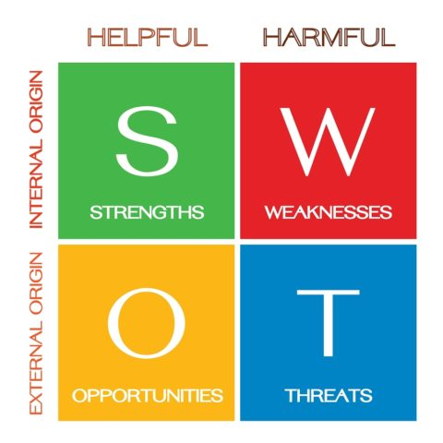

Figure: SWOT analysis

Weaknesses: Weaknesses are the internal characteristics that are harmful to achieving the objectives of a business. Sweet n Eat shop is a sole proprietor shop business but the owner has no managerial experience to conduct such a desserts shop. As it is a new one to launch in the market, it has no brand value to get the customers loyal. This business has no sure of maintaining safety and food qualification

Opportunities: Opportunities give immense scope to extract benefits from the available environmental situations. Here, Sweet n Eat has a potential to create a customer base as it has chosen an attractive location, where there are few gym centres too. Moreover, the growing awareness for healthy foods is an important factor to boost its business growth.
Threats: Threats are the external environmental factors that hinder prominent business growth. Sweet n Eat face its competitors brand value as a threat for its brand expansion. Suppliers may increase price of raw materials which will affect the business negatively.

PESTLE analysis

PESTLE analysis requires a thorough study of the macro environment of a business where factors of macro environment affect businesses significantly (Shaikh, 2015). Actually, PESTLE analysis does a distinguished analysing of the environment what SWOT analysis does in opportunities and threats.

Political Factors: Businesses are highly affected by the political factors like political instability, frequent changes in legislature, tax policy, trade policy, government policy, trade restrictions, etc. BREXIT is having a negative impact on the UK political condition, overall instability in global politics. Thus, Sweets n Eat will be affected greatly due to BREXIT.

Economic Factors: Due to this pandemic COVID-19, people are getting lowered their disposable income. Thus, Sweet n Eat shop will face how changes in income level, tax policy affects its business. Currently, this is predicted that after pandemic situation, people will have lower income or savings which will lower customer demand.

.



Figure: PESTLE analysis
Social Factors: Social factors refer to the socio-cultural factors which are mostly common among a group of people. People in the UK are getting conscious of health and hygienic issues. As Sweet n Eat will offer organic food items maintaining quality issues, customers will be more satisfy.

Technological Factors: Sweet n Eat can open a website to sell its products through e-commerce site. It will reduce warehouse costs, more convenient to the customers. Technological advancements is creating opportunities for promoting business products.

Legal Factors:
To operate a business successfully, businesses must be aware of what is legal and what is not. Sweet n Eat must be aware of employee rights and consumer laws available and they must follow it properly; otherwise the victim one can sue against this shop. this will lower its brand image and thus, reduce sales.

Environment:
Customers become loyal to a shop when they find that particular shop maintain environmental issues with priority. Considering this Sweet n Eat will launch organic products which will enjoy great customer choices as it is environment friendly product.

Management Process Marketing:
Target market for Sweet n Eat is health conscious but dessert loving people living in London. There are 4 specific target market segments of the company which are presented below.
- Young and health conscious people
- People with certain health issues like diabetes, obesity, heart diseases etc.
- School going children
- Elderly people who love having desserts on a daily basis
Sweet n Eat shop will make products available for all classes of targeted customers.
Market Analysis
The overall sales of desserts and sweet bakery products has increased by approximately 10% in the last 5 years. The popularity of chilled desserts is increasing continuously. here is a continuously increasing level of awareness about obesity and healthy eating habits among British people.
Market research
We have conducted a thorough market research to identify whether there is a sufficient demand for our products in the market or not. This is essential to assess the potentiality of the business idea and the possibility of success or failure.

Who are your customers?
Health conscious young people, dessert loving children and elderly people, diabetic patients, people with heart diseases and obesity.
What do they buy now?
Our target markets are currently buying dessert items available in the market which contain sugar. Some of our target customers are being deprived of eating desserts because of their health issues.
Why do they buy?
Desserts are highly popular among British people and is traditionally a part of the regular meals and eating habits.
We have conducted a market research by surveying a total of 200 people. There were 50 people from each of our 4 target market segments. The market comprises of heath conscious people, people suffering from obesity, school going children and people in general who like dessert. The results of the survey and market research is presented below:
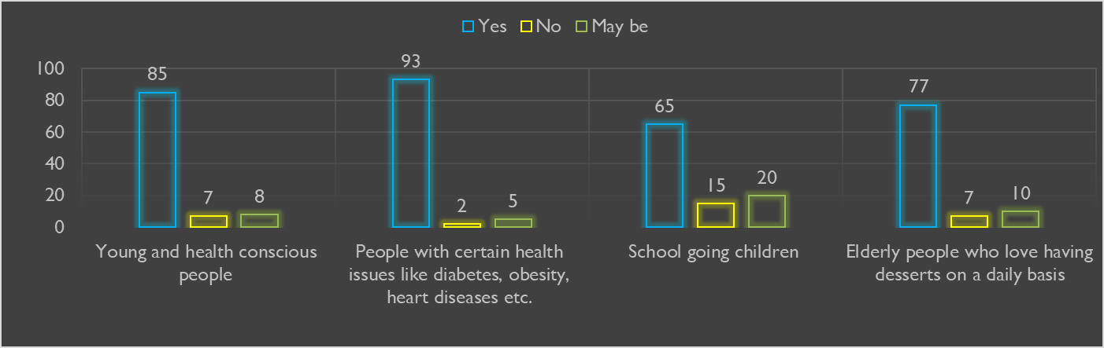
•According to a global research firm IRI, the level of health consciousness in increasing day by day among the people living in the UK and the amount of healthy food items bought by the UK people is also increasing continuously.
•72% of the UK consumers are preferring to buy food items which contain less fat, salt, sugar and calories.
•43% of the UK consumers prefer to buy organic food items.
•Obesity is becoming a major health issue among British people since past several years.
•In 2018, an average of 25 grams of ice cream, desserts and/or cakes was consumed per person per week.

this concept refers to the psychological and functional needs, demands, preferences and desires of a product among the target markets of a business organization or company. In the case of our business idea, the customers in our target market are already aware of the necessity of the products being offered by the business. There is an existing demand in the market for the products but no specific solutions or products that can meet the demands or serve the purpose.
A lot of people are becoming health conscious but as their love and affinity towards desserts is strong, they are being compelled to buy desserts with high amount of sugars and calories because they have no healthy options available to themselves.
In addition to that, the number of diabetic patients and heart disease patients are also increasing in the UK who can not consume foods with high sugar and calorie. As a result, they are not being able to enjoy desserts. Our products will allow them the joy of having desserts and will be good for their health due to the usage of fruits and vegan in the products.
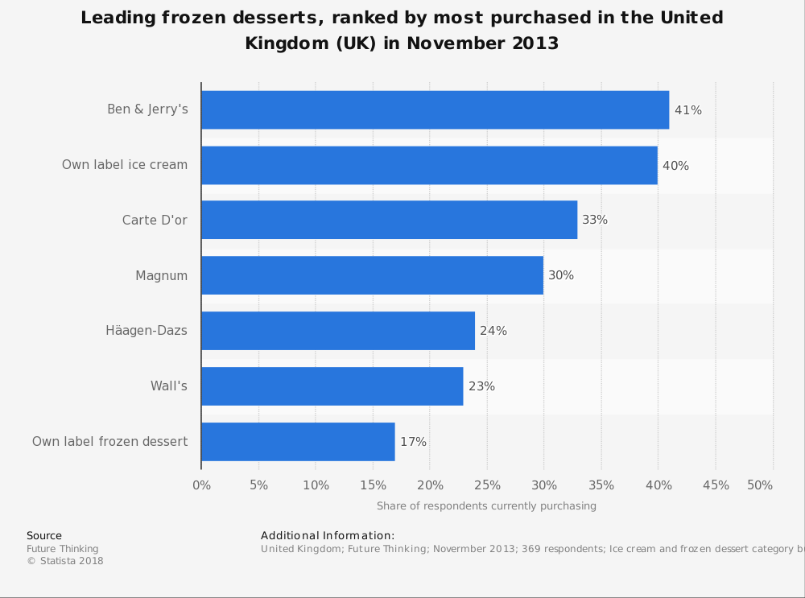
Figure: Market situation

Management Process Finance
Cash Flow Planning
The cash flow planning refers to the planning on what amount of money and resources will be spent on which sectors (Worthington et al, 2018). In addition to that, the sources from which money will be earned and revenue will be generated for the business and in what amounts is also a part of the cash flow planning.
Start up amount: | £90,000
§Lease amount for the location and space of the shop: | £15,000
§Cost of buying Equipment required for production: | £15,000
§Cost of raw materials for production and inventories: | 15,000
Salaries expense: | £25,000  §3500
Miscellaneous expenses: | 2,500
§Cost of acquiring legal documents of the business (Trade licence, insurances, bank accounts etc.): £ | 3500

Weekly/ Monthly Financial Monitoring
The monitoring of the overall financial performances of the business will be conducted every week and month and on a regular basis as it is important for the sustainability, profitable survival and ensuring expected level of financial performance for the business organization.
Monthly Profit & Loss Statements
The determination and maintenance of monthly income statement will allow the owners to have a clear idea of the financial performances of the business.
- Keep track of the expenses
- Maintaining salary expenses
- Determining whether the company is incurring financial profits or loss.
Breakdown Analysis
This strategy allows the business owners to identify the lists and specific costs of all the materials needed to develop each specific product or service. After that, the unit production cost of each product can be identified and thus assists the determination of the final selling price of each product.

Book keeping
This approach will help the business to have a strong control over the expenses. Each and every transaction should be recorded accurately in the accounting books as well as software utilized by the business. This strategy is assistive for maintaining transparency in the business activities.

Management Process Administration
Work Scheduling
There is huge advantages and importance of work scheduling. This approach is assistive for maintaining and recording the working hours perfectly for each employee. It helps to determine the availability of employees for each business shift. There are 4 persons in the workforce of the business. There is an 8 hour shift in each day. 2 employees are always present in each of the shifts to perform the business activities. This scheduling allows the assigning and finalizing of the responsibilities of each employee. The chain of command and managerial responsibilities are also determined.

Payroll Handling
This activity includes the maintenance and recording f the total working hours of each employee and determining the salaries of each of them accordingly. The instructions and rules of HMRC are followed in this task.
•Insurance
•Payments of Salaries
•Pension schemes
•Maintaining Payslips
•Bonuses and benefits
•Time sheets

Staff Training
The business will provide necessary training to the employees in order to assist them to perform better for the business. This strategy is imperative for the improvement in the overall performance of the business. It creates a sense of bonding among employees. Job satisfaction will be increased among the employees.

Conclusion
The business has a motto of serving healthy food items to the consumers and thus doing good to the society (Young, 2007). Additionally, health consciousness is promoted through the business activities. Based on the analysis it is expected that our organization will be feasible in this market.

References
2009. Business Environment. Amsterdam: Elsevier/Pergamon Flexible Learning.
Botten, N., 2006. Management Accounting. Oxford, U.K.: CIMA Publishing/Elsevier.
Bpp Learning Media., 2015. Business Essentials Business Strategy. [Place of publication not identified]: Bpp Learning Media.
Ford, B., Bornstein, J., Pruitt, P. and Young, E., 2010. The Ernst & Young Business Plan Guide. Chichester: John Wiley & Sons.
Shaikh, S., 2015. Business Environment. Pearson India.
Worthington, I., Britton, C. and Thompson, E., 2018. The Business Environment. Harlow, United Kingdom: Pearson Education Canada.
Young, P., 2007. Business Plan. Chandni Chowk, Delhi: Global Media.

Appendix: Presentation slides


