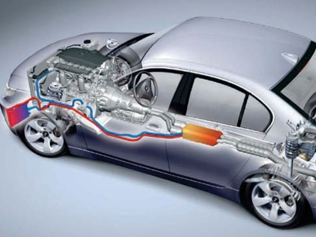

Thermal Energy Recovery Systems for Automotive Applications
  - Seminar paper
Gwyddian Thomas | BSC Level 6 Motorsport Engineering | 20/11/17
Contents
Abstract 2
Literature review 3
INDIANA SECTION PAPERS INCREASING AUTOMOBILE-ENGINE THERMAL EFFICIENCY By C. E. SARGENT 3
EXHAUST SYSTEM ENERGY MANAGEMENT OF INTERNAL COMBUSTION ENGINES by M. Anusha Wijewardane B.Sc.Eng. (Hons.) 3
Development of Effective Exhaust Gas Heat Recovery System for a Hybrid Electric Vehicle by Hyundai Motor Company 3
Introduction 4
Nomenclature 4
Theory & Research 5
first law of thermodynamics 5
Second law of thermodynamics 5
energy in exhaust systems 6
carnot cycle 6
losses within the i.c.e 7
otto cycle 8
methods of thermal energy recovery 9
Thermal electric Generator/ Seebeck Generator 9
Rankine cycle 11
Turbo chargers 13
Procedures and methodologies 14
Decision matrix 14
personal NEDC 14
Project Aims moving forward 15
Bibliography 15

Abstract
With the rising cost of crude oil prices, due to ever decreasing resources, increasing pressure from government legislation, CO2 taxation and public awareness of motor vehicles environmental impact. This has forced automotive manufacturers to put a substantial amount of effort into the development of internal combustion engines. Mainly in the fields of fuel consumption, emissions outputs and engine efficiency. This has been accomplished by way of the development of engine management systems, cylinder head and inlet design, forced induction systems and the implementation of hybrid technologies. Whilst these systems have had a drastic improvement such areas as fuel consumption, engine performance and emission outputs. Manufactures have not solved a major flaw in the fundamental design of ICE’s. It is well known that ICE’s are only 30 > 40 % thermally efficient, with on average two thirds of the total energy introduced into the system being dissipated to atmosphere in the form of heat energy. A sensible assumption would be to harness some if not all the wasted energy from the system and repurpose it in the form of electrical or mechanical energy. Thermal recovery systems such as thermal electric generators could be implemented along the exhaust to convert the wasted energy to electrical energy. Which in turn may be used to power a component that under normal circumstances would be driven via belt by the ICE, thus reducing the parasitic losses and improving fuel economy.

Literature review

INDIANA SECTION PAPERS INCREASING AUTOMOBILE-ENGINE THERMAL EFFICIENCY By C. E. SARGENT
The paper addresses the thermal inefficiency issues that face ICE systems in automotive applications and opens a discussion on as to how these issues may be addressed by engine modifications alone. The paper was published in 1987 this shows that these inherit efficiency issues were under review well before major emissions legislation was in place. The author suggests improved methods of ignition and valve timing as a means of solving the issues presented in the paper. Unfortunately, at the time that this paper was published the thermal recovery technology that available today which would enable the application to be used in an automotive application.

EXHAUST SYSTEM ENERGY MANAGEMENT OF INTERNAL COMBUSTION ENGINES by M. Anusha Wijewardane B.Sc.Eng. (Hons.)
This paper acknowledges the thermal losses from the exhaust system. The author states various methods of thermal recovery and mathematically establishes which method would be appropriate for automotive use. The author states that in a small-scale materials test with the use of thermoelectric generators. There could in fact replace or at least significantly downsize the alternator charging system which all ICE’s are currently using, to provide electrical power to systems battery. This would reduce the parasitic losses on the ICE and would increase fuel economy by up to 5% with current material technologies. The study is comprehensive and weighs heavily in favor of the thermoelectric system

Development of Effective Exhaust Gas Heat Recovery System for a Hybrid Electric Vehicle by Hyundai Motor Company
This paper discusses the development of a cost effective thermal recovery system to operate in conjunction with a hybrid vehicle to improve fuel economy. The system developed harnesses heat energy from three different sources, the engines coolant, gearbox oil and exhaust gas all feed one singular unit drawing the excess heat away by way of a thermoelectric generator. This system is electronically monitored and controlled via a control module. It is able to monitor and control the heat being drawn in by way of sensory units and solenoid actuated cut of valve that allow the unit operate at maximum efficiency.

Introduction
The development of current battery technologies is a major issue in the automotive sector. With development of these systems being costly and time consuming. The performance and effective driving range of and fully electric vehicles are not yet a suitable replacement for internal combustion engines. Therefore, internal combustion must undergo further development, until such a time as the development of EV technologies, have reached a point where they may be considered a viable replacement for the ICE.
This report will highlight the fundamental issues with the internal combustion engine, from a thermal efficiency standpoint and present a selection of thermal recovery systems to be implemented in conjunction with the ICE, to at least partially mitigate, the internal combustion engines fundamental efficiency downfalls. To accomplish this, it is paramount to establishing an excellent understanding of the systems along with the mathematical processes with which they operate. From there it will be possible to choose an effective method of energy recovery that may be taken further as a potential design to be employed in an automotive scenario.

Nomenclature
Qh = Heat transfer to the system
Qc = Heat transfer from the system
W = Effective work done
η = Efficiency
ΔE = Change in energy
ΔV = Change in Volume
Cp = Specific heat capacity
KE = Kinetic energy
P = Pressure
PE = Potential energy
E = Specific energy
Σ = Sum of Value

Theory & Research

first law of thermodynamics
The first law of thermodynamics otherwise known as the theory of the conservation of energy, states that energy within a thermodynamic system must remain the same as energy can neither be created nor destroyed.
A ICE is what is referred to as an ‘open system’ as the working fluid (air fuel mixture) flows through the system and is not reused for the next cycle. (Twigg, 1996)
$$ΔU=Q-W$$
The change in the internal energy of a system is equal to the heat added to the system minus the work done by the system (Twigg, 1996)
The thermal efficiency of a system is the ratio of total amount of work output for the total amount of energy input to the system.
η= $W/{Qh}$
Where Q= Energy in, W= effective work done.

Second law of thermodynamics
The second law of thermodynamics states that it is impossible to extract all energy from a system and use all of it, to perform useful work. This prevents any system from obtaining 100% efficiency through its working cycle.
η= $\frac{Qh-Qc}{Qh}$
For a thermodynamic system to be 100% efficient the exhaust side of the system (Qc) would have to equal absolute zero, meaning that all the energy input will have been converted to work. Which is as the second law states is not possible due to Entropy. Entropy is a measure of the amount of energy that is no longer available to perform work. (Stone, R. and Ball, J. 2004).

energy in exhaust systems
When gases are observed in a thermodynamic study, they are referred to as thermofluids due to the nature in which the molecules behave on a fundamental level. The energy in an exhaust system will differ due to the large number of variables found between different systems, in different environments and under specific loads. The energy then would have to be calculated as an average to solve for the various loads that the ICE may be under at any one time.
One method of calculating energy in an exhaust system is as follows:
$$Q=V x rho x Cp x ΔT$$
Where Q = Heat content in Kcal/hour, V= Flowrate in m³/hour, rho= Density of gas in Kg/m³, Cp= Specific heat capacity of substance in kCal/Kg°C and TΔ= temperature difference.
The answer to above would give out a value in kCal/hour. For ease of use this should be converted to Kj/s.

carnot cycle
The Carnot cycle is a theoretical model which represents the best example of a heat engine. Mathematically the Carnot cycle is the most efficient engine possible under a strict thermodynamic process.
ηc = $\frac{Th-Tc}{Th}$
ηc = $\frac{1000K-650K}{1000K}$
ηc =0.35 or 35%
The above equation can be observed to show a Carnot efficiency calculation of a hypothetical petrol engine with averaged cylinder and exhaust gas temperatures at part load. This shows that the maximum efficiency possible for this engine at these specific heat values is 35% no accounting for friction losses occurring during the cycle. (Twigg, P. 1996)

losses within the i.c.e
It is a well-known fact, that internal combustion engines only use, approximately one third of the total energy input into the system as useful work, to drive the vehicle. This figure can vary depending on the age and type of ICE used for the comparison. Other energy is lost as heat into the water jacket and exhaust and small percentage is lost due to friction losses in the engine. (Sargent:2002) States that with the ICE used for his papers testing they found that the effective work output was as low as 20% with a 5% loss to friction 41% as heat energy out of the water jacket and 34% lost to the exhaust. With only a third of the energy input into the ICE.
With developing engine and engine lubricant technologies losses due to friction have been reduced greatly over the last 20 years. “Among the several factors, oil consummation and frictional power losses play vital roles in the performance of IC engines. A thorough understanding of lubrication condition at piston- ring-cylinder liner interface is vital in determining the source of frictional loses and consumption of lubricating oil.” (Shivakant Kurbet, 2007).
Losses to the water jacket during the combustion process are unavoidable. Although many manufactures are currently in the process of mitigating a percentage of the heat loss via this outlet. “The increasing importance of electric mobility results into the need for optimizing all power train components to further reduce the energy consumption of the vehicle. “(Karras, Kuthada and Wiedemann, 2017).

otto cycle
The Otto cycle named after the German physicist is a thermodynamic cycle that best represents the working cycle of an ICE.
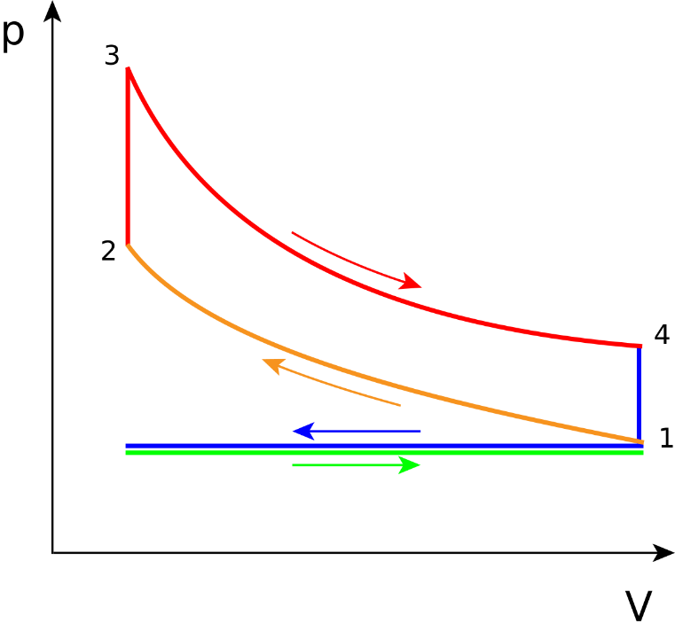
Intake stroke
Qc
Qh

Compression stroke
Ignition stroke
The diagram above shows in an x y format a four-stroke internal combustion cycle. Qh represents heat energy in notice that Qh is at the point of compression when the energy over the specific area is at its highest and then the energy decreases on the ignition stroke as the effective area decreases as the piston travels down the cylinder. (Web.mit.edu, 2017)
Points 1 > 2 show the first adiabatic process ΔEin = Work done on the system as a ΔV is observed and the pressure increases.
Points 2 > 3 show the first isovolumetric process ΔEin = Qh. No work done on the system as ΔV = 0
Points 3 > 4 show the second adiabatic process ΔEin = Work done on the system as a ΔV is observed.
Points 4 > 1 show the second isovolumetric process ΔEin = Qc. No work done on the system and heat exits the system.
Whilst calculating the efficiency of the Otto cycle one would have to understand the two processes that are occurring in the cycle. Between points 4 & 1 and 2 & 3 are known as isovolumetric processes. Isovolumetric refers to a point where there is no change in volume meaning that there is no work done at these points. The process Between points 3 & 4 and 1 & 2 is known as an adiabatic process where there is a change in volume within a closed system meaning that effective work must be taking place. (AK LECTURES, 2017)

methods of thermal energy recovery

Thermal electric Generator/ Seebeck Generator
The basic principle of a TEG is that it operates by temperature differentials between two dissimilar materials. As illustrated in this diagram Qh represents the hot side of the system, Qc represents the cold side of the system. The two-dissimilar materials act as the positive and negative poles in the system. The difference generates an electrical current, this current is proportional to the temperate difference between the hot and cold side of the system. The current generated can then be reintroduced into the vehicle to power a chosen component. This process is referred to as the Seebeck effect and is written as the Seebeck coefficient as below:
$$V=αΔT$$
The issue facing the developers of these systems currently is the temperature limitations on the hot side of the unit with maximum of 250°C generating a maximum output of 1KW. materials development in Cardiff university is aiming to achieve a maximum temperature limit of 500°C on the hot side with any corresponding modules being able to withstand 400°C.
The equations used to theorize the operation of a TEG is as follows using Seebeck coefficient.
Where Vl = Voltage load, R = resistance in the module, RL = load placed on the system,
Il = current load and Pmax = peak power
$$Vl=αΔT\frac{Rl}{R+Rl}$$
$$Il=\frac{αΔT}{R+Rl}$$
$Pmax=\frac{(αΔT)²}{4R} (assuming Rl=R$)
$$η=\frac{Pmax}{Qh}$$
(Yang et al., 2017)

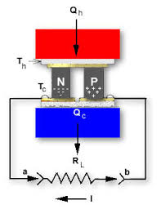

Rankine cycle
The ideal Rankine cycle is a system that utilizes the isobaric expansion, rejection and compression of a working fluid to power a steam turbine.
  - The working fluid is pumped under pressure to a boiler. Heat is fed via an external source to heat the fluid, in the case of an automotive application this heat could either be taken from the ICE’s coolant/oil or the exhaust.
(2-3) The heated fluid boils and converts from a liquid into a gas which is funneled into a smaller diameter channel to increase the pressure. This channel runs to a steam turbine which outputs useful work.
(4-5) The working fluid then passes through a condenser. The condenser reduces any residual heat from the working fluid to convert is back into liquid from so it may begin the cycle again.
This system is often utilized in large industrial applications such as steam turbines for nuclear power plants where their heat recovery properties can achieve up to 55% thermal efficiency when incorporated into a system on a large scale. Due to the scale that RC systems are normally utilized in it create a packaging issue when developing an equivalent system to be used in an automotive application. The environment in which the RC system operates efficiently is not ideal in an automotive application as the working temperatures vary drastically during the drive cycle. The Toyota group of north Americas addressed similar concerns when developing RC systems of automotive use.” heat sources on vehicles are different from other typical industrial heat sources, which are stable and no space limitation for the RC system. To be technically feasible for vehicle RC application, the cycle system should be kept as simple as possible and utilize components that already exist in the vehicles in order to reduce the added expense, weight and complexity of the system.” (Zhou, Dede and Joshi, 2016)
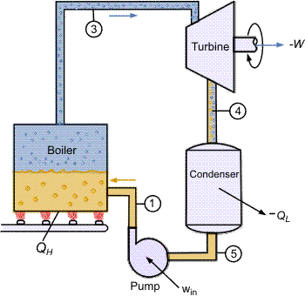

Turbo chargers
Turbo charging is a well deployed method of utilizing waste energy output by the ICE. It utilizes the flow of exhaust gases to power a turbine which is via a connecting rod powers a compressor wheel, which in turn draws air from outside the ICE into the system under pressure to improve performance. There are a few issues with turbo charging systems which include:
Weight of the system the turbocharger unit in itself is not a significantly heavy component, but the supporting systems that need to be incorporated to allow the system to function to add a significant amount of weight. These components include, intercooler unit, intercooler piping, additional oil and water lines, an exhaust manifold suitable for housing a turbocharger, boost regulating systems and the wastegate (if not already integrated into the turbo unit).
Turbo lag. This occurs at a point usually at low engine rpm, where the exhaust flow is not substantial enough to power the turbine to its operating rpm so that the system con function effectively. This issue may be mitigated by the use of compounding turbocharger units, although it does add an additional layer of complexity to the system. (Petitjean et al., 2004)
Advantages of turbo charging include:
Increased volumetric efficiency, the availability for engine downsizing by up to 30%, increased power and torque figures and an increase in fuel economy by up to 10% (Petitjean et al., 2004)
Electronic turbo chargers such as Aeris Tech FE.tt systems operate very similarly to a standard turbo charging system. The electronic component introduces a higher level of control that a standard system. Instead of the Turbine having a permanent connection to the compressor wheel they are connected via an electronic motor/generator. Aeris Tech state that these systems improve drivability and power delivery with no turbo lag as the motor can deliver maximum torque to the motor from low rpm. (Aeristech, 2017). This system uses similar technologies to formula 1 utilizing the spinning shaft of the turbine to generate energy.

Procedures and methodologies

Decision matrix
Decision Matrix | Rating 1-10
 | Thermoelectric | Rankine cycle | Turbo charging
Complexity | 5 | 3 | 4
Weight | 5 | 3 | 3
Effectiveness | 6 | 6 | 3
Cost to develop | 2 | 2 | 7
Total Score | 18 | 14 | 17
Above is a personal evaluation of the three systems discussed previously. The highest scoring of all the systems is the thermoelectric system. It is shown that thermoelectric is a relatively lightweight, efficient and simple method of thermal recovery. The main concern of this system is that no automotive manufacturer has made this commercially available on any of their vehicles as a method of thermal recovery.
The second-best scoring is the turbo charger system which was let down by the low score in the effectiveness category as the system doesn’t utilize and repurpose heat energy specifically to increase efficiency. Where it does score well is in the cost to develop as the research and development process is well past its infancy and are commercially readily available. (Petitjean et al., 2004)
The lowest scoring system is the Rankine cycle. This is due to the high complexity, weight with an average weight of a system reaching 45Kg (Zhou, Dede and Joshi, 2016) and development cost of the system.

personal NEDC
To establish a personal NEDC for the purposes of this project two thing are needed to carry out the testing firstly a personal vehicle that is functioning effectively in the case of these tests a 2012 1600 cc Nissan Juke was selected to act as the baseline for the test. To record the data during the test a Race Technologies DL1 data logger with GPS will be used to record all relevant test data. Once a consistent data set is acquired, it will be possible to establish a vehicle specific duty cycle accounting for the weight of the vehicle and frictional losses sustained during the testing process. Then utilizing the format and testing procedures of the New European driving cycle (NEDC) it will be possible to create a personal NEDC for the vehicle chosen. From there it will be possible to theoretically implement a thermal recovery system to evaluate both the fuel economy and ICE efficiency gains.

Project Aims moving forward
From the information gathered during the research phase of this project it has been established that most effective thermal recovery system that may be investigated and tested in the time span of this project is the Thermoelectric Generator system. Moving forward, the project aim is to launch a study to specific potential gains of implementing a TEG to a road vehicle. This would include packaging of the system to be implemented along with an effective design that would be suitable for use in automotive applications. An in depth thermodynamic of the system using mathematical methodologies as a means of validation of the employment of the system. And finally to develop a functional prototype of the system in question.

Bibliography
SHUDO, T. and TOSHINAGA, K., 2010. Combustion control for waste-heat recovery system in internal combustion engine vehicles: increase in exhaust-gas heat by
combustion phasing and its effect on thermal efficiency factors. International Journal of Engine Research, 11(2), pp. 99-108.
TEH, K., MILLER, S.L. and EDWARDS, C.F., 2008. Thermodynamic requirements for maximum internal combustion engine cycle efficiency. Part 1: optimal combustion strategy. International Journal of Engine Research, 9(6), pp. 449-465.
SARGENT, C. E., 1987. INCREASING AUTOMOBILE-ENGINE THERMAL EFFICIENCY. SAE International, [Online]. 1, 506.
Ferrotech. 2017. Thermoelectric generator technical diagram. [ONLINE]
Thermopedia.com. (2017). RANKINE CYCLE. [online] Available at: http://www.thermopedia.com/content/1072/ [Accessed 17 Nov. 2017].
Stobart, R. and Wijewardane, A. “Exhaust System Heat Exchanger Design for Thermal Energy Recovery in Passenger Vehicle Applications”. IMechE, VTMS 10, Vol. 2011, Vehicle Thermal Management System Conference, Warwick, UK, 2011
Aeristech. (2017). FullElectric Turbocharger | Aeristech. [online] Available at: http://www.aeristech.co.uk/full-electric-turbocharger-technology/.
Zhou, L., Tan, G., Guo, X., Chen, M. et al., "Study of Energy Recovery System Based on Organic Rankine Cycle for Hydraulic Retarder," SAE Technical Paper 2016
Dong, G., Stobart, R., Li, J. and Wijewardane, A. “Transient Performance Analysis of a Thermo-Electric Generator installed in EGR path of a Diesel Engine”. ICACMV 2011, China, 2011
Twigg, P. (1996). Science for motor vehicle engineers. Waltham, Mass.: Butterworth-Heinemann.
Aeristech. (2017). Presenting the Benefits of Electric Turbochargers at IQPC | Aeristech. [online] Available at: http://aeristech.co.uk/presenting-the-benefits-engine-downsizing-potential-of-electric-turbocharger/
Massoud, M. (2005). Engineering thermofluids. Berlin: Springer.
Web.mit.edu. (2017). 3.5 The Internal combustion engine (Otto Cycle). [online] Available at: http://web.mit.edu/16.unified/www/SPRING/propulsion/notes/node25.html.
David, D., Kulzer, A. and Bosch, R. (2009). Investigations on the Transient Wall Heat Transfer at Start-Up for SI Engines with Gasoline Direct Injection. SAE international, 1(1).
Petitjean, D., Bernardini, L., Middlemass, C. and Shahed, S. (2004). Advanced Gasoline Engine Turbocharging Technology for Fuel Economy Improvements. SAE International, 1(1), p.4.
hou, F., Dede, E. and Joshi, S. (2016). Application of Rankine Cycle to Passenger Vehicle Waste Heat Recovery. SAE International, 2(4).
Karras, N., Kuthada, T. and Wiedemann, J. (2017). An Approach for Water Jacket Flow Simulations. SAE International, 2(3), pp.1-3.
Shivakant Kurbet, P. (2007). Review On Effects of Piston and Piston Ring Dynamics Emphasis with Oil Consumption and Frictional Losses in Internal Combustion Engines. SAE international, 1(2), pp.1-3.
AK LECTURES. (2017). The Otto Cycle. [online] Available at: http://www.aklectures.com/lecture/the-otto-cycle.
Stone, R. and Ball, J. (2004). Automotive engineering fundamentals. Warrendale, Pa.: SAE International.
Yang, Z., PradoGonjal, J., Phillips, M., Lan, S., Powell, A., Vaqueiro, P., Gao, M., Stobart, R. and Chen, R. (2017). Improved Thermoelectric Generator Performance Using High Temperature Thermoelectric Materials. SAE, 1(1).

