Student name: Geminiano (Gio) Aguilar
Student ID: 2001127
Module: Introduction to Web and Database Concepts
Module code: ACCA4023
Submission deadline: May 5th, 2021

Table of contents

- Introduction…………………………………..…pg. 1

- Initial findings…………………………………..pg. 2

- Implementation & Documentation…..pg. 2
3.1 Context Level Diagram……………....pg. 2
3.2 Level 0 DFD…………………………………pg. 3-4
3.3 Entity Relationship Diagram……....pg. 4-5

- MS-Access functionality………………..…..pg. 5-6

- References…………………………………………pg. 6

Introduction
I will be implementing and designing several database diagrams for a Catering business located in Swansea. The business wants to have an online presence as all orders taken by customers are dealt in hand. Having orders taken through online will help the business become more organized and work more efficiently. These database diagrams will enhance the functionality of the business as well as their performance. The business demands well-designed databases. I will be creating these databases with the use of software applications: Microsoft Visio and Microsoft Access.

Initial findings
Considering the above scenario, I will be producing a context diagram, a level 0 DFD, and an Entity Relationship Diagram. I will update the current system into a more effective and organised system to help the business grow more profit and become more successful. The business states that they are aiming to exchange their method of receiving orders through paper receipts to an online system. I will fit in an online management system into these diagrams as an online system will help the company to do less work but perform much better. There are many benefits of switching to online for a business. An example could be that it can lead to the growth and increased sales of a business [1].

3. Implementation & Documentation
3.1 Context Level Diagram

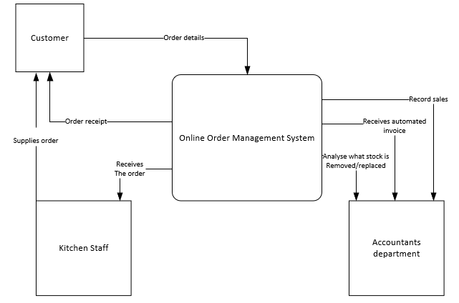

The image above shows the Context Level Diagram I have created for the business. As shown, there are only three entities involved in this diagram: The customer, kitchen staff and the accounts department. I have decided to remove the manager because the customer orders can be shown directly to the kitchen staff directly without having the manager to tell them. This can increase the work rate as the orders will come through quicker meaning that more orders will be created, and the business can make more profit. Firstly, the customer places an order. The order will then be created, and all the order details will be transferred to the kitchen staff and the accounts department. Once the kitchen staff receives the order details, they will create and supply the order to the customer. Once the accounts department receives the order, they will analyse the stock that needs to be removed and replaced, they record the number of sales and they receive an automated invoice. This system is enhanced from the old system as an extra person in the business is involved. Replacing the manager with an online system will increase the work rate as orders will come through quicker.

3.2 Level 0 DFD
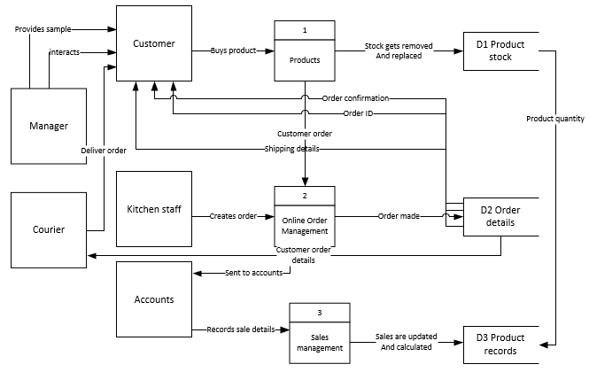

The image above shows the Level 0 DFD I have created for the business. The Level 0 DFD is a more developed design then the Context Level Diagram as it reveals stages and functions that were not shown in the Context Level Diagram. This Level 0 DFD is a more detailed version and includes most of the functions that are performed in the business in real-time. As shown, there are more entities involved in this diagram compared to the previous diagram. This is because the Level 0 Diagram includes for detail. Additionally, there are now ‘Data Stores’ involved in this diagram. These type of data shows where data is collected and stored. The data stores include:

Product stock – product stock is calculated and updated to suit the needs of the business. Once an item is purchased by a customer, the stock of the product gets removed and updated. These changes are recorded into the other data store called the ‘product records’.

Order details – the customers order gets analysed and details regarding the order gets sent to the customer, the courier, kitchen staff and the accounts management.

Product records – product sale, profits and the quantity of the products are recorded to ensure that the overall quantity of stock is up to date.

The Manager interacts with the customer directly to guide and help them. The Manager also provides the customer with some samples to figure out what products the customer will purchase. The manager is not involved much in the ordering system, the manager is just present to guid and help the customer. Once the customer decides and purchases a product/products, the order details will then be delivered to the online management system as well as the product stock details. The product quantity gets analysed and stored into the product records. Once the order reaches the online order management system, the order gets passed onto the order details and the kitchen staff. The order details (order, shipping details and order ID) reach the customer and the courier. The courier will receive all the information about the order of the customer and will ship their order to them. The kitchen staff receive the order from the online order management system and creates the order for the customer. Once the accounts management receives the order, they record the sale details and update the number of sales and calculate the profit made.

The design of the Level 0 DFD meets the user requirements because of the functions included in the system. Functions such as sending the customer order details (order ID, order confirmation, and shipping details) will make the customer satisfied with purchasing from this business as it provides the essential needs when a customer purchases a product. If the customer has purchased a product and has not received any updates, the customer is likely to be disappointed in the service and is not likely to revisit the business in the future. The statement “Customer retention powers sales and helps businesses maintain sustainability” [2] suggests that keeping customers close to the business will lead to an increase in sales. This shows that it is important to keep customers satisfied with the service so that they will return in the future and help grow the business.

3.3 Entity Relationship

I have created an entity relationship diagram for the business. In total, there are six entities, most entities are connected to each other and have a close relationship. As shown above, the store entity is connected with the product and stock entity. They are connected with each other because they are related to each other in some way. For example, the store has a foreign key for the stock entity (‘stock_num’). they are connected because the store needs to have stock and vice versa. In addition, the courier entity has a close relationship with the customer and orders entity because they all relate to each other. In this case, the courier has a foreign key for the customer entity and orders entity because the courier needs to ship the right order to the right customer. They are close relationships because one entity needs or uses another entity.
The tables I have created meets the standards for 3NF (3 Normal Form). This Is because the values that are stored in each entity do not depend on each other. This means that non-key attributes are independent.

MS-Access Functionality
Tables linked
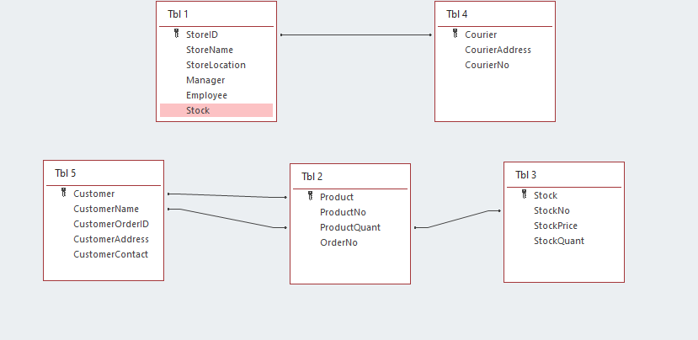
Query

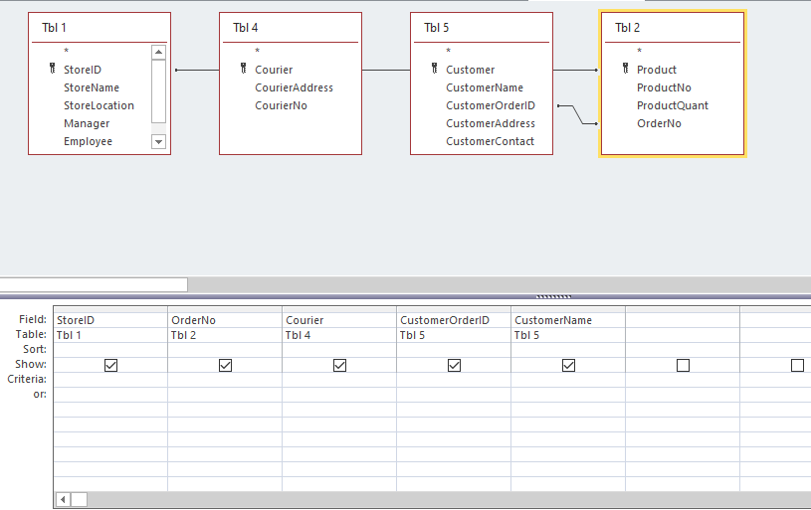

Forms
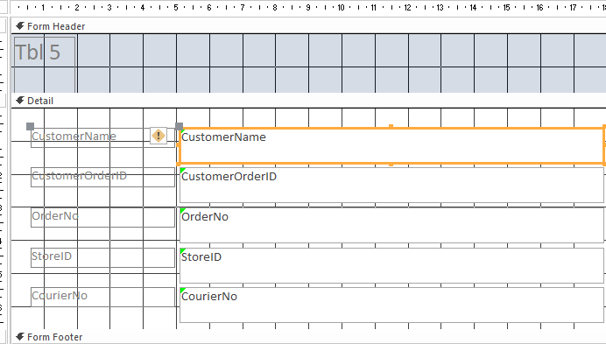

References
[1] infotechsite, “WHY HAVING A STRONG ONLINE PRESENCE CAN HELP YOUR BUSINESS”, infotechsite, May. 29, 2020 [Online] Available: https://www.siteforinfotech.com/why-having-a-strong-online-presence-can-help-your-business/#:~:text=If%20you%20can%20use%20some%20of%20your%20business,products%20online%20rather%20than%20going%20into%20a%20store [Date Accessed: May. 1, 2021]
[2] indeed, “Why is customer satisfaction important”, indeed, Mar. 9, 2021 [Online] Available: https://www.indeed.com/career-advice/career-development/what-is-customer-satisfaction [Date Accessed: May. 1, 2021]

