Why has the First World War cast such a long shadow over the history of the British Isles, even eclipsing the legacy of World War Two? This exercise can address the political, social, cultural, and psychological impact of the conflict.

The First World War was undoubtably the first of its kind and it certainly lived up to the various names attributed to it such as ‘The Great War’ and ‘The War to end all wars’. It changed the way that people thought about war due to the immense scale of events not known up to now. Samuel Hynes writes ‘no one after the war…could ignore its historical importance or frame his thought as though the war had not occurred or had simply been another war’. The scale that it was fought on and the impacts which could be felt in every country, not just Britain, meant that it could not be ignored, and the ramifications echoed throughout the world for many years to come. Britain would never go back to how it was in the pre-war days of summer 1914 of which Vera Brittain writes, ‘it seems to me that an ominous stillness, an atmosphere of brooding expectation, must surely have hung about the sunlit flower gardens and the shining green fields.’ Indeed, this essay will discuss the long-lasting legacy that The Great War left upon Britain and the reasons as to why it eclipsed the legacy of World War Two. This will be done by discussing the impacts on various different facets of society such as politically, socially, culturally and psychologically. In order to do this, I will be using works such as Alan Simmonds Britain and World War One as books like this will allow me to go in depth into discussion and analysis.
Politics in Britain was changed dramatically as a consequence of The Great War both throughout the four years that the war spanned and during the aftermath as well. This was predicted in an article in the Times newspaper from August 3rd which said ‘Mr. Asquith may find it no disadvantage to take fresh blood into his Administration’ suggesting that politics needed to shift, and it did. Alan G.V Simmonds writes in his work Britain and World War One, the party in power at the start of the war were the Liberals, who had an alliance with Labour and Irish Nationalists. However, this was soon taken over during the war by David Lloyd George who was ‘backed mainly by the Conservatives, but also with a group of his own Liberal supporters and a smattering of Labour MPs’. Simmonds argues that a ‘coalition government of this type was relatively new to British politics’ and that ‘pushing aside traditional party loyalties for the sake of defeating Germany persuaded some in Westminster that coalition was the future model of political governance.’ This suggests that the Great War provided a catalyst for coalition governments in Britain as it meant that politicians had to put aside their differences and work together in order to ensure that the country stayed together to keep Britain safe and win the war.
By the end of the war, the Liberal Party that had been in power since 1906 started to go into decline and essentially split into two parties, with some allying with Herbert Asquith and the others allying with Lloyd George. The Great War certainly took its toll on the Liberal party as it caused the dominant party in Britain to become divided eventually resulting in them losing power which they have not regained since. The political impact of the war also resulted in other changes such as the Labour party expanding its own influence and becoming second only behind the Conservatives. John Turner states that ‘The Irish Nationalist party had disappeared from the face of politics’ and the 1918 election resulted in an increase of power for the Conservatives who ‘had become the party of the capitalist class’. Turner goes further to say that the changes caused by World War One were never reversed and that the Great War ‘had ‘broken’ the mould of the nineteenth-century party system’. Indeed it is safe to say with the growing emergence of the Labour Party and the Conservatives increasing their power, the Great War’s impact on the political situation in Britain paved the way for years to come. This can be seen in the present day with power still changing hands between Labour and Conservative.
Perhaps, one of the biggest political impacts felt in Britain as a result of the war was the Easter Uprising which ultimately led to the War of Irish Independence. The Easter Uprising was an armed uprising by the Irish Republicans against the British government in order to establish an independent Irish Republic. This was a significant moment that happened during the Great War as it led to the Irish republicans gaining their independence. The fact that this occurred during the First World War was not a coincidence as whilst the British were preoccupied with fighting the war they were vulnerable which meant that it was an ideal time for the Republicans and allowed them to press home the advantage. Although the insurrection was completely crushed, it resulted in the Sinn Féin party ultimately gaining most of the seats in Ireland during the 1918 election allowing them to actively campaign for independence. This proved fruitful as in 1922 they managed to gain independence with only the six Ulster counties remaining under British rule. Without a doubt this is one of the biggest political impacts that happened as a result of the Great War, as without it the Easter Uprising might not have happened which would have meant that the movements popularity might not have taken off ultimately resulting in Ireland still being under British control. The Irish War Of Independence and the Easter uprising has cast a big shadow over Britain, helping the Great War to eclipse the legacy made by World War Two as the ramifications of it can still be felt today, and without a doubt the independence of a country cannot be ignored.
The impact on British Politics as a result from World War One was a lot stronger than the effects of World War Two, in fact since 1945 the ruling party has only changed hands between two parties, namely Conservative and Labour (see Figure 1), which as discussed earlier they increased their power through the effects of the First World War. Perhaps the reason as to why World War Two’s legacy upon British politics was significantly less could be due to the changes that the First World War brought to politics. This could mean that the structures put in place due to World War One were more capable of withstanding another World War. Interestingly, another reason could be because during Neville Chamberlain’s government, which was formed in 1937, ‘seven out of twenty-two cabinet ministers held the Military Cross, won in the Great War’ and ‘almost every cabinet minister had served in the war in some capacity’. This suggests that the memory of the Great War would have been in the mind of many people going into World War Two and perhaps it eclipses the legacy of the later war due to the fact that many people in charge of the country would have had first-hand experience of horrors of war and as such their approach to World War Two and the way Britain fought it might have directly been influenced by it.
One of the main social impacts resulting from the Great War was the impact on women’s lives. With many households bereft of their main earner as most men volunteered or conscripted into the army, many jobs required women to take the place of men. Whiteside writes ‘the constant demand for men and munitions at the Front revolutionised the nature of the economy and the organization of the labour market’ resulting in the ‘extensive participation by women in the formal labour market’. Women were required to work in munitions factories but also to work in areas that only men had previously been allowed to work in. Women no longer had to be content with being housewives as they were required to become the main household earners. Although post-war women’s roles were once again contained to the home, it set the stage for future developments. Whiteside states that that ‘the use of female workers expanded chiefly in munitions (by 700,000, in transport (by 100,000) and in banking, finance, commerce and public administration (by 400,000)’. Not only this, women could be found working in areas such as farming and agriculture as the need for food had risen during the war. The social impact of this was immense as it proved to society that women could do just as good a job as men, and ultimately this is where the push for more women in the workplace really took hold and provided a stepping stone for the future. It is easy to see why this is a significant part of World War One’s legacy as it was a big factor in gaining equal rights for women, and World War Two only helped to continue this legacy.
Surprisingly, but conditions for British people generally improved throughout the war, even for those who were in poverty in the years before the change. In fact research from the 1920’s suggest that ‘poverty had fallen by more than a half’ as a result of the war. Rex Pope states in his book War and Society In Britain 1899-1948 that in the city of Bristol ‘the number of schoolchildren requiring free meals fell sharply from 1,445 on the last day of March 1915 to 114 on the equivalent day in 1916’. This provides a clear correlation that the standard of living was improving dramatically throughout the course of the war. This can be understood due to the increase in women and boys having to find work and poorer people having to work in higher end jobs in order to fill the gaps left by the men going off to war. Furthermore the infant mortality rate is a good indicator on what the standard of living is in a given area, and in Wigan between 1901 and 1903 it was averaging around 181. By the end of the war it had fallen to 119, which further proves the idea that the standard of living rose as the number of babies that were dying before they had seen a year declined.
It would be hard for a country to go through such an experience without having some sort of cultural change or impact. In this way Britain was affected heavily, with a variety of culturally significant events and changes resulting directly from the Great War. Many of these are deeply ingrained in our modern culture today. Written works such as poetry as well as novels are a consequence of individuals personal experiences in World War One. J.R.R Tolkien’s works has drawn comparisons from scholars to his experiences fighting in the Great War, specifically on the Somme. In fact, Tolkien’s first experience of warfare was the Battle of The Somme and it was during this engagement that two of his friends died. Indeed he wrote himself that ‘By 1918 all but one of my close friends were dead’. Many themes from his experiences are without a doubt echoed within his works. Janet Brennan Croft quotes Tolkien as saying ‘My ‘Sam Gamgee’ is indeed a reflexion of the English soldier, of the privates and batmen I knew in the 1914 war, and recognized as so far superior to myself’ and ‘[t]he Dead Marshes and the Morannon owe something to Northern France after the Battle of the Somme’. Not only this but it is widely believed that the four Hobbits in Lord Of The Rings who go on the adventure echo Tolkien himself and his friends going off to war. Perhaps the subtle ways that Tolkien uses to translate his experiences into his works, whether deliberately or not might explain why they resonate strongly with British people. It is safe to say that if World War One had not happened and Tolkien had not experienced it, then the impact upon modern culture from his works would not have happened. As a result of this, modern fantasy writing would not be as enriched, and cultural facets of British society such as Dungeons and Dragons as well as the massively successful Lord of the Rings films would not exist. From this it is easy to see the legacy left by the Great war upon British Culture as without it a considerable chunk would not exist.
Perhaps the most recognised cultural impact from the Great War is Remembrance Day or Armistice Day. Simmonds states that in some places remembrance had begun as early as 1914 with roll of honour tablets and in 1916 memorial plaques began to be placed on walls as a sign of remembrance. However, what we now know as Remembrance Day commemorates the day in which the peace agreement was signed ending World War One. This was originally done on the 11th November every year, however after World War Two it was decided that it would be commemorated on the second Sunday of November in order for all the people that fell during both World War’s to be honoured. The fact that we still honour this day every November and participate in the commemoration shows the impact that the war had on our culture and society. Our society had never seen a war on this scale before which illustrates the need for an annual holiday to honour those that had died for our country.
There are many people who participated in the Great War, whether they were civilians or those who fought in it, who were affected by the horrors they experienced. Many of these were manifested in psychological issues, of which there were numerous different types. Peter Leese, in his article Problems Returning Home: The British Psychological Casualties of the Great War lists a few typical experiences that soldiers returning home might have experienced. Some ‘experienced feelings of guilt over separation from, and neglect of, family and friends…the mundane realities of postcombat life could breed resentment and festering anger and that changes in the composition of the household by death, birth or marriage forced veterans to adapt very rapidly to changed circumstances’. This has resulted in our society developing a greater understanding of the effects of PTSD, perhaps because it was more common after such a global event.
To conclude, the First World War has a long-standing legacy that eclipses World War Two’s. This could be because people did not want a repeat of the horrors that the first war exhibited, as Martin Gilbert writes, that British policy towards Germany between the two wars showed that ‘war was a ghastly experience that should be avoided at any cost’ but also ‘that if war came, there were in Britain reserves of patriotism and national unity to ensure that it would be fought with determination. Suggesting that the Great War eclipses the legacy of the Second World War due to the fact that it was arguably the first war that could be considered a global war. Lyn Macdonald in her book The Roses of No Man’s Land summaries it well:
No Lunatic imagination could have envisaged that half the youth of half the world could be sucked into a conflict that would rage across the sudden wastelands of France and Belgium; among the sandstorms of Egypt and Mesopotamia; on the high peaks of Alsace; among the mountain passes of the Tyrol; on the barren rocks of Gallipoli; in the hinterland of Africa; and across half the oceans of the world.
This quote really allows for a descriptive understanding of why the Great war is considered to be the First World War and truly why the legacy of it eclipses the second. No one had ever seen anything or endured anything like it before, for many civilians it was the first time that they had ever been directly or even indirectly involved in the horrors of war, and as such it comes to no surprise that the legacy of the First World War is stronger in people’s minds. By the time World War Two came around most people had experienced or grown up with tales of the first so they might have had an idea of what to expect. The Great War overshadows World War Two due to the many changes that it brought to the country such as political reforms, as well as setting the stage for the women’s vote and equality.
Word Count: 2733

Bibliography

Primary Sources
Brittain Vera, Testament Of Youth An Autobiographical Study Of The Years 1900-1925, 9th edn (London: Victor Gollancz Ltd, 1935).

Editorial Article of The London Times, Aug. 3, In Project Gutenberg THE GERMAN INVASION. <https://www.gutenberg.org/files/16331/16331-h/16331-h.htm#FIRST_WARNINGS_OF_EUROPES_PERIL> [accessed 15 November 2019]

Tolkien, J.R.R., The Lord Of The Rings, (London: HarperCollinsPublishers 1995).

Secondary Sources

‘Easter Rising’, Encyclopædia Britannica, 17, April 2019 < https://www.britannica.com/event/Easter-Rising > [Accessed 4th November 2019].

Cowell-Meyers Kimberly , Arthur, Paul , ‘Sinn Féin’, Encyclopædia Britannica, 5th November 2019 < https://www.britannica.com/topic/Sinn-Fein > [Accessed 14th November 2019].

Croft, Janet Brennan, ‘The Great War and Tolkien 's Memory: An Examination of World War I Themes in The Hobbit and The Lord of the Rings’, Mythlore: A Journal of J.R.R. Tolkien, C.S. Lewis, Charles Williams, and Mythopoeic Literature, 23(4) (2002), 4-20.

Cunningham, John M., ‘Remembrance Sunday’, Encyclopædia Britannica, 12 April 2017, < https://www.britannica.com/topic/Remembrance-Sunday > [Accessed 14th November 2019].

De Bromhead, Alan, Fernihough, Alan, Hargaden, Enda, 'Representation of the people: Franchise extension and the "Sinn Féin election" in Ireland, 1918', QUCEH Working Paper Series, 2018(08), (2018), 1-30.

Gilbert, Martin, Britain and Germany Between the war, ed. By Hugh F. Kearney (London, 1964)

Hynes, Samuel, A War Imagined: The First World War and English Culture, (London, Pimlico, 1992).

Institute For Government, The history of changes of Prime Minister, <https://www.instituteforgovernment.org.uk/blog/history-changes-prime-minister> [accessed 4 November 2019].

Leese, Peter, 'Problems Returning Home: The British Psychological Casualties Of
The Great War', The Historical Journal, 40(4), (1997), 1055-1067.

Macdonald Lyn, The Roses Of No Mans Land (London, Papermac 1984).

Pope, Rex, War and Society in Britain, 1899-1948 (New York, Addison Wesley Longman Publishing, 1991)

Simmonds, Alan G.V., Britain and World War One, (Abingdon, Routledge, 2012).

The National Archives, People: Officer's service record: J R R Tolkien < http://www.nationalarchives.gov.uk/pathways/firstworldwar/people/tolkien.htm > [Accessed 1st November 2019]

Turner, John, Britain and the First World War, (London, Allen and Unwin, 1988).

Appendix
Figure 1: Institute For Government, The history of changes of Prime Minister, <https://www.instituteforgovernment.org.uk/blog/history-changes-prime-minister> [accessed 4 November 2019]
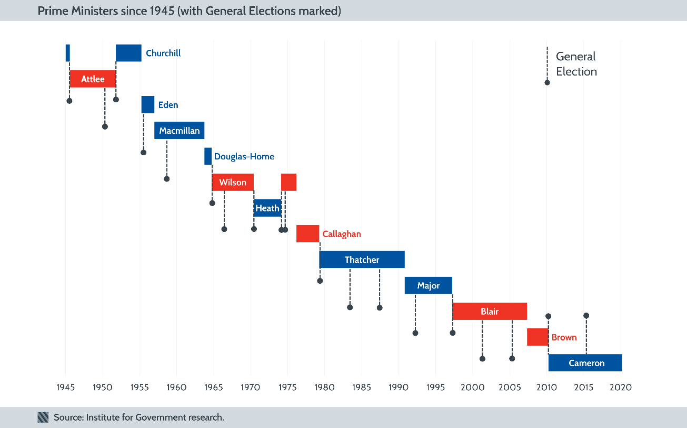

Samuel Hynes, ‘Introduction: A Gap in History’, In A War Imagined: The First World War and English Culture, (London, Pimlico, 1992) p.9.
Vera Brittain, ‘Provincial Young-Ladyhood’ In Testament Of Youth An Autobiographical Study Of The Years 1900-1925, 9th edn (London: Victor Gollancz Ltd, 1935), p. 87.
Editorial Article of The London Times, Aug. 3 Found In Project Gutenberg THE GERMAN INVASION. <https://www.gutenberg.org/files/16331/16331-h/16331-h.htm#FIRST_WARNINGS_OF_EUROPES_PERIL> [accessed 15 November 2019].
Alan G.V. Simmonds, ‘The Eclipse of Part Government’, In Britain and World War One, (Abingdon, Routledge, 2012), p.97.
Ibid., p.97.
Ibid., p.97.
John Turner, ‘British Politics and the Great War’ In Britain and the First World War, (London, Allen and Unwin, 1988) p.117.
Ibid., p117.
Ibid. p.117
‘Easter Rising’, Encyclopædia Britannica, 17, April 2019 < https://www.britannica.com/event/Easter-Rising > [Accessed 4th November 2019].
Alan De Bromhead, Alan Fernihough, Enda Hargaden, 'Representation of the people: Franchise extension and the "Sinn Féin election" in Ireland, 1918', QUCEH Working Paper Series, 2018(08), (2018), 1-30 (p. 2).
Kimberly Cowell-Meyers, Paul Arthur, ‘Sinn Féin’, Encyclopædia Britannica, 5th November 2019 < https://www.britannica.com/topic/Sinn-Fein > [Accessed 14th November 2019].
Martin Gilbert,’The Great War’ In Britain and Germany Between the war, ed. By Hugh F. Kearney (London, 1964) p.1.
Noel Whiteside, ‘The British Population at War’ In Britain and the First World War, ed. By John Turner, (London, Allen and Unwin, 1988), p.85
Ibid., p.92.
Ibid., p.92.
Ibid., p.86.
Ibid., p.86.
Rex Pope ‘Part Two: War and Social Change in Britain’ In War and Society in Britain, 1899-1948 (New York, Addison Wesley Longman Publishing, 1991) p.27.
Ibid. p.26.
Whiteside, Britain and the First World War, p.86.
The National Archives, People: Officer's service record: J R R Tolkien < http://www.nationalarchives.gov.uk/pathways/firstworldwar/people/tolkien.htm > [Accessed 1st November 2019].
J.R.R. Tolkien, ‘Foreword to the Second Edition’ In The Lord Of The Rings, (London: HarperCollinsPublishers 1995), p.17.
Janet Brennan Croft, ‘The Great War and Tolkien 's Memory: An Examination of World War I Themes in The Hobbit and The Lord of the Rings’, Mythlore: A Journal of J.R.R. Tolkien, C.S. Lewis, Charles Williams, and Mythopoeic Literature, 23(4) (2002), 4-20 (p.6).
Simmonds, Britain and World War One, p.302.
John M. Cunningham, ‘Remembrance Sunday’, Encyclopædia Britannica, 12 April 2017, < https://www.britannica.com/topic/Remembrance-Sunday > [Accessed 14th November 2019].
Ibid. 2017.
Peter Leese, 'Problems Returning Home: The British Psychological Casualties Of The Great War', The Historical Journal, 40(4), (1997), 1055-1067 (p. 1060).
Gilbert, Britain and Germany Between the war, p.1
Lyn Macdonald, ‘1914-1915’ In The Roses Of No Mans Land (London, Papermac 1984) p.17.

