
Skills for the Workplace
Module Assignment Submission
Student Name: | Gemma Senatore
Student Number: | 2017238
Module No: | BMSK4007
Module Title: | Digital Skills and Personal Branding

Statement of Confirmation of Authenticity
By the act of making this submission, the student declares that this is the work of the student named above. The work has not, in whole or in part, been knowingly presented elsewhere for assessment, or where assessment has been built on a previous assessment, this has been identified. Where materials have been used from other sources it has been properly acknowledged. If this statement is untrue, the student acknowledges that an assessment offence has been committed.
Attention is drawn to the plagiarism and unfair practice policies of both the University and of ILM.
Permission for ILM to use this script
ILM uses learners’ submissions – on an anonymous basis – for assessment standardisation. By submitting, both the centre and the learner agree that ILM may use this script on condition that identifying information is removed. However, if you are unwilling to allow ILM use this script, please refuse by ticking the box: □

Table of Contents

What has been the impact of 21st Century Technologies on the modern workplace? 3
Evaluate the appropriate use of modern technologies and social media in the workplace generally 3
Explore the use of modern technologies and social media in own workplace 3
How can Personal branding help YOU? 4
Your LinkedIn Profile to promote your Personal Brand 4
Evaluate the value of other social media platforms to enhance networking and career prospects 4
Examine the impact of Personal Branding on your own employability 4
Discuss personal and professional security and safety online. 4
References 6
Appendix 1 7
Appendix 2 8

What has been the impact of 21st Century Technologies on the modern workplace?

Objective | Current Position | Deficiency | Action
What technology is used in the workplace | What is it used for? | What could it be used for? | Improvement suggestions
Cisco | To listen into calls, log customer details and check daily stats | Customers could leave their own feedback by login into it instore | It could run faster as when too many people are on it, it crashes.
Outlook 365 | To deal with customers who prefer to email rather than call, keep staff up to date. | Keeping our customers up to date with our products and services. | Have more space on the system to type with more characters.
Facebook messenger | To keep in contact with our customer and answer queries. | To keep in contact with our suppliers. | Make it more secure so more companies can use it to contact each other.
Work mobile | To keep in contact with staff, management and stores. | To text customers mass messages about store information | Make it so all staff have access to a mobile for work purposes only.

Technology has changed dramatically over the last 10 to 20 years. It has gone from using typewriters, paper and posters to much more advanced means.
Now workers and employers have work mobiles, email accounts, WhatsApp groups, Facebook groups and many more to keep in contact and make sure everyone is up to date. Also systems have updated so employees can access more information to complete their workload in a more timely and efficient manner. It is also opening the door with communicating with more customers, making more profit and making your brand outstanding in its field.
Workers can also now be tracked my employers using modern technology by how long they have been on break, when they have logged in and out for their shift and even going to the toilet. This can help the company speak to more customers, finish more workload and also find what employees are not complying with their contact and causing setbacks for the brand.
Social media can help a company to grow by promoting your brand and find out what your customers wants. It can also help with finding employees that your company will benefit from. It can also be a downfall for potential employees especially due to Facebook as employers do check to see what you are like as a person. Any photos or comments employers do not like could jeopardize your career.
In my own workplace we rely on Facebook to keep up with our customers. We will respond efficiently to any customer queries or complaints. We also set an account for customers to speak to each other about different experiences they have had and we can keep a close eye on it so we can learn and work on anything that will broaden our brand. We use Twitter to help with these issues. It also lets us advertise any promotions and to have a good and cheerful conversations with our customers.
We also have the use of WhatsApp for each team. This allows their team leader to keep them up to date with their shifts, progression, team and floor stats and any questions their team needs answered.
The first technology based system my company used to help customers and colleagues was Email ( Outlook). We had teams dedicated to receiving and responding to complaints and queries which were very effective for our brand and made us seem we were keeping up with the times as a lot of customers prefer this method of contact rather than speaking on the phone. It also helps management and employees to stay up to date and keep in contact over the 3 buildings and many stores that we manage.
We use a system called Cisco that helps us find where a colleague is and record calls so we can listen to them to give feedback and improve on our customer service. It also gives information on how long a call took, what time the call came in and how well a colleague is doing in their daily stats.
LinkedIn has been used in my workplace to find potential employees as out brand is always growing. Especially the social media side. We do have colleagues that are not confident to use social media, even after training and would prefer to take calls from our customers.
OneDrive is used due to our company having 3 offices in different parts of the country. This helps us to keep up to date with each other at any time at the same time. This helps us all work together and help our customers efficiently. It can be accessed on work mobiles, laptops and PC’s. This is done mainly by management due to sensitive information being stored and to comply with GPDR rules.
Social media and new technologies have changed the way people work and how companies and their employees are perceived. It has made companies become more sufficient, how to know more about their market and be the best in their field. It can also affect the brand in a more serious way. For example, customers will write on Facebook when they have a bad experience, this can be liked and shared over social media in a matter of minutes. This then can damage and destroy a brand.
Not all people like to use social media. This can cause anxiety for employees who, even after training, feel they cannot get to grip with the idea. A lot of younger people are computer and social media literate. A lot of the older generation have mobiles but do not use them the same as the younger generation, so may not have WhatsApp or Messenger to keep in contact with work. This can cause the employee to leave the company or not even be considered for a position.

How can Personal branding help YOU?

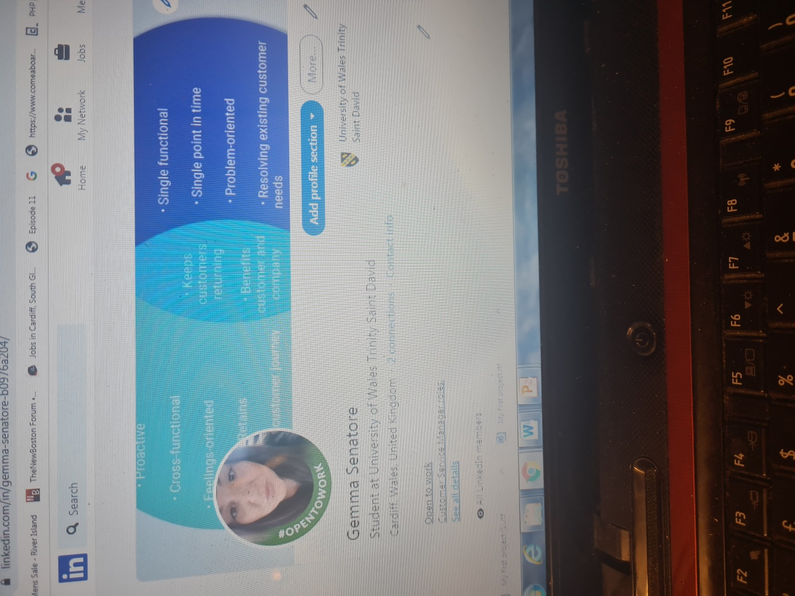

https://www.linkedin.com/in/gemma-senatore-b0976a204/

A personal brand is what sets you apart from everyone else; it makes you who you are. It is how you present yourself to others. It can help you figure out who you are and potentially get you a better role in the workplace and also help you in your personal life. There are many ways to start your brand such as defining your audience, researching your industry so you have the best knowledge and growing your online presence. You can brand yourself in many ways via social media such as Facebook, Twitter and LinkedIn.
LinkedIn is the best way to promote you, to get better job offers or look for potential employees. Mine shows what my best skills are and shows potential employers what I will bring to their business. I find that LinkedIn is very professional compared to Facebook. You can connect with people who have the same interests as you and find the best job for you. While Facebook can be a useful tool it can also show things that may portrait you as something you are not in, a bad way. Employers do sometimes checked Facebook as you must make sure that your account is set to private.
Whether you’re an employee or entrepreneur, cultivating a personal brand has become more important than ever. One reason is that it is more popular for recruiters to use social media during the interview process. According to a Google, 70% of employers use social media to screen candidates during the hiring process, and 43% of employers use social media to check on current employees. Personal branding is also beneficial from the employer’s perspective. Companies should encourage employees to build strong personal brands because it’s good business. When employees are allowed to represent their company at conferences or events, they are not only developing themselves but also providing the organization more exposure. Employees can help acquire new customers and retain existing ones when they are viewed as trustworthy thought leaders. Another reason personal branding is valuable is that the gig economy is not going away anytime soon.

Evaluate the value of other social media platforms to enhance networking and career prospects

Social media has many platforms to help promote yourself or your brand. Influencers on YouTube and Instagram are one of the highest paid people in the industry. Some have even become billionaires by promoting brands of other companies and their own. It is now essential to have some sort of social media. Professionals can use social media platforms as a way to enhance their knowledge of technology, marketing and news for their industry; network with other professionals; and provide an online space where clients can interact with them and provide feedback about their products or service. Individuals use social media to express themselves, discuss their interest, connect with friends and grow their careers. Different social media platforms are used for specific things. For example, expressing creativity is mostly on Tik Toc and Instagram whereas LinkedIn is better for promoting your career. Social media changes all the time so to promote your brand so you need to evolve also. It also helps you discover new ideas and trends so your brand can keep expanding. Social media is now an essential tool in networking with most employers checking before hiring anyone. Staying on social media can help you expand your knowledge of your target market. A lot of sites have surveys for their customers so they can keep up to date with what the customer wants.

Examine the impact of Personal Branding on your own employability

I have worked in the customer service industry for over 15 years and have an extensive knowledge in my field. This can be seen on my LinkedIn page. It has helped me to connect with people in my line of work. It helps me promote myself and show why I am unique at what I do. It allows me to show my customers and clients why I am the better choice and way of distinguishing myself from others. It helped me develop a persona that is reachable in a professional manner. Personal branding has a positive and indirect effect on career satisfaction via perceived employability. It helped me get a job that I love and that I am the best at. I also help other people in my field with any questions or queries as my personal branding shows how good I am at what I do.

Discuss personal and professional security and safety online.

Whenever you join a new social network, you should always look at the privacy and security settings so you are aware of how much information the service is sharing about you, and who is going to be able to see it. If you’ve been a member of a social network for some time, it’s worth looking at the privacy and security settings frequently as they are subject to change. Each social network deals with privacy and security in different ways, and you shouldn’t share information on their service until you know where that information will end up. In my line of work security online is essential due to having customer’s personal details. We must comply with the GDPR act (General Data Protection Regulation) if not then we will get a large fine and even closed down. We make sure all systems have passwords that only we can access and make sure there is a foot print so we know who has looked at it. There are 7 key principles that are set out for GDPR that must be followed. Lawfulness, purpose limitation, data minimisation, accuracy, storage limitation, integrity and accountability.
Cookies also help guard your privacy online. It helps websites remember you, your login details shopping carts and more. Most cookies are safe to use but there are also cookies that can be used to track you or sometimes even spied on. Every day you should clear your cookies, especially if using a shared computers.
Cookies are text files with small pieces of data — like a username and password — that are used to identify your computer as you use a computer network. Specific cookies known as HTTP cookies are used to identify specific users and improve your web browsing experience.

Reference list
Forbes. (2019). Forbes. [online] Available at: https://www.forbes.com/.
Kaspersky (2018). What Are Cookies? [online] www.kaspersky.com. Available at: https://www.kaspersky.com/resource-center/definitions/cookies.
Linkedin.com. (2019). LinkedIn: Log In or Sign Up. [online] Available at: https://www.linkedin.com/.
try.imperva.com. (n.d.). GDPR compliance: Meeting EU rules for data privacy. [online] Available at: https://try.imperva.com/gdprcompliance/ [Accessed 31 Jan. 2021].
try.imperva.com. (n.d.). GDPR compliance: Meeting EU rules for data privacy. [online] Available at: https://try.imperva.com/gdprcompliance [Accessed 31 Jan. 2021].

Appendix 1

Appendix 2

