

Student name: | Md Ekram Hossain | Student ID number: | 2523284
Programme: | MSc/PgDip/PgCert Cybersecurity and Digital Forensics
Module: | Data Security, Governance and Compliance
Module code: | ACCA7028 | Assignment Title: | Apply the principles and practices of Data security, Governance and Compliance based on a given scenario.
Lecturer: | Dr. Ayman Al Hajjar | Word count: | 3000
Submission deadline: | 29th April 2026  14:00 (2 PM)

Table of Contents
1. FinSure Bank (FSB) Security Frameworks and Models: How to fill Gaps in Governance, Risk and Compliance 3
2. a) FSB Secure Governance Framework (FSB-SGF): Customised Hybrid Method of Information System Security, Governance, and Compliance 9
2. b) Critique, Analysis, and Discussion: The Value of Constantly Updating Regulations and Standards in Information Security 14
References 18

FinSure Bank (FSB) is a digital-first financial organisation employing more than 90 per cent cloud-based infrastructure, embracing a BYOD policy, and mobile banking applications that serve more than 20 countries. It manages very sensitive financial and personal data but experiences a disjointed security policy, lacks consolidated governance, has no official risk policy, and has poor compliance controls, leaving it vulnerable to violations of the GDPR, data breaches, insider threats, fraud, and cyberattacks [6]. To develop a strong Information Security Management System (ISMS), combine risk management, make sure that both regulatory frameworks and models are aligned, and promote continuous enhancement, it is necessary to adopt the existing security frameworks and models.
The Cornerstone ISMS Framework ISO/IEC-27001: 2007
ISO/IEC-27001:2022 is the chair of the ISO-27000 series that offers the international standard to establish, implement, maintain, and continually improve an ISMS [12]. It is risk-based and concentrates on the CIA triad (confidentiality, integrity, availability) and covers Annex A controls (114 controls in the 2022 version, organised into 4 categories: organisational, people, physical, and technological). Importantly, it implements the Plan Do Check Act(PDCA) cycle of continuous improvement, which perfectly fits the demand of FSB to have organised governance in the context of the cloud growth and GDPR necessities.
During the Plan phase, FSB would outline the scope of ISMS, perform risk analysis (e.g., defining BYOD risk, cloud risk such as unauthorised access or data leakage), and pick controls. Do refers to the adoption of policies, training and technical controls (e.g., encryption, access controls). Check consists of internal audits, monitoring and performance evaluation [19]. The Act promotes remedial measures and corrections. This loop assures that FSB's fragmented approach advances to proactive, auditable security.
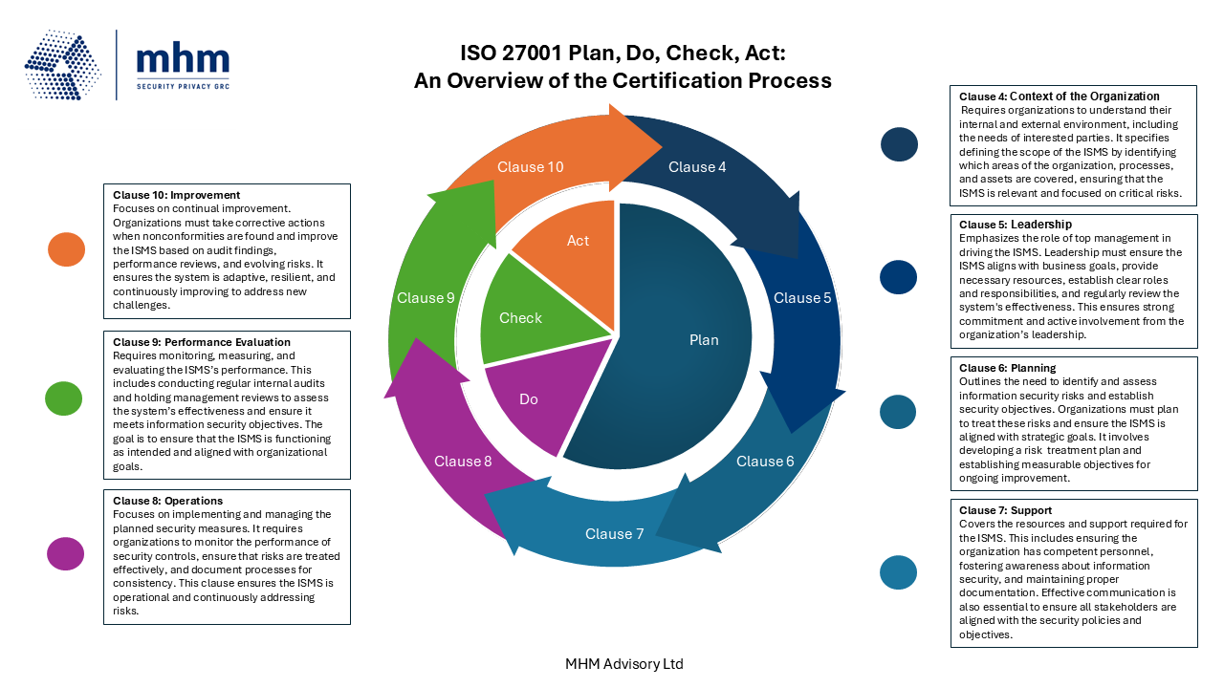

Figure: Achievement of ISO 27001 Certification: A Guide to the Plan, Do, Check, Act Process [19]

The diagram above represents the PDCA cycle that is overlaid on ISO 27001 clauses (4-10), the commitment to leadership (Clause 5), risk treatment (Clause 6), and operations (Clause 8). In the case of FSB, certification would show that the company is doing what regulators and customers want and ensure that insider threats are mitigated by having specific roles and safeguarding intellectual property. The cost of implementation is saved on breach risks because, in a field where data breaches cost millions in losses on average, the breach risk is minimal.
ITIL 4: The Security Integration in IT Service Management
ITIL 4 is not as process-oriented as it used to be, but a holistic Service Value System (SVS) that focuses on co-creation of value via guiding principles, governance, practices, and continuous improvement [2]. Information Security Management is a fundamental general management activity that safeguards organizational information throughout the service value chain. It’s part of 33 other practices, meaning that security is not isolated but built into service design, incident management, and supplier relationships, which is best suited to the cloud platforms and third-party relationships of FSB [16].
In contrast to the older versions, ITIL 4 considers security as a business enabler, which is in line with the digital expansion of FSB. In the case of BYOD and mobile applications, it complies with such practices as access management, risk management, and change enablement to avoid unauthorised access to devices without compromising service availability. The SVS facilitates a teamwork culture, which will deal with the deficiency of a single governance in FSB, connecting security to general IT service provision and data management that meets the requirements of GDPR [6].

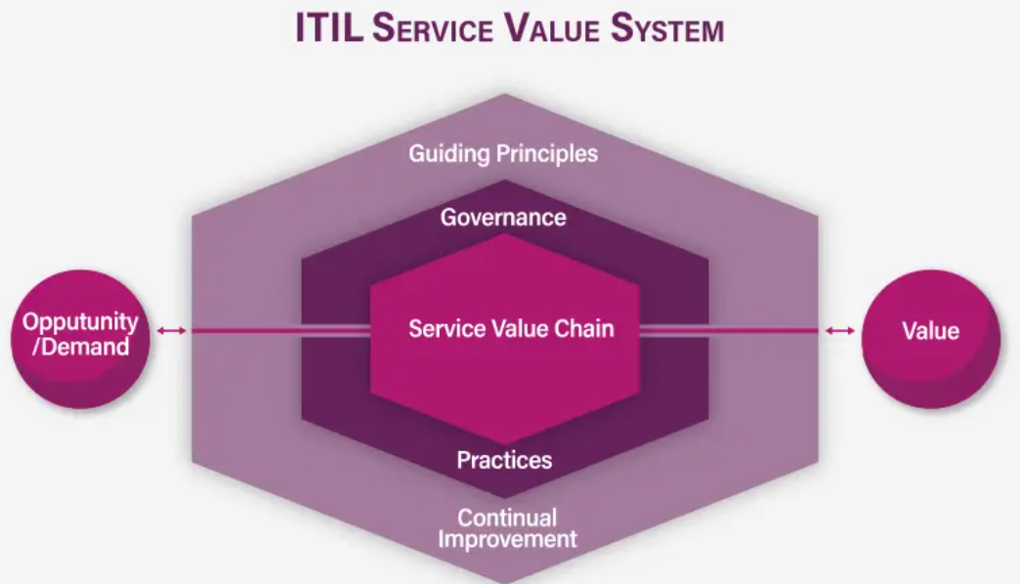
Figure: ITIL 4 Service Value System [2]
In this ITIL 4 SVS diagram, the inputs (Opportunity/Demand) are represented in the Service Value Chain by the outputs (Value) and are surrounded by Guiding Principles, Governance, Practices (including Information Security Management) and Continual Improvement. A complementary perspective throws light upon security in the wider practice ecosystem.
NIST Cybersecurity Framework 2.0: Risk-Based Cyber Resilience
NIST CSF 2.0 [13] is a voluntary and flexible framework that is widely used in financial services because of the outcome-oriented core, six Functions: Govern (new-in-2.0), Identify, Protect, Detect, Respond, and Recover [13]. It focuses on board-level governance, supply-chain risk (important to FSB cloud providers) and customisation profiles. For cloud/BYOD environments, it maps controls to emerging threats like AI-driven fraud or mobile vulnerabilities.
Govern makes a cybersecurity risk management enterprise-wide strategy. Locate inventory assets (e.g., cloud data, BYOD devices)[4]. Protect implements defences (e.g., no-trust to mobile access). Identify anomalies in detection monitors; Respond and Recovery provide quick handling of the incident and resilience. FSB is able to establish a Current Profile (evaluation of deficits) and a Target Profile in line with GDPR and financial guidelines[6].

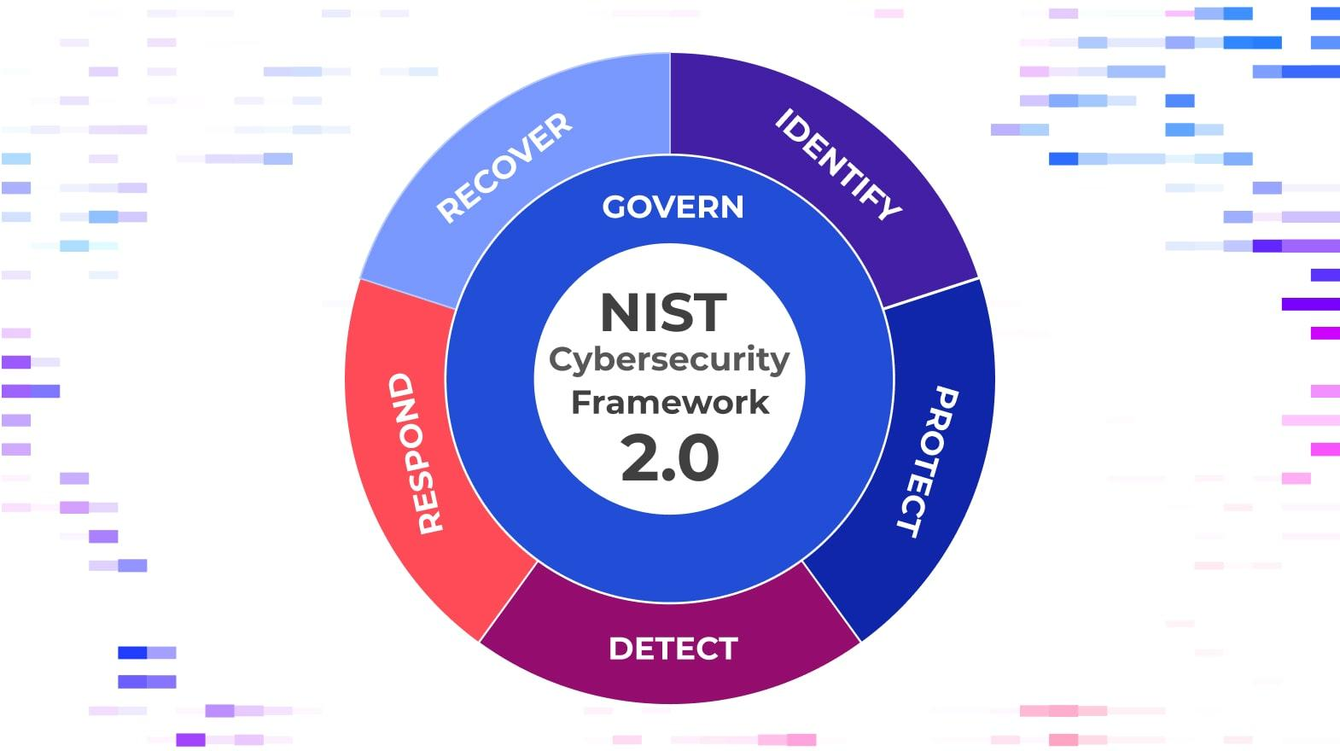
Figure: NIST CSF 2.0: Roadmap to Cybersecurity in the modern world [13]

The NIST CSF 2.0 wheel diagram presents the six interdependent Functions with Govern in the middle - to represent its overall role. This graphic highlights the cyclical, risk-focused nature of this framework, ideal in the high-stakes world of FSB.
The compatibility between NIST and ISO 27001 and cloud solutions makes it feasible for FSB and minimises the duplication of compliance, but covers insider threats and data privacy.
COBIT 2019: Enterprise IT Governance Alignment
The above is complemented by COBIT 2019, which aims at achieving enterprise IT governance and management objectives [10]. Its central model connects enterprise objectives to 40 governance/management objectives in five areas, which allow FSB to establish security alignment with business objectives, risk optimisation, and compliance with regulations (e.g., GDPR, SOX-like financial rules). It is compatible with standards such as NIST and ISO, offering maturity and design considerations specific to digital banks.
The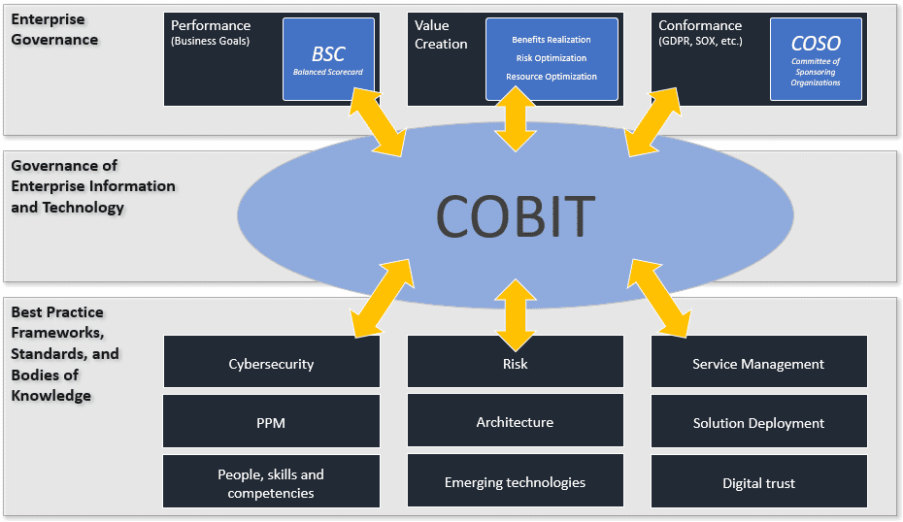
Figure: The most important principles and framework of IT governance [11].

The COBIT overview diagram demonstrates that the enterprise governance enters the centre of COBIT and takes into consideration the best practices of cybersecurity, risk, and service management, which ensures comprehensive management of cloud infrastructure by FSB [11].
Comparison and Hybrid Recommendation of FSB
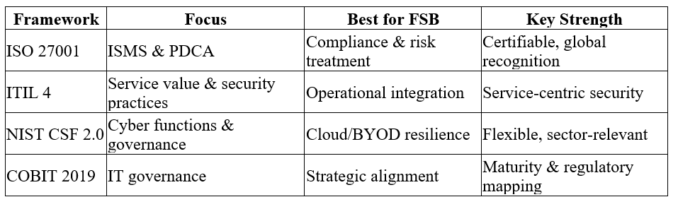
These frameworks are complementary: ISO offers the basis of ISMS, ITIL operationalises the services, NIST offers cyber-specific functions, and COBIT provides governance. A hybrid model, e.g. ISO-certified ISMS supported by NIST profiles and ITIL practices, managed with the help of COBIT, would bring FSB a fragmented model together. Begin with a gap analysis (PDCA or CSF profile), introduce BYOD/ cloud controls, perform regular audits and promote constant improvement. This would reduce GDPR risks, insider threats, and fraud and allow it to grow on a scale [6]. It is estimated that the benefits are 30-50% faster incident response and audit-ready compliance.

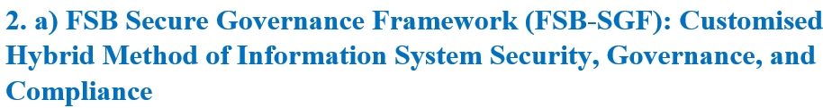
As a fast-growing digital-first bank with more than 90 per cent of its infrastructure being cloud-based, a high level of BYOD adoption, and mobile banking services, FinSure Bank (FSB) is at a very high risk of data breaches, GDPR breaches, insider attacks, fraud, and cyberattacks. Based on the existing frameworks, which are ISO/IEC 27001 (ISMS with PDCA) [9], NIST CSF 2.0 (Govern Identify Protect Detect Respond Recover), ITIL 4 (Service Value System) and COBIT 2019 (enterprise IT governance), I suggest the FSB Secure Governance Framework (FSB-SGF). This is a risk-based, flexible, and integrated model that integrates fragmented practices into an integrated system that instils security in operations, regulatory compliance and business growth.
The FSB-SGF has a five-pillar framework in line with the PDCA cycle and NIST functions, and COBIT governance and ITIL service integration. It puts cloud and BYOD details in the first place and takes into consideration all the mentioned factors.
i. Security (COBIT + NIST Govern) Governance and Strategic Planning
Create a Security Governance Board led by CISO and comprising C-level executives, legal, compliance and business representatives. This board prioritises security to business goals with COBIT design factors based on the profile of the digital bank (e.g., heavy regulatory exposure, heavy reliance on clouds) at FSB.
An enterprise risk appetite statement and annual security roadmap are the start of strategic planning. The board endorses policies, audits maturity reviews (through COBIT) and guarantees board-level awareness of cyber risks [11]. This will deal with the present absence of integrated governance that FSB is facing by establishing a sense of accountability and incorporating security into the cycles of strategic planning.

Proposed Governance Structure Diagram (Text Representation):
Board of Directors
↓
Security Governance Board (CISO-led)
├── Strategy & Planning
├── Risk & Compliance
├── Operations & Services (ITIL-aligned)
└── Audit & Continual Improvement
2. Compliance (Laws and Ethics)
FSB is involved in the work of several countries, and GDPR (and other similar standards such as the data protection regulations) is at the centre [6]. The framework requires an office of a Data Protection Officer (DPO) that has direct access to the board. Data-Protection-Impact-Assessments (DPIAs) are carried out on all processing activities, particularly on mobile applications and cloud storage. Ethical principles are clear use of data, consent and fair processing.
Compliance is integrated through policy-as-code checks during automated checks in CI/CD pipelines and periodic third-party audits (SOC 2, ISO 27001 certification target within 18 months). This guarantees compliance with the law and the creation of an ethical culture by providing compulsory training.
iii. Security Policies
Design a package of control guidelines to ISO 27001 Annex A, tailored to FSB:
• Acceptable Use Policy (AUP) — BYOD with explicit guidelines on personal vs. corporate data separation [20].
• Data Classification and Handling Policy - Classifies data (public, internal, confidential, restricted) with controls applied.
• Access Control Policy — Imposes a zero-trust policy, role based access control (RBAC) and multi factor authentication (MFA) on any system [5]
• BYOD Policy - Must have MDM/EMM solutions to containerise, remote wipe, encrypt and minimum device security (e.g., biometric lock, up-to-date OS). Agreements are signed by employees on the right monitoring and the right-to wipe data.
Policies are dynamic documents that are reviewed after incidents or once every year, and are disseminated through awareness programs.
iv. Risk Management (NIST Identify + ISO 27001 Risk Treatment)
Introduce a formal risk management process:
• Asset Inventory - Map cloud assets, BYOD, and data flows [20].
• Risk Assessment — Quarterly, a 5x5 matrix (likelihood x impact) addressing cloud misconfigurations, BYOD malware, insider threats and supply-chain risks.
• Risk Treatment — Prioritise through residual risk acceptance by the Governance Board; implement controls of NIST Protect/Detect and ISO Annex A.
The risk register is centralised and is connected to cloud security posture management (CSPM) tools to monitor continuously.
Example of Risk Assessment Table:
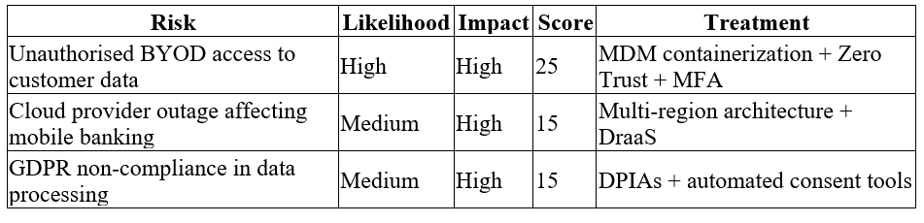
v. Security Management models and practices (ITIL + NIST protect/detect)
Implement the Service Value System of ITIL 4 to incorporate security practices within the value chain. Key practices include:
• Information Security Management
• Access Management
• Incident Management (built-in with NIST Respond)
Protection mechanisms feature:
Technical: Encryption (at-rest/transit), endpoint detection and response (EDR) on all devices, web application firewalls (WAF) and AI-based threat detection in mobile applications to detect fraud.
• Administrative: Background checks of contractors, compulsory security awareness training (simulated phishing).
Physical: Any on-premise remnants have controls, but minimal since it focuses on the clouds.
Zero-trust architecture presupposes breach, which checks all access requests irrespective of their location or device [5].
vi. Contingency Planning (NIST Recover + Business Continuity)
Develop integrated plans:
Business Continuity Plan (BCP) — Makes sure that essential services (e.g., mobile banking, payments) are accessible in case of disruption.
Disaster Recovery Plan (DRP) - Uses cloud DRaaS and established Recovery Time Objective (RTO < 4 hours) and Recovery Point Objective (RPO < 15 minutes) to access financial data.
Incident Response Plan (IRP) — Respond, based on NIST playbooks, to respond to ransomware, data breaches, and cloud outages. Has notification timeframes of GDPR (72 hours) [3].
Test plans are run through tabletop exercises and simulations, and an annual full-scale exercise with cloud providers.
vii. Services Level Agreements (SLA’s)
All cloud and third-party partners, enter into strong SLAs and have a shared responsibility model:
• Ownership of security controls (e.g., infrastructure controlled by provider; data and access by FSB).
• Penetration testing needs, audit rights and incident response schedules.
• Residence of data, encryption and destruction of data at termination.
• Availability guarantees (99.99%) with penalties and reporting on security metrics.
Review of SLA and monitoring of performance are provided regularly to keep it in line with the risk appetite of FSB.
Implementation Roadmap (Staged approach)
1. Months 1-3 (Plan): Gap analysis to ISO/NIST, establish Governance Board, draft policies.
2. Months 4-9 (Do): Implement MDM, zero-trust controls, training initiatives, and initial risk controls (Ping Identity, 2024)
3. Months 10-15 (Check): Perform internal audits, penetration tests and maturity tests.
4. Ongoing (Act): Never-ending improvement through PDCA, yearly reviews, and measures (e.g., mean time to detect/respond, compliance audit score).
Key Performance Indicators (KPIs):
• Training of all employees/contractors every year.
• None of the critical findings in external audits.
• Response time of less than 1 hour to high-severity cases.
• BYOD compliance rate >95%

Benefits
The FSB-SGF converts the disjointed approach of FSB into a vigorous, certifiable (target ISO 27001) and robust security stance. It helps to mitigate GDPR risks, lessens the probability of breaches by employing layered defences and zero-trust, provides business continuity by having strong contingencies, and establishes customer trust by adhering to ethical compliance [5]. Combining established models with the unique demands of FSB (cloud, BYOD, mobile), the framework ensures the possibility of scalability and cost reduction due to automation and distributed responsibility.
The adoption needs executive sponsorship, cross-functional teamwork and cultural change towards security as a business enabler to succeed. Through a disciplined execution, FSB will be able to establish itself as a safe leader in online financial services.

In the ever-changing digital environment, especially in a cloud-heavy, BYOD-enabled organisation like FinSure Bank (FSB), it’s always good practice to introduce new or modified regulations and standards. It responds to the changing cyber threats, technological changes (including AI-driven fraud and cloud vulnerabilities), and attitudes to the privacy and ethics of information in society. Although updates create compliance overheads, their advantages, including increased resilience, proactive risk mitigation, and enduring trust, significantly outweigh the disadvantages when effectively handled.
Driving Force: Keeping pace with Changing Threats and Technology
The financial sector is becoming more vulnerable to cyber threats, and ransomware, supply-chain attacks, and mobile/BYOD vulnerabilities are on the rise. Permanent rules are soon forgotten. Recent changes to frameworks, such as NIST Cybersecurity Framework 2.0 (with a Governance function emphasis) or ISO 27001:2022 [12] (with more streamlined controls), reflect the experience of recent events, and organisations need to respond to emergent risk, such as AI misuse or mass data transfers to hostile organisations. In the case of FSB, which operates with 90%+ cloud infrastructure across borders, the outdated standards would create loopholes in ensuring the security of sensitive financial data against identity theft or online fraud.
Conformance (Laws and Ethics)
Emerging rules enhance legal and ethical requirements. The changes to GDPR, combined with the state privacy legislation of the United States and industry-specific regulations, such as NYDFS Part 500 amendments or the EU Digital Operational Resilience Act (DORA), require stricter data protection, breach reporting (e.g., 72-hour timeframes), and accountability [3]. Such updates seal loopholes that breaches expose, instil ethical data management, and cause customer harm. In the case of FSB, new legislation requires sound Data Protection Impact Assessments (DPIA) of mobile applications and cloud-processing to promote ethical transparency and consent management.
Governance and Strategic Planning for Security
New standards put security at the board level as a strategic issue. The focus on governance in NIST and maturity models in COBIT promotes the inclusion of cyber risk in enterprise strategy [11]. In the case of FSB in its disjointed condition, this would lead to the establishment of a Security Governance Board where the C-level plays the driving role, in line with the business growth goals. Routine updates help avoid the stagnation of governance and allow flexible planning in the wake of cloud growth and reliance on third parties. More importantly, they encourage the culture of continuous improvement through the ISO 27001 PDCA (Plan-Do-Check-Act) cycles that help to keep leadership accountable.
Security Policies
Policy refresh is required as standards evolve. The changes or the refinements required by ISO 27001 Annex A or the PCI DSS 4.0.1 require an updated BYOD, data classification, and zero-trust access controls Acceptable Use Policies (AUP) [15]. This makes policies up-to-date, instilling ethical standards and legal provisions. In the case of FSB, new policies would require MDM solutions, remote wipe features, and policy-as-code automation.
Risk Management
Vital risk management is built into dynamic regulations. NIST CSF and ISO risk treatment processes are changed to address supply-chain and cloud-specific risks (e.g., misconfigurations) [17]. The updates require FSB to keep living risk registers, perform regular evaluations with 5x5 matrices, and prioritise interventions in high-impact events such as GDPR breaches or cloud failures [3]. This preventive measure minimises residual risk and the probability of incidents. The analysis indicates that organisations that comply with the revised standards are detected more quickly and pay less in the event of breaches.
Security Management Practices and Models
ITIL 4 and NIST are frameworks that encourage integrated practices. The updates also include DevSecOps, AI threat detection, and zero-trust architecture- critical to FSB digital services [1]. They promote the concept of integrating security into the Service Value Chain and practices to change with threats. Advantages such as fewer silos and greater resilience in operations. The pace of change, however, poses a challenge to teams that have resource constraints, which may result in fatigue during implementation.
Contingency Planning
The requirements of Business Continuity and Disaster Recovery are becoming stronger and more enforced, including the operational resilience requirements of DORA. In the case of FSB, defined RTO/RPO targets, regular testing (tabletops and simulations), and incident response playbooks are driven by updates based on NIST Respond/Recover functions. This will guarantee the rapid recovery from cyberattacks or outages of mobile banking.

Protection Mechanisms
New standards promote technical defences, e.g., encryption standards, EDR tools, Web application firewalls, and automated monitoring. In the case of BYOD/cloud, they require a layered defence against data leakage or mobile malware [18]. Updates are based on real-world attack vectors, enhancing the effectiveness of protection. Modern mechanisms enable FSB to gain reduced attack surfaces.
Service Level Agreements (SLAs)
There are more and more regulations on third-party risks, and they require detailed SLAs with cloud providers, which would address shared responsibilities, incident reporting, audit rights, and data residency [8]. Revisions (e.g., increased scrutiny of supply-chain) will guarantee the presence of penalties in SLAs, security metrics and compliance with the risk-appetite of FSB. This helps to defend against breaches caused by vendors and facilitates safe collaboration.
Critique and Balanced View in general
The benefits of this practice are huge: it encourages new ideas, allows everyone equal opportunities, safeguards our entire financial system, and creates a good reputation among people. Banks and other financial services that have implemented the new standards say they have better positions and also get ahead of the competition by showing that they can be trusted. On the contrary, critics point out the drawbacks like compliance being costly, complexity due to different regulations (EU vs. US), and the possibility of killing the innovation of small players [17]. Changing regulations too fast may lead to "regulatory overload" and can cause depletion of the resources of organisations from their main activities. For FSB, good practice means going beyond to actively chase, using the regulatory intelligence tools, doing gap analyses with the frameworks and integrating gradually with the FSB-SGF that has been suggested. One feature is fewer consequences of breaches, readiness for audits, and the strongest ethical position. The key idea is that the continuous changes are like in the threat landscape: the ones that see changes as a chance for development will do well, and the rest will become obsolete, more vulnerable.

References
- Akamai (2024) 3 Ways Zero Trust Architecture Protects Your Financial Institution. Available at: https://www.akamai.com/resources/ebook/3-ways-zero-trust-architecture-protects-your-financial-institution (Accessed: 12 April 2026).
- Axelos (2019) ITIL Foundation: ITIL 4 Edition. London: The Stationery Office.
- BDO Global (2022) ‘GDPR compliance in the financial sector’, BDO Insights. Available at: https://www.bdo.global/en-gb/industries/financial-services-en/banking/gdpr-compliance (Accessed: 14 April 2026).
- Bank Policy Institute (BPI) (2022) Adaptive Trust: Zero Trust Architecture in a Financial Services Environment. Washington, DC: BPI. https://bpi.com/adaptive-trust-zero-trust-architecture-in-a-financial-services-environment
- Cloud Security Alliance (2023) ‘Putting Zero Trust Architecture into Financial Institutions’, CSA Blog, 27 September. Available at: https://cloudsecurityalliance.org/blog/2023/09/27/putting-zero-trust-architecture-into-financial-institutions (Accessed: 8 April 2026).
- Comarch (2024) ‘Navigating GDPR in Banking, Insurance and Financial Institutions’, Comarch Cybersecurity Articles, 11 January. Available at: https://www.comarch.com/cyber-security/articles/navigating-gdpr-in-banking-insurance-and-financial-institutions/ (Accessed: 13 April 2026).
- European Union (2016) Regulation (EU) 2016/679 of the European Parliament and of the Council of 27 April 2016 on the protection of natural persons with regard to the processing of personal data and on the free movement of such data (General Data Protection Regulation). Official Journal of the European Union, L 119. Available at: https://eur-lex.europa.eu/eli/reg/2016/679/oj.
- Forbes Business Council (2023) ‘Why Cybersecurity Regulations And Oversight Are As Important As Safety Standards In The Modern Workplace’, Forbes, 30 January. Available at: https://www.forbes.com/councils/forbesbusinesscouncil/2023/01/30/why-cybersecurity-regulations-and-oversight-are-as-important-as-safety-standards-in-the-modern-workplace/ (Accessed: 12 April 2026).
- Humphreys, E. (2022) Implementing the ISO/IEC 27001 Information Security Management System Standard. 3rd edn. Norwood, MA: Artech House.
- ISACA (2019) COBIT 2019 Framework: Governance and Management Objectives. Schaumburg, IL: ISACA.
- ISACA (2023) COBIT 2019 and IT Governance: Aligning IT with Business Objectives. Schaumburg, IL: ISACA.
- International Organisation for Standardisation (ISO) (2022) ISO/IEC 27001:2022 – Information security, cybersecurity and privacy protection – Information security management systems – Requirements. Geneva: ISO. (Standard available for purchase at: https://www.iso.org/standard/27001)
- National Institute of Standards and Technology (NIST) (2024) The NIST Cybersecurity Framework (CSF) 2.0. Gaithersburg, MD: NIST. Available at: https://doi.org/10.6028/NIST.CSWP.29 (Accessed: 8 April 2026).
- NordLayer (2025) ‘12 common BYOD security risks & how to mitigate each one’, NordLayer Blog, 26 March. Available at: https://nordlayer.com/blog/byod-security-risks/ (Accessed: 8 April 2026).
- Ping Identity (2024) ‘Zero Trust: Redefining Security in Banking & Financial Services’, Ping Identity Resources, 31 July. Available at: https://www.pingidentity.com/en/resources/blog/post/zero-trust-financial-services.html (Accessed: 13 April 2026).
- PeopleCert (2022) ITIL 4 Practitioner: Information Security Management. London: PeopleCert. Available at: https://www.peoplecert.org/browse-certifications/it-governance-and-service-management/ITIL-1/itil-4-practitioner-information-security-management-3873 (Accessed: 11 April 2026).
- U.S. Government Accountability Office (GAO) (2025) Cybersecurity Regulations: Industry Perspectives on the Benefits and Challenges of Harmonisation (GAO-25-108436). Washington, DC: GAO, July. Available at: https://www.gao.gov/products/gao-25-108436 (Accessed: 14 April 2026). PDF: https://www.gao.gov/assets/gao-25-108436.pdf.
- SentinelOne (2025) ‘BYOD Security Risks: How to Protect Your Organisation’, SentinelOne Cybersecurity 101, 21 July. Available at: https://www.sentinelone.com/cybersecurity-101/cybersecurity/byod-security-risks/ (Accessed: 12 April 2026).
- Splunk (2025) ‘Using ISO/IEC 27001 for Information Security Management’, Splunk Blog, 9 May. Available at: https://www.splunk.com/en_us/blog/learn/iso-iec-27001.html (Accessed: 13 April 2026).
- Venn (2023) ‘What is BYOD Security? Top 10 Best Practices’, Venn Resources. Available at: https://www.venn.com/learn/byod/byod-security-best-practices/ (Accessed: 14 April 2026).

