

Level 5 Assignment – BSc (Hons) / BEng (Hons) - Ordnance, Munitions and Explosives
Digital Signal Processing and Communications – ACDA 5008

Simulation of Digital Modulation Techniques
Boswell, John S
March 2021

Student Number 1906963

Abstract
There are many different systems that transmit and receive digital data, digital signals, and digital messages. Modulation is a process whereby a carrier wave is altered to accommodate the data being transmitted and then returned to its original form at the receiver. This report details a series of three computer simulations of three different modulator systems. Amplitude-shift keying (ASK), phase-shift keying (PSK), and quadrature-phase shift keying (QPSK) systems were constructed using computer software, and a number of simulations were run to evaluate the effect that additive white Gaussian noise has on Bit error rate. The results show that ASK and PSK systems had an increase in Bit error rate as the signal to noise ration decreases. The QPSK had a consistently high bit error rate as the signal to noise ration changed. Some basic conclusions and suggestions for further studies are included in the final section.

Table of Contents
List of figures 4
- Introduction 5
  - – Background Information 5

- Method 5
  - – Computer Simulation Models 6

- Results 7

- Discussion 10
  - – Description of Results 10
  - – Analysis of Results 10
5. Conclusions 11
6. References 11

List of figures
Figure 1. A diagram of the basic structure used for constructing the system models
Figure 2. Screen image of ASK Modulator circuit created using Simulink
Figure 3. Screen image of PSK Modulator circuit created using Simulink
Figure 4. Screen image of QPSK Modulator circuit created using Simulink
Figure 5. A graph to show the BIT error rate of the ASK circuit with decreasing signal to noise ratio of additive Gaussian white noise
Figure 6. A graph to show the BIT error rate of the PSK circuit with decreasing signal to noise ratio of additive Gaussian white noise
Figure 7. A graph to show the BIT error rate of the QPSK circuit with decreasing signal to noise ratio of additive Gaussian white noise
Figure 8. A graph to show the BIT error rate of the ASK, PSK and QPSK circuits with decreasing signal to noise ratio of additive Gaussian white noise

- Introduction

Billions of message signals are transmitted and received daily in a wide variety of communications channels such as mobile telephones, digital radios and laptop computers. During the transmission, the range of the frequencies within the signal being sent requires a shift change so that the frequencies are suitable for transmission. When the message is received, the shift change must be reversed so that the signal returns to the original frequency range. This shifting of frequencies is called modulation [1].
The signal that has undergone the shift in frequencies is called the modulated wave and the change back to the original frequency range is called demodulation [1].
Amplitude modulation (AM) and Frequency modulation (FM) have been used for many years in radio broadcasts throughout the world. Audio content contained within carrier waves is demodulated at the receiver which provides the listener with the original message.

  - Background Information

There are three basic digital signalling techniques, namely, amplitude-shift keying (ASK), frequency-shift keying (FSK) and phase-shift keying (PSK) [1]. The two techniques included in the simulations in this report are amplitude-shift keying and phase-shift keying. In an ASK system, a carrier wave which has a fixed amplitude and a fixed frequency, transmits binary bits of 1 by switching the carrier wave on for a fixed period, and transmits binary bits of 0 by switching off the wave for a fixed period. In a PSK system, the carrier wave with a fixed amplitude and fixed frequency transmits both binary bits 1 and 0. The carrier phase for each symbol differs by 180 degrees [1].
In Quadrature phase-shift keying (QPSK), there are four possible phases which the carrier wave can have at a given time [2]. The four phases correspond to 0, 90, 180 and 240 degrees. In a QPSK system, two bits of data are transmitted within each timeslot. This increases both the Bit rate and the Baud rate which will increase the speed at which data can be transmitted.
The objective of the tests described in this report was to compare the Bit error rate of an ASK, PSK and QPSK modulator circuit with increasing levels of additive white Gaussian noise. Descriptions of the simulations carried out, the results from these simulations, and some preliminary conclusions are included.

- Method

2.1 Computer Simulation

A model of an amplitude-shift keying system, a phase-shift keying system and a quadrature-phase shift keying system were built using Simulink, part of the Matlab R2020b software package. All three of these models followed the structure as outlined in the diagram below (Fig.1).

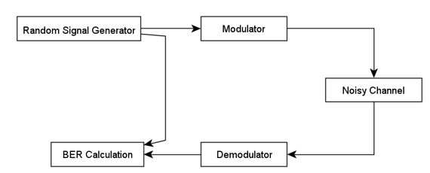

Fig.1 A diagram of the basic structure used for constructing the system model using Simulink

A Bernoulli random binary generator was used as a source which provided 11 data bits at random when the simulation was run. 15 simulations were run on each system, with different levels of Additive White Gaussian Noise. These ranged from having a signal to noise ratio between 10 and - 60. Readings were taken from the Bit Error Rate calculator of the number of incorrect data bits that had been received.

Diagrams of the models are included below. (Fig.2, Fig.3, Fig 4)

Amplitude-shift keying model

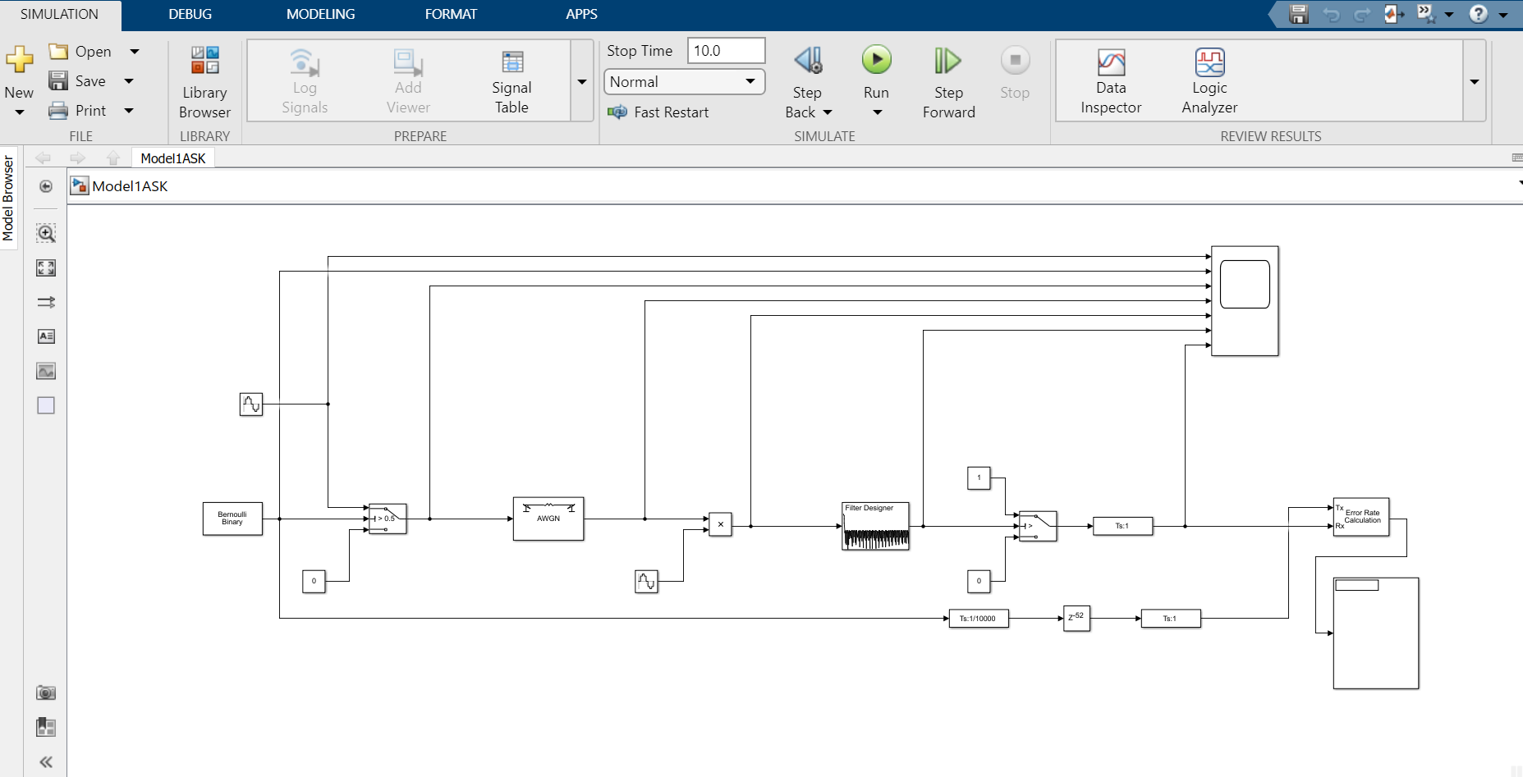
Fig.2 Screen image of ASK Modulator circuit created using Simulink
Phase-shift keying model
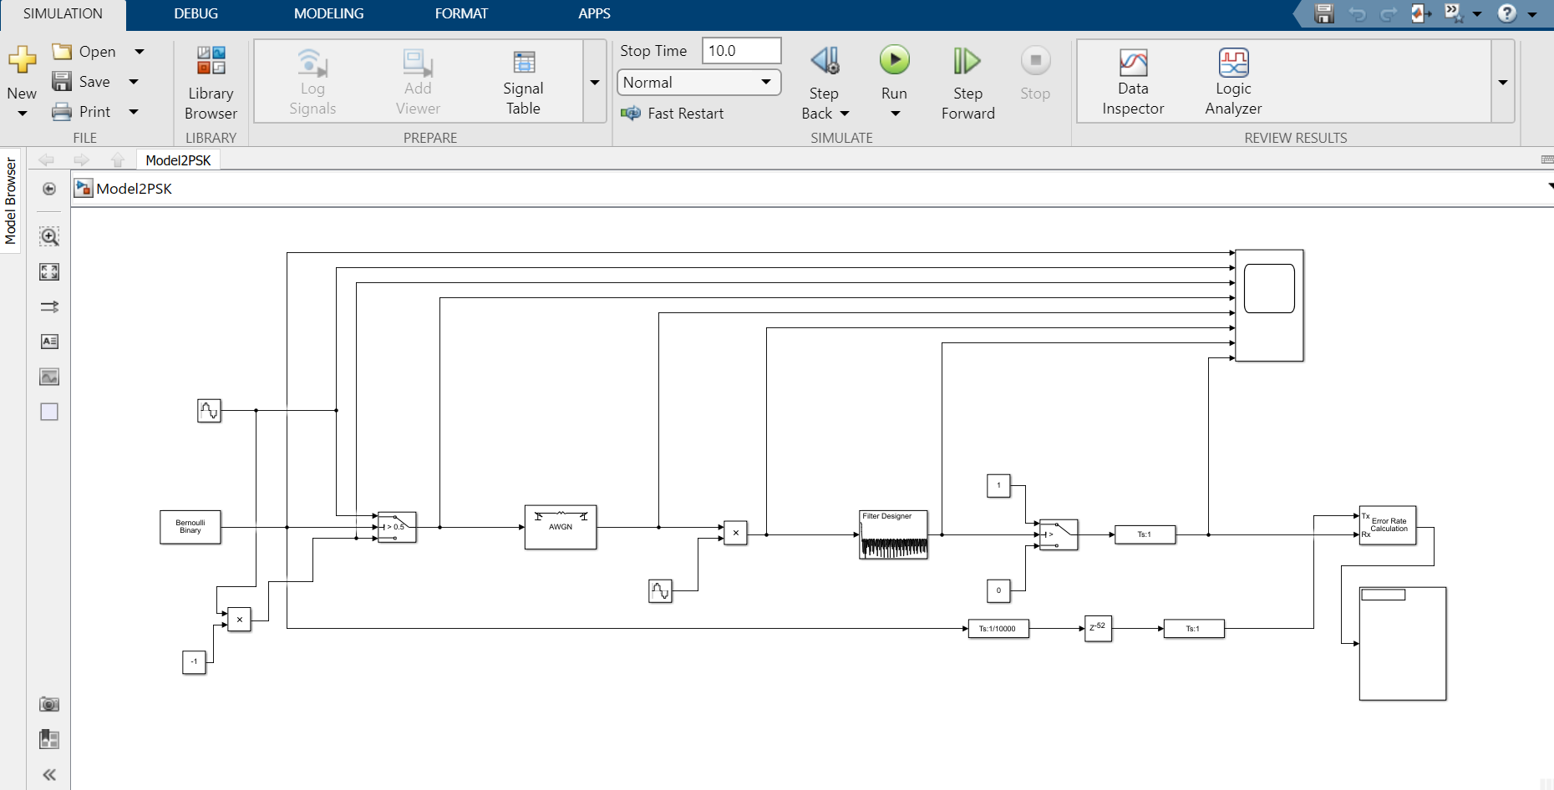
Fig.3 Screen image of PSK Modulator circuit created using Simulink

Quadrature phase-shift keying model

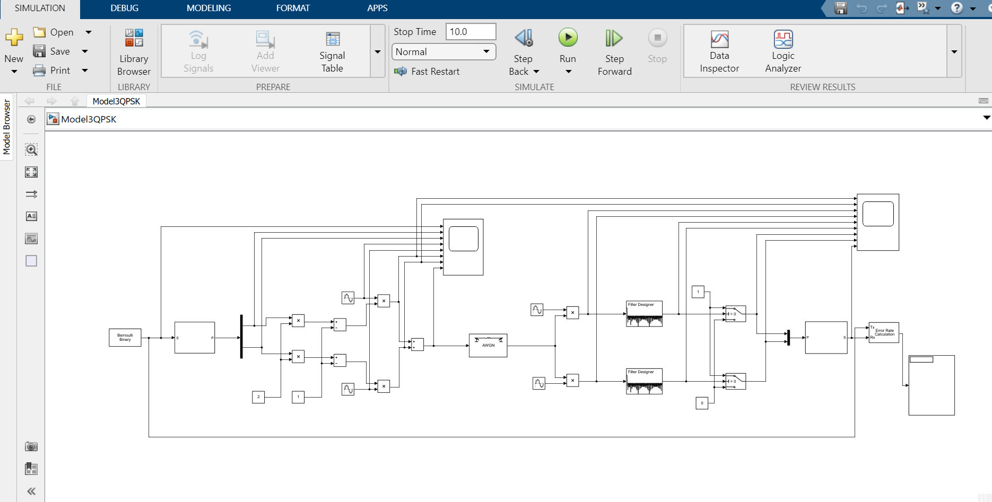
Fig.4 Screen image of QPSK Modulator circuit created using Simulink

- Results

The graphs included in this section were produced using Microsoft Excel. The data was collected from the simulations as described in section 2.1.

3.1 ASK (Amplitude-shift keying)

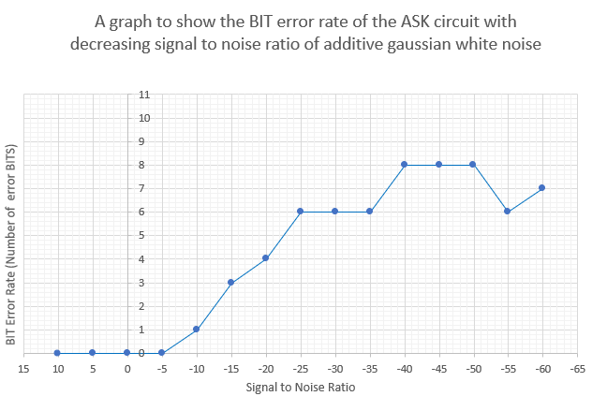
Fig.5

  - PSK (Phase-shift keying)

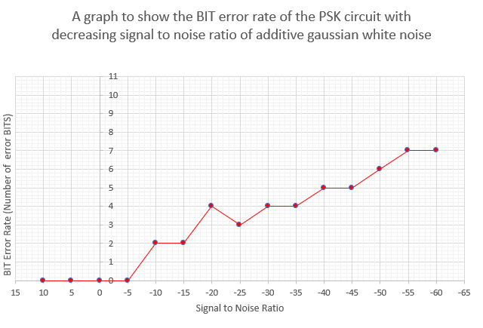
Fig.6

  - QPSK (Quadrature phase-shift keying)
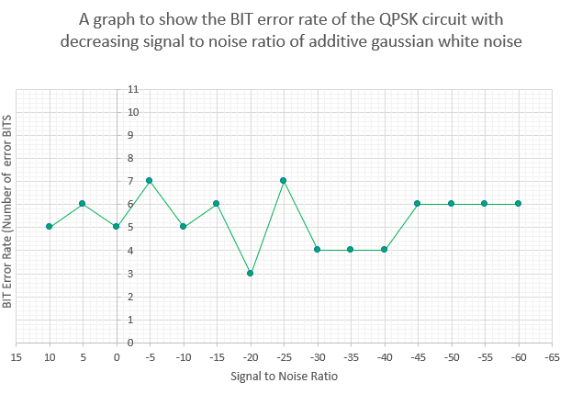
Fig.7

  - ASK, PSK, QPSK Comparison
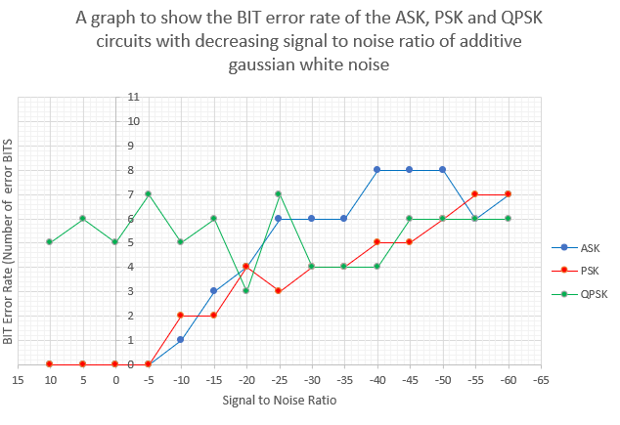
Fig.8

- Discussion

4.1 Description of Results

The results from the ASK model simulations show that as the amount of noise increased in relation to the signal, the Bit error rate also increased. At a signal to noise ratio of -25 Decibels, the Bit error rate increased to over 50% (6 out of the 11 sent Bits received were incorrect.) This was the point at which the system is believed to have failed.

The results from the PSK simulations show that like the ASK system, as the amount of noise increased, so did the Bit error rate. However, the rise in the bit error rate was slower than the ASK system, and the point of failure for this system was not reached until a signal to noise ratio of -50 Decibels. In the series of simulations run and according to the data collected, the PSK system performed better with higher levels of additive white Gaussian noise than the ASK system.

The data from the QPSK simulations show that the Bit error rate in this system was influenced by the noise at a much earlier point. At a signal to noise ratio of 5 decibels, there were 6 error bits received, reaching the point of failure.

A comparison of the three types of system shows that both the ASK and PSK systems had an increase in the Bit error rate as the level of noise increased. The QPSK had a consistently higher bit error rate which remained consistently high during all the simulations.

  - Analysis of Results
While the results show that with there is a link between the Bit error rate and the level of additive noise, it is difficult to make detailed suggestions as to why this is the case. The increase in noise is likely to effect the modulation of the initial wave, and the de-modulation back to its original form. This is the most probable cause of the increase in the error rate.
A more detailed set of results including smaller increases in the signal to noise ratio between each simulation would provide a better set of data for analysis.
The complexity of the models created and the detail of the various settings of the individual components used will undoubtedly influence how the models run and how the circuits function. A better understanding of all the individual components, the correct values that need to be set, and their role in the circuits would enable a better judgment to be made as to whether the simulations are reliable, and the circuits are functioning as intended.

- Conclusions
The models created, the simulations run, and the data collected show that it is possible to make comparisons between computer simulated ASK, PSK and QPSK modulators and measure the effect that additive white Gaussian noise has on Bit error rate. Further studies involving a larger number of simulations with more accurate levels of noise are required in order to draw reliable conclusions.

- References
[1] | S. Haykin, An Introduction to Analogue and Digital Communications, Toronto: John Wiley and Sons, 1989.
[2] | R. Tervo, “ECE 4253 - Digital Communications,” Department of Electrical and Computer Engineering - University of New Brunswick, Fredericton, New Brunswick, Canada, 03 March 2015. [Online]. Available: www.ece.unb.ca/tervo/ece4253. [Accessed March 2021].

