Name Sarah Rafique
Student number 2230737
E-portfolio report
Learning in the Digital Era – BMPL4007/BMPS4009

Table of Contents

Task 1 – Written summary 2
Task 2 – Mind map 3
Task 3 – Presentation 4
Task 4 – Reflection 5
Reference list 6

Task 1 – Written summary
Whilst studying at university, Academic Integrity is extremely important. There are many reasons why this is considered important and enables others to think critically. When producing a piece of work, it is essential to ensure that they are being always honest about where they have conducted research and based their ideas on and ensure that is referenced correctly to give credit to the rightful owner. This can be done by using ‘Cite them Right’. This is essentially important because they could be classed as cheating and lose their place of study on their course due to academic misconduct.
Plagiarism is a very serious breach as they would be presenting another’s individual ideas or work as their own and misleading others to believe they are the rightful author. Another breach of misconduct is self-plagiarism. Self-plagiarism is essentially when a student submits the same piece of work for a different assessment. Cheating in exams is another breach.
At all times a student at the university should ensure at that they understand Academic integrity and comply with the terms of it. They should ensure that they have read the universities handbook regarding misconduct and any policies set out in it. An example is a policy regarding bullying or harassment. The guidelines of what is considered bullying, and harassment will be set out and will also have a complaints procedure in place in case such an incident occurs.
If unsure if they could be in breach of Academic Misconduct a student can reach out to their tutor or student support to clarify this and to be guided in the right direction. This will ensure they make the most of their course and ensure they complete it and move on to the next year and complete their degree. It is really essential that they know what can jeopardise their studies and take careful steps to avoid this happening.

Task 2 – Mind map

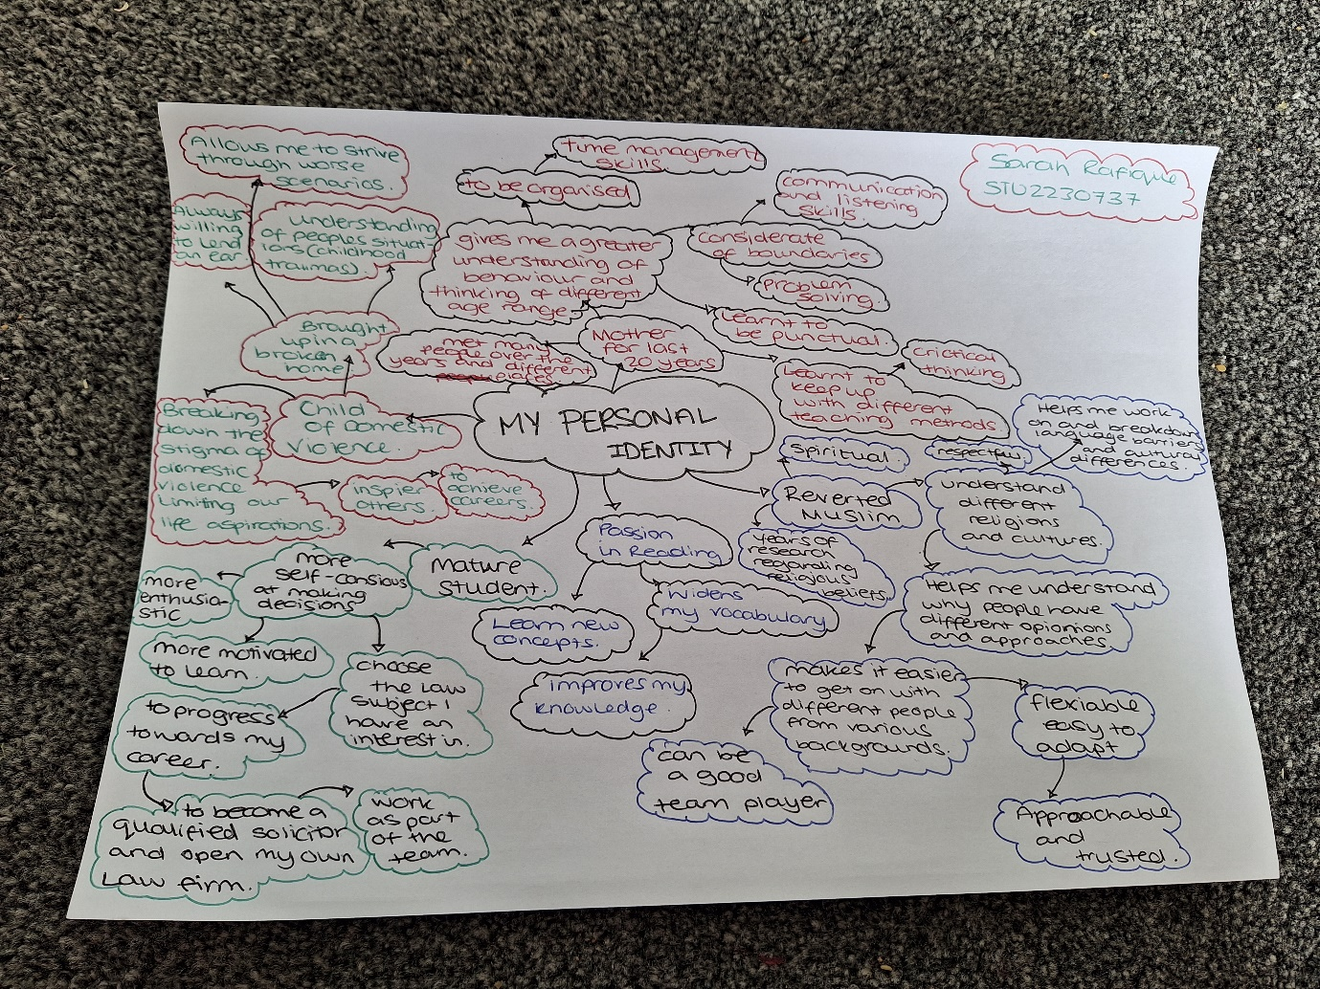

Task 3 – Presentation
Please follow this link to view my presentation: https://youtu.be/Us1q8PDTqzE

Task 4 – Reflection
When first starting university, I was filled with various emotions as this was my starting point. Excited to be finally starting my dreams but fearful of failing. I had to prepare myself mentally for it and work from a preplanned list to ensure I covered things like a place to study and finance. To do this I had to research different universities offering my desired courses online and attend open days. I also had to look at what financial support was available like student finance and then apply for it. I then had to familiarise myself with the new software like Office 365 and its various applications for different structures of work required and the new terminology that was like a foreign language. Once I was accepted at a university, I started to prepare myself to find a new time management plan that would ensure I could balance my home life with studies. I looked online at websites for study skill techniques and purchased a ’study skills handbook’, ’critical thinking’ book and a ’Cite them right’ referencing book to aid me with my studies and understand what is required in higher education and how to prepare for it effectively. I found these particularly useful as I was previously out of studies for around 20 years and now transitioning back into it. Once I understood what is required and started, I slowly got the hang of it, and it soon started to flow. Although it was a lot to consider and understand I found it is achievable by keeping myself organised, motivated and prepared for any unexpected circumstances. Alongside my course, I looked at ways of improving my basic skills like grammar and accessed study support for additional meetings to cover anything I was unsure of. I learnt to work as part of a team as well as independently. I record my achievements and use the feedback I receive from my assignments to improve areas I struggle with and overall, I keep reminding myself I can do this.

Reference list
Academic integrity journal accessed at: Full article: Integrity: What it is and Why it is Important (tandfonline.com)
Askey, S. and McLeod, I. (2014) Studying law. Hampshire, UK. Palgrave Macmillan 4th edn
Borton’s reflective tool accessed at: What? So What? Now What? Model of Reflection – StudyPrism
Cottrell, S. (2017) Critical Thinking skills. London, UK. REDGLOBEPRESS. 3rd edn
Cottrell, S. (2019) The Study Skills handbook. London, UK. REDGLOBEPRESS. 5th edn
Gibbs, G. (1988) Learning by doing: a guide to teaching and learning methods. Oxford, London. Oxford Polytehnic

Pears, R. and Shields, G. (2019). Cite them right. London, UK. REDGLOBEPRESS. 11th edn
Rennie, F. and Smyth, K. (2020) Digital learning, the key concepts. Oxon. Routledge. 2nd edn

