

Title of Assignment: | Programme Improvement Project
Programme name: | MSc Digital Transformation for the Health and Care Professions
Academic year: | 2022/23
Module name and code: | Digital Technology in Health and Social Care (BMDS7006)
Student ID: | 2211614
Total word count:
Date of submission: | 03/03/2023

Table of Contents

List of Tables and Figures..………………………………………………………………….……………………..……….…3
Glossary of Terms..…………………………………………………………………………….………………..……..………..4
Introduction…………………………………………………………………………………………………………….….…..……5
Method…………..…………………………………………………………………………………….………………………....….7
Fit Between Individuals, Task and Technology (FITT) Framework…………………………….…7
Data Collection…………………………………………………………………………………………………….…...9
Results………………………………………………………………………………………………….……………….............….9
Fit between Individual and Task………………………………………………………………………….……10
Fit between Individual and Technology Fit………………………………………………..………….….11
Fit between Task and Technology Fit………………………………………………………..……………..12
Discussion…………………………………………………………………………………………………….….………….………14
Comparison with Prior Studies…………………………………………………………………………….…..16
Evaluation Methods………………………………………………………………………………………….……..17
Appendices…………………………………………………………………………………………………….….……..….…….21
References…………………………………………………………………………………….………..…….…..……..…..……22

List of Tables & Figures
Table 1. Responses………………………………………………………………………………………………….………..10
Table 2. Fit between Individual and Task Fit………………………….…..……………………………….….…11
Table 3. Fit between Individual and Technology Fit ………………..…………………..…………………..12
Table 4. Fit between Task and Technology Fit………………………………………….…..………………..…13

Figure 1 - The FITT framework……………………………………………………………………………………………..8
Figure 2 - The FITTE framework……………………………………………………………………………………….…19

Glossary of Terms

Term | Definition
Community Resource Team (CRT) | A team of health and social care professionals who work in the community providing support to service users
Seamless Care | Making the transition between care services as smooth as possible for patients.
District Nursing | A service consisting of registered nurses and health care support workers who provide nursing care to patients within their own environment.
Local Authority | An organisation which has responsibility for providing facilities and services to residents within set geographical boundaries.
Domiciliary care package | A range of care services is provided to service users within their own homes to help with daily tasks and aid independence.
Single Point of Access (SPA) | A dedicated team of call handlers who receive and process referrals on behalf of the frailty service.

Introduction
The delivery of public health services through the Gwent region of South Wales is the responsibility of the Aneurin Bevan University Health Board (ABUHB), a National Health Service (NHS) organisation. Operating within ABUHB is the community-based Gwent Frailty Programme, which is a joint funded provision between the health service and the five local authorities in Gwent. The services combine to form five multi-disciplinary Community Resource Teams (CRTs) situated across each locality. The objective of CRTs is to deliver care closer to home for Gwent residents by providing individuals aged 18 years and over with short-term health and/or social care and interventions within their own homes. The seven-day service aims to reduce unnecessary admissions to hospital by delivering alternate medical and social solutions in the community, minimise hospital length of stay by expediting early hospital discharge and promote independence and preserve dignity to allow people to remain at home (Aneurin Bevan University Health Board, n.d.).
To support these objectives each team consists of a diverse range of health and social care professionals. Each CRT has a slightly varied establishment, but the fundamental primary structure is as follows:
- Rapid Medical and Nursing team - Consultants, doctors, and registered nurses providing advanced medical care to unwell patients who may otherwise be admitted to hospital. Patients who are referred to this service, typically by their General Practitioner (GP), are to be seen within four hours of the team accepting the referral.

- Reablement team – Occupational therapists, physiotherapists and reablement assistants provide rehabilitation therapy and equipment aids to allow people to stay independent at home.

- Falls service - A programme for the older population who fall frequently or where there is concern about balance and safety. Assessments, advice and adaptions are provided to prevent future falls resulting in injury or hospital admission.

- Social Workers and Home Care – Social care support to identify the social needs of individuals, and provision of temporary domiciliary care packages to support independence.
When the frailty programme was commissioned in 2011, it was a new way of working for both health and social care organisations and therefore required an appropriate bespoke software system that could support the new programme and be accessible by both organisations. A purpose-built integrated software system called the Frailty Portal, which can be described as an information capture and sharing system was designed and implemented by the company Anoto. The Frailty Portal software was developed with the aim to create a more patient-centric care model with a comprehensive auditable electronic patient record to support seamless, integrated community working (Building Better Healthcare, 2014). The software enables multi-agency teams to jointly manage caseloads, access and update a single electronic patient record and oversee and document all aspects of patient care until the patient is discharged from the service. The software was also designed to offer managerial functions that support activity and performance reporting.
Patients access the frailty service via a referral made by a healthcare professional through the centralised single point of access (SPA) team. A SPA call handler records the referral details including patient demographics and the reason for referral and processes the referral instantaneously onto the Frailty Portal to be triaged by the appropriate CRT. Upon receipt of a referral, a delegated clinical CRT team member will triage the content and assess if the referral is appropriate for the service. Referral outcomes are recorded on the Frailty Portal and those patients deemed suitable are accepted and allocated onto a team’s caseload where the assigned staff member receives a notification e-mail informing them of a new patient on their caseload.
An essential function of the Frailty Portal is to hold the live caseload of the CRTs and the sub-teams within it allowing each team to identify and safely manage their caseloads effectively. Accurate caseload information enables rapid services to assess their workload capacity in line with meeting the four-hour assessment target that is in place. It also supports reablement and social care teams to plan upcoming hospital discharges. To relieve the pressures on hospitals, CRTs can support patients in their own homes where they can continue their recovery without unnecessarily occupying a hospital bed, and it has been documented that patients benefit from being in their usual place of residence with familiar surroundings (Building Better Healthcare, 2014). To ensure support is available upon discharge and providing seamless care for the patient, hospitals communicate with CRTs via referrals to the SPA to allow the CRT to plan an appropriate care plan for patients immediately upon discharge.
The frailty service is a jointly commissioned provision requiring collaborative patient-centred working and the Frailty Portal facilitates the cross-agency exchange of patient records so that all practitioners involved in the patient's care may access the records. Some patients require intervention from more than one service within the CRT and for these situations, the Frailty Portal was designed to allow users to create internal referrals. This function allows teams to refer patients to other specialist teams internally within the CRT, allowing the patient continuous and efficient access to additional services without leaving the care system.
A primary aim of the CRTs is to provide care closer to home (Aneurin Bevan University Health Board, n.d.), therefore patient assessments are typically undertaken within a community setting. To aid remote community working, the Frailty Portal was designed to support the use of digital writing technology which allows professionals to complete assessment paperwork in the patient’s home using digital pens (Building Better Healthcare, 2014). Following completion of a written hard copy assessment, the pen updates the patient record on the Frailty Portal software system by uploading the written information into an electronic digital copy of the assessment form. This function enables care notes to stay in the patient’s own home and clinical staff to remain in the community without frequenting the team base, therefore increasing patient-facing time.
The Welsh Government invested £6.9 million in the Frailty initiative (McQuaid et al., 2012), and to help demonstrate the program's effectiveness and value for money the Frailty Portal contains built-in reporting tools. These reports present performance measures including outcome and effectiveness of patient interventions following service discharge which can support both management and clinical users.
Methods
Fit Between Individuals, Task and Technology (FITT) Framework
To ensure that the anticipated benefits of technological implementations are realised it is important to evaluate the ‘fit’ between the technology, its users and the required tasks (Prgomet et al., 2019). The objective of this paper is to retrospectively evaluate the Frailty Portal software system and review its usability by applying the Fit between Individuals, Task and Technology (FITT) evaluation framework developed by Ammenwerth et al., (2006).
The FITT framework helps analyse the relationship between the individual, task and technology and is based on the principle that successful adoption of information technology (IT) is inter-dependent on the optimal fit between the individual and technology, the individual and the task, as well as the task and the technology (figure 1) (Ammenwerth et al., 2006).
The ‘individual’ aspect represents users or user groups who will perform the tasks and therefore must be motivated to adapt to changes, the technology is the hardware or software tools that are in place and must be functional to support the required tasks, and the task consists of procedures that need to be completed using technology, by the user (Ammenwerth et al., 2006; Kujala et al., 2020). If the fit between any of these dimensions is poor it may influence the adoption and success of the healthcare system. Numerous case studies have already demonstrated the value of adopting the FITT framework to review information systems (Cho et al., 2019; Kujala et al., 2020; Prgomet et al., 2019; Schnall et al., 2012; Tsiknakis & Kouroubali, 2009)
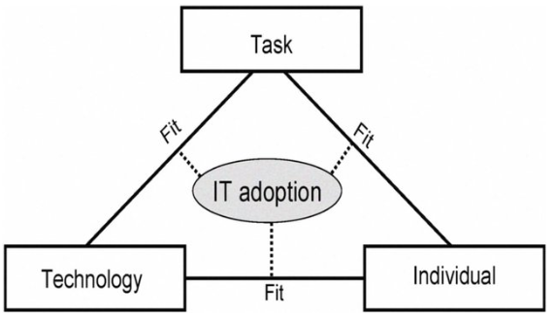
Figure 1 - The FITT framework (Ammenwerth et al., 2006)

To evaluate the fit quality of the Frailty Portal, the FITT framework was applied by examining the applicability of the software to the FITT dimensions.
- Individual – Do the users have adequate IT skills and confidence in using IT? Did users receive appropriate training? Is there motivation from the users to embrace technology?

- Task – Does the system functionality support clinical tasks and meet the needs of the users? Do the deliverables of the software meet the expectations and perceived benefits?

- Technology – Is the technology, including relevant hardware and networks, fit for purpose and supports the software and user?

Data Collection
The evaluation of the Frailty Portal system was undertaken between January and February 2023. Due to the vast geographic scale of ABUHB and the lack of accessibility to meet with multiple staff who are community-based, an anonymised Microsoft (MS) Form questionnaire (appendix 1) was produced. A link to the questionnaire was circulated via e-mail to all CRT staff via the team managers and was kept open to responses for two weeks. The MS Form permitted all software users to participate and express their opinions, allowing the researcher to obtain a comprehensive user evaluation of the software system across all of Gwent.
Completion of the questionnaire was voluntary and a consent statement was included in the MS Form permitting the researcher to include user responses anonymously in the study. The responses from the MS Form questionnaire were transcribed and documented into an MS Excel spreadsheet for analysis and to allow FITT dimensions to be identified.
In addition to user feedback, the study's researcher was able to provide feedback based on their personal experience attained while serving in a secondment capacity as a Business Manager for the frailty service from 2014 to 2016. The researcher utilised the software from an administrative and managerial perspective and worked alongside clinical users whilst based in the teams.

Results
A total of 21 questionnaire responses were received which provided a range of qualitative and quantitative feedback from the software users. Of the responses from staff groups, 38% were nursing/medical, 29% were admin/management, 24% were allied health professionals and 2% were in the ‘other’ category. There were no responses from social care users.
From personal experience, the researcher is aware that the Frailty Portal has not been fully adopted by some of the CRTs across Gwent, particularly those with a higher proportion of social care management and workforce. Based on the number of responses to the questionnaire, those CRTs who use the Frailty Portal regularly showed more engagement in the evaluation than those teams who do not (table 1). There was no engagement from CRT2 and very little from CRT3, both of which are not fully engaging in the Frailty Portal, are social care managed and have limited interest in fully embracing the software. CRT1 is a small team undergoing a new management structure which may have hindered the distribution of user questionnaires.
Table 1 – Responses
Community Resource Team | Full Adopted Frailty Portal | Responses | Health Care Responses | Social Care Responses
CRT1 | Yes | 2 | 2 | 0
CRT2 | No | 0 | 0 | 0
CRT3 | No | 2 | 2 | 0
CRT4 | Yes | 11 | 11 | 0
CRT5 | Yes | 6 | 6 | 0

User feedback and comments from the MS Form questionnaire were organised and aligned to the dimensions of the FITT framework based on the quality of fit between individual and task, individual and technology, and task and technology (tables 2-4).
Fit between Individual and Task
42.9% of users involved in the evaluation stated they have had no formal training, however, 85.7% of participants declared they are confident in using the software and have the desire to undertake additional training to improve their knowledge of other functionalities. Due to a lack of software expertise, some users may not completely utilise the Frailty Portal's features to maximise benefits and those who do not fully comprehend the software's potential may fail to recognise any limitations of the features.
The capacity to collect comprehensive referral data from the referrers and the ability to have all relevant patient documentation in one location are seen as benefits of the software.
Some groups of individuals have adopted the system differently and are not fully completing the patient record on the Frailty Portal, resulting in other users not having the full overview and context of the patient intervention. The lack of compliance could be attributed to a lack of understanding as to what is expected of the user and the impact it has on others. It may also be caused by the interoperability issues of the software (see fit between task-technology section) which causes duplication of tasks and therefore some users have reduced motivation to use the software and document only the basic information electronically.
The Frailty Portal's goal of having an extensive patient record is undermined by the lack of user adoption. From the responses, it is evident that there is a varied fit between the individual-task dimension across CRTs as well as staff groups as some users feel the software is not fully suited to their needs and that standard built-in templates are not suitable or applicable for all professions.
Table 2
Sample Quotes
“Easy to see referrals in one place and helps with triaging”
“Visible by everyone who wishes to see patient details and provides the ability to see previous admissions for patients and other services involved”
“The detail that the referrer can add to the referrals can be very specific”
“Minimal training at roll-out means that everyone filled the forms out differently”
“Non-mandatory fields left incomplete by users which results in lack of data analysis and interrogation”
“Would be good for MDT (multi-disciplinary team) working if all CRTs used it”
“It is not necessary for how we work”
“Forms that are embedded in the system are badly designed and therefore often not filled in correctly or if at all, depending on the profession there are sections that are not relevant and little space for free text”
“I have had minimal training so would benefit from additional help”
“I have never received training to use this portal, therefore only know how to accept or reject a referral. I am unable to use any other functions of the system.”
“There are functions on the system that I don’t know how to use, so I just stick to the basics but would like to know how to use other functions”

Fit between Individual and Technology Fit
Individuals stated the software layout was straightforward to navigate and 56% of responders found the Frailty Portal easy to use. Having safe storage for patient notes rather than hardcopies is an emphasised technological benefit.
Overall there appears to be a good fit between individual-technology and staff are confident in the general use of technology and see the benefits of technology. One user addressed the issue of a lack of computer workstations but it is possible that the problem applies to only one team and without further investigation, cannot be deemed to apply to other teams.
Table 3
Sample Quotes
“Not enough computers in the office for us to use to write up our notes”
“Provides a safe storage environment of patient notes”
“User friendly and easy to navigate”

Fit between Task and Technology Fit
Most of the user feedback suggests a poor fit between task and technology as illustrated in table 4. The unavailability of software updates to optimally customise the interface and the lack of functionality to work remotely and report information are just some of the recurring themes.
Users were informed by the developers that the software would aid them to work remotely in the community using digital pens that would transfer data from written assessments onto the Frailty Portal (Building Better Healthcare, 2014). Based on the researcher’s previous knowledge of the service, the Frailty Portal software intermittently failed to upload data from the pens resulting in users having to revert to manually entering patient assessment information directly onto the Frailty Portal once back in the team base. This defect causes users to enter minimum data onto the patient record or use alternative systems, impacting the level of detail held within the patient record and the accuracy of output reporting. Also, it necessitates the storage of written hard copies of comprehensive patient assessments, which are not remotely accessible to other users.
The software doesn’t allow for additional sub-teams to be added which affects a variety of tasks such as accurate patient allocation, caseload management and performance reporting. Users state they are not able to have more than one referral open at a time or have more than one user in the patient record. These built-in restrictions may be in place to stop inaccurate data entry onto a patient record or to stop other users from entering contradicting data in fields. However, if the technology is impeding the users to complete tasks the functionality should be reviewed and possible risks evaluated.
The function to internally refer patients does not fully work as intended, causing confusion over the patient status within the team. In addition, the Frailty Portal's built-in reporting functions cannot be customised to meet their requirements and the function is no longer utilised.
There were comments made about how slowly the software loads and how frequently it freezes. This was observed by more than one team therefore potentially ruling out local network connection as the source of the problem.
Table 4
Sample Quotes
“System hasn’t been updated, lack of team options to record against”
“Unable to collate required performance indicators within the system or manipulate the built-in reports”
“Didn’t support the digipens, not ideal for a community-based service”
“Can only input data when in the office”
“Not fit for purpose for some professions within CRT, therefore not everyone uses it”
“The internal referral function has never worked properly for example a referral from rapid medical to reablement would end up getting closed down by rapid medical when still open to reablement”
“It is impossible to see which service users are allocated to staff as only one allocation is allowed on the system. Staff have no way electronically of knowing who they are dealing with so need to keep a separate list”
“Once information is saved, no way of correcting it”
“Only able to see one referral at a time on the screen”
“Only one person allowed to work in referral at any time; have to wait for colleagues to finish notes, etc before adding your own notes”
“Allocation e-mail alerts no longer work”
“Sometimes freezes when uploading information”
“When completing assessments it logs out quite quickly which means you have to regularly save your input”

It is to be noted that due to the unequal distribution of responses amongst CRTs and staff groups, the findings cannot be construed as a consensus for all users of the system. The researcher however supports the issues highlighted in the current responses and acknowledges them as genuine viewpoints based on prior personal experience.

Discussion
The purpose of this study was to evaluate the fit between individual, task and technology of the Frailty Portal software system by applying the FITT framework and identifying any limitations that impede the use of the software technology.
Adoption of new technology can vary between work areas and users, and it is not uncommon for an IT system or just one component of the system, to be more successfully adopted in one area compared to another, with some user groups having an impact on the adoption (Dixon, 1999). A noticeable observation from this evaluation highlights the diverse adoption of the Frailty Portal within ABUHB. In a previous review of the frailty programme undertaken in 2012 by the Welsh Audit Office, it was noted that the level of engagement from stakeholders was variable with possible tensions affecting adoption and benefits realisation (McQuaid et al., 2012). The variation in adoption is still present, whereas some areas use it to the best of its ability, other areas use the bare minimum functions.
A lack of software adoption can be correlated to a lack of organisational support (Noblin et al., 2016) and the opinion of leaders can also have an impact on the successful adoption of software (Dixon, 1999). This evaluation draws attention to the variations in how the five CRTs have adopted the Frailty Portal, which may be at least partially due to the diverse structure and organisations that collaborate on the frailty service. Software adoption is strongly influenced by perceived usefulness (Dixon, 1999), and the Frailty Portal's failure to provide all the functionality users had come to expect, along with socio-organizational differences such as management, IT infrastructure and variation in working methods have resulted in different levels of adoption and opinions of the same system. The CRTs that have embraced the Frailty Portal and who get support and encouragement from management report having a little more favourable assessment of the software. These teams are often more health-focused and lack access to alternative systems, so have had to adopt software more broadly.
Kujala et al., (2020) identified the influence stakeholders can have on the successful adoption of a health system, and a key factor for the lack of software adoption with the frailty programme is the Frailty Portal does not meet the needs of many users. Accessing and updating the Frailty Portal can be seen as a duplication of effort and time-consuming for some CRTs who have access to a more efficient up-to-date local authority software system that performs many of the same functions. Those CRTs who are predominantly local authority focussed use the Frailty Portal as a source to receive referrals only. The referral information is then transposed over to a local authority system for managing the remainder of the patient journey, leaving the Frailty Portal referral open and sparsely complete. This does not support the collaborative working and sharing of documentation defined in the Frailty Portal objectives. Health focussed users also expressed concerns about duplication of effort and how inefficient the Frailty Portal is due to the inability to work remotely and their need to return to the office to re-enter information they recently collected manually. Although the Frailty Portal can hold a central patient record as intended, the software’s aim to assist staff who work in the community by remotely updating the patient record and minimising commuting times has been unsuccessful. In turn, this has affected the commitment and enthusiasm of the users, who for efficiency, complete the bare minimum.
Since implementation, the frailty programme has increased its portfolio to support the care closer-to-home strategy (National Health Service, 2015) and has enhanced its therapy provision with the introduction of community physiotherapy and community occupational therapy to all CRTs. In addition, the programme also now supports a range of additional community-based services which include sensory impairment, respiratory, telecare, step-up/down beds and hot clinics. However, due to software limitations, the interface has not been adapted to reflect the CRT growth and additional service teams. The inability to modify and add pre-fixed team groupings, which would allow for accurate patient allocation and the recording of activity data against the appropriate services, has had a negative impact on caseload and performance management and leaves an unclear record of the accurate teams responsible in the patient’s care.
Although not all users' expectations have been met by the Frailty Portal, there are advantages to the software when adopted correctly. The capacity to promote joint working underpins the delivery of seamless care between social and health care services for the adult population in Gwent. Coordinated working between health services with local authorities allows patients to receive both effective health and social care intervention simultaneously. The efficient communication between these services as well as shared documentation ensures continuity of care. This is more effective when both services are using the Frailty Portal, however, even with the lack of full adoption in some areas, teams maintain a robust joint working relationship with colleagues.
A limitation of the Frailty Portal is the lack of interoperability to share data wider with other key internal community services to create a truly patient-centric model stated by the developers (Building Better Healthcare, 2014). The Frailty Portal is a stand-alone software system and cannot link to other systems such as the district nursing software. Therefore teams cannot easily refer patients between services to support seamless care and neither team is informed if the other service is involved in the patient's care. This can result in multiple staffing resources attending to one patient which is not only a resource and communication issue but can result in discontinuity for the patients.
The contract with the Frailty Portal software developer has expired and no further modifications can be made to the software to meet the changing needs of the NHS. CRTs will continue to utilise the Frailty Portal partially or fully until a more suitable alternative is available which can coordinate referrals, record clinical patient data and support remote working on an integrated pan-Gwent basis.

Comparison With Prior Studies
Integrated working is a challenge faced by many public organisations (Mathew & Patel, 2021) yet there is an array of literature supporting the integration of care (Baker & Oliver, 2018). Most studies report the same common objective as the frailty programme, to support people to remain at home with the provision of integrated multidisciplinary teams. There are some thematic comparable challenges to ABUHB addressed in existing research reviewing other integrated services however, there is little information published on the type of information technology utilised to support the provision.
An integrated health and social care team in Pembrokeshire, Wales, utilised a system called Care First, however in a report by Theil et al., (2013), it is documented that the system was slow and too time-consuming so was not adopted well by the stakeholders involved. The report also notes that data collection and performance reporting were poor due to a lack of system development, mirroring similar issues experienced by ABUHB.
In a consultation paper by Wright et al., (2017) describing the integrated community service in North Mersey, they state the service uses a single point of access to receive referrals, much like the teams within ABUHB. The paper, however, fails to refer to specific or bespoke software that was used across the integrated service to record and manage the referrals. The paper states the service was not new but a “collaboration arrangement” between organisations which may indicate existing software systems were utilised to support the arrangement. Due to the lack of functionality of the Frailty Portal, a proportion of social care users within ABUHB have resorted to using existing systems to manage patients.

Evaluation methods
For this software evaluation, the FITT framework was selected as the evaluation technique as it facilitates the analysis of various factors which could affect applicability and adoption.
An alternative evaluation approach is the Technology Acceptance Model (TAM) which focuses on just two variables, perceived usefulness and perceived ease of use (Wallace & Sheetz, 2014) assuming users who perceive the technology as easy to use will use and accept it. The TAM model assesses the user’s acceptance of information technology and can predict software adoption however was not utilised in this evaluation as it fails to evaluate other factors that may influence adoption (Ajibade, 2018).
The Task Technology Fit (TFF) model supports the theory that the fit between the required tasks and the functionality of the technology can predict the utilisation of the technology (Marikyan & Papagiannidis, 2022). Similarly to one of the FITT dimensions, TFF can be used to assess the relationship between the capabilities of information technology and the requirements of the tasks that must be achieved (Furneaux, 2012), however, fails to incorporate the fit with individuals.
The System Usability Scale (SUS) method is described as a quick yet reliable tool for evaluating the usability of a system (System Usability Scale (SUS), 2013). The evaluation requires users to score a set list of statements based on if they strongly agree or disagree with the statement. Although this method can be reliable with only a small sample size, it is limited to providing only feedback on the usability of the system and is not as dynamic as FITT and does not take into consideration other factors affecting adoption or system success.
The Technology, People, Organizations, and Macroenvironmental (TPOM) framework incorporates many factors such as technological, social and human, organisational and wider macroenvironmental when evaluating the implantation of information technology. The many themes which can be addressed allow organisations to focus on the dimensions that could influence or impact the outcome and avoid unintended consequences (Cresswell et al., 2020). TPOM focuses on assisting technology implementers to review the implementation and identify possible risks that may arise, however, is not focused on future technology adoption and growth. Despite having extensive dimensions that address important healthcare technology issues, this method was deemed less appropriate for this evaluation because the software had already been fully implemented.
Although highly recognised and effective, the FITT framework does have its limitations. The framework lacks the ability to incorporate the environmental, external or organisational factors that can impact the implementation and adoption of IT systems (Ammenwerth et al., 2006; Kujala et al., 2020; Zhai et al., 2022). External factors can enhance or weaken the fit (Ammenwerth et al., 2006) and because of those external factors, there will never be a completely static state regarding the three fit dimensions. Examples of external impacting factors are:
- Individual: Staff turnover and loss of knowledge, changes in workload
- Task: Increasing complexity of required tasks due to organisational or changes in needs
- Technology: Technological advancements, upgrades and specifications changes
As previously indicated, the adoption of the Frailty Portal has not been fully successful in some areas of ABUHB partially due to organisational and managerial differences. Zhai et al., (2022) recommended expanding the FITT framework to include a dimension that represents multi-disciplinary collaborative working. In studies by Kujala et al., (2020) and Prgomet et al., (2019) it is proposed that an organisational/environmental dimension should be incorporated as additional context to aid the evaluation of factors affecting the success of information system implementation and adoption.
The additional ‘environmental’ dimension to the current FITT framework forms the FITTE framework whereby adoption and use of information technology are determined by the fit between individuals, tasks, technology and environment (figure 2). This alternative approach may be more appropriate for the frailty programme as it would take into account environmental factors like community working, and joint organisational factors.
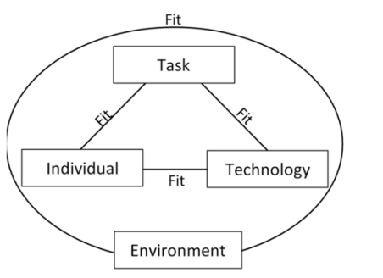
Figure 2 - FITTE Framework (Prgomet et al., 2019)

Evaluations can potentially improve the quality of healthcare services as well as reduce costs and safety issues (Yusof et al., 2008). Evaluating a health information system that has already been put into place, such as the Frailty Portal, provides insight into its effectiveness and allows for more efficient practices to be identified based on valuable experiences (Sligo et al., 2017). Undertaking evaluations whilst the system is still in the prototype stage provides an opportunity for any flaws to be addressed in future developments (Honekamp, 2011) and potentially increases the end performance and acceptability.
The findings emphasise the intricate connection between stakeholder acceptance and successful technology implementation and adoption. Many of the problems with the Frailty Portal might have been avoided if appropriate user engagement had been sought across all staff groups with the Frailty Programme and rigorous field testing of technology had been carried out prior to final deployment. If software implementations are to be successful, it is equally important that ongoing evaluations take place so that technology can be adapted to meet the changing needs of the patient and the organisation (Mathew & Patel, 2021; Sligo et al., 2017).
A better fit among the dimensions such as individual, task and technology can have an impact on the adoption, use, and effectiveness of the technology (Noblin et al., 2016). To improve the fit of future software implementations the researcher advises undertaking evaluations periodically whilst in the project development phases, ensuring key stakeholders are engaged, the software performs as required and intended, is compatible with other hardware and software and is appropriate for all organisations involved.

Appendix 1 - Example of Microsoft Form questionnaire
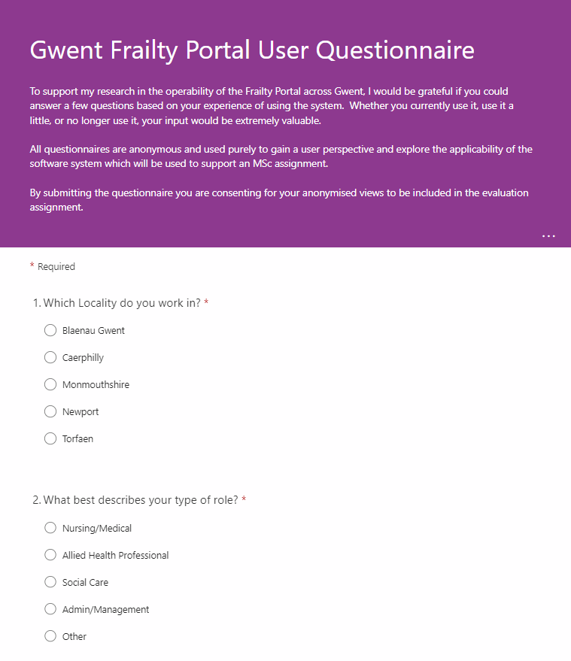
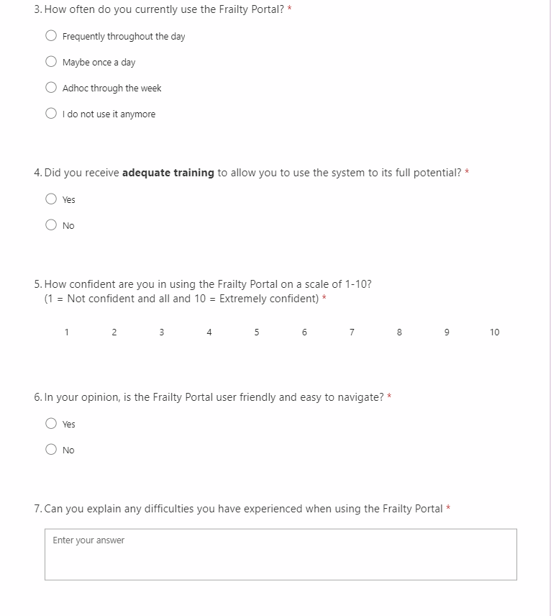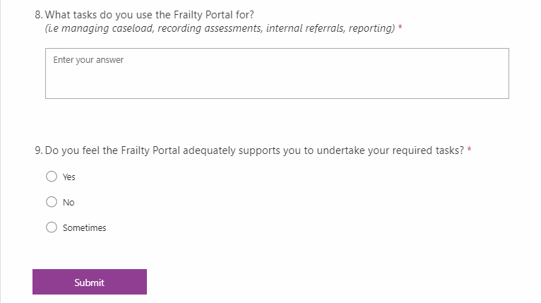
References

