Unit 4 Topic 1: Learning to Learn
(Agile learning & Employability)

This section has sub-sections. These are:
Sub-section 1 Describe learning agility and its relevance to employability
Sub-section 2 Recognise the importance of unlearning and the ability to let go of unhelpful habits
Sub-section 3 Identify the characteristics of an agile learner and select methods to develop learning ability
-
Sub-section 1: Describe learning agility and its relevance to employability
Upon completion of this sub-section, you will be able to:
- Appreciate that the ability to learn skills quickly is the key feature that employers are looking for in their graduates in the 21st century
- List the features of agile learning that you can develop.
Introduction
It is reasonable to think that taking time to learn new things will improve your life. The fact that you are studying with UWTSD shows you are committed to this. In this section, however, you will explore the existential question of what skills you are trying to develop in your time at UWTSD. You are living in a period where the skills you use today are unlikely to be used in the future, as technology such as the internet is changing every aspect of life on an almost daily basis.
Introductory activity
What skill do you think is most important for the future? Do you think this will change, and if so, how long will it take to make a difference in the area you are aiming to work in?

Learning as a skill
Watch the following video, where Kelly Palmer gives advice on future skills for the workplace.
Why the school you went to is no match for learning agility | Kelly Palmer | Big Think

Change is constantly happening throughout life, but sometimes it is not so noticeable. The author of ‘The Lion, the Witch and the Wardrobe’, CS Lewis, wrote that ‘Isn't it funny that day by day, nothing changes, but when you look back, everything is different.’
Do you agree with this?
In 2020, the world was hit by a pandemic that has caused nearly everyone to rethink how they work. At UWTSD, for example, many lectures started to be delivered online using technology like Microsoft Teams. As you have seen in earlier lectures, some of your assessments will take a similar form, e.g. videos.

Agile learning
In this lecture, Dr Warner Burke talks about having a mindset that facilitates agile learning.
Learning Agility and How Motivation Drives Change | Dr. W. Warner Burke | Talks@Columbia


In essence, agile learning is your willingness to take risk in attempting to deal with a novel situation when not knowing exactly what to do.
This can be an uncomfortable feeling, often because learners feel embarrassed and may worry that dealing with a novel situation incorrectly leads to being wrong. Agile learners reject the idea of embarrassment because of failure; instead, they embrace it because they understand that failure feeds success.
Check out this Nike Advert starring Michael Jordan (the man that Nike Air Jordans are made for).
Michael Jordan "Failure" Nike Commercial

Jordan’s advert shows how a professional athlete deals with letting down millions of adoring fans wishing him to succeed. Every elite athlete has this issue: succeed and the world adores you, fail and the world does not.
This kind of mindset that addresses pushing on despite the risk to self-esteem is one of the key factors in everybody’s agile learning strategies.
Michael Jordan may not be your idol, but can you think of a similar hero who commands such emotional resilience? It may be another sports star, a musician or even a politician.
It is often said that people learn by their mistakes. Most people instinctively believe this, yet one of their biggest problems is not asking for feedback. This may be due to a fear negative feedback, but it is precisely this feedback that gives you an insight into what you have learnt, or some cases failed to learn.
The key issue here is that people can become instinctively defensive. When seeking feedback, you should try to remain aware but aloof, avoiding emotional attachment in a logical way – similar to the character Mr Spock from Star Trek. When you get chance, try to critically evaluate others to understand what happens in the process of reflection.
When you find yourself in unfamiliar territory, it is natural to seek out people with similar backgrounds and points of view. This can often produce an effect called an ‘echo chamber’. This is where people simply repeat or echo the same ideas from the same point of view.
An agile learner actively seeks to work with colleagues from different backgrounds. This brings learning perspectives or completely different points of view that in turn give opportunities to learn different things in different ways.

Stop and Think: Remembering and recalling key learning
What does it mean to be an agile learner?

Application:
Spend some time using Google to research the concept of agile learning. In your own time, answer the following questions.
- What is learning agility?
- Why is it important to be able to demonstrate learning agility in a workplace environment?

Summary
The future workplace is unlikely to value a qualification unless you can demonstrate the skill of learning. It is argued that agile learners will be the kind of people valued in future work environments, as they are able to embrace the risk of embarrassment by placing themselves in novel situations where the risk of success of failure is finely balanced. Agile learners are aware that every situation presents a learning moment, and that failure is a natural part of the process. They reflect on their learning both in the moment and after the event, reaching out seek to seek feedback from colleagues as they do so.
Wider learning
The deliberate attempt to think about your learning in two different ways is known as ‘reflection in action’ and ‘reflection on action’, according to Schön (1983).
Read through the following webpage to learn more:
What is Reflection-in-action? - Reflection-in-Action (weebly.com)

Sub-section 2: The unlearning of unhelpful habits
Upon completion of this sub-section, you will be able to:
- Explain how habits are created and broken
- Describe the neurological responses that make procrastination so easy thing to do
- Design approaches to unlearning unhelpful habits of your own.
Introduction
English poet John Dryden once said that ‘we first make our habits and then our habits make us.’ He warns that habits are behaviours that define us, and creating the right sort of habits is something everyone should spend time focusing on.
Introductory activity
Think about a time you set your phone to mute. Was there a moment when you heard your ringtone and automatically reached to your phone to answer it?
Most people will have experienced this sort of thing.
Can you think of any other times you made an automatic reaction to something and then realised it was a silly thing to do?
Maybe you …
- Brushed your teeth twice in one morning
- Made a cup of tea or coffee even though you had one on your desk
- Answered the door when the doorbell rang on TV.
These are all examples of your brain automatically doing things without really thinking through the results. This is an example of habit or routine responses.

The Pavlovian Response
In the 1890s, a Russian psychologist called Ivan Pavlov realised that his dogs always drooled when food was placed in front of them. However, his discovery was enhanced when he noticed that they would start to salivate in anticipation of the food coming. What is known as the Pavolvian response is also seen in humans; in short, it seems that your brain can operate subconsciously to instinctively react to external events without you being aware of what you are doing.

What are habits?
Habits are fixed behaviours that may be good or bad, but are an instinctive reaction triggered by previous life experiences.
Your brain is hardwired to reward things it likes by releasing a chemical called dopamine whenever you do something ‘good’. Dopamine is like the brain’s gift to you and is delivered in shots whenever you experience fun.
However, dopamine is also released when the brain feels lazy. Therefore, when you procrastinate, your brain rewards you for being lazy too. Although it sounds strange, sometimes you have to become consciously aware that you need to work past the feelings of success that bad habits reward you with in order to become productive.
Watch this video for a visual explanation of this process:
https://youtu.be/vdo0h3DQQmw
To change a habit, you must consciously redesign what Duhigg (2012) calls the ‘habit loop’. This is where you receive a stimulus or cue which automatically triggers a routine behaviour that is then rewarded by the brain with a shot of dopamine.
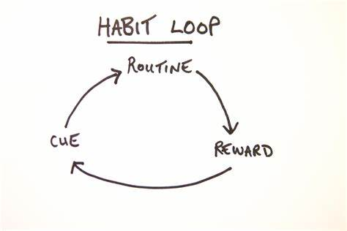
Activity: Remembering and recalling key learning
Summarise the Pavlovian response in your own words.

Application: Think of a habit you have that limits your ability to concentrate on your learning. Document an approach that you could use to unlearn this habit.

Developing depth:
Procrastination is a bad habit that everybody needs to work to avoid. Watch this funny lecture by Tim Urban where he talks about the problem that everyone must fight to avoid.
Tim Urban: Inside the mind of a master procrastinator | TED Talk

Summary
Habits are like your brain operating on autopilot and are often how your brain can relax from doing hard work. Your brain rewards this idea of work reduction by releasing a chemical called dopamine that makes you feel good. While this is a good thing when you are relaxing, it is a bad thing if you are wanting to learn. By understanding that habits are a process that can be controlled, you can consciously work to promote good habits by giving yourself incremental little rewards when learning.

Further Research
If you have time, consider researching journalist Charles Duhigg and the concept of the habit loop in The Power of Habit: Why We Do What We Do in Life and Business.

References
Duhigg, C. and Chamberlain, M., 2012. The power of habit. New York, N.Y.: Random House.
---

Sub-section 3:
Identify the characteristics of an agile learner and select methods to develop learning ability

Upon completion of this sub-section, you will be able to:
- List the approaches recommended to improve agile learning
- Identify your personal approaches to developing an agile learning approach to your studies.
Introduction
Learning new things that make a change in your life can be hard. As you have seen, your brain is hardwired to be looking for fun things to do, and when you are challenged and even fail, it is not always fun!
Agile learners are aware of the uncomfortable feelings associated with these challenges and furthermore reflect on them in ways that improve their outcomes.
Introductory activity
Do you drive a car? If so, can you remember your first lesson? Did it go well?
Maybe you have learnt to play a musical instrument – when you started, were you good at it? Would you be prepared to play a recording of your early music to your peers now?
If you are a gamer, do you remember how hard it was to finish the first level and progress to the next?
Take a moment to reflect on the learning experiences in your life that are not necessarily to do with school.
What were your feelings when you were a novice and failing all the time?

The anatomy of a learning experience
Learning a new thing is hard. Your brain will only reward you with hits of dopamine when things go right; this means that doing anything new might not give you that same feeling of fun.
When you begin a new learning experience, you are often challenged by the fact you are masterful at doing things in the old way. This is one of the features that makes learning so hard – you are likely to fail often in the early stages of learning anything new. It can be so tempting to give up and revert back to the old way.
Take a look at this graph of how your experiences affect your emotions when learning something new.
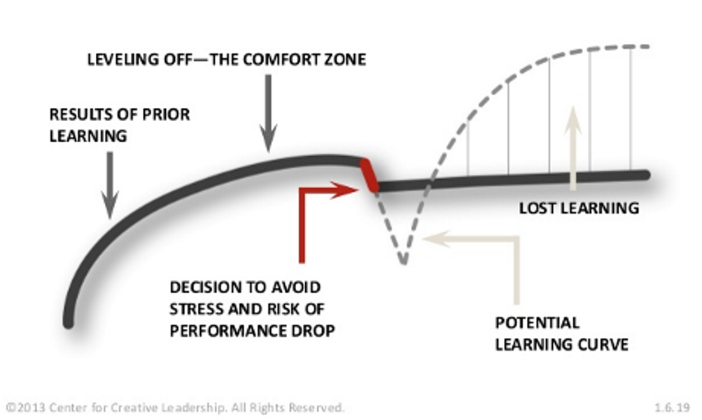
As you can see in this chart, decisions to avoid stress and risk and stick with the familiar can lead to potential opportunities being lost in the long run. However, going against the grain initially leads to a dip in your performance, which can produce feelings of stress and discomfort. It is at this point that you might decide it is better to avoid or stop learning. In practice, the opposite is true. A decision to embrace the stress and the risk of a performance drop will lead to greater learning and growth. Think back to how Michael Jordan, or your favourite athlete, performer or politician deals with their failure.
Learning and growth happens when you step out of your comfort zone. Below is a map demonstrating how comfort zones work, as well as setting out opportunities to learn and grow. Note how the further from the comfort zone you are, the more rewarding the opportunities are. Do you remember the adage ‘there’s no gain without pain’?
\/
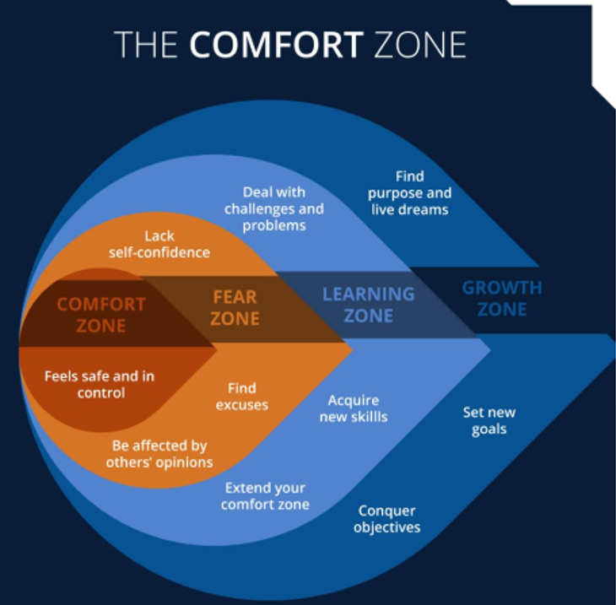
Pushing against the initial feelings of stress and living outside your comfort zone is where learning is most actively achieved. Agile learners actively seek out these places of discomfort because they know that when this feeling emerges, they will be rewarded further down the line with new and productive habits.
Hallenbeck (2016) identifies four practices of learning: agility seeking, sense making, internalising, and applying.

Seeking
Seeking many quality experiences plays a key role in developing your learning agility. It is said by many agile learners that life begins at the edge of your comfort zone.
Make sure that your experiences have novelty and complexity. The newer and more complicated the experience, the greater the opportunity. Do not just look for things that are straightforward and low risk – the diversity of experience matters. The more that you encounter new types of situations that require different skills for success, the more you learn.

Sense making
Agile learners recognise that the best way to learn is to forget what they already know. As you have seen with in the first video, you must demonstrate courage to be curious. Learning is active – it involves making deliberate and intentional effort. It is important to accept errors and mistakes as part of the learning experience.

Internalising
Getting an insight from your learning experience can be challenging and, just like sense making, requires deliberate effort. Practices such as reflecting, actively seeking feedback and embracing criticism take us out of our comfort zone. As you will recall, these are the places where you are likely to learn the most.

Applying
In any new situation, you will not have any direct experience to guide you. Instead, you must reference indirect or seemingly unrelated experiences. Any new and challenging experiences will be full of ambiguity, and solutions are not always clear. When this happens, focus on what you've done in the past that is similar to this new experience. Remember that your first steps rarely work the first time, so be prepared to look for alternatives and focus on the way Michael Jordon, or your sporting, performing or political hero, learns from their failures.

Stop and Think
Remembering and recalling key learning:
What are the four strategies explained by Hallenbeck?

Developing depth
Read the following article:
If You’re Not Outside Your Comfort Zone, You Won’t Learn Anything (hbr.org) - (Molinsky, 2021) – No longer available. Suitable alternative:
- How to Leave your Comfort Zone and Enter your ‘Growth Zone’ by Oliver Page, MD (2020)
Ref: PositivePsychology.com. This evidence-based article defines the comfort, learning (growth), and panic zones, discussing how stepping just beyond comfort fosters self-actualization, resilience, and a growth mindset. Includes practical tips like reframing stress, taking small steps, and embracing challenges.
- And: “Why Stepping Outside Your Comfort Zone Promotes Learning”
https://www.psychologytoday.com/us/blog/understanding-hypnosis/202312/why-stepping-outside-your-comfort-zone-promotes-learning
- Ref: Psychology Today. This article draws on psychological research showing that expanding your comfort zone builds self-efficacy, lowers anxiety around new challenges, and enhances adaptability—up to a point of overwhelm. Uses examples like learning a musical instrument to illustrate these ideas.
Summary
Learning anything new is challenging, and agile learners must appreciate the emotional labour that is required to push past early disappointment and uncomfortable feelings. Learning in an agile way means that you must bravely try to seek out zones that, whilst uncomfortable, are places where you will learn in the most effective way. You can develop your learning agility using the four strategies highlighted by Hallenbeck: seeking, sense making, internalising, and applying.

Extend your learning
Reflect on any new experiences you've had in the past. Using the Hallenbeck (2016) principles to guide you, how do you think you learnt throughout this experience using the definitions of seeking, sense making, internalising, and applying?

-

References
Hallenbeck, G., 2018. Learning Agility. La Vergne: Center for Creative Leadership.
Molinsky, A., 2021. If You’re Not Outside Your Comfort Zone, You Won’t Learn Anything. [online] Harvard Business Review. Available at: <https://hbr.org/2016/07/if-youre-not-outside-your-comfort-zone-you-wont-learn-anything> [Accessed 2 July 2021].

