Contents
1. Introduction 3
2. Job Advertisement 3
3. Job Role Employability Skills 4
4. Evaluating My Own Skills 5
4.1 Experiences 5
4.2 Strengths 5
4.3 Improvement 5
4.4 Who can help? 6
5. Action Plan and Timeline 6
5.1 Action Plan 6
5.2 Timeline 6
6. Building Personal Brand 7
7. Promoting Professional Identity 7
8. Building a Network for Successful Employment 8
9. Conclusion 8
References 9

Raluca Sultana

2325938

Component 2 – Written Assignment (Report)

BMHP5015

Tuesday 25th November

Tutor: Danni Dune

Introduction
In this report, an overview of my personal brand, employability skills, and preferred job role will be discussed in detail. The job role I have chosen is “Registered Nurse”, a role which may require, but not limited to, administrating medication, working together with doctors to understand what the best care for a patient is and keep track on the patient’s progress (National Careers Service, 2019). Throughout this report, I will explore the skills required, analysing my own skills and identifying what can be improved. I have chosen this job role as I am interested to be a contributing and helpful member in the NHS.

Job Advertisement
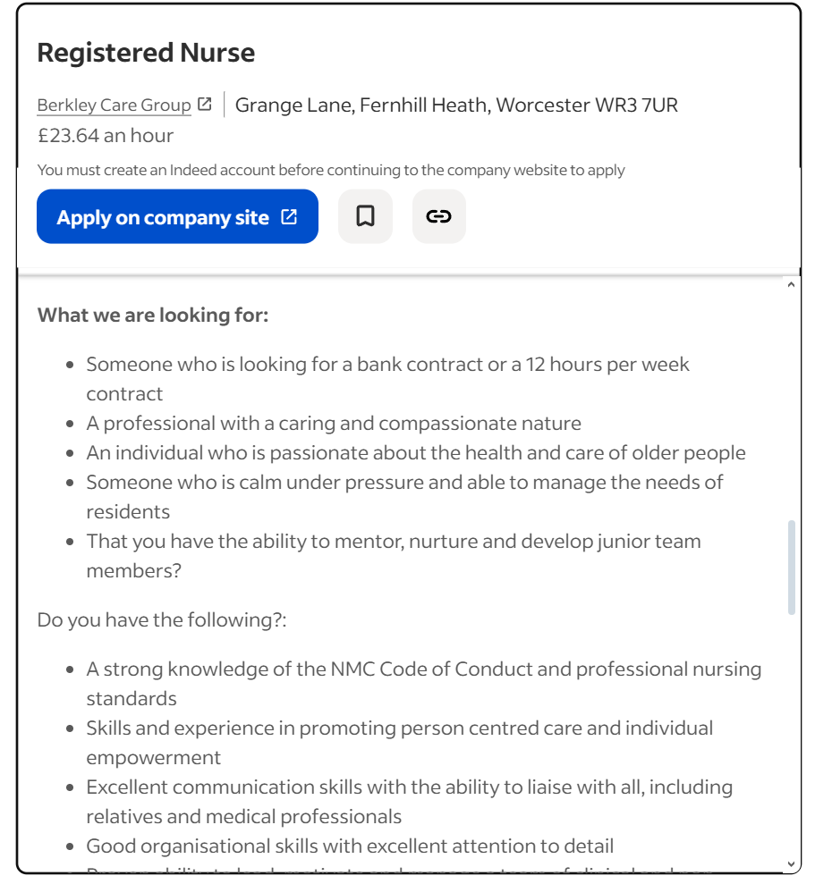
Figure 1 - Indeed (2025)
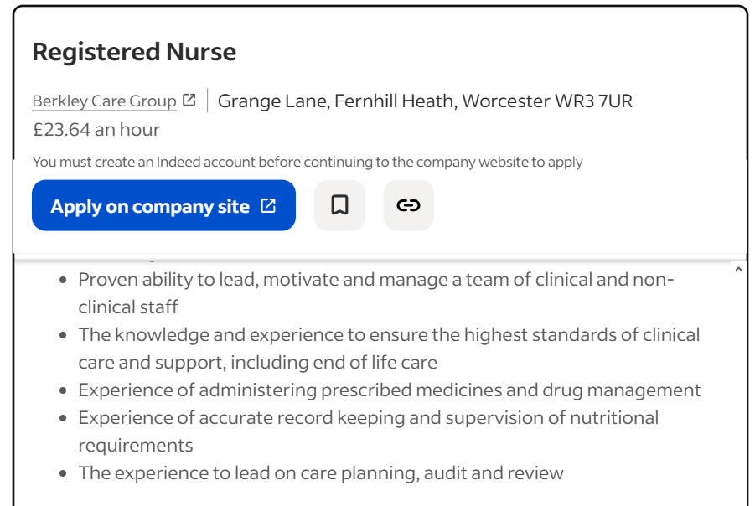
Figure 2 - Indeed (2025)

Job Role Employability Skills
As seen in the screenshots provided above, working as a registered nurse requires quite a few skills. Nurses need to be registered in the UK to ensure the safety of both nurse and patient and that the nurse bears the required education and training to be qualified. An unqualified nurse could possess a serious threat to patients. Thus, these are some of the required skills as shown in the job advertisement:
- Experience, knowledge and professionalism: as observed in other similar job advertisements, experience of at least 6 months is required; as mentioned before, this could be for the safety of the patients.
- Can work under pressure: hospital, clinics, care homes and other professional settings requiring of a nurse can get quite chaotic. Nurses should be able to maintain composure in the face of an emergency.
- Compassion and empathy: this job requires communication with the patient, being able to communicate in a friendly, understanding, yet professional manner is key to building trust with the patient.
- Leadership: much alike the previous point, nurses are required to communicate with other staff and leading a team to achieve satisfying results.
- Recordkeeping: records of patients must be kept so that it can be communicated with doctors and other professionals to achieve the betterment of the patient.
- Administrating medication and drug management: on the surface, this is the most common skill required of a nurse and a basic necessity to become a nurse.

Evaluating My Own Skills

Experiences
Currently, I lack the important experiences needed to excel as a registered nurse. However, some of my current experiences that may contribute to the job role are:
- A CertHE in Skills for the Workplace in Health and Social Care: this allowed me to gain knowledge on record keeping, basic IT and Excel skills, and self-assessment for my own betterment.
- A certificate in Mental Health First Aid training course: this will aid in case of panic or anxiety attacks and help me show compassion to patients, including communicating and building trust with staff and patients. According to Gamble and Ion (2017), in elderly care there are cases of “ageism” shown by nurses and bad relationships between staff, resulting in bad care provided by the nurse. Being able to communicate and show compassion can mitigate the chances of that happening.

Strengths
My strengths align with some of the requirements for the job role. I possess strong communication skills and an understanding of mental health and body language; this will help me build meaningful relationships with staff and offer a safe place to patients. This skill was further strengthened by my training course in Mental Health First Aid where compassion and understanding were taught. Moreover, I am a quick learner, and I will be able to quickly pick up the required miscellaneous tasks that I will need to carry out as a nurse.

Improvement
Recognising areas of improvement will bring about quality of life to both nurse and patients. My first priority is gaining experience to minimise any risks my lack of experience my cause. As discussed previously, lack of experience can be a real threat to the patient and may cause problems to the nurse as well. In Happell’s (2008) study, it was found that undergraduate mental health nurses may hold negative prejudice against individuals experiencing mental illness. To avoid causing the same mistake, I must familiarise myself with different situations and people to gain an understanding of how to conduct myself.

Who can help?
Currently, the respective career team in my university can help me acquire knowledge of what the appropriate start would be. From my own research, I have discovered that I must first complete a degree in a programme approved by the Nursing and Midwifery Council (2025). Moreover, I could personally seek out assistance from job centres, but the most appropriate course of action would be to acquire a degree in an approved programme. This would solidify the start to my preferred career path.

Action Plan and Timeline

Action Plan
As mentioned previously, to be able to become a registered nurse in the UK I must first complete a degree in an approved programme. Within the course of this degree, I should be able to find occasional training experiences and volunteering work where I can partake to gain hands-on work experience and accustom myself to the ins and outs of the job role. As discussed earlier, a measurable quantity of Registered Nurse job advertisements required 6 months of work experience. I aim for at least one year of work experience to stay on top of my priorities and become a suitable candidate for employers. Furthermore, I plan to build connections with fellow work colleagues and professionals with years of experience in this work field. This can be achieved over time throughout the course of the degree as I will have the opportunity to work and learn alongside other trainees as well as professionals. However, I will first prefer to complete my current BSc degree in Health and Social Care, as it only requires one more year before graduation and will allow me to experience distinct training courses (like the Mental Health First Aid training course) and various work experiences which are offered throughout the year.

Timeline
- Short term: I plan to continue my studies and get my BSc degree in Health and Social care. Within this time and beyond this, I will strive to garner work experience through training courses and volunteering work, whether related to nursing or not. I believe all work experience within health and social care will allow me to gain an understanding of the environment I aspire to work in.
- Medium term: Afterwards, I plan on pursing 3 years of studying a nursing degree in an approved university. This will also grant me opportunities to proper experience working as a nurse through volunteering and training; as well as connecting with people within this work field, allowing me to garner meaningful connections which could help me progress as a nurse in the long run.
- Long term: I will continue to work as a nurse and strive to gain further work experience; this will allow me to gain more knowledge, so that I can continue to grow as a person and as a nurse.

Building Personal Brand
Personal branding allows for upstanding and professional social image if done correctly. It is no surprise that background checks will be performed when applying for jobs and that social life will have an impact on it; according to Johnson (2017), if not careful of your social image, this could negatively impact the chances of landing a job. In regard to nursing, personal branding helps understand what sets an individual apart from other nurses and reflect on myself and my professional career; creating a SWOT (strengths, weaknesses, opportunities, threats) analysis and a LinkedIn profile can aid in this journey (NursingEducation, 2024). Therefore, there are two factors worth noting: conducting myself with professionalism on the internet as I would in my day to day life and creating a social life that can create connections and social networking opportunities. As observed on most blogs and articles, LinkedIn appears to be a crucial tool to creating a professional social image, consequently I will apply that knowledge and engage with other professionals with the help of LinkedIn. Flavio (2024) offers insights into creating a professional LinkedIn to appease health care employers, one notable tip is creating regular posts in relation to the nursing career.

Promoting Professional Identity
Most employers will require a CV and in some cases a cover letter, this is used to showcase our experience, skills and basic personal information such as name, email address, phone number and more. Cover letters specifically can be used to address the employer directly to accentuate the reason behind applying for the job role and how personal qualities apply to this job (Gottlieb et al., 2021). Inside these cover letters various strategies can be applied, which can also be used outside of cover letters (for example interviews), one of these strategies is the PAR story, problem-action-result, as detailed by Wolfe (2024) this method allows to demonstrate problem solving skills to the employer. This is a useful strategy as one question that can be potentially addressed during interviews is “What is one challenge you faced and how did you overcome it?” Moreover, as mentioned earlier, maintaining a LinkedIn profile is another essential tool to promote professional identity; however, Yang (2024) argues that LinkedIn should not be used as a constant promoting tool, but as a tool to engage with other professionals trough regular daily posting. Much alike other social media outlets, clever engagement allows for the right audience to interact with my posts.

Building a Network for Successful Employment
Building a network can be essential in attaining a job role, especially in health and social care where vacancies are rare and easily inhabited soon after the job advertisement. However, networking is also used as a tool between professionals to communicate, improve the care provided to patients, researching, supply chains and many other quality improvements that can be brought to patients (Rajamani and Iyer, 2023). Overall, networking is a useful aspect to start a career and throughout the career serving as a pillar for improvement as an individual and shaping the future of how health care advances throughout the years.
Hence, identifying connections that will aid in growing professionally goes along with networking.
- Mentors: this can be anyone with years of experience, including senior colleagues, doctors, peers and more. Mentors can be found inside universities, hospitals or other similar establishments, and the internet (social media, LinkedIn.)
- Professional Associations: Nursing and Midwifery Council is an indispensable association as mentioned previously in this report, even necessary in becoming a qualified nurse in the UK.
- Networking events: NHS Providers offers conferences and exhibitions, HMFA accommodates events, The Royal Society of Medicine also offers conferences and events, and many more health care institutions which provide networking events for professionals.

Conclusion
In this report it has been discussed the skills needed for a registered nurse, this includes record keeping, leadership, medication and drug management, communication and compassion. Moreover, experience is significant to assure the safety of patients and communication between colleagues and patients will in addition improve the quality of care provided to patients. To succeed in a job role requires a few factors to consider; these are personal branding and networking. Both coexist together to shape professional image and build connections with professionals within the designated job role; when expanding into social media it creates an algorithm to connect with the right people and promote professional identity. Lastly, I would like to reinstate why I have chosen registered nurse as my preferred job role choice: I personally desire to contribute to society through helping people heal, either physically or mentally. As a registered nurse I can treat patients’ wounds, but I can also offer a safe space to patients and encourage them to seek help and treatment.

References
- Flavio (2024). LinkedIn for Nurses: 7 Tips To a Memorable Healthcare Brand • Grow Your Personal Brand On LinkedIn. [online] Taplio. Available at: https://taplio.com/blog/linkedin-for-nurses [Accessed 17 Nov. 2025].
- Gamble, C. and Ion, R., 2017. Poor care and the professional duty of the registered nurse. Nursing Older People, 29(4).
- Gottlieb, M., Promes, S.B. and Coates, W.C., 2021. A guide to creating a high‐quality curriculum vitae. AEM Education and Training, 5(4), p.e10717.
- Happell, B., 2008. The importance of clinical experience for mental health nursing–Part 2: Relationships between undergraduate nursing students’ attitudes, preparedness, and satisfaction. International Journal of Mental Health Nursing, 17(5), pp.333-340.
- Indeed.com. (2025). Registered Nurse. [online] Available at: https://shorturl.at/JXrgI [Accessed 12 Nov. 2025].
- Johnson, K.M., 2017. The importance of personal branding in social media: educating students to create and manage their personal brand. International journal of education and social science, 4(1), pp.21-27.
- National Careers Service (2019). Nurse | Explore careers. [online] Service.gov.uk. Available at: https://nationalcareers.service.gov.uk/job-profiles/nurse [Accessed 12 Nov. 2025].
- Nmc.org.uk. (2018). Approved programmes - The Nursing and Midwifery Council. [online] Available at: https://www.nmc.org.uk/education/approved-programmes [Accessed 13 Nov. 2025].
- NursingEducation. (2024). NursingEducation. [online] Available at: https://nursingeducation.org/insights/personal-brand [Accessed 17 Nov. 2025].
- Rajamani, S.K. and Iyer, R.S., 2023. Networks in healthcare: a systematic review. BioMedInformatics, 3(2), pp.391-404.
- Wolfe, A.D., Davidson, L.K. and Paul, C.R., 2024. Put Yourself out There! A Strategy for Effective Self-Promotion in Academic Medicine. MedEdPORTAL, 20, p.11409.
- Yang, A.B. (2024). Self-Promotion on LinkedIn Without the Cringe. [online] Anna Burgess Yang. Available at: https://blog.annabyang.com/make-linkedin-less-cringe [Accessed 18 Nov. 2025].

