Suzanne Pearton-Scale 2105981
Rehabilitation Proposal Presentation
Psychopathology ECAP6006

Link to powerpoint:
https://uowtsd-my.sharepoint.com/:p:/g/personal/2105981_student_uwtsd_ac_uk/EcU1GT3Q9gJMvfc1OkgFasYBVnj0GGAMt6salk7buEEQcw

https://uowtsd-my.sharepoint.com/:p:/r/personal/2105981_student_uwtsd_ac_uk/Documents/LEVEL%205/PSYCHOPATHOLOGY/Rehab2.pptx?d=w3d1935c5f6d04c02bdf7353a48056ac6&csf=1&web=1&e=KlxYHg

https://uowtsd-my.sharepoint.com/:p:/r/personal/2105981_student_uwtsd_ac_uk/Documents/LEVEL%205/PSYCHOPATHOLOGY/FINAL%20Rehab%20SPS.pptx?d=w3d1935c5f6d04c02bdf7353a48056ac6&csf=1&web=1&e=tjYraH

Presentation:
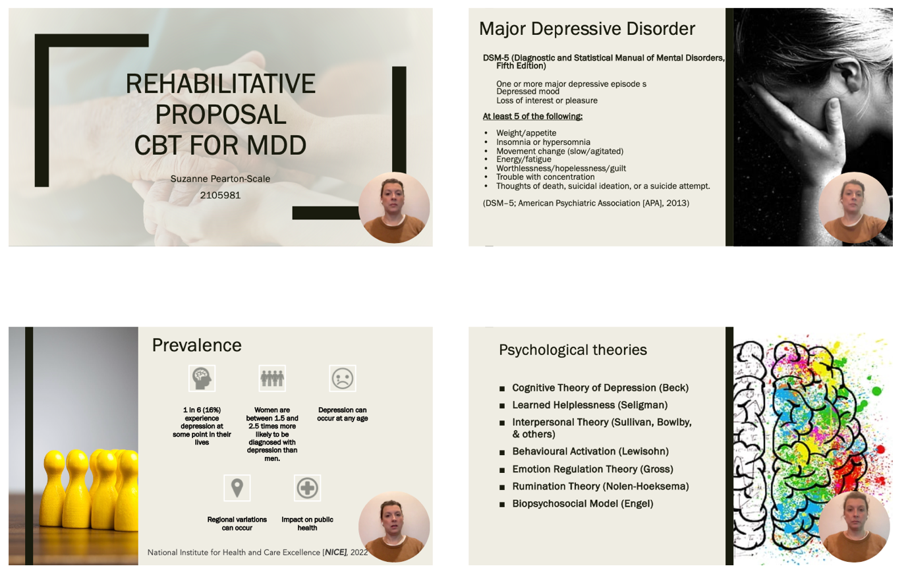

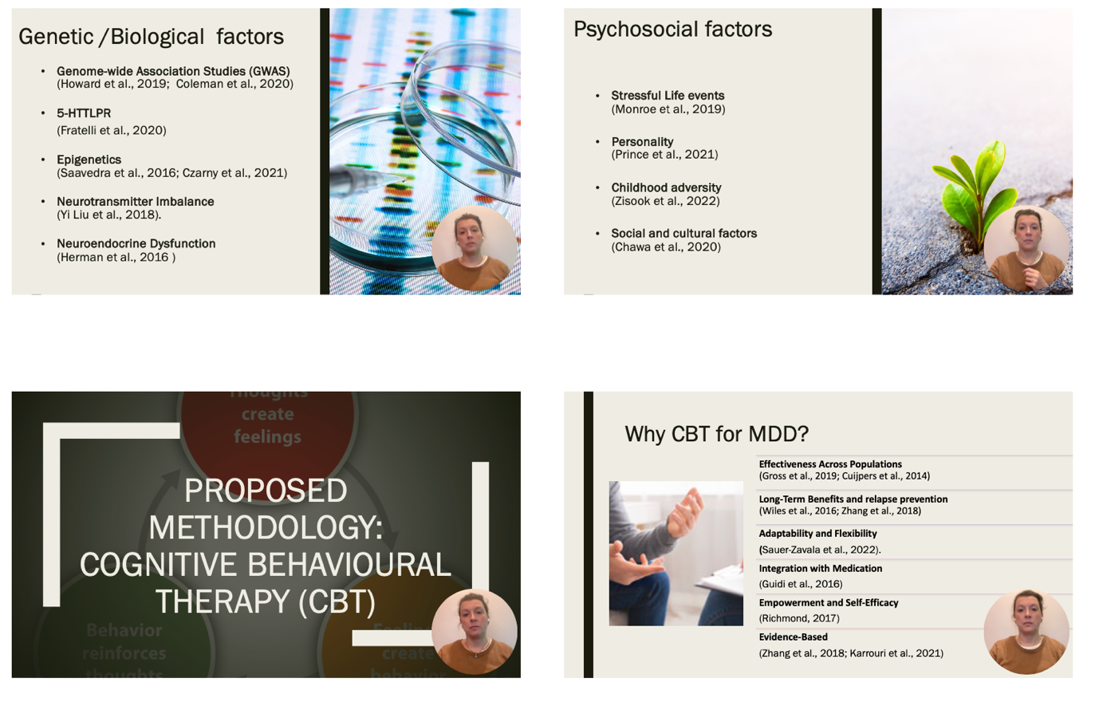
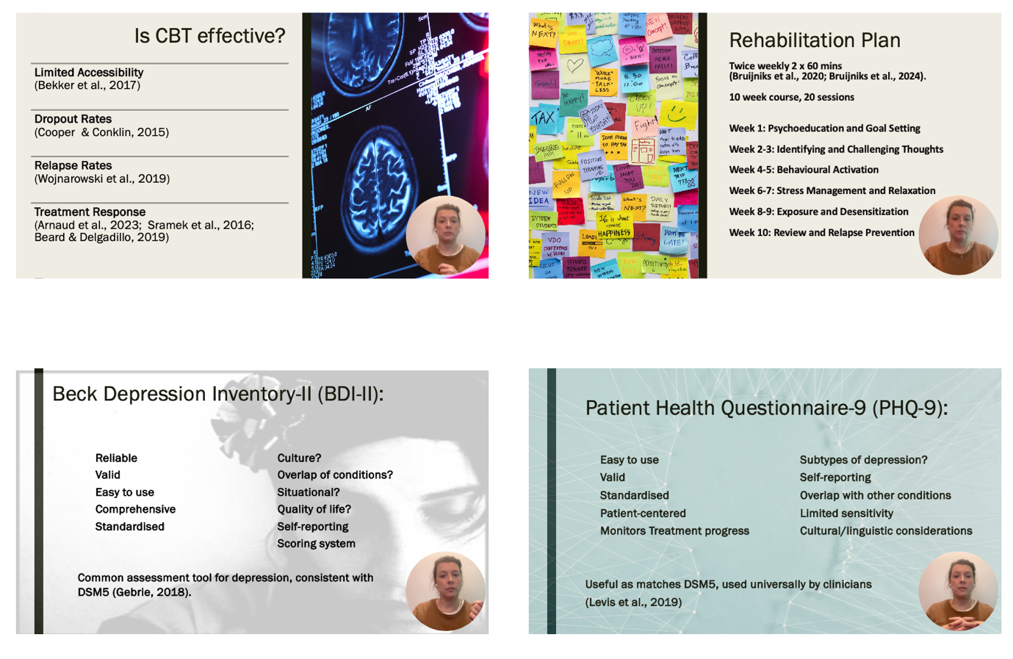
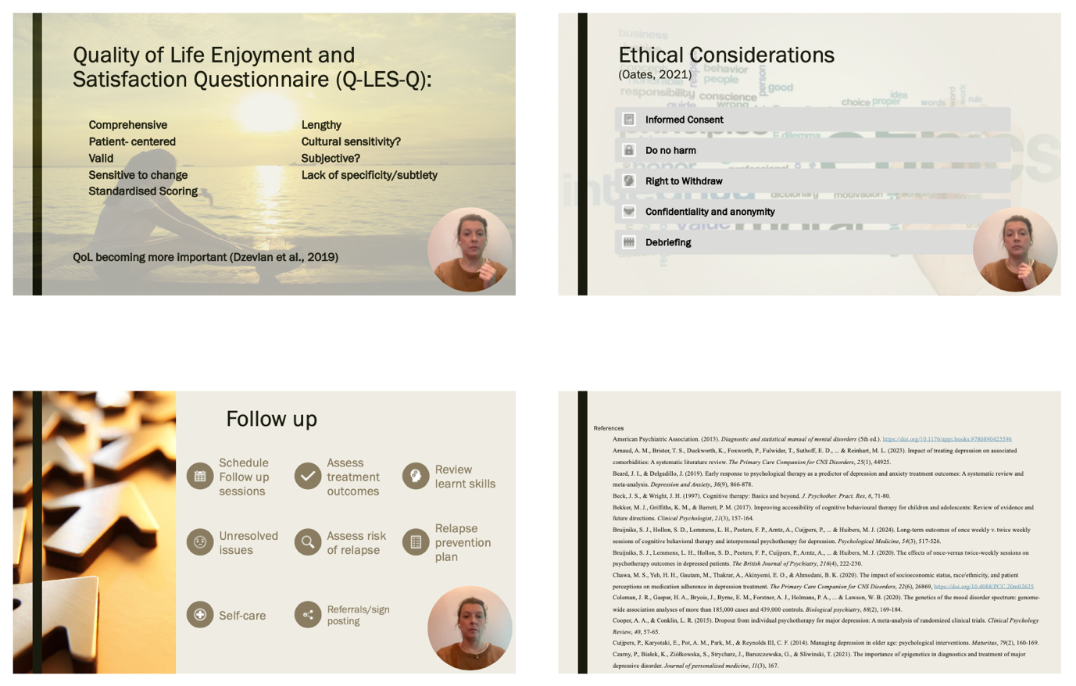
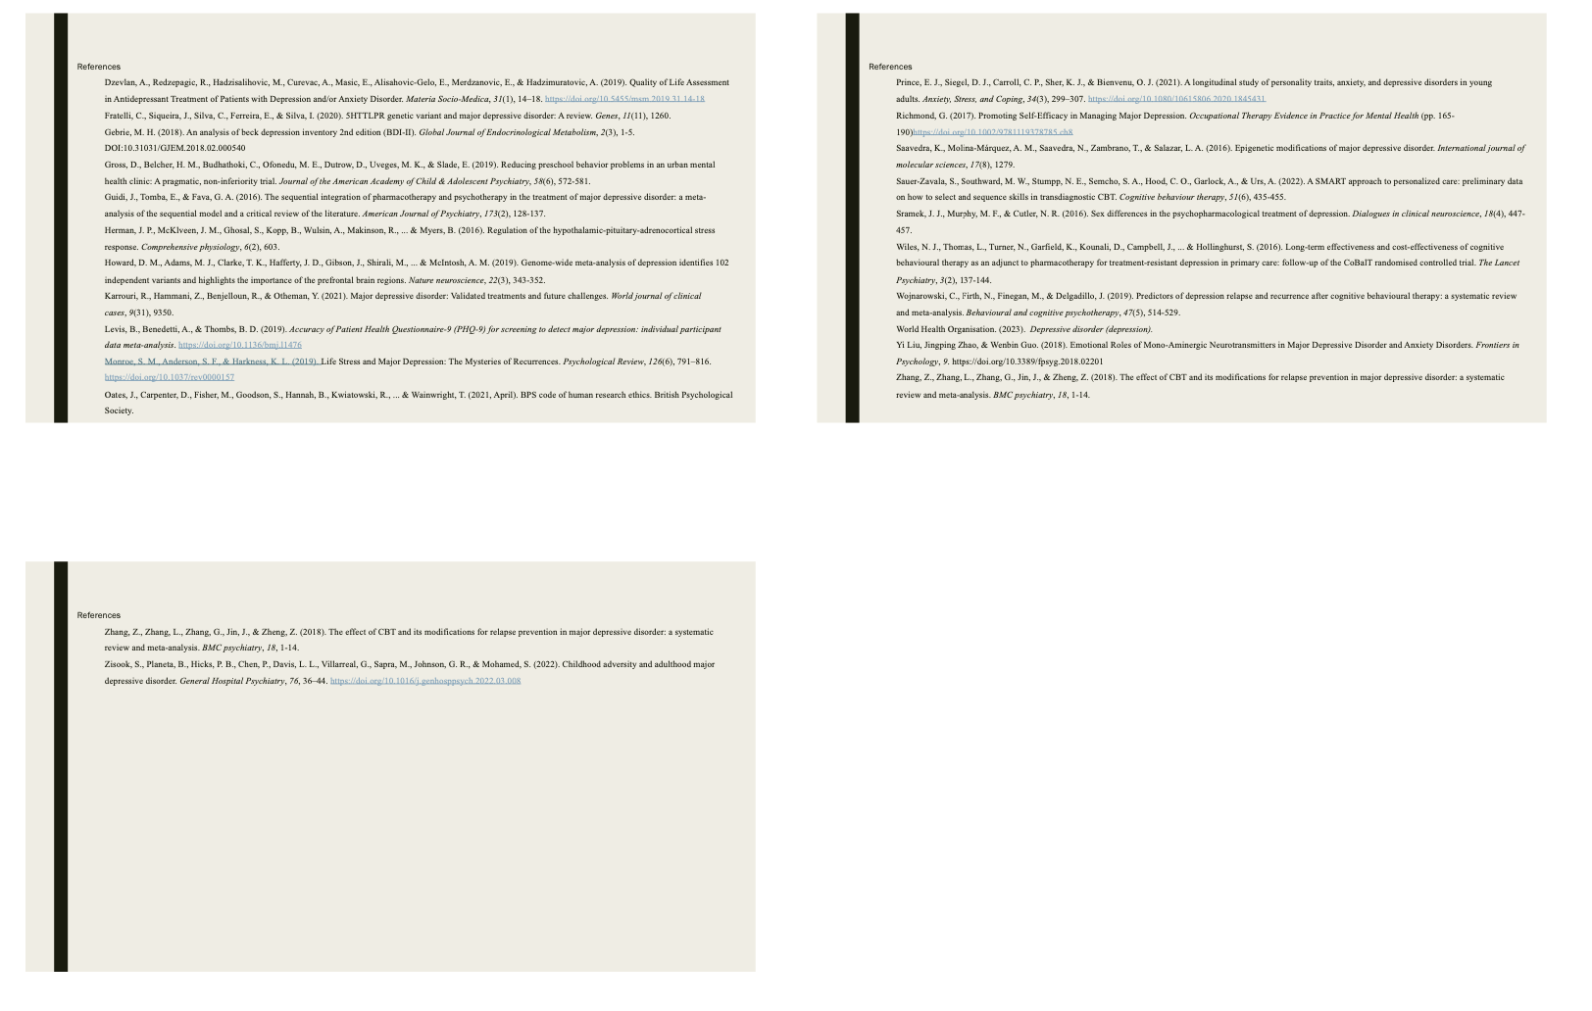

References
American Psychiatric Association. (2013). Diagnostic and statistical manual of mental disorders (5th ed.). https://doi.org/10.1176/appi.books.9780890425596
Arnaud, A. M., Brister, T. S., Duckworth, K., Foxworth, P., Fulwider, T., Suthoff, E. D., ... & Reinhart, M. L. (2023). Impact of treating depression on associated comorbidities: A systematic literature review. The Primary Care Companion for CNS Disorders, 25(1), 44925.
Beard, J. I., & Delgadillo, J. (2019). Early response to psychological therapy as a predictor of depression and anxiety treatment outcomes: A systematic review and meta‐analysis. Depression and Anxiety, 36(9), 866-878.
Beck, J. S., & Wright, J. H. (1997). Cognitive therapy: Basics and beyond. J. Psychother. Pract. Res, 6, 71-80.
Bekker, M. J., Griffiths, K. M., & Barrett, P. M. (2017). Improving accessibility of cognitive behavioural therapy for children and adolescents: Review of evidence and future directions. Clinical Psychologist, 21(3), 157-164.
Bruijniks, S. J., Hollon, S. D., Lemmens, L. H., Peeters, F. P., Arntz, A., Cuijpers, P., ... & Huibers, M. J. (2024). Long-term outcomes of once weekly v. twice weekly sessions of cognitive behavioral therapy and interpersonal psychotherapy for depression. Psychological Medicine, 54(3), 517-526.
Bruijniks, S. J., Lemmens, L. H., Hollon, S. D., Peeters, F. P., Cuijpers, P., Arntz, A., ... & Huibers, M. J. (2020). The effects of once-versus twice-weekly sessions on psychotherapy outcomes in depressed patients. The British Journal of Psychiatry, 216(4), 222-230.
Chawa, M. S., Yeh, H. H., Gautam, M., Thakrar, A., Akinyemi, E. O., & Ahmedani, B. K. (2020). The impact of socioeconomic status, race/ethnicity, and patient perceptions on medication adherence in depression treatment. The Primary Care Companion for CNS Disorders, 22(6), 26869, https://doi.org/10.4088/PCC.20m02625
Coleman, J. R., Gaspar, H. A., Bryois, J., Byrne, E. M., Forstner, A. J., Holmans, P. A., ... & Lawson, W. B. (2020). The genetics of the mood disorder spectrum: genome-wide association analyses of more than 185,000 cases and 439,000 controls. Biological psychiatry, 88(2), 169-184.
Cooper, A. A., & Conklin, L. R. (2015). Dropout from individual psychotherapy for major depression: A meta-analysis of randomized clinical trials. Clinical Psychology Review, 40, 57-65.
Cuijpers, P., Karyotaki, E., Pot, A. M., Park, M., & Reynolds III, C. F. (2014). Managing depression in older age: psychological interventions. Maturitas, 79(2), 160-169.
Czarny, P., Białek, K., Ziółkowska, S., Strycharz, J., Barszczewska, G., & Sliwinski, T. (2021). The importance of epigenetics in diagnostics and treatment of major depressive disorder. Journal of personalized medicine, 11(3), 167.
Dzevlan, A., Redzepagic, R., Hadzisalihovic, M., Curevac, A., Masic, E., Alisahovic-Gelo, E., Merdzanovic, E., & Hadzimuratovic, A. (2019). Quality of Life Assessment in Antidepressant Treatment of Patients with Depression and/or Anxiety Disorder. Materia Socio-Medica, 31(1), 14–18. https://doi.org/10.5455/msm.2019.31.14-18
Fratelli, C., Siqueira, J., Silva, C., Ferreira, E., & Silva, I. (2020). 5HTTLPR genetic variant and major depressive disorder: A review. Genes, 11(11), 1260.
Gebrie, M. H. (2018). An analysis of beck depression inventory 2nd edition (BDI-II). Global Journal of Endocrinological Metabolism, 2(3), 1-5. DOI:10.31031/GJEM.2018.02.000540
Gross, D., Belcher, H. M., Budhathoki, C., Ofonedu, M. E., Dutrow, D., Uveges, M. K., & Slade, E. (2019). Reducing preschool behavior problems in an urban mental health clinic: A pragmatic, non-inferiority trial. Journal of the American Academy of Child & Adolescent Psychiatry, 58(6), 572-581.
Guidi, J., Tomba, E., & Fava, G. A. (2016). The sequential integration of pharmacotherapy and psychotherapy in the treatment of major depressive disorder: a meta-analysis of the sequential model and a critical review of the literature. American Journal of Psychiatry, 173(2), 128-137.
Herman, J. P., McKlveen, J. M., Ghosal, S., Kopp, B., Wulsin, A., Makinson, R., ... & Myers, B. (2016). Regulation of the hypothalamic-pituitary-adrenocortical stress response. Comprehensive physiology, 6(2), 603.
Howard, D. M., Adams, M. J., Clarke, T. K., Hafferty, J. D., Gibson, J., Shirali, M., ... & McIntosh, A. M. (2019). Genome-wide meta-analysis of depression identifies 102 independent variants and highlights the importance of the prefrontal brain regions. Nature neuroscience, 22(3), 343-352.
Karrouri, R., Hammani, Z., Benjelloun, R., & Otheman, Y. (2021). Major depressive disorder: Validated treatments and future challenges. World journal of clinical cases, 9(31), 9350.
Levis, B., Benedetti, A., & Thombs, B. D. (2019). Accuracy of Patient Health Questionnaire-9 (PHQ-9) for screening to detect major depression: individual participant data meta-analysis. https://doi.org/10.1136/bmj.l1476
Monroe, S. M., Anderson, S. F., & Harkness, K. L. (2019). Life Stress and Major Depression: The Mysteries of Recurrences. Psychological Review, 126(6), 791–816. https://doi.org/10.1037/rev0000157
Oates, J., Carpenter, D., Fisher, M., Goodson, S., Hannah, B., Kwiatowski, R., ... & Wainwright, T. (2021, April). BPS code of human research ethics. British Psychological Society.
Prince, E. J., Siegel, D. J., Carroll, C. P., Sher, K. J., & Bienvenu, O. J. (2021). A longitudinal study of personality traits, anxiety, and depressive disorders in young adults. Anxiety, Stress, and Coping, 34(3), 299–307. https://doi.org/10.1080/10615806.2020.1845431
Richmond, G. (2017). Promoting Self-Efficacy in Managing Major Depression. Occupational Therapy Evidence in Practice for Mental Health (pp. 165-190)https://doi.org/10.1002/9781119378785.ch8
Saavedra, K., Molina-Márquez, A. M., Saavedra, N., Zambrano, T., & Salazar, L. A. (2016). Epigenetic modifications of major depressive disorder. International journal of molecular sciences, 17(8), 1279.
Sauer-Zavala, S., Southward, M. W., Stumpp, N. E., Semcho, S. A., Hood, C. O., Garlock, A., & Urs, A. (2022). A SMART approach to personalized care: preliminary data on how to select and sequence skills in transdiagnostic CBT. Cognitive behaviour therapy, 51(6), 435-455.
Sramek, J. J., Murphy, M. F., & Cutler, N. R. (2016). Sex differences in the psychopharmacological treatment of depression. Dialogues in clinical neuroscience, 18(4), 447-457.
Wiles, N. J., Thomas, L., Turner, N., Garfield, K., Kounali, D., Campbell, J., ... & Hollinghurst, S. (2016). Long-term effectiveness and cost-effectiveness of cognitive behavioural therapy as an adjunct to pharmacotherapy for treatment-resistant depression in primary care: follow-up of the CoBalT randomised controlled trial. The Lancet Psychiatry, 3(2), 137-144.
Wojnarowski, C., Firth, N., Finegan, M., & Delgadillo, J. (2019). Predictors of depression relapse and recurrence after cognitive behavioural therapy: a systematic review and meta-analysis. Behavioural and cognitive psychotherapy, 47(5), 514-529.
World Health Organisation. (2023). Depressive disorder (depression).
Yi Liu, Jingping Zhao, & Wenbin Guo. (2018). Emotional Roles of Mono-Aminergic Neurotransmitters in Major Depressive Disorder and Anxiety Disorders. Frontiers in Psychology, 9. https://doi.org/10.3389/fpsyg.2018.02201
Zhang, Z., Zhang, L., Zhang, G., Jin, J., & Zheng, Z. (2018). The effect of CBT and its modifications for relapse prevention in major depressive disorder: a systematic review and meta-analysis. BMC psychiatry, 18, 1-14.
Zhang, Z., Zhang, L., Zhang, G., Jin, J., & Zheng, Z. (2018). The effect of CBT and its modifications for relapse prevention in major depressive disorder: a systematic review and meta-analysis. BMC psychiatry, 18, 1-14.
Zisook, S., Planeta, B., Hicks, P. B., Chen, P., Davis, L. L., Villarreal, G., Sapra, M., Johnson, G. R., & Mohamed, S. (2022). Childhood adversity and adulthood major depressive disorder. General Hospital Psychiatry, 76, 36–44. https://doi.org/10.1016/j.genhosppsych.2022.03.008

