Management Ethics
Assignment 1
Dr Caroline Jawad


19th November 2018

MODULE NAME: Management ethics
Project Name: assignment 1
Name: grazia martone
Student Number: 1703121

Introduction
Nestle is a well-known brand across the world, Heininrich Nestle was the founder of the Nestle company. Heinrich and his family started off with producing carbonated water, they then went on to expand their ideas and moved on to combined cow’s milk using wheat flour and sugar this then produced a substitute of mother’s milk for any children not latching on to the breast milk. The milk formula was developed in 1866 for any young babies that was unable to tolerate milk from the breast. Of course Heinrich’s invention became a success and there was a huge demand across the whole of Europe. By the 1960’s Nestle grew to one of the biggest company’s in Switzerland. Heinrich had now opened over 200 factories across the globe. Nestle today have expanded to sell various different products such as baby food, bottled water, breakfast cereals, coffee and tea, confectionery, dairy products, ice cream, frozen food, pet foods, and snacks. They have 447 factories across 194 countries and employ around 333,000 people.
‘’The mission statement was “Breast milk nutrients that nourish protect and promote growth and development. However, for different reasons, not all mothers are able to breastfeed their babies or choose to do so, and need a safe, high-quality alternative that provides babies with the precise nutrition they need in the first months of life (Nestle 1990).”
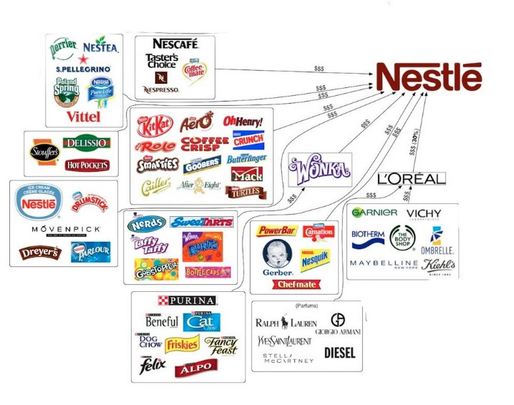(Bing.com, 2018)
The cooperate social responsibilities and unethical practices
Nestle took place in a various different unethical issues, concentrating on the baby formula and boycott, it is a very sad and sensitive subject to many individuals as Nestle concentrated pushing their breastfeeding formula in less economically developed countries targeting the poor for example Africa. Heininrich put the message across that their brand of baby formula was just as good as a mother’s breast milk. There were many reasons making this unethical one of the first problems would be the water sanitation, as Africa didn’t have access to clean water and still to this day clean water is a basic need they lack. It was necessary for them to boil the water, but because there was low literacy rates many mothers was not made aware of this. So the baby formula would be mixed with polluted water this is resulting in children being put at great risk. Nestle knowingly ignored the problem and still was encouraging this on mothers even with all the complications it will cause.
For a baby the most important part of its starting life is feeding and getting all the nutrients it requires but even in these un-sanitized areas it was cast aside. The baby formula was required to be “the nearest thing in the world”, and this “splendid triumph of care and science” is “so like mother’s milk that the tiny stomach won’t notice the difference”. But the tiny stomach did notice the difference. Some may argue that this is was the new way to help mothers maintain their time more efficiently and have more time to get other things done rather than a child always wanting breast milk.
The CSR theory solutions
‘’Corporate Social Responsibility is the continuing commitment by business to behave ethically and contribute to economic development while improving the quality of life of the workforce and their families as well as of the local community and society at large’’(Mallen Baker's Respectful Business Blog, 2018).
Nestle claims to have worked with millions of milk and coffee farmers to make them better suppliers. It has helped the communities out of poverty and to prosper. Nestle work directly with almost 600,000 farmers throughout the world with providing over 27 USD million worth of microfinance in 2008 and around 2.4 million people in developing countries earn their livelihoods from the nestle supply chain. Nestle state themselves that social corporate responsibility is not something that is imposed from any outsiders but is an essential part of Nestle’s business strategy and its principles in which this guides the way they operate. Nestle are stewards of large amounts of shareholders capital it is their belief that for the business to create value for any shareholders it must always bring value to society. Nestle stated in the first edition of the nestle management and leadership principles ‘’our investments must be good for the countries where we operate, as well as good for the company’’(Sharedvalue.org, 2018). Cooperate social responsibility and sustainability represent useful principles and practices, nestle believe that business should bring long term value for society, for developing countries this is very beneficial as nestles aim is to improve the capabilities of farmers, create a skilled workforce and develop improved standards for everything to operate successfully. Most of Nestle’s factories are in developing countries they still aim to meet the same requirements for example food quality, safety and business practices that are already running in the developed world. Nestle ethic and social responsibility is important in February 2002 for the bad backlash over the years they decided to join the fair labour association to enable a sustainable supply chain and prevent child labour on cocoa supply in the ivory coast. Nestle source their products from around the world and their approach with stakeholders is ‘’ Our global stakeholder network ranges from people we engage with regularly through our operations to those in public positions who influence our activities. They span employees, consumers, suppliers, communities, governments, non-governmental organisations, shareholders, trade associations and academia’’ (Nestle.com, 2018). Freeman, is a theorist and says stakeholders can be anyone from employees, stockholders, competitors, customers, the local community, The firm is constantly asking the question “For whose benefit and at whose expense should the firm be managed?”.
Stakeholders are a main key factor to any business.Stakeholders are usually all the groups of individuals that may affect or be affected by an organizations day to day working process and include all those who could have shares or interests in the same organisation. (Stakeholdertheory.org, 2018).
A few of the stakeholders for nestle are
- Academia
- Communities
- Consumers and the public
- Customers
- Employees and their representatives
- Governments
- Industry and trade associations
- Intergovernmental organisations
- Non-governmental organisations
- Reporting agencies
- Shareholders and the financial community
Suppliers (including farmers and smallholders).
Nestle conduct a stakeholder community survey which is an annual survey with global key opinion leaders (KOLs) which helps them identify any evolving views on the company’s issues and reputation management. Their employees work closely with rural communities to ensure that there is a relationship between the both.

To conclude this, we can see that it was completely unacceptable in any society some still till this day affects the way they do their shopping avoiding purchasing nestle brands. Overall some may call it murder and same may call it an accident and not enough research was conducted and everyone makes mistakes in this case nestle did not have a good enough argument to back their wrong doings.

References
Biz Gov Soc. (2018). Freeman vs Friedman. [online] Available at: https://mg312.wordpress.com/2011/09/20/freeman-vs-friedman/ [Accessed 14 Nov. 2018].
Mallen Baker's Respectful Business Blog. (2018). Definitions of corporate social responsibility - What is CSR?. [online] Available at: http://mallenbaker.net/article/clear-reflection/definitions-of-corporate-social-responsibility-what-is-csr [Accessed 13 Nov. 2018].
Nestle.com. (2018). [online] Available at: https://www.nestle.com/csv/what-is-csv/stakeholder-engagement [Accessed 15 Nov. 2018].
Sharedvalue.org. (2018). [online] Available at: https://www.sharedvalue.org/sites/default/files/resource-files/Nestle_Corporate_Social_Responsibility_in_Latin_America.pdf [Accessed 13 Nov. 2018].
Stakeholdertheory.org. (2018). R. Edward Freeman | Stakeholder Theory. [online] Available at: http://stakeholdertheory.org/team/r-ed-freeman/ [Accessed 14 Nov. 2018].
ZME Science. (2018). Why Nestle is one of the most hated companies in the world. [online] Available at: https://www.zmescience.com/science/nestle-company-pollution-children/ [Accessed 13 Nov. 2018].
ZME Science. (2018). Why Nestle is one of the most hated companies in the world. [online] Available at: https://www.zmescience.com/science/nestle-company-pollution-children/ [Accessed 14 Nov. 2018].
Bing.com. (2018). nestle products - Bing images. [online] Available at: https://www.bing.com/images/search?view=detailV2&ccid=uU5ronn%2b&id=06578C2724C36147D41FFDE7BBA3963BE0EF8A15&thid=OIP.uU5ronn-UAJ_AN5wcdjEOQHaF1&mediaurl=http%3a%2f%2fcdn.zmescience.com%2fwp-content%2fuploads%2f2015%2f05%2fnestle-subsidiaries.jpg&exph=774&expw=983&q=nestle+products&simid=608028262106467248&selectedIndex=1&ajaxhist=0 [Accessed 15 Nov. 2018].

