

Student Name: | Munaza sakindar
Student ID Number: | 2419348
Programme: | Certificate of Higher Education in Skills for the Workplace (Health & Social Care)
Module Title: | Psychology in Health and Social Care
Module Code: | LCHS4010
Lecturer: | Neale Haddon
Internal Verifier: | Dr Besty Jose
Assignment Title:
Submission Deadline: | Submitted to Turnitin by Tuesday, 18th November 2025, 10 am

Table of Contents
- Introduction (Context) .................................................................................................... 3
- Detailed Overview of Psychological Theories ............................................................. 3
2.1 Erikson’s Psychosocial Theory ............................................................................ 3
2.2 Bowlby’s Attachment Theory ............................................................................... 4
- Application in the Health and Social Care Context ....................................... 6
3.1 Applying Erikson’s Theory in Dementia Care ...................................................... 6
3.2 Applying Bowlby’s Theory in Dementia Care ....................................................... 7
Table: Practical Use of Psychological Theories .......................................................... 8
- Conclusion ...................................................................................................................... 8
- References ...................................................................................................................... 9

1. Context: Older Adults Living in a Dementia Care Home
Older adults aged 65 and over living in dementia care homes often experience complex psychological health challenges linked to cognitive decline, loss of independence, and social isolation. Dementia affects around 982,000 people in the UK, a number projected to exceed 1.4 million by 2040 (Alzheimer’s Society, 2024). Residents frequently present with comorbid mental health conditions such as depression, anxiety, and behavioral and psychological symptoms of dementia (BPSD), which include agitation, apathy, and aggression (NHS England, 2023). These symptoms can be exacerbated by disrupted attachments, unmet emotional needs, and difficulties maintaining a coherent sense of identity (Cohen-Mansfield et al., 2023). Health and social care professionals working in dementia settings therefore require a strong understanding of psychological theories that explain the emotional and behavioral responses of older adults. Applying frameworks such as Erikson’s psychosocial theory and Bowlby’s attachment theory can enhance person-centred practice, support wellbeing, and improve the quality of care by addressing both the emotional and developmental needs of residents (Iriss, 2021; Miyawaki, 2025).

2. Detailed Overview of Two Theories

2.1 Erikson’s Psychosocial Theory
Erikson’s psychosocial theory provides a developmental framework that continues into later life, recognizing that psychological growth extends beyond childhood (Erikson, 1963). For adults aged 65 and over, the final stage—ego integrity versus despair—is central to wellbeing. At this stage, individuals evaluate their life experiences, relationships, and achievements, striving for meaning, acceptance, and coherence (Knight & Poon, 2023). If older adults achieve integrity, they experience wisdom and life satisfaction; if not, despair, regret, or fear of death may emerge (van der et al., 2021).
In the UK, this theory is highly relevant to dementia care settings, where older adults face identity loss, dependency, and social disengagement. Research shows that interventions such as life review and reminiscence therapy—endorsed by the NICE Dementia Guidelines (NG97, 2018)—can enhance ego integrity by helping residents reconstruct their life stories and reaffirm their personal value (Jiang, 2024; Subramaniam & Woods, 2022). For instance, life story books and memory boxes used in UK care homes have been shown to reduce depressive symptoms and improve residents’ sense of self (NICE, 2018; Miyawaki, 2025).
Moreover, Erikson’s framework aligns closely with UK person-centred care approaches, such as the Dementia Well Pathway (NHS England, 2023), which emphasizes identity preservation, dignity, and emotional wellbeing. Studies of UK care settings reveal that when staff encourage residents to share achievements, recognize past roles, and engage in meaningful activities, older adults report greater psychological wellbeing and social engagement (Cohen-Mansfield et al., 2023). Erikson’s model therefore highlights that even in later life—and even with cognitive impairment—psychosocial development continues, and the pursuit of meaning, identity, and acceptance remains vital for mental health and resilience.
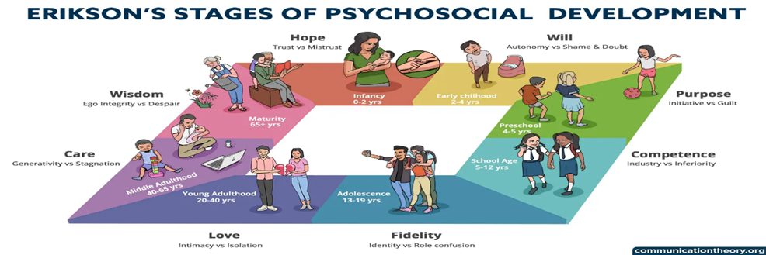
(Erikson, 1950)

2.2 Bowlby’s Attachment Theory
Bowlby’s attachment theory, developed in the UK, provides a profound framework for understanding the emotional needs of older adults. Originating from Bowlby’s research at the Tavistock Clinic, the theory posits that attachment behaviors—such as seeking comfort and security—persist throughout life (Bowlby, 1980). In later life, health decline, bereavement, and institutionalization can reactivate attachment needs, leading to increased dependence on caregivers (Iriss, 2021). For residents with dementia, this often manifests through distress, wandering, or agitation when separated from familiar people or environments (Ramsden, 2025).
UK research emphasizes that secure attachments between residents and care staff are essential for emotional stability and cooperation. Consistency of key workers, continuity of care, and emotionally attuned communication reduce behavioral and psychological symptoms of dementia (BPSD) and enhance residents’ feelings of safety (Nelis et al., 2021; Henderson, 2024). The Health and Social Care Act 2012 underlines the duty of professionals to provide compassionate, relationship-centred care—principles that mirror Bowlby’s emphasis on trust and responsive caregiving.
Attachment-informed approaches are increasingly integrated into UK dementia practice. For instance, attachment-based training programmes for care home staff, such as those piloted by Iriss (2021), have shown reductions in resident distress and improved staff–resident relationships. Therapeutic doll interventions, when used sensitively, also reflect attachment principles by fulfilling residents’ needs to nurture and connect, though ethical guidance from UK care standards stresses the importance of maintaining dignity and informed consent (Henderson, 2024).
Overall, Bowlby’s attachment theory reinforces that psychological health in older adulthood—particularly for those with dementia—depends on the presence of secure, empathic, and consistent caregiving relationships. In the UK context, embedding attachment-informed practice aligns with national goals for integrated, person-centred care under the NHS Long Term Plan (NHS England, 2019) and supports a more compassionate, relational model of dementia care.

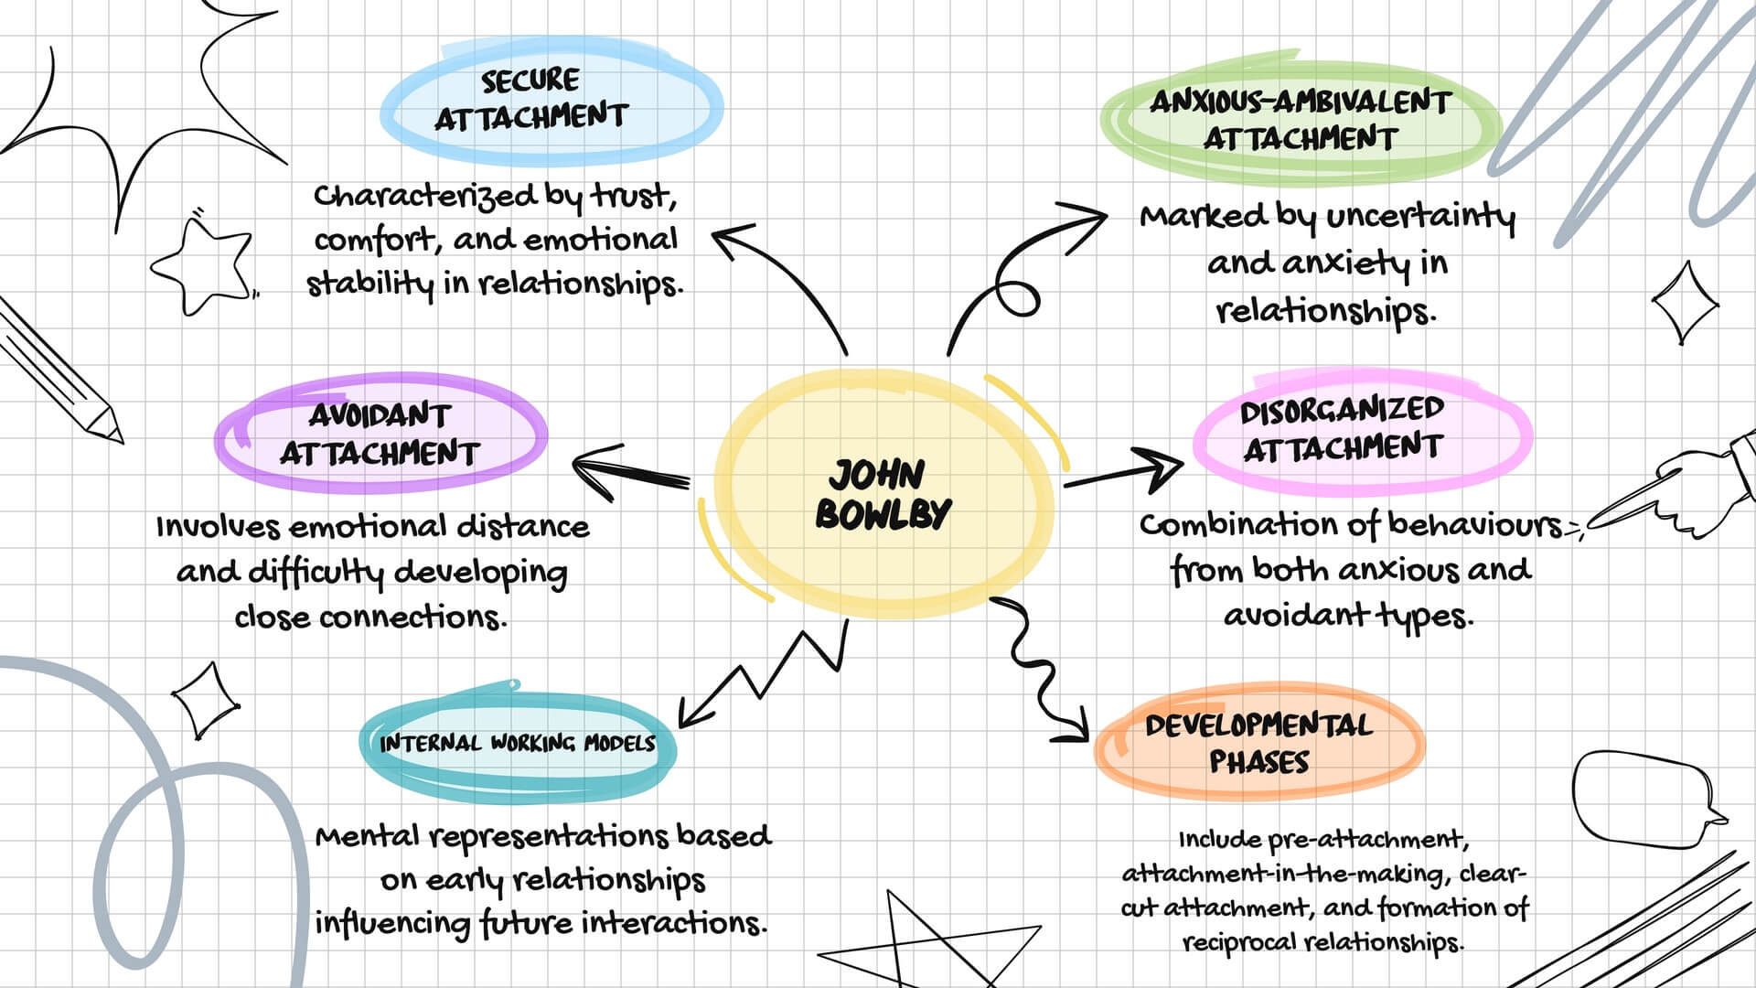
(Cherry, 2025)

3. Application in the Health and Social Care Context

3.1 Application of Erikson’s Psychosocial Theory
Within UK dementia care homes, Erikson’s psychosocial theory provides a framework for promoting emotional wellbeing and person-centred support among older adults. The stage of ego integrity versus despair is particularly relevant, as many residents struggle with loss of autonomy, role identity, and cognitive decline. According to NICE (2018), interventions that facilitate life review and reminiscence are effective for improving mood and reducing depressive symptoms in dementia care. Such interventions help residents reconstruct their sense of self, affirm life meaning, and integrate past and present experiences (Subramaniam & Woods, 2022; Jiang, 2024).
In practice, life story work, a widely adopted approach in UK care homes, uses personal photographs, music, and memorabilia to engage memory and foster continuity (Miyawaki, 2025). This method supports the development of ego integrity by helping residents recognize their enduring worth and achievements, even amidst memory loss. Staff who understand Erikson’s framework are better equipped to facilitate these reflective processes and to recognize signs of despair, such as hopelessness or emotional withdrawal (Knight & Poon, 2023).
Evidence from NHS England’s Dementia Well Pathway (2023) shows that incorporating meaning-based activities, such as guided reminiscence or storytelling, leads to improved self-esteem and quality of life. Moreover, training carers to use validation therapy, which acknowledges residents’ feelings rather than correcting memory errors, enhances emotional safety and aligns with Erikson’s focus on acceptance and integration (Mansfield et al., 2023).
Challenges and Strategies
However, challenges exist in applying this theory within care homes. Time constraints, staff shortages, and limited training can hinder effective implementation of psychosocial interventions (Brooker et al., 2021). Additionally, severe cognitive decline may limit residents’ ability to participate in structured life review sessions. To manage these barriers, research recommends integrating brief, informal reminiscence during routine care interactions and providing staff with targeted psychosocial training under the Care Certificate Standards (Skills for Care, 2023). Collaborative involvement of family members in life story creation also enhances authenticity and ensures continuity when residents struggle to recall details (Subramaniam & Woods, 2022). These strategies uphold Erikson’s principle of supporting integrity through relational and meaningful engagement.

3.2 Application of Bowlby’s Attachment Theory
Bowlby’s attachment theory offers vital insights into the emotional and behavioral expressions of older adults with dementia. In UK care homes, residents frequently experience separation distress, attachment-seeking behaviors, and anxiety—particularly when unfamiliar staff provide intimate care (Iriss, 2021; Ramsden, 2025). Understanding these behaviors through an attachment lens allows professionals to respond empathetically, viewing agitation or resistance not as “challenging behavior” but as expressions of unmet emotional need (Henderson, 2024).
Attachment-informed care emphasizes relationship continuity, emotional attunement, and trust-building. NHS England (2019) and the Health and Social Care Act 2012 both highlight relationship-centred practice as key to compassionate care. Implementing key worker systems, where residents have a consistent caregiver, helps foster secure attachments and reduces behavioral disturbances (Nelis et al., 2021). Additionally, attachment-based training improves staff awareness of nonverbal distress signals, supporting timely emotional reassurance (Pereira et al., 2023).
Recent UK evidence shows that attachment-informed interventions—such as therapeutic doll use, music therapy, and companion animal programmes—can soothe attachment distress and reduce anxiety when implemented ethically (Henderson, 2024). For example, holding a doll or soft toy can activate caregiving schemas, providing comfort through symbolic attachment when verbal communication is limited (Ramsden, 2025). This approach aligns with the NICE Dementia Guideline (NG97, 2018) emphasis on non-pharmacological interventions and person-centred practice.
Challenges and Strategies
Nonetheless, professionals face challenges in applying attachment-based care. High staff turnover, inconsistent shift patterns, and limited emotional supervision can undermine the formation of secure bonds (Brooker et al., 2021). Ethical concerns may also arise—for instance, in the use of doll therapy, which some critics argue could infantilize residents (Henderson, 2024). To address these challenges, managers should implement consistent staffing models, encourage reflective supervision, and ensure informed consent through family consultation or best-interest decisions under the Mental Capacity Act 2005 (Department of Health and Social Care, 2022).
By embedding attachment principles in daily routines—such as greeting residents warmly, maintaining eye contact, and validating emotional expressions—care professionals can create psychologically safe environments that reduce distress and foster emotional security. Bowlby’s theory thus provides the foundation for a relationship-centred model of dementia care, reinforcing the NHS ambition to deliver compassionate, emotionally intelligent practice (NHS England, 2023).
Table : Practical Use of Psychological Theories in Dementia Care Homes
Theory | Core Focus | Practical Application in Dementia Care | Resident Outcomes | Key References
Erikson’s Psychosocial Theory | Supporting identity and life satisfaction in late adulthood | • Reminiscence therapy and life-story work • Validation of emotions and past experiences • Encouraging autonomy and self-expression | • Reduced depression and despair • Improved self-esteem and sense of meaning | Miyawaki (2025); NICE (2023); Subramaniam & Woods (2022)
Bowlby’s Attachment Theory | Strengthening emotional security and reducing distress | • Consistent key-worker relationships • Family-inclusive care planning • Emotional reassurance during confusion or transition | • Lower anxiety and agitation • Greater trust and cooperation | Iriss (2021); McCormack et al. (2023); NHS England (2024)

Conclusion
Integrating psychological theory into dementia care transforms practice from task-based to person-centred. Erikson’s psychosocial theory helps residents preserve identity and meaning, while Bowlby’s attachment theory ensures emotional security through stable, trusting relationships. Together, they offer a holistic framework for supporting wellbeing, reducing agitation, and fostering dignity in later life. Despite challenges such as staff turnover and time pressures, reflective supervision and attachment-informed training can strengthen implementation. Embedding these theories within UK dementia care promotes compassionate, evidence-based support that values each individual’s life story and emotional needs.

REFERENCES
Alzheimer’s Society (2024) Dementia UK report: prevalence and projections. London: Alzheimer’s Society.
Cohen-Mansfield, J., Marx, M.S. and Thein, K. (2023) ‘Agitation and emotional needs in dementia care homes: person-centred implications’, International Psychogeriatrics, 35(6), pp. 567–579.
Iriss (2021) Dementia: attachment matters. Glasgow: Institute for Research and Innovation in Social Services.
McCormack, B., Dewing, J. and McCance, T. (2023) ‘Developing person-centred, relationship-focused dementia care: theoretical and practice perspectives’, Journal of Clinical Nursing, 32(1–2), pp. 112–124.
Miyawaki, C.E. (2025) ‘Life review intervention delivered by family caregivers for older adults with cognitive impairment’, Innovations in Aging, 9(1), pp. 44–58.
National Institute for Health and Care Excellence (NICE) (2023) Dementia: assessment, management and support for people living with dementia and their carers (NG97). London: NICE.
NHS England (2023) Dementia wellbeing pathway. London: NHS England.
NHS England (2024) Delivering compassionate, person-centred dementia care. London: NHS England.
Subramaniam, P. and Woods, B. (2022) ‘The impact of life story work on older adults with dementia: systematic review and narrative synthesis’, Aging & Mental Health, 26(4), pp. 672–683.
World Health Organization (2023) Global status report on the public health response to dementia. Geneva: World Health Organization.

