ACDB4011 LAB SESSION #4

RATE OF REACTION

AIM OF THE EXPERIMENT: Determine the effect of concentration, temperature and surface area on the rate of reaction

INTRODUCTION
The rate of reaction is a fundamental concept in chemistry and it measures how quickly reactants are transformed into products in a chemical reaction. It is typically expressed as the change in concentration of reactants or products per unit of time.
Understanding the factors that influence reaction rates is crucial for predicting and controlling chemical reactions. In this experiment, the rate of reaction between hydrochloric acid (HCl) and magnesium (Mg) in terms of the volume of produced hydrogen gas, will be investigated focusing on three key variables:
- HCl concentration,
- Temperature, and
- Surface area of Mg.
In each case, the rate of reaction will be equal to:
$rate= \frac{∆V_{H2}}{∆t}$ [cm³/s] Equation 1
In Part I the effect of HCl concentration on the speed of hydrogen gas (H₂) evolution will be investigated. By varying the concentration of HCl while keeping other factors constant, you will observe how changes in reactant concentration impact the rate at which hydrogen gas is produced.
Part II investigates the influence of temperature on the rate of reaction. Temperature affects reaction rates by altering the kinetic energy of molecules, which in turn influences the frequency and energy of collisions between reactant particles. By changing the temperature of the HCl, you will observe how it affects the speed of H₂ gas evolution.
In Part III, you will explore the effect of the surface area of magnesium on the rate of reaction. The surface area of a solid reactant impacts the rate of reaction by affecting the frequency of collisions between reactant particles. By varying the surface area of Mg while keeping other factors constant, you will observe how these changes influence the rate of H₂ gas evolution.
The rate of reaction can be determined from the plot V (H₂) vs t. To measure the initial rate of a reaction from a graph, you will find the slope of the gradient at the very beginning of the reaction (at t = 0) where the change in concentration with respect to time is the greatest.
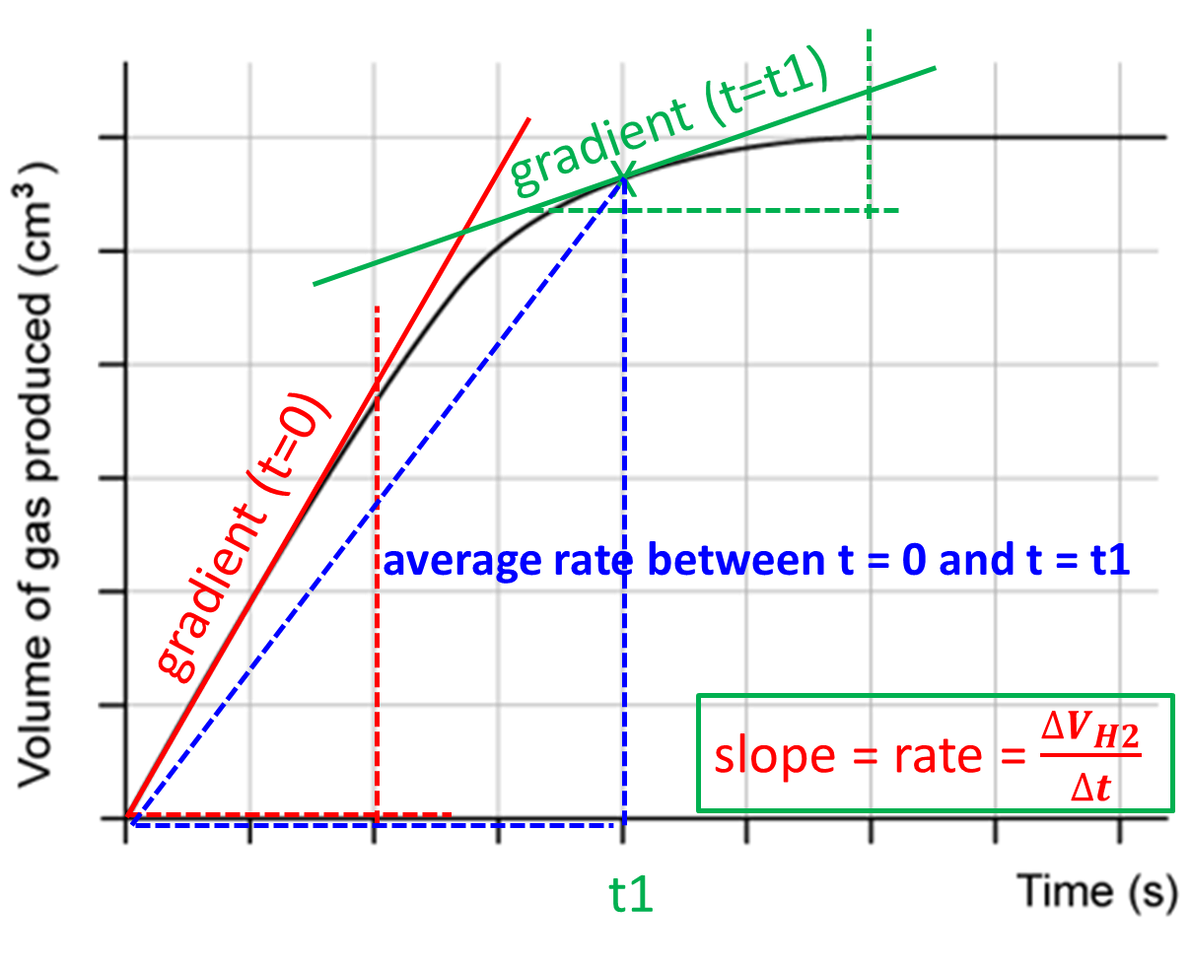
Figure 1: Plot of volume of gas vs time that can be used to calculate the rate of reaction at t = 0 s, t = t1 and the average rate between time t = 0 and t = t1..
You can also determine the rate of reaction at any time (called also instantaneous rate) by plotting the gradient at the selected time and calculating its slope.
The average rate of reaction is the slope of the line between time t = 0 and t = t1 and the corresponding volumes of liberated gas.

PROCEDURE
Put on the lab coat, safety goggles, and gloves. Make sure that long hair is tied.
IMPORTANT: Record all your observations, calculations, and conclusions in the data sheets at the end of this script.
Lab tools and supplies:
- Long test tube with arm
- Gas syringe*
- Rubber bung and delivery tube to fit the test tube
- Two large beakers for the water bath and reaction mixture
- Pipette and pipette filler
- Two clamp stands
- Test tube holder
- Thermometer
- Ring stand, Bunsen burner, clay triangle
- Stopwatch
- Graph paper
* syringe should not be allowed to become wet, or the plunger will stick inside the barrel
Chemicals:
- Magnesium ribbon cut into 4 cm length and weighed
- Magnesium turnings (same mass as ribbon)
- Hydrochloric acid (2.0 M and 1.0 M)
- DI water

Apparatus:
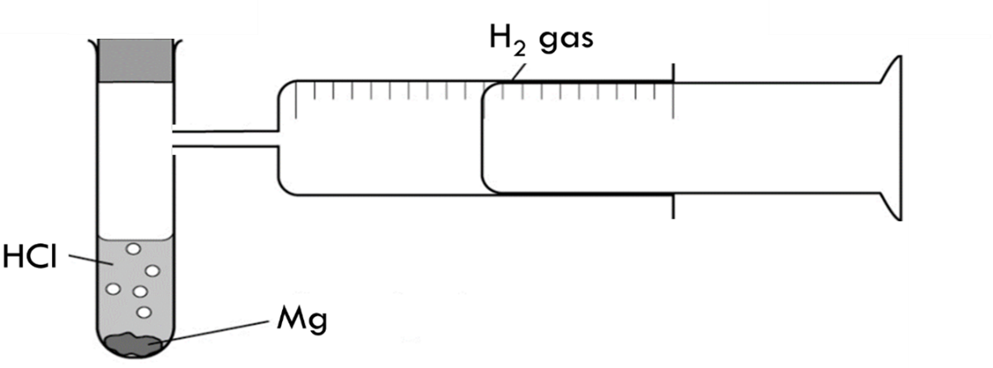

Procedure:
- Effect of HCl concentration on the speed of H₂ gas evolution
- Prepare FOUR 20.0 mL solutions of HCl with the following concentrations: 2.0 M (stock), 1.5 M, 1.0 M and 0.5 M. Use the pipette to measure appropriate volumes of the 2.0 M HCl solution and DI water.
- Pour the HCl solution with the lowest concentration into the test tube with arm.
- When ready, add a 4 cm strip of magnesium ribbon to the test tube, quickly put the bung back, and start the stopwatch.
- Record the volume of hydrogen gas given off at suitable intervals (e.g. 10 seconds). Continue timing until no more gas is given off.
- After the reaction is completed, discard the reaction mixture in the waste beaker.
- Measure the temperature of 1.0 M HCl.
- Repeat the same experiment for three other concentrations of HCl.
Plot the graph (V_{H2} vs t) showing the change in volume of H₂ gas over time for each concentration of HCl.
For each concentration of HCl determine the:
- Average rate of reaction (between t = 0s and t = t1; use the same t1 for all concentrations)
- Instantaneous rate of reaction at t = 0.
- Effect of temperature on the speed of H₂ gas evolution
- Set up a water bath. Pour water into the large beaker and heat it over the Bunsen burner till the temperature of water increases by approximately 10 degC when compared to the initial temperature of 1 M HCl measured in the previous part.
- Pipette 20 mL of 1.0 M stock solution into three test tubes.
- Place the first test tube with 1.0 M HCl in the water bath and wait until the temperature of the acid reaches the temperature of the water in the water bath.
- Quickly transfer the warm HCl into the tube with the arm, put 4 cm piece of magnesium ribbon, put the bung back, and start the stopwatch.
- Continue timing until no more gas is given off.
- After the reaction is completed, discard the reaction mixture in the waste beaker.
- Repeat the same experiment for two more temperatures (ideally 10 degC apart).
On the separate graph paper provided, plot the graph (V_{H2} vs t)) showing the change in volume of H₂ gas over time for each temperature.
For each concentration of HCl determine the:
- 1 Average rate of reaction (between t = 0s and t = t1; use the same t1 for all concentrations.
- Instantaneous rate of reaction at t = 0.

- Effect of the surface area of Mg on speed of H₂ gas evolution
- Use the pipette to transfer 20 mL of 1 M HCl at room temperature into the test tube with arm.
- Quickly add the Mg turnings into the test tube, put the bung back, and start the stopwatch.
- Continue timing until no more gas is given off.
- After the reaction is completed, discard the reaction mixture in the waste beaker.

Plot the graph (V_{H2} vs t)) showing the change in volume of H₂ gas over time for each temperature. Determine the:
- 1. Average rate of reaction (between t = 0s and t = t1; use the same t1 for all concentrations.
- Instantaneous rate of reaction at t = 0.
DATA SHEET to RECORD OBSERVATIONS, CALCULATIONS and RESULTS
STUDENT’S NAME: ____________________________________________________
PARTNERS’ NAMES: ____________________________________________________

REPORT IS DUE MAY 23 2024 submitted via Moodle

Write the balanced chemical equation for the reaction between magnesium and hydrochloric acid:

………………………………………………………………………………………………………………………………

Moles of reactants:
Mg |  | 2 M HCL
mass | moles | volume | moles

I. Effect of concentration of HCl on speed of H₂ gas evolution:
0.5 M HCL |  |  | 1.0 M HCl |  |  | 1.5 M HCl |  |  | 2.0 M HCl
 |  |  | T 1 = …...................
time, s | V H2, mL |  | time, s | V H2, mL |  | time, s | V H2, mL |  | time, s | V H2, mL

[HCl] | time to dissolve Mg | average rate | instantaneous rate at
[HCl] | time to dissolve Mg | average rate | t = ….......
0.5 M
1.0 M
1.5 M
2.0 M

II. Effect of temperature on speed of H₂ gas evolution
T 2 = …................... |  |  | T 3 = …................... |  |  | T 4 = …...................
time, s | V H2, mL |  | time, s | V H2, mL |  | time, s | V H2, mL

temperature | time to dissolve Mg | average rate | instantaneous rate at
temperature | time to dissolve Mg | average rate | t = ….......
T 1
T 2
T 3
T 4

III . Effect of the surface area of Mg on speed of H₂ gas evolution
T 1 = …...................
time, s | V H2, mL

Mg turnings |  | rate
mass | moles | average | instantaneous at t =

SHOW ALL YOUR CALCULATIONS and REMEMBER THE UNITS !!!

Guidance for lab report:
- Title page, TOC, etc
- Purpose (Aim) of the experiment
- Hypothesis: based on the experience and knowledge, what do you expect to observe? Why?
- Variables: independent, dependent, controlled
- Theory (background information)
  - Basic concepts, principles and laws, definitions
  - Chemical equation and formulas for calculations (if relevant)
  - Examples of applications/importance of the kinetics in OME supported by literature
- Observations/Data (as of the Data Sheet provided)
- Calculations (where relevant)
- Results and Discussion: How do the observations compare to your hypothesis — do they match? What are primary sources of experimental errors?
- Conclusion
- References (IEEE)
- Appendix
  - Chemicals and equipment
  - Procedure

