  Component One: Student Journal (learning log) 750 words +/- 10%  Contribution to Overall Module Assessment: 25% | Student  Name:  Student No: | Loredana-Marina  Pal  2222512
 | Module Title: | Hotel Placement Operating Hotel Facilities
 | Module Code: | BMIH4006
 | Lecturer: | Giulia Chifari
My placement involved a wide array of tasks essential to the upkeep and smooth running of the hotel's guest service experience. Responsibilities ranged from the daily cleaning and preparation of guest rooms to the meticulous maintenance of public areas. A significant emphasis was placed on adhering to rigorous standards of cleanliness, organization, and presentation to ensure guest satisfaction (Stuart, 2022). The role demanded a keen eye for detail—every aspect, from the crispness of the bed linens to the placement of toiletries, was carefully crafted to enhance the guest experience. (Langvinienė & Daunoravičiūtė, 2015).

Feelings
Initially, the pace and expectations of the department were overwhelming. The physical demands and the constant pressure to meet deadlines while maintaining high standards were challenging (Jin-Zhao & Jing, 2009). However, as I adapted, I found a deep sense of satisfaction in seeing the immediate results of my work—transforming rooms into welcoming havens for guests. Collaborating with the team brought a sense of camaraderie and belonging, mitigating the stress of the fast-paced environment (Karatepe, 2013).

Evaluation
Reflecting on my performance, I acknowledge my strengths in attention to detail and adherence to the established standards of cleanliness and presentation (Stuart, 2022). My ability to learn quickly and adapt to the department's routines was crucial in meeting the daily objectives (Jin-Zhao & Jing, 2009). However, time management and the efficient prioritization of tasks under pressure emerged as areas needing improvement. Balancing speed with thoroughness without compromising quality was a consistent challenge (Karatepe, 2013).

Analysis
The experience underscored the critical role of housekeeping in guest satisfaction and the overall success of the hotel. The meticulous attention to detail in room preparation directly influences guests' perceptions and their overall experience. Effective communication and teamwork were pivotal in ensuring operational efficiency, particularly in addressing unexpected challenges or guest requests promptly. This placement experience highlighted the importance of every operational task in maintaining the hotel's reputation and operational success.

Conclusion
This placement has been instrumental in my personal and professional development. It has enhanced my appreciation for the intricacies of the hospitality industry and the pivotal role of housekeeping in shaping guest experiences (Solnet et al., 2022). The challenges faced have taught me the value of teamwork, resilience, and the constant pursuit of excellence.

Detailed Action Plan for Future Improvement in the Housekeeping Department
To ensure continuous growth and success in my hospitality career, specifically within the housekeeping department, I have devised a comprehensive action plan that focuses on enhancing my skills, knowledge, and overall capability to contribute more effectively to my team and the organization. This plan is structured around key areas identified during my reflective practice, including time management, leadership development, physical stamina, feedback mechanisms, and professional education.

Enhance Time Management Skills
Objective: Improve efficiency in completing tasks within tight deadlines without compromising quality (Stuart, 2022).
Actions:
Attend time management workshops, focusing on prioritization, scheduling, and delegation.
Implement daily and weekly planning sessions, using tools like digital calendars and task management apps to organize and allocate time for specific tasks(Jin-Zhao & Jing, 2009).
Practice the "Pomodoro Technique" during work hours to increase focus and productivity (Andel et al., 2021).

Develop Leadership Abilities
Objective: Prepare for future supervisory roles within the department by building leadership skills.
Actions: Enrol in a leadership development program or course, with a focus on management skills in the hospitality context.
Volunteer for leading small teams or projects in the workplace to gain practical leadership experience.
Seek mentorship from a current manager or supervisor in the housekeeping department to gain insights and guidance on effective leadership.

Improve Physical Stamina
Objective: Enhance physical endurance to better handle the demanding nature of housekeeping tasks.

Actions: Begin a regular exercise regimen, including cardiovascular and strength training exercises, 3-4 times a week starting immediately.
Consult with a fitness professional to develop a tailored exercise plan that focuses on areas most utilized in housekeeping work.
Incorporate stretching and proper lifting techniques into daily routines to prevent injuries.

Seek Feedback
Objective: Utilize constructive feedback to identify strengths and areas for improvement continuously.
Actions: Establish a formal feedback session with supervisors and peers every quarter, starting Q2 2024, to review performance and set development goals.
Implement a "feedback journal" to document insights received and progress made towards addressing feedback.
Actively ask for on-the-spot feedback during tasks to make immediate adjustments and improvements.

Stay Informed
Objective: Keep updated with the latest trends, technologies, and best practices in housekeeping and hospitality management.
Actions: Subscribe to and regularly review industry publications and online forums.
Attend at least two industry conferences or webinars annually, starting in 2024, focusing on innovations in housekeeping and guest experience.
Participate in online courses related to hospitality management and housekeeping operations offered by reputable hospitality schools or organizations.

(Words 781)

Component Two:Health and Safety Guide
Contribution to Overall Module Assessment: 25%
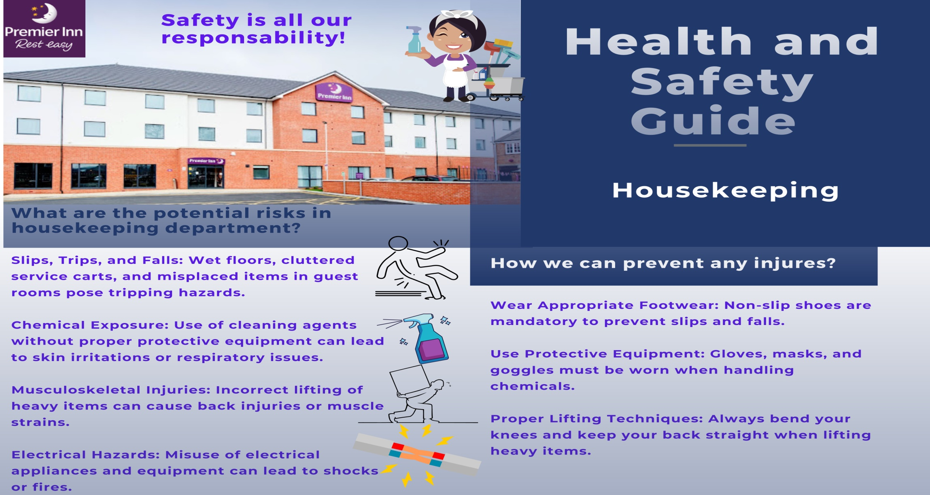
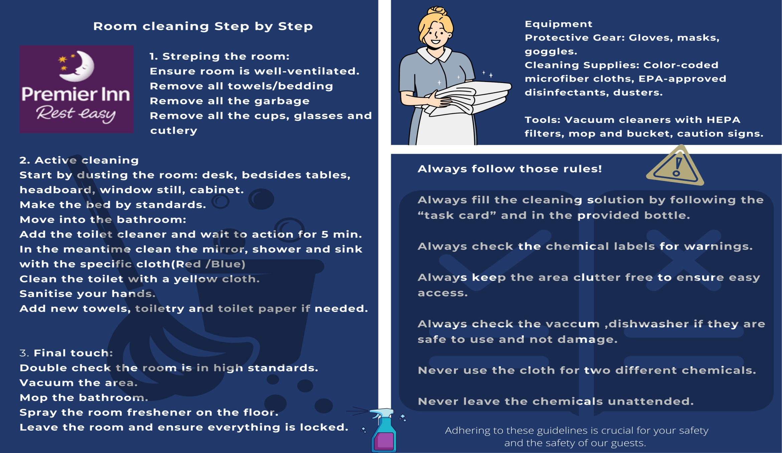

Reference List

Component one:
Andel, S. A., Pizam, A., & Thyne, M. (2021). Pomodoro technique interventions in hospitality education: A systematic literature review. Journal of Hospitality, Leisure, Sport & Tourism Education, 29, 100330.
Brownell, J. (2019). Hospitality management: front office operations. Cengage Learning.
Jin-Zhao, W., & Jing, J. (2009). Issues, challenges, and trends, that facing hospitality industry. Management Science and Engineering, 3(4), 53-58.
Karatepe, O. M. (2013). High-performance work practices, work social support and their effects on job embeddedness and turnover intentions. International Journal of Contemporary Hospitality Management, 25(6), 903-921.
Langvinienė, N., & Daunoravičiūtė, I. (2015). Factors influencing the effectiveness of housekeeping service as an element of accommodation service in spa hotels. Social Transformations in Contemporary Society, 3(1), 84-97.
Pizam, A. (2016). Planning a hotel human resources department. International Journal of Hospitality Management, 60, 104-115.
Solnet, D., Subramony, M., Ford, R. C., Golubovskaya, M., Kang, H. J., & Hancer, M. (2022). Leveraging employee engagement for competitive advantage in the hospitality industry. Journal of Hospitality and Tourism Management, 52, 275-286.
Stuart, E. A. (2022). Examining housekeeping operations and management (HOM) and the guest experience in hotels. International Journal of Hospitality Management, 102, 103218.
Component two
Retrieved 02 2024, from Premier Inn: https://www.premierinn.com/gb/en/hotels/england/leicestershire/melton-mowbray/melton-mowbray.html
Retrieved 02 2024, from Libbusp: https://libbusp.blogspot.com/2016/11/our-guests-personal-belongings.html
Retrieved 02 2024, from GOV: https://www.hse.gov.uk/coshh/
Retrieved 02 2024, from Whitbread: https://academy.whitbread.co.uk/
Retrieved 02 2024, from Carnegie Mellon University: https://www.cmu.edu/ehs/Workplace-Construction/housekeeping.html
(2019, 05 9). Retrieved 02 2024, from Ecoonline: https://www.ecoonline.com/blog/11-tips-for-effective-workplace-housekeeping
(2020, 06 29). Retrieved 02 2024, from Walker: https://walkersafety.co.uk/
(2022, 12 14). Retrieved 02 2024, from Safetytalker: https://safetytalker.com/safety-talks/poor-housekeeping-hazards/
Melanie. (2022, 12 9). Retrieved 02 2024, from Amenitiz: https://amenitiz.com/en/blog/health-and-safety-protocols-in-the-hospitality-industry/
Jagmohan, N. (2008). Housekeeping (Theory and Practice).
Joan Branson, M. L. (1988). Hotel, Hostel & Hospital Housekeeping .

