Classic and Modern Management Theory applied to a Test Range Environment | January 28  2017
A glimpse into classic and modern management strategies of motivation and organization, followed by personal interpretation of theory applied to a Test Range Environment.

Table of Contents
1. Introduction 2
1.1. Aims and Objectives 2
2. Overview of Management Theory and Evolution of Business 2
2.1. Classical Pre-1960 2
2.2. Modern Post-1960 4
3. Workplace Utilisation 6
3.1. Corporate Application and Image 6
3.2. Local Application, Culture and Challenges 8
4. Works Cited 9
5. Bibliography 9
APPENDIX A. 11

Introduction

Aims and Objectives

The report will critically evaluate a selection of classical and modern theories of management and motivation, by briefly exploring the evolution of business, discussing and evaluating the development of some fundamental ideas that shaped the culture of large organisations.
The report will then consider these theories in the context of a QinetiQ Test Range environment, critiquing the implementation of corporate policy at a local level, identifying the perceived reality of the workplaces utility of classical and modern management theory.

Overview of Management Theory and Evolution of Business

Classical Pre-1960

The classical view of management theory relies primarily on a hierarchical tiered approach to business in both form and function. Division and oversight are the most distinctive features of a company or sub-division run in this manner. It is a top driven approach designed to improve productivity, with all employees irrespective of level working to individual procedures, universally designed with task efficiency as the main focus. Interpersonal relationships are seen as a weakness, the employee is a tool to be used as required and then discarded if the business deems them to be obsolete. Established boundaries are absolute with recruitment of personnel being limited to skills acquisition.
Fredrick Taylor is a founding figure within the realm of classical management theory, born March 20th 1856, Taylor is an American engineer who is widely regarded for his work striving to improve industrial efficiency. While considered an intellectual, Taylors origins were in fact more humble. After dropping out of higher education at Harvard due to declining eyesight, he began work as an apprentice machinist. Taylor’s skill and aptitude advanced his career quickly he is credited with the development of a number engineering tools, before moving on to management theory and manufacturing process.
Scientific management otherwise known as ‘Taylorism’ is a theory of management primarily developed between 1880-1890. It is considered as one of the earliest management strategies that investigated production and attempted to provide quantifiable evidence to improve performance.
Taylor’s approach to scientific management is defined by 4 main principles:
1. Replace guesswork methods with a scientific study of the tasks.
2. Select, train, and develop each worker rather than leaving them to train themselves.
3. Ensure that the scientifically developed methods are being followed.
4. Make sure the managers apply scientific management principles to planning of the work and the workers actually perform the tasks. (1)
His systematic approach to work, linked pay to performance with staff becoming static rather than dynamic components of the production line. Major businesses leaders including Henry Ford adopted the principles ‘Taylorism’ for the benefits it showed, production rates increased whilst simultaneously associated waste costs fell.
Clear boundaries between worker, supervisor and manager are established using these principles. To quote Taylor himself in his book ‘Principles of Scientific Management’:
‘It is only through enforced standardization of methods, enforced adoption of the best implements and working conditions, and enforced cooperation that this faster work can be assured. And the duty of enforcing the adoption of standards and enforcing this cooperation rests with management alone’ (2)
Conceptually this limited the workforce at each level where ever possible through implementation of rigid process and mechanization of people.
Another icon in early management theory is Frank Gilbreth born July 7th 1868; he again was an American engineer. Like Taylor, Gilbreth had humble beginnings starting his career for the Widden Construction Company as a labourer. Gilbreth noted in his early years within the construction business there was a huge variety in the workforce’s approach to menial tasks, struck by the inefficiencies his search for the ‘one best way’ began.
After the outbreak of World War 1 in July 1914 and his drafting into the US Army, Gilbreth found himself assigned with developing a process to more quickly assemble and breakdown small arms weapon systems. He did this by reducing the number of physical motions required by a soldier to the absolute minimum, there by streamlining and speeding up the work.
Where Taylor and Gilbreth’s work differ is that Taylor was far more concerned with the time taken to complete a task, irrespective of how many steps were involved. Gilbreths study of motion when combined with Taylor’s management style augments the classical management approach to business.
Gilbreths work in itself was one the first meaningful pieces work looking at process design, his work has become the fundamental underpinnings of many modern process driven businesses throughout the world.
Instigators of classical management theory attempt to motivate employees primarily via monetary reward. The work is merely a means to an end with the incentive of pay being the primary method of control. Abraham Maslow attempted to evaluate and challenge this approach in the mid 1940’s, with his hierarchy of needs,
Maslow’s psychological approach prioritised fulfilment using hierarchy beginning with physiological requirements and culminating in self-actualisation.

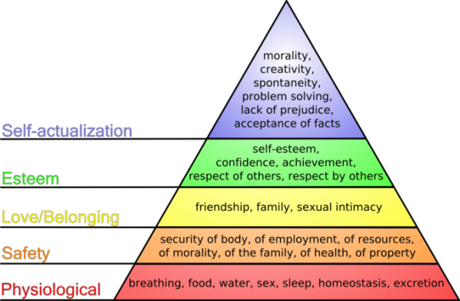

(3)
In the eyes of Maslow each step brought a person closer to achieving their full potential, with the internal drive of the individual determining what level they achieve. Each level is mutually dependent on the foundation below it. The belief was that self-actualisation was impossible to achieve without satisfying the categories of the previous steps.
Maslow’s tool while not necessary correct challenged Taylors thinking on motivational theory introducing new complexities for managers to consider.
Strength can be found in the classical approach to management through transparency and organisation even in a modern business. It is a robust approach that corporately protects the business from litigation, through defined process that is compliant with the legal obligations imposed by regulatory bodies. A skill based environment where employee personal relationships are kept at a minimum level, reduces the need for punitive action due to unproductive behaviour by attenuating the complexity of human relationships. In essence the man or woman becomes a machine, where empirical data is absolute. The next industrial revolution will optimise the classical management approach as the ‘human’ element will be removed as far as reasonably practicable from the equation that is business.
Classical management theory isn’t however without its weaknesses, the rigid structure in which it relies limits growth by stifling innovation and creativity. Failure to recognise people as individuals compromises the productivity of the team as a whole. High staff turnover and the resultant damage to reputation can do significant harm when winning business. Without imagination and development growth is impossible, internal development can be a source of growth that doesn’t comply with the principles found in a classical management structure.

Modern Post-1960

In the early 1960’s there was a fundamental shift within the realm of management theory, behavioural management otherwise known as human relations has risen and is very much at the fore front of business acumen. Industry has begun to transition away from a labour based population seen by business as a 2 dimensional tool, to a knowledge based society.
Attempting to address the weaknesses of previous management styles, two way communications between employee and employer became a keystone of modern business. Redirecting focus to the individual and away from a process, procedure and rules demonstrates a cultural change in the assessment of the value of the employee. Through consultation between managers and staff decisions can be more effectively evaluated and implemented (Quantitative Theory).
The change in management theory also demonstrates a new understanding of motivation at work; no longer are monetary incentives seen as the singular factor for attracting skilled labour. Emotional fulfilment and manipulation are now recognised variables in worker productivity, with personal investment in the company becoming the foundations of a strong team. Work conducted by Katharine Briggs and Clarence Myers beginning in 1943 started to explore team dynamics through personality assessment. Dr Raymond Meredith Belbin and Henry Minzberg also pioneers in management theory, continued to expand on Myers-Briggs premise establishing predetermined roles that predominantly are better suited to employees of a certain temperament. Recognising the value of an employee not just for their skills or intelligence but also the dynamics and intangible strengths that can be brought to a group, demonstrating a cohesive team can be more effective and productive than group of individuals that on paper are more qualified(Team Building Theory). Minzberg primarily focused on the development of the leaders while Belbin principally investigated team dynamics.
Belbin’s work in the mid 1980’s researching team roles involved the development of a behavioural assessment studying a subjects personal compatibility against 9 team roles, unlike the Myers-Briggs personality test before it people may exhibit strong connections to a multitude of roles. Belbin’s 9 team roles can be found in Appendix A.

Henry Minzberg identified in the mid 1990’s that the work of the manager could be broken down into 10 primary roles that could be used to categorise his or her functions within the business place.
Minzberg then split these roles between 3 subcategories; interpersonal, informational and decisional.
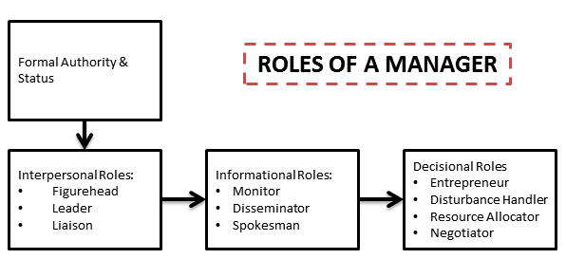 (4)
Using this simple method, managers are better able to identify with their own role at work and identify techniques to develop prevalent skills. In order to develop these skills this model requires the manager to correctly assess their primary function within the business which may be challenging in certain environments.

Behavioural management without classical business elements brought to its zenith isn’t without its flaws, chaotic in nature with no clear leadership; a lack of direction can be extremely detrimental to growth. The overwhelming complexity of human relationships brings the business to an emotive precipice where reliable data can be simply ignored. Poor performance is tolerated as fragmented leadership lacks the inclination to correct the errors.
Successful modern businesses tend to incorporate elements of classical and modern management theory in an attempt to balance the strengths and weaknesses of both. A systematic approach to business construction often defines the structure of a current large organisation. Modular in nature the independent departments or subsystems are interconnected and interdependent of one another. The organisation remains adaptive by continuously engaging the market place, feeding data to management who adjust each subsystem accordingly.

Workplace Utilisation

Corporate Application and Image

QinetiQ’s corporate image and application of management theory as one would expect incorporates the latest elements of systems engineering and motivational theory. Primarily the business appears to take a collaborative matrix approach to its internal structure; under a new internal initiative currently a large scale reorganisation is underway known as ‘Transform’
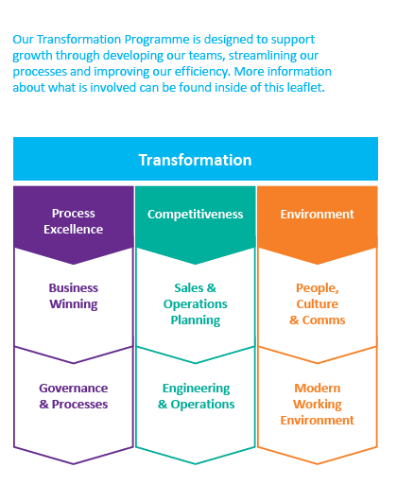

(5)

All subdivisions have been reorganised to fall within one of the six main groups shown above, the purpose being to:
- Improve collaboration through working with and learning from colleagues who have similar skillsets, who can share expertise, best practice and lessons learned.
- Better use of skills, experience and expertise by having the potential to work across the company.
- More personal and career development opportunities and a consistent approach to training and availability of opportunities.
- Consistent governance and process with fit-for-purpose tools and systems so it’s easier to for fill roles.
- A more agile and dynamic resourcing of people to projects and tasks which reduces uneven productivity and in turn increases efficiency.
Between each of the main organisations integrated data capture teams (ICT’s) and integrated deliver teams (IDT’s) are being formed to act as project nexus point between each area of governance.
Previously technicians, scientists and engineers were split between independent divisions Air, Land, Maritime, Cyber etc. This pigeon holed employee’s expertise to a specific group. While this may not have been optimum for company performance it better complies with Minzberg’s theories on management roles as teams were local and better able to socially interact. Under the new structure all operational staff are now pooled and interchangeable as parts of the ICT’s and IDT’s.
Theoretically this practice has a number of advantages however the author can see risks associated with this matrix management approach.
Customer-Long term relationships established with customers potentially could be put at risk if their access point to the business changes, this is a human factors consideration that will need to be carefully managed to prevent negative repercussions.
Staff-Employees also appear to be being redirected towards multiskilling and away from a specialist skill sets, talent within individual fields must be maintained to prevent a loss of future capability.
Chain of Command- A more fluid organisational structure runs the risk of blurring a clear chain of command with line managers and personnel separated potentially by hundreds of miles. While this is a more modern business practice it has a significant risk in the author’s opinion of becoming chaotic due to multiple reporting streams each with different priorities.
Perception-This streamlining operation could be perceived primarily as a cost saving exercise directing additional scrutiny on staffing levels; sales and delivery teams that are willing to travel may directly compete with local employee’s on projects putting jobs at risk. It is also unclear whether sufficient research has been conducted into how customers will be directly affected. Undoubtedly individual project costs will rise due to additional travel and expenses requirements. It is unclear whether a reduction in staffing levels will offset the additional cost in the long term, or how these potential savings and costs will be split between company and customer. The author is unable to access information that may mitigate these risks due to commercial sensitivity and therefore are entirely his own thoughts on the subject.
The complexities of an organisation the size of QinetiQ are tremendous, clear communication and resource allocation between the business at all levels remains challenging. Leadership and direction from the most invested and senior have to be communicated through the permafrost of middle management, to a workforce that for the majority either fails to comprehend the big picture, or isn’t interested. This issue is faced business both corporately and locally. QinetiQ attempts to mitigate this issue by distributing regular emails from senior directors to all staff and holding regular ‘Q- talk’ sessions in which current business strategy and related affairs are outlined.

Local Application, Culture and Challenges

MOD Shoeburyness and the majority of local personnel primarily fall within the ‘Engineering and Operations’ division of the new corporate structure. While the company wide directive is to switch to a matrix based system, local structuring appears more simplistic for day to day activities. All major heads of department report directly to the capability manager with each department lead managing a local team beneath them. Smaller IDT teams do conduct activities on range but usually under the supervision and support of local staff that are familiar with range process and procedure. It is yet to be seen whether local stakeholders will allow complete autonomy to these teams in the future. The current Shoeburyness hierarchy is shown below; corporate interests prevent the author expanding further than the departmental level:
Capability Leader

Operations

Recycling and Scrap
Munitions Disposal
L
Engineering

Transport and Logistics
Range Support
Dynamics
Statics

Due to the nature of the activities that take place on range the managerial approach to staff on site remains significantly screwed towards the classical approach to management theory. Process is king with management allowing little to no flexibility for innovation and development, because of the unique activities conducted on range. Documentation and risk assessment are the pillars of all activity on site, which is slowly expanding to even the most trivial tasks (author’s opinion). An organisation the size of QinetiQ has a legal requirement in this regard. While health and safety are fronted as the primary reason for this, it becomes clear when delving into internal politics and culture that litigation issues in regard to accredited training, responsibility and accountability dominate.
For most personnel the primary motivator is that of a steady if low income, many older staff are long serving and comfortable in their role however retention of younger, self-motivated and highly skilled individuals appears to be in decline especially if ‘home grown’. Eskmeals over the past 5 years has a 0% retention of apprentices on completion of their studies. Applying Maslow’s theory of motivation to this situation it becomes quiet clear that staff are failing to achieve the 2nd tier of his hierarchy. Across the business this is compensated for by the graduate scheme and succession planning, the latter being less successful.
Corporate initiatives have attempted to introduce a ‘no blame culture’ for incidents, mistakes are to be evaluated and learned from. This is still far from the cultural norm. Internal divisions and ‘point scoring’ between local management remain common place. It is the author’s opinion that without sweeping and fundamental changes range wide the current hostile culture will remain intact for the foreseeable future. Transform is attempting to address these issues but as a relatively new initiative only time will tell whether it is successful.
The most significant challenge affecting all aspects of the Shoeburyness range is a lack of market growth, the entire industry remains in recession with an ever dwindling defence budget. While the unique capabilities of the site; geographical, infrastructure and byelaws remain, it is unlikely that range will be closed, but without concerted effort to either expand local capabilities or diverge into other business areas. At best steady output, or at worst stagnation appears to be the immediate future.

References
1. Artman, Phil. Linkedin. [Online] 10 August 2014. [Cited: 7 February 2017.] https://www.linkedin.com/pulse/20140810222706-5472229-the-4-principles-of-scientific-management-or-modern-times.
2. Taylor, Fredrick Winslow. Principles of Scientific Management. 1911.
3. Boundless. Boundless.com. [Online] https://www.boundless.com/management/textbooks/boundless-management-textbook/organizational-behavior-5/employee-needs-and-motivation-46/maslow-s-hierarchy-of-needs-171-7621/.

4. IEdunote. [Online] https://iedunote.com/mintzbergs-10-managerial-roles.
5. QinetiQ Transform Team. Transform Direction. s.l. : QinetiQ internal communications, 2017.

Bibliography
1. Artman, Phil. Linkedin. [Online] 10 August 2014. [Cited: 7 February 2017.] https://www.linkedin.com/pulse/20140810222706-5472229-the-4-principles-of-scientific-management-or-modern-times.
2. Taylor, Fredrick Winslow. Principles of Scientific Management. 1911.
3. Boundless. Boundless.com. [Online] https://www.boundless.com/management/textbooks/boundless-management-textbook/organizational-behavior-5/employee-needs-and-motivation-46/maslow-s-hierarchy-of-needs-171-7621/.
4. IEdunote. [Online] https://iedunote.com/mintzbergs-10-managerial-roles.
5. QinetiQ Transform Team. Transform Direction. s.l. : QinetiQ internal communications, 2017.
6. David S. Walonick, Ph.D. statpac. [Online] 1993. [Cited: 01 February 2017.] http://statpac.org/walonick/organizational-theory.htm.
7. Rolag, Keith. faculty.babson.edu. [Online] http://faculty.babson.edu/krollag/org_site/encyclop/human_relations.html.
8. Atken, Hugh. Scientific Management in Action: Taylorism at Watertown Arsenal. 1985. ISBN 978-0-691-04241-1..
9. Nelson, Daniel. A Mental Revolution- Scientific Management since Taylor. 1992. ISBN 978-0-8142-0567-9..
10. Mind Tools Editorial Team. Mind Tools. Management Roles. [Online] [Cited: 12 February 2017.] https://www.mindtools.com/pages/article/management-roles.htm.

Appendices

APPENDIX A.



