
BA International Hotel Management

Business model canvas Essay

Module BMIH5001Entrepreneurship Module
Student name: Alexandra Craescu
Student ID:2111926
Lecturer:Charlotte Joyner

Table of Contents
Introduction 3
Providing a structured framework of Business Model Canvas 4
Business Model canvass for restaurant business 5
Gibbs reflective cycle 8
Conclusion 11
References 12

Introduction
Business Model Canvass is a strategic tool that visualisation all of the important components of the business function. It consists of 9 elements which integrate all of the important factors including the business elements' key activities. For starting a new business the business model Canvas is a very significant tool to demonstrate the business organization (Baker and Welter, 2020).It is very helpful for an entrepreneur to integrate all of the components and their organisations in an effective and efficient and helpful to how they work and integrated all of the elements. the business model Canvas identifies the strengths of the weaknesses of an organisation which is the strength point and makes you that it identifies the problem (Porfírio et al., 2020). For all of these the Business Model Canvass is a very significant tool for the entrepreneurs we start a new business

Providing a structured framework of Business Model Canvas
Business Model Canvass is a structured Framework that identifies the main structure of the business. it identifies the business organisation's key elements and the main resources to operate and successfully maintain their business organization (Daou et al., 2020). It is helpful for all of the entrepreneurs to operate the business. can I help entrepreneurs find their gaps and they can increase their efficiency (Burns, 2022).
Identifying the potential strengths and weaknesses
business model Canvas entrepreneur business strengths and weakness. It will help the business organisations in the people who operate their business function find out the gap where they can increase their efficiency and increase their strength. it can also help them to identify their weakness and hide what they can improve to take a competitive advantage over the other business holders in the existing market. in this consequence, the business model Canvas is a very significant tool to identify the strengths and weaknesses (Dobrowolski et al., 2021).
Increasing collaboration and communication
business model Canvas increase the collaboration and communication among the Easter folder of the business organisation. it helps them to visually represent there all of the factors toward their stakeholders. the members of the business organisations will discuss the major factors and all of the possible consequences to communicate all of the factors to their members. In these consequence circumstances the business model process ensures all of the factors is there communicated among business organizations (Micieta et al., 2020).

Business Model canvass for restaurant business
Business model Canvas is a strategic tool to visualise all of the important factors of the organisation. it finds all of the important elements of the business organisations and includes the key components the main ideas and the resources all of these things that are visually represented in the model. this consequences in this consequences the operation of the new business in the restaurant business which is very significant to demonstrate all of the important elements under this business model (Hamwi et al., 2021).
Key partners
by analysing the Business Model Canvass the organisations can able to find out the key partners in the business organisation. the partners may include providing the kitchen materials and supply of the raw materials infrastructure developments and providing financial support organisation. so this model helps the business organisation like a restaurant business which will be helpful to understand the key partners in the relationship among the business organisation to operate in the support from them (Walke, 2021).
Key Activities
the key activity of the restaurant business is delivering the ghost to the customers at the right time in the right manner which is flexibility to provide the goods to the customers at hand. it includes the fruit planning system delivering the goods maintaining the service system to their organisations and identifying the activities to operate the restaurant business properly. It will help them to attend the fight the staff having the stuff and providing the training to serve the goods to them. So business model canvas is a significant tool for identifying the main activities of the organization (Chin et al., 2021).
Key resources
key resources means identifying the main ones that help to operate the restaurant business. it includes the staff money and the word forced labour (Nelson, 2013). In this consequence, the main resource that organisations must identify to operate the business organisation in an effective manner way the business organisations need to provide the itching in the right manner and find the goods and the services to provide the customers in the proper way (García-Muiña et al., 2021).
Value proposition
Mere proposition means providing the evening value to the customers like the environmental quality of the goods in the services and delivery at the right time. the organisation need to increase their value proposition toward the customers. As a result, they will take a competitive advantage over the market. the restaurant business must provide vibrant environment situations to track the customers correctly. the value proposition that must be ensured ki resources to operate their business organization (da Costa Fernandes et al., 2020).
Customers Segment
the customer segment includes the mainstream of the organisations that need to identify the segments and divide the customers according to their categories. the customer's baby in old age young adult so on. according to the customer segment, the restaurant abstracts the customers' advertising promotion strategies to tackle all of their situations under this consideration. so in this consequence, the customer segment is a very important tool to identify the important customers in their respective locations (Simanjuntak, 2021).
Customer Relationship
customer relationship is a significant component of the business model Canvas. the restaurant business should maintain good customer relationships. they must keep track of their customers and deliver the product at the right time. In this consequence, they can take a competitive advantage of the other competitors in the market. business organisations have to maintain good customer relationships identify the key customers in the market and segment them according to their needs and demands (Hamwi et al., 2021).
Channel
channel refers to which the company delivers its product to their customers. company should take all of your important channels to reach their product to their customers. channel that can be online media electronic media or any other tools they can take the order from the customer. They need to understand their customer in which way they prefer and check all of their essential elements to be substituted for any other resources that might be helpful to them. in this consequence, they can able to know the customers want and what they have cherries to find out the major channels to reach the product to them (Rickman et al., 2013).
Cost structure
the cost is the structure of the restaurant that might include the delivery system and the payment system and the food item price which is reasonable or the luxurious foods they need to be delivered to their customers according to their needs (Barringer et al., 2018). In this consequence, the organisation should check all of their customers according to their incomes and they need to fix their restaurant menu. in the college area, the product price may be lower or office the price can be set higher (Shakeel et al., 2020).
Revenue stream
The revenue scheme system that organisations collect from the revenues in delivery of their beverage and restaurant items like Burger pizza sandwiches or any other fast food products. organisation should maintain a good revenue system to tackle the uncertainty like and remix of Brexit issues to take all of the uncertain political movements and take over their losses from there. so the business model Canvas identifies the revenue structure that the restaurant business should cultivate among all of the do the business. restaurant business that might be profitable and in this consequence, the restaurant business can take over control over the competitive advantage if they analyse the business model canvas properly (Helmold et al., 2020).
Gibbs reflective cycle
Gibbs's reflective cycle is widely used to understand one reflection. It consists of six stages including description, feeling, evaluation, analysis, conclusion, and Action plan (Adeani et al., 2020). Gibbs's reflective cycle will provide much more development with the way my career goal to achieve the best success in my life.
Description
In the description stages, I need to understand the basic entrepreneurial skills that are needed to carry out the operation of success. in the class I need to understand all of the components of the entreprenewable is that carry out to my goal of success. entrepreneur skills are significant for an entrepreneur to grab all of the Essential elements of it. I am so lucky to understand all of the skills that will help me operate my new restaurant business (Williams, 2021).
Feeling
I am concerned about my results and ensure the best way to do the significance is to follow. but in class, I am so much more attentive in listening to all of the important elements in significant elements of entrepreneurship. so I am confident about my region and what is going to happen soon and I am so much of optimistic about it (Hisrich et al., 2008).
Evaluation
After publishing the results I will discuss with my mentor that I need to better in my leadership skills and creative thinking. in communication skills, I do very well and communication approaches the techniques that will play a good role in my life to success. So in this consequence, I will try my best to improve my leadership skills and creative thinking soon
Analyses
I need to work well on my critical thinking and leadership skills. I have to work with this and after that, I will give more return in my career later. Throughout the analysis that is needed to overcome my problems.
Conclusion
In conclusion, I will understand my strengths and weaknesses to carry on the ghost and organizations and overcome all of the problems in my life in the career. As a result, I will continue my entrepreneurial schemes to overcome the problems and barriers to understand the possible consequences that can occur. I need to be better in skills like leadership skills creative thinking
Action plan
In the action plan, I have to work more closely with the teammates who work in the leadership practices and communicate with the others significant understand the critical learning. I have to develop creative thinking and leadership skills to overcome the problem to navigate all of the consequences and the activities that the organisation operates to succeed in life. after all of the evaluation and analysis techniques, it will be helpful to understand and that will be more helpful to go forward in the better future.

Conclusion
Entrepreneurial skills are very important for people to operate a business organisation successfully. all of the doing of making the good advantage and creativity that have to be cherries of the leadership and the entrepreneurs that combine all of the skills in there in the mental model. the entrepreneur should learn the missions and understand their customers and what they want and need to operate in the market (Zimmerer et al., 2011). After analysing all of the situations and the success factors organisations will move forward soon to take a competitive advantage over the other computers in the market. after completing all of the business it starts in the restaurant business and that will be more helpful to go forward if I overcome all of the problems that I discuss in the reflective model that will be helpful to me for going in the ultimate future. As a result, I will overcome all of the problems and the barriers by discussing all of the situations and cultivating myself in better situations to overcome the problem.

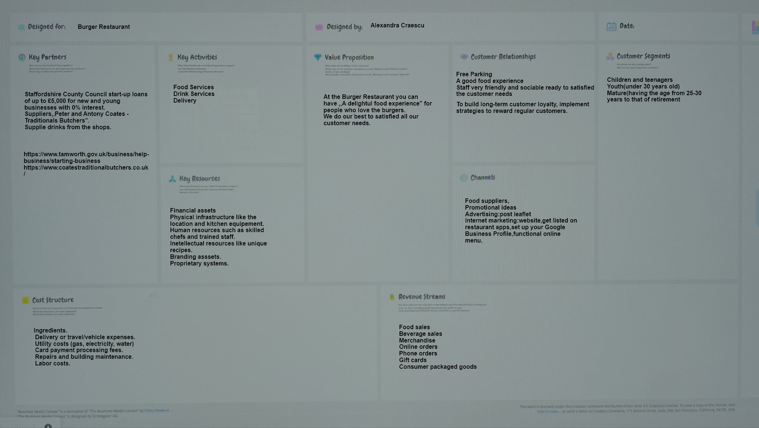

References
Adeani, I.S., Febriani, R.B. and Syafryadin, S., 2020. Using GIBBS’reflective cycle in making reflections of literary analysis. Indonesian EFL Journal, 6(2), pp.139-148.
Baker, T. and Welter, F., 2020. Contextualizing entrepreneurship theory (p. 188).
Barringer, B. R. &amp; Ireland, R.D. (2018) Entrepreneurship: Successfully Launching New Ventures, 4 th Ed., Prentice Hall: New Jersey
Burns, P. (2022) Entrepreneurship and Small Business, 5 th Ed., Palgrave Macmillan: Basingstoke
Chin, T., Shi, Y., Rowley, C. and Meng, J., 2021. Confucian business model canvas in the Asia Pacific: a Yin-Yang harmony cognition to value creation and innovation. Asia Pacific Business Review, 27(3), pp.342-358.
da Costa Fernandes, S., Pigosso, D.C., McAloone, T.C. and Rozenfeld, H., 2020. Towards product-service system oriented to circular economy: A systematic review of value proposition design approaches. Journal of Cleaner Production, 257, p.120507.
Daou, A., Mallat, C., Chammas, G., Cerantola, N., Kayed, S. and Saliba, N.A., 2020. The Ecocanvas as a business model canvas for a circular economy. Journal of Cleaner Production, 258, p.120938.
Dobrowolski, Z. and Sułkowski, Ł., 2021. Business model canvas and energy enterprises. Energies, 14(21), p.7198.
García-Muiña, F.E., Medina-Salgado, M.S., Ferrari, A.M. and Cucchi, M., 2020. Sustainability transition in industry 4.0 and smart manufacturing with the triple-layered business model canvas. Sustainability, 12(6), p.2364.
Hamwi, M., Lizarralde, I. and Legardeur, J., 2021. Demand response business model canvas: A tool for flexibility creation in the electricity markets. Journal of Cleaner Production, 282, p.124539.
Helmold, M. and Helmold, M., 2020. Total revenue management (trm) (pp. 1-12). Springer International Publishing.
Hisrich, R.D., Peters, M.P. &amp; Shepherd, D.A. (2008) Entrepreneurship, 7th Ed.,McGraw Hill: NY
Markkanen, P., Välimäki, M., Anttila, M. and Kuuskorpi, M., 2020. A reflective cycle: Understanding challenging situations in a school setting. Educational Research, 62(1), pp.46-62.
Micieta, B., Fusko, M., Binasova, V. and Furmannova, B., 2020. Business model canvas in global enterprises. In SHS Web of Conferences (Vol. 74, p. 02010). EDP Sciences.
Nelson, O. (2013) Enterprise development in SMEs and entrepreneurial firms dynamic processes. IGI Global.
Porfírio, J.A., Felício, J.A. and Carrilho, T., 2020. Family business succession: Analysis of the drivers of success based on entrepreneurship theory. Journal of Business Research, 115, pp.250-257.
Rickman, C., &amp; Roddick, D. (2013) The Small Business Start-Up Workbook: A step-by-step guide to starting the business you’ve dreamed of. London, How To Books
Shakeel, J., Mardani, A., Chofreh, A.G., Goni, F.A. and Klemeš, J.J., 2020. Anatomy of sustainable business model innovation. Journal of cleaner production, 261, p.121201.
Simanjuntak, M., 2021. Designing of service-dominant logic and business model canvas: Narrative study of village tourism. Golden Ratio of Marketing and Applied Psychology of Business, 1(2), pp.73-80.
Walker, J.R., 2021. The restaurant: from concept to operation. John Wiley & Sons.
Williams, S. (2021) FT Guide to Business Start Up: The most comprehensive guide for entrepreneurs, 32nd Ed., Financial Times Press: Harlow.
Zimmerer, T.W. &amp; Scarborough, N.M. (2011) Essentials of Entrepreneurship, 6th Ed., Prentice Hall: New Jersey

