
Skills for the Workplace
Module Assignment Submission
Student Name: | KHALED HUSSAIN
Student Number: | 1604277
Module No: | EMPL4011
Module Title: | Smart Technology in the Workplace

Statement of Confirmation of Authenticity
By the act of making this submission, the student declares that this is the work of the student named above. The work has not, in whole or in part, been knowingly presented elsewhere for assessment, or where assessment has been built on a previous assessment, this has been identified. Where materials have been used from other sources it has been properly acknowledged. If this statement is untrue, the student acknowledges that an assessment offence has been committed.
Attention is drawn to the plagiarism and unfair practice policies of both the University and of ILM.
Table of Contents

Table of Contents 2

Part 1

Introduction 3

1.1 Web based email 3-4

1.2 Smart phone I phone 7 vs. Tablet I pad 5-6

Part 2

2.1 Facebook, twitter and LinkedIn. 7-8

Conclusion 9

Reference list 10-11

Appendix A 12

Appendix B……..…………………………………………………………………………………………….13

Introduction

Part one of this report is discussing about the difference between
Web-based e-mail’s G mail and yahoo mail also, which one would be more useful in the workplace. And technology’s such as smart phone the apple I phone 7 2016 and tablet apple I pad first generation Wi-Fi which one of these would be better to use in the work place. Part two of this report will be discussing about social media sites such as twitter Facebook and LinkedIn could be used for communication in the workplace. Followed by a conclusion and a reference list.

Web-based e-mail

Web-based e-mail allows its users to access their e-mail account online as long as they have access to an Internet connection. And a web browser. Hotmail was the first web-based e-mail created by Indian American man Sabeer Bhatia in 1996 (Kumar, 2013).

Yahoo mail vs. G mail

For an office workplace which one of these two web based e-mail provider would be better to use for all the employees to use.
Firstly Yahoo mail was created long before Gmail it is older out of the two and anyone could sign up for a free e-mail account on both yahoo mail and Gmail. But yahoo mail also offers a plus service with a fee.
With a Gmail one can access YouTube, Picasa, Google Docs and with a Yahoo mail account can be used with Flickr, Yahoo Messenger. Gmail has better filters then yahoo mail Also sometimes yahoo mail wrongly sends emails to spam folder mistaking it for junk mail.
Gmail offers POP mail access for free and Yahoo mail charges a fee for this service also Gmail offers e-mail forwarding service for free and Yahoo mail again charges a fee for this service.
On the welcome page of yahoo mail there is so much information like lottery results international news fashion financial news or what ever is trending. Gmail keeps it simple all advertisements go straight to inbox (Differencebetween.net, 2018).
There is an app for both tablet and smart phones. For both iOS and android Yahoo mail offers premium service for a fee it is called mail plus which has mail forwarding service live customer care no graphical ads.

This screen shot is comparing the difference between yahoo mail free version and the premium yahoo mail plus.

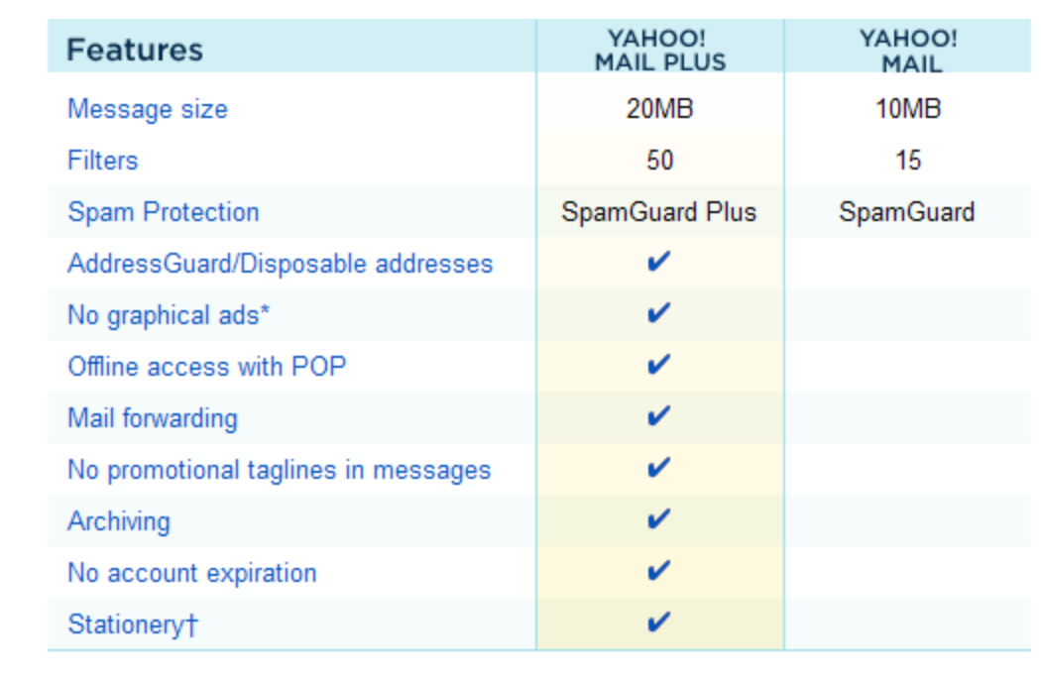

Smart phone I phone 7 128gb 2016 vs. Tablet I pad 2010 16gb Wi-Fi

For the last few years, most people in the developed world are using smart phones and tablets. Industries such as restaurants and some fast food outlets are using tablets and smart phones to take orders instead of the old fashion way of writing it on a pen and paper or checking stocks of what they have and what is sold out or temporally off the menu. Even for drink some restaurant and bars are using apps for wines and other drinks and food to bring interactive dining experience. A restaurant called Chicago Cut, a Chicago-based restaurant is bringing its customers an interactive dining experience use of the iPad and a virtual cellar app. Using their wine app, people can choice there own drinks were a lot more information is on the app and make an educated decision (Beta, 2011). The iPad first generation has a 16gb and the iPhone 7 has a massive 128gb, which has a lot more space compared to the 16gb. For a restaurant it will be more convenient to use the iPad then the iphone7 for the customers to see the menu because of the screen size 9.7" touchscreen display, and the iPhone7 screen size is 4.7, which is very tiny for a menu app. The iPad is Wi-Fi only the iPhone 7 has Wi-Fi and one can insert a sim card for additional Internet pay as you go or a contract tariff. If the restaurant was to lose electricity or there was a failure with the Wi-Fi the I pad would run into problems that could create some problem such as slow orders or delivery orders not temporarily out of service and create confusion in the kitchen where staff cannot use the Ipad to see what the orders are also to do a full stock count stocks until the internet is back on While the Iphone will be unaffected in that kind of situations. And the customers can order there food-using apps like just eat or hungry house through both ipad and the iPhone. The app will then inform the restaurant about the order. The iPhone has 14 hours battery life and I pad has 10 hours battery life which means that the iPad has to be out of use or charged more frequently then the iPhone also iPad cannot multi task.
The IPhone 7 come out in the year 2016 a second hand version of iPhone 7 128gb can be bought for around £300-£350. And the iPad first generation 2010 model 16gb Wi-Fi only can be bought second hand around under £140 in the year 2018.
The restaurant would need roughly around ten to fifteen devices to serve the whole team from the waiters and waitress, management, kitchen staff that could be quite costly.
The IPhone 7 is water resistances incase of accidental water spillage or if dropped inside the sink also has higher security features like the finger print scanner. While the pad first generation does not have high security features or is not water resistance. Still iPad first generation was selected by Time magazine as one of the fifty best Inventions of 2010 (McCracken, 2010).

2.1 Facebook, twitter and LinkedIn
Possibility for communications and
Collaborations in the work place using
Social media networks.

For a few years, social media platforms have been used by many around the world in there everyday life, affecting people's informal interactions, as well as institutional structures and professional routines. It a way how people communicate on the Internet like emailing social media have changed the conditions and rules of social interaction
(Dijck and Poell, 2013). With all three of these social media platforms people can interact with each another and communicate. Facebook allows companies and to create groups where the employee’s of that company can join the group to interact and get any latest new and updates. Facebook also allows groups to set up invitations to a function or an event where the person who was invited can confirm or decline the invitations. Many work colleagues communicate through social media instead of using text message or e-mail. Facebook and other Social media platforms have changed how people at communicate with each other. For the past few years, social networking sites have overtaken e-mail, as the primary means of online communication e-mail still remains more popular. Many in the computer industry think that in the next decade social networking will over takes e-mail as the main form of inter personal business communication as well as workplace communication
(Cardon and Marshall, 2014). Celebrities mainly use twitter. Adding a person via Twitter is called following and message, is known as ‘’tweet’’ but there is a restriction of how many character’s one cannot go over 140 character’s an employee can follow and interact with his or her company’s twitter account. Lastly LinkedIn is a social media were most profesnal people from all back grounds have accounts from doctors, accountant, and business executives ’ Top level executives mainly use LinkedIn for industry networking and promoting their businesses (Gunelius , 2011). An individual has the option to add information about their education an previous employment also current employment. All three of social media company’s are free for members to join. There is also apps for all three of these company’s for both android and IOS.

Conclusion

The report can be concluded that for web-based email I have compare and contrasted between yahoo and Gmail. I would prefer Gmail to yahoo because yahoo some times sends emails to spam folder what if that was an important email. Gmail has better spam filters compared to yahoo mail although yahoo mail premium is an evenly match with Gmail but for that account there is a fee where Gmail offers the same service for free. The iPhone 7 and ipad first generation in my view after using them both as I am an owner of both this devices my family and relatives are in partnership in Indian restaurant in the north of England. Recently the restaurant has started to use
iPads for delivery and waiters, kitchen staff, management all use iPad’s only difference is they are using the latest version of the iPad the iPad pro more upgraded and comes with stylus. The iPad in my opinion will be better to use by the restaurant staff compared to the IPhone. Facebook has a lot of use for communication in the work place a company can set up a page where the employees can follow the page or the company can send out invitations to followers. Twitter has the least functions for communications and Collaborations in the work place it is only useful to follow celebrities. LinkedIn is a very good social media for interaction with similar profesnal people or work colleagues.

Reference list

Kumar, M. (2013). Sabeer Bhatia: Founder of Hotmail, World’s First Free Web-based Email Service. [online] BrainPrick. Available at: http://brainprick.com/sabeer-bhatia-founder-of-hotmail-worlds-first-free-web-based-email-service/ [Accessed 5 Apr. 2018].

Differencebetween.net. (2018). Difference Between Yahoo Mail and Gmail | Difference Between. [online] Available at: http://www.differencebetween.net/technology/internet/difference-between-yahoo-mail-and-gmail/ [Accessed 6 Apr. 2018].

Website-hostingco.com. (2018). [online] Available at: http://www.website-hostingco.com/images/yahoomailplus.gif [Accessed 7 Apr. 2018].

Beta, B. (2011). How Restaurants are using the iPad. [online] The Next Web. Available at: https://thenextweb.com/apple/2011/01/05/how-restaurants-are-using-the-ipad/ [Accessed 7 Apr. 2018].

McCracken, H. (2010). The 50 Best Inventions of 2010 - TIME. [online]Availableat:http://content.time.com/time/specials/packages/article/0,28804,2029497_2030652_2029804,00.html [Accessed 9 Apr. 2018].

van Dijck, J. and Poell, T. (2013). Understanding Social Media Logic. Media and Communication, [online] Vol. 1(Issue 1), pp.pp. 2-14, 2013. Available at: https://papers.ssrn.com/sol3/papers.cfm?abstract_id=2309065 [Accessed 10 Apr. 2018].

Cardon, P. and Marshall, B. (2014). The Hype and Reality of Social Media Use for Work Collaboration and Team Communication. International Journal of Business Communication, 52(3), pp.273-293.

Gunelius, S. (2011). Forbes Welcome. [online] Forbes.com. Available at: https://www.forbes.com/sites/work-in-progress/2011/08/09/study-reveals-how-professionals-use-linkedin/#3301c2c659b3 [Accessed 16 Apr. 2018].

Appendix A

screen shot user name is uncle Charlie and email address is smarttecnology1604277@yahoo.com and 1604277smarttecnology @gmail.com

Yahoo.com email
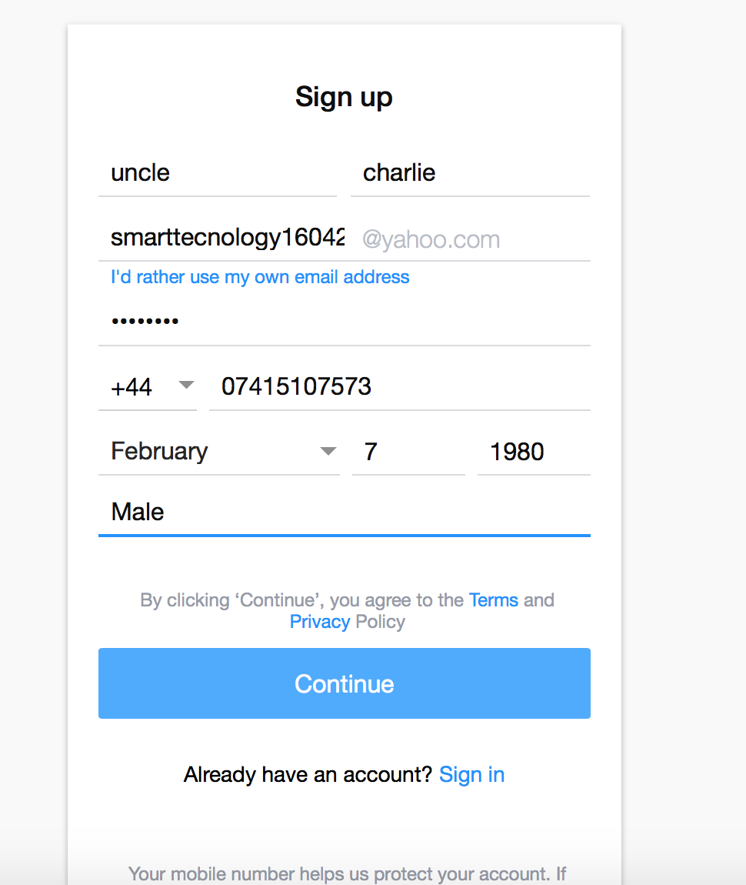

Gmail
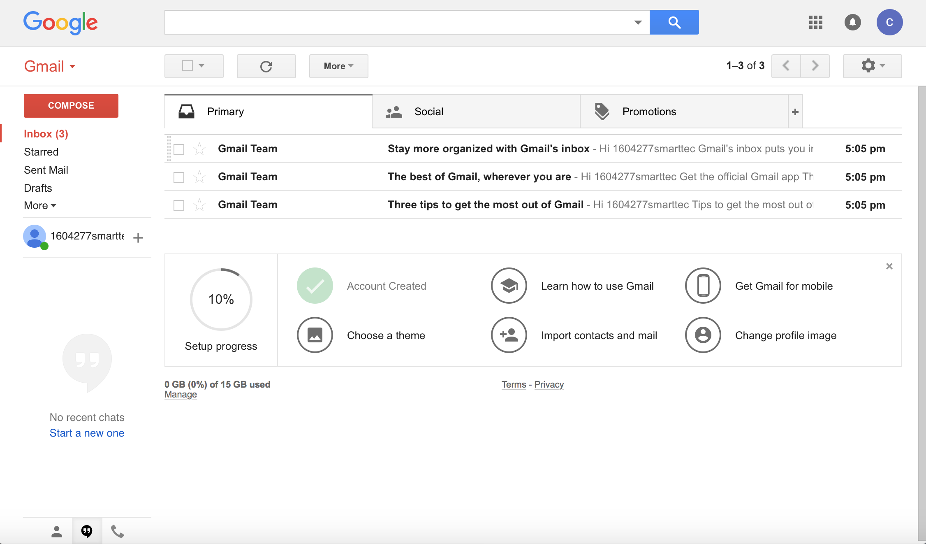

Appendix B

https://www.facebook.com/unclle.charlie.9
New Facebook account created.

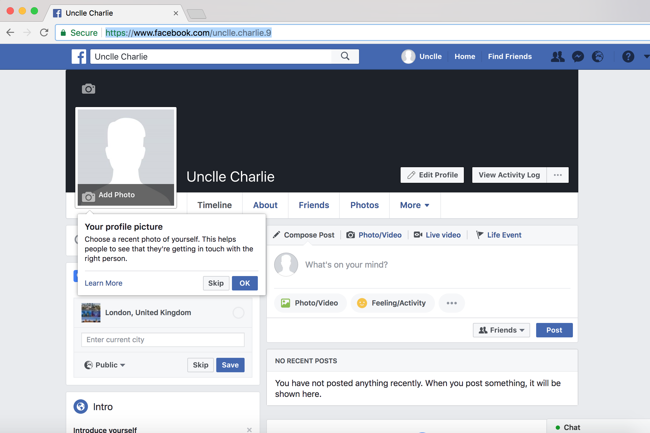

https://twitter.com/smarttec1604277
New twitter account created.

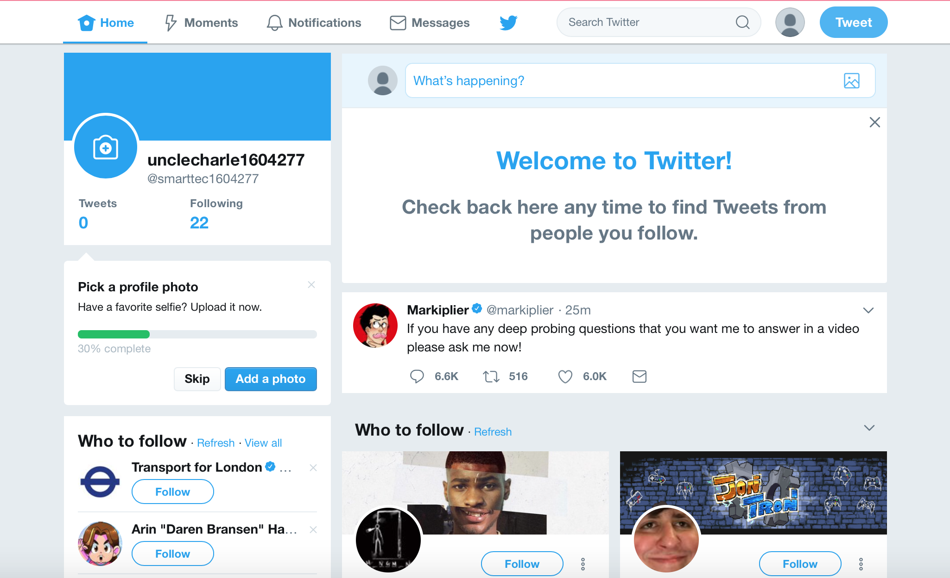

New LinkedIn profile created.
https://www.linkedin.com/in/uncle-charlie-04589615a/



