Managing Enterprise in the 21st Century
(BMSW4006_LON)

Lecturer: Afzal Munna

Business Plan
for
“The 12 Olympian Gods”
Boutique Hotel

Students: Caterina Stejar (1913738)
Ana-Maria Racu (1913741)
Andrei Sarealba (1913748)
Junior Tshili (1917482)

Caterina Stejar (1913738)
Cover Letter
Afzal Munna
Winchester House, 11 Cranmer Rd, London SW9 6EJ
a.munna@uwtsd.ac.uk
Dear Mr. Afzal,

We are writing to express our interest that we are a group of 4 partners, owners of the12 Olympian Gods hotels with poor experience and knowledge in hotel industry. Our role in the hotel is to provide a great customer experience through great services and high-quality amenities.
We all have different skills and we will work in a team to combine our skills, creativity, and passion. We have Ana-Maria with a big passion for design she will create an Greek ancient design in our hotel, Andrei he is passioned about technology he will combine the ancient style with a modern technology, Junior he is our expert in financial and Caterina with 10 years’ work experience in the hotel she will keep our hotel clean and tidy. We all are happy to have the chance to combine our creative skills and passion for Greek mythology and history, to create an amazing ambiance and entertainment, moreover, to give to our customer the felling of gods and goddess.

We are trustful in our abilities to make a significant change in the hotel industry through our innovation and passion for our customer service. Please feel free to contact us as soon as possible to set up a meeting and discuss our business plan. We are looking forward hearing from you and thank you in advance for your concern.

Sincerely,
The 12 Olympian God Team

Executive Summary

The 12 Olympian gods is a luxury hotel on the Crete Island in the Greece. The business is a general partnership founded by 4 owners: Ana Maria Racu, Andrei Sarealba, Junior Tshili, and Caterina Stejar aiming to host the most exclusive guests, anyone who is willing to pay to feel like a god and goddess. The hotel has only 12 rooms, and each room is decorated and themed by the nature of the power to the 12 Olympian goods: Athena, Hera, Aphrodite, Zeus, Apollo, Ares, Hephaestus, Demeter, Artemis, Dionysus, Hermes and Poseidon with an satisfaction view of sea each room have a personal servant dressed much alike as ancient Greek (with an undergarment and a cloak), which will be delivering the highest service executing command as to wake up at certain time or to brink the breakfast in bed.

Ground floor is going to serve as the entrance and it will lead to the hotel lobby which give access to the café bar, restaurant, and cortyard. Our restaurant ‘The Hestia’ will be providing a la carte Menu and a good range of wines. In the restaurant will be served only wine because is considerate the drink of the gods. On the roof top garden-bar will be served for our customers a good range of spirits. Every Friday will be organising a small lottery with a mystery present named ‘’The day of Pandora Box’’ that we hope to become our visit card. From the restaurant will be an exit to the Olive Garden where is a beautiful and relaxing place with green grass and olive trees where you can have your breakfast and coffee. In the Olive Garden will have place every Sunday a party with wine, dance and Greek music, everyone will be required to be dressed like an ancient Greek God with an undergarment and a cloak to fest and honour the power of gods.

At basement floor is located our spa and a small gym. The Temple of Pasithea is the name of our free spa centre there is the place where they can heal their mind, body and souls with a therapy service in acupuncture, massage, meditation yoga and a bath with ‘The Aphrodite Power’ bath milk and herbs and essential oils named The path of Gaea.

The lower grand floor will be the service kitchen for restaurant and back of house areas there is located a place for our delivery for food and beverages and for laundry in a specific time, and a private parking with 15 parking space. All access in and out of the hotel will be controlled from the lobby by the reception staff, 24 hours service.

In term of technology we will provide for our customer a new top smart technology as: free wireless, voice assistance, smart Philips Hue lights, smart draperies, compatible TV’s, smart thermostat in every room and every room will be keyless all of these can be controllable by voice command with amazon Alexa voice assistance. We will have an own hotel app that allow guest to check -in, check-out and to book appointment for our facilities like massage, acupuncture, and yoga. To have access in their rooms by using own smart phone with our hotel app this reduce the hassle of innovatory of key cards that are prone to loss and save plastic pollution. Also is helpful for our managers to manage the staff and to save labour cost and to let them to know when the room are empty and avoiding uncomfortable situation. As well the guest can control their room even, they are rooming outside of the hotel, also they can select the room which they want to live and to request customised service.
As security will have a CCTV camera at the entrance, back and the hallway of the hotel also will be the fire alarm in every room and every department, hallway of the hotel which include automatic detection audible alarm and fire sprinklers.
We are responsible for health and safety training and fire awareness of our personnel we will arrange to trainings and to be keep them informed. The training will be provide for our new and old staff, this is a regularly session to understand how to use and how is working the new technology, especially the application in order to provide the service to our customer required online. We will provide as well shadow training where a newbie it will learn from an experienced worker to get accommodated with daily job.

The responsibility

For the impact of the environment and surrounding of the town culture and to help the local economy we will hire local personnel and will bay local products and the hotel will provide more eco sustainable alternative travel like instead of paper brochures we will use an electronic brochure send by email to our customers as they will check-in with all the information about the car/taxi, public transport and attractions. We will have energy savers in all the rooms installed like motion sensors lights and water sensors (Hannah, 2017). Using Led bulbs high isolation windows separate biodegradable waste of oils and fats agreements made with suppliers on returnable packaging use of solar panels and solar boilers.
The hotel will have another app ‘’too good to go ‘’for waste food, using the app to sell the products that we could not sell helping as to reduce the waste food.

With all that we want our customer to leave with an unforgettable experience that will make them to come back to us and to recommend our hotel to their friends, family members, and to business partner.
Our target market is mostly the young adults who are interesting in exploring the goddess like presence also have the target customers with high level of income and mostly target is the consumers who highly are fascinated by Greek mythology, culture and Greek cuisine. In Greece, the working season for hotels are from April to end of October we aim on targeting of 3.600 customers for the whole season.

We are planning to focus more on advertising online in order to meet our expectation to created install a Facebook Pixel with a tracking cod on our website to reward our customer with 10% discount in the first month and to the last month from the season when the number of travels are low, and they can share with family members and friends.

Our strengths are that the hotel is decorated in a combination of modern technology and ancient Greek design. This concept is quite unique, and it will help us to attract many audiences towards us. Our weakness is that we have only 12 rooms and we will be not able to handle a higher demand from customers. Our opportunity is that we can expand our business and to make more rooms availability, so that a greater number of travellers can stay. We can bring up more innovation and creative services to attract the customers.

The hotel will need many suppliers such as furniture, food and alcohol suppliers but the most important to run our business are energy suppliers PPC S.A the biggest Greek company also EYATH S,A water suppliers that manage a common good water and the city’s sewage system through the biological treatments. We will provide a tax identification number and social security, provide safe and secure working environment, data protection, advertising truthful information, employability, and property insurance for company.

The 12 Olympian gods having 27 employees well trained and professional with wide knowledge and passion, and the excellent management team and finance head, in different teams that have been involved in making sure that the roles and responsibilities has been clear and providing high quality of service to the travels who has visited our place. This also assisted the hotel in increasing their consumer satisfaction.

The 12 Olympian gods asking for an investment of £2.5 million to start our business and we are offering in return a 20% stake in our business.

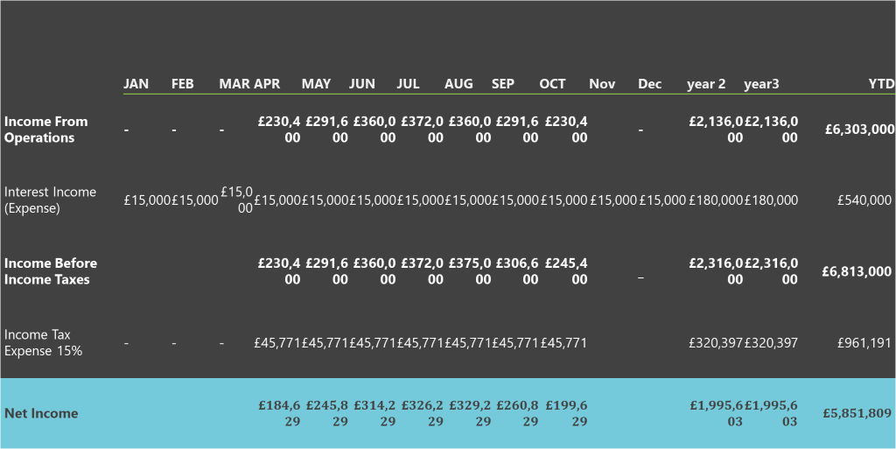

Caterina Stejar
(1913738)
I have 10 years work experience in the hotel and I am glade to share my knowledge and skills with my team.
At the University I discovered new skills and knowledge how to run a business and work in a team.
Andrei Sarealba
(1913748)
I have chosen operations and management because I have some experience in this domain.
I have been responsible for an entire supermarket of its management and operations especially suppliers, orders, closing and opening times.
Table of content

Ana-Maria Racu
(1913741)
I have no experience regarding managing a business, but to become an entrepreneur is enough being creative and think big.
I am due to finish my HE Certificate: Skills for the Workplace where I learned how to manage an enterprise.
I consider I have good critical and analytical thinking skills which are imperative in managing a business. Furthermore, I show good potential of interpersonal skills and creativity.
Junior Tshili
(1917482)
Being responsible for creating the financial plan for my business has been very insightful for me as I learnt the detail that goes in to creating a business.
I have learnt the importance of planning and gathering data to support ideas, I would like to consider myself confident enough now to start my own business in the future.
Me and my team are proud of our work and have implemented knowledge from some of our personal experiences into this project.

Business description and history

The 12 Olympian gods are a Boutique Luxury hotel located in Greece more precisely in Crete Island on the southern side of Aegean Sea, Crete is the biggest of all Greek Island. Its beauty, though, is even bigger than its size with natural beauty, rich in culture and worldwide famous gastronomy, to create the dreamiest holyday paradise. Crete beaches are amazing historical sites and with a magnificent medieval architecture that will make you feel as if you’ve traveling back in time. The 12 Olympian gods is a seasonal business and in Greece, the working season for the hotel are from April to end of October for that we will be open for 7 month at year in this time we aim on targeting 3.600 customers for whole season .
The 12 Olympian Gods offers various luxury services to our customers, with the 12 rooms with the name of Greek Gods and decorated in a combination of modern technology and ancient Greek design this unique will help us to attract many audiences towards us. Also, the hotel is been engaged in providing luxury service and high quality so that the needs and demands of customers can be fulfilled a great customer experience through great service and high-quality amenities. Having a well-trained professional staff with wide knowledge and passion we will be delivering constantly high standards, also we are targeting to maintain a 90% of occupancy through multiple marketing channels to promote the business. All of that help us to increasing the satisfaction of our customers and this help us to a customer loyalty so that can grow and also expand our business and to create a well-known worldwide brand obtained through premium products and services delivered with personalized care.

Business structure

The 12 Olympian gods are a general partnership founded by 4 partners as follows:
Caterina Stejar – Partner and General Manager
Ana-Maria Partner and Head of Marketing
Junior Tshili -Partner and Head of Finance
Andrey Sarealba -Partner and Head of Technology
Our team are responsible for the daily activities in the business and is personally liable for all debts and enjoys the pass-through. While forming a partnership we are mandatory to follow all the legal requirements. As a partnership agreement we must capture each partner’s financial contribution and the responsibilities in the partnership to avoid a possible dispute in the future and the process to be followed even one of us decide to break our agreement.

Ana- Maria Racu (1913741)
Services
We want for our customers to experience the best staying at our hotel that being the main reason for us to achieve the highest level of the service. Every room will be appointed with a personal servant who will be delivering the highest skilled service of any kind related to the client needs. For instance, executing commands as to wake up our client at certain time or to bring breakfast in bed.
Everything is strongly related to customer desire. We will offer services of individual boat renting on the Mediterranean Sea and car renting on the premises of the Crete island. In addition, we can arrange excursion upon request on the historical sites or getting around other islands. Every client before arriving to the hotel must download our mobile app from where he/she will be able to check in/out and communicating with their personal servants.
On the territory of our Boutique hotel we will be providing clients with a beautiful wellness spa center called “ The Temple of Pasithea” where we have taken the Ancient Greek healing philosophies and united them with other cultural ethnicities as to deliver the best kind of healing and relaxation place. A place where they can heal their minds, bodies and souls.
The therapists will be providing services in acupuncture, deep tissue massage, body scrub, chocolate therapy, aromatherapy, meditation, yoga. Every session is individual and can be processed in the premises of the spa or in the client’s private rooms. The spa services are not ending here, we also will pamper our customers with exclusive moisturizing baths. ‘The Aphrodite Power” which is a milk bath with essential oils and herbs and ‘The path of Gaea’ which is a nature sounds bath that will include different sessions of breathing and balancing techniques in water.
The restaurant ‘The Hestia’ will be providing a la carte Menu and a good range of wines. Wine was considered the drink of the gods and we will be serving only this alcohol drink in the restaurant. The hotel’s alcohol assortment is not limiting only to wines, customers will have a good range of spirits in the roof top garden-bar. The exclusive service that we hope to become our visit card is ‘The Day of Pandora Box’. Every Friday we will celebrate the end of the week by organizing a small lottery. The pandora box will be the 2 meters high goddess statue located at the entrance of the restaurant. She will be holding a box that every customer prior entering to the restaurant should extract a random small envelope from the box and to give it to their waiter once they have been sited to the table.
Exact at 8 o’clock we will do a small lottery and find out who won what. Everyone loves mystery. Another exclusive service we will be providing every Sunday is The Ritual of Gods. Every customer will be given with an undergarment and a cloak and waited in the Olive Garden to fest, dance and drink wine to honor the power of gods, meaning themselves as they are staying in the god themed hotel. We hope that this will become our visit card as well. Also, we will be providing reception service, concierge service, luggage storage, currency exchange, 24-hour front desk, cleaning service as ironing service, dry cleaning, laundry, daily housekeeping.

Market Analysis and Needs
In Greece, the working season for the hotels are from April to the end of October. We aim on targeting 3,600 customers for the whole season on the Crete island. In 5 years’, time we consider expanding on Ionian Islands, Lefkada and Corfu. Our demographic target customers are aged between 27-40, luxury customers, either are solo travelers or couples. People who are fascinated by Greek mythology, culture and Greek cuisine. People who wants to know more about it and once in a lifetime to experience unforgettable journey in time to ancient Gods. The focus is to deliver the highest customer service and to create for our clients a unique place where they can forget about everything.
We address our service to the potential clients who seek intimacy and isolation. Those who wants to find relaxation and recharge their bodies and minds in the temple of the god. People who desire a peaceful experience and money is not a decision-making factor. Our pricing approach is quite simple. “Price skimming— setting a high price and lowering it as the market evolves”. (The 5 most common pricing strategies, 2020). Setting a high price will help us build a high image and create high profit margins. In addition, it enables us to lower our prices to create deals and discounts and maintain the profit.
Market and Competition
I conducted an online research to identify my competitors and to understand our market. I identified two leading 5 stars hotels who hold the highest rate in satisfying customers. I did a SWOT Analysis to find out the competitors’ strengths, weaknesses, opportunities and threats.

Competitor 1 (Daios Cove, 5-star luxury resort and villas)
Strengths: They have a large variety of rooms and 165 private seawater pools. They have a private beach and skilled, knowledgeable staff. Families with kids under 12 years old are not paying for their child’s staying at the hotel. They are in collaboration with the Greece’s 50 best bars. They provide a rich entertaining program including global star musicians, DJ’s and vocalists. Their restaurants chefs are very experienced and deliver a Michelin- starred cuisine.
Weakness: the location of the hotel is quite far 53.4 km driving by car from the Heraklion International airport which is the primary airport on this island. The resort is gathered around a cove and there are too many stairs everywhere and can be tricky for children and elderly. Their beach is not safe for kids because it goes deep straight away. Some of the reviews were saying that their nights amenities have poor choice and you have not much to do after dinner. The hotel is family friendly which is very good but there is no adults section for couples wanting a quieter holiday.
Opportunity: they can offer a free of charge airport transfers not depending on how many days you are staying in their hotel.
Threats: they are more likely to became losing couples auditory. High competition with the others 5 stars hotels around who may give better offers and facilities. Uncertain economic environment as for example the afterwards impact of COVID-19.

Competitor 2 (Nana Princess, suites villas and spa 5-star hotel)
Strengths: authentic and first-class hospitality. Beautiful contemporary design and 3 restaurants with different cuisine. Almost every property comes with an own private sea water pool and they have a generous selection of rooms and villas. Every room is well technological equipped. They have quiet, relaxing and intimate atmosphere despite how big Is the hotel. Big spa center 1,4000 square meter facilities with many treatment options.
Weakness: 3 restaurants with not much choice of the food and they do not serve Greek cuisine. High technologies in the room but the rooms are not soundproof clients are disturbed by neighborhood noises. A large choice of spa treatments but all are extra cost.
Opportunity: this is a very good hotel and can became the top destination of the island. They can implement a rewarding system for regular customers.
Threats: the customer demands are continuously changing

Our Company (The 12 Olympian Gods)
Strengths - The strength of the hotel is that the rooms are been named on ancient Greek God and it is an original idea. This concept is quite unique, and it will help us to attract many audiences towards us. In addition will have high service level, skilled and knowledgeable staff.
Weakness: The weakness of the hotel is that consists of only 12 rooms, we are limited in rooms availability. We will not be able to handle a higher demand from customers which can make them unsatisfied and the goodwill of the hotel can also be reduced because of this.
Opportunities: The 12 Olympian Gods hotel also can expand their business and make more rooms, so that a greater number of travellers can stay. This will also help us in increasing the profit as well as revenue. We can implement diverse in-room technology in order to combine ancient luxury with modern accessibility. We can personalize our clients experience and to reward the repeat ones as to win their loyalty.
Threats: The hotel possess threat from the competitors as they can bring up more innovative and creative services in order to attract the consumers. So, 12 Olympian Gods hotel needs to be engaged in thinking about the strategy to overcome it.

Marketing and Sales Plan
Our target market is well living countries and with a high-income rate per capita. According to Statistica.com (2019) in top 20 countries for 2019 with high standards of living is listed Switzerland, Norway, Ireland, United State, Canada and more. Furthermore, we will keep targeting and countries with less income rate as United Kingdom, Germany, France, Italy as they have been a source of tourism for Greece for the last 4 years. (Statistica.com, 2019) We are planning to focus more on advertising these areas in order to meet our sale expectations of 4.600 customers in the first financial year. We will be advertising online, make use of search engine marketing and social media platforms to cover as much ground as possible.
Market Strategy
We will reward our loyal customers with 10 % discount, and they can share it with family members and retargeting our dormant users. We will send strategically timed alerts via SMS and emails offering our sessional deals. We will create and install a Facebook Pixel which is like a tracking code on our website which follows site visitors around the web (Influencer Marketing Hub,2020).We will be targeting people who have visited our sites in the past 7 days, whose who have made a reservation but left without checkout and whose who have been in our hotel in the last year.
Operations
We will be needing many suppliers including furniture suppliers, food suppliers, alcohol suppliers, etc. Two key suppliers that will be important to running our business is the energy supplier and water supplier.
Our energy supplier will be PPC S.A which is currently one of the biggest Greek companies and holds a leading position in the Greek electrical energy market, it is an experienced provider with a minimal probability of sudden power outages (Global Sustain ,2020). The relationship status between us will be as electricity provider and consumer. The key terms of our relationship will mainly be defined by transparency and confidential data protection, monthly provision of payment invoices, a fixed annual contract price and up to 2 months notification of its renewal or any incoming changes.
“EYATH S.A manages a common good water at the same time it manages the city’s sewage system, through the biological treatment of urban and industrial waste, contributing to protecting a common good the environment” (EYATH, 2019). The relationship status between us will be as water retailer and business consumer. The key terms of our relationship will be transparency and maintaining high quality of water, continuous and steady supply of water of enough pressure.
We do not currently employ staff because the business it is in the stage of creating but we enlisted key staff roles for our business. In the restaurant we are looking for chef and Head cook who would prepare and cook food of all types, Greek cuisine especially. His responsibility is to check the quality of the food and to ensure high standard of it. Furthermore, must be creative and to determine the decorative look of the food.
In the wellness spa we are looking for massage therapist and acupuncturist with good communication and interpersonal skills. Therapist must know different massage techniques and have at least 5 years of experience in field. Be able to guide our customers how to improve their posture and explain effectively how to achieve total relaxation. Acupuncturist must have a basis in Chinese medicine theory along with other western sciences. He must be able to consult the client before service, conduct a treatment and give a clear explanation of the client’s heath situation. At the roof top bar garden, we need a creative bartender with experience more than 5 years who would plan the bar menu, create and mix cocktails and other drinks and take care of supply orders.

Laws considerations
In our industry we need to consider laws as tax payment, employment and labor law, advertising legal regulations, email marketing, licensing and permits for opening a wellness center and restaurant and permits for spirits drinks for our bar, insurance, environmental regulations, health and safety laws.
Insurance
It is uncertain what insurance type it will be necessary for our business because we need to consult with an insurance company first and they will advise on appropriate insurance and will inform us of any legal requirements we have to follow and we are not aware of. In Greece, they have mainly only 4 types of insurance and we may try Public Liability Insurance which is “ … a compulsory form of cover in Greece, and protects from claims by third parties against negligence, death, injury, loss and damage of property, and economic or financial loss” (Startupoverseas, 2020). In addition, we will have an employability insurance.

Andrei Sarealba (1913748)

Technology plan

In terms of technology, we will have free wireless for guests and add amazon Alexa voice assistance, smart Philips Hue lights, smart draperies, amazon Alexa compatible tv’s and smart thermostat in every room all which can be controlled by voice command. Every guest room will be keyless, and it can be controllable by voice command with amazon Alexa. Motion lights will be installed in hallways and toiles. We will have our won hotel app that will allow guests to check-in and out as well to book massage, acupuncture and yoga appointments. By allowing the guests to check-in and out via the mobile phone the managers of the hotel can better manage the staff and that can save significantly on labour cost. By allowing guests to check-out via the hotel app, will let the staff knowing when the room is empty and thus avoiding uncomfortable encounters and discomfort.
Having access to the room via the smartphone app, reduces the hassle of inventory of key cards that are prone to loss. As well having keyless room access is environmentally friendly and saves plastic pollution.
As security we will have installed CCTV cameras at the entrance, back and the hallways. Fire alarms in every room and every department of the hotel, which will include automatic detection, audible alarm and fire sprinklers.

Operations management

This operational management statement relates to a new hotel and associated facilities in the island of Crete, Greece. The statement sets out the guiding principles for the hotel’s service and facilities. The aim of this Statement is to highlight the main principles to be followed regarding the hotel, bar, restaurant and facilities in order to ensure efficient management and proper protection of the amenities of the local area.
Operations management is the process that is used by the firm to manage and coordinate their resources. The plan helps the firm to reduce their waste of the resources and to improve the quality of their services. It assists the firm to grow. The goal of the operations management is to convert the goods into finished services.

The hotel
The 12 Olympian gods operate in the Greek island of Crete
The hotel operates a comprehensive management service which leaves no room for errors.
The hotel 12 Olympian gods firmly believe their management goes above the norm. The smart technology will allow guests to personalise and control certain aspects of their room through the 12 Olympian Gods hotel app. In this the guest will be connected to their rooms even if they are roaming outside. It has also been analysed that in this high technology services the guest can select the room in which they want to live and can ask the manager of hotels to provide them customised services. Every room are made on the theme of 12 Olympian Greek God (Pambreni and et.al., 2019) and instead of numbers, every room is going to be named by the name of one of the Greek mythology gods. This is making the guest feel like god and goddess. The hotel is also been involved in making sure that they add more high-tech features in that. This has assisted the 12 Olympian God hotel in marking their presence in market and it has also assisted the firm in growing and they have been able to achieve their set target and mission because of it.
The hotel's service and ancillary functions will be carried out and monitored by Ana-Maria Racu, Andrei Sarealba, Stejar Caterina and Junior Tshili.
The hotel is made on 4 levels comprising ground level, lower level, basement and upper levels.

Ground floor.
At the ground floor is going to be the entrance and it will lead to the hotel lobby which give access to the café bar, restaurant and courtyard. At the ground level as well, it will be located the lifts and stairs to the upper level bedrooms and roof terrace. The windows and doors are going to be closed between 11pm and 07:00am the following morning.

Lower ground floor
The lower ground level will contain hospitality facilities and a full-service kitchen, serving the restaurant and the back of house areas. There it will be a mezzanine level between lower ground and ground floor where it will be found toilets accommodation.

Basement
The basement will contain a spa and a small gym.

Upper floors
The upper floors contain 12 unique bedrooms. Every room is designed different from all the other rooms in a theme of a Greek mythology god, which it will offer a unique experience for our customers. Every room is going to have a different name relating to the Greek gods.

Rooftop terrace
An external terrace will be located on the roof of the building giving a view over the beach. Access to the terrace will be restricted between 12:00am and 07:00am

Parking
The parking spaces will be available on site only for staff and guests. There is going to be available 15 parking spaces

Arrivals/Departures

All access, in and out of the hotel will be controlled from the hotel lobby by the reception staff which will always include a CCTV monitoring. The lobby it will be the main access for guests and non-residents visiting the bar and restaurant during the day.
Given the location of the hotel are expected that most guests will arrive in the island by flight and public transport. The hotel will have a small coach which can be booked in advance online. The reception area will be active 24 hours.

Deliveries.
The goods will be received no earlier than 07:00am and no later than 06:00pm. Occasional deliveries not later than 10:00pm.
Food deliveries: approx. 1 delivery a day, like vegetables, seafood, meat and dry goods.
Beverages: approx. 1 time a day, water, fizzy drinks, beer, wine and traditional spirits
Laundry: to be daily picked up and delivered. To be picked up and delivered after 2:00pm
All the servicing will take place via the allocated bay for deliveries and refuse containers without creating clutter and obstruction.
Hotel management will monitor the delivery schedules to anticipate deliveries in advance, this way will reduce the time taken for deliveries to be made.
In the basement is going to be a large refuse store. This will be large enough to host a variety of refuse containers and allow for wastage isolation and compaction. This will reduce the landfill and collection needed.
Recyclable waste will be processed in a specific area until it is due to be collected. They will be ready to collect in the service bay. All service will take place from Monday to Saturday between 08:00am and 06:00pm.

Hours of operation.
The hotel will operate 24 hours 7 days a week.

Dedicated smoking area.
There is a separated area at the ground floor next to the restaurant to be used by visitors wanting to smoke. It will not be allowed to smoke in any other parts of the hotel, exempt from the dedicated area.

Personnel
The 12 Olympian god’s hotel it will have 27 employees.
For restaurant we will need, 1 chief, 2 waiters, 1 dish washer and 1 manager
For the rooftop terrace we will need 2 bartenders
For spa we will need 2 therapists, 1 acupuncturist and a yoga instructor.
Hotel personnel: we will need 6 servants, 1 concierge, 2 housekeepers, 1 laundry attendant, 1 receptionist. There will be as well 1 operations manager, 1 H.R manager, 1 finance director and 1 head of marketing department.
Payroll
The hotel chief – 2400euro/month
Acupuncturist – 1200euro/month
Massage therapist and yoga instructor – 1000euro/month
Concierge and receptionist – 1000euro/month
Housekeepers, laundry attendant and servants 700euro/month
Total of 13.100euro/month

Sustainability management plan.
Combined with modern comforts, the historic ambience of Crete gives an aura of discreet luxury and offers a rare and inspiring environment for a visit to Crete. Whether guests enjoy a beautifully planned dinner at the hotel's restaurant or a night in one of the twelve exclusive, unique rooms, outstanding personal service is always available. The 12 Olympian gods it is responsible for the impact it has on the environment and surrounding nature. Because the town and its culture will be a part of the gusts experience the hotel must strive for the efficient management of the environmental quality aspect. To help the local economy and as well the environment we will hire local personnel and we will buy local products.
The 12 Olympian gods hotel provides a more eco sustainable travel alternative for tourists. At the reception we will have electronic brochures e-mailed to our customers with hybrid cars/taxi, information about public transport and attractions. They can buy tickets for public transit and as well they can rent cars from the hotel. We will not provide paper brochures but instead one it will be automatically sent to their personal e-mail as soon as they check-in at the reception. We will have energy savers in all the rooms installed like motion sensors lights and water sensors (Hannah, 2017).
In our restaurant menus it will always be available an option to dine vegetarian. Our menus will be based on seasonal and regional organic products. Our hotel takes vegetarian dinning serious and we will always have interesting and tasty dishes. We will not use ingredients from endangered species and always opt for organic ingredients as an alternative for goods.
We will reduce our food waste by signing up our company with the app ‘’too good to go’’ which lets us to sell food that we did not sold at the end of the day to a very low price to anyone on the island including guests.

Training
We are responsible for health and safety training of our personnel. Meetings will be arranged for health and safety to be explained and to keep it up to date. Our staff are required to take part regularly in sessions in avoidance of fear and panic.
There is going to be a specific training for the new staff to get to understand how to use the technology that is used within the hotel, especially the hotel application in order to provide the service to our customers required online. We will use the app to give a live training.
We will provide as well shadow training, where a newbie it will learn from an experienced worker to get accommodated with the daily jobs and to learn faster. Every member of our hotel will be as well trained in fire awareness for their safety and our customers in a case of fire.

Suppliers
The 12 Olympian gods suppliers will be local, and use mostly traditional products, in this way will help to reduce carbon emission and fuel consumption as well to sustain the local economy. (Egle Silenaite-Enyed, 2019)

Environment
The 12 Olympian gods hotel it will everything they can to reduce its carbon footprint to neutral if it is possible. We will do that by installing energy savers like motion light sensors in hallways and toilets, Using LED light bulbs, High insulation windows, Improved climate control system, use of paper bundler, as well in use for plastic. Separate bio-degradable waste of oils and fats, agreements made with suppliers on returnable packaging, use of solar panels and solar boilers. In terms of food waste we are going to sign up our hotel with the app ‘’too good to go’’ where we can sell the products that we could not sell until the end of the day to non-residents and residents for a very low price, helping us to reduce food waste.

Junior Tshili (1917482)
Development, milestone and exit plan
(no data available)

Financial Plan
For the successful start-up of the 12 Olympian gods Resort an initial investment of £2.5 million will be needed for all operational and startup costs, the allocation of funds is broken down as follows.
The 12 Olympian Gods is a luxury resort concept that will be situated in Greece and will therefore require a property to operate its functions from, we are seeking to allocate £1.3 million of our budget towards the purchasing of the property. The property will be registered under the names of all four share members within the business the potential investor included, the property asset will be shared amongst five shareholders giving each shareholder 20% owner ship of the property with a cash equivalent of £260,000 per share holder in the case of liquidation at the current purchase price.
The first step in the operations to get our business established is the purchasing of the property, this will be the first investment as well as the first asset that The 12 Olympian Gods Group will own, the selection of our property has been strategically done with attention to location and the current property appreciation rate of the country of Greece to ensure the appreciation of our property and the overall growth and profitability of the venture. According to Global property guide “In Greece’s urban areas, house prices rose by 9.32% during the year to Q3 2019, far higher than the previous year” indicating an opportunity to enter the Greek property market through the purchase of our hotel.
One of the reasons we made the collective choice of basing and operating our business in Greece is to take advantage of the many opportunity it provides one of which is a reduced tax rate compared to setting up in a country such as the UK, the income tax rate for Greece is 15% so by utilizing this and starting our business you as a potential investor would be benefiting from this tax rate. The 12 Olympian Gods Resort will be registered as a General Partnership, ownership of the business will be shared amongst four of the founders and the potential angel investor and with an initial investment of £2.5 million they will acquire a 20% stake in the business.
We have chosen to register our business as a general partnership because registering as general partnership is beneficial to the structure of our business, some the factors that made us chose this type of business are benefits such as ownership and control of the business being equally shared, making it easier to get started and allowing for better decision making within our operations. According to Griffin. D (2020) “ When two or more parties work together to carry on a business for profit, you form a general partnership, All partners are responsible for the business, and they share all assets, liabilities and profits within the partnership as a separate entity.” There for making it the right business model for us as we are aiming to create a uniform approach to the running of our business with our potential angel investor.
The 12 Olympian Gods will employ 27 people across the resort as follows, one chief, two waiters, one dish washer, one manager, two bartenders, two massage therapists, six servants, one concierge, two housekeepers, one laundry attendant, one receptionist, one acupuncturist, one yoga instructor, one customer service representative. There will also be one operations manager, one H.R manager, one finance director and one marketing director. our acupuncturist, yoga instructor, concierge and the receptionist will be paid £1000 a month while the servants, housekeepers laundry attendants and the customer service will be paid £700 a month our total staff salary expense for every month of operation will be £11,000 rounded.
The four founders will cover roles within the business such as marketing, operations, finance, and human resources. The four founders will not be paying themselves a salary and as part of the business model we will be paid through the growth and future expansion of the 12 Olympian Gods Resort group and the acquisition and distribution of assets. Our Resort is designed to be a summer destination for potential global cliental, therefore our operating months will be from the months of April through to October. Due to the climate of Greece we experience the benefits of warm weather for an extended amount of the year which in turn increases our operating window and increases our revenue and profitability. Our peak seasons which correlate with the months of the best weather conditions will be June,
July and August with bookings being at 99% capacity we will experience a high revenue return of £365,000 a month on average. For the remaining four months of the year which are not considered peak holiday periods we will still maintain revenue in a profitable zone, such months within the calendar of our operations will be in April, May, September, and October. Our booking within the off season will be at an average of 90% with a revenue at £260,00 a month on average. Below is our projected sales forecast with the breakdown.

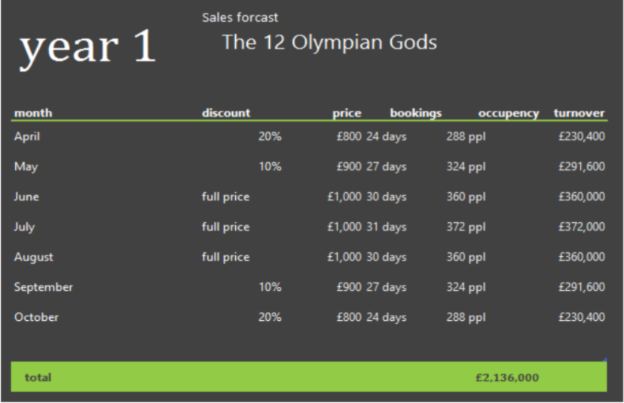

Within the first year of operations we are forecasted to make over £2.1 million pounds through room bookings, as we are asking for an initial investment of £2.5 million pounds we are presenting a lucrative opportunity for our potential investor to make returns as well as break even within a short period of time. Our main source of revenue is through bookings and by creating an exclusive Resort experience for our customers we will ensure bookings are always at maximum capacity for each given holiday season. To insure this, we will be offering promotions and discounts during the less busy months of the year the discounts and pricing are as stated above.
With the contribution of the initial investment we are proposing we will be able to get the 12 Olympian Gods Resort in operation, the allocation of funds and operational expenses to run the business for the next three years are as follows below. Within the first year our biggest expenses will be the purchasing of our property which will become the 12 Olympian Gods Resort this will come at an expense of £1.3 million pounds of our budget, the following biggest expense to operate our resort on a monthly and annual basis will be our salary pay out which is at £77,000 a month during our operating months of April – October.
Some of our adjustable expenses include contract labor which will be £30,000 in the starting phase of establishing our business as our property will need to undergo refurbishment, but this expense will then adjust to a fixed £1,500 after in every month of operation. Another initial expense in the first month of establishing our busines will be the purchasing of furniture which will cost us £50,000 but this cost is non reoccurring.
3-year Operations and Expenses statement:
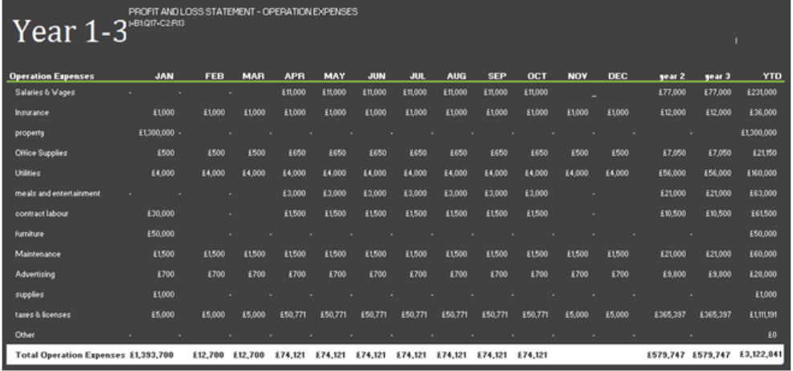
Taxes and licensing for our business will be at a current fixed cost of £365,397 annually. Our lowest monthly expenses will be allocated to office supplies and marketing which are currently at a £700 fixed per month for marketing and £500 per month for offices supplies in the off season and £650 per month during the peak season. Our maintenance allowance is capped at £1,500 a month for general maintenance of the property i.e. plumbing and painting as well as any other small tasks to be carried out to the property on a monthly basis.

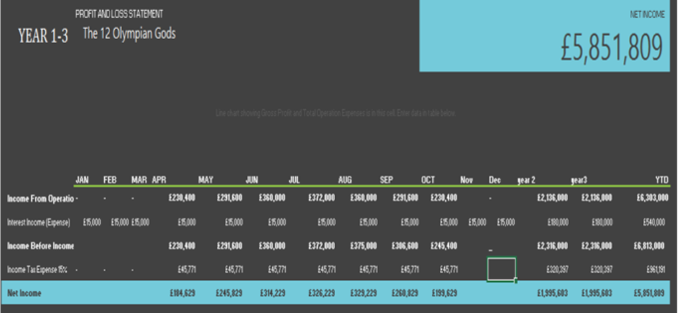

3-year Profit and loss statement above:

The 12 Olympian Gods Resort is projected to break even in Q1 of the second year with a closing balance of £2.7 million pounds after tax, as we are asking for an initial investment of £2.5 million we will be able to insure the return of our potential investors initial investment as well as providing them realised profits within the first 2 years of operations. According to Hayes. A “Break-even analysis entails the calculation and examination of the margin of safety for an entity based on the revenues collected and associated costs. Analysing different price levels relating to various levels of demand a business uses break-even analysis to determine what level of sales are necessary to cover the company's total fixed costs.” According to our break even analysis The 12 Olympian Gods resort will be in a profit zone of £228,000 by the end of year 3, the main revenue that we receive will come through the our amenities such as our restaurant, museum and room bookings.

Reference List:

BDC. (2020) The 5 Most Common Pricing Strategies. [online] Available at: <https://www.bdc.ca/en/articles-tools/marketing-sales-export/marketing/pages/pricing-5-common-strategies.aspx> (Accessed: 27 July 2020).
Business Plan Template-PDF Templates |JotForm [Online] Available at: https://www.jotform.com/pdf-templates/business-plan (Accessed: 28 August 2020).

Cvetkovic, A. (n.d.). The 7 best hospitality training ideas. [online] blog.typsy.com. Available at: https://blog.typsy.com/the-seven-best-hospitality-training-ideas. (Accessed: 17 August 2020).

Egle Silenaite-Enyed (2019). This is how you can be green with hotel sustainability strategy. [online] Sabeeapp.com. Available at: https://www.sabeeapp.com/blog/hospitality-industry-inside/be-green-with-hotel-sustainability-strategy (Accessed: 25 August 2020).

EYATH.gr (2019) [Online]. Available from: https://www.eyath.gr/vision-and-business-strategy/?lang=en (Accessed: 3 August 2020).
Globalsustain.org. (2020). Global Sustain: Public Power Corporation S.A. (PPC). [online] Available at: <http://globalsustain.org/en/member/47/profile/1> (Accessed: 20 July 2020).

Growthink. (n.d.). Hotel Business Plan Template. [Online] Available at: https://www.growthink.com/businessplan/help-center/hotel-business-plans (Accessed: 24 August 2020).

hannah (2017). 7 Hotel Sustainability Trends You Should Consider. [Online] Gourmet Marketing. Available at: https://www.gourmetmarketing.net/7-hotel-sustainability-trends-consider/#:~:text=7%20Hotel%20Sustainability%20Trends%20You%20Should%20Consider%201 (Accessed: 19 August 2020).
‌

Influencer Marketing Hub (2020) 10 Of the Best Marketing Strategy Examples. [Online] Available from: <https://influencermarketinghub.com/marketing-strategy-examples/amp/?fbclid=IwAR2DFCc0zv2Q37X8pFP0tRVBeagK6G4_KNcQuxFs4rMqD7ak72v16jYM5dw> (Accessed: 7 August 2020).

Lawdepot.co.uk. (n.d.). Business Plan Template | Write Your Free Business Plan (UK) | LawDepot. [online] Available at: https://www.lawdepot.co.uk/contracts/business-plan/?loc=GB&pid=msnppc-buspln_gb-businessplan_sl7-msnkey_hotel%20business%20plan&utm_source=bing&utm_medium=cpc&MSCLKID=853911f213a916471b424eb190619627#.X0OD0kBFw2w (Accessed: 15 August 2020).

Martijn (2019). Hotel Technology Trends: 11 Upcoming Innovations for 2020! [online] Revfine.com. Available at: https://www.revfine.com/hotel-technology/. (Accessed: 17 August 2020).

Mound, A. Schriek, M. and Tinkler, P. (2017). Certificate in Higher Education: Skills for the Workplace Student Yearbook. Sage Publications | Chapter 23: Writing a Successful Business Plan.

Plecher, H. (2020) The 20 countries with the largest gross domestic product (GDP) per capita in 2019 [Online]. Available from: https://www.statista.com/statistics/270180/countries-with-the-largest-gross-domestic-product-gdp-per-capita/ (Accessed: 23 July 2020).

Revfine.com (2019). Smart Hotel Technology: 7 Technologies to Smart Up Your Hotel. [online] Revfine.com. Available at: https://www.revfine.com/smart-hotel-technology/ (Accessed: 15 August 2020).

STARTUPoverseas (2020) [Online]. Available from:
https://www.startupoverseas.co.uk/starting-a-business-in-greece/insurance.html (Accessed: 7 August 2020).
What is a business structure [Online] Available at: https://ecommerce-platforms.com/glossary/business-structure ( Accessed: 30 August 2020).


