Obscura – A Design Proposal for Neutralising Hostile Communications Centres

Thomas Appleby (2217664)

Systems Engineering (ACDA5021)

Wales Institute for Science and Art
University of Wales Trinity Saint David



Table of Contents
Table of Contents 1
Table of Figures 2
Abstract 3
Introduction 4
Project Brief 4
Allocation of Work 4
Customers’ Requirements 5
Producing a Solution 6
Solution Selection 8
Determining Criticality 9
Further Analysis 11
Manufacturing the System 13
Conclusion 15
References 15

Table of Figures
Figure 1 – Requirements Table ……………………………………………………………………………. 5
Figure 2 – Pair Wise Diagram ……………………………………………………………..……………….. 6
Figure 3 – QFD1 ……………………………………………………………………………………………….. 7
Figure 4 – Functions Means Analysis …………………………………………………………………… 8
Figure 5 – Pugh Matrix ……………………………………………………………………………………….. 9
Figure 6 – QFD2 ……………………………………………………………………………………………… 10
Figure 7 – Parameter Diagram …………………………………………………………………………… 11
Figure 8 – What Why Table ……………………………………………………………………………….. 12
Figure 9 – Manufacturing Requirements ……………………………………………………………… 13
Figure 10 – Manufacturing Flow Chart ……………………………………………………………….. 14
Figure 11 – QFD3 …………………………………………………………………...………………………. 14

Abstract

The aim of this report is to show the thinking and collaborative processes used by the project team when making a design and then planning the manufacture of the briefed task. The project shows of the tools used by the team and the purpose they served. It also endeavours to show how all of the separate steps taken to produce one whole solution.

Introduction
Systems engineering is defined as ‘A technique of using knowledge from various branches of science and engineering to introduce technological innovations into the planning and development stages of a system’ [1]. This can be achieved through the use of various formula designed to compare different solutions with each other. Systems Engineering is a crucial part of the design process as it allows the developer to discuss and evaluate multiple solutions without having to waste resources and time.

Project Brief
The first stage of this project consisted of everyone being placed in teams of no more than 7 people. The teams were selected by the lecturers so that the teams would be made of people who had not previously interacted much so that there was no preformed team dynamics. The basis for this report was collated by the author and 4 other colleagues with assistance from the lecturers where it was deemed necessary and appropriate. The teams were all given the brief that they were to develop an anti-communications centre solution with targets designated as 3 information terminals and 6 opposing assailants.

Allocation of Work
The team initially worked collaboratively on the task until it was deemed necessary that each member would have to take on specific roles according to each member’s background and knowledge areas. The six assigned roles; Manufacturing, Safety & Governance, Trials & Testing, Product Safety and Disposals. Each member of the team had a specific role, the role assigned to the author was disposals.

Customers’ Requirements
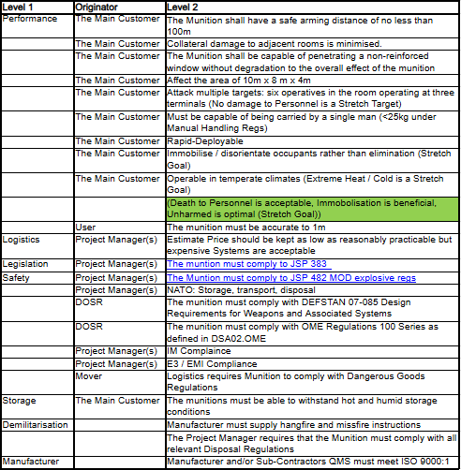
With the brief the teams were given a list of customer requirements that the solution must adhere to. These requirements can be seen in the Figure 1.

From these given requirements it was then the job of the team to use the tools provided to determine what the key requirements for the project would be. This was achieved using a pair wise diagram. A pair wise diagram compares each requirement against each other, if a requirement is deemed to be slightly more critical than another it is given a score of if it’s seen to be more significant that the other it is given a score of 5 and if it’s measured to be a lot more important than the other requirement it is given a score of 9. The other requirements are given the responding reciprocal of the score given to the more favourable requirements. This is 0.5, 0.2 and 0.1 respectively. The table seen in Figure 2 is a graphical representation of this.

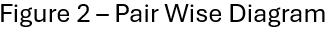
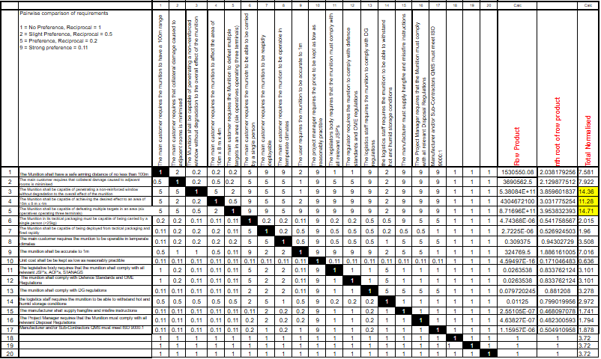
Using what can be seen from the pair wise diagram shown in Figure 2 the two requirements that are most critical for the success of the system are ‘The munition must be capable of defeating multiple targets in an area (6 operatives operating three terminals)’ and ‘The munition must be capable of penetrating a non-reinforced window without degradation to the effect of the overall munition’. These two requirements then became the main focus of the team when developing the solution.

Producing a Solution
The team produced a set of functions which the solution would have to complete in order to successfully meet the brief. The team worked together in collaborative meetings to determine the functions, drawing on the members individual skill sets within the team to make sure no crucial functions were missed. These functions were then paired against the requirements given by the customer in order to determine what the crucial steps of the solution would be. The Quality Function Deployment (QFD) table below shows the method used to score the functions.

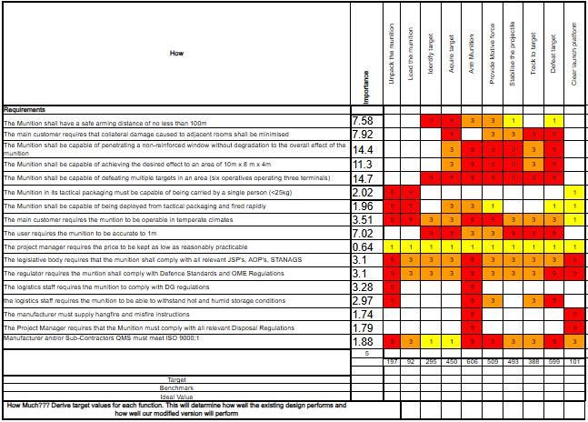

The greater the number the greater the requirements affect the function. The most critical function was deemed to be the ‘arm munition’ function. The importances of each requirement are used in the table to act as a weighting to measure the function.

Solution Selection
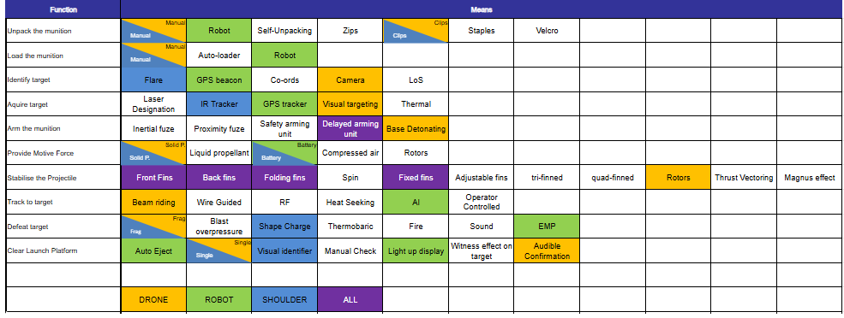
Using a Function Means Analysis (FMA) the team worked together to formulate as many different means as possible to complete each function so that three different proposed solutions could be formed.

Using the wide array of ways to achieve each function the team developed three distinct solutions to the given brief. The table is colour coordinated to show the three solutions. The team decided to give each solution a general theme, one theme was a drone based system, one was a shoulder launched system, and the final solution was intended to use techniques that may not be viable yet but with future technology develops could be an viable innovative solution.
The formed solutions were put into a Pugh matrix which is used to measure different solutions against each other using the requirements as a metric that each solution has to be able to achieve, if a solution meets the requirement then it is given a score of 0, if a solution slightly exceeds the requirement then it is given a score of 1 and if it greatly exceeds the requirement it receives a score of 2 the opposite is applied for if a solution does not reach the requirements.
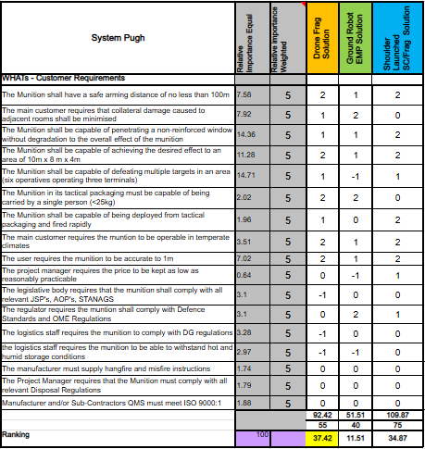

The Pugh Matrix shows that first solution, the drone solution, is the solution that fulfils the requirements the best of the three solutions. Future iterations of the design could be proposed to incorporate solutions that achieve the goal better, one of the extended tasks of this challenge was to see if the communications towers could be eliminated without risking the lives of the operators so developing a solution that achieves that goal could improve the system as a whole.

Determining Criticality
Criticality is defined as ‘the fact of being extremely important’ [2], in the context of this report it refers to the most important subsystem of the chosen solution. The first step to achieve solutionising this was to work within the team to determine what each individual sub-system would be. The team had several different meetings where they discussed what the concept would look like in further detail so that they could determine different sub-systems. Once the team had determined the subsystems the data could be then inputted into a second Quality Function Deployment (QFD), this can be seen in figure 6 below.
Quality Function Deployment (QFD) 2 works by multiplying the importance of each functionality by the score given to it in the means column along the top, the score is determined by how closely the function links to the means, for example manually unclipping the box for the munition is heavily linked to how the munition is un-packed but as no link to how the target is acquired. There are 3 scores; 9, 3 and 1, the closer the link the higher the score received is, the team worked together to successfully score each individual means using in person discussions and debates.

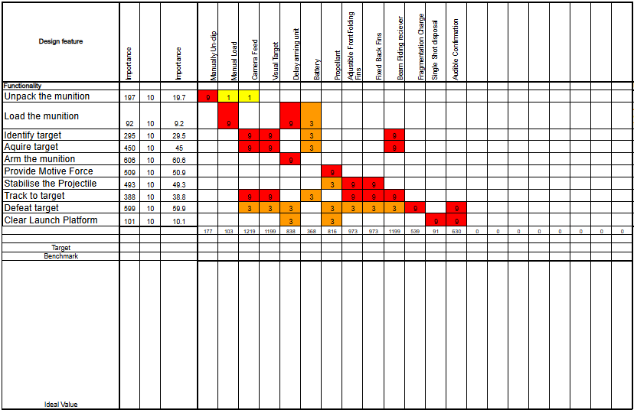

What can be seen from the Quality Function Deployment (QFD) above is that the most critical sub component of the solution is the camera feed closely followed by the visualization of the target and the beam riding receiver, this can be seen by looking at the small score at the bottom of each of the columns, this is taken from the scores assigned and how important each function is as earlier determined in the first Quality Function Deployment (QFD).

Further Analysis
The team discussed where to look further at the solution, the usual approach is to use the most critical sub system outlined by the second Quality Function Deployment (QFD) but as the team expertise lay more in the energetics area the team decided to use the high explosive and fragmenting sleeve as that played more into the teams skill set and fitted better with the course as a whole.
The team worked together to develop a P – Diagram for the High Explosive and the Frag Sleeve as a combination. A P – diagram stands for ‘parameter’ diagram and shows the input of noise factors, signal factors and control factors to get an output. The desired effect for the combination was high explosive fragmentation scattered omnidirectionally around the target area with intent to immobilize the communications terminals and its operators.
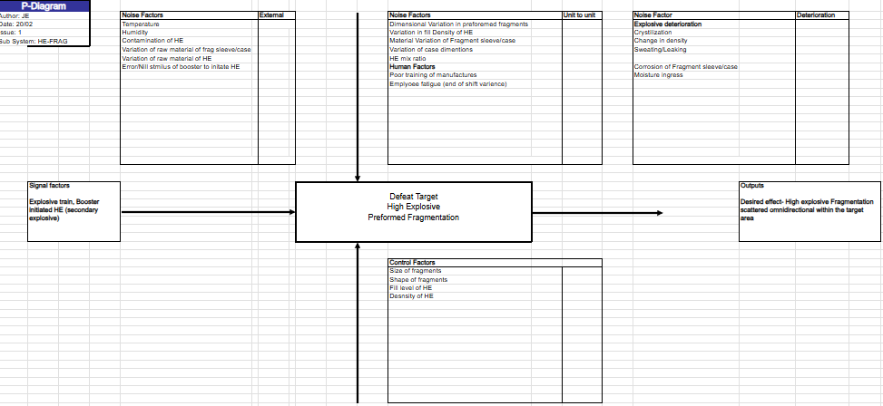

The noise factors were split into 3 categories; external noises, unit to unit noises and deterioration noises. External noises refer to noises not directly in control of the process such as humidity and variation in the high explosive base materials. Unit to unit refers to when it an error caused by an operator such as if the high explosive was not mixed enough or if the ratios were to be off, it can also be due to the operators themselves getting tired or if they haven’t been trained in the processes. Deterioration noises are noises that tend to occur as a result of long term storage such breakdown of the high explosive via ingress of moisture or crystallisation, this can cause the explosive to become unstable and self initiate which can be dangerous. Signal factors refer to how the process is initiated, in this case that can be done either by completing an explosive train which means using a secondary explosive to initiate the high explosive. Control factors are the areas that are within the control of the user of the system, the user has the ability to control factors such as size of fragmentation, this is done by changing the formation of the fragmenting sleeve, the fragmenting sleeve is broken apart by the high explosive after initiation, the way it made has the ability to determine the number, shape and size of the fragments produced.

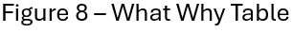
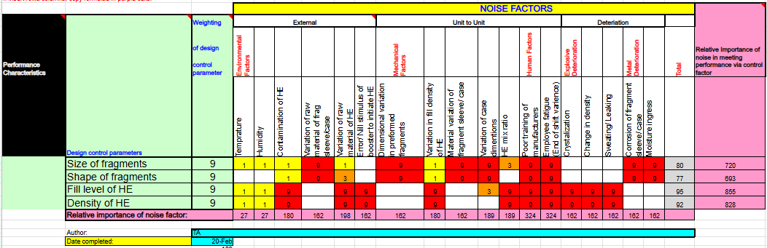
A P – Diagram is used so that there is data to fill out a what why table, a what why table compares the noise factors of a function and compares it with the control factors of the same function. These are then scored so that a relative important for each can be determined, this will then be used in a later process.

The what why table shows all of the noise factors along the top as well as the sub sections that they are divided into. On the left hand side of the table is where the four control parameters are situated and next to them are the weightings, the team did not make a decision what the individual weightings should be so in order to be consistent with the rest of the report the weightings were to set as the same across all of the different parameters.

The table shows that ‘poor manufacturer training’ and ‘employee fatigue (End of shift variance)’ were the key noise factors as they greatly affect each design control parameter. The table also shows us that the design factor with the greatest influence from noise factors is the level that the high explosive is filled to, as there are more noise factors that affect the high explosive rather than the fragmenting sleeve and the fill level is also affected by the container being filled whereas that has no effect to the density of the fill itself.

Manufacturing the System
Prior to manufacturing certain requirements need to be met. These can be determined by making a flow chart that shows the key customer considerations and what make up those key considerations, this is laid out in figure 9 below.
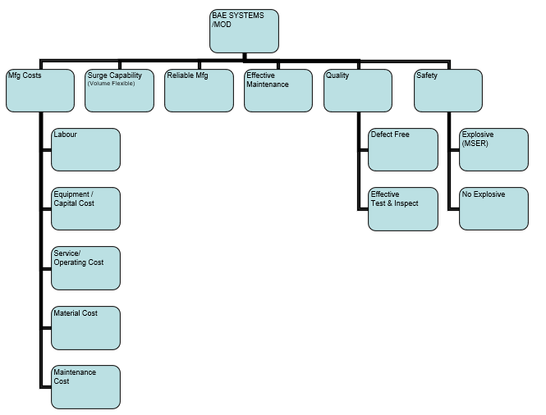

The team developed these requirements with heavy influence from the team member that had been designated the task of manufacturing as the member already had prior experience in manufacturing so was able to lead and guide the decision making process.

The team then produced a manufacturing flow chart to show how the high explosive and fragmenting sleeve would be produced. The team went through what the different stages of manufacture and also commented on different standards and parameters the manufacturer had to be kept to.
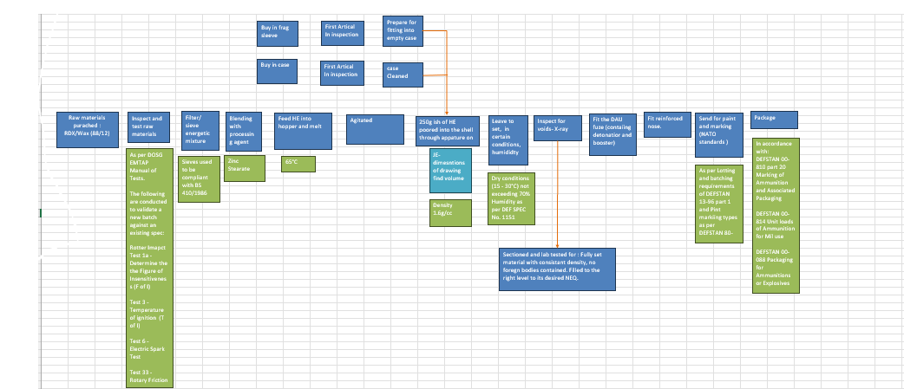

The manufacturing flow chart was combined by the team with the requirements already set out into a third quality function deployment (QFD) to show the most crucial manufacturing step.
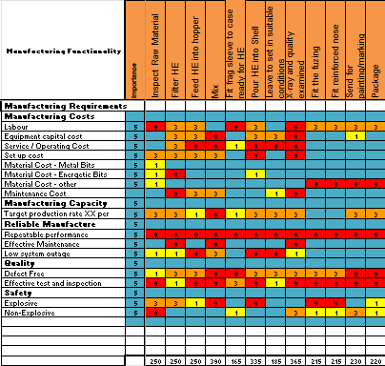

The table shows that the key manufacturing step is the mixing, with a score a 390 it was the highest scoring closely followed by the examination with x-ray step. The mixing was the most critical as it was heavily involved with a lot of the requirements.

Conclusion
This report outlined the design and manufacturing process taken to develop and achieve the requirements set out at the beginning of the project. It showed the teamwork used to collaboratively undertake each step of the design progress and how using the acquired knowledge of individual members a solution capable of achieving the given brief.
The concept ultimately produced had room for improvement but achieved what it was set out to do. Though, if the task were to be repeated, then steps the team could have gone through to improve the design would have been to consider the stretch goals, such as to try and develop a solution that was able to defeat the communications towers without causing injury to the personnel working in the communications centre.
The solution that the team develop eventually had two separate ways that the rocket could be fired at the target so a further development point could have been to think of way to cut down the costs and only use one system or develop a greater reasoning for why the team did it the way it was done.

References

[1] Bode, Hendrik W., Holstein, William K.. "systems engineering". Encyclopaedia Britannica, 2 May. 2025, https://www.britannica.com/topic/systems-engineering.

[2] Criticality | English meaning - Cambridge Dictionary. Available at: https://dictionary.cambridge.org/dictionary/english/criticality.

