Group G Project
University of Wales Trinity Saint David

Pipe Climbing Challenge
Task 2

Group Members:
Omaira Hernandez 1802664
Peter Olliffe 1806692
Wesley Patrick 1701708
Daniel Wilcox 1802007

Dan Wilcox Electronics concept development
Figure 1.1: Circuit one.
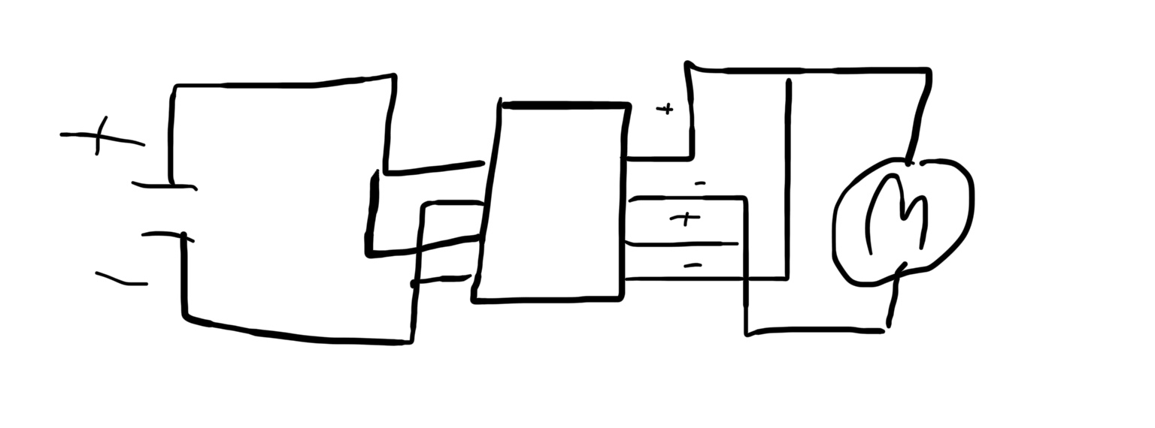
After writing the specification, it was known an input will be required to turn the motor around to return to the bottom. It was also known the device will require electric power and a motor.
From this, a simple electronic circuit was drawn as seen in figure 1.1. The circuit reverses polarity of the motor when the switch is thrown at the top of the pipe. This will mean the device will ‘reverse’ down the pipe to the base.
Figure 1.2: Circuit two. Two switches 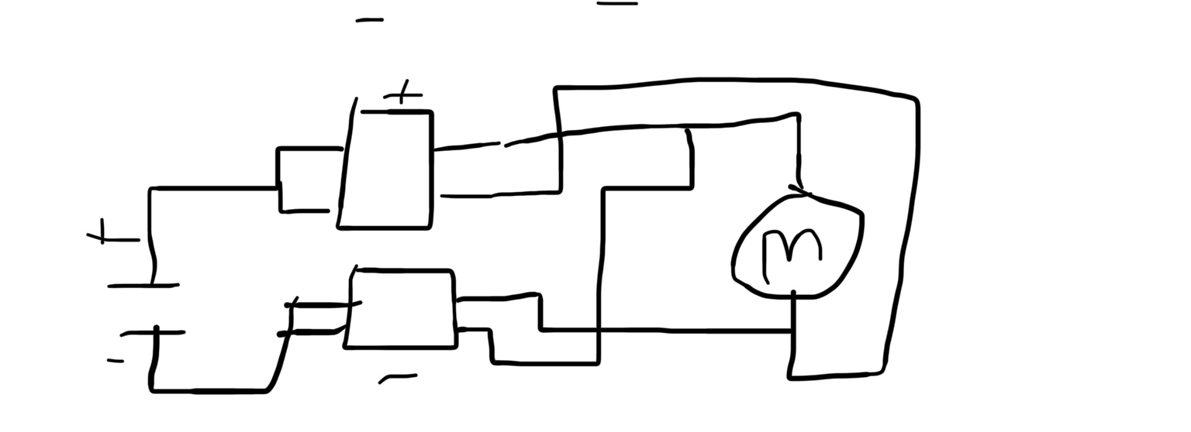
Figure 1.2 shows a development of this. The single switch which could have been thrown incorrectly and was hard to source has been changed to two SPDT switches. These will be thrown at the same time as they will be the highest point of the circuit so the top of the pipe will push the switch into reverse switching the direction of travel for the device.
Figure 1.3: Circuit 3. DPDT
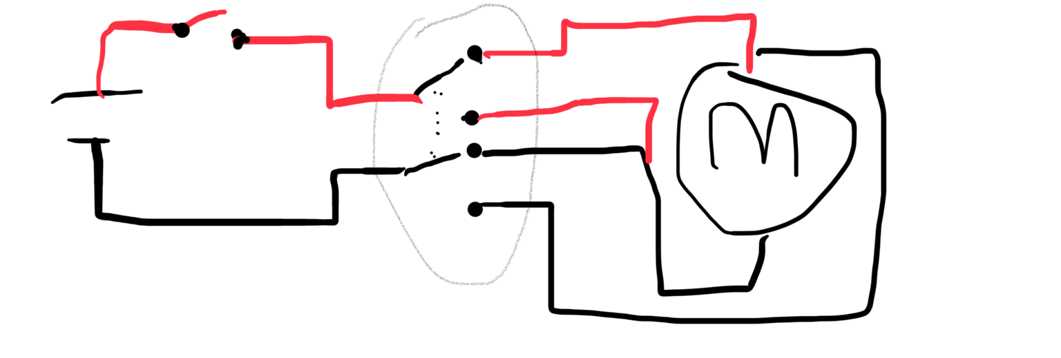
The next development will be a SPST switch to simple act as an on/off switch. This will increase battery life and reduce wear on the mechanism as can simple control the motor and drivetrain when the device is being attached on the pipe and when it completes the challenge.
To incorporate my circuit into the group design, it has been discussed to include the two switches onto the exterior at the top of the frame and enough space is required in the frame for the motor and mechanism. Then enough wire is required for all this. Batteries will try to be place towards the centre for a balance of mass but also need to be easy to access in the device for maintenance.
Figure 1.4: Circuit 4 LDR Op Amp
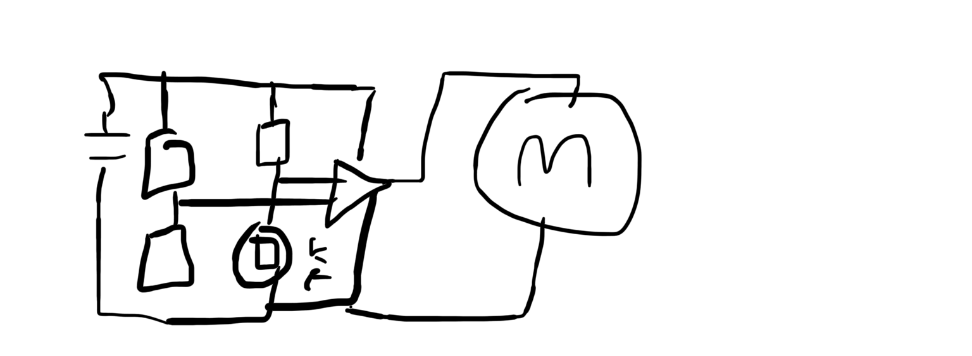
After some research into Double Pole Double Throw switches, it seems they will make a sensible alternative to the two switches. A DPDT will complete the same process but should increase reliability as with Figure 1.2, one switch could have been thrown and not the other. A DPDT will resolve this. This development is shows in Figure 1.3 and red means positive.
Figure 1.4 shows a different approach to the input. When the device reaches the top, the Light Dependant Resistor would go dark, therefore increase in resistance and the Operational Amplifier would be ‘thrown’ and the motor would turn. This system won’t be as reliable as Figure 1.3.

Parts
Figure 1.5:9V motorhttps://uk.rs-online.com/web/p/dc-motors/2389715/
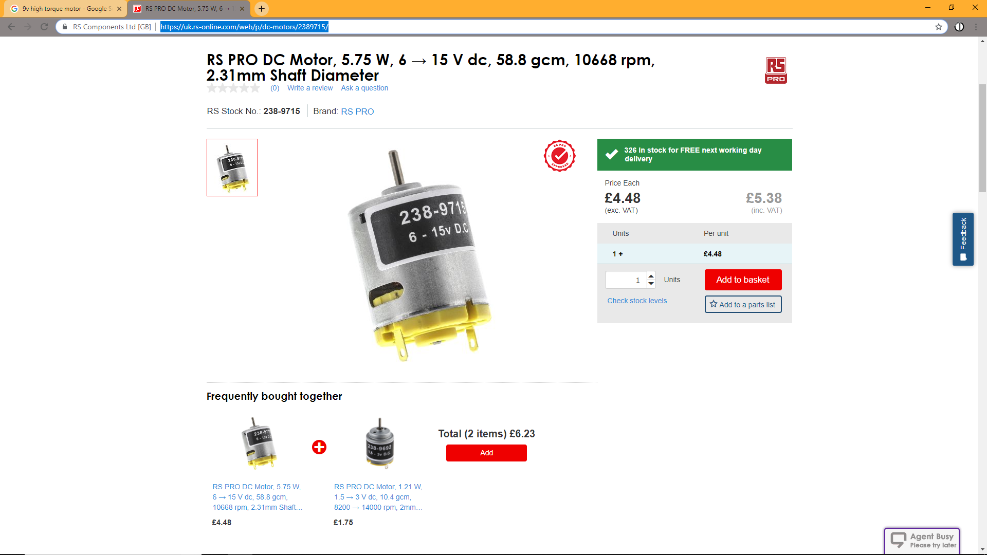
This 9V motor will produce enough torque to propel the device up the pipe. It is expensive but it is almost the only one at a reasonable price than can be delivered in time that matches our requirements.
There is a similar issue with DPDT switches. They can’t be purchased at a reasonable price to be delivered in a reasonable time frame. To get them for the first test, it’s going to be expensive and be purchased in a multipack.
Part | Price GBP | Link To part
9V Battery | 0.66 | https://www.digispot.co.uk/zinc-chloride-battery-pp3-9v-packed-1-per-blister-186152-p.asp?gclid=Cj0KCQiAnNXiBRCoARIsAJe_1cqi27NqRaQf-svg7U0WoWmSzYYub1TAQDS5qWsNlnJks6yyY555xYoaAg_IEALw_wcB
DPDT Switch | 2.29/10 | https://www.ebay.co.uk/p/10-X-RVFM-Ss-22f24-g7-DPDT-Miniature-Slide-Switch/1038083887?iid=362307885141&chn=ps
Motor | 4.48 | https://uk.rs-online.com/web/p/dc-motors/2389715/
SPST switch ( avoided for budget reason)
Wire | 3.40 | https://www.halfords.com/workshop-tools/garage-equipment/fuses-electricals-fixings/halfords-5-amp-cable-red-hef711
Electrical tape | 0.89 | https://www.toolstation.com/insulation-tape/p68110?r=googleshopping&rr=marin&utm_source=googleshopping&utm_medium=feed&utm_campaign=googleshoppingfeed&gclid=Cj0KCQiAnNXiBRCoARIsAJe_1cqgqZwCVFZ5_xxWWekk5nsi1AnOxqS_aOem5cRL6kTTI9vRMlZzmJsaAlfwEALw_wcB
Battery clip | 0.19 | https://www.reichelt.com/gb/en/battery-clip-for-9v-blocks-i-shape-halter-9vi-p113165.html?CTYPE=0&MWSTFREE=0&PROVID=2788&gclid=Cj0KCQiAnNXiBRCoARIsAJe_1coGvCDwGI_-XHrsJ782HcxL9WqyO8IF3VuSixK03vsKb0kX1khEWpIaAlIdEALw_wcB&&r=1
Total | 9.85

From this parts list, it’s observed that the electronics are over the proposed budget for this section. This is far from ideal but all that can be done to create the device before the deadline which is the first stage of competition.
The weight of the chain is 0.302Kg and the motors power is 5.75W and engine speed is 10,600RPM from this we can complete some calculations to check the electronics are to the challenge. We can calculate Torque of the motor as 5.18E⁻⁶Nm. From this stage I will assume the mass of the device will be 0.3Kg then the total mass the motor needs to lift is 0.6Kg. As long as Pete gets a good gear ratio, the motor should be able to achieve this.
Reference
Design Chalenge Specification and Rules, 2018, IMechE https://moodle.uwtsd.ac.uk/pluginfile.php/216835/mod_resource/content/1/DESIGN%20CHALLENGE%20-%20GENERAL%20SPECIFICATION%20V1.1.pdf
Omaira Materials development
To allow the robot moving along the pipe, the robot should have included some wheels. Therefore, from the materials point of view, it must be taken into consideration that the wheels should be made of a material that provides a good surface friction and an excellent grip to the pipe. One of the few materials available with these properties is rubber. Also, due to the high elasticity of rubber as well as its high tensile strength, which does not only give a good shock absorption in the case of an impact but also makes it difficult for the robot to break, rubber should be allocated at the bottom of the robot, considering that this is the part that could be touching the surface in the case of an impact.
Another material option to be place at the bottom of the robot and prevent this one from breaking in the event of a shock is foam. Foam is a lightweight material, cheap and it provides good shock absorption.
To build a robot’s frame, there are a few possibilities amongst the one it could be highlighted: ABS plastic and steel. Steel could be the appropriated material as it is strong as well as light and cheap, however it would require more tooling than plastic. On the other hand, ABS plastic is significantly lighter than steel, it provides construction facilities and a rigid design and is considerably cheaper than steel. Hence, ABS plastic is the chosen material to construct the robot’s frame.

MATERIAL | PRICE | LINK
Rubber wheels  (pack of 3) | £4.99 | https://www.ebay.co.uk/itm/Heavy-Duty-Swivel-Rubber-Castor-Caster-Wheels-Cart-Wheel-50-65-75-100-125-160-mm/361363428635?hash=item5422f0551b:m:mN78osQTe5KBNIMHalfmaVg:rk:10:pf:0
Foam | reused
ABS | £1.99 | https://www.ebay.co.uk/i/282538396426?chn=ps&var=581701183698
TOTAL | 6.98

Foam can easily be reused from a sponge to clean dishes.
Rubber wheels in a pack of 3 cost between 4.50-6.00
A 2 mm thickness ABS sheet cost £1.99. From this ABS sheet we could build a couple of designs if we are not convinced with one.

Pete Mechanisms
Pete Olliffe, Mechanism
The mechanism must allow the driving and coasting wheels to be forced into contact with the copper pipe in order to achieve enough traction for the drive wheel to push/pull the crawler up the pipe. Therefore, it will need to have a mechanism to apply force between the wheel and pipe in order to clamp it together. This will wither be done with a sprung mechanism or using a bolt which will be manually tightened.
In order to keep the design simple and reduce build costs the design will be using one motor which will need to be geared down to provide enough driving force to pull the crawler up the pipe. Therefore, there will only be one drive wheel using a cog system to multiply the torque output.

The driven wheel will be using a rubber tyre while any other wheels will be just to hold the crawler in place. This helps reduce costs in the mechanism and also keep the crawler as light as possible.

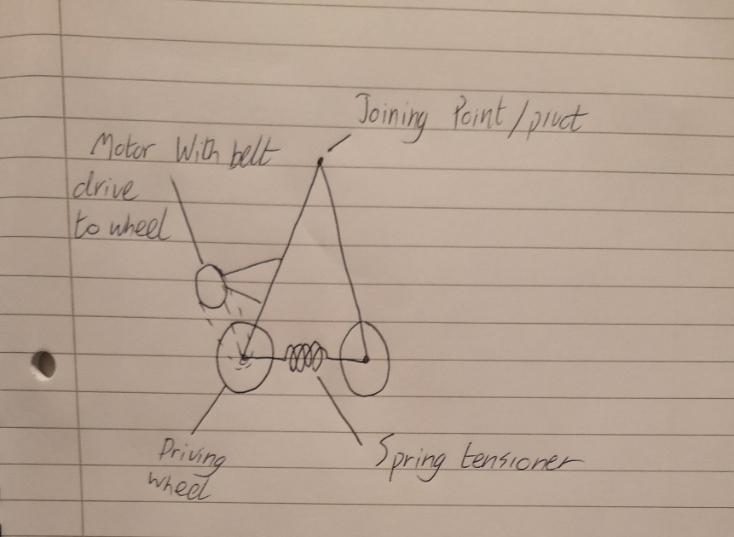(side on view)
My first design idea for the mechanism incorporated a double A frame design around two wheels and using a pair of springs to provide a clamping force on the copper pipe. The A frame would prevent the wheels from moving laterally off the pipe and the combination of the pivot point and springs would enable quick fitting and removal of the crawler to the pipe. The motor would be mounted to one side of the frame and provide a belt or cog drive to the motor which would enable the wheel to be underdrive in order to achieve a greater driving force at reduced speed. With the wheels being the lowest point, they would have to be strong themselves and also be well fixed in order to cope well with the collision that may occur when the crawler returns to the base of the pipe.
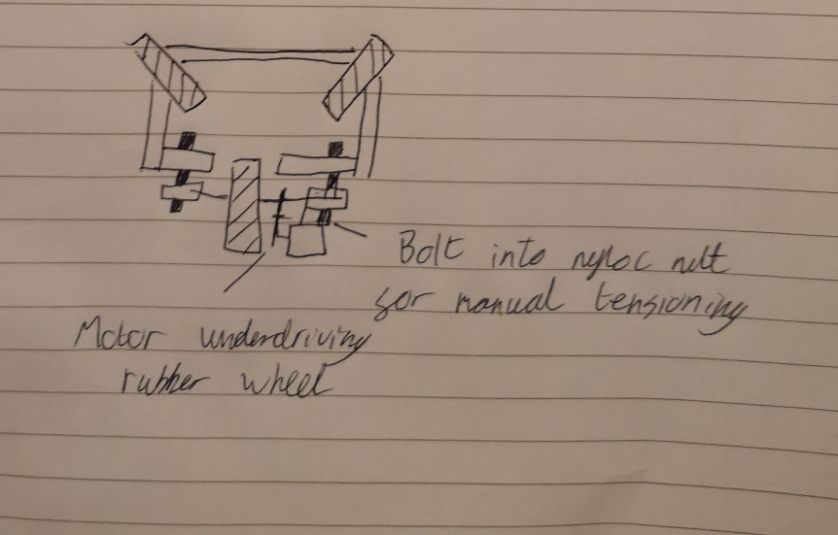(Birds eye view)
My next design uses 2 separate assemblies. One for the free-wheeling wheels and another for the driven wheel. They will be joined by 2 bolts and 2 nuts which could be captive. Using bolts would allow for adjusting the dimensions and allow the wheels to clamp the pipe. They will also provide greater rigidity in the chassis than using a pair of springs would. This may help the crawler travel without flex and loss of traction. This three wheel design should allow for the most stable design as the direction of force applied by the wheels will keep the crawler centralised around the pipe. Again the motor uses a cog system to enable the wheel to be under driven as the torque delivered by a small motor running off a battery power supply may not provide sufficient torque to pull the chain and crawler without gears. The nuts used would be nyloc so that they will not come undone from the vibrations as the crawler ascends causing loss of traction.
Pinion and main gear to increase drive force from motor | £3.45 | https://www.ebay.co.uk/itm/21T-3-175mm-Motor-Pinion-Gears-Main-Gear-64T-for-1-10-HSP-94123PRO-RC-Cars/372401902755?hash=item56b4e214a3:g:zrgAAOSwW2Nbcrbf:rk:18:pf:0  Parts designed for high torque R/C car easily capable of driving the crawler.
Metal axles for wheel mounting | £2-3 | https://www.ebay.co.uk/itm/Stainless-Steel-T303-Rod-Round-Bar-1-6-2-3-4-5-6-8-10mm-Dia-Stock-Metal/223355108211?hash=item3401007b73:m:mYZKiz57mzofoqBYUkEU3TA:rk:1:pf:1&frcectupt=true  Various sizes available.
Bolt and nyloc nut. | <£2 | Only available at higher price per unit or in larger quantities. Price also dependant on thread type an bolt length.

Wes Chassis
Task 2
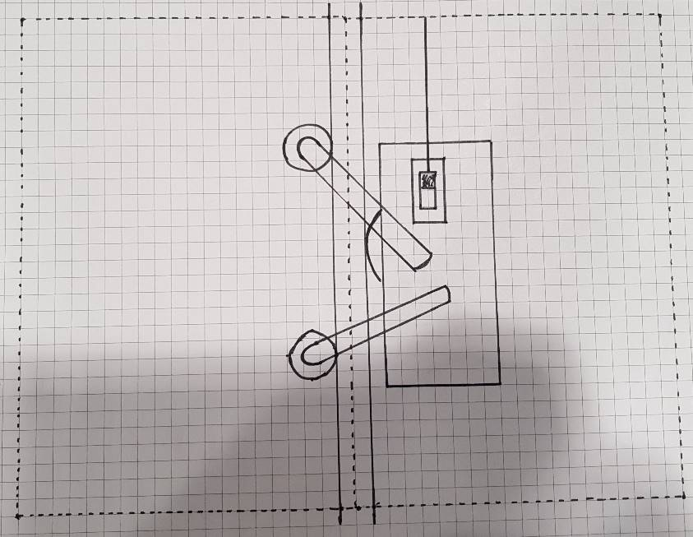
Design selection and final design
Design 1
This design is comprised of one powered wheel with two free wheels on the opposite side of the copper pipe, one above and one below. The mechanics of this design are encased inside the rectangular box. A switch is attached to the side with a pole that extends to the upper limit of that will make contact with the board at the top of the copper pipe, pushing the switch and reversing the motor. A downside of this design is that maintenance may be difficult as the mechanics are sandwiched inside the chassis where it is not easily accessible.
Design 2
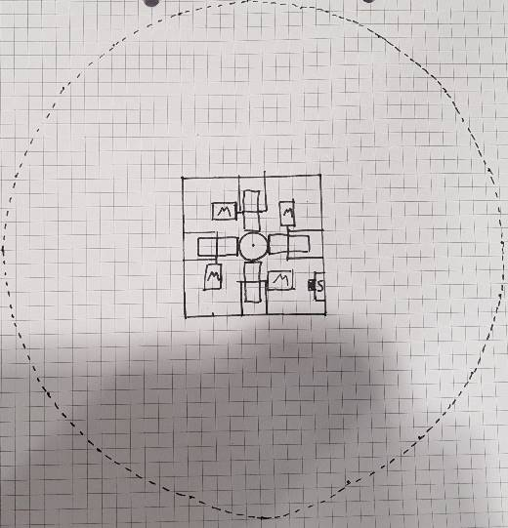
Design 2 is comprised of four wheels each with individual motors that would be connected to the same switch system as the previous design. The wheels are mounted on a single board with a hole in the centre to allow for movement up the copper pipe. To improve durability the deign the board is surrounded by a wall that would cover the upper and lower limits of the mechanics. A downside of this design is that four wheels with four motors would mean the cost of the design rises and also the chance of failure, more components also adds weight and the battery would need to have a larger capacity. A positive of this design is that maintenance would be easy as all the components are easily accessible.

Design 3
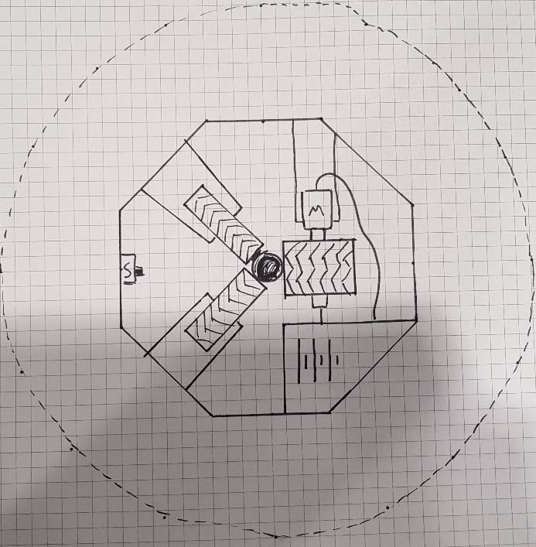
Design 3 is designed inside an octagon wall that extends past the upper and lower extremities, similar to design 2. This design utilises two free wheels and one larger powered wheel, the motor and battery are mounted on shelves which would also where the powered wheel is mounted. The two free wheels are mounted centrally on the opposite diagonal sides so that the copper pipe is completely surrounded by wheels and the pipe climber is supported. The switch system is the same as the previous designs and mounted opposite the powered wheel. Positive notes on this design are easy maintenance and durability and maximises the useable space given to us in the design specification. Downsides to this design are that the shelves might not be the most robust design.
Design 4
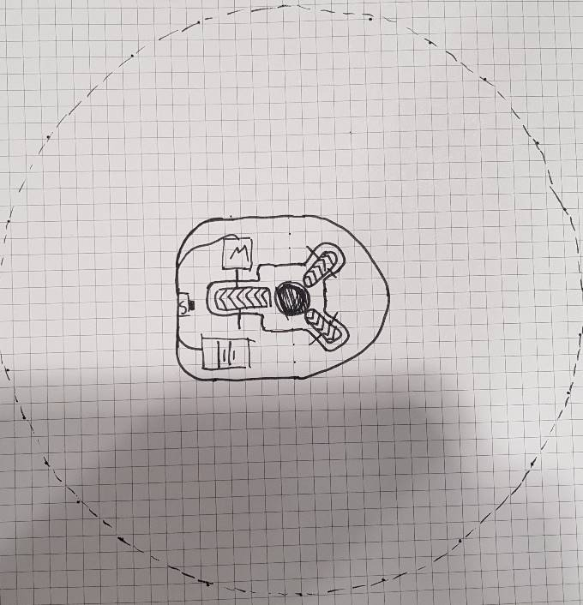
design 4 is the simplest of the designs as it is composed of a single piece chassis with a cut out for the copper pipe and wheels. There are two free spinning wheels and one powered wheel in a similar pattern to design 3. The switch system remains the same as the previous designs. This design is the least robust as there is no impact resistance before the mechanism hits the floor also the design doesn’t look very balanced as the majority of the weight is over to one side of the design which may compromise the run. Positives of this design are the simplicity and the ease of maintenance in case anything were to happen.

Final design
we chose design 3 to develop into a final design by adding fins underneath the shelves to increase robustness from which a hook can be mounted to the underneath to carry the payload. We decided this design would be the most durable and easiest to maintain for completing multiple runs. Below is a CAD design of what this design would look like when complete prior to attaching the wheels and propulsion system.

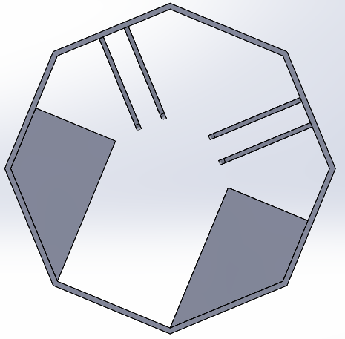

Final Design Proposal
Our final design will include sections from different designs from each subsection to create an efficient and simple final product which is within budget and simple to produce once we have the parts. We worked with our product specification to make sure the product we are producing matches our requirements. WE will produce the pipe climber with 3 wheels, one driven by a 9v motor which is turned at the top of the pipe by a DPDT switch. The frame will be mostly plastic and will be within the size regulations.

