CYBER RESILIENCE AT FINSECURE LTD
Modern policies to meet modern threats
Zoe Selina Clark
Student University of Wales Trinity St David, Swansea, Wales
97011450@student.uwtsd.ac.uk
BSc Degree Apprenticeship Computing (Computer Networks & Cybersecurity)
ACCA4024 – Networks and Cyber Security Essentials

Introduction
This report sets out a proposed security framework with analysis and justifications. FinSecure Limited (FSL) policies, have previously, served the business well. Yet, recent events saw several cyber incidents occur in an environment with increasing demand for digital transactions, online client interactions and cloud-based working.

Working practices are changing, internally and for suppliers bringing potential efficiencies, additional opportunities, and additional risks. The recommendations will support FSL manage risks more effectively in dynamic conditions. Through mapping pathways, FSL moves towards a resilient, and secure future.

Context
As a medium sized, advisory and wealth management services provider, maintaining a trusted reputation is critical and central to FSL. This includes adherence to UK regulation.
This Board commissioned report explores threats, possible impacts and provides recommendations. In addition to internal policies, products and procedures, external influences, including regulatory duties, stakeholder expectations, brand reputation and the wider operating environment are considered which help systemically guide how to manage associated risks.
The scope of this report encompasses protecting FSL assets and networks including any non-cyber measures that directly support this goal.

Understanding the Threats
Not every threat becomes an incident. Tracking threat trends allows FSL to focus resources on the most likely risks. Using available external trusted resources helps identify relevant threats, shaping effective defences and mitigation against impacts (Fig. 1).
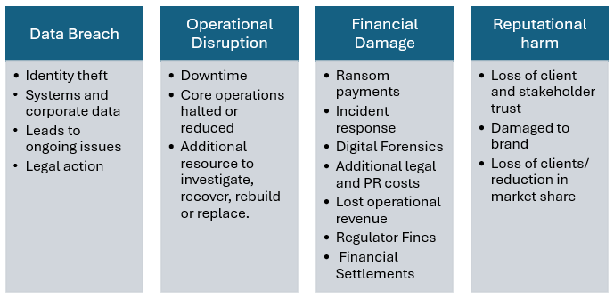
Figure 1: Range of potential impacts [1]

Threat Types
Threats are varied and evolving, however they are generally categorised in some common types (table 1).
- : : CISCO definitions of Common Attack Types [2]
Table 1
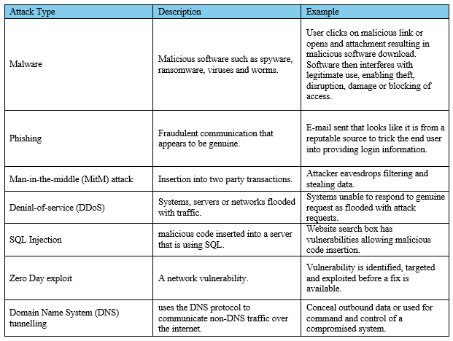
he 2024 UK Government Cyber Security Breaches Survey found phishing caused 84% of breaches among affected businesses. Most threats were described as “relatively unsophisticated.” [3] (Fig 2).
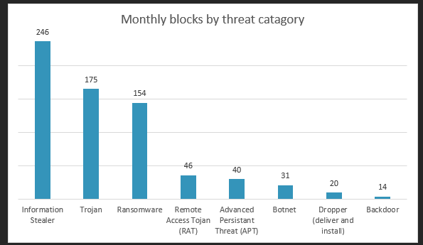
Figure 2: Key findings from Cisco report. Figures recorded in millions [4]

Threat Actors
Insiders pose serious risk due to legitimate authorised access. Increased access and technical skill, increases potential harm, through deliberate action or concealment. Damage may also occur through curiosity, negligence, accident or ignorance (Fig. 3). Sending data to personal accounts, attaching incorrect files, opening phishing links etc. While affiliates are technically external, it is recommended they be considered alongside insider threats as access is enabled through insiders.
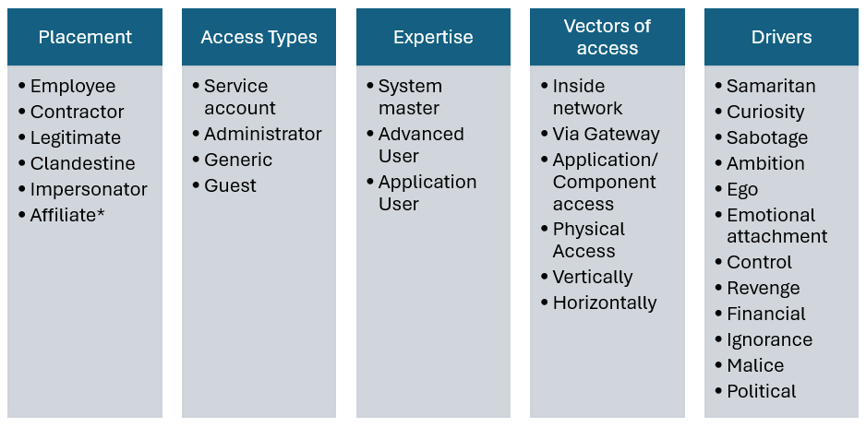
Figure 3: Insider threat actors [5][6]
Technical controls such as monitoring are essential. A holistic approach should support these focusing on the human centric elements. Non-technical measures such as background checks, access approvals, and a “two-person rule” for high-risk actions improve scrutiny of activity. [7]
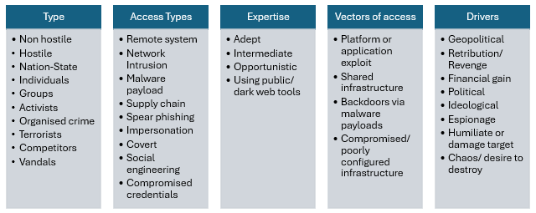
Figure 4: External threat actors [8]

The National Cyber Security Centre (NCSC) 2024 report highlights AI and Ransomware, “one of the most pervasive cyber threats to UK organisations” also drawing attention to supply chains meaning that there are risks link via stakeholder suppliers as well as directly. AI may also make it harder for defenders to identify social engineering attacks. [4]
Emerging cybersecurity challenges to focus on include Supply chain attacks, Hacking ‘as -a-service’ AI, connected smart products especially Chinese manufactured. [9]
AI brings new opportunities and risks, so tools and usage need to be covered by policies and processes to balance risks and maximise benefits.
Researchers demonstrated in 2024 that Microsoft 365 Copilot could be manipulated into replacing genuine bank details with spoofed ones. E-mail content interfered with AI search functionality, causing it to treat the injected data as a legitimate document recovered by the assistant. In live use, trusted content may lead to financial misdirection and loss. [10]
This example highlights both the need to use intelligence in assessing evolving technological threats and the importance of user awareness, supported by clear policies and procedures for safe system use

Tactics
More detailed intelligence can be gathered from the MITRE ATT&CK knowledgebase (Fig. 4) the volume of “Defence Evasion” indicates that awareness and measures to monitor for these techniques is essential.
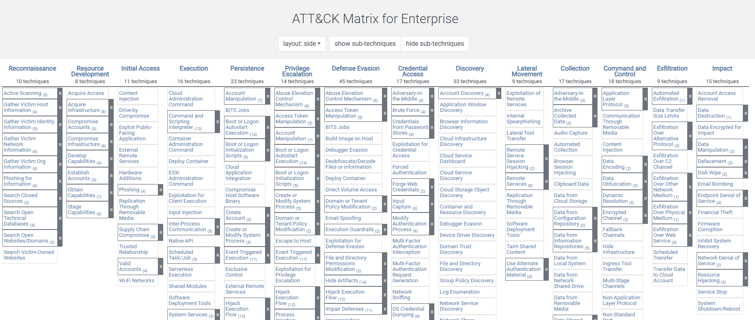
Figure 5: ATT&CK Matrix. Shows the variety of attack types and techniques. A recommended intelligence resource. [11]
Common tactics exploit familiar platforms and interactions. Awareness and vigilance are essential.

Social engineering persuades or misleads users into unsafe actions, such as clicking links or disclosing information, without using technical force. Often involves building trust through a false story or persona (pretexting) [12].
Examples include phishing, malicious links, compromised sites, denial of service, email attachments, social engineering, software exploits, detection evasion, and use of built-in software functions to create remote access backdoors. Cisco recommend Domain Name System (DNS) monitoring, endpoint security, regular patching, backups, user education, and incident response [4]

Enviroment to be protected
Remote working, increased use of cloud services, supply chain access, and personal or smart devices have expanded the digital environment. This increased exposure, introducing new entry points. Common issues include misconfiguration, outdated infrastructure, and limited visibility. These are actively exploited through ransomware and phishing, often made possible by poor segmentation and weak access controls. [13][14]
Physical access to systems and critical areas should be controlled through appropriate building access measures. This complements other controls and prevents local compromise.

Looking ahead – Risks and Measures
Cyber risk results from the likelihood of a threat exploiting vulnerability (Fig. 6). Risk is assessed, recorded, and managed in line with business needs and business appetite. Once assessed, it can be avoided, transferred, accepted, or treated. Controls should work over time, with residual risks documented and regularly reviewed. Priorities are identified by combining likelihood and impact. For example, weekly phishing attempts with blocked credential use may be rated “High” likelihood, “Medium” impact [15-16].
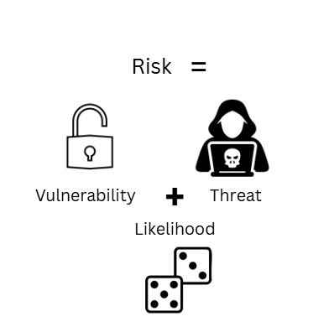
Figure 6: Risk as the likelihood of a vulnerability being exploited by a threat, this helps define what might happen, how and the probability
Incidents can be costly and cause long lasting damage and losses beyond the immediate incident, so risk need to be actively managed. [17] Equifax settled a financial penalty with the Financial Conduct Authority (FCA in 2023 for a 2017 data breach of at £11,164,400 (after 30% reduction agreed). [18]
Risk management also links up with FSL responsibilities under the FCA standards which also cover controls, cyber resilience and risk assessment. [19]
Emerging and silent cyber risks [20] may not be fully captured by existing policies, cyber insurance is worth exploring. [21] To ensure value for FSL, detailed research is recommended. German studies have pointed out variation in cover and exclusions. [22] Therefore is recommended to carry out regular research and review of risks. Expanding connected services may introduce unmanaged exposure [23] Exercises such as vulnerability scanning and penetration testing are recommended to assess potential risk and effectiveness of mitigations and measures. [24]
The aim is to find a balance (Fig. 7). Preventing access completely secures data but prevents business operation. High tech email filtering may be desirable but leave no budget for crucial monitoring tools.
Others in the business that may be impacted by risks should be involved or consulted in risk assessment. This will help inform this balance and capture operational business needs.
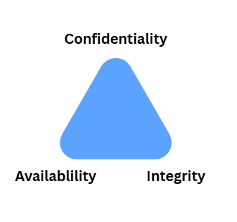
Figure 7: Balance between Confidentiality, Availability and Integrity

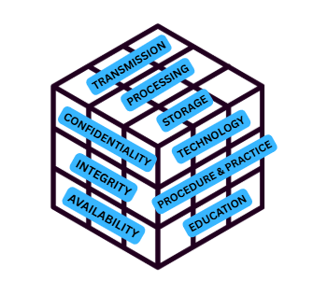
Figure 8: A McCumber Cube builds on CIA and assists in considering where and when data should be protected.
From here polices can define intent and should align with overall business aims as cyber security supports and defends the core functions of the business.

Policy, define and align
Security policies set the rules, responsibilities, and process expectations that support secure working across the organisation. They set out technical and procedural requirements, such as access rights, password rules, encryption, and how incidents should be reported or escalated. Enforcing these reduces the risk of data breaches and unauthorised access. Compliance ensures policies are followed, and supports secure asset management, contract oversight, and prevention of internal misuse. Regular audit identifies weaknesses in how policies are applied, supports continuous improvement, and keeps risk management effective. As threats and technologies change, audit and review ensure policies remain relevant and risks stay within acceptable limits [25].

Compliance and guidance
As seen with Equifax, non-compliance can incur fines. Meeting legal obligations may also increase security and build trust with stakeholders. Guidance and Frameworks can give advice and structure to planning and policies. It is recommended FSL policy refers to those in table 2.
Table 2: Relevant legislation, frameworks and guidance [26-33].
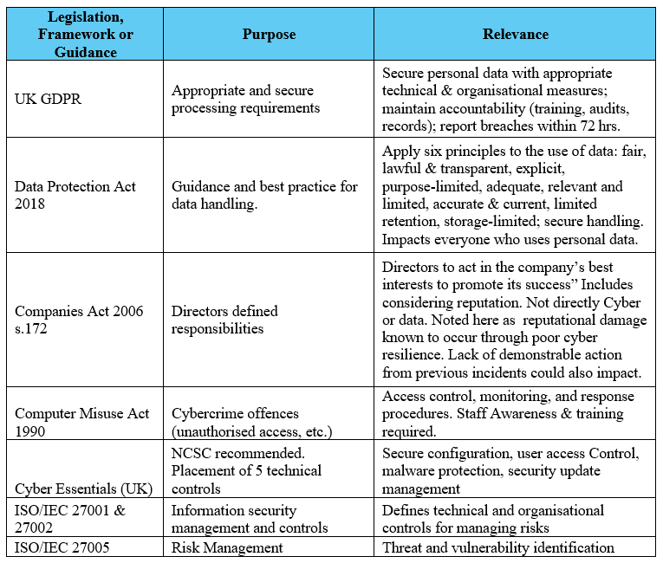
Resources such as NCSC, Government publications and professional organisations like Deloitte can assist with regular review and keeping up to date with regulations in development. Making use of Frameworks such as Cyber Essentials [31] can assist with establishing and reviewing organisational policies and processes.
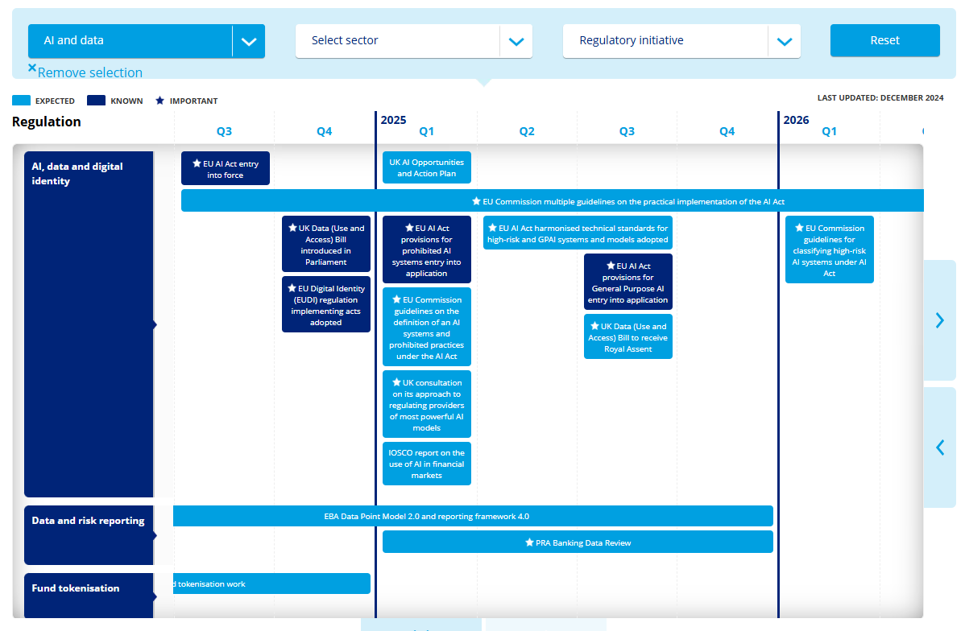
Figure 9: Shows the upcoming volumes and prominence in regulation around AI that will require forward planning by FSL. [34].

Proposed Policies
Each policy should set out its purpose, who it applies to, and how it supports risk reduction. This helps staff understand expectations and sets a clear line of accountability. Security is strengthened by more holistic design, control, and behaviours.
Table 3: Proposed policy framework for FSL
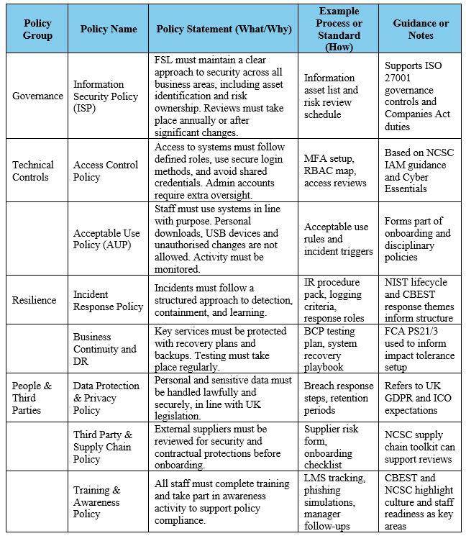

Mitigation Measures
A layered control approach is recommended, using recognised standards and practical measures to address identified threats. ISO/IEC 27002:2022 outlines four types of controls: preventive, detective, corrective, and compensating [33]. These should be selected and applied according to the organisations current risk assessment and reviewed regularly.
Table 4: Measures in the form of controls to manage risk [33]
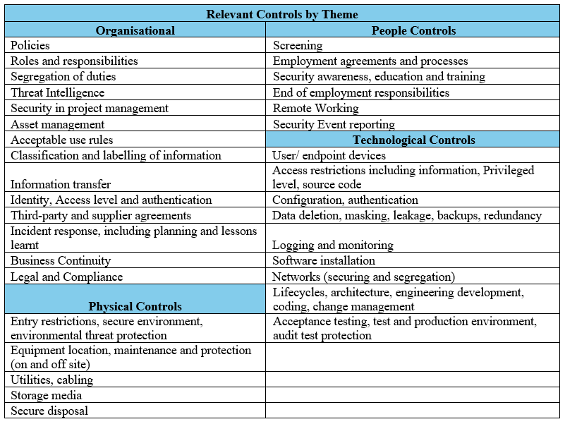
Preventive controls such as MFA and encryption reduce the chance of compromise. Detective controls, including logging, monitoring, and alerting tools, enable early identification of suspicious behaviour. Corrective controls e.g. tested recovery plans, backup processes, and response playbooks help restore systems and isolate further impact. Where gaps exist, compensating controls such as awareness programmes or insurance can help reduce risk. Together, these controls should work in layers across organisational, technological, people, and physical domains (defence-in-depth) [35] to support resilience and maintain proportionality with risk.
The control types can be seen applied, within groups in table 5.
Table 5: Improving Cyber Resilience. cybersecurity Best Practice Testing (CBEST) review findings mapped to related control types [36-37]
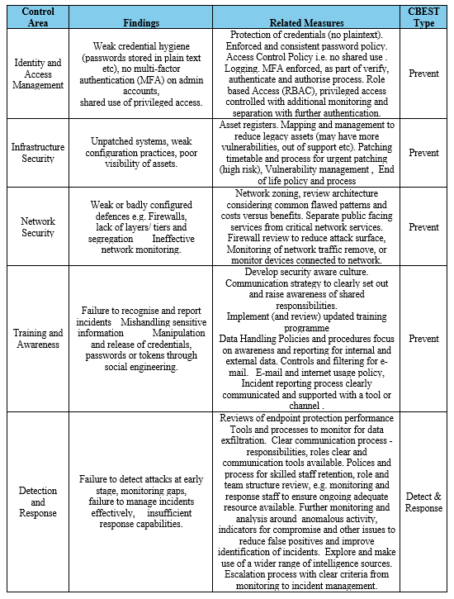

Monitoring and Response
Monitoring detects unauthorised or unusual activity across systems, files, and network traffic. As systems expand, especially with Internet of Things (IoT), high volumes of data can lead to missed threats if logging rules are unclear. Overloaded firewalls and Intrusion Detection Systems (IDS) are also less effective when overwhelmed by high traffic volume and variety [38].
Endpoint Detection and Response (EDR) improves detection accuracy across devices, speeds up isolation, and reduces false positives [39]. Logs showing time, source, and type of activity support detection, investigation, and recovery. Audit trails allow review of actions taken, supporting post-incident analysis.
Alerts from monitoring are passed to the Security Operations Centre members (SOC) for triage. These are categorised by severity and impact, helping teams focus on what poses the greatest risk. This avoids wasted effort on low-level events and ensures higher-risk activity is acted on quickly. An incident is any event that disrupts or threatens normal service or system operation. The aim of the process is to mitigate impact and maintain service levels. [40] Communication processes and roles
Monitoring and incident response involves continuous and circular process aimed at improvement and updating (Fig. 10).
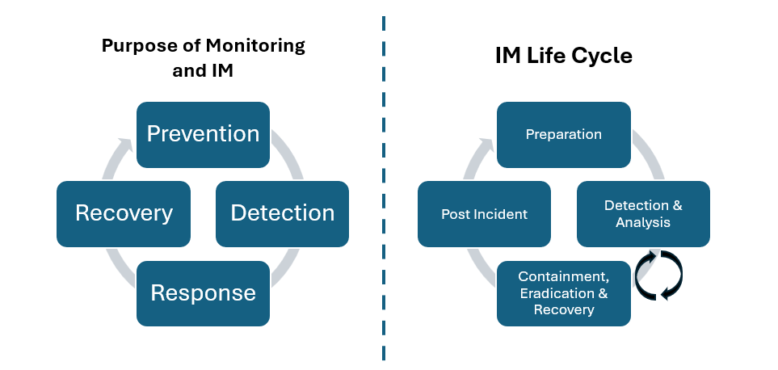
Figure 10: Incident management purpose and process (National Institute of Standards and Technology (NIST) [41-42]
Response plans must define roles, escalation points, and agreed actions. Playbooks (incident guidance) support consistent handling. Post-incident reviews help capture lessons and improve future readiness.
Activities can support effective incident management (Fig. 11). These support readiness, reduce handling delays, and ensure processes remain fit for purpose.
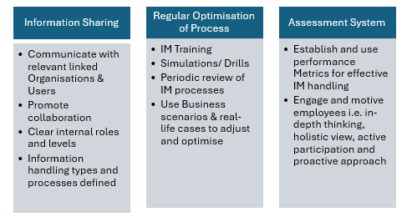Figure 11: Important aspects of Incident Management. [43]

Please refer to Annex A for detail on the process. Table 6 outlines a plan to be implemented promptly, then maintained through regular review as part of circular improvement and good practice.
Table 6: Proposed ongoing monitoring and Incident Management plan. [44]
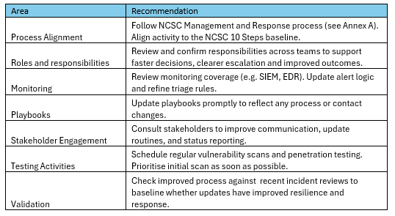

Secure mindsets and application, training FSL.
The most advanced technical controls are ineffective without an informed workforce. FSL therefore adopts a continuous‑learning approach:
As FSL policies are tailored to organisational drivers and specific risk appetite, new staff will require security training that explains and supports the policies. This will help clarify and build understanding before they interact with the controls and processes informed by the policies.
Recommended approaches an activities are set out and described in table 7.
As policies and threats can change it is recommended that an annual refresher be given to staff. If there are significant changes or threats between this additional awareness activities and training should happen as soon as feasible.
Using a variety of techniques and approaches in training is recommended to suit different learning styles and make the content engaging. To build security mindsets and culture engagement is key. Breaking down information, making it relatable to the working environment and not overwhelming with technical detail is recommended. Using text based and game-based training is also recommended to have positive impact on long term habits and behaviours. [45]
Table 7: Plan of action for FSL training programme.[45-46]
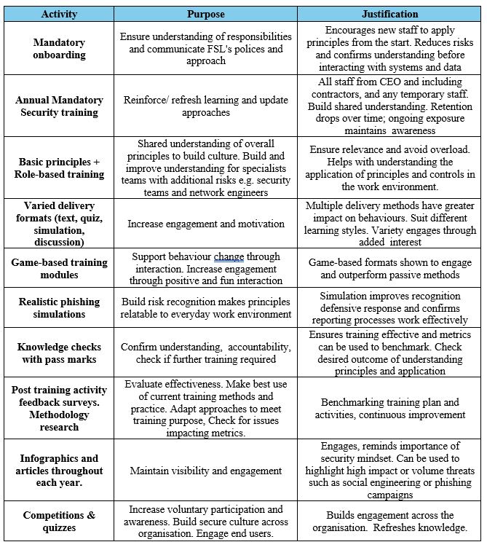

Conclusion
The evolving operating environment for FSL requires an adaptive, layered approach to build cyber resilience. Awareness of relevant threats is key supported by a clear framework of policies, controls, and staff-focused actions that reflect industry best practice and regulatory expectations. By embedding these measures, FSL can enhance its operational resilience, reduce incident likelihood, and protect its clients, assets and reputation in an increasingly dynamic digital operating environment.

appendices

Appendix A

PowerPoint file “Cyber Resilience at FSL uploaded separately
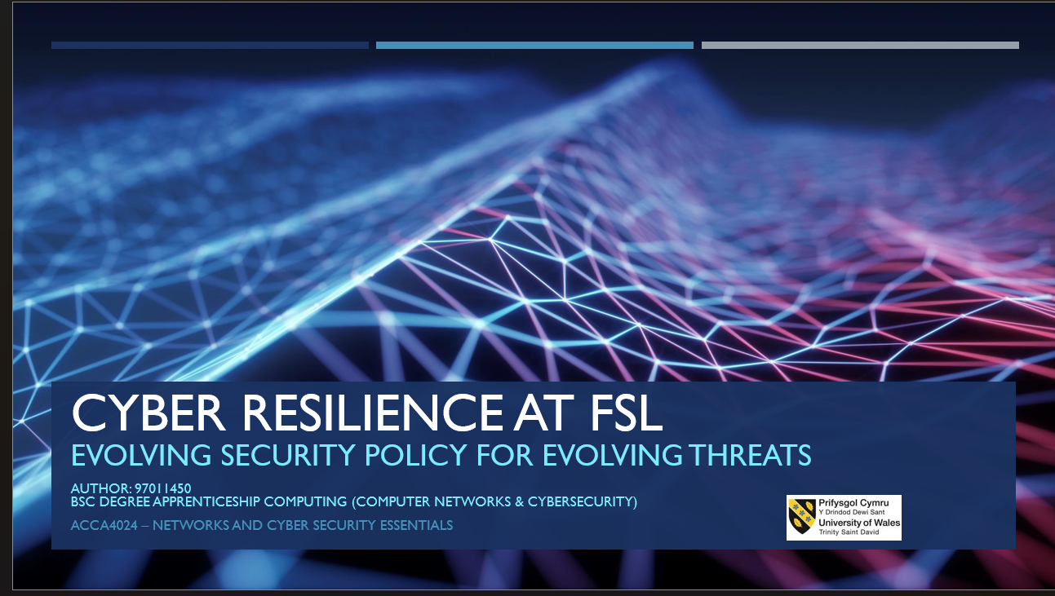
Figure 12: Screenshot Appendix A cover page

Appendix B
Excel file ‘Cyber Assignment Figures uploaded separately.
Document contains tables and images from report.

  - Table of Figures
Figure 1: Range of potential impacts [1] 1
Figure 2: Key findings from Cisco report. Figures recorded in millions [4] 2
Figure 3: Insider threat actors [5][6] 2
Figure 4: External threat actors [8] 2
Figure 5: ATT&CK Matrix. Shows the variety of attack types and techniques. A recommended intelligence resource. [11] Common tactics exploit familiar platforms and interactions. Awareness and vigilance are essential. 2
Figure 6: Risk as the likelihood of a vulnerability being exploited by a threat, this helps define what might happen, how and the probability 3
Figure 7: Balance between Confidentiality, Availability and Integrity 4
Figure 8: A McCumber Cube builds on CIA and assists in considering where and when data should be protected. 4
Figure 9: Shows the upcoming volumes and prominence in regulation around AI that will require forward planning by FSL. [34]. 4
Figure 10: Incident management purpose and process (National Institute of Standards and Technology (NIST) [41-42] 6
Figure 11: Important aspects of Incident Management. [43] 6

Table 1 1
Table 2: Relevant legislation, frameworks and guidance [26-33]. 4
Table 3: Proposed policy framework for FSL 5
Table 4: Measures in the form of controls to manage risk [33] 5
Table 5: Improving Cyber Resilience. cybersecurity Best Practice Testing (CBEST) review findings mapped to related control types [36-37] 5
Table 6: Proposed ongoing monitoring and Incident Management plan. [44] 6
Table 7: Plan of action for FSL training programme.[45-46] 7

References
[1] H. Li, Y. Wu, D. Cao, and Y. Wang, “Organizational mindfulness towards digital transformation as a prerequisite of information processing capability to achieve market agility,” Journal of business research, vol. 122, pp. 700–712, 2021, doi: 10.1016/j.jbusres.2019.10.036
[2] The National Archives, “Data Protection Act 2018”, legislation.gov.uk. [Online] Available: https://www.legislation.gov.uk/ukpga/2018/12/contents/enacted pub The national archives [Accessed Jun 16, 2024]
[3] The National Archives, “Data Protection Act 2018”, legislation.gov.uk. [Online] Available: https://www.legislation.gov.uk/ukpga/2018/12/contents/enacted pub The national archives [Accessed Jun 16, 2024]
[4] PCI Security Standards Council, “PCI DSS: v4.0?”, pcisecuritystandards.org, (Mar, 2022) [Online] Available: https://www.codecademy.com/resources/blog/kernel/ [Accessed Jun 16, 2024]
[5] ISO, “ISO/IEC 27000 family”, iso.org,[Online] Available: https://www.iso.org/standard/iso-iec-27000-family [Accessed Jun 16, 2024]
[6] NCSC, “Cyber Essentials Overview”, ncsc.gov.uk, [Online] Available: https://www.ncsc.gov.uk/cyberessentials/overview [Accessed Jul, 7, 2024]
[7] ISO, “ISO/IEC 27017:2015”, iso.org,[Online] Available: https://www.iso.org/standard/43757.html [Accessed Jun 16, 2024]
[8] ISO, “ISO/IEC 27003:2017”, iso.org,[Online] Available: https://www.iso.org/standard/63417.html [Accessed Jun 16, 2024]
[9] ISO, “ISO/IEC 27000:2018(en)”, iso.org, [Online] Available: https://www.codecademy.com/resources/blog/kernel/ [Accessed Jul 13, 2024]
[10] K. Razikin and B. Soewito, “Cybersecurity decision support model to designing information technology security system based on risk analysis and cybersecurity framework,” Egyptian informatics journal, vol. 23, no. 3, pp. 383–404, 2022, doi: 10.1016/j.eij.2022.03.001. p383
[11] M. Suorsa, & P. Helo, “Information security failures identified and measured – ISO/IEC 27001:2013 controls ranked based on GDPR penalty case analysis,” Information Security Journal: A Global Perspective, vol. 33, no. 3, pp. 285–306, 2023, doi: 10.1080/19393555.2023.2270984
[12] IBM, “Cost of a Data Breach Report 2024”, ibm.com, [Online] Available: https://www.ibm.com/reports/data-breach?utm_content=SRCWW&p1=Search&p4=43700075239447581&p5=e&p9=58700008280240525&gad_source=1&gclid=Cj0KCQjwtZK1BhDuARIsAAy2Vzs6L9xmXPcHVBYIk6E5-Lg9ADcs0in37H4UIMjrIUtdTmMfVbo5MZQaAlVEEALw_wcB&gclsrc=aw.ds [Accessed Jun 23, 2024]
[13] NCSC, “Cyber Essentials Overview”, ncsc.gov.uk, [Online] Available: https://www.ncsc.gov.uk/cyberessentials/overview [Accessed Jul, 7, 2024]
[14] H. E. Amin et al, "An Integrated Approach to Cyber Risk Management with Cyber Threat Intelligence Framework to Secure Critical Infrastructure," Journal of Cybersecurity and Privacy, vol. 4, (2), pp. 357, 2024.
[15] A. Mughaid, I. Obeidat, L. Abualigah, S. Alzubi, M. S. Daoud, and H. Migdady,
“Intelligent cybersecurity approach for data protection in cloud computing based Internet of Things,” International journal of information security, vol. 23, no. 3, pp. 2123–2137, 2024, doi: 10.1007/s10207-024-00832-0.
16] NCSC, “Device Security Guidance”. ncsc.gov.uk, [Online] Available: https://www.ncsc.gov.uk/collection/device-security-guidance/infrastructure/enterprise-authentication-policy [Accessed Jul, 7, 2024]
[17] K. Jawaharrani, R. S. Lekshmi, G. Nirmala, and K. Dheenadhayalan, "Role of CISO - Cyber Security & Risk Management," 2023 International Conference on Advances in Computing, Communication and Applied Informatics (ACCAI), Chennai, India, 2023, pp. 1-5, doi: 10.1109/ACCAI58221.2023.10200017.
[18] S. Perera, X. Jin, A. Maurushat, and D.-G. J. Opoku, “Factors Affecting Reputational Damage to Organisations Due to Cyberattacks,” Informatics (Basel), vol. 9, no. 1, pp. 28-, 2022, doi: 10.3390/informatics9010028. Page 13 (derived from tables 4, 5, 6,)
[19] A. S. and S. D., “Understanding insiders in cloud adopted organizations: A survey on taxonomies, incident analysis, defensive solutions, challenges,” Future generation computer systems, vol. 158, pp. 427–446, 2024, doi: 10.1016/j.future.2024.04.033.
[20] Codecademy Team, “About Cyber Essentials?”, talosintelligence.com, [Online] Available: https://talosintelligence.com/ [Accessed Jul, 24, 2024]
[21] Microsoft, “Security Update Guide” microsoft.com, [Online] Available: https://msrc.microsoft.com/update-guide/vulnerability [Accessed Jul, 24, 2024]
[22] A. Jeyaraj, A. Zadeh, and V. Sethi, “Cybersecurity Threats and Organisational Response: Textual Analysis and Panel Regression,” Journal of Business Analytics, vol. 4, no. 1, pp. 26–39, 2021. doi: 10.1080/2573234X.2020.1863750. – pages 27-29
[23] Financial Times, “London hospitals declare critical incident after cyber attack” ft.com, [Online] Available: https://www.ft.com/content/64ac2bd3-7bff-4323-9263-c70fa0b6ca51 [Accessed Jun, 15, 2024]
[24] Synnovis “Security Update Guide” synnovis.co.uk, [Online] Available: https://www.synnovis.co.uk/news-and-press/synnovis-cyberattack [Accessed Jun, 15, 2024]
[25] R. Pereira, J. B. de Vasconcelos, Á. Rocha, and I. S. Bianchi, “Business process management heuristics in IT service management: a case study for incident management,” Computational and mathematical organization theory, vol. 27, no. 3, pp. 264–301, 2021, doi: 10.1007/s10588-021-09331-2.
[26] [L] M. Thangavelu, V. Krishnaswamy, and M. Sharma, “Impact of comprehensive information security awareness and cognitive characteristics on security incident management – an empirical study,” Computers & security, vol. 109, pp. 102401-, 2021, doi: 10.1016/j.cose.2021.102401
[27] Radu Moisescu and Aurel – Mihail Țîțu, “Improving intellectual property data security at the organizational level as a result of streamlining quality management,” Journal of Research and Innovation for Sustainable Society, vol. 6, no. 1, pp. 88–97, 2024, doi: 10.33727/JRISS.2024.1.11:88-97.
[28] S. N, G. T, R. S. R, A. Sungheetha, C. R, and S. Hamsanandhini, "Secured and Optimized Application Delivery Service in Public Cloud," 2024 4th International Conference on Innovative Practices in Technology and Management (ICIPTM),
[29] P. T. Kalpeshkumar, S. Patel, K. Krimilkumar, B. D. Anilbhai, A. Patel, and A. Nayak, "Navigating the Cloudscape: Framework and Strategies for Seamless Migration to the Cloud," 2024 3rd International Conference on Applied Artificial Intelligence and Computing (ICAAIC), Salem, India, 2024, pp. 1298-1302, doi: 10.1109/ICAAIC.2024.00050.
[30] V. Bhatia, S. Choudhary and K. R. Ramkumar "A Comparative Study on Various Intrusion Detection Techniques Using Machine Learning and Neural Network," presented at the 2020 8th International Conference on Reliability, Infocom Technologies and Optimization (ICRITO), Noida, India, 2020, pp. 232-236, doi: 10.1109/ICRITO48877.2020.9198008.
[31] C. Fan, N. M. Kaliyamurthy, S. Chen, H. Jiang, Y. Zhou, and C. Campbell, “Detection of DDoS Attacks in Software Defined Networking Using Entropy,” 2021.
[32] B. J. Saunders, P. Kisanga, G. H. S. Carvalho, and I. Woungang, “A Graph Convolutional Networks-Based DDoS Detection Model,” in 2024 IEEE International Systems Conference (SysCon), IEEE, 2024, pp. 1–5. doi: 10.1109/SysCon61195.2024.10553611.
[33] M. A. Hossain,Working Principle of IDPS” researchgate.net, [Online] Available: https://www.researchgate.net/publication/348269149_SDN_based_Intrusion_Detection_and_Prevention_Systems_using_Manufacturer_Usage_Description_A_Survey/figures?lo=1 [Accessed Jul, 9, 2024]
[34] M. Hristov, M. Nenova, G. Iliev and D. Avresky, "Implementation of Splunk Enterprise SIEM for Improved Security Posture," presented at the 2021 IEEE 20th International Symposium on Network Computing and Applications (NCA), Boston, MA, USA, 2021, pp 1-5 doi: 10.1109/NCA53618.2021.9685977.
[35] T. Krüger, L. Faulhaber, L. Hermerschmidt, S. Mödersheim, "Securing Your Crypto-API Usage Through Tool Support - A Usability Study," in Proc. 2023 IEEE Secure Development Conference, San Diego, CA, USA, 2023, pp. 1-8, doi: 10.1109/SecureDev.2023.1234567.
[36] S. D. Çakmakçı, H. Hutschenreuter, C. Maeder and T. Kemmerich, "A Framework For Intelligent DDoS Attack Detection and Response using SIEM and Ontology," 2021 IEEE International Conference on Communications Workshops (ICC Workshops), Montreal, QC, Canada, 2021, pp. 1-6, doi: 10.1109/ICCWorkshops50388.2021.9473869. p6
[37] S. M. Z. U. Rashid, A. Haq, S. T. Hasan, M. H. Furhad, M. Ahmed, and A. B. Ullah, “Faking smart industry: exploring cyber-threat landscape deploying cloud-based honeypot,” Wireless networks, vol. 30, no. 5, pp. 4527–4541
[38] U. Bartwal, S. Mukhopadhyay, R. Negi, and S. Shukla, "Security Orchestration, Automation, and Response Engine for Deployment of Behavioural Honeypots," 2022 IEEE Conference on Dependable and Secure Computing (DSC), Edinburgh, United Kingdom, 2022, pp. 1-8,
[39] N. Nagy et al., “Quantum Honeypots,” Entropy (Basel, Switzerland), vol. 25, no. 10, pp. 1461-, 2023, doi: 10.3390/e25101461.
[40] M. E. Whitman and H. J. Mattord, Principles of information security, Seventh edition. Boston, MA: Cengage, 2022.
[41] C. Rohith and G. Kaur, "A Comprehensive Study on Malware Detection and Prevention Techniques used by Anti-Virus," 2021 2nd International Conference on Intelligent Engineering and Management (ICIEM), London, United Kingdom, 2021, pp. 429-434, doi: 10.1109/ICIEM51511.2021.9445322.
[42] M. Botacin, "GPThreats-3: Is Automatic Malware Generation a Threat?," 2023 IEEE Security and Privacy Workshops (SPW), San Francisco, CA, USA, 2023, pp. 238-254, doi: 10.1109/SPW59333.2023.00027.
[43] E. Chikohora and L. Mogomeli, "A Study on the Impact of Network Vulnerability Scanners on Network Security," 2021 3rd International Multidisciplinary Information Technology and Engineering Conference (IMITEC), Windhoek, Namibia, 2021, pp. 1-4, doi: 10.1109/IMITEC52926.2021.9714598.
[44] T. Zhang, H. Huang, Y. Lu, K. Zhu, and J. Zhao, “State-Sensitive Black-Box Web Application Scanning for Cross-Site Scripting Vulnerability Detection,” Applied sciences, vol. 13, no. 16, pp. 9212-, 2023, doi: 10.3390/app13169212.
[45] T. Krüger, L. Faulhaber, L. Hermerschmidt, and S. Mödersheim, "Witcher: A Novel Web Vulnerability Discovery Framework," presented at the 2023 IEEE Symposium on Security and Privacy (SP), San Francisco, CA, USA, May 21-25, 2023. Available: doi: 10.1109/SP46215.2023.10179317.
[46] M. Li, Y. Yang, G. Chen, M. Yan, and Y. Zhang, “SoK: Understanding Design Choices and Pitfalls of Trusted Execution Environments,” in Proceedings of the 19th ACM Asia Conference on Computer and Communications Security, New York, NY, USA: ACM, 2024, pp. 1600–1616. doi: 10.1145/3634737.3644993.
[47] T. Kulik et al., “A Survey of Practical Formal Methods for Security,” 2022, doi: 10.1145/3522582.
[48] S. Hare, "Fallout from the CrowdStrike Global IT Outage," BBC Breakfast, N. Munchetty and C. Stayt, 20 Jul. 2024. [Online]. Available: https://www.bbc.co.uk/iplayer/episode/m0021c4d/breakfast-20072024.
[49] NCSC, “10 Steps to Cyber Security?”, ncsc.gov.uk, [Online] Available: https://www.ncsc.gov.uk/collection/10-steps [Accessed Jul, 28, 2024]
[50] - QA Ltd., “BCS Certificate in Information Security Management Principles (CISMP),” Remote Course, V6.0 PDF notes, QA Ltd., based on BCS CISMP 3rd edition, Jan.–Mar. 2024.
[51] - A. Taylor, D. Alexander, A. Finch, D. Sutton, and A. Taylor, Information Security Management Principles, 3rd ed., Swindon, U.K.: BCS, The Chartered Institute for IT, 2020.
[52] ISO/IEC 27002:2013, "Information technology — Security techniques — Code of practice for information security controls," ISO, 2013.
[53] [2] ISO, “ISO/ IEC 27005:2022”. www.iso.org, [Online] Available: https://iso.org/standard/80585.html [Accessed Jul, 20, 2024]
[54] ISO, “ISO 31000:2018 - Risk management A practical guide”. iso.org, [Online] Available: https://www.iso.org/publication/PUB100464.html [Accessed Jul, 20, 2024]
[55] ICO, “Overview – Data Protection and the EU”. ico.org, [Online] Available: https://ico.org.uk/for-organisations/data-protection-and-the-eu/overview-data-protection-and-the-eu/ [Accessed Jul, 20, 2024]
[56] Department for Science Innovation and Technology, “Cyber security breaches survey 2024”. gov,uk, (Apr, 9, 2024) [Online] https://www.gov.uk/government/statistics/cyber-security-breaches-survey-2024/cyber-security-breaches-survey-2024#chapter-3-approaches-to-cyber-security [Accessed Jul, 25, 2024]
[57] [2] NIST, “Security and Privacy Controls for Information Systems and Organizations”, nist.gov, (Dec 19, 2023) [Online] Available: https://csrc.nist.gov/pubs/sp/800/53/r5/upd1/final#:~:text=This%20publication%20provides%20a%20catalog,human%20errors%2C%20natural%20disasters%2C%20structural/ [Accessed Jun, 20, 2024]
[58] European Commission, “Ethics guidelines for trustworthy AI”, ec.europa.eu, (Apr 08, 2019) [Online] Available: https://digital-strategy.ec.europa.eu/en/library/ethics-guidelines-trustworthy-ai [Accessed Jul, 28, 2024]
[59] - G. Gray et al., “Assessing aeromedical risk: a three-dimensional risk matrix approach,” Heart (British Cardiac Society), vol. 105, no. Suppl 1, pp. s9–s16, 2019, doi: 10.1136/heartjnl-2018-313052

