

An Entrepreneurial University:
Assessing the Strategic Orientation
of
JiuJiang University

Student Number: 1806484
Module Title: Strategic Change and Organisations (LCDB7005)
Module Lecturer: Dr Gladius Kulothungan

1 Introduction
Entrepreneurship is considered to be one of the decisive factors for innovation and economic prosperity (Acs, 2006; Isenberg, 2011; Qian, 2018). Universities has been increasingly interconnected with entrepreneurship in today’s knowledge-based economy because: on the one hand, universities can provide knowledge and human resources, catalyse innovative and entrepreneurial culture, or even become valuable allies or partners of entrepreneurial ventures (Diaconu and Duţu, 2015; Miller and Acs, 2017; Wadee and Padayachee, 2017; Reichert, 2019); on the other hand, entrepreneurship can benefit universities by providing financial investment, improving graduate employment, and facilitating the technology transfer and IP capitalisation (Boh, De-Haan and Strom, 2016; Miller and Acs, 2017). Thus, entrepreneurial university strategy, defined by Guerrero et al. (2014) as “a natural incubator that tries to provide a supportive environment in which the university community can explore, evaluate and exploit ideas that could be transformed into social and economic entrepreneurial initiatives”, is incrementally adopted by Chinese universities as a strategic alternative so as to gain sustained competitive advantage and serve local economy (MOE, 2010).
JiuJiang University (JJU), located in JiuJiang City, JiangXi Province, south-east China, is a public-funded university established by the National Education Ministry and specialised in undergraduate education. As the only comprehensive university in JiuJiang City, JJU has always considered serving the local economy as her primary goal. Currently, there are 22 schools, one affiliated hospital and one affiliated dental hospital within the university portfolio. JJU offers 77 different undergraduate programs, including economics, law, education, literature, mathematics, physics, agriculture, medicine, management, art, etc. And there are more than 34,000 full-time students, 1916 full-time lecturers, more than 800 professors and associate professors on campus.
From 2017, corresponding to the call of the National Education Ministry on promoting entrepreneurship, a major strategic change program, the Entrepreneurial University Program, has been launched by the university board of JJU. The objective of this article is to evaluate the “Entrepreneurial University” strategy of JJU and obtain a better understanding of the strategic changes within the public-funded higher education institutions in China.
It can be argued that organisational strategy is shaped by both external and internal factors (Rothaermel, 2015), thus this study starts by examining JJU’s external forces via PEST model and internal resources through VRIO framework. Then, the article focuses on evaluating the organisational structure of JJU and proposing different alternatives to the structural design.

2 External Factor Analysis
Organisational environments contain potential forces that can affect the organisation’s decision-making, assessing the environmental factors can facilitate the organisation to exploit market opportunities and avoid risks; PEST is a useful and straightforward instrument to “scan, monitor, and evaluate the important external factors and trends” for the organisation (Rothaermel, 2015).

2.1 Political
Political factor generally refers to various governmental policies which can influence the decision-making and behaviour of an organisation (Rothaermel, 2015). For the last two decades, the Chinese Government has been promoting strategic reform and development in higher educational institutions. In the last few years, the process has been accelerated and two major trends have emerged.

2.1.1 The role of universities in serving the local economy
In the 13th Five-Year Plan, the State Council has suggested that it is necessary for universities to implement strategic and systematic changes in terms of organisational structures, programs offerings, curriculum contents, teaching methods, and faculty management in order to promote the cultivation of talents with practical skills, the integration between research and application, the capability of innovation, and to assume the key role in boosting regional economy (State Council of PRC, 2017).
According to the National Medium- and Long-Term Programme for Education Reform and Development (2010-2020), the Chinese Ministry of Education has resolved to facilitate the development of application-oriented universities and stressed the importance of universities in regional development (MOE, 2010). Aiming at facilitating the development of both education and industry, fostering entrepreneurship, cultivating knowledgeable workforce, and boost socio-economic development, the General Office of the State Council developed the strategy of integration between industry and education in 2017 (MOE, 2018). The Chinese Ministry of Education is also determined to promote innovation and entrepreneurship education in universities. With years of efforts, Innovation and Entrepreneurship has been covered by most undergraduate curriculums across the country. The yearly Nationwide Internet Plus Contest of University Students has become one of the most important contests among universities students, and the yearly results have been considered as the index of the development of innovation and entrepreneurship education of universities.

2.1.2 The governance reform in higher educational institutions
The Chinese Government also decided to further the governance reform in higher educational institutions. Traditionally, the public-funded universities in China generally follow the structural design of governmental organisations. The funding policy, the hierarchical and centralised structure, and the quasi-civil servant identity of faculty have resulted in some negative issues like bureaucracy, inefficiency, and redundancy.
The State Council has developed a series of plans to carry forward strategic changes of the university governance. According to the State Council of PRC (2017), Chinese universities will become more and more autonomous and independent in terms of finance, HR and academic matters.
Within current political contexts, the “Entrepreneurial University” strategy can facilitate JJU to access more support and benefit from national and local policies. Although the governance reform can result in changes of funding, employment and organisational structure which may lead to financial and HR turbulence, the “Entrepreneurial University” strategy can help JJU not only to improve value creation and value capture but also to recruit and retain more talents.

2.2 Economic
Economic factors refer to the external, macroeconomic environment that can affect an organisation’s strategy (Rothaermel, 2015).
China has made great achievements in economic development during the last three decades. However, the economic boom is to a large extent based on demographic dividend through the development of manufacturing, logistics and international trade. The slowed growth of the national economy and the 2008 financial crisis implied the urgent needs for new sources of economic growth.
It has been widely recognised that knowledge and innovation are the main driving factors of sustained and fast economic growth, and entrepreneurship is considered as a major source of the development of knowledge and innovation (Isenberg, 2010; Soto-Rodríguez, 2014; Yoon et al., 2015; Zheng and Wang, 2018). By implementing the strategy of the entrepreneurial university, JJU can be expected to be more adaptive to today’s knowledge-based global economy and to better contribute to the growth of the local economy.

2.3 Sociocultural
Sociocultural factors mainly concern with a society’s cultures, norms, and values which can be influential to an organisation (Rothaermel, 2015).
With the joint impacts of both educational policies and demographic factors, the first decade of the 21st century is the “golden age” of the higher education institutions in China characterised by the dramatic increase of new undergraduate enrolments. The increase of students further triggered the fast expansion of universities. From 1998 to 2008, the number of higher education institution was more than doubled.
Figure 1: Yearly New Undergraduate Enrolments in China 1998-2018 (thousand)

(Source: MOE, 2019b)
Figure 2: Number of Higher Education Institutions in China 1998-2018

(Source: MOE, 2019b)
However, the birth rate has dropped significantly since 1990, resulting in a significant cut in potential university recruits since 2010 (National Bureau of Statistics of China, 2010). Furthermore, with the development of the Chinese economy and globalisation of education, the Chinese market has attracted more and more overseas universities. According to the Chinese Ministry of Education (2019a), over 662 thousand students went to overseas college in 2018. Another significant sociocultural change is the shift of social expectations on higher education institutions. In the new innovative and knowledge-based economic landscape, universities are expected to contribute to the businesses and welfare of society besides knowledge creation and dissemination (Guerrero et al., 2014).
Above factors have made it more and more challenging for JJU to recruit enough fresh students each year. The competition among Chinese universities will certainly become more and more intense. Thus, it becoming increasingly important for JJU to identify innovative ways to gain sustained competitive advantage.

2.4 Technological
Technological factor refers to the advancement and application of technology that can affect an organisation’s strategy or behaviour (Rothaermel, 2015).
The internet users in China reportedly exceeded 772 million in 2017, and the active users of social media platform surpassed 1 billion in 2018 (Atkinson, 2018; Yu, 2018). The development of mobile and social media technology has made the business environment more and more friendly to entrepreneurs. In JJU, many undergraduate students start their own businesses in the second or third year of their undergraduate programs, and most of the businesses are online-based.
The users of Massive Open Online Courses (MOOC) in China exceeded 100 million in 2018 (Crace, 2018). The fast growth of various MOOC platforms has caused both revolutionary changes and posed unprecedented threats to the traditional higher education system.
Thus, JJU needs to identify strategies to address the challenges and exploit the opportunities brought by technological development.

3 Internal Resource Assessment
Emerging in the 1980s and 1990s (Wernerfelt, 1984; Prahalad and Hamel, 1990; Barney, 1991), Resource-based View (RBV) has become one of the prevalent theories in strategic management. As argued by Rothaermel (2015), organisational performance is more determined by internal resources than external factors.
RBV adopts the concept of organisational resources to cover both tangible resources, which refer to the visible or physical attributes such as labour, capital, equipment, land, etc., and intangible resources, which refer to invisible or non-physical attributes such as brand name, reputation, IP, knowledge, experiences, culture, etc. (Barney, 1991; Jurevicius, 2013; Rothaermel, 2015).
To apply RBV strategic management, Rothaermel (2015) proposed the VRIO framework and argued that the organisational strategy should be based on the organisational resources that are valuable, rare, costly to imitate and organised to capture value.
Figure 3: RBV Model
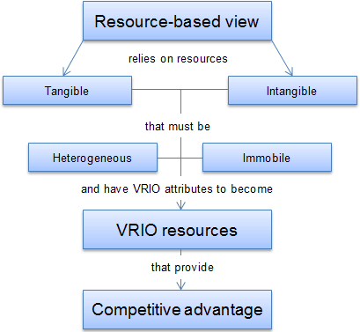
(Source: Jurevicius, 2013)
After assessing the internal assets of JJU, four items of resources and capabilities are identified as major pillars for the “Entrepreneurial University” strategy:
- Infrastructures,
- Strong programs and teams,
- Culture,
- Social Network.

3.1 Infrastructures
Currently, there are 22 Education and Research (E&R) centres and 52 laboratories in JJU. Every year, substantial financial and HR resources have been invested in maintaining and upgrading these facilities.
- The E&R infrastructures serve as necessary and valuable instruments to improve academic and practical skills, and to enhance the E&R performance for faculty, students, local community and business partners.
- JJU is the only organisation in JiuJiang City possessing and operating such large scale of E&R facilities.
- Building and maintaining the E&R facilities require years of substantial investment. Current E&R assets of JJU are estimated to be worth of over £30 million, overwhelming for other organisations to imitate.
- Among the E&R centres and laboratories, the majority are joint programs between JJU and commercial organisations which have already been creating value for the partnerships. For example, the E-commerce E&R centre was established as a cooperative program between the School of E-commerce and the JiangXi branch of China Mobile Ltd aiming at enhancing the R&D capability and commercialisation of both organisations.

3.2 Strong Programs and Teams
After over 20 years of efforts, some leading programs have emerged, such as International Trade, Tourism, Engineering Design, etc.
- These programs can greatly enhance the image and reputation of JJU to attract fresh candidates and E&R talents.
- As one of the 24 universities in JiangXi Province, although the competition is fierce, JJU has retained its leading position in the above programs.
- A regional leading program is the result of systematic efforts, including development of outstanding faculty teams, substantial investments in E&R infrastructures, accumulation of E&R experiences and achievements, recruitment, fostering, and cultivation of large number of qualified graduates, establishment of unique culture, and so on, which make it extremely difficult to imitate.
- Majority of the lecturers of these programs have professional experiences prior to their teaching career, and several teams have become regional leading E&R teams of their perspective area, such as international trade and logistics.
- Closed partnerships have been established between the leading teams and local companies. For example, the logistics team has closely cooperated with the dominant local retailers, LianSheng Chain Supermarket, for many years. The cooperation has both improved the E&R activities of JJU and commercial activities of LianSheng, and helped the students and faculty develop both entrepreneurial knowledge and skills.

3.3 Culture
JJU’S strategic orientation of the cultivation of talents with practical skills not only facilitate to develop unique entrepreneurial cultures but also provide invaluable experiences and first-mover advantage for promoting entrepreneurship.
- The entrepreneurial culture has led positive impact on E&R. Many students have created their businesses either their academic years or after graduation. In 2017, over 20 start-ups were established in the campus-based incubator. Some of them become the pioneering figures of entrepreneurs in e-commerce via Alibaba platform. The entrepreneurial culture and experiences have also led to extraordinary academic performance. The JJU student teams have made great achievements in the “Internet Plus” National College Student Innovation and Entrepreneurship Competitions and "Challenge Cup" National College Student Business Plan Competitions, which not only have improved the practical skills of students and faculty but also have enhanced the university reputation.
- Most of the universities in China are research-oriented, while JJU is one of the handful ones exploring the orientation of application. The rarity of such culture and experiences make it easier for JJU to adapt to the incoming innovation and entrepreneurship-oriented policies for higher education institutions in China.
- Establishment of organisational culture and acquisition of experiences requires long-term practice and accumulation which make them extremely hard to imitate.
- The entrepreneurial culture has already been systematically exploited to create value for the university, including effective entrepreneurship and career counselling services, active alumni union to maintain close contact and cooperation with JJU graduates who later became successful entrepreneurs, developing policies, using social contacts and networks, and sometimes providing loans to promote venture creation of students and faculty.

3.4 Network and Ecosystem
JJU has established complex and entrenched social contacts and network with local government, local media, companies, and other individuals and organisations. According to Spigel (2017), entrepreneurial ecosystems are “combinations of social, political, economic, and cultural elements within a region that support the development and growth of innovative start-ups and encourage nascent entrepreneurs and other actors to take the risks of starting, funding, and otherwise assisting high-risk ventures”. After years of efforts to promoting entrepreneurship, a unique and supportive entrepreneurial ecosystem has been established.
- The social network and entrepreneurial ecosystem can not only help university-based entrepreneurs to access necessary supports and resources but also facilitate the commercialisation of the R&D activities of the university and the integration of education, research and industry.
- JJU’s social contact and ecosystem are created by the university due to its unique value in education, research, and economy of the area. And as the only comprehensive university in JiuJiang City, JJU plays a vital role in the local entrepreneurial ecosystem.
- The social network built by JJU needs both substantial financial investment and enormous input of time and personnel, which make it impossible for others to imitate in the short term.
- The social network and ecosystem not only provide support to the E&R activities of JJU but also facilitate JJU and its partners to create value. More than 20 strategic partnerships have been formed between JJU and local commercial organisations during the last decade including consulting services, personnel training, business incubator, technology transfer, etc.

4 Organisational Structuring of Entrepreneurial University

4.1 Current Organisational Structure
According to Mintzberg (1980), organisations generally consist of five basic parts: the operating core, the strategic apex, the middle line, the technostructure and the support staff; and the structures of organisations are shaped by the various configuration of these parts.
Currently, JJU’s organisational portfolio includes two major sectors: the administrative sector, which serves as the strategic apex, and the E&R sector, which represents the operating core of the university. The administrative sector follows the functional structure where employees are grouped into various functional departments with certain expertise, such as HR department; while the E&R sector adopts a multi-divisional structure where employees are allocated into various professional units, such as the School of Economics and Management (Rothaermel, 2015).
Due to the quasi-governmental characteristics of universities in China and the diversity of the programs, the Divisionalised Form of organisational structure is generally adopted by Chinese universities, including JJU. Such organisational structure is the common arrangement for “diversified its product or service lines horizontally”, which, in this case, provision of diverse programs to students studying various disciplines (Mintzberg, 1980). Limited vertical decentralisation of JJU, which refers to the bounded delegation upon divisions because of the requirements of specialised knowledge for different disciplines, leads to certain autonomy of the schools and little coordination among them.
Figure 4: The Divisionalised Form
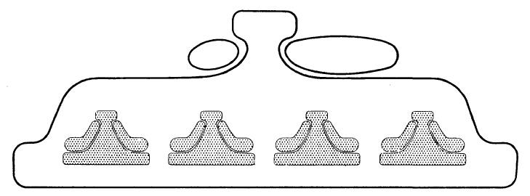
(Source: Mintzberg, 1980)
The Divisionalised Form is characterised by each division following its own organisational structure and pursuing its own goals; thus, the primary responsibility of the strategic apex of JJU is to leverage the diverse goals of different schools (Mintzberg, 1980).
According to Mintzberg (1980), organisations adopting the Divisionalised Form is driven by Machine Bureaucracy may lead to issues relating to communication, coordination, bureaucracy, hierarchy, etc..

4.2 Mintzberg’s Structural Configuration Framework
Mintzberg (1980) identified 9 key parameters which leverage the organisational structuring, namely, job specialisation, behaviour formalisation, training and indoctrination, unit grouping, unit size, planning and control systems, the liaison devices, vertical decentralisation, horizontal decentralisation. Thus, the organisation of JJU’s activities pertaining to entrepreneurship is analysed according to the above parameters.
- Job specialisation
Activities of JJU relating to entrepreneurship are education and facilitation. Such activities within different disciplines require specialised knowledge of the respective areas.
- Behaviour formalisation
Since entrepreneurship is characterised as innovative and unstandardised, entrepreneurship education and facilitation are discipline-specific and individual-specific, which means these operations are hard to formalise to universal and explicit standards.
- Training and indoctrination:
The personnel assigned for entrepreneurship education and facilitation need not only insight to their own academic area, but also systematic knowledge pertaining to entrepreneurship.
- Unit grouping
There are two basic options on how to cluster the entrepreneurship-related functions for JJU: by function, which means integrating all entrepreneurship-related functions into a single department or division, or by market, which refers to disperse the entrepreneurship-related functions as per different divisions (Mintzberg, 1980).
- Unit size
According to Mintzberg (1980), standardisation is positively correlated to the size of the unit. Lack of standardisation in entrepreneurship implies small units of personnel specifically assigned for education and facilitation.
- Planning and control systems
Because the entrepreneurship education and facilitation are almost impossible to standardise, plan and control systems need to be highly decentralised, which means these activities can only be monitored and measured at the division level instead of the university level.
- The liaison devices
Implementation of “Entrepreneurial University” strategy requires effective coordination between the administrative sector and E&R sector, and close cooperation among different schools, thus the personnel and the mechanism to smooth the communication among different administrative departments and different schools, which currently do not exist in JJU, are necessary.
- Vertical decentralisation & horizontal decentralisation
Due to the individual-specific and discipline-specific characteristics of entrepreneurial activities in JJU, furthering vertical decentralisation is vital to the implementation of the “Entrepreneurial University” which means more decision-making power needs to be delegated down to the division level or even the program level.

4.3 Structural Design Alternatives
The current organisation of entrepreneurship-related functions in JJU is unsystematic, characterised by lack of manifest policy, ambiguity of responsibility, and confusing chain of command. In the administrative sector, the Entrepreneurship and Career Service Centre, a branch of the Department of Admission and Career Service, is responsible for developing policies and coordinating different schools in terms of entrepreneurial education, research and other activities, including supervising the campus-based incubator. Since JJU institutionalised entrepreneurial education across the university, the School of Philosophy and the School of Economics & Management have been assigned to design and organise entrepreneurship education. However, each school needs to allocate its resources to promote and facilitate entrepreneurial activities, including participating entrepreneurship contests and mentoring entrepreneurial ventures. Such arrangement has resulted in a number of issues, including lack of support from top management, lack of support of knowledge, lack of cooperation and coordination, redundancy, etc.
Aiming at facilitating the effective and efficient implementation of the “Entrepreneurial University” strategy, I propose three structural design alternatives:
- Centralised design
- Decentralised design
- Hybrid design.

4.3.1 Centralised design
Centralised design mainly focuses on the integration of resources. In the administrative sector, it is necessary to establish a Department of Entrepreneurship to develop policies and coordinate the entrepreneurship activities across the university. In the E&R sector, resources closely related to entrepreneurship are gathered into a specialised division, the School of Entrepreneurship, which is directly supervised by the Department of Entrepreneurship and is responsible for all entrepreneurship education and facilitation operations. The advantages of centralised design may include the integration of resources and a clear chain of command, while the negative issues may also exist, such as lack of coordination between the School of Entrepreneurship and other schools, redundancy caused by the establishment of a new division, and standardised education and facilitation.
Figure 5: The Centralised Design for JJU
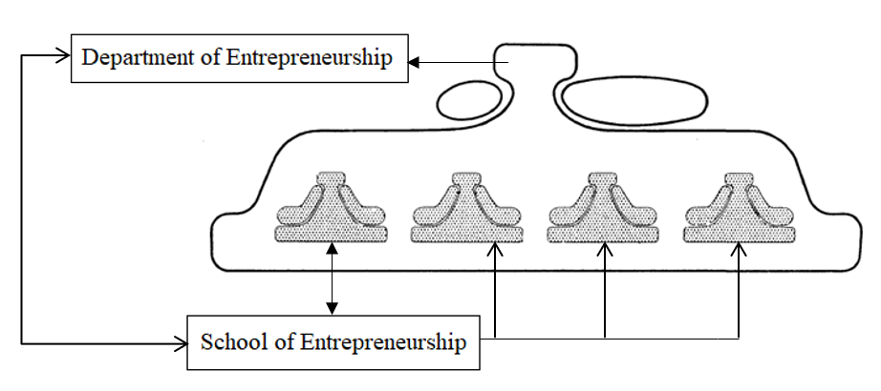
(Developed by the author based on Mintzberg’s model)

4.3.2 Decentralised design
The decentralised design mainly focuses on delivering specialised entrepreneurship education and facilitation. In this model, each school needs to set up its own entrepreneurship unit, which is only responsible for the entrepreneurship activities within the respective school. Thus, entrepreneurship education and facilitation are mainly controlled by different schools. Establishment of the Department of Entrepreneurship in the strategic apex is also necessary. And each entrepreneurship unit is under the joint supervision of both the head of its division and the Department of Entrepreneurship. The major advantage of the decentralised design is the effectiveness brought by the discipline and individual-specific entrepreneurship education and facilitation, but this mode may also cause lack of coordination and communication between divisions, the ambiguity of chain of command, redundancy and separation of resources due to duplicated units in different divisions.
Figure 6: The Decentralised Design for JJU
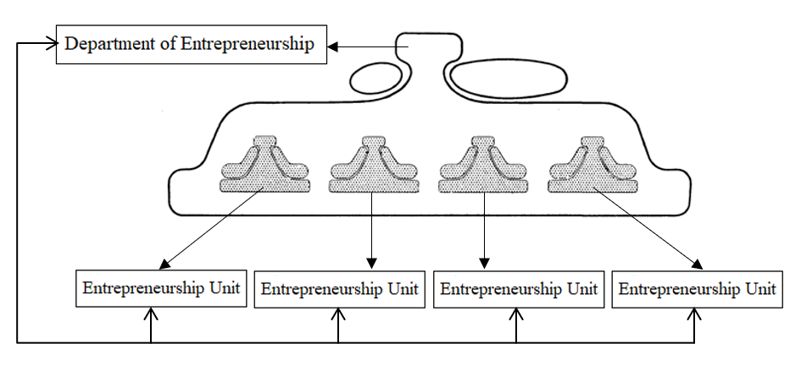
(Developed by the author based on Mintzberg’s model)

4.3.3 Hybrid design
The hybrid design is the combination of both centralised and decentralised model, which focuses on maximising the effectiveness and efficiency with minimum turmoil derived from organisational changes.
In the strategic apex, the establishment of the Department of Entrepreneurship is still necessary, like the previous two designs.
A cross-discipline training program needs to be developed and implemented to inform and communicate professional knowledge of entrepreneurship. The experts of entrepreneurship at the School of Economics and Management can be responsible for the training, while the trainees should include all teaching and supporting staff of all schools in JJU. With effective training, every one of the faculty can participate in entrepreneurship education and facilitation in his/her own area. To enhance coordination, each school can nominate a liaison to be in charge of formal and informal communication with the Department of entrepreneurship and other schools. Certain rotation system can be introduced to the nomination of the liaison so that each employee has the opportunity to assume the responsibilities of the liaison for a certain period, which in time can greatly enhance the coordination and communication among the entire faculty.
To conclude, the hybrid design can improve the effective implementation of entrepreneurial university strategy by cultivating qualified personnel with both specialised knowledges of different disciplines and professional knowledge of entrepreneurship and improve the efficiency by enhancing communication and coordination. The biggest challenge of this design may be the significant investment required for the large scale of training, both in term of capital and time.
Figure 7: The Hybrid Design for JJU
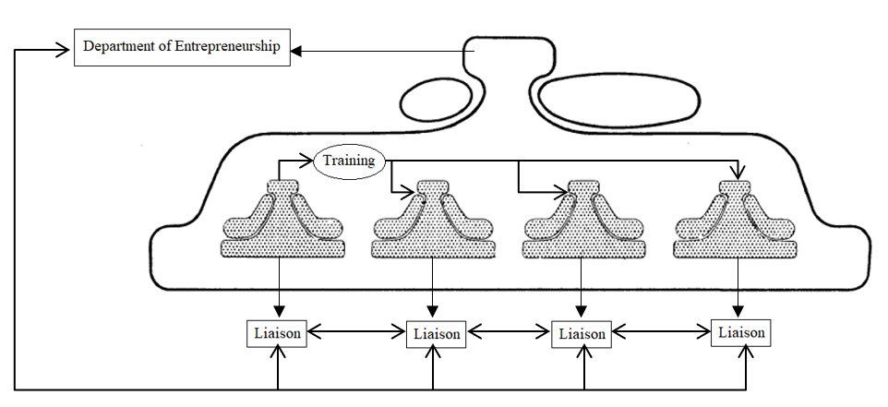
(Developed by the author based on Mintzberg’s model)

5 Conclusion
The objectives of this study are to evaluate the “Entrepreneurial University” strategy and relative organisational structuring of JJU. The study starts with examining the external contexts from the political, economic, sociocultural and technological aspects. Numerous external changes have emerged challenging the traditional E&R functions of JJU, including demographic changes, change of public perceptions toward universities and competitions from online education and overseas universities, while a number of opportunities pertaining to the promotion of entrepreneurship, including favourable policies, development of knowledge-based economy, widespread of Internet and social media, are identified. The study then assesses the internal resources and capabilities of JJU which can facilitate the implementation of the “Entrepreneurial University” strategy to gain sustained competitive advantages. By applying VAIO framework, four items of resources and capabilities, including infrastructures, strong programs and teams, entrepreneurial culture, social network and ecosystem, are identified which can greatly enhance the entrepreneurship education and facilitation. Then, the current organisational structure of JJU is outlined. Aiming to address the issues derived from existing structural design, such as lack of support from top management, lack of support of knowledge, lack of cooperation and coordination, redundancy, which may hinder the effective implementation of the “Entrepreneurial University” strategy, three structural design alternatives, centralised design, decentralised design and hybrid design, are proposed based on Mintzberg’s structural configuration framework. And the hybrid design, which can more effectively improve the communication, coordination and cooperation among different organisational sectors and different divisions with the minimum turbulence caused by structural changes, can be a more preferable way to achieve the successful implementation of the “Entrepreneurial University” strategy.

Reference
Acs, Z. (2006) ‘How Is Entrepreneurship Good for Economic Growth?’, Innovations: Technology, Governance, Globalization, 1(1), pp. 97–107. doi: 10.1162/itgg.2006.1.1.97.
Atkinson, S. (2018) WeChat hits one billion monthly users - are you one of them? - BBC News. Available at: https://www.bbc.co.uk/news/business-43283690 (Accessed: 13 December 2018).
Barney, J. (1991) ‘Firm Resources and Sustained Competitive Advantage’, Journal of Management, 17(1), pp. 99–120. doi: 10.1177/014920639101700108.
Boh, W. F., De-Haan, U. and Strom, R. (2016) ‘University technology transfer through entrepreneurship: faculty and students in spinoffs’, Journal of Technology Transfer. Springer US, 41(4), pp. 661–669. doi: 10.1007/s10961-015-9399-6.
Crace, A. (2018) Chinese online learners increase 20% and could hit 100 million. Available at: https://thepienews.com/news/chinese-online-learners-increase-20/ (Accessed: 18 August 2019).
Diaconu, M. and Duţu, A. (2015) ‘The Role of the Modern University in Supporting the Entrepreneurial Ecosystem 2 . Innovative Entrepreneurship , Entrepreneurial Ecosystem - Components of Entrepreneurial Culture’, European Journal of Interdisciplinary Studies, 7(1), pp. 11–24. Available at: http://www.ejist.ro/files/pdf/390.pdf.
Guerrero, M. et al. (2014) ‘Entrepreneurial universities in two European regions: A case study comparison’, Journal of Technology Transfer, 39(3), pp. 415–434. doi: 10.1007/s10961-012-9287-2.
Isenberg, D. J. (2010) ‘How to Start an Entrepreneurial Revolution’, Harvard Business Reivew, 88(6), pp. 40–50.
Isenberg, D. J. (2011) ‘The Entrepreneurship Ecosystem Strategy as a New Paradigm for Economic Policy: Principles for Cultivating Entrepreneurship’, in Presentation at the Institute of International and European Affairs. Available at: http://www.innovationamerica.us/images/stories/2011/The-entrepreneurship-ecosystem-strategy-for-economic-growth-policy-20110620183915.pdf.
Jurevicius, O. (2013) All you need to know about a Resource-Based View - Strategic Management Insight. Available at: https://www.strategicmanagementinsight.com/topics/resource-based-view.html (Accessed: 11 August 2019).
Miller, D. J. and Acs, Z. J. (2017) ‘The campus as entrepreneurial ecosystem: the University of Chicago’, Small Business Economics. Small Business Economics, 49(1), pp. 75–95. doi: 10.1007/s11187-017-9868-4.
Mintzberg, H. (1980) ‘Structure in 5’s: A Synthesis of the Research on Organization Design’, Management Science, pp. 322–341. doi: 10.1287/mnsc.26.3.322.
MOE (2010) National Medium- and Long-Term Programme for Education Reform and Development (2010-2020). Available at: http://www.moe.gov.cn/srcsite/A01/s7048/201007/t20100729_171904.html (Accessed: 18 August 2019).
MOE (2018) Review of China’s education reform in 2017 - Ministry of Education of the People’s Republic of China. Available at: http://en.moe.gov.cn/News/Top_News/201801/t20180130_326023.html (Accessed: 18 August 2019).
MOE (2019a) 2018 Statistics of Chineses Students Studing Abroad. Available at: http://www.moe.gov.cn/jyb_xwfb/gzdt_gzdt/s5987/201903/t20190327_375704.html (Accessed: 14 August 2019).
MOE (2019b) Educational Statistics. Available at: http://www.moe.gov.cn/jyb_sjzl/sjzl_fztjgb/ (Accessed: 18 August 2019).
National Bureau of Statistics of China (2010) Tabulation on the 2010 Population Census of the People’s Republic of China. Available at: http://www.stats.gov.cn/tjsj/pcsj/rkpc/6rp/indexch.htm (Accessed: 13 December 2018).
Prahalad, C. K. and Hamel, G. (1990) ‘The Core Competence of the Corporation’, Harvard Business Reivew, 68(3), pp. 79–91. doi: 10.1016/0094-5765(81)90092-8.
Qian, H. (2018) ‘Knowledge-Based Regional Economic Development: A Synthetic Review of Knowledge Spillovers, Entrepreneurship, and Entrepreneurial Ecosystems’, Economic Development Quarterly, 32(2), pp. 163–176. doi: 10.1177/0891242418760981.
Reichert, S. (2019) The Role of Universities in Regional Innovation Ecosystems, EUA 2019. Geneva.
Rothaermel, F. T. (2015) Strategic Management. Second Edi. New York: McGraw-Hill Education,.
Soto-Rodríguez, E. (2014) ‘Entrepreneurial Ecosystems As a Pathway Towards Competitiveness: the Case of Puerto Rico’, Competition Forum. American Society for Competitiveness, 12(1), pp. 31–41. Available at: http://content.ebscohost.com/ContentServer.asp?T=P&P=AN&K=112289256&S=R&D=bsu&EbscoContent=dGJyMNLr40SeqLQ4xNvgOLCmr1GeqLBSsai4SrSWxWXS&ContentCustomer=dGJyMPGrskuurLVMuePfgeyx44Dt6fIA.
Spigel, B. (2017) ‘The Relational Organization of Entrepreneurial Ecosystems’, Entrepreneurship: Theory and Practice, 41(1), pp. 49–72. doi: 10.1111/etap.12167.
State Council of PRC (2017) ‘The 13th Five-Year National Plan for Education Development’. Available at: http://www.gov.cn/zhengce/content/2017-01/19/content_5161341.htm.
Wadee, A. A. and Padayachee, A. (2017) ‘Higher Education: Catalysts for the Development of an Entrepreneurial Ecosystem, or … Are We the Weakest Link?’, Science, Technology & Society, 22(2), pp. 284–309. doi: 10.1177/0971721817702290.
Wernerfelt, B. (1984) ‘A Resource-Based View of the Firm’, Strategic Management Journal, 5(2), pp. 171–180.
Yoon, H. et al. (2015) ‘Entrepreneurship in East Asian Regional Innovation Systems: Role of social capital’, Technological Forecasting and Social Change. Elsevier Inc., 100, pp. 83–95. doi: 10.1016/j.techfore.2015.06.028.
Yu, X. (2018) Over 770m Internet Users in China. Available at: http://www.chinadaily.com.cn/a/201807/13/WS5b48384ea310796df4df64ec.html (Accessed: 13 December 2018).
Zheng, X. and Wang, H. (2018) ‘Mapping Entrepreneurial Ecosystem of China:a Multi-Perspective Comparison’, in 2018 IEEE International Symposium on Innovation and Entrepreneurship (TEMS-ISIE). IEEE, pp. 1–8. doi: 10.1109/TEMS-ISIE.2018.8478544.

