The Importance Of Employability Skills During Recruitment

A report by Lyndsey Copp

Student number – 2118579

University of Trinity St David

Contents

Page 3 Introduction
Page 4/5 Main findings/what are employability skills?
Page 5 Why are employability skills so important?
Page 6/7 What employability skills are important for employers? /communication and teamwork
Page 7/8 Teamwork
Page 9/10 Digital competence
Page 10 Resilience
Page 11/12 Emotional Intelligence
Page 13 Conclusion
Page 14/15 Reference list

Introduction
The purpose of this report is to display and understand various employability skills. It focusses on real life scenarios and ideas on how to develop employability skills for recruitment. We all have employability skills. These are not just skills that are particularly specific to one type of career path but are skills that are useful across all sectors of employment. Very often, employers are looking for skills other than just qualifications and experience. Employment is a critical stage of an individual’s life.
Education and experience alone can make you suitable for a specific job role but very often, to be successful in a job role, you will need to have different skills that can be developed over time.

Main Findings
What are employability skills?

What are employability skills and why are they important in the recruitment and hiring process?
Well, employability skills are the core skills that are enticing to an organisation.
- Doyle states “Employability skills are the soft skills that allow you to work well with others, apply knowledge to solve problems, and to fit into any working environment. They also include the professional skills that enable you to be successful in the work place. These are considered as transferable skills because you can apply them to a job in any industry” (Doyle, A 2011)

Throughout life, a number of individuals change careers or they work for several employers undertaking different job roles. At the moment, the researcher have been working at the same job and for the same employers for just over twenty four years, throughout this time, the researcher has completed several training courses to improve their skills, knowledge, understanding and to increase their personal development. Thus, they have decided to switch their career path in order to provide them with more opportunities, flexible hours and an increased salary. Nevertheless, in many industries and job roles, you need to have a set of transferable or employability skills.

Employability skills increase your verbal communication, work readiness and teamwork ability. Employment skills are also called fundamental employment, soft or job readiness skills.

Why are Why are employability skills so important?
Employability skills are important because, while not often listed in job descriptions, most employers look for them when interviewing applicants. Having employability skills can help you stand out from other candidates applying for the same position. It is important to list employability skills that are most relevant to the role to improve your chances of being hired.

What employability skills are important for employers?

Communication and Teamwork
It is an important skill for everyone to have good communication and teamwork skills. As an employee, you are required to work alongside colleagues and communicate well with them. It is commonly said that communication is one of the most important employability skills because it is an essential part of almost any job (UK, Y.E. (2019)). The communication process involves five elements; these are the sender, the receiver, message, medium and feedback. When all of these stages work together well, you are able to deliver and understand communication skills more clearly, which will prevent any mistakes, misunderstandings or errors. It is so important to have excellent communication skills. In the opinion of the researcher, they make you more inviting to an employer because this skills enhances a company’s efficiency and productivity which then helps to prevent wasting valuable time and resources.
We use various forms of communication daily in nearly every environment; this can be verbally, by using gestures, using eye contact or using non-verbal cues. It is an essential part when building relationships, sharing ideas, showing how we feel, delegating responsibilities, managing staff members and so much more. The four main types of communication that we use daily are, verbal, non-verbal, written and visual. When we consider communication skills, it is so important to also actively listen, observe and to show empathy. Learning and developing effective communication skills can help you to succeed in all occupations and can particularly help to develop and fulfil your preferred career.
The researcher has recently undertaking a job interview and they did a lot of practice on their own communication skills.


Teamwork
Harmony in the workplace is essential. Teamwork is a fundamental principle of this. Showing that you have effective teamwork skills such as collaboration will almost definitely increase your chances of being employed. Teamwork is defined by (Scarnati (2001, p. 5) “as a cooperative process that allows ordinary people to achieve extraordinary results”. (Harris & Harris (1996) also explain that a team has a common goal or purpose where team members can develop effective, mutual relationships to achieve team goals. Teamwork replies upon individuals working together in a cooperative environment to achieve common team goals through sharing knowledge and skills. The literature consistently highlights that one of the essential elements of a team is its focus toward a common goal and a clear purpose (Fisher, Hunter, & Macrosson, 1997; Johnson & Johnson, 1995, 1999; Parker, 1990; Harris & Harris, 1996). Teams are an integral part of many organisations and should be incorporated as part of the delivery of tertiary units. Successful teamwork relies upon synergism existing between all team members creating an environment where they are all willing to contribute and participate in order to promote and nurture a positive, effective team environment. Team members must be flexible enough to adapt to cooperative working environments where goals are achieved through collaboration and social interdependence rather than individualised, competitive goals (Luca & Tarricone, 2001). To become a great team player, you need to be comfortable working with people, take responsibility for your share of work and contribute to team goals.


Digital competence
What are digital skills?
Digital skills are broadly defined as the skills needed to “use digital devices, communication applications, and networks to access and manage information,” from basic online searching and emailing to specialist programming and development. (“Why digital skills are the foundation of our future workforce” October 22 and 2021, 2021)
These skills help employees to communicate and collaborate, problem solve, share their digital knowledge and expertise.
Examples of digital skills.
- Computer literacy
- Social media such as Facebook and Twitter
- Email and chat
- Word processing
- Web-based communications
- Research
- Programming, web and app development
Digital competence has become crucial for employability. Not only considering its role as a transversal skill to develop employability, but also because about 85% of all jobs need at least basic digital skill level one.
The most recent available statistics collecting digital skills in Europe2 for the year 2017 show, however, that 43 % of the EU population had an insufficient level of digital skills (no skills or low level). Furthermore, for the same year, 10 % of the EU labour force had no digital skills, mostly because they did not use the internet, and 35 % did not have at least basic digital skills, which are now required in most jobs (Centeno et al., 2019).

Resilience
Fundamentally, resilience refers to positive adaptation, or the ability to maintain or regain mental health, despite experiencing adversity. (Herrman et al., 2011). Resilience is a skill that employers value and require by employees. Resilience is an ability to overcome barriers and setbacks. It is a way of adapting to change and problems in the workplace if they arise. It is a way of bouncing back after an obstacle, trying again and a way of boosting your self-esteem. Bowden states that‘Resilience is a skill that can be learnt and developed’ (Bowden, 2014).
The researcher undertook a job interview recently. The researcher consider themselves a very shy person, one of which struggles with confidence. Nevertheless, throughout the interview, they maintained good eye contact and remained engaged and focussed, even when they had tricky questions to answer. After the interview, the employer fed back to the researcher and complimented them on their resilience as they had previously explained to the employer how nervous they was before the interview. Therefore, the researcher believes that resilience is defiantly a skill that can be developed over time. Even if you are a shy person that lacks confidence (like the researcher), you can learn to be more resilient with practice thus bringing power, direction and energy to your career.



Emotional Intelligence
Emotional intelligence is an ability to identify and deal with our own emotions. It is a way of compensating and recognising our behaviours and subsequently adjusting our responses to others. It is understanding and considering other people’s feelings and showing empathy. It is a way of building friendships in your life and workplace and it could even improve your own performance at work. It is a way of self-regulating yourself and understanding if you are feeling stressed and finding a way to relieve this. The writer of this report states that sometimes they take too much on and they get stressed out but they have enough emotional intelligence to offload and find ways to manage their time more efficiently, this also helps with their resilience too.
The flow chart below suggests that there are four basic phases to the training process. The first occurs even before the individual begins formal training. This initial phase, which is crucial for effective social and emotional learning, involves preparation for change. This preparation occurs at both the organisational and individual levels. The second phase, training, covers the change process itself. It includes the processes that help people change the way in which they view the world and deal with its social and emotional demands. The third phase, transfer and maintenance, addresses what happens following the formal training experience. The final phase involves evaluation. Given the current state of knowledge about social and emotional learning, the complexity of programs designed to promote such learning and the great unevenness in the effectiveness of existing programs, evaluation always should be part of the process. (Cherniss et al., 1998b). Emotional intelligence is the single most important influencing variable in personal achievement, career success, leadership, and life satisfaction. Learning emotional knowledge and skills requires an intentional, active, learner-centred approach involving self-directed coaching, mentoring, and visualisation. Emotional learning those results in increased self-awareness, improved behaviours, and the acquisition of new skills must actively engage the individual in the learning process. (Nelson et al., n.d. 2010)

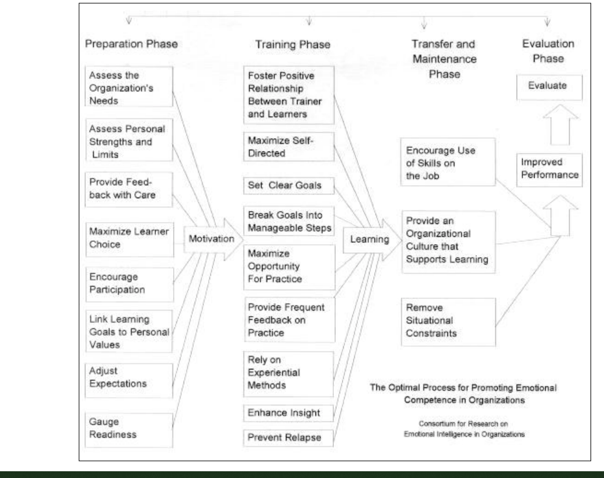
FIGURE 1 The Optimal Process for Developing Emotional Intelligence in Organisations (Cherniss et al., 1998)

Researchers stated that employers demand their employ-
ees to develop all the skills and knowledge to produce a
better result and improve performanc
Researchers stated that employers demand their employ-
ees to develop all the skills and knowledge to produce a
better result and improve performanc

Conclusion
Based on the writers report, it can be said that employability skills are essential for not just recruitment but also for sustaining a job and for daily life. Teamwork, communication, resilience, emotional intelligence and having accomplished digital competence are some of the key elements of interpersonal skills that are essential for employees to show during the recruitment process. They have carefully studied and analysed a number of methods of employability skills and they can conclude that the skills that they have discussed in this report are imperative. They help with improved performance and advance the overall productivity of the organisation. This report has also helped the researcher to reflect on their own performance during a recent job interview, upon their reflection, they feet that it gave them the opportunity to think about how they felt, what questions they asked, what went well and what they were unhappy with. The researcher can honestly say that this report helped them with their overall performance as they spent more time preparing for the interview.

Reference list
Bowden, S. (2014). Resilience – an attractive skill for employers and your career | Surrey Careers blog. [online] Surrey.ac.uk. Available at: https://blogs.surrey.ac.uk/careers/2017/08/17/resilience/. Accessed on 01.03.22
Centeno, C., Vuorikari, R., Punie, Y., O´keeffe, W., Kluzer, S., Vitorica, A., Lejarzegi, R., Martínez De Soria, I. and Bartolomé, J. (2019). Developing digital competence for employability: Engaging and supporting stakeholders with the use of DigComp. Developing digital competence for employability. Accessed on 04.03.22
Cherniss, C., Goleman, D., Author, Emmerling, R., Cowan, K. and Adler, M. (1998a). BRINGING EMOTIONAL INTELLIGENCE TO THE WORKPLACE A TECHNICAL REPORT ISSUED BY THE CONSORTIUM FOR RESEARCH ON EMOTIONAL INTELLIGENCE IN ORGANIZATIONS. [online] Available at: https://www.eiconsortium.org/pdf/technical_report.pdf. Accessed on 04.03.22
Cherniss, C., Goleman, D., Author, Emmerling, R., Cowan, K. and Adler, M. (1998b). BRINGING EMOTIONAL INTELLIGENCE TO THE WORKPLACE A TECHNICAL REPORT ISSUED BY THE CONSORTIUM FOR RESEARCH ON EMOTIONAL INTELLIGENCE IN ORGANIZATIONS. [online] Available at: https://www.eiconsortium.org/pdf/technical_report.pdf. Accessed on 05.03.22
Costanzo, L.S. and Scarnati, E. (2001). Fisiologia. Napoli: Edises. Accessed on 05.03.22
Doyle, A. (2017). Top 5 Employability Skills. [online] The Balance Careers. Available at: https://www.thebalancecareers.com/employability-skills-list-and-examples-4143571. Accessed on 05.03.22
Harris, R. (1996). The language connection : philosophy and linguistics. Bristol, U.K. ; Dulles, Va.: Thoemmes Press. Accessed 0n 06.03.22
Herrman, H., Stewart, D.E., Diaz-Granados, N., Berger, E.L., Jackson, B. and Yuen, T. (2011). What is resilience? Canadian journal of psychiatry. Revue canadienne de psychiatrie, [online] 56(5), pp.258–65. Available at: https://www.ncbi.nlm.nih.gov/pubmed/21586191. Accessed on 06.03.22
Indeed (2020). Employability Skills: Definition and 10 Examples. [online] Indeed Career Guide. Available at: https://www.indeed.com/career-advice/finding-a-job/employability-skills. Accessed on 06.03.22
Luca, J. and Tarricone, P. (2001). Does Emotional Intelligence Affect Successful Teamwork?. Accessed on 06.03.22
Nelson, D., Low, G., Columbus, B., New, I., San, Y., Upper, F., River, S., Cape, A., Dubai, T., Madrid, L., Munich, M., Montreal, P., Delhi, T., Sao, M., Sydney, P., Kong, H., Singapore, S. and Tokyo, T. (n.d.). Emotional Intelligence Emotional Intelligence SECOND EDITION Prentice Hall. [online] Available at: https://catalogue.pearsoned.ca/assets/hip/ca/hip_ca_pearsonhighered/preface/0135022991.pdf. Accessed on 07.03.22
October 22 and 2021 (2021). Why Digital Skills Are the Foundation of Our Future Workforce. [online] Salesforce News. Available at: https://www.salesforce.com/news/stories/what-are-digital-skills/#:~:text=Digital%20skills%20are%20broadly%20defined. Accessed on 07.03.22
The WOW Show (2020). Employability skills – have you got them? YouTube. Available at: https://www.youtube.com/watch?v=tKKPUYfOkvw. Accessed on 07.03.22
UK, Y.E. (2019). See how to show resilience in a CV or job interview. [online] Youth Employment UK. Available at: https://www.youthemployment.org.uk/see-how-to-show-resilience-in-a-cv-or-job-interview/ Accessed on 08.03.22

