Name: Eleisha Katherine Price
Student Number: 2005610
BA Course Title: Surface Pattern Design, Research in Context (ADAD5003).
Lecturer’s Name: Julia Lockheart
Chosen Question: (5) From the series of Thinking Making research strand lectures, choose a theme, movement, or selection of artists or designers that relate to your practice or interests. Critically assess primary themes, key writers, and relevant practitioners.
Word Count: 2557

Unmasking the Word ‘Design’: the Value in Creative Language

Before any of us are able to create, we first have to observe. As John Berger phrased it, “Seeing comes before words. The child looks and recognizes before it can speak.”, and through this sense of understanding we form another that establishes our place in the surrounding world (2008, p. 7). We explain our world with words; text and language that justifies connections with us and exterior identities. It is this problem between what we observe, and our collective knowledge that brought about a solution - or language - that we use to make sense of design. This essay is written in hopes of establishing and understanding these connections through design values.
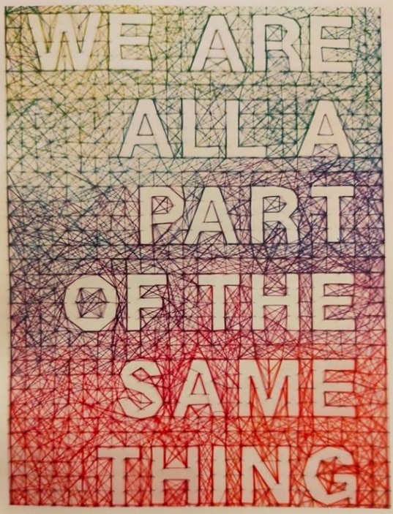
Everything has symbolic meaning. When we think of fire, we describe it as being hot, bright, evil, orange – there are numerous descriptions for one entity, but they could depend on where we were brought up and whom with. Religious people may connect the sight of fire with Hell, but a traveler might say fire is connected to one’s survival. However, this type of language was never invented by anyone, only to take in what we can see. Using this language as a tool to reveal this entity could not be done, but rather, by using this language it instils knowledge, a behavioral coordination that brings forth a world of understanding (Maturana and Varela, 1998, ‘The Tree of Knowledge’). The key differences within this language are that the subject is only seen by those willing to look, and to look is an act of choice (Berger, 2008, p. 8). When we look at art, we see design ideas based on someone’s personal understanding of a subject, but the way we see that piece of art is affected by what we know or what we believe, so our understanding of it may contrast to its maker’s.
Fig 1. We are all a part of the same thing, Dominique Falla, 2011.
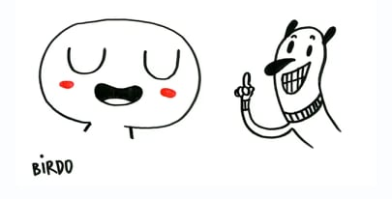
Language is everywhere, and we are all an essential part of it. The tactile typography shown in figure 1 emits a complexity of the synergetic relationships within creative language. Art is essentially a mode of communication, and as creatives we often use images instead of words to reach a much wider audience than if we were to just write in our native language. Sharing work on social platforms can also expand on these connections and gain an artist valuable feedback. The feedback we receive may not always be positive – as everyone inherits these different expressive languages – but by sharing artwork, it creates instant bonds between people.
Fig 2. ‘BIRDO’ by Luciana Eguti and Paulo Muppet.
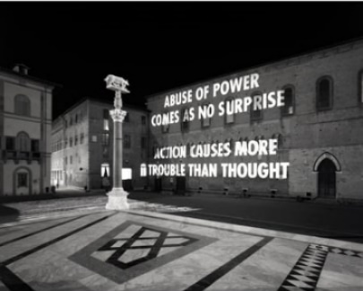
The artwork in figure 2 is interesting regarding the topic of visual language. In this piece, the language highlighted is the importance of empathy. Where the artist needs to connect to their creations, there is a sense of understanding of the emotional language whereby the characters are looking at something or what the character is looking for. Characters in this way are used as visual metaphors for very abstract concepts, giving them meaning and defining what the artist wants to convey. Paulo explains that this outcome holds not just a spatial-visual process, but a helping of social processing too. Visual and social language helps us understand complex subjects.

Fig 3. 1982 projection in New York by Jenny Hoizer.
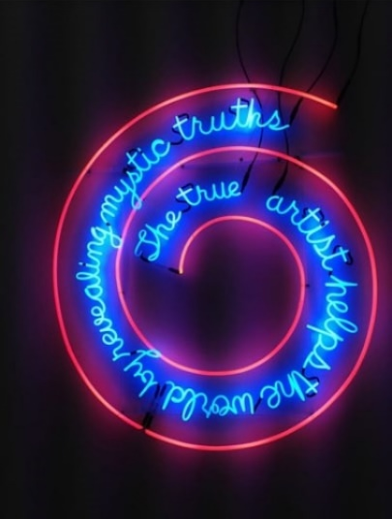
Fig 4. The true artist helps the world by revealing mystic truths, 1967, by Bruce Nauman.

Contrary to using images to convey artistic language, there are also artists who use words within their art to project meaning. Text within art creates a statement and is used to draw out emotion. The versatility and the power behind the written word forces viewers to reflect; it is clever word play, political activism, subversion of advertising and appropriation of form that portray these powerful characteristics. Jenny Hoizer’s piece from figure 3 uses direct language and a juxtaposition of shocking phrases that forces the public to confront a societal issue. Often being the main theme in her works, her LED displays broadcast her messages to a wider audience with reoccurring tribulations of modern life, and issues of religion and gender. Using a similar illumination is Bruce Nauman’s piece in figure 4 which uses neon lights in 3D installations. His work focuses on semantics, depicting how slight changes within society can have a fundamental impact on meaning. The subject matter that lies within his pieces has a perceptive language – the viewer’s encounter with the piece above is related with the body and mind in response to the art object.
If we look at the word ‘design’ we understand that in the English language it is both a noun and a verb. As a noun, it means as many things as intention, plan and motif. If you were to think deeply about it, these meanings – amongst others – are connected with the word ‘deception’. As a verb, ‘to design’ means to simulate or to sketch (Flusser, 1999, p. 17). When summarizing the word through historical routes, it derives from the Latin word signum, which means ‘sign’ in English. Etymologically, the word design means ‘de-sign’. The problem does not lie within the word itself, but with whom creates through it. Going back to choice, we know that creating things in response to our observations may impact us positively or negatively. An extreme example of this highlights the modern-day machines and mechanics. Flusser teaches us that to design is to deceive; like that of a lever that defies gravity, and mechanics that fool heavy bodies. If we visualize this language as a new form of culture, where design is seen as being deceptive, we then need to understand who and what we are deceiving. If we took the lever as an example, that in which allows us to create an artificial form of the human arm, we are able to escape our natural circumstances through the strategic exploitations of the laws of nature. Flusser states that we deceive nature by means of technology, “to replace what is natural with what is artificial and build a machine out of which there comes a God who is ourselves.” (1999, p. 19), and we understand through this design language that our culture has to be deceptive, or innovative enough, to turn a species that is conditioned by nature into free artists.
There is an evident conflict of values between human languages and design. The moralist values of a designer might be speculated in a way that the ‘lived life’ is the true value of the individual, and that it would be disastrous if the designer failed to recognize a necessary subservience of their design to a communal reality. When a point is reached within their process that negative boundaries are crossed; be these taste, taboo, or conduct, and even to assume a god-like role as a designer, a hubristic act is committed that dries up the very essence of design (Barry, 2009, p. 30). If we looked at still life as an example, where the artist selfishly feeds off of his subject as a degenerative and lifeless form of art whose values are purely aesthetic, as Peter Barry phrased in his book: Beginning Theory, “art for art’s sake” (2009, p. 31), with no reference to personal or psychological health - a number of things stand out to us in this approach, whereby language would not be portrayed as fluently. The artist would not be demonstrating anything, but rather creating with no one’s ideals or benefit in mind. The language highlighted here would be disconcerting to any audience who values creative language.
Another problem design language has is of the designs that already exist in the world. If we look at these designs, we can see insurmountable problems; a pattern of problems in fact, that cause issue for many of us. A simple device like the door for example: a design feature with an open and shut function. Then you see signs on some doors – but not all – that say to either push or pull. What if some people are unable to read these signs, or even see them at all? What about those doors that don’t have those signs – do you push them, or pull them, or maybe they slide? These are called ‘Norman Doors’, an example of confusing design (Norman, 1977, p. 1). We can see a pattern of problems here, almost like a domino effect. It’s not just doors that have this problem. By adding design on top of design, we seem to be creating more problems for everyone, and this cycle continues the more we try to redesign. The designs of everyday things should indicate how to work them without any need for signs, and without need for trial and error (Norman, 1977, p. 2). The language of design we encounter here is of a ‘cutting corners’ approach; it is not a visible language, and not a universal one. It is personal, whereby the designer understands his design but his audience does not. Norman states that good design has characteristics of discoverability and understanding (1977, p. 3). The doors analogy is an example of when these two characteristics fail. Consumerism is often to blame for these problems. People buy design objects for the sake of their aesthetics, but it is the easy accessibility of these items that causes design to spiral so their functionality is now less contemplated upon, “In the absence of social unity and a sense of community, people seek relief from alienation in the hedonistic pleasures of consumerism.” (Walker, 1989, p. VII), and therefore we start to see disasters of all kinds occur with monotonous regularity. This is purely down to humanly devised systems. It evokes in us a feeling that to achieve good design, it is not a matter of taste or style, it is a matter of life and death. Where we see shear numbers of failures within design, it indicates that it is too important to be left to designers or politicians who think of it as a mere tool for higher profits or revamping their personal image.
The problems highlighted brings us to another issue where language struggles with depicting physical action. This struggle is evident in the language that tells us what to do. When we add instructions to a design that involves interaction, we offer up a choice. We understand that choices can sometimes be difficult in themselves, and not everyone is confident in their personal understanding. If the instructions cause too much stress, one realizes the gap between instructive language and the body (Sennett, 2009, p. 179). In learning spaces, especially on design courses, we learn more through communication than that of instructions. Whenever a task becomes difficult, we can rely on peers and tutors by directly asking questions, whereas if you’re reading the information from a page, you are discussing that information with yourself without feedback from others. Instructions are limited, but privileging the speaking voice is also an incomplete solution; you have to be in the same spot; the learning becomes local. Another form of language is expressed through hand gestures, and these are most useful to us in coordinating words with movements. We can understand movement better than words as it does not always require speech. The act of copying one’s movements allows children to quickly learn and understand the world. The neurologist Frank Wilson suggests that bodily movement is the foundation of all language. Artists and designers use movement to illustrate feelings and stories, where the hand is used to paint, craft, or to gesture. The experiences of touch and grip not only allow designers to expand on their understanding, but give their personal language a directive power, and where this was first directed into ‘show and tell’ as young children, creatives now value “show, don’t tell” (Sennett, 2009 p. 181), where a physical display of design conveys more than a label.
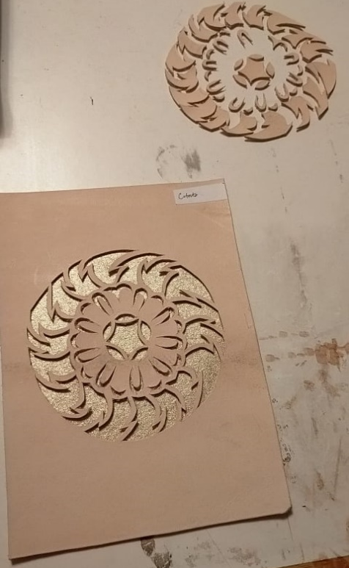
The way we use language is vital to the future of the world. The way in which we raise new generations all depends on our agenda for finding new nurturing solutions that are very different to initiatives that harm the environment (Braungart and McDonough, 2009, p. 3). The language we need to use here would be of sustainability. An example of this language that I have found while studying is the sustainability of leathercraft. This traditional craft uses pieces of leather that are often dyed, cut and put through various chemical processes; the processes however, can be recycled. Offcuts can be upcycled, and leather – being an organic material – is biodegradable. If students and creatives were to learn more about the material, we could reduce unsustainable practice through materials that aren’t as recyclable. Sometimes, we are, as Braungart suggests, “too quick to embrace some solutions” (2009, p. 5), and this often means that where we find ‘sustainable’ solutions, we often forget that some solutions require behind the scenes processes that have a medieval type of behaviour. Going back to fire, we can look at incinerators as an easy way of getting rid of waste. But when this occurs, it is because of the effects of paranoia and insecurity that we fall back on behaviour that supposedly saves us time and effort. The approach that Braunbart and McDonough wrote about suggests a language that proposes waste becomes a food for future use; where leather offcuts can be innovated in a way that makes them useful for future generations.
Fig 5. An example of my leathercraft work utilizing leather offcuts and repurposing separate cut-outs.
Creative language speaks to me through various constructs. I have learnt that it can be cunning; seducing people into perceiving distorted ideas. The word design has come to occupy a position in contemporary discourse through my awareness that being a human being is a design against nature, and that the destruction of the natural world is down to a crisis of human behaviour - but somehow design is still an increasingly popular subject within education and the industry. Learning through design has taught me that by watching, listening and feeling – by paying attention to what the world has to tell me – I can expand on my creative language and values. But I have also come to realise through my studies that by redesigning ideas, we do not go through the same creative languages that were used to first design the existence of a subject. To create new means of language I must apply a new language of design. Most importantly, I have discovered that good design is about being beneficial, about avoiding panic and destroying resources that we can pass onto future generations.
Bibliography:
Books:
Berger, J., 2008. Ways of seeing. 2nd ed. London: Penguin Books Ltd, pp.7-15.
Braungart, M. and McDonough, W., 2009. Cradle to cradle. 3rd ed. London: Vintage, pp.3-5.
Barry, P., 2009. Beginning theory. 3rd ed. Manchester and New York: Manchester University Press, pp.30-31.
Chapman, J., 2015. Emotionally durable design. 2nd ed. New York: Routledge, p.65.
Flusser, V., 1999. The Shape of Things. 1st ed. London: Reaktion Books Ltd, pp.17-51.
Ingold, T., 2013. Making. 1st ed. New York: Routledge, pp.1-19.
Maturana, H. and Varela, F., 2008. The Tree of Knowledge. Boston: Shambhala.
Norman, D., 2013. The Design of Everyday Things. 1st ed. London: The MIT Press, pp.1-36.
Sennett, R., 2009. The Craftsman. 3rd ed. London: Penguin Books Ltd, pp.179-182.
Walker, J., 1989. Design history and the history of design. 1st ed. London: PLUTO PRESS, pp.1-14.
Online:
Jordan, J., 2015. 9 Artists From 7 Countries Discuss Art As A Language. [online] Babbel Magazine. Available at: https://www.babbel.com/en/magazine/art-as-a-language [Accessed 28 November 2021].
Stewart, J., 2017. 8 Artists Who Harness the Power of Words in Art. [online] My Modern Met. Available at: https://mymodernmet.com/text-art-masters/ [Accessed 28 November 2021].

List of Figures:
Figure 1.
‘We are all a part of the same thing’ (Dominique Falla, 2011). Chapman, J., 2015, Emotionally Durable Design, p. 3.
Figure 2.
‘BIRDO’ (Luciana Eguti and Paulo Muppet, n/a). Available at: https://www.babbel.com/en/magazine/art-as-a-language [Accessed 28 November 2021].
Figure 3.
‘Projection in New York’ (Jenny Hoizer, 1982). Available at: https://mymodernmet.com/text-art-masters/ [Accessed 28 November 2021].
Figure 4.
‘The true artist helps the world by revealing mystic truths’ (Bruce Nauman, 1967). Available at: https://mymodernmet.com/text-art-masters/ [Accessed 28 November 2021].
Figure 5.
Price, E., ‘An example of my leathercraft work utilising leather offcuts and repurposing separate cut-outs.’, Photographed in Wales. [Created 6 December 2021].

