3/24/2025
University of Wales Trinity Saint David
London campus
E-Portfolio Link:
Module Name: Learning In the Digital Era
Module Code: ACCA 4025

Student Name:
Student ID:
Group: 1

Lecturer’s Name: Koushik Modak

LDE Assignment 1
E-Portfolio
Table of Contents
Introduction 2
Main Body 2
Task 1: Essential Academic and Employment Skills for the future career Path 2
Task 1 (a): Report on Essential Academic and Employment Skills 2
Task 1 (b): Evaluation of Task 1 (a) based on Similarity report 2
Task 2: Collaborative Mind Map and Individual Poster 2
Mind Map (Collaborative) 2
Poster (Individual) 2
Task 3: Virtual Collaboration and RefWorks 2
Report on Virtual Collaboration 2
Step-by-step process of using RefWorks with visuals 2
Task 4: E-Portfolio Creation and Evaluation 2
Task 4 (a): E-Portfolio Creation 2
Task 4 (b): Illustrative Review of E-Portfolio tool Selection 2
Conclusion 2
References 2
Task 1 References: 2
Task 3 References: 2

Introduction

Main Body

Task 1: Essential Academic and Employment Skills for the future career Path

Task 1 (a): Report on Essential Academic and Employment Skills
In the future, I understand that I would still have to continue studying beyond college. It is said that half of all workers will be required to reskill by 2025 due to such rapid transformations in technology. According to the employers, the most valuable skills at the moment are critical thinking and problem-solving. They are also seeking self-management skills such as resilience and flexibility. That is, I need to be able to compose myself during stress as well as have an aptitude to undergo change. Although machines will probably replace some jobs, come up will be a number of new jobs that people can do with technology and algorithms. Majority of the business leaders have come to expect that we will acquire these new things as we work through the job. Fortunately, with the help of online platforms, one can acquire new skills, such as digital marketing or data science, within several months. In my case, this implies that I am only ready to be a lifelong learner so that I will remain prepared to work in the future [1], [2].
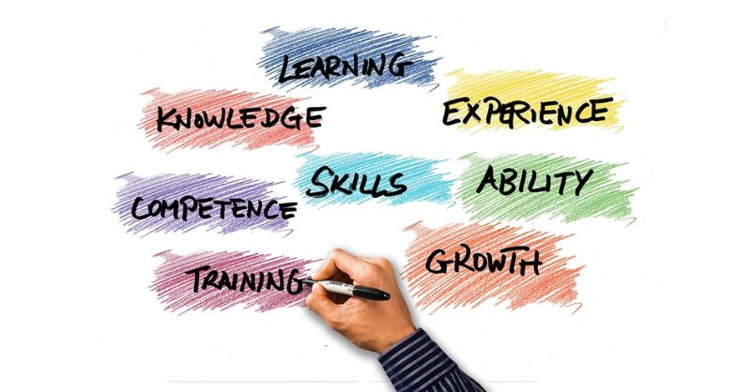Figur:1 picture [3]

I am sort of scared to think of my future career because tech is so changing everything so rapidly. I have just learned that of the entire world, some half of the workers will need to acquire new skills by the year 2026, in order to remain competitive. The majority of the businesses are largely seeking individuals with the ability to resolve issues and be critical thinkers. Digital literacy is also the desire, or more precisely the ability to use digital resources and be safe on the Internet. Nonetheless, the equally significant ones are soft skills such as communication and adaptability. Research indicates that a flexible personality and self-confidence make you get employment and enjoy your working environments. I need to possess a growth mindset and engage in life-long learning in order to be prepared tomorrow. By emphasising these human capabilities, I will be able to provide value that machines and AI cannot [4], [5].
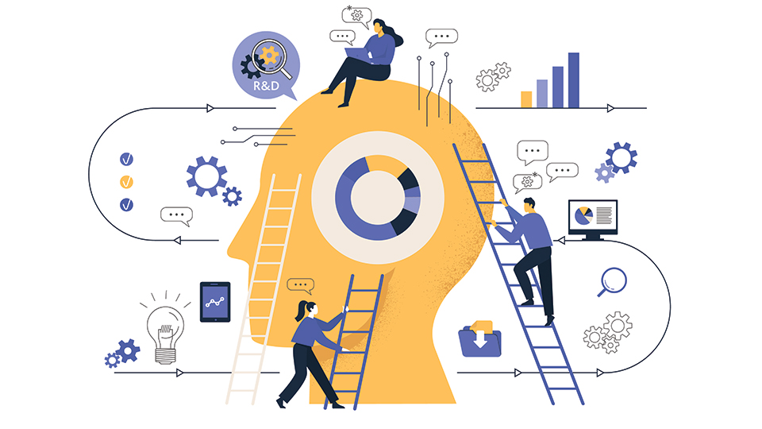Figure: 2 picture [6]

Task 1 (b): Evaluation of Task 1 (a) based on Similarity report

Task 2: Collaborative Mind Map and Individual Poster

Mind Map (Collaborative)

Poster (Individual)

Task 3: Virtual Collaboration and RefWorks

Report on Virtual Collaboration
Put your Chosen topic here

Step-by-step process of using RefWorks with visuals

Task 4: E-Portfolio Creation and Evaluation

Task 4 (a): E-Portfolio Creation

Task 4 (b): Illustrative Review of E-Portfolio tool Selection

Conclusion

References

Task 1 References:

Task 3 References:

