I acknowledge the use of AI tool . I use the prompts
- https://www.scribbr.com/ to generate references
- https://app.grammarly.com/ to check grammar
- https://www.google.com/search?q=scholar+google to research articles
- https://www.google.com/search?q=translate&rlz= for translating
I confirm that I have not presented any AI generated text as my own work.

Title: Understanding the Everyday Impact of ADHD: A Qualitative Exploration of Adolescents’ Perspectives
Aim: To examine how adolescents with ADHD describe the impact of their symptoms across different environments and aspects of daily life
Participants: Five children aged 9–13 with a formal ADHD diagnosis, interviewed individually using semi-structured questions.

Coding data:
Below are initial descriptive codes (short, concise labels that capture meaning):
Transcript | Initial Codes
P1 | Vicious cycle of distraction and punishment; depends on reminders; emotional resignation; occasional hyperfocus on interesting tasks.
P2 | Difficulty staying focused; needs visible progress to stay motivated; frustration with self; little recognition of positives.
P3 | Hyperactivity in all settings; misunderstood by others; too much energy; bravery and risk-taking; enjoyment of physical activity.
P4 | Feels rejected and labelled; emotional exhaustion; strong wish for understanding; success in sport gives confidence.
P5 | Forgetfulness and poor attention in school; supportive teachers; high effort to manage focus; hyperfocus when painting models; fear ADHD will limit ambitions.

Generating themes
After collating and grouping codes with shared meanings, the following themes and sub-themes emerged:
Themes | Sub-themes | Example Codes Feeding In
1. Feeling Misunderstood and Frustrated | 1.1 Being labelled and punished for behaviour they can’t control | They were often told off or called troublemakers even though they couldn’t help their behaviour, and this made them feel angry and helpless.
 | 1.2 Emotional exhaustion and low self-esteem from misunderstanding | Constant criticism made them feel tired, lonely, and sad, and they started to believe that something was wrong with them.
2. Focus and Motivation in Different Situations | 2.1 Structure and support improve focus | They said they worked better when someone reminded or encouraged them, and when teachers were patient instead of strict..
 | 2.2 Interest and enjoyment drive attention (hyperfocus) | They could focus for hours on things they enjoyed, like football or skateboarding, and forgot about their ADHD during those moments.
3. Using Energy and Learning to Accept ADHD | 3.1 Using energy in positive ways (sport, creativity, bravery) | Their high energy helped them do well in things like sports, painting, and trying brave new activities.
 | 3.2 Developing acceptance and self-understanding | Over time, they began to accept ADHD as part of who they are and realised it could bring good things as well as challenges.

Results
This section integrates themes, narrative, and participant quotes, showing the interpretative work of Thematic Analysis.
Analysis of the interviews identified 3 overarching themes that capture:
1. Feeling Misunderstood and Frustrated

2. Focus and Motivation in Different Situations

3. Using Energy and Learning to Accept ADHD
Theme 1: Feeling Misunderstood and Frustrated

Most of the youth in this research claimed that they felt very misunderstood living with ADHD and individuals near them frequently felt frustrated due to the inability of those who were close to them to understand that their behaviours were not something they could easily regulate. They explained that at times, they were considered lazy, rude, and other times inattentive, unresponsive, and emotional by their teachers, parents, and friends, yet as a matter of fact, they could not control their mind, concentration, and emotions. One of them replied that, “People don’t have patience with me… their reactions are negative,” this indicates that they did not really comprehend me most of the times they criticised me. Another one remarked, “People simply believe that ADHD is about being naughty, disrespectful, disruptive” and this is where wrongly imaginative children with ADHD can be blamed as troublemakers even where they did not intend to become bad.

1.1 Being labelled and punished for behaviour they can’t control
In a majority of instances, young people claimed that they were punished a lot due to actions that they would not do and this was at both school and at home. One replied, for instance, “Teachers just think I’m kicking off for the sake of it”. Such a response angered and hurt them, since they wished people knew that their behaviour was not intended. Another respondent gave an explanation of how they were referred to as trouble makers yet they were making an attempt to do well. That experience of being told off yet again and again had the effect of making them demotivated, since they felt stuck in what one of them characterised as a ‘’large vicious circle - not concentrating, being told off, not finishing stuff, loosing the will, being told off.’’ Once they became mistreated, finding something to concentrate on was more difficult and even more difficult to believe in themselves.

1.2 Emotional exhaustion and low self-esteem from misunderstanding
In the long run, a sense of emotional exhaustion and low self-esteem were experienced as a result of being misunderstood. One of them stated that “I hate ADHD. I have no friends, probably because I’m too noisy”. This demonstrates that they would feel that they were annoying or other because of the continuous negative feedback, which hurt their self-esteem. Some other one, “Like shit, can I say that? Sorry. But that’s how I feel. It gets me down.” This frank remark gave the extent to which they were changed by these experiences. Their lives were in between what they desired to and what ADHD had complicated.
Often teachers were touched upon as those who did not know what to do. One of the respondents replied that “Most of the teachers just tell me off, because honestly I don’t think they have a clue what to do with me.” Due to this, school became a stressing scenario where they found themselves being unwanted and they did not belong. Other individuals added that individuals even jested about ADHD by making jokes that it was only about being naughty. One of the participants replied, “People just don’t get it. They think I’m a troublemaker” and another one said “They just think I’m being a pain in the backside,” and not understanding this, caused them to feel alone and judged.

Theme 2: Focus and Motivation in Different Situations
According to a lot of respondents, they were not always equally affected by ADHD, since their ability to concentrate was variable and relied on the circumstances, task and others. They claimed that they were able to be switched on to a long period in cases where they were interested in something and in cases where people were behind them but when they got bored, criticised or alone, they lost known of their concentration within a short period.

2.1 Structure and support improve focus
Some of the youth alleged they required reminders or organisation to be on task. One of them had an explanation, “If people are nagging and reminding me, it can spur me on. But if I’m left to carry on myself, I find focusing hard.”. This demonstrates that ADHD is not lack of focus, but a variation of the functioning of attention since with the support they are doing better. Some other one said, “Teachers are okay with me… they know I’m trying my best.” Favourable instructors provided them with more relaxed atmospheres in which they were able to concentrate more. Conversely in other cases where teachers were strict or impatient, their attention failed them.
Another major issue was boredom. One of them replied, “It takes me a long time to get into something, and if I’m not interested in it, I lose concentration really quickly.” They said that they transitioned between unfinished tasks, and it was not easy to remain active. According to many, the school lessons were too redundant and tedious and due to that, they became distracted. One of them, It’s not like I choose not to listen to him, it’s just I carry on without thinking. This caused them to become more apprehensive and de-motivated.

2.2 Interest and enjoyment drive attention (hyperfocus)
Even though they had difficulty in focused attention when in the boring or stressful circumstances, they indicated that when engaging in activities that they enjoyed or found meaningful, they could focus their minds. This experience became a so-called hyperfocus. According to one of the participants, “If I like something, I can spend hours concentrating on it and seeing the task through to the end.”. A second one said that “When I play football, I forget I have ADHD. I can concentrate on that.” This demonstrated that ADHD does not simply concern distraction but attention which varies depending on interest and emotion.
One of them was how it felt like to be hyperfocused: “When skateboard, I only think of myself, skateboarding, no one. Just me and the board.” These were the moments they found themselves in a state of peace and pride and this was not the case when they were at school. Fun, liberty and empathy in other people all made them remain focused.
Others replied that, “If I’m trying to revise for something, unless I can see I’m getting closer to the end goal, I find it quite hard to continue.” They had to have visible evidence that they were attaining something as that gives them satisfaction and motivation. Some claimed that, when doing something, they felt good as it was done infrequently. One of them said to me, “When I do finish something, I feel good because it doesn’t happen often.”
Comprehensively, this theme demonstrates that attention and motivation in ADHD are not fixed but they are pliant. Through organisation, motivation, and activities that are interesting, the ADHD young people can excel and feel empowered. However, their symptoms are likely to be deteriorated without adequate support, and they tend to become less confident due to boredom, pressure, and criticism.

Theme 3: Using Energy and Learning to Accept ADHD

Other participants indicated that ADHD was not a problem issue only, but also a strength issue since it provided them with energy, creativity, and courage. They came to understand that the same qualities that got them into trouble at school could ease their lives at sport or in other arts.

3.1 Using energy in positive ways (sport, creativity, bravery)
One said, “I’m good at running. I guess because I’ve got loads of energy”. Another one justified it by “If I’m out on my skateboard, I can go for longer and stuff, I don’t get tired as easy.” These quotes demonstrated that hyperactivity may benefit physical activities. Bravery and impulsivity were also discussed by them in a positive way. One of them was like, “When I went bungee jumping my mum and dad, and me, noticed that grown men were crying and backing out and saying they didn’t want to do it, and I was like yeah, I just jumped.” Another said, “I think not having that fear helps me try new things.”
They were however aware that this fearlessness may at times be dangerous. One of them said, “I suppose some things this isn’t good, because I don’t see the risks like other people.” However, it is a fact that their courage and energy allowed them to have new opportunities and to lead a more exciting life, which many people agreed with.
Another strength was in creativity. One of the participants remarked that “I love painting models, especially dinosaur models… I can put all that time and effort into it without getting bored.” This reveals that ADHD can enable individuals to have concentration once they take passion in something. They felt peaceful and proud when they engaged in enjoyable activities, when they felt not pressurised and judged.

3.2 Developing acceptance and self-understanding
Some of the participants started living with ADHD as their identity as they became older. They were educated that it was not just an issue but it was who they were. One of them said, “It is what it is… you just gotta live with it.”Another one replied that “I just get on with it. I can’t control it, so what’s the point in worrying about it.” Such acceptance minimised frustration and allowed them to dedicate their energies on what they could perform well.
Others associated ADHD with their works and they started realising that ADHD can also cause something good to happen in their lives. One of them said, “School would be better if I didn’t have ADHD, but I might not be as good as I am at football.” This demonstrates that they were just starting to realise the good and bad aspects of ADHD. Whenever they got the chances of applying their energies in constructive ways, they felt strong, imaginative and courageous and this made them feel proud and not humiliated.
According to these quotes, life with ADHD continued to be the difficult one but they were just beginning to accept it as themselves. They also learned that kindness and patience of people calmed them down and gave them control after years of frustration. In general, this theme demonstrates that an inability to perceive and misunderstanding and punishment add to the level of frustration and sadness, whereas understanding and support make young adults with ADHD feel stronger and more capable of coping.
This theme in general demonstrates that ADHD is not a simple condition, it may be quite wearisome and challenging but it could be a source of strength, inspirations, and innovations. Youngsters in need can be helped and motivated to be okay with themselves to apply their energy in productive practises.

Summary

A combination of these themes demonstrates that ADHD not only influences young people in terms of their ability to pay attention and act in a certain manner, but also impacts the way young individuals perceive themselves and how they are perceived by others. Whenever they are misunderstood and punished, they get frustrated, sad, and lonely, and when people are patient, kind, they become even better and motivated. The interviews also reveal that poor attention as it is perceived is not the only aspect of ADHD but rather depending on interest, emotion and being supported in attention. In case activities are amusing and teachers are supportive, young people may concentrate and be proud of themselves.

Most of them also found the good about ADHD including energy, boldness, and creativity. They discovered that as long as they were able to utilise these traits in areas of sports or other hobbies, they felt like they were winning and feeling confident. With time, others started embracing ADHD as part of their being as they learned how to manage both the challenges and its strength. All in all, the results provide evidence that the knowledge and encouragement can impact significantly on the true experience of the adolescents with ADHD and make them shift to being frustrated and rejected to being accepted, confident and able to progress as individuals.

A Home-Based Behavioural Intervention to Reduce Off-Task Behaviour in Adolescents with ADHD

Aim and Rationale
The main goal of this home-based psychosocial treatment is to support the children diagnosed with Attention Deficit Hyperactivity Disorder (ADHD) to reduce, at least moderately, off-task behaviours at home such as daydreaming, playing with things, or not doing their homework. The intervention focuses on attention training, task completion, and self-regulation while providing parents with the same guidance in relation to the Functional Behavioural Assessment (FBA) techniques. Moreover, it aims at strengthening the parental-child communication and creating a less hectic and less startling home environment.
Inattention and task incompletion, among other issues, are reported as the main problems of children and adolescents with ADHD during unstructured times like self-study at home (Barkley, 2014). What is really off-task behaviour is not always a sign of laziness; rather kids may find the tasks very hard or uninteresting, or they may simply be looking for some excitement or an escape (Evans et al., 2014). This intervention aims at helping to identify the function of such behaviours and training the family at the same time to respond more effectively.
The parents will be in the role of "coaches," and they will apply the techniques of positive reinforcement, setting clear expectations, and short breaks to help the youngsters keep their attention on the task. The main purpose of the programme is to reduce stress, to get children more participating in their tasks, and to teach them self-regulation through the parents helping by identifying triggers and the teenagers being trained in distraction management. In the long run, all this may transform into better academic performance, emotional well-being, and family ties.

Theory and Empirical Research Supporting the Intervention
The home-based intervention is grounded on the theories of behaviour and cognition, which together give rise to the understanding of the learning, thinking, and acting patterns of adolescents with ADHD. The perspectives described above not only rationalize the use of the FBA method at home but also give a strong empirical basis for such practices.
Behaviourally, ADHD (Pelham & Fabiano, 2008). According to the behavioural theory, the main reason for persistence of behaviours is the consequences for instance, sudden relief from difficult assignments may encourage students to continue avoiding the task. The research suggests that when parents set up the structured reinforcement system, it leads to better persistence in performing tasks and less conflict among adolescents with ADHD (Evans et al., 2014).
The social learning theory (Bandura, 1977) states that children and especially adolescents acquire their knowledge not only through their active participation but also through the passive observation of other people's actions. Studies have institutions that reinforce the assertion that modelling and feedback are the two most important factors for children to improve in behaviour regulation and to become more involved in tasks (Garcia et al., 2019).
The cognitive-behavioural framework (Beck, 1979; Barkley, 2015) is the key to deciphering the interplay between emotions and behaviours that are routed through the cognitive process. Children and adolescents diagnosed with ADHD regularly conclude: "This is too hard for me", and as a result, they further shun the situation. Subsequently, the therapist will teach the parents how to apply the positive communication prompting the child's reframing. Research has shown that cognitive-behavioural approaches alone yielded better results in terms of attention and emotional control but the effect was even more pronounced when accompanied by reinforcement of the desired behaviour (Zlotnik & Toglia, 2018).
The emotion regulation model (Gross, 2013) is also relevant as several off-task behaviours are emotional reactions to frustration or boredom. It will be permissible for parents to acknowledge feelings ("I notice this is hard") before guiding problem-solving as this will reduce stress and improve the trust relationship.
Functional Behavioural Assessment (FBA) is a way to integrate all of the theoretical viewpoints into a systematic process for problem solving. FBA applies the ABC model which detects the triggers (antecedents), behaviours, and consequences that reinforce the maladaptive patterns (O’Neill, 2015). By a systematic evaluation of these patterns, the facilitators and parents can know whether the off-task behaviours have the functions of avoiding difficulty, seeking stimulation, or gaining attention. Studies have proved that FBA-based interventions are more effective and have a longer-lasting effect on behaviours modification as compared to the use of general behavioural techniques since they target the root cause (Pelham & Fabiano, 2008; Evans et al., 2014).
In general, the empirical literature is somewhat consistent in advocating the use of the combined methods of behavioural therapy and cognitive-behavioural therapy in family interventions. Barkley (2015) claims that it is possible to train the executive functions such as working memory and inhibitory control through the method of learning by doing, in a controlled environment. The studies of Durlak et al. (2011) and Pelham and Fabiano (2008) support the view of using a combination of interventions with the parents and in natural settings home to achieve larger scale improvements regarding attention, organization, and emotional adjustment than using clinic or school interventions alone.
Moreover, one’s emotional and mental processes are factors that add to the success of the behaviours. Gross (2013) showed that emotional regulation training is the factor that leads to the long-term improvement of the two traits: persistence and frustration tolerance. Similarly, Zlotnik and Toglia (2018) found that emotional maturity and self-awareness in the young people were closely associated with the ability to concentrate and get the work done. (Garcia et al., 2019).
Therefore, it equips the parents to apply consistently, evidence-based strategies that are tailored to the child's individual needs and the home environment. Over the years, empirical studies have established the intervention as effective, collaborative, and sustainable, thus paving the way for the development of adolescents with ADHD in focusing, emotional regulation, and family relations.

Methodological Details
Design of the Intervention
This study is conducted using a quantitative pre-test–post-test design for measuring the changes in off-task behaviour of the adolescents suffering from ADHD and taking part in home-based psychosocial intervention for 10 weeks. The intervention follows Functional Behavioural Assessment (FBA) model and is additionally supported by qualitative data from semi-structured parent interviews that are analysed thematically. The combination of these two methods ensures that the intervention design is influenced not only by the reliable behavioural data but also by the unique family experiences.
The fusion of these two sources gives a detailed account of off-task behaviour which consequently, makes the intervention more reliable and closer to real-life situation. In addition, the intervention is geared towards improving emotional regulation, communication skills, and parental confidence in handling ADHD-related behaviours.

Participant Group
The study will involve participation from 25–30 adolescents, the age range being 12–17, who have a formal diagnosis of ADHD in accordance with DSM-5 standards. The entire group will consist of children living with at least one parent who is ready to participate completely in the weekly meetings and apply the strategies that have been agreed upon. Recruitment will be done in local schools, youth clinics, and family support organizations in the UK.
Inclusion criteria:
- Official ADHD diagnosis (any presentation).
- Ages 12 to 17 years.
- Sound and safe domestic environment as well as the presence of a caregiver.
- Adequate knowledge of English to complete the questionnaires.
Exclusion criteria:
- High intellect disabilities or severe mental disorders.
- Currently, the patient is involved in behavioural intervention, which is a continuing process.
- It puts the individual in a boring situation in which one or more senses are suddenly put off or hindered halfway.
Prior to the launch of the program, families would be required to attend an orientation meeting where they would get instructed on the procedures, their expectations would be talked about, and the matter of confidentiality would be made clear. The analysts also came up with behaviour support plans for every family, which came after the functional assessments (FAs) and discrete trials.

Materials and Measures
Here are three quantifying evaluation standards for evaluating pre- and post-intervention outcome enhancement:
- The Vanderbilt ADHD Parent Rating Scale (Wolraich et al., 2003) - evaluates the symptoms associated with ADHD, school performance, and disturbance to family life through the process of administration and analysis.
- Strengths and Difficulties Questionnaire (SDQ; Goodman, 1997) - measures the child's emotional, behavioural, and social problems and also the child's positive interactions with others.
- Emotion Regulation Checklist (ERC; Shields & Cicchetti, 1997) - a measurement devise that ascertains the teenager's point of view and skill in managing their emotions.
- ABC Chart (Antecedent-Behaviour-Consequence Record): it is a record that stages the identification of the antecedent and the consequential component in the maintenance of behaviour.
- Behaviour Support Plan Template: This chap shows the goals, their reinforcers, and functionally originated interventions for the behaviour.
- Parent Handouts: Some simple facts on ADHD, positive reinforcement, and connecting emotionally that parents might benefit from.
- To ensure that the Behaviour Chart is beneficial, it should include a count of the Reward/Token utilized which will be used for retaining the observations made during the implementation of a contingency plan.
- Emotion Cards and Reflection Sheets: assist adolescents in identifying and dealing with their emotions when emotionally challenged.
- Interview Notes/Thematic Summaries: The time management and conflict loop parental dynamics are the chief causes of the strategy shifts.

Intervention Procedure
Prior to the launch of the program, families would be required to attend an orientation meeting where they would get instructed on the procedures, their expectations would be talked about, and the matter of confidentiality would be made clear. With the help of FBA analysis and thematic interviews, it happens that an incident behaviour support plan for establishment makers is chalked.
Weeks 1–2: FBA assessment, interviews, and goal setting.
Sometime facilitators observe the family day by day, are involved in FBA discussions to know about antecedents, behaviours, and consequences, and vice versa. In addition, there are semi-structured interviews that look into family stress and communication difficulties. The support plan for each family is based on the issues that come out from the data . Parent baseline forms returned (Vanderbilt, SDQ, ERC) are used.
Weeks 3–6: Behavioural strategy implementation.
Parents make extensive use of function-based intervention methods, such as:
- Positive reinforcement was applied in the form of rewards and stepping up the task's difficulty which resulted in engagement and persistence with the task.
- Mild misbehaviour was neglected.
- The task was divided into small and simple parts.
- Signs and organized habits were used as a mean to help maintain focus.
The facilitators offer live coaching and weekly feedback, while the plans are modified according to the progress and obstacles that were revealed in the parents' reflections.
Weeks 7–9: Emotional regulation and self-monitoring.
The kids learn valuable techniques as such mindfulness, slow breathing, and "stop-think-do" to control their rage. The emotional regulation activities are connected to the previously discussed issues in the interviews such as coping with perceived criticism or handling school stress.
Week 10: Review and evaluation.
In the previous session, the facilitators and the families held a discussion on the child’s behavioural improvement and the strategies that had been employed, they also continued to plan for the future.
Ethical Considerations
Before data collection starts, the university research committee will be asked for ethical clearance. Parents and adolescents will be given thorough information about the study including issues of confidentiality, anonymity, and the right to leave at any time without suffering any disadvantages. All records will be stored securely and in password-protected files with numeric codes assigned to them.
Summary
The intervention at home built on quantitative FBA and interviews intends to make use of evidence-based behavioural strategies, parent engagement, and emotional self-regulation techniques to decrease off-task behaviour in adolescents with ADHD. rather, it is also a practical and research-based model provided for and supported by real life since it has been ethically, collaboratively, and importantly conducted within the framework of real family life.

Appendix
- Reference List
Bandura, A. (1977). Self-efficacy: Toward a unifying theory of behavioral change. Psychological Review, 84(2), 191–215. https://doi.org/10.1037/0033-295X.84.2.191
Barkley, R. A. (2015). Concentration deficit disorder (sluggish cognitive tempo). Attention-deficit hyperactivity disorder: A handbook for diagnosis and treatment, 81-115.
Beck, A. T. (1979). Cognitive therapy and the emotional disorders. Penguin.
Durlak, J. A., Weissberg, R. P., Dymnicki, A. B., Taylor, R. D., & Schellinger, K. B. (2011). The Impact of Enhancing Students’ social and Emotional Learning: A Meta‐Analysis of School‐Based Universal Interventions. Child Development, 82(1), 405–432. https://doi.org/10.1111/j.1467-8624.2010.01564.x
Evans, S. W., Owens, J. S., & Bunford, N. (2013). Evidence-Based Psychosocial Treatments for Children and Adolescents with Attention-Deficit/Hyperactivity Disorder. Journal of Clinical Child & Adolescent Psychology, 43(4), 527–551. https://doi.org/10.1080/15374416.2013.850700
Garcia, A. M., Medina, D., & Sibley, M. H. (2019). Conflict between Parents and Adolescents with ADHD: Situational Triggers and the Role of Comorbidity. Journal of Child and Family Studies, 28(12), 3338–3345. https://doi.org/10.1007/s10826-019-01512-7
Goodman, R. (1997). The Strengths and Difficulties Questionnaire: A research note. Journal of Child Psychology and Psychiatry, 38(5), 581–586. https://doi.org/10.1111/j.1469-7610.1997.tb01545.x
Gross, J. J. (2013). Emotion regulation: Taking stock and moving forward. Emotion, 13(3), 359–365. https://doi.org/10.1037/a0032135
O'Neill, R. E. (2015). Functional assessment and program development for problem behavior: A practical handbook. (No Title). (3rd ed.). Belmont, CA: Cengage Learning.
Pelham, W. E., & Fabiano, G. A. (2008). Evidence-Based Psychosocial Treatments for Attention-Deficit/Hyperactivity Disorder. Journal of Clinical Child & Adolescent Psychology, 37(1), 184–214. https://doi.org/10.1080/15374410701818681
Shields, A., & Cicchetti, D. (1997). Emotion regulation among school-age children: The development and validation of a new criterion Q-sort scale. Developmental Psychology, 33(6), 906–916. https://doi.org/10.1037/0012-1649.33.6.906
Wolraich, M. L., Lambert, W., Doffing, M. A., Bickman, L., Simmons, T., & Worley, K. (2003). Psychometric properties of the Vanderbilt ADHD diagnostic parent rating scale in a referred population. Journal of pediatric psychology, 28(8), 559-568.
Zlotnik, S., & Toglia, J. (2018). Measuring adolescent self-awareness and accuracy using a performance-based assessment and parental report. Frontiers in Public Health, 6, 15. https://doi.org/10.3389/fpubh.2018.00015

- Quantitative Measures
- Vanderbilt ADHD Parent Rating Scale

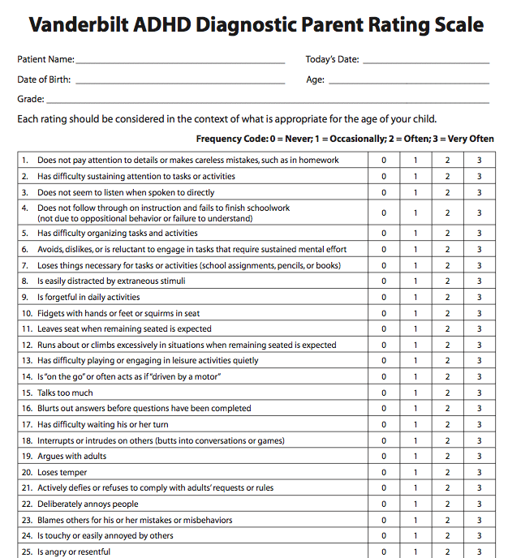

- Strengths and Difficulties Questionnaire (SDQ)
Assesses emotional, behavioural, and social functioning (Goodman, 1997).
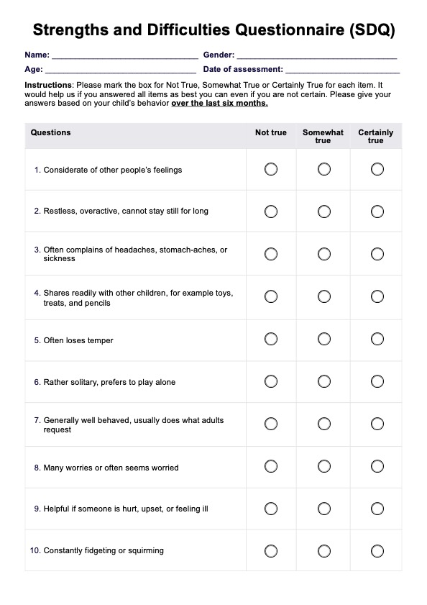
- Emotion Regulation Checklist (ERC)
Evaluates emotional awareness and control (Shields & Cicchetti, 1997).
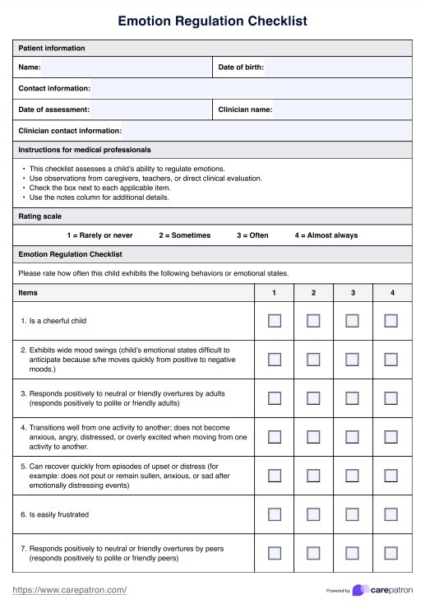
Observation and Intervention Materials
- ABC Observation Chart
Used to identify antecedents, behaviours, and consequences maintaining off-task behaviour (O’Neill et al., 2015).
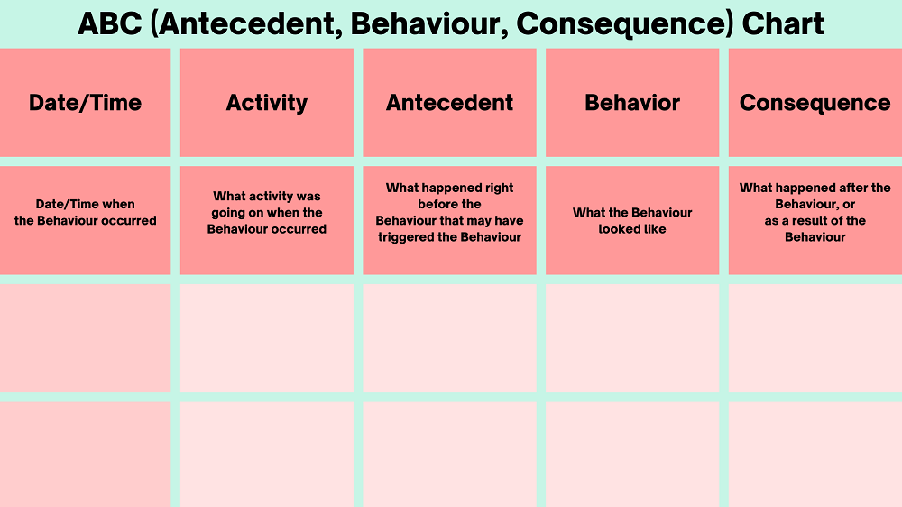
- Behaviour Support Plan Template
Developed using FBA principles to define function-based strategies and reinforcement systems (O’Neill et al., 2015).
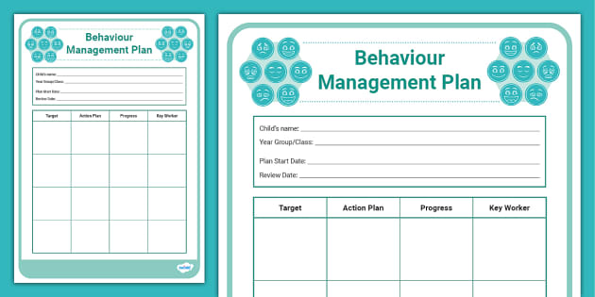
- Parent Handouts and Reward/Token Charts
Based on Barkley’s (2015) ADHD management framework and Gross’s (2013) emotion regulation model.
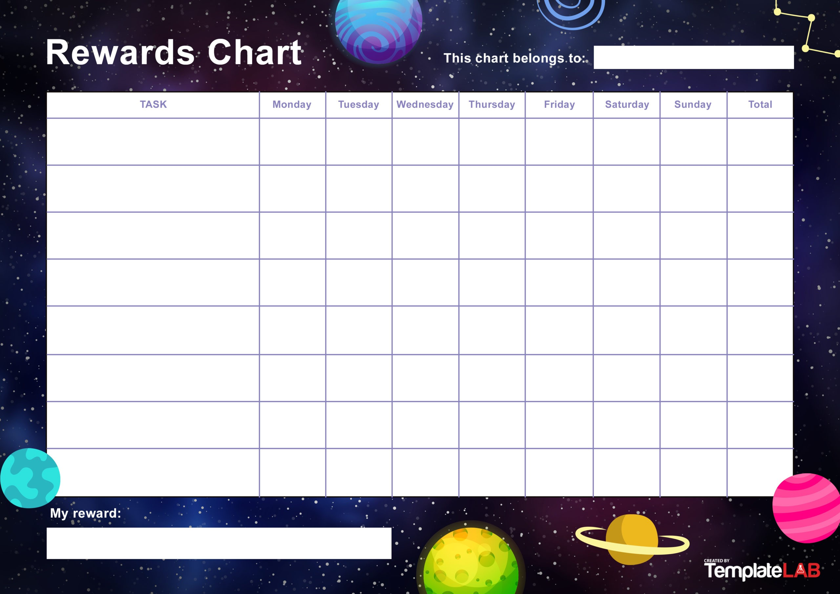

- Emotion Cards and Reflection Sheets
Created to support emotional awareness and mindfulness exercises during sessions.
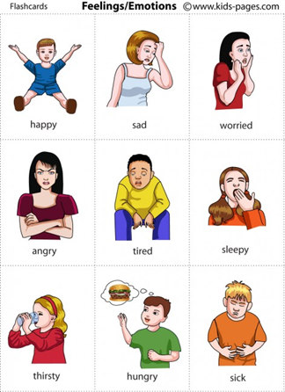
Ethical and Administrative Documents
- Participant Information Sheet
- Parent Consent Form
- Adolescent Assent Form
- Confidentiality Agreement for Facilitators

