  Component One:  What are the key skills required when working in the housekeeping team? 750 words (+/- 10%)  Contribution to Overall Module Assessment: 25% | Student No: | 2207147
 | Module Title: | OPERATING HOTEL FACILITIES
 | Module Code: | BMIH4006
 | Lecturer: | LISA BASSLER
In this section, analysis of the key skills required while working on the housekeeping team in a hotel will be discussed. In this way, a personal reflection alongside the industry-based examples will be provided, which will help a wider understanding of a theoretical perspective while working in the hotel industry respectively. Furthermore, important industry-based examples of housekeeping services in major hotels will be provided, which make the study appropriate.

According to the report of Bhatnagar and Dheeraj (2019), housekeeping service within the hotel sector includes several activities for providing high-quality service to customers. In this way, high-quality skills are required for the housekeeping service of the hotel sector. It has been identified that effective interpersonal skills are required for the hotel sector, which will help to create high excellence regarding the job role. Considering the module learning, I have observed that effective determination, ability to handle any stressful situation, flexibility, and openness to change adaptation, business management skills and high communication skills are required for the housekeeping and customer engagement aspects in the hotel sector. In this way, better operational excellence could be possible.
Furthermore, the report from Resume (2021) stated that efficient room service, time management, organisational, coordination and problem-solving skills are required for the housekeeping service in the hotel sector based on which better guest service and guest retention could be possible. From the module learning, I have come to know that guest satisfaction is the key service for hotels and in this way, the housekeeper should be more skilled and efficient. Henceforth, with the help of the above skills, effective guest service could be provided, which would help to improve guest satisfaction within the hotel sector respectively.
Additionally, it has been stated housekeeping services in the hotel considers an important factor, as it helps in maintaining the utmost standards of cleanliness and room quality. The housekeeping services in the hotel consider the delivery of high-quality accommodations to the guests based on which the brand value and awareness of the hotel could be enhanced effectively (Choi et al., 2020). As per the module and personal experience, I observed similar concepts, which prove the importance of the subject matter in the context of the hotel sector respectively. Furthermore, Aldabbagh et al. (2022) reported that standard and effective housekeeping service helps to incorporate the value-added differentiation based on which interpersonal and professional skill development is required among the housekeeper in the hotel sector respectively.
Considering this aspect, the theoretical analysis of consumer service theory in the context of the housekeeping service of the hotel would be effective. From the module outcome, I have come to know that effective and high-quality service to the guest should be provided for retaining them on a long-term basis. Ahmed (2021) opened the consumer service theory which has helped businesses by providing high-quality services and thereby ensuring superior customer service as well as achieving their business goals with the help of the housekeeping service in the hotel, the continuous maintenance of room service, maintaining the hotel standards, cleanliness and better accommodation that is being delivered has been proven effective. For example, it has been identified that Hotel giant Hilton continues to provide quality housekeeping service without any cost across the 18 brands around the world (Goldstein, 2021). In this way, guests have enjoyed their on-demand and flexible housekeeping service during the pandemic, which provides high guest satisfaction respectively.
Henceforth, the housekeeping team within the hotel sector need to develop proper interpersonal skills based on which quality service and accommodation to the customers could be provided and help the hotel to remain competitive through guest engagement during the crisis as well. Additionally, considering the consumer service theory, the housekeeping team within the hotel sector need to improve their interpersonal skills and other customer management skills, which are mentioned above. In this way, better service delivery to the guest could be possible with proper excellence.

At the end of this section, it has been identified that the housekeeping services within the hotel sector is considered important based on which the guest engage in with the hotel is more possible. Several skills and excellences of the housekeeping team within the hotel sector have been identified such as communication, problem-solving, guest handling, room cleaning and other skills, which would help in improving the brand performance of the hotel respectively. Additionally, industry-based examples and theoretical analysis of the subject matter have been provided, which has further explained the importance of the topic in the context of the study as well.

Word Count | 750

Component Two:
Contribution to Overall Module Assessment: 25%
In this scenario – You have just been promoted to team leader for a floor within the hotel. A guest complains that on their arrival, their room had not been properly cleaned. Create an action plan and answer the following questions.

Problem | Why did it happen? | What are you going to do? | How will you prevent this from happening in the future? | What measures would you introduce to improve team effectiveness?
Dust on the floor | This problem has been raised due to improper vacuuming and cleaning by newly appointed housekeeping staff. | In this aspect, I am going to recruit an experienced member of staff to resolve the complaint made by the guest. | Considering the issue faced by guests, I will recruit new staff with more experience to provide better room service in future. | Additionally, I will collaborate with the team members and provide them with better training regarding room service, which will help to reduce this kind of issue in the future.
Fingerprints on the bathroom mirrors | Complaint from guest about fingerprints on the bathroom mirrors, which might be possible due to cleaning malpractice and the lack of observation skills of the housekeeping staff. | I am going to interact with the guest who made the complaint and send experienced staff to resolve the issue as soon as possible. | In this scenario, I have experienced that a lack of observation skills might lead to generating this issue in future. This, I will be focusing on more training. | Considering this issue, I will take measures regarding the training session among the employees regarding the development of proper housekeeping management and observation skill, which would help to reduce the chance of this kind of issue happening again in the future. I will focus on communication skills and collaboration skill development among the housekeeping staff for further and better outcome respectively.
Problems regarding toiletries | Additionally, some of the guests on this floor have complained about the lack of toiletries in the bathroom, which has created unhappy guest in the hotel. It has been stated to me that the bathroom in the guest hotel room did not contain necessary toiletries. The following problem might be raised due to a shortage of the toiletry stock in the housekeeping service. | In this context, I am going to provide an experienced housekeeping staff to offer deepest apologies. Additionally, I will personally interact with the guests and assure them that this sort of issue will never happen again in future. | In future, I will focus on the housekeeping service stock myself and make sure there’s no shortage of toiletries before check-in. Also, I will recruit a team of new housekeeping staff with experience based on which quality service could be improved on. | Furthermore, I will take certain measures regarding the housekeeping services, which will help to mitigate the problem. In this aspect, I will put in place new regulations regarding the room service and influence the staff interactively to maintain the rules while doing housekeeping services in future.
Broken lights | Besides, the above problems, I have found that some of the guests found broken lights in their rooms and in their bathrooms. This is due to a lack of observation from the housekeeping staff. | After recognising the issue, I will apologise to the guest regarding the issue and resolve the problem as early as possible and have the lights replaced immediately by maintenance staff. | This problem has been resulted due to poor observation skills among the employees. This, I need to focus on improving the above skills among the housekeeping staff based on which quality service could be provided to them with proper guest satisfaction respectively. | In the context of the previous problem, I will arrange a training and workshop session for the new and experienced staff on better housekeeping service. Additionally, I will take measures for the skill development of the newly hired staff based on which avoidance of this problem in future could be possible.
Garbage under the bed | Moreover, some of the guests have complained about the presence of garbage under the bed, which indicates the lack of proper cleaning and room service facilities provided by the housekeeping team. | In this aspect, I would send an experienced housekeeping team to the room and resolve the problem as early as possible. Additionally, I will tell the team to crosscheck the rooms properly and assure the best service is received. | In future, I will supervise the entire housekeeping process and crosscheck every room properly for better operational management. | Moreover, I will arrange a training session for the staff regarding operational excellence in future as well.

Component Three:
Contribution to Overall Module Assessment: 50%
Your task is to create and prepare a presentation following the detailed scenario provided below.

As the floor housekeeping manager and given the recent guest complaints you need to put together a basic training presentation for your colleagues within the housekeeping team to get the best out of them, ensure that brand standard is being achieved and that Health and Safety procedures are also being followed.



Training Notes: The following presentation will provide a training session on the improvement of required skills through which the relationship between work efficiency and guest satisfaction in the context of the housekeeping service could be achieved.
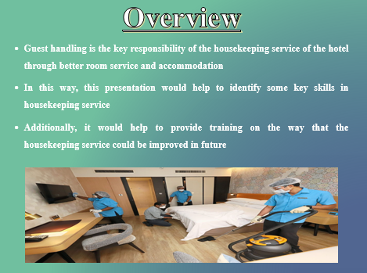
Training Notes: It has been identified that some of the guests in the hotel faced significant issues regarding the presence of dust on the floor, fingerprints in the mirrors of the bathroom, unavailability of the necessary toiletries, broken lights, and the presence of garbage under the bed. Additionally, guidance on health and hygiene practices within the hotel and housekeeping service would be provided for better learning outcomes for the housekeeping staff respectively.
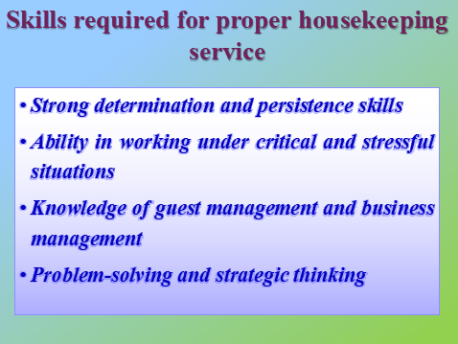
Training Notes: It has been observed that housekeeping service in the hotel room requires effective skills including the previous ones, based on which proper brand value of the hotel could be enhanced. As reported by Juetten (2020), strong determination and persistence skills could help to focus on the work that has to be done for providing the best quality service to the customers. Additionally, working under critical and stressful pressure is required to be present among the housekeeping staff, as it helps to calm the mind and focus on the work and thereby ensuring the best quality service in a situation similar to the mentioned ones.
Furthermore, the housekeeping staff is required to know effective guest and business management skills, as in this way, the tactics, and strategies for providing guest satisfaction could be possible based on which better brand engagement with the guests would be possible (Hollander, 2022). Besides, problem-solving, and strategic thinking skills are the two important aspects required to be present inside the working strategy based on which high-quality service could be provided to the customers. Considering this, the housekeeping staff are requested to engage in a critical working situation and interact with each other, which would help to improve their situational analysis skills among them and thereby gradually developing problem-solving and strategic thinking skills. Additionally, experienced staff are requested to assist the new housekeeping staff with better skill development and service delivery.
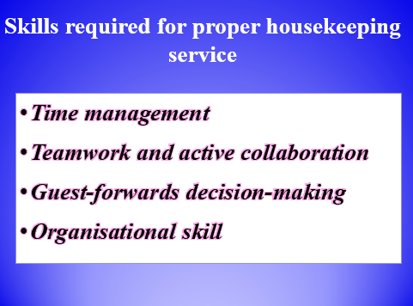

Training Notes: Housekeeping staffs require effective time management skills to provide high-quality room service timely. In this way, better guest satisfaction could be possible. Lutkevich and Wigmore (2023) stated that time management skill helps to maintain the proper working process and thereby reducing the occurrence of errors within the tasks. In this way, the housekeeping staffs need to develop proper scheduling of allocated tasks and set a goal for providing the best quality task within time. Besides, teamwork and collaboration among the housekeeping team would help to resolve any problems in the guest rooms and thereby helping to implement effective procurement methods for resolving that (Hollander, 2022).
Additionally, housekeeping staff should focus on decision-making skill development by considering guests' perspectives, which would result in high guest satisfaction within the hotel respectively. Alongside, Kurdi and Alshurideh (2020) stated that organisational skill is the necessary skill that must be present among every employee and based on this, housekeeping staff should maintain their organisational capability while doing room service. In this way, minute errors in the room service and previous issues faced by the guest could be eliminated effectively.
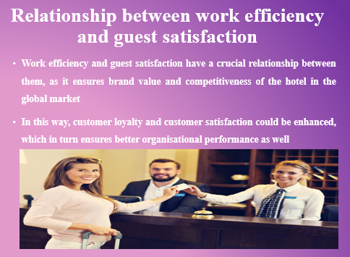

Training Notes: It has been identified that service quality could be enhanced with the help of effective working efficiency provided by the staff based on which customer loyalty and satisfaction would be enhanced (Ali et al., 2021). In this way, overall brand performance, value and endorsement in the target market could be improved on a long-term basis. In this way, the housekeeping staffs need to focus on their work efficiency through the development of the above-mentioned skills and potential based on which they could reduce the occurrence of previous issues in future and provide high-quality service to the hotel guest in terms of room service and accommodations. Considering this, the brand value and awareness among the target consumer could be high and thereby ensuring long-term engagement with the consumers respectively for better business operations.
Furthermore, Chang et al. (2017) stated that customer satisfaction in the business sector is directly linked with several elements such as reliability, tangibility and empathy, which are influenced by efficient working practices. Therefore, housekeeping staff should be aware of all of these aspects while doing the room service and thereby limiting the occurrence of issues further respectively. In this way, guests become satisfied with the hotel service and refer the hotel to other guests, which would help to increase guest engagement with the hotel as well.

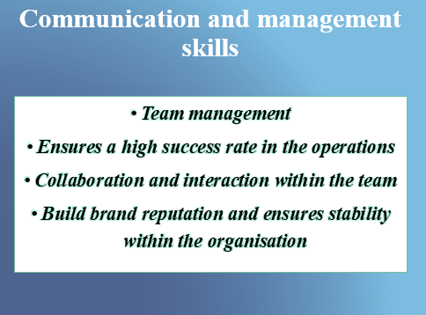

Training Notes: According to the study by Sinha (2018), effective communication and management skills are required for the housekeeping staff in the hotel, as it helps to maintain better interaction, collaboration, and teamwork. Considering the previously mentioned issues faced by the hotel guests, the key problem was the lack of communication and management skills among the newly hired staff based on which systematic working processes in room service and accommodation could not be possible. Based on this, every housekeeping staffs are requested to build active interaction with each other based on which better knowledge and skill delivery could be possible.
Additionally, Knight, Patterson and Dawson (2019) stated that with the help of better management skills, a systematic flow of the working process could possible and in this way, errors could be handled properly without any mistakes. Thus, the experienced staff should focus on the organisation and management of overall room service activities and thereby ensuring better guest satisfaction for the long-term future respectively.
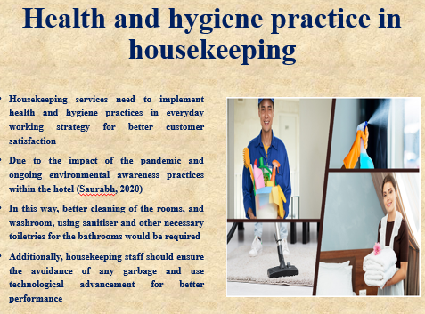

Training Notes: As per the opinion of Saurabh (2020), due to the impact of the pandemic, the guests become focused on the hotel that provides health and hygiene practices. In this way, improper health and hygiene practices would reduce guest satisfaction and thereby reducing guest satisfaction with the hotel as well. Furthermore, it can be stated that personal hygiene factor maintenance could influence the overall brand value of the hotel effectively in the global market based on which the guest could be attracted to the brand as well.
Considering this, the housekeeping staff are requested to improve their working process and follow the health and hygiene policies provided in the code of conduct of the hotel. In this context, maintenance and cleaning of the rooms, furniture, floor and bathroom need to be done properly alongside the cleaning of garbage present inside the room with disinfectant. Furthermore, sanitisers, hand wash, clean towels, medical soap, body wash and other necessary toiletries should be present in the bathroom, which would ensure better hygiene practices for the guests. Additionally, housekeeping staff should effectively use technological advancements such as vacuum cleaners for the cleaning process, which would ensure better results and in this aspect; skilled staff are required.
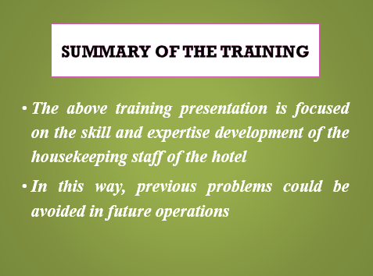

Training Notes: Several necessary skills and strategies, which would help to improve the operational performance of the housekeeping staff, have been mentioned. This would ultimately enhance their skill, knowledge and capability based on which guest satisfaction and loyalty of the hotel could be managed in the long-term future as well. Furthermore, a guideline on health and hygiene practice within the housekeeping service has been provided based on which the operational process could be further improved as well.
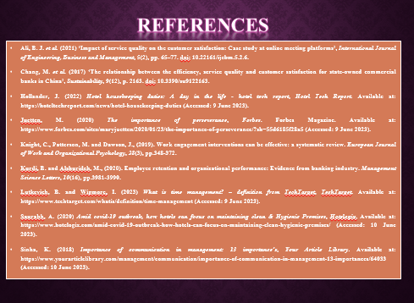

Training Notes: Here are some important study materials, which could be accessed by the staffs for skill and knowledge development.


Training Notes: Thank you so much for your cooperation and attention to this training session.

References
Ahmed, A. (2021) Customer service theory, Bizfluent. Available at: https://bizfluent.com/about-6502641-customer-service-theory.html (Accessed: 7 June 2023).
Aldabbagh, A., Neyazi, D., Alsahafi, M., Sarhan, A. and Palaniswamy, T., (2022). Improving the Quality of The Housekeeping Management Process for Stay at Bridge Suites Hotel. Journal of Advances in Humanities Research, 1(1), pp.26-41.
Ali, B. J. et al. (2021) ‘Impact of service quality on the customer satisfaction: Case study at online meeting platforms’, International Journal of Engineering, Business and Management, 5(2), pp. 65–77. doi: 10.22161/ijebm.5.2.6.
Bhatnagar, E. and Dheeraj, N., (2019). Impact of housekeeping services and practices on customer satisfaction and repeat business. Prabandhan: Indian Journal of Management, 12(8), pp.46-57.
Chang, M. et al. (2017) ‘The relationship between the efficiency, service quality and customer satisfaction for state-owned commercial banks in China’, Sustainability, 9(12), p. 2163. doi: 10.3390/su9122163.
Choi, Y., Choi, M., Oh, M. and Kim, S., (2020). Service robots in hotels: understanding the service quality perceptions of human-robot interaction. Journal of Hospitality Marketing & Management, 29(6), pp.613-635.
Goldstein, M. (2021) As hotels like hilton make daily housekeeping optional, will it damage the hotel product?, Forbes. Forbes Magazine. Available at: https://www.forbes.com/sites/michaelgoldstein/2021/07/19/hotels-like-hilton-drop-daily-housekeeping-will-it-annoy-customers/?sh=1858ebd07205 (Accessed: 7 June 2023).
Hollander, J. (2022) Hotel housekeeping duties: A day in the life - hotel tech report, Hotel Tech Report. Available at: https://hoteltechreport.com/news/hotel-housekeeping-duties (Accessed: 9 June 2023).
Juetten, M. (2020) The importance of perseverance, Forbes. Forbes Magazine. Available at: https://www.forbes.com/sites/maryjuetten/2020/01/23/the-importance-of-perseverance/?sh=55d6185f28a5 (Accessed: 9 June 2023).
Knight, C., Patterson, M. and Dawson, J., (2019). Work engagement interventions can be effective: a systematic review. European Journal of Work and Organizational Psychology, 28(3), pp.348-372.
Kurdi, B. and Alshurideh, M., (2020). Employee retention and organizational performance: Evidence from banking industry. Management Science Letters, 10(16), pp.3981-3990.
Lutkevich, B. and Wigmore, I. (2023) What is time management? – definition from TechTarget, TechTarget. Available at: https://www.techtarget.com/whatis/definition/time-management (Accessed: 9 June 2023).
Resume (2021) Housekeeping skills: Best skills & examples, Resume. Available at: https://www.resume.com/career-advice/resumes/how-to-list-housekeeping-skills-on-resume/ (Accessed: 7 June 2023).
Saurabh, A. (2020) Amid covid-19 outbreak, how hotels can focus on maintaining clean & Hygienic Premises, Hotelogix. Available at: https://www.hotelogix.com/amid-covid-19-outbreak-how-hotels-can-focus-on-maintaining-clean-hygienic-premises/ (Accessed: 10 June 2023).
Sinha, K. (2018) Importance of communication in management: 13 importance’s, Your Article Library. Available at: https://www.yourarticlelibrary.com/management/communication/importance-of-communication-in-management-13-importances/64033 (Accessed: 10 June 2023).

