ACDA6001 Electronics 2

Contents
Table of Contents
Contents 2
Abstract 5
Introduction 5
Design 6
logic circuit design 6
Multiplier block diagrams 8
Implementation 10
RTL design 11
constraints 12
I/O planning 13
Implementation schematic 15
device 16
hardware implementation 22
Testing 24
Evaluation 33
design and implementation 33
timing 33
power consumption 33
speed and power efficiency 33
LUTs 33
fpga implementation 34
tests 34
tools and techniques 34
Conclusion 34
Bibliography 34
Appendix 1 35
Appendix 2 45
Appendix 3 54

Figures

Table of Figures
Figure 1: half adder logic 6
Figure 2: full adder logic 7
Figure 3: Braun multiplier logic diagram [2] 9
Figure 4: Wallace logic diagram 10
Figure 5: braun rtl 11
Figure 6: wallace rtl 11
Figure 7: braun multiplier longest path [2] 12
Figure 8: wallace multiplier longest path 13
Figure 9: io planning braun 14
Figure 10: io planning wallace 15
Figure 11: implmentation diagram braun 15
Figure 12: implementaion diagram wallace 16
Figure 13: device implentation braun 17
Figure 14: device implmentation wallace 17
Figure 15: braun LUT usage 18
Figure 16: Braun pin out 1 18
Figure 17: Braun pin out 2 18
Figure 18: timing braun synthesised 18
Figure 19: braun utilisation timing and power implemented 19
Figure 20: braun timing implmented 19
Figure 21: braun power 1 19
Figure 22: braun power 2 20
Figure 23: wallace LUT usage 20
Figure 24: Wallace pinout 1 20
Figure 25: wallace pinout 2 21
Figure 26: wallace timing sythesised 21
Figure 27: wallace power utilisation and timing implmented 21
Figure 28: Wallace power 22
Figure 29: braun basys test calculator [5] 22
Figure 30: braun on basys3 board test 23
Figure 31: wallace basys3 test calculator [5] 23
Figure 32: wallace basys3 test 24
Figure 33: braun sim test 1 25
Figure 34: braun sim test calc 1[5] 25
Figure 35: braun sim test 2 26
Figure 36: braun sim test calc 2 [5] 26
Figure 37: braun sim test 3 27
Figure 38: braun sim test calc 3 [5] 27
Figure 39: braun sim test 4 28
Figure 40: braun sim calc 4 [5] 28
Figure 41: wallace sim test 1 29
Figure 42: Wallace Calc test 1 [5] 29
Figure 43: walace sim test 2 30
Figure 44: wallace sim calc 2 [5] 30
Figure 45: wallace sim test 3 31
Figure 46: wallace sim calc 3 [5] 31
Figure 47: wallace sim test 4 32
Figure 48: wallace sim calc 4[5] 32
Figure 49: braun code 1 36
Figure 50: braun code 2 37
Figure 51: braun code 3 38
Figure 52: braun code 4 39
Figure 53: braun code 5 40
Figure 54: braun code 5 41
Figure 55: braun code 6 42
Figure 56: braun code 7 43
Figure 57: braun code 8 44
Figure 58: wallace code 1 45
Figure 59: walllace code 2 46
Figure 60: wallace code 3 47
Figure 61: wallace code 4 48
Figure 62: wallace code 5 49
Figure 63: wallace code 6 50
Figure 64: wallace code 7 51
Figure 65: wallace code 8 52
Figure 66: wallace code 9 53
Figure 67: wallace code 10 54
Figure 68: constants code 1 55
Figure 69: constants code 2 56

Abstract
- In this report the author demonstrates Wallace and Braun multiplier developed in Vivado. The author also demonstrates the similarities and difference of the Braun and Wallace multiplier. The authors results show that Wallace has a faster operation and as such is best used in high speed computation while Braun uses less LUTs and as such is better used in space dependent FPGA boards.

Introduction
This report will demonstrate how to design, implement and simulate two binary multipliers using Vivado, an integrated development environment produced by Xilinx now owned by AMD. these multipliers will be of 8×8 size and simulated on a basys3 development board

binary multipliers are regularly used in microcontrollers, computers and FPGA's anywhere where the user will need to perform multiplication calculations. From the earliest computers capable of multiplication such as the “mark-1 from the USA”[7] the mark1 was developed in 1943 when Wallace multipliers were not developed as such this machine likely used Bruan multipliers. Computers capable of multiplication needed a form of multiplier. There are two focused on in this report Braun and Wallace. Braun and Wallace multipliers take unsigned number inputs and produce a multiplied output.

The Braun multiplier was first implemented in a “mechanical calculator made by Anton Braun” [8] these are the basis of modern electronic Braun binary multipliers.

The Wallace multipliers were first devised by Chris Wallace in 1964 when he was asked to provide suggestions on high speed multiplication methods. His methods used operand reduction in parallel layers. [9]

Literature Review
This literature review examines two texts that inform on VHDL design “Fundamentals Of Digital Logic With VHDL Design 3rd Edition” [5] and “free range VHDL” [6].
“Fundamentals Of Digital Logic With VHDL Design 3rd Edition” [5]
This book provides a from the ground up approach to how to design logic circuits in VHDL.
This book goes through the design basics, the implementation technologies and numeric representation of arithmetic circuits.
The author of this book provides a good foundation for novices. This was useful for the author of this report. They provide numerous snippets of VHDL code as well as touching on multipliers. The multipliers section assisted the author of this report with checking their designs.
in comparison with a book like free range VHDL it provides a more circuit based look at VHDL design and focuses more on the circuits rather than the VHDL code that free VHDL looks at.

The author of the book has a from basics up approach with a start at basic logic and logic gates working its way up to sequential circuits. This approach benefits learners but will be less efficient to those with strong fundamentals such as experts in the field.

“free range VHDL” [6]
Free range VHDL is a book focused on the VHDL and how to best design VHDL code such as its syntax applications and best practices. This book helped the author best understand how to layout their VHDL code according to best practices and how to prepare for the design process.
Unlike fundamentals of digital logic with VHDL" changed to "This contrasts with Brown and Vranesic's (2008) 'Fundamentals of Digital Logic with VHDL Design,' which adopts a more circuit-centric approach.

Design
- In this section the author designs the block diagrams for the Wallace and Braun multiplier and the logic circuits.

logic circuit design

half adder logic
The half adder is a logic circuit comprised of an and an or logic gate that produces a sum and a carry from two inputs
its circuit looks as below

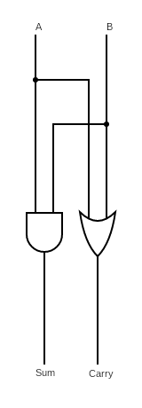
Figure 1: half adder logic
the half adder has a truth table demonstrated below

A | B | sum | carry
0 | 0 | 0 | 0
0 | 1 | 1 | 0
1 | 0 | 1 | 0
1 | 1 | 0 | 1

you can simplify the truth table into two k maps shown below
sum
ba | 0 | 1
0 | 0 | 1
1 | 1 | 0
(A or B)= sum
carry
ba | 0 | 1
0 | 0 | 0
1 | 0 | 1
(A and B)=carry

full adder logic
the full adder logic circuit comprising the gates shown below.

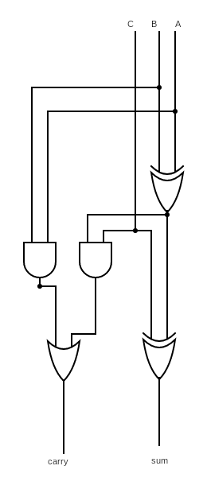
Figure 2: full adder logic

It produces two outputs: a carry and a sum from three inputs.
the truth table is as below

a | b | c | sum | carry
0 | 0 | 0 | 0 | 0
0 | 0 | 1 | 1 | 0
0 | 1 | 0 | 1 | 0
0 | 1 | 1 | 0 | 1
1 | 0 | 0 | 1 | 0
1 | 0 | 1 | 0 | 1
1 | 1 | 0 | 0 | 1
1 | 1 | 1 | 1 | 1

The full adder truth table can be simplified into the two maps below
abc | 00 | 01 | 11 | 10
0 | 0 | 1 | 0 | 1
1 | 1 | 0 | 1 | 0
sum = (A XOR B XOR c)

carry
abc | 00 | 01 | 11 | 10
0 | 0 | 0 | 1 | 0
1 | 0 | 1 | 1 | 1
carry = AB+AC+BC

After identifying the outputs and logic design of the half and full adder the author designed them in VHDL to reduce the time taken later these were to be defined as components of the system.

Multiplier block diagrams

The author drew the multipliers out ahead of producing the VHDL code for the multiplier to allow them to better visualise the paths the circuit would take and how the VHDL would need to be written.

The 8×8 Braun multiplier is as shown below
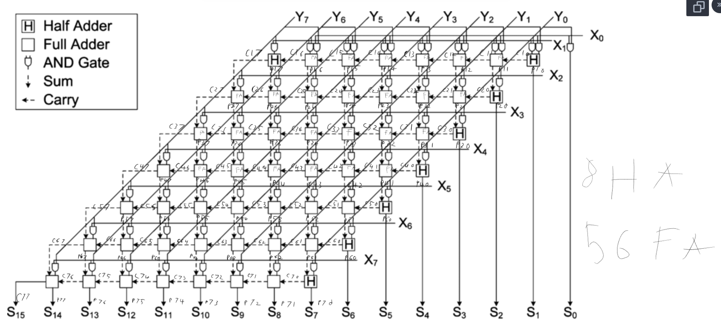Figure 3: Braun multiplier logic diagram [2]

In the authors 8×8 Braun multiplier they map out all the internal signals that the latter implementations will use to reduce development time.

The Wallace multiplier is drawn similarly; the only difference is that the drawing used as a base by the author combined the last set of adders into a single block called vector merging that was broken out into its respective adders by the author as shown below.
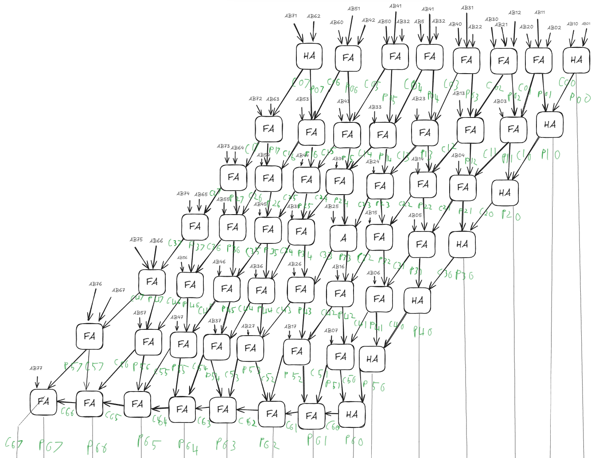Figure 4: Wallace logic diagram

Implementation
Using the drawings made in the design the author produced an 8×8 Braun multiplier the variables are named P, C, S, AB these decided on based on the names on the drawing. The P is the internal output of the sums from each half and full adder with the first number after the P being the row or bank of the adder and the second being where it is in the bank.
C follows the same format as P only that C is for Carries.
S is the final sum and only appears at the bottom of the multiplier.
AB are the outputs of the Ands taken from the A, B input with the first number being what bank and the second being where in the bank it is located AB0 is bank 0.
These are defined as vectors giving them 0 to 7 and 15 in the case of the 8×8 this allows the AB to iterate through the A parts in the multiplier.

Mapping as vectors reduces the number of logic statements the author has to make and allows for easier coding. This allows the author to reference different logics outputs using c1(0) this means in the authors code carry bank1 array value 1.

The Wallace multiplier the author designed is defined in the same way as the Braun multiplier allowing for the use of the same inputs and outputs in the constraints file.

RTL design
Braun
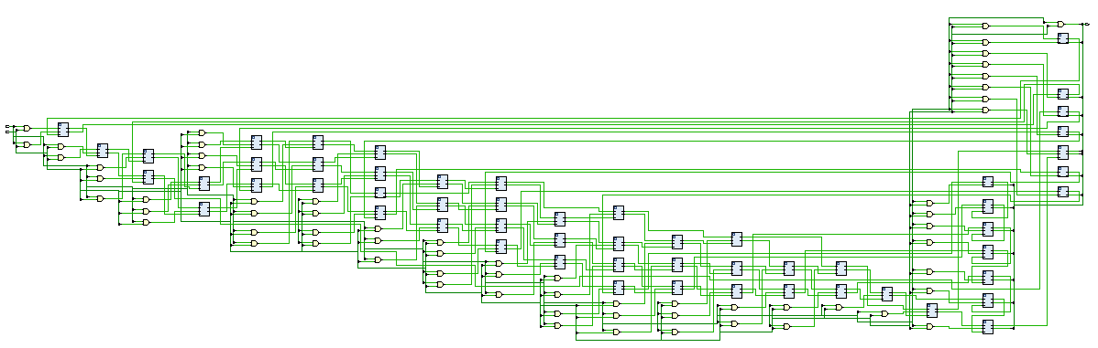Figure 5: Braun RTL
Wallace
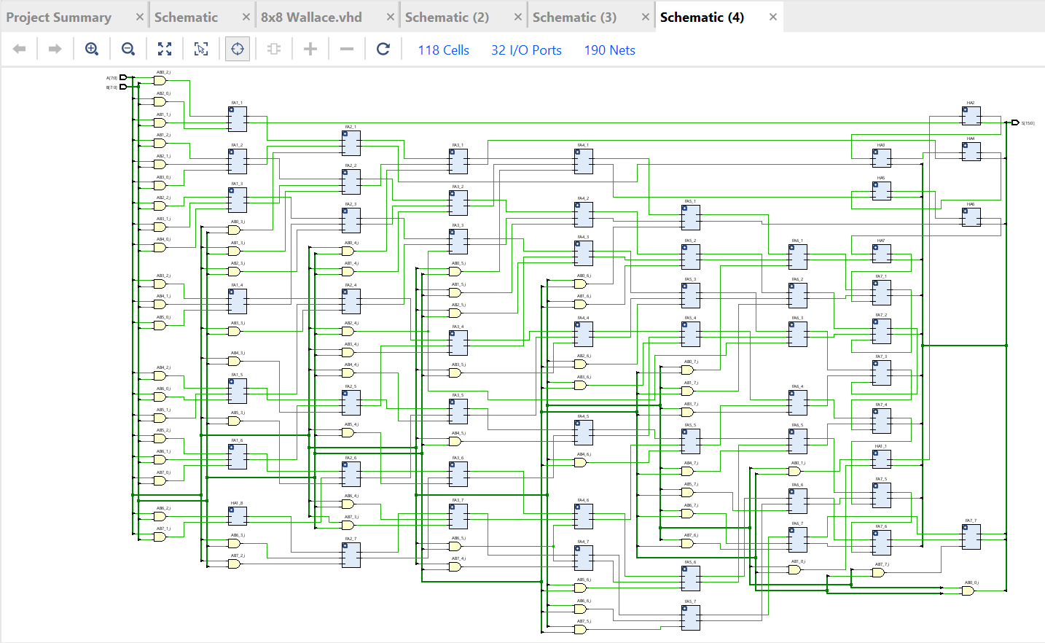Figure 6: Wallace RTL

constraints

for a half adder the delay is 1 nano second.
for a full adder the delay is 2 nanoseconds

For the constraints file the author defined the minimum input delay for both the A port and B ports; they also defined the max input delay for both. The author defines the max as 1 microsecond as this is the longest it should take for an input to be registered on the author's process. This is different from the max time to input which would cause errors if there was no input at all.

the author defined the virtual clock on the constraints to have a 20 microsecond period

The author defined the output of S port to have a max of 2 micro second and a min of 0.
The author then defined the minimum delay from port A to Port B For Braun to 0 and the max as 47 microseconds; this is the max length the process should take to get through the longest route. The author calculated the Wallace multiplier as 0 to 26 as it passes through 13 full adders.
Code in appendix 3
Below is how the author calculated the maximum length for both Wallace and Braun.
Braun
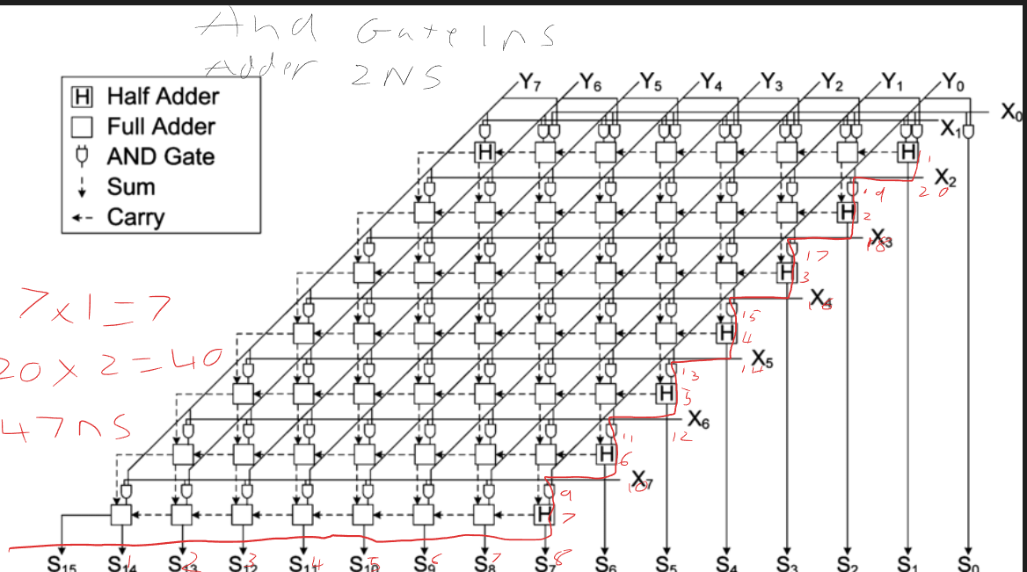Figure 7: Braun multiplier longest path [2]
Wallace
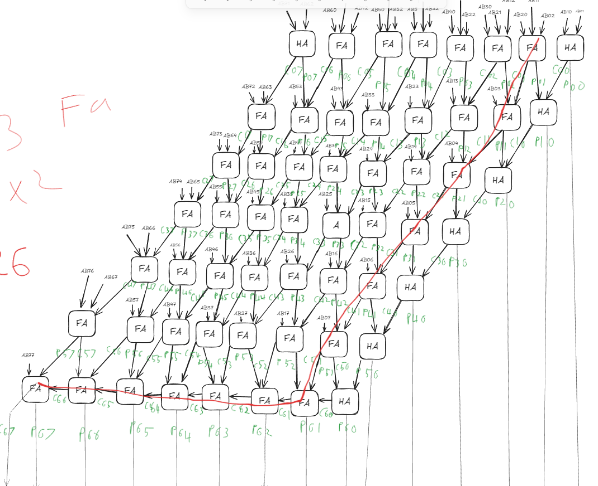Figure 8: Wallace multiplier longest path

I/O planning
The author defined pins A1 to B2 as the inputs and B3 to C4 as the outputs these were then set to have their standard for IO set as LVCMOS18 this is a standard that works at 1.8 V this decision was made to minimise power usage and to follow the advice of the program that the user should not leave the program to default. This advice is given to the author to allow the author to look at the next component in the circuit and check what it needs as an output. In the case of this program it will be powering a simulation or a led these are not power intensive parts.

LVCMOS comes in many versions the most common are 33 25 18 the difference is listed in the sysIO document[3] from lattice Corporation they indicate that the main differences are slew rate max voltage and amperage with 33 maxing at 24mA and 18 maxing at 12mA[3].

Braun
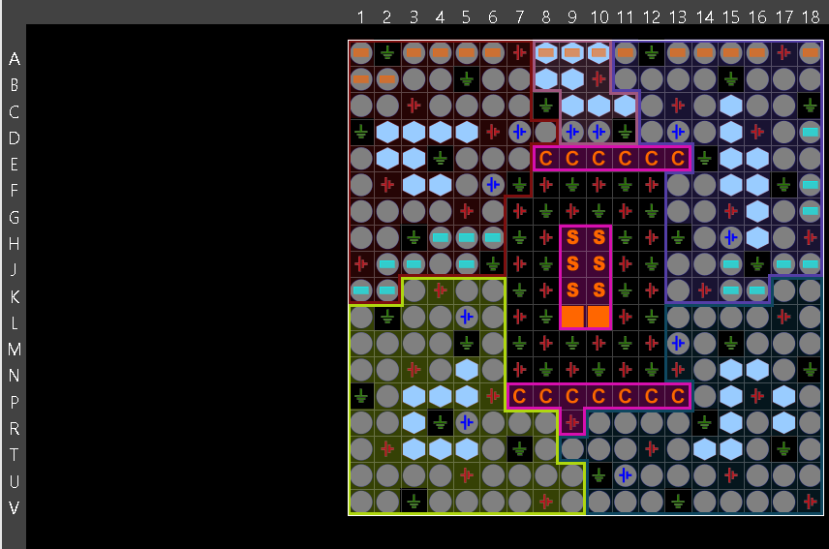Figure 9: io planning Braun

Wallace
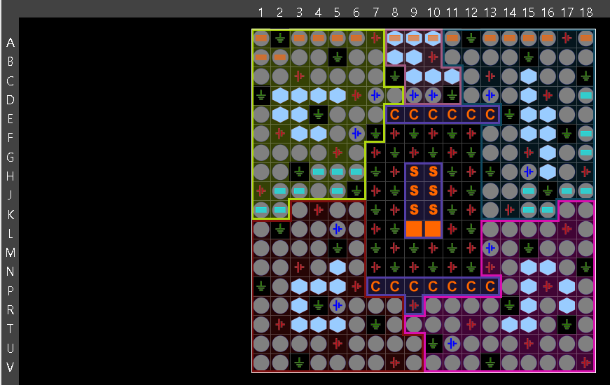Figure 10: io planning Wallace

Implementation schematic
Braun
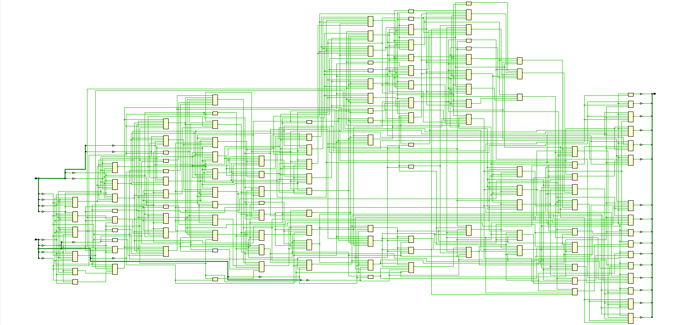Figure 11: implementation diagram Braun
Wallace
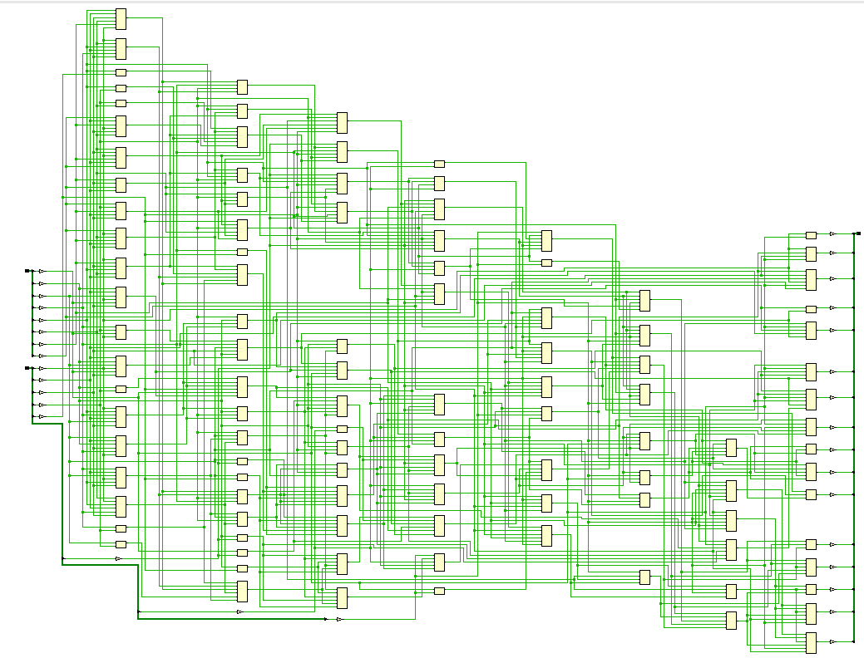Figure 12: implementation diagram Wallace
These schematics are generated by the Vivado design software to make it easier to trace how the logic of the circuit is flowing. This particular schematic is more difficult to read than the RTL design view as it is how the circuit is implemented on FPGA rather than in concept.

device
Braun
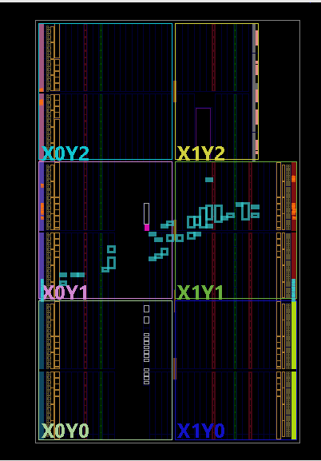Figure 13: device implantation Braun
Wallace
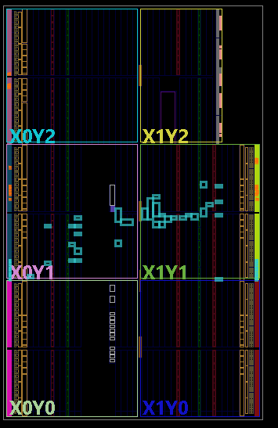Figure 14: device implementation Wallace
This shows how the circuit is allocated across the FPGA from pin to logic bit this is not something the user controls in Vivado as the software looks to avoid the user causing inefficiency inside the circuit.
Below is the setup of both Wallace and Braun in their constraints and design.
Braun
LUT’S used
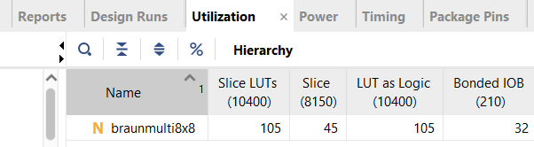Figure 15: Braun LUT usage
pin setup
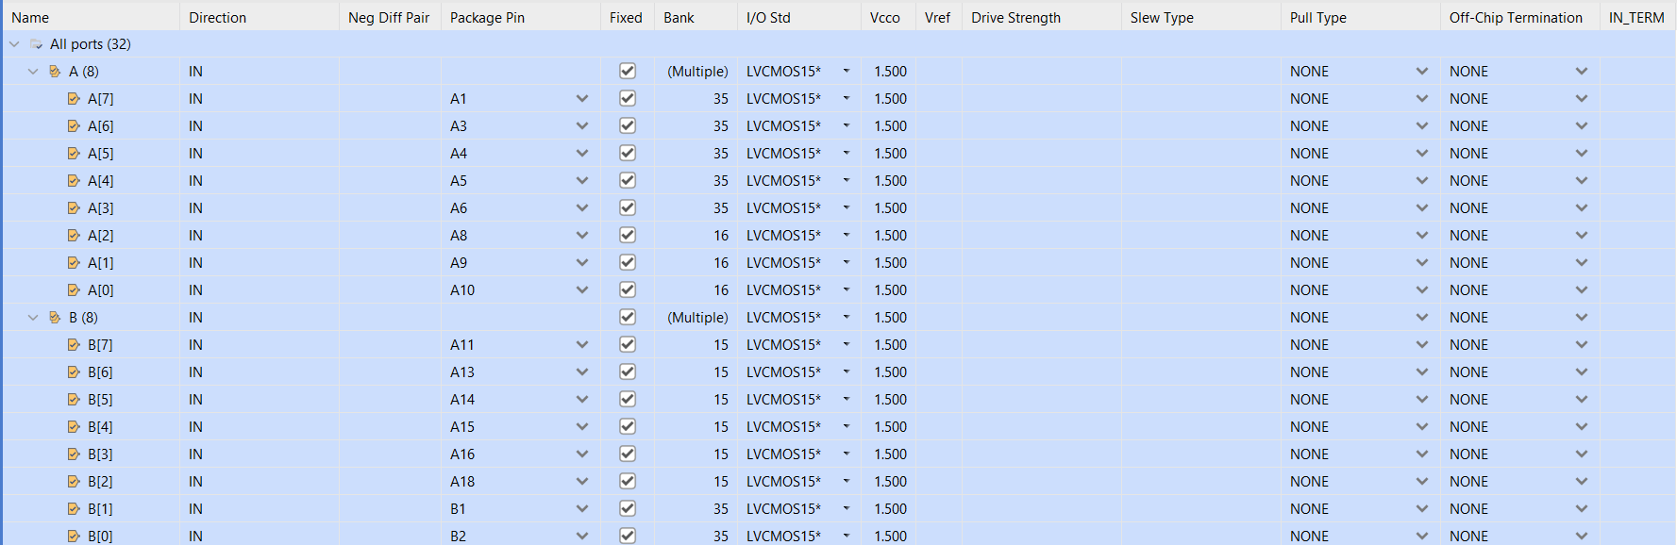Figure 16: Braun pin out 1
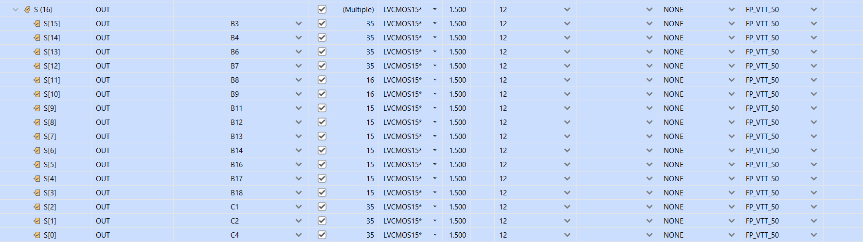Figure 17: Braun pin out 2
timing
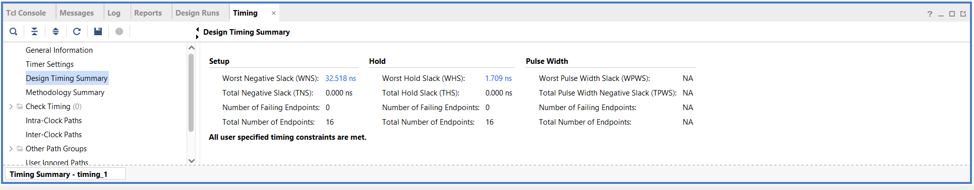Figure 18: timing Braun synthesised

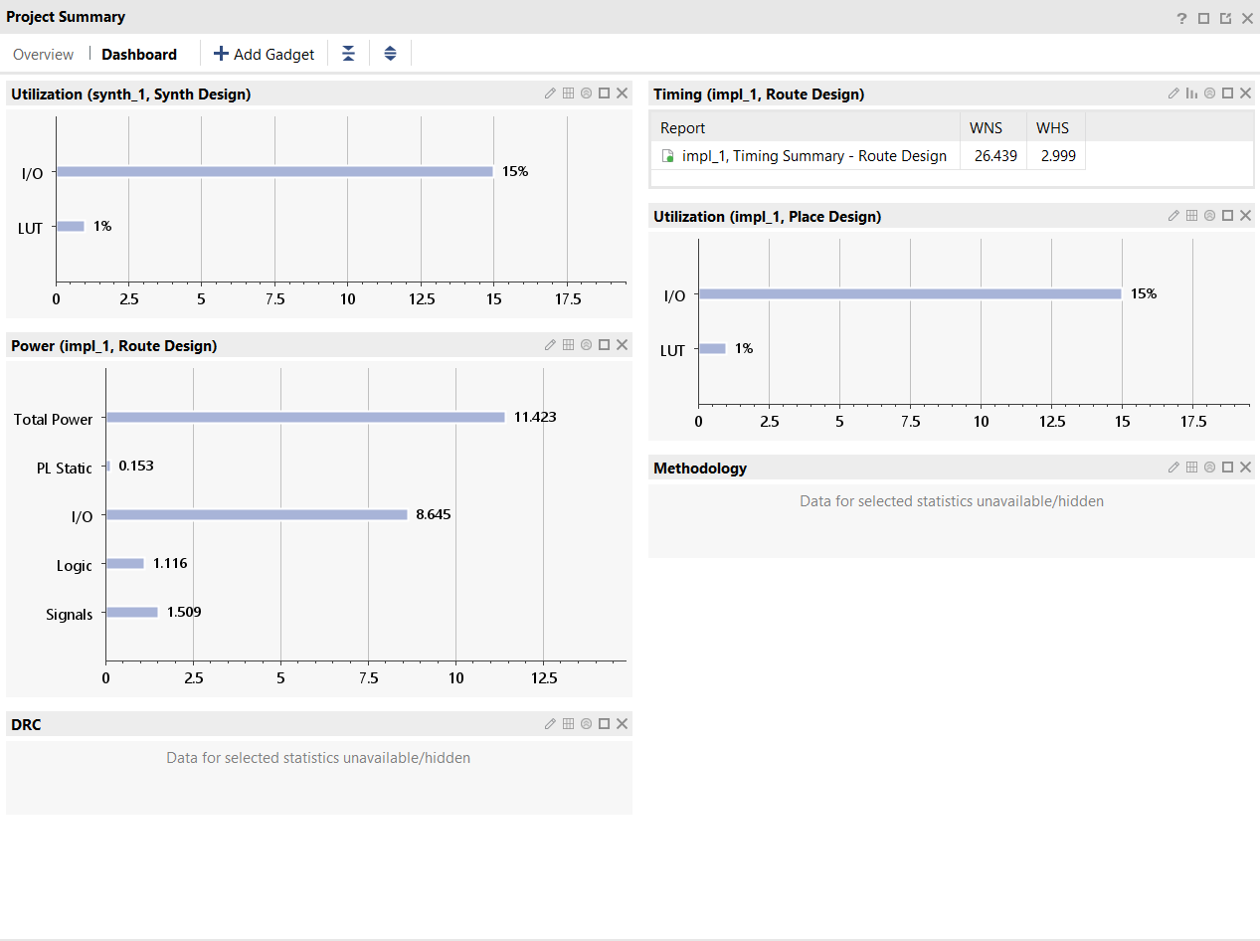Figure 19: Braun utilisation timing and power implemented
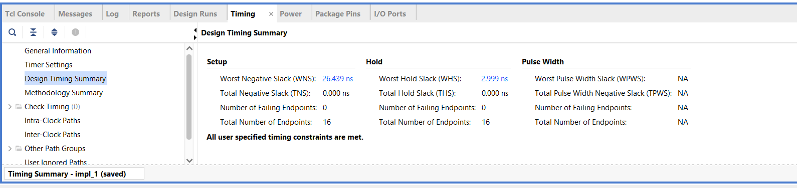Figure 20: Braun timing implemented
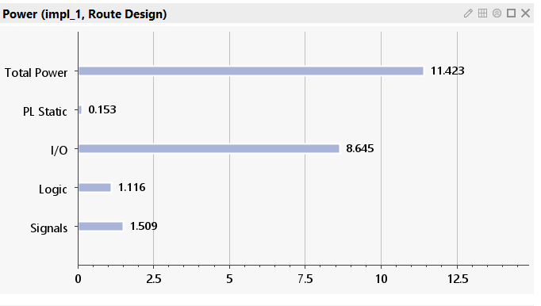Figure 21: Braun power 1
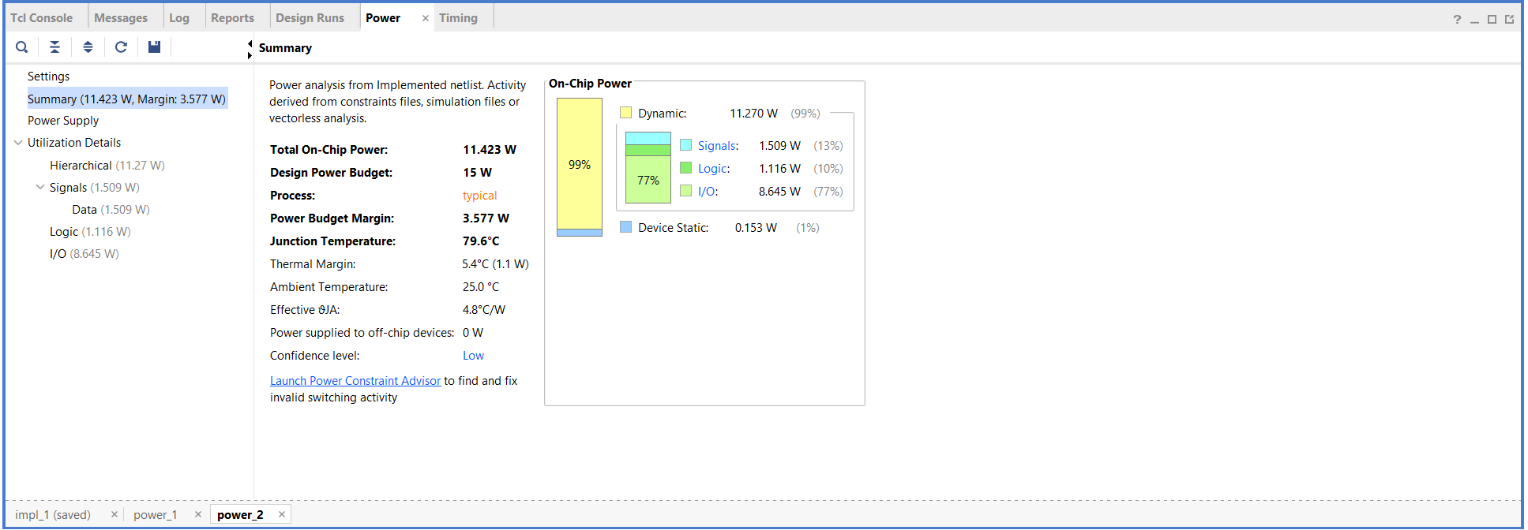Figure 22: Braun power 2
Wallace
LUT’S used
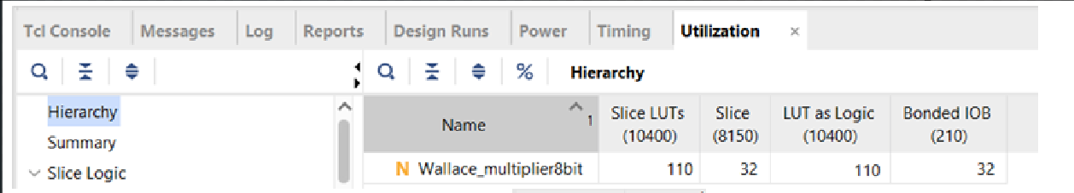Figure 23: Wallace LUT usage
pin setup
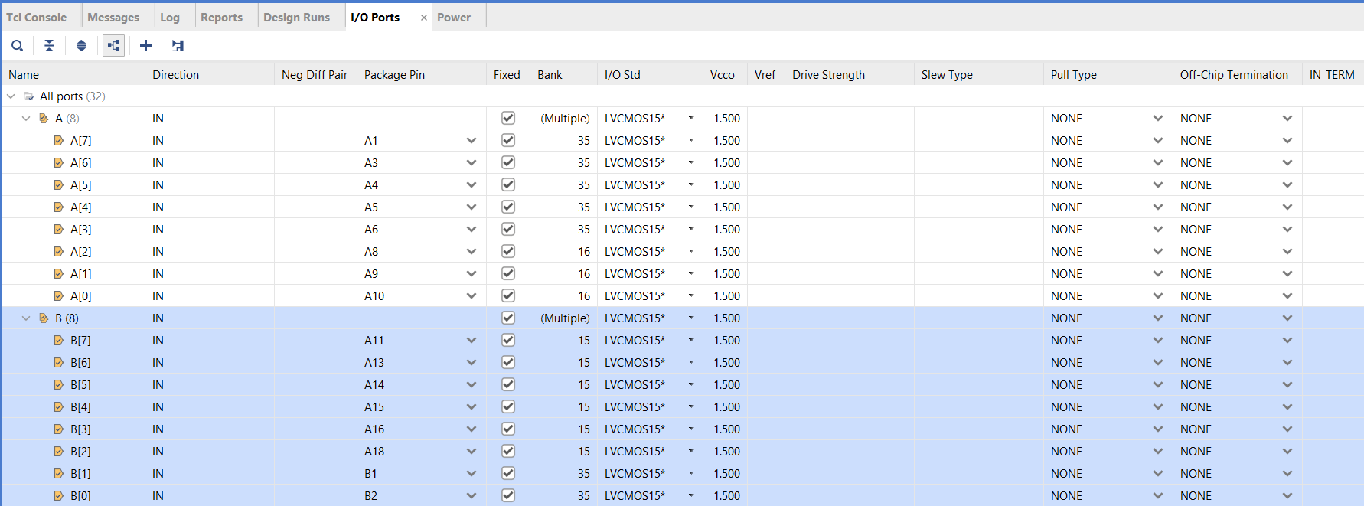Figure 24: Wallace pinout 1
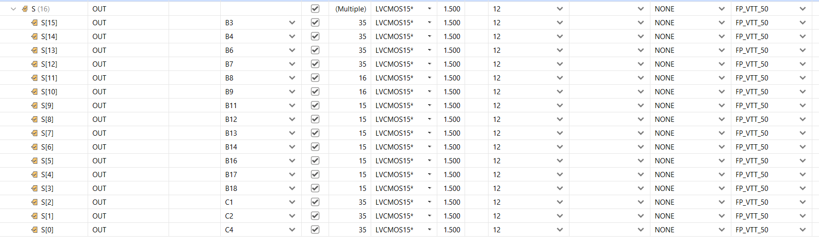Figure 25: Wallace pinout 2
timing
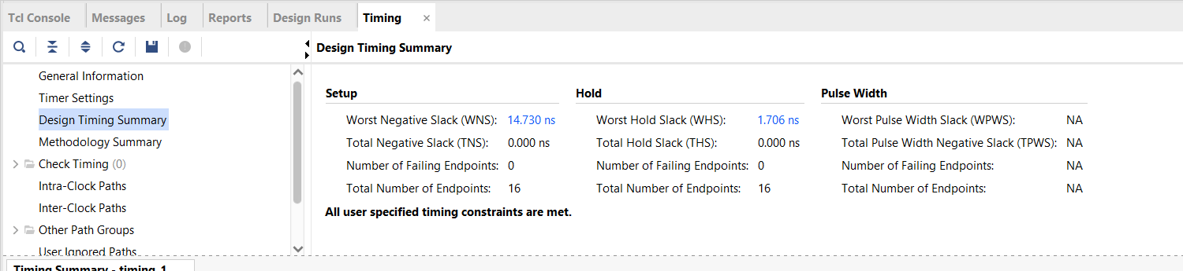Figure 26: Wallace timing synthesised
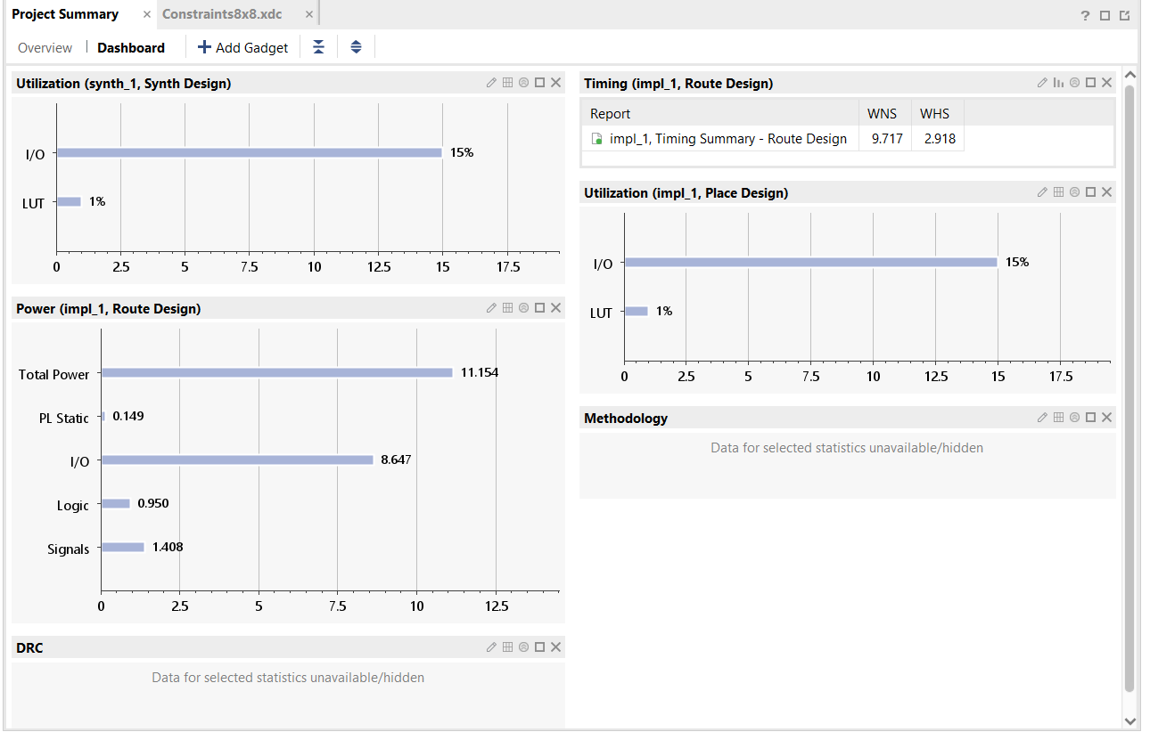Figure 27: Wallace power utilisation and timing implemented

power
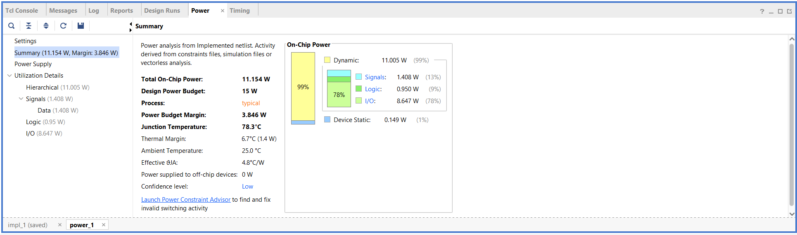Figure 28: Wallace power

hardware implementation

Braun
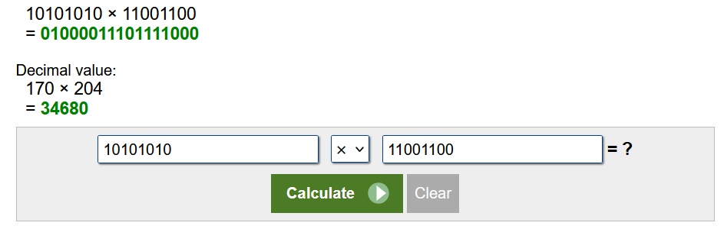Figure 29: Braun basys test calculator [5]
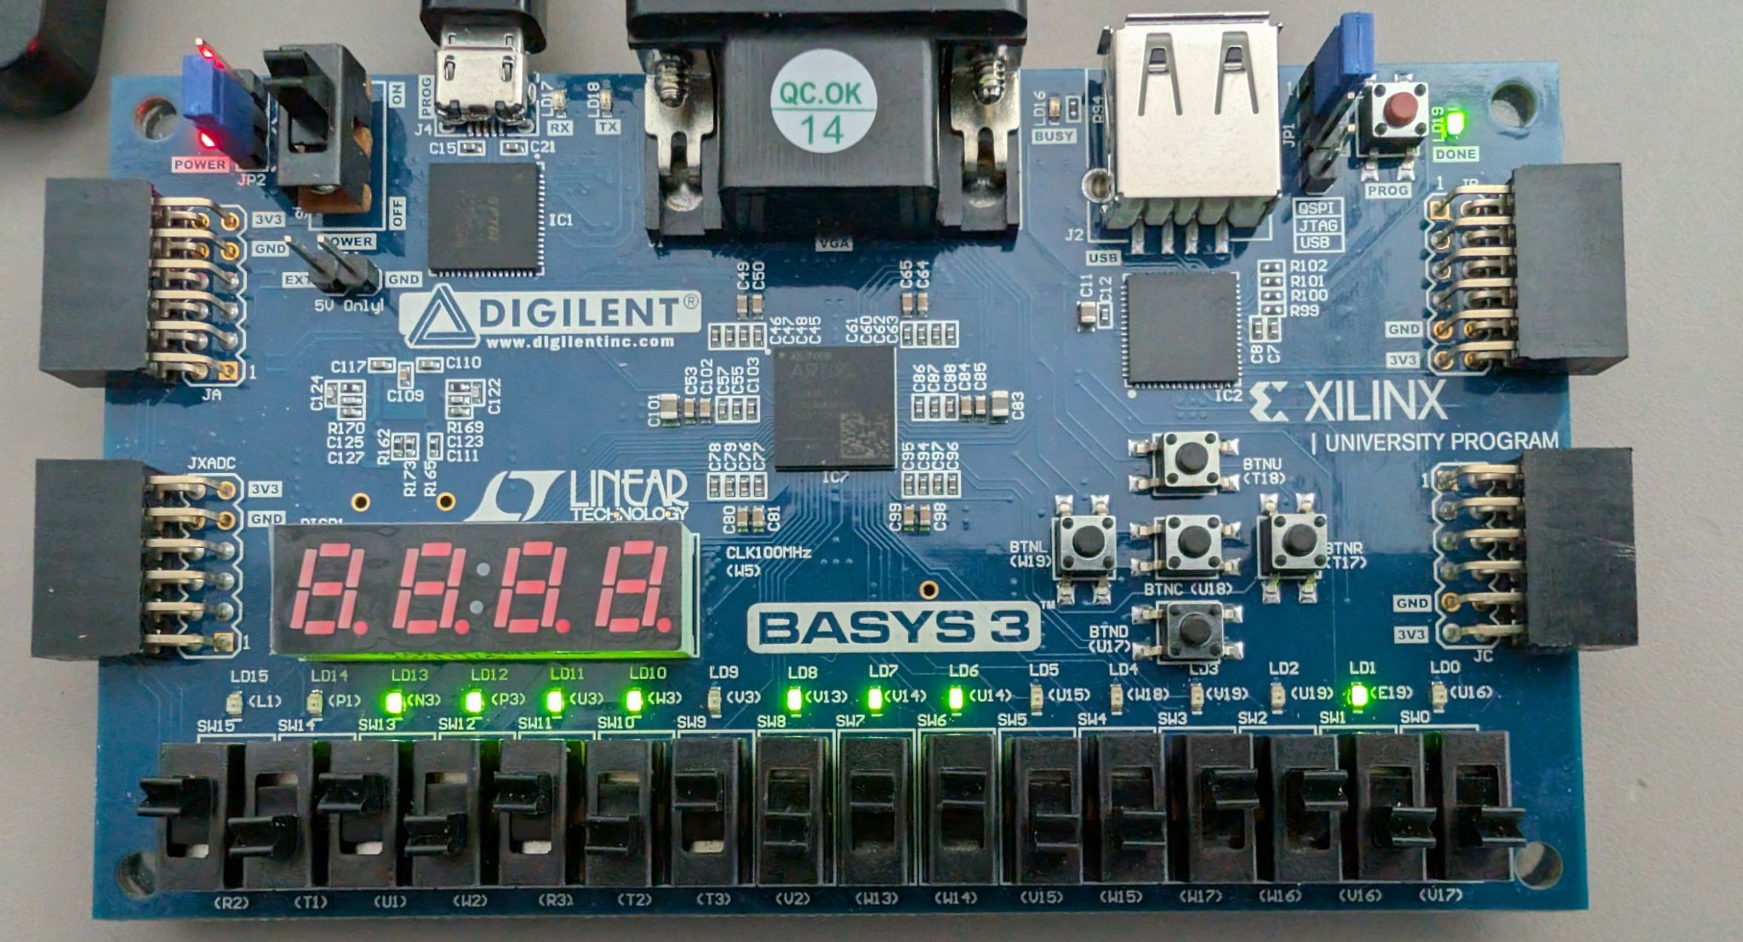Figure 30: Braun on basys3 board test
read right to left on the led's
an and b inputs are swapped between v2 w13

Wallace works the same this is the program working below
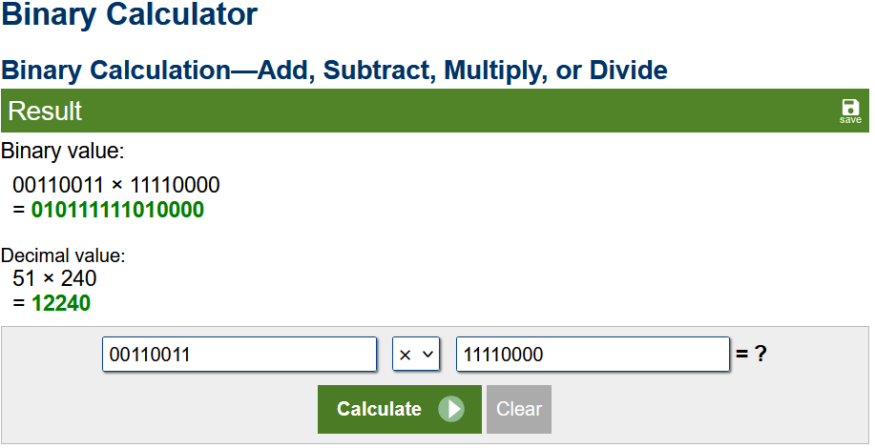Figure 31: Wallace basys3 test calculator [5]
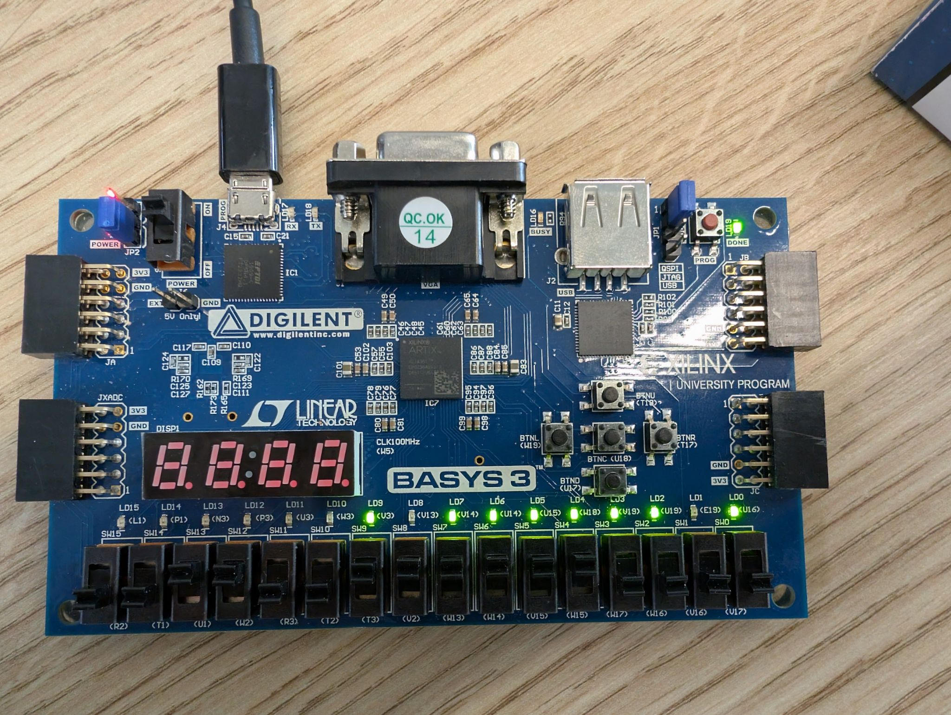Figure 32: Wallace basys3 test

all code is in appendix 1

Testing
Braun
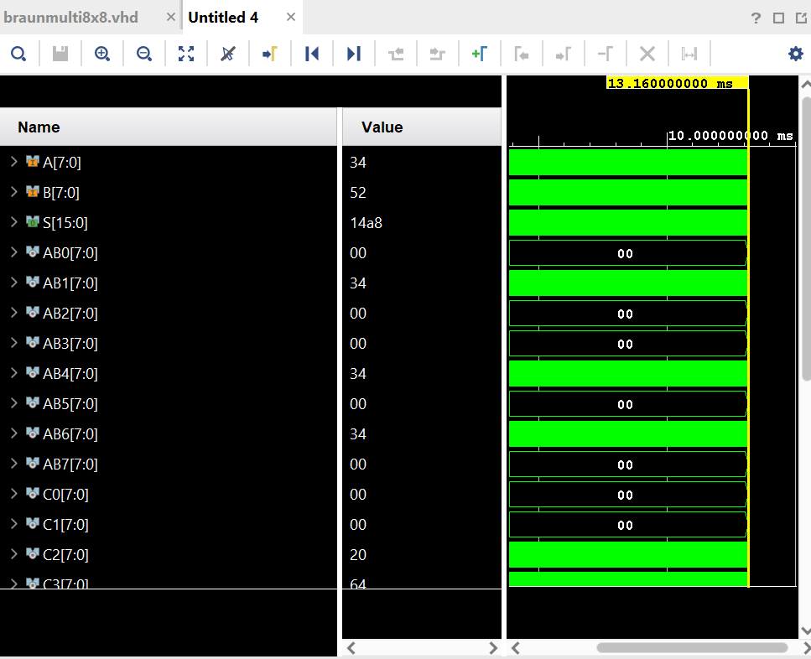Figure 33: Braun SIM test 1
34=52
52=82
14a8=4264
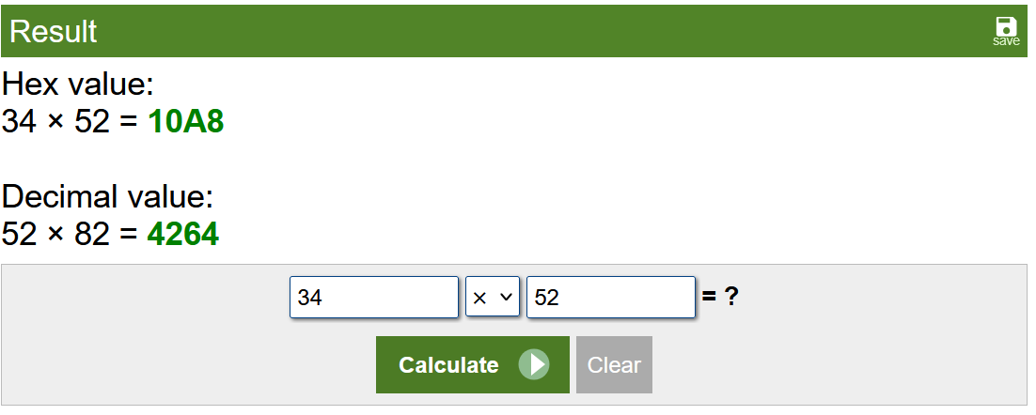Figure 34: Braun SIM test Calc 1[5]
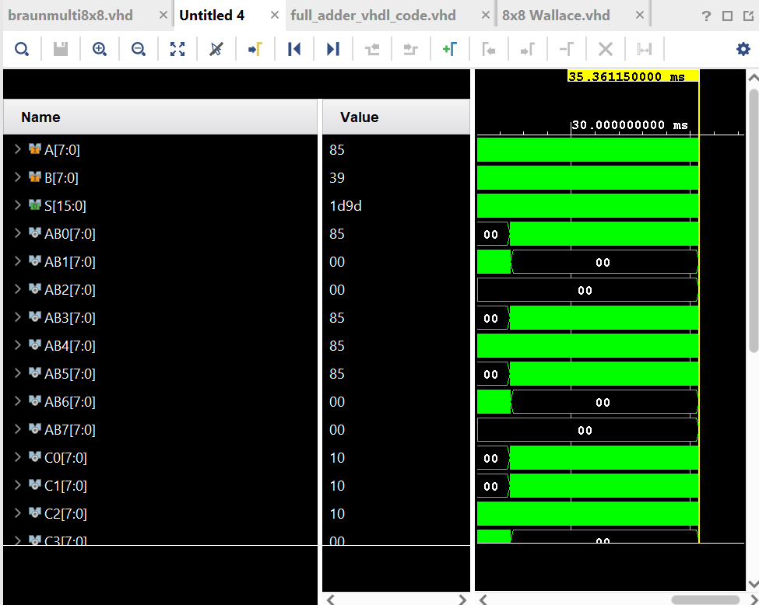Figure 35: Braun SIM test 2
85=133
39=57
1d9d=7581
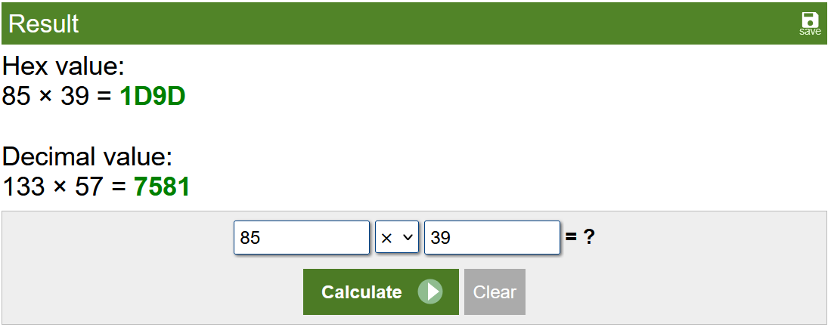Figure 36: Braun SIM test Calc 2 [5]

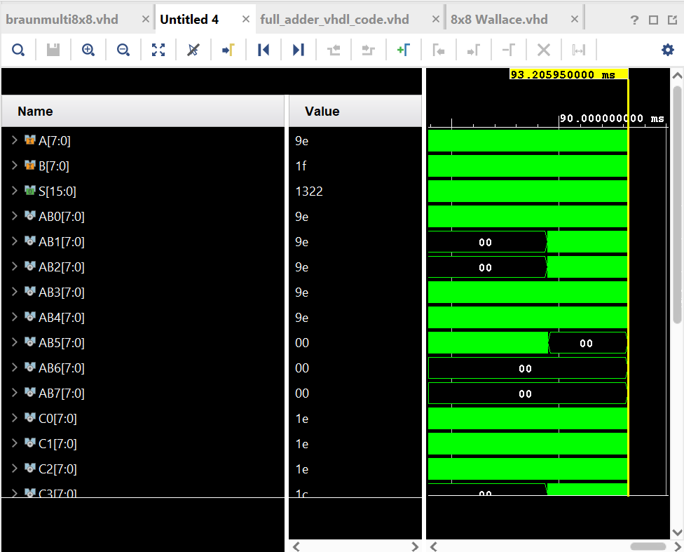Figure 37: Braun SIM test 3
9e =158
1f =31
1322 =4898
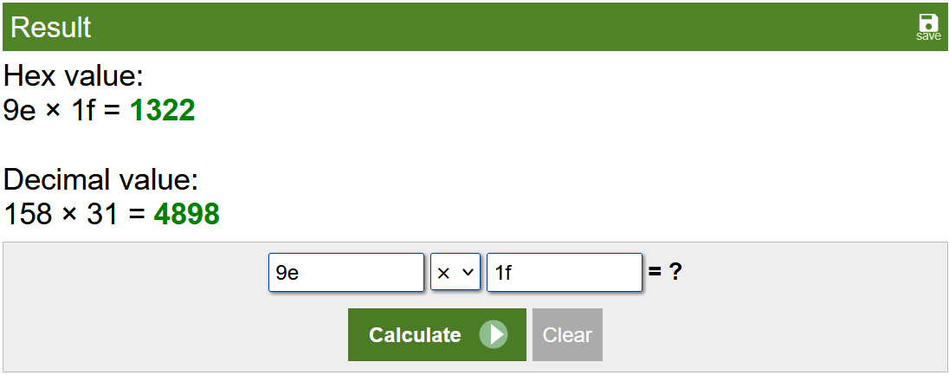Figure 38: Braun SIM test Calc 3 [5]
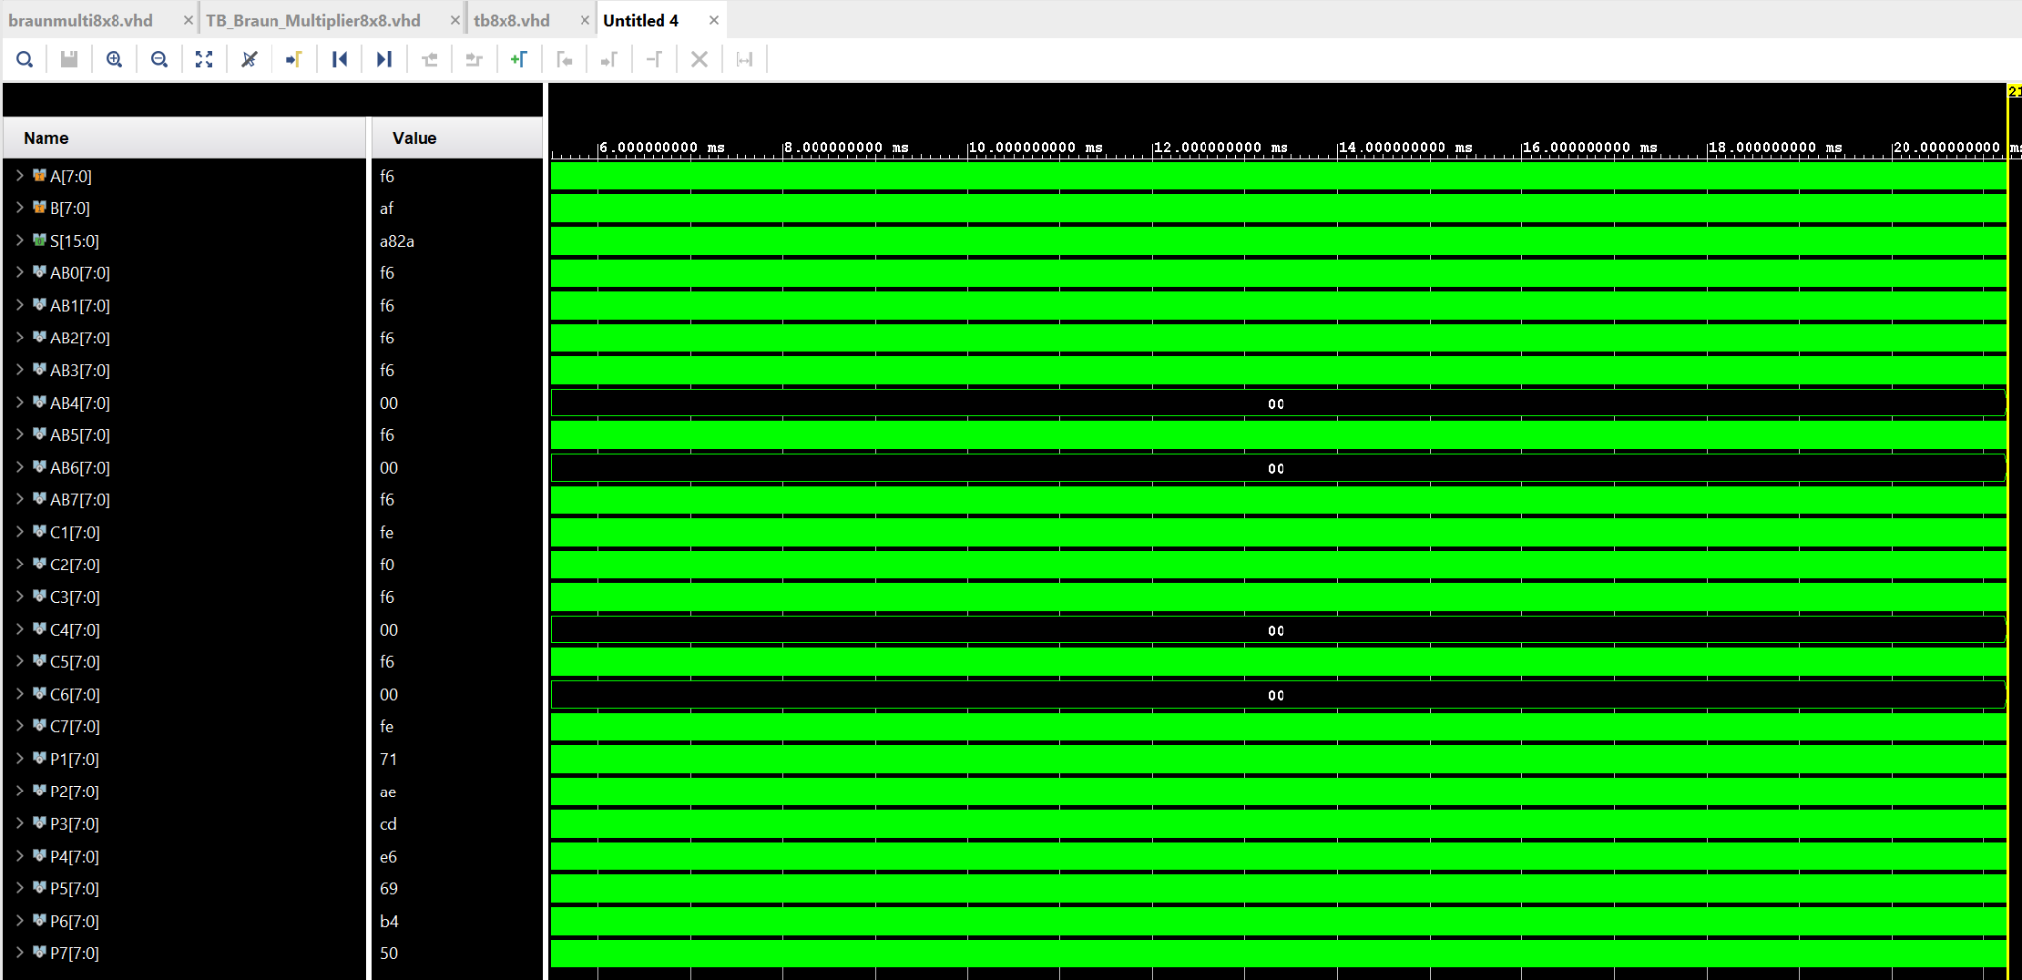Figure 39: Braun SIM test 4
f6=246
fa=175
a82a= 43050
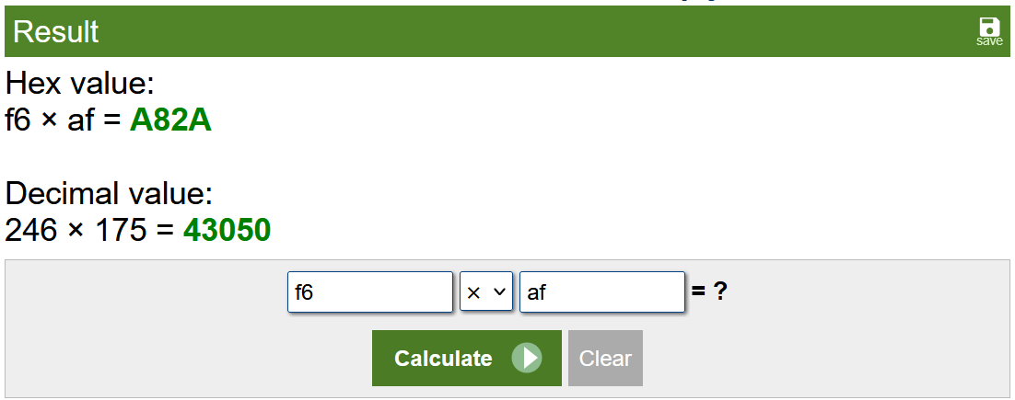Figure 40: Braun SIM Calc 4 [5]
Wallace
all code in appendix 2

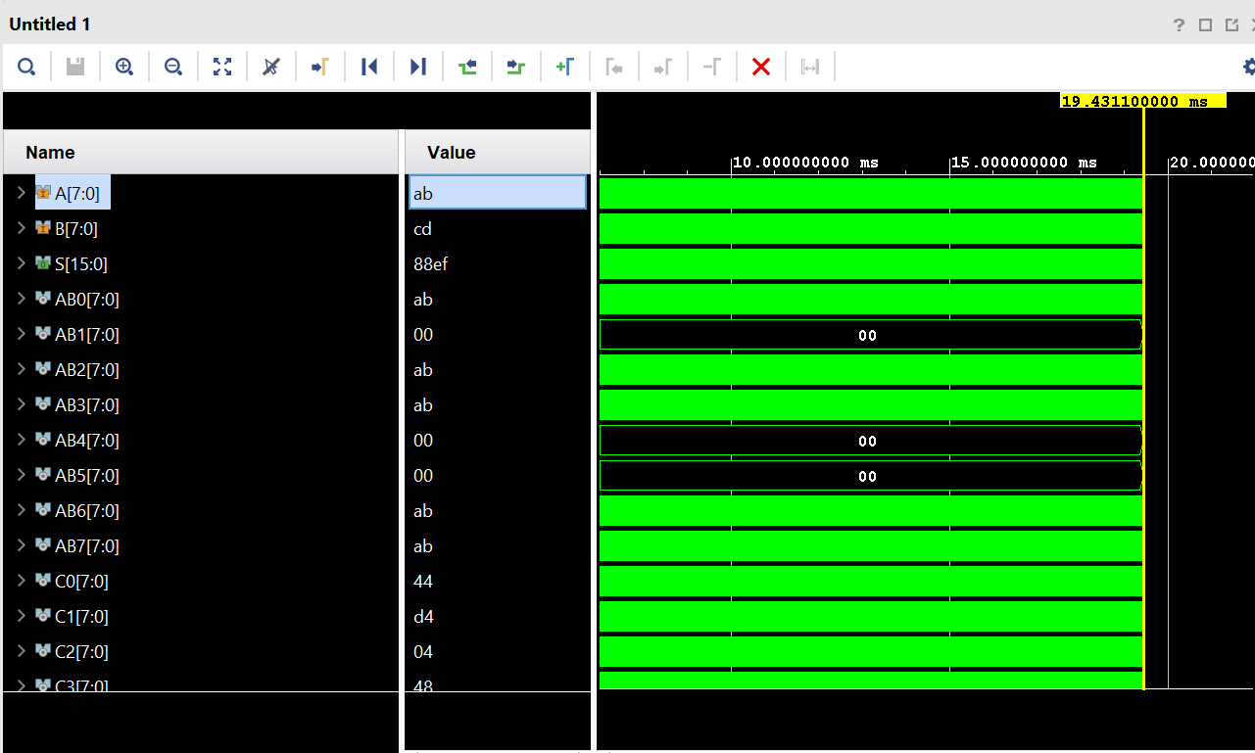Figure 41: Wallace SIM test 1
the author set the program to clock and input of ab and 00 for A CD and 00 for B this outputs 88ef
when converting this to unsigned decimal the author got the same answer.
ab is 171
CD is 205
88ef is 35055
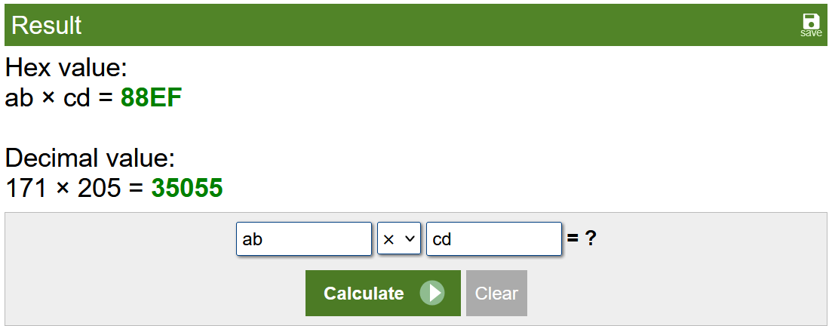Figure 42: Wallace Calc test 1 [5]

Figure 43: Wallace SIM test 2
The author set the program to clock and input of ff and 00 for A 11 and 00 for B this outputs 10ef
when converting this to unsigned decimal the author got the same answer.
ff is 255
11 is 17
10ef is 4335
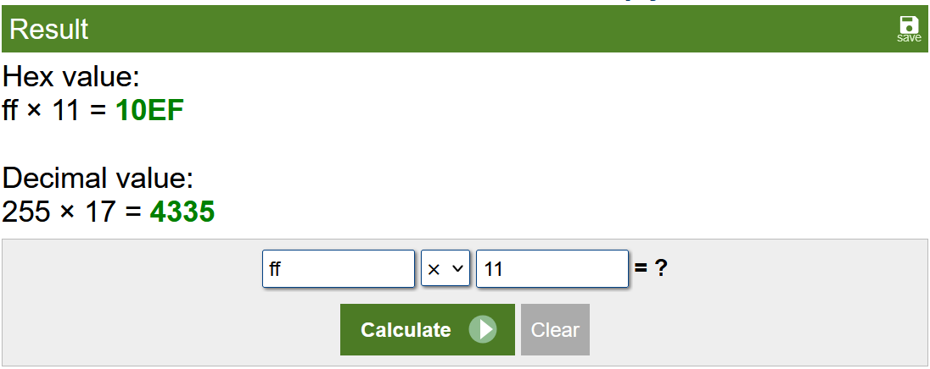Figure 43: Wallace SIM Calc 2 [5]

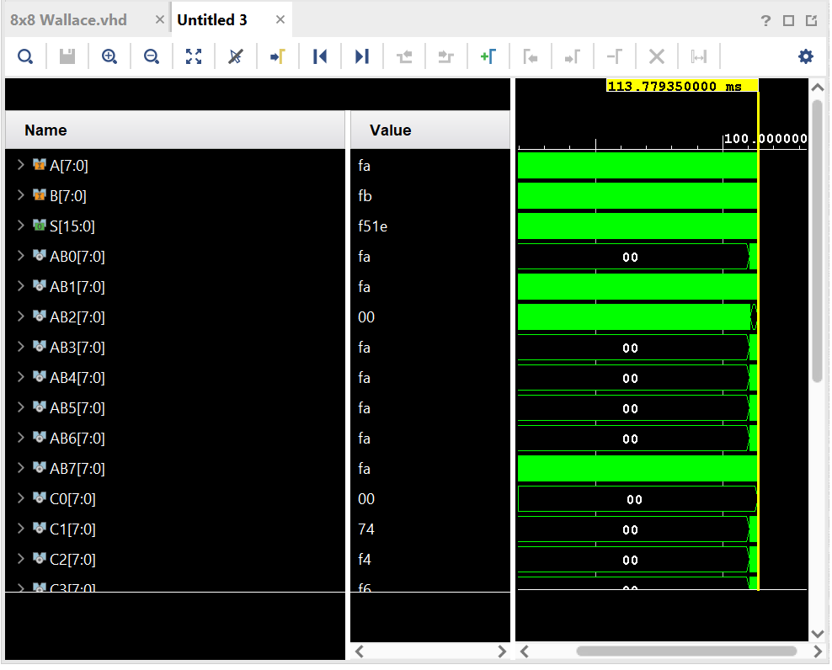Figure 44: Wallace SIM test 3
fa = 250
fb= 251
f51e = 62750
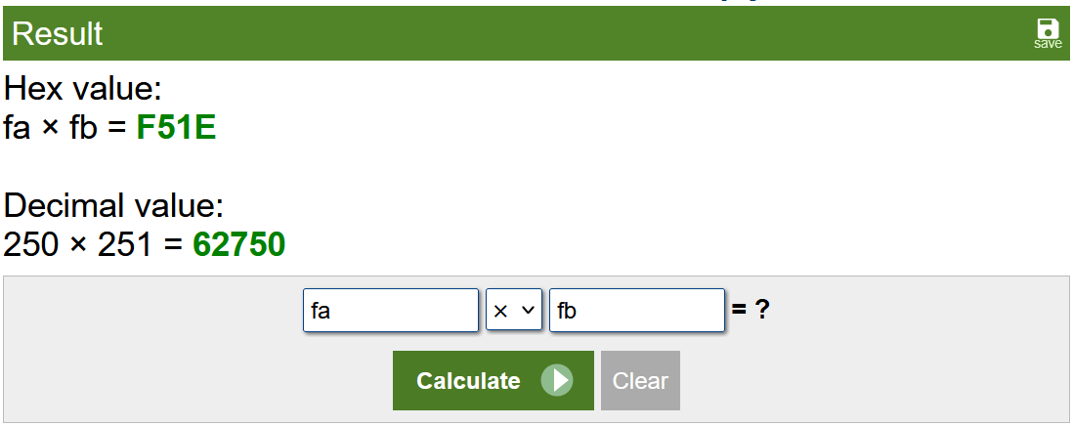Figure 45: Wallace SIM Calc 3 [5]

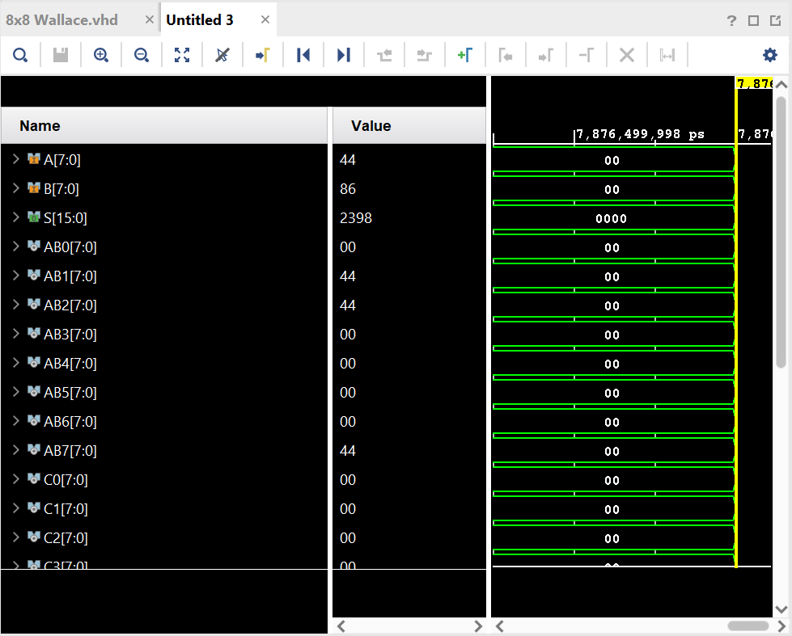Figure 46: Wallace SIM test 4
44 = 68
86 = 134
2198 = 9112
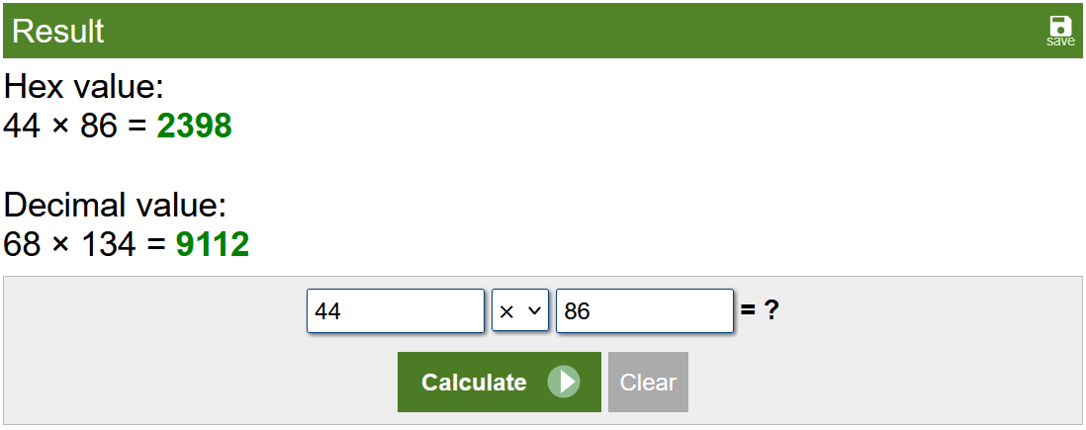Figure 47: Wallace SIM Calc 4[5]

Evaluation
The author in this section evaluates the Braun and Wallace multipliers from design to final results of their testing as well as a critical evaluation of their VHDL development in Vivado

design and implementation
During the design phase the author started by designing the components of their VHDL this makes it easier to develop later and allows the author to have a greater understanding of the adders before creating the block diagram for the Wallace and barn.

The block diagram for Wallace and Braun showcases how the author used their knowledge of the adders to map the outputs and inputs to assist with early development.

This focus on the adder VHDL made the k maps the author made less relevant as they used the truth table and the VHDL code for their adders to develop their block diagram.

timing
The authors calculated the longest route in their block diagram. They then calculated the time of these longest routes using assumed times for a half and full adder. For Wallace the longest delay was 26ns and for Braun it was 47ns. This is then visible in the timing tests as Braun is shown in both synthesis and implemented designs to be slower by nearly double of Wallace. This matches the longest route being nearly double Wallace's.

power consumption
the author gives a power budget of 15w for both Wallace and Braun they use most of their power in their io with 0.95 for Wallace used on logic and 1.408 for signals the board uses 11w at maximum this is similar to Braun with it also using around 11w and most of its power in its signals this data is shown in figs [] [] above.

speed and power efficiency

Due to the speed Wallace processes at the and its lower power usage in the authors implementation it is by far the most power efficient and fastest. although the differences in power are very minimal so most of its efficiency comes from its speed.

LUTs
The Wallace uses 5 more LUTs than the Braun in its slice LUTs and the same amount of bonded io as that's the input output of the circuit this increase in LUTs would be consistent as y increase the size of the multiplier to 16x16 or 32x32 and in a space limited implementation would limit its usage. This is shown in figure[] and figure [] above for both Braun and Wallace and can be seen on the device image for both above figure[] figure[]

FPGA implementation
When implementing it on FPGA the author decided to use the switches provided and the led’s above them to input and show output respectively. This enabled them to input 8 binary numbers to A and B as well as get 16 led outputs on S port. This was simplistic and effective as a route.

tests
The test method of inputting a hex value to the simulation to test the device made it quick and simple to identify bugs. After these tests demonstrating it on FPGA showed that it was not just the software informing that it was functional and that it worked on physical hardware.

tools and techniques
The author used Vivado as an industry standard tool and developed their knowledge of VHDL development the authors use of Vivado. shows an understanding of FPGA development and VHDL syntax.

When implementing Braun and Wallace in Vivado it is similar in approach the components are the same; the difference between the two comes in the inputs and outputs of the components. in Braun the components in each bank feed their carry’s to the final adder and then down and their sums move down to the next bank. whereas Wallace moves its carry’s down as well as its sums enabling it to shorten the route of the logical operations.

Conclusion
- This report demonstrates a comparative analysis of Braun and Wallace multipliers and critically evaluates their function in both VHDL synthesis via the Vivado software and implementation on the basys3 board.

The analysis of Wallace and Braun multipliers revealed that the Wallace had faster operation and as such performed more power efficiently than the Braun multiplier while the Wallace was more space efficient due to its reduced usage of LUTs utilisation. These findings indicate that the Braun multiplier would be best used for space dependent projects while the Wallace would be best used for high speed processing. while Braun also allowed the processing system to be split at any point in the system to get a valid output up to that point for example removing the last 2 b inputs and taking from adders above would give a valid output for that set of inputs whereas Wallace does not.

In conclusion this report demonstrates the trade-offs between the speed of Wallace and area efficiency Braun multipliers that must be taken into account when developing multipliers.

Bibliography

[1]
P. Mishra, “A study on Wallace tree multiplier,” vol. 7, no. 5, Apr. 2018, Accessed: Feb. 28, 2025. [Online]. Available: https://www.researchgate.net/publication/327209221_A_study_on_Wallace_tree_multiplier
[2]
Magnus Själander, “Efficient Reconfigurable Multipliers Based on the Twin-Precision Technique,” Reasearch gate, Jan. 01, 2006. https://www.researchgate.net/publication/228867197_Efficient_Reconfigurable_Multipliers_Based_on_the_Twin-Precision_Technique (accessed Feb. 28, 2025).
[3]
Lattice Semiconductor Corporation, “www.latticesemi.com 1 tn1000_09.1 sysIO Usage Guidelines for Lattice Devices,” Digchip.com, 2025. https://application-notes.digchip.com/030/30-20552.pdf (accessed Mar. 21, 2025).
[4]
“Hex Calculator,” Calculator.net, 2025. https://www.calculator.net/hex-calculator.html?number1=ab&c2op=x&number2=cd&calctype=op&x=Calculate (accessed Mar. 21, 2025).
[5]
S. D. Brown and Z. G. Vranesic, Fundamentals of Digital Logic with VHDL Design. 2005.
[6]
B. Mealy and F. Tappero, Free Range VHDL. 2023. Accessed: Apr. 08, 2025. [Online]. Available: https://faculty-web.msoe.edu/johnsontimoj/EE3921/files3921/Book_FreeRangeVHDL.pdf
[7]
P. A. Freiberger and M. R. Swaine, “Harvard Mark I | computer technology,” Encyclopædia Britannica. Dec. 18, 2014. Available: https://www.britannica.com/technology/Harvard-Mark-I
[8]
“Anton Braun – Computer Timeline,” Computer-timeline.com, 2025. http://www.computer-timeline.com/timeline/anton-braun/ (accessed Apr. 10, 2025).
[9]
D. S. ROY, “Wallace and Dedda Multiplier Design - Digital System Design,” Digital System Design, Jun. 18, 2019. https://digitalsystemdesign.in/wallace-and-dedda-multiplier-design/ (accessed Apr. 10, 2025).

Appendix 1

code
Braun
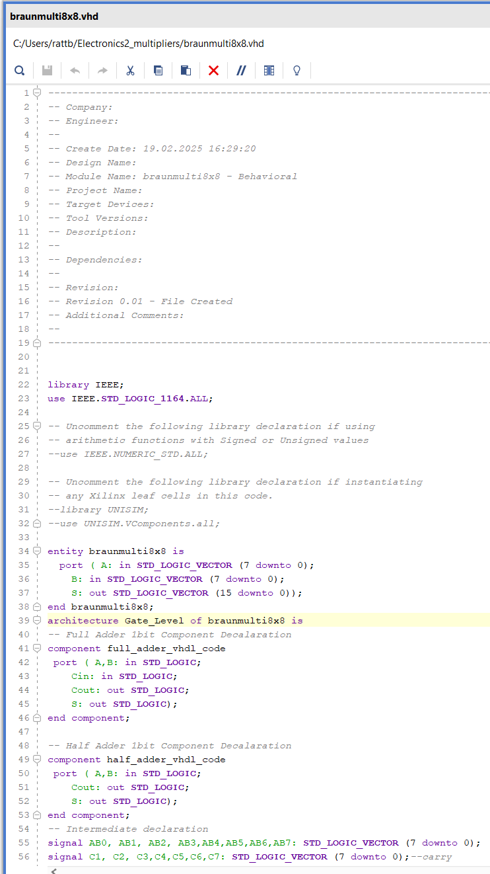Figure 48: Braun code 1
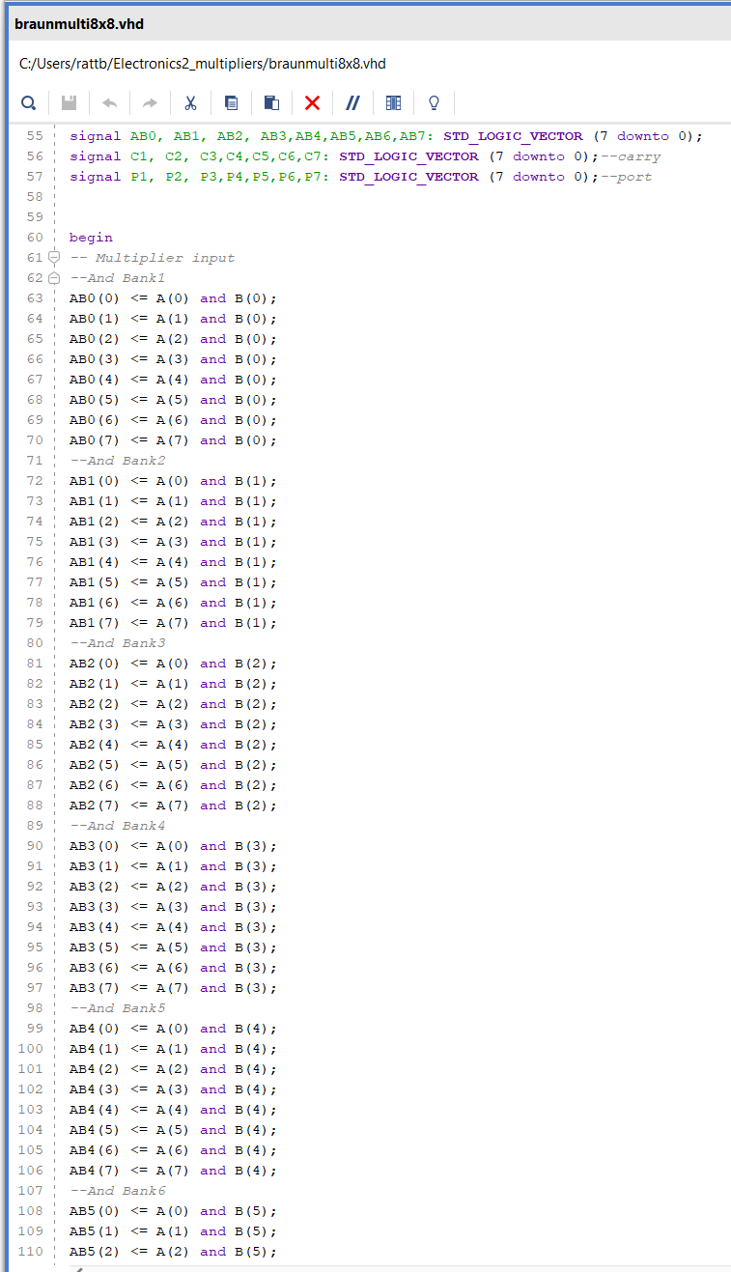Figure 49: Braun code 2
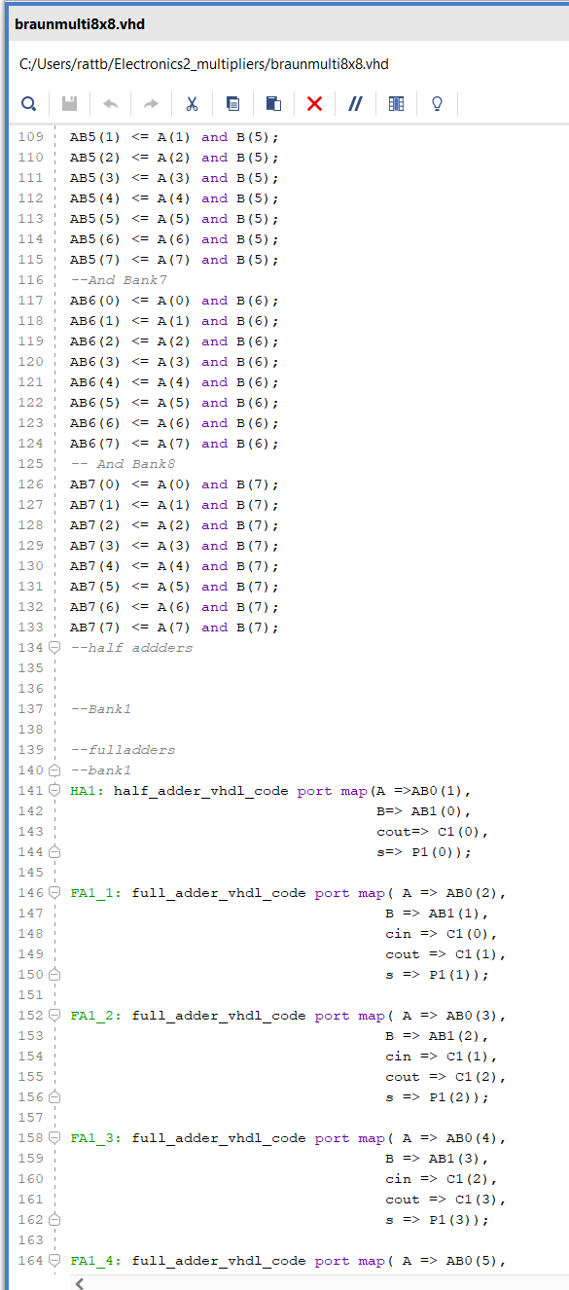Figure 50: Braun code 3
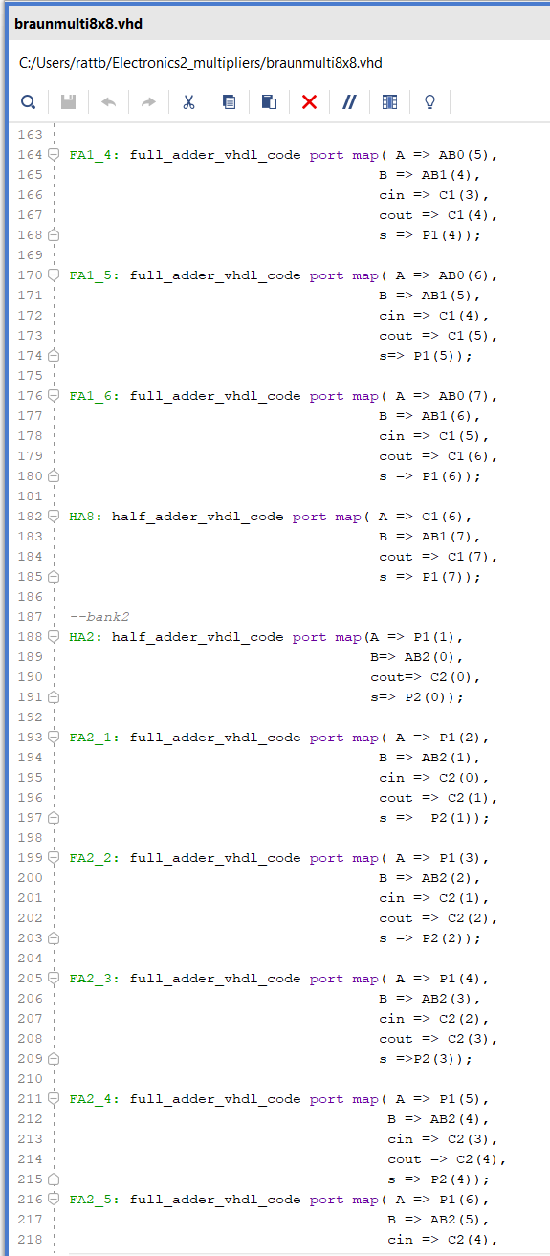Figure 51: Braun code 4
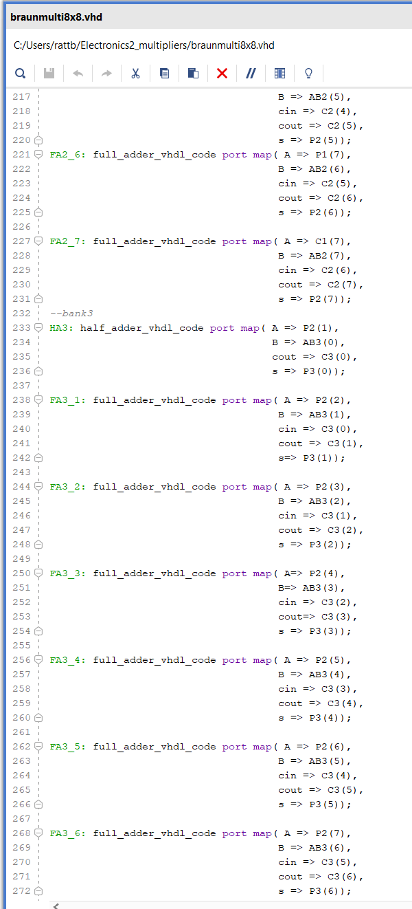Figure 52: Braun code 5
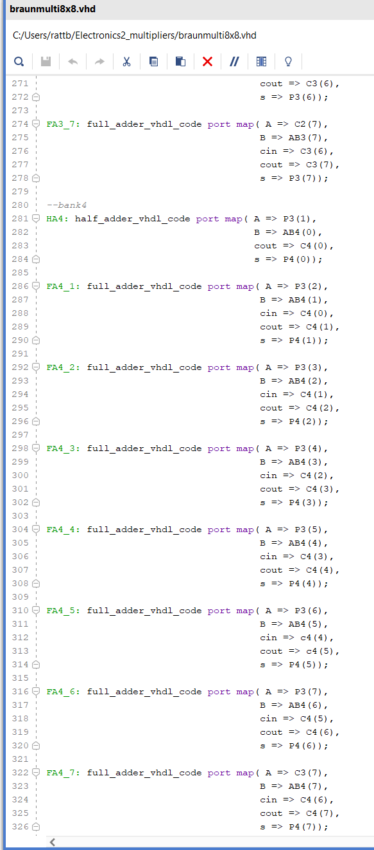Figure 53: Braun code 5
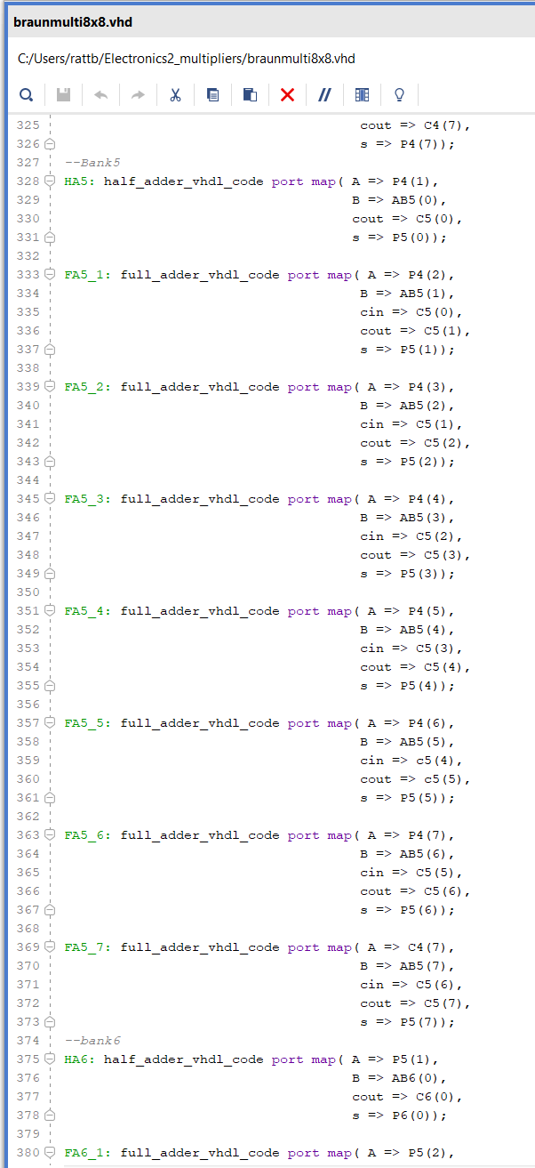Figure 54: Braun code 6
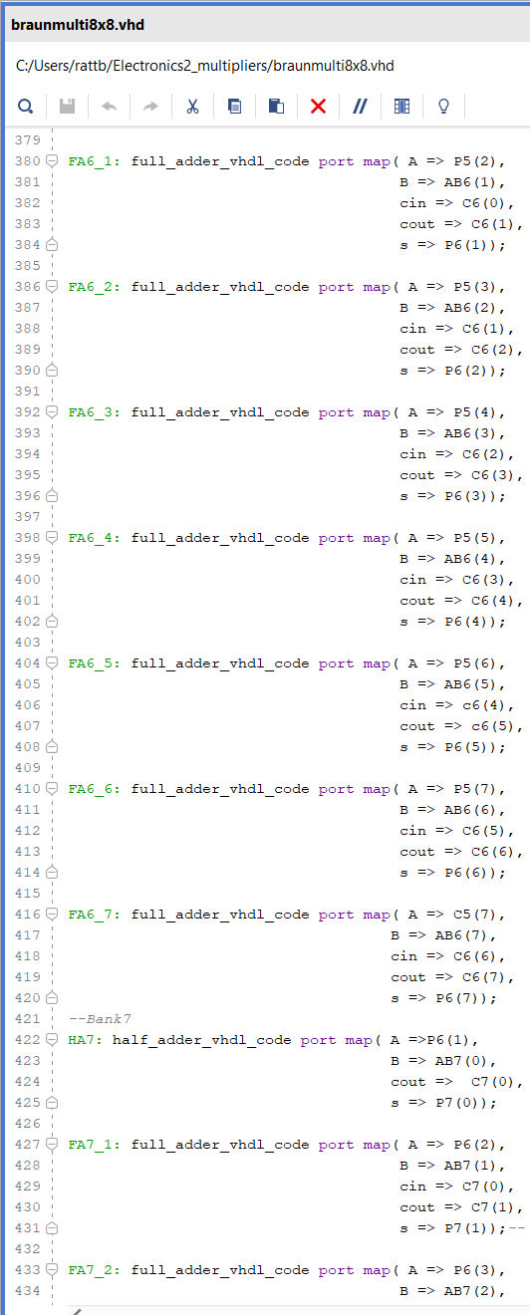Figure 55: Braun code 7
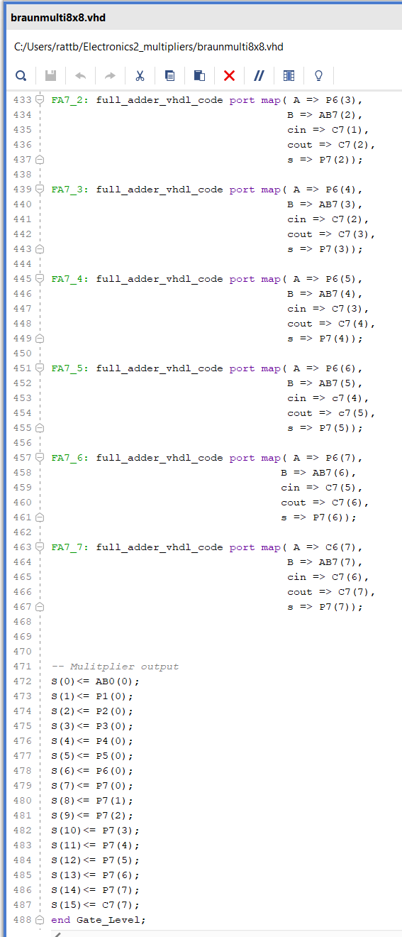Figure 56: Braun code 8

Appendix 2
Wallace
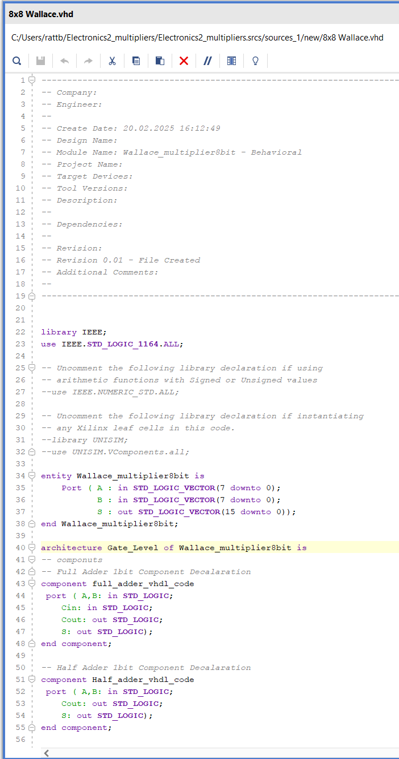Figure 57: Wallace code 1
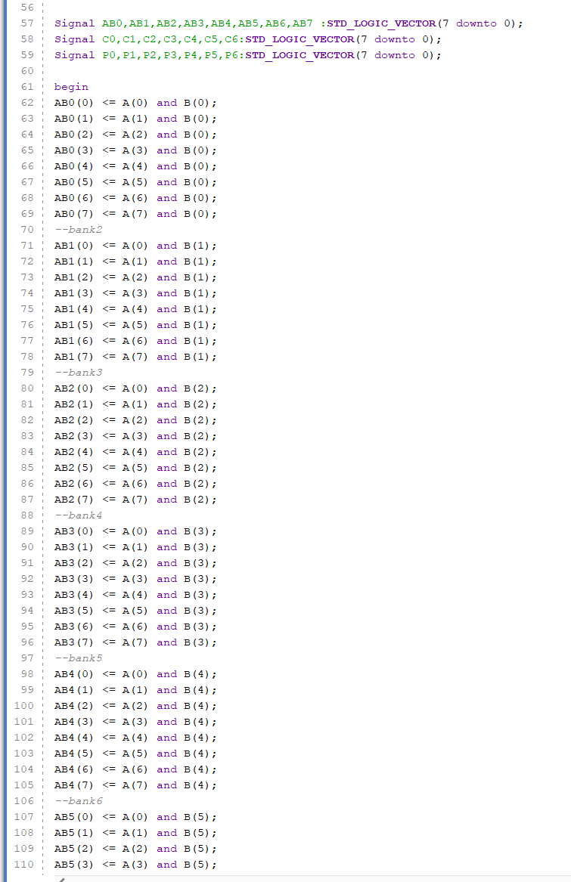Figure 58: Wallace code 2
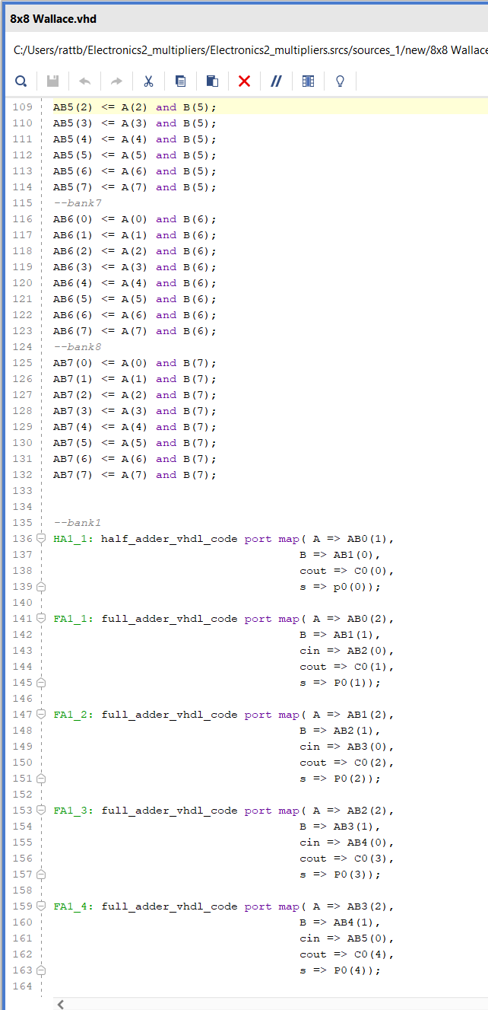Figure 59: Wallace code 3
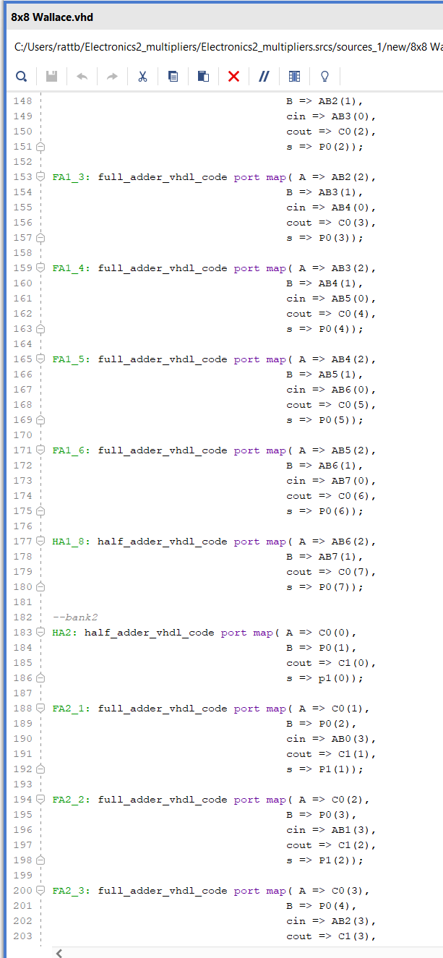Figure 60: Wallace code 4
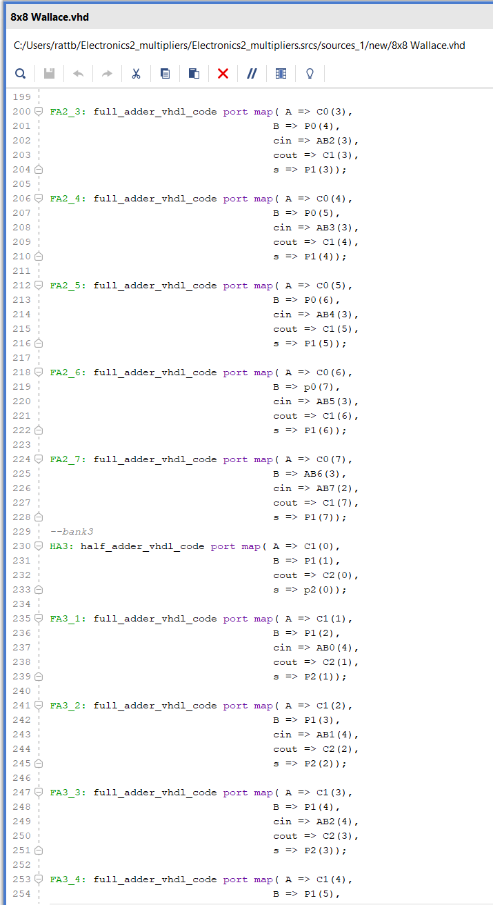Figure 61: Wallace code 5
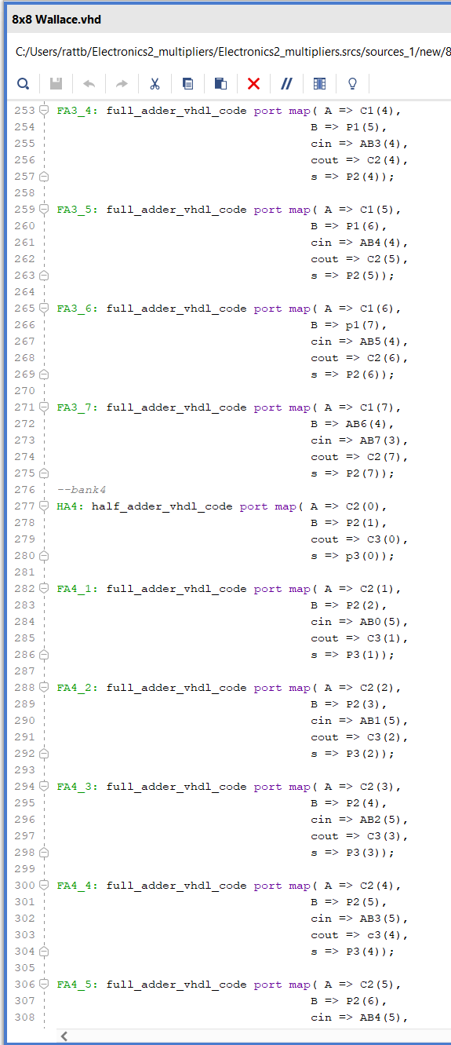Figure 62: Wallace code 6
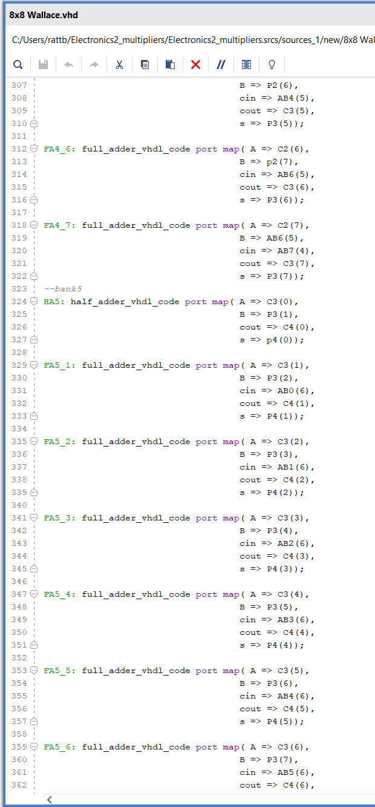Figure 63: Wallace code 7
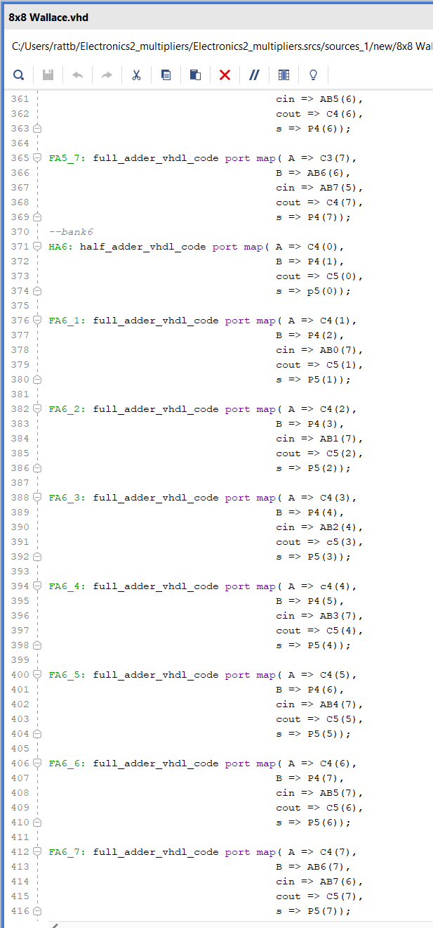Figure 64: Wallace code 8
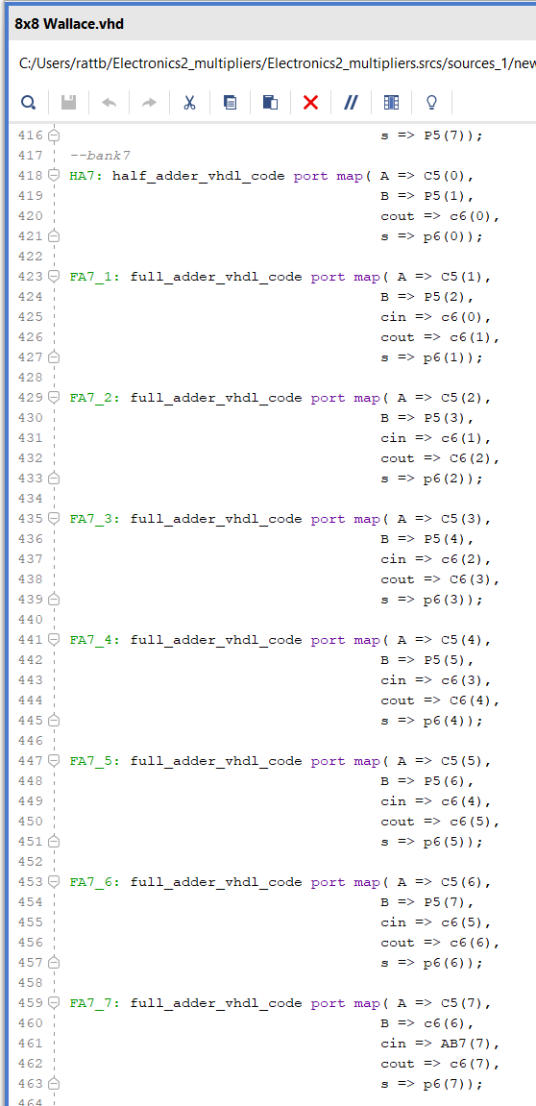Figure 65: Wallace code 9
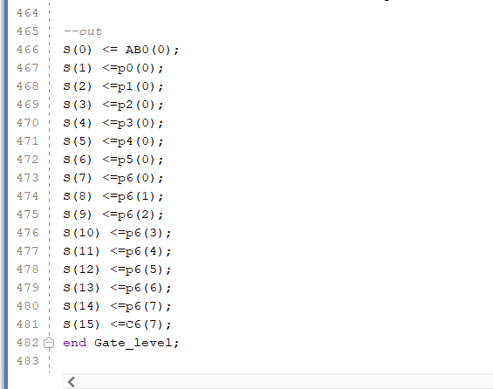Figure 66: Wallace code 10

Appendix 3
the section below changes slightly between Braun and Wallace implementation and synthesis with brans max delay on line 10 changing to 47.00
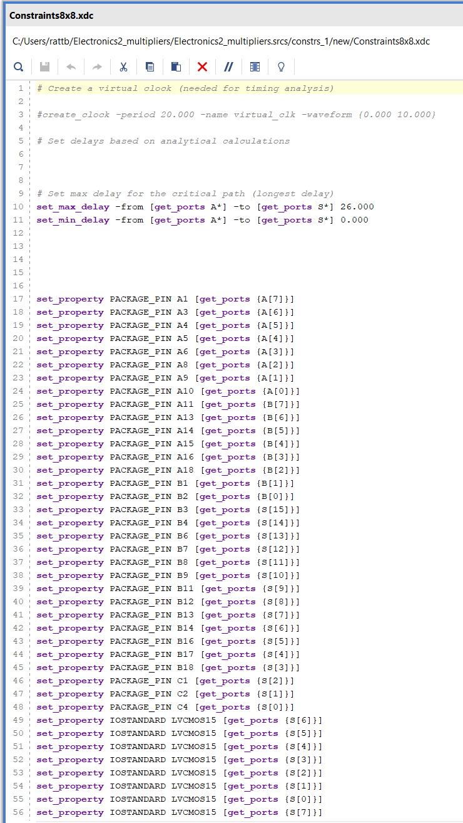Figure 67: constants code 1
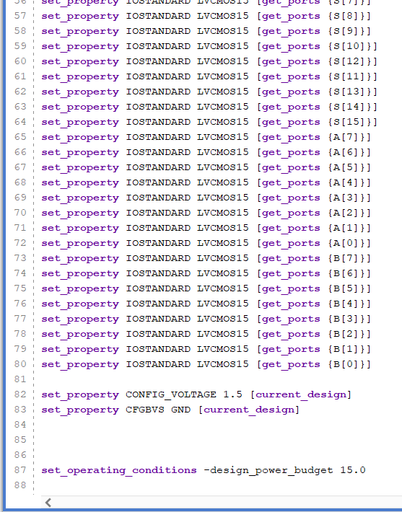Figure 68: constants code 2

