

Module Name: Academic Skills in the Digital Era
Module Code: BMSW4013
Assessment 1: E-Portfolio
Student Name: Khalil Ullah
Student Number:2508657
Lecturer: Scott James
Deadline: Friday 21st November 23:59PM

Navigating Student Success in the Digital Era
A Combined Research Plan and Analytical Report on Challenges, Opportunities, and Adaptation Strategies for Modern Learners

Table of Contents
Component 1: Research and Planning 3
1. Source Exploration 3
2. Key Challenge for Students 3
3. Key Opportunity for Students 3
4. Planning Your Report 4
Component 2: Answering the Question 5
Introduction 5
Challenges Students Face 5
Opportunities Digital Tools Provide 6
How Students Can Adapt 6
Conclusion 7
Component 3: Reflective Presentation 8
Slide 1: Title Slide 8
Slide 2: Overview 9
Slide 3: Research Process 9
Slide 4: Planning & Writing 10
Slide 5: Key Challenges & Successes 10
Slide 6: Looking Forward 11
Slide 7: References 11
Reference list 12

Component 1: Research and Planning

1. Source Exploration
To conduct this research, I have referred to the article by Stella Timotheou et al., published in Education and Information (Timotheou et al., 2022). The article is called Influences of the digital technologies on education. It finds that implementation of ICT in education has the potential to enhance student attention, engagement, motivation, and communication skills, but it is a matter of how a school is digital, has the proper infrastructure, and teacher skills and access, rather than technology itself. I have decided to select this recent peer-reviewed source since it has presented an objective perspective on opportunities and challenges of digital tools in learning. It is relevant, reliable, using the CRAAP test: Currency, Relevance, Authority, Accuracy, Purpose. This can be used to answer the primary question concerning the challenges and opportunities of learning in the digital age among students. I will also incorporate the review of digital technologies in learning by Mhlongo et al. (2023) to conduct triangulation and make a more compelling argument.

2. Key Challenge for Students
Lack of access to digital tools and low digital competence are among the impediments that students encounter. Timotheou et al. (2022) discovered that most schools had inadequate digital capacity that enhanced disparities (Zou et al., 2025). Mhlongo et al. (2023) singled out unanticipated relations between technology, students, and teachers and noted complications that arise during implementation. Personally, untrustworthy internet and scanty instructions make useful tools a liability. During the digital era, a lack of infrastructure and literacy creates more divisions since technology will not ensure that learning succeeds.

3. Key Opportunity for Students
Tools of a digital nature provide flexibility, resources, and help with self-directed and collaborative learning. Timotheou et al. observe that ICT environments enable students to have access to quality resources, peer review and independent tasks, facilitating learner-based approaches (Timotheou et al., 2022). According to Chen and Singh (2025), the benefits of digital learning to students with diverse backgrounds include using digital libraries, interactive modules, and online collaboration. On these tools, one will have the option of learning at their own pace, watching the audio again, and interacting with colleagues throughout the world. In digitalised times, one must be independent, flexible and digitally literate, and digital tools are the way to make students successful in college and even in the professional environment.

4. Planning Your Report
In the case of Component 2 (the 800-word report), I will also pay not less attention to the challenges and opportunities because the primary query dwells on the interactions between them (how can they adjust to succeed?). I will incorporate digital means (LMS, mobile applications, online collaboration tools, online libraries) and refer to the research (e.g. Timotheou et al., Mhlongo et al., Chen and Singapore). The structure: Introduction (digital era context) → Challenges (access, competence, integration) → Opportunities (flexibility, resource access, collaboration) → Strategies (digital literacy, time management, tool selection, peer networks) → Conclusion (summary and takeaway).

Component 2: Answering the Question

Introduction
In the age of the digital world, students find themselves enclosed in a world that runs on systems like learning management systems, interactive courses, mobile application, and online teamwork tools. It is essential to learn the advantages and disadvantages of these technologies since they may either support or impair learning with regard to their application. Students have to negotiate their way through this place with growing demands on digital literacy, autonomy and adaptability in universities, employment, and society. The report will focus on two critical problems, two significant opportunities, and three successful strategies of digital learning (Bogiannidis, Southcott and Gindidis, 2023).

Challenges Students Face
Lack of equality and gaps in digital competence are one of the main challenges. It has been found that the implementation of digital tools can further widen, instead of decreasing, inequity in learning when circumstances limiting the infrastructure, capacity of the teachers, or student readiness exist (Haleem et al., 2022). To illustrate, in a systematic review of online learning, Akpen et al. (2024) discovered that some students were less engaged and isolated when they could not access the internet or when the student support system was not close by. This is one of the main challenges as students might think that the mere fact that they are given digital tools is the sure way of learning better, but without the quality infrastructure, digital literacy learning and training and supportive pedagogy, tools do not do it. The accompanying problem is the overuse of digital tools without any self-regulation: Chen and Singh (2025) emphasise that most digital tools demand self-controlling learning abilities, and the underdevelopment of design or deficient integration may result in superficial use. Both problems are so significant in the present since, with increased schooling going online or hybrid, students are not just required to access the digital platforms; however, they must be mindful of, and behave constructively and efficiently in these environments.

Opportunities Digital Tools Provide
On the contrary, computer-mediated tools are game changers. A major advantage is that it is flexible and resources are accessible: digital learning tools enable students to have access to any material around them, can pace themselves and collaborate, regardless of the location. As an example, Rueda et al. (2024) indicate that learners enjoyed the option of watching the recorded lectures again and interacting with peers asynchronously and having access to various high-quality resources online. The other opportunity is that of collaborative, personalised and self-directed learning: Mhlongo et al. (2023) state that smart digital technologies, in their good use, may enable students to participate in peer review, independent work and student-related active learning. Such opportunities are significant as students who successfully exploit digital tools become more autonomous, more adaptable to different learning environments, and become digitally literate, which will help them in their academic and professional learning.

How Students Can Adapt
Here are three practical suggestions for how students can adapt and thrive in a digital learning environment:
- Structured time management and use of digital planners
Time management is essential in a world of a lack of various digital tools and distractions. Students may rely on digital calendars (Google Calendar, Notion) and such approaches as Pomodoro (25 minutes study, 5 minutes break) to concentrate. The studies indicate that structured planning is one of the factors that enable engagement and performance in online studies (Akpen et al., 2024), thereby aiding in alleviating overloads and online fatigue.
- Critical and informed use of digital/AI-aided tools
Digital and AI tools have emerged, and this requires students to utilise them carefully by critically reviewing the materials they find and focusing more on what they are actually learning. The SELF framework lays emphasis on the importance of self-regulation and situational influence on the tool effectiveness (Chen and Singh, 2025). Academic integrity is essential when coaching the AI chatbots in order to prevent errors and ethical concerns (Wiitavaara and Widar, 2025).
- Develop digital literacy and seek support services actively
In order to fill in the competence gaps and access problems, the students are encouraged to seek institutional support, such as the digital skills workshops, library tutorials, and sessions guided by peers. According to Zou et al. (2025), digital learning is inclusive and must be developed over time and infrastructure. Critical thinking and flexibility in the domain of digital tools can be reinforced by training, including the CRAAP method.

Conclusion
In summary, the digital age provides not only disparities in access and lack of competence but also passive use of tools, as well as some chances of flexible, resource-rich, collaborative learning. Timely management of work with digital planners, critical use of digital and AI tools, and institutional promotion of literacy are the keys to success among the students. In such a way, they reduce the risks and use the best opportunities of digital learning, which means becoming successful academically and being ready to live in a digitally connected world.

Component 3: Reflective Presentation

Slide 1: Title Slide
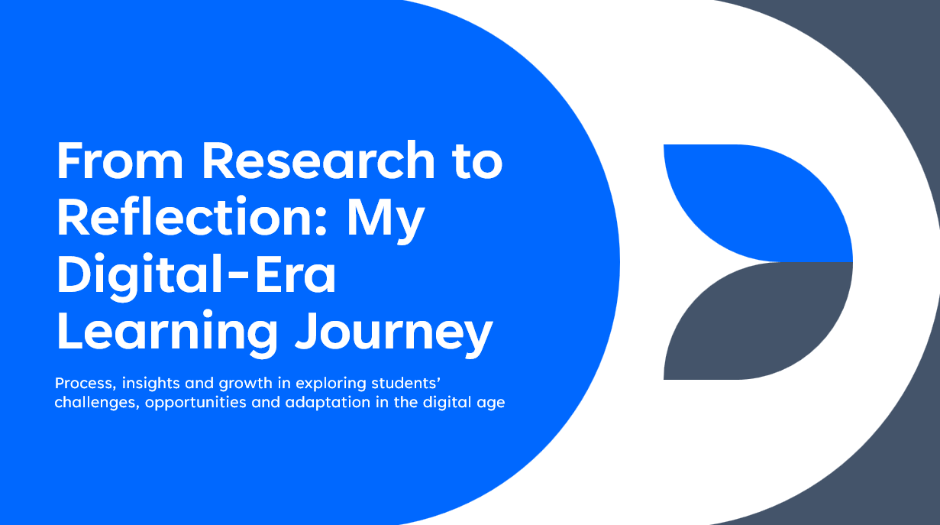

Slide 2: Overview
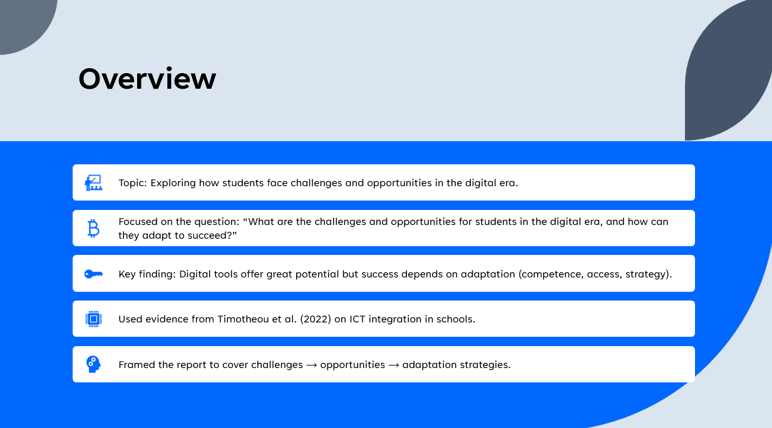

Slide 3: Research Process
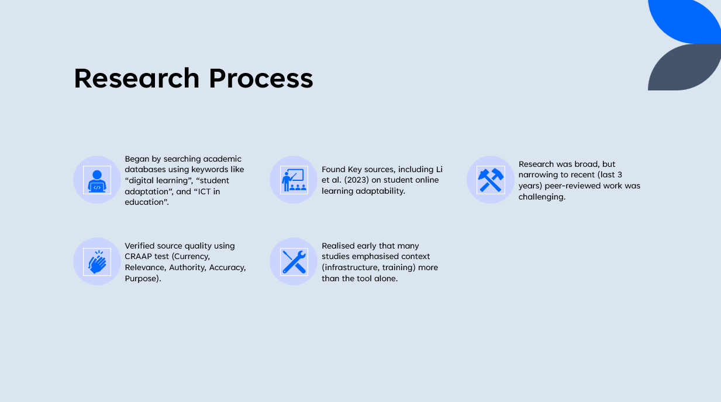

Slide 4: Planning & Writing
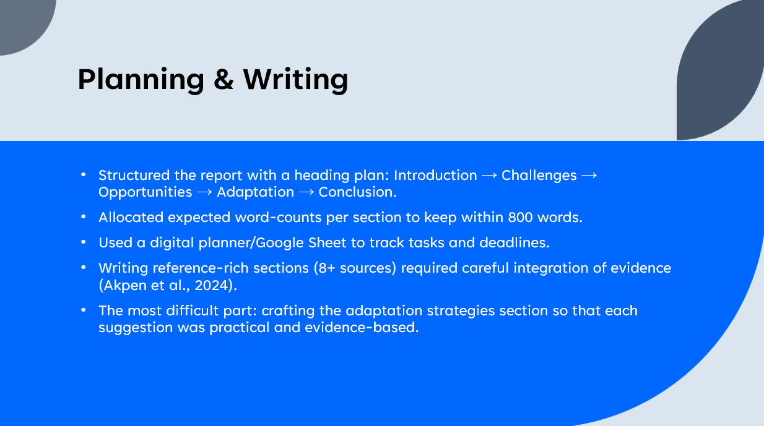

Slide 5: Key Challenges & Successes
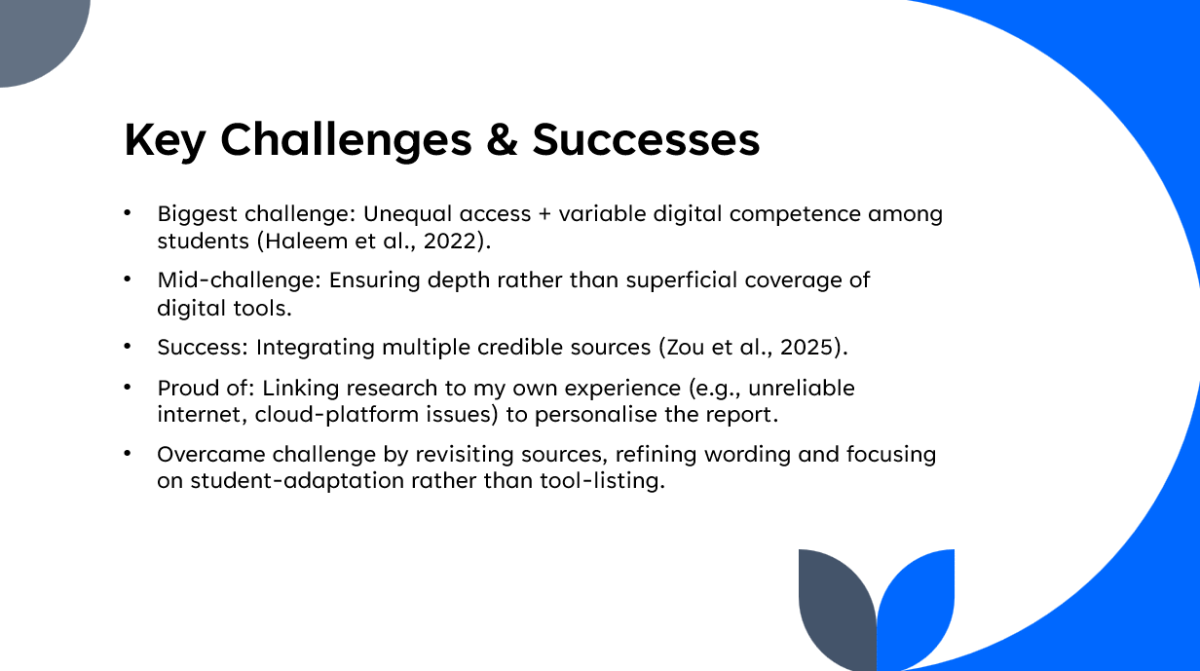

Slide 6: Looking Forward
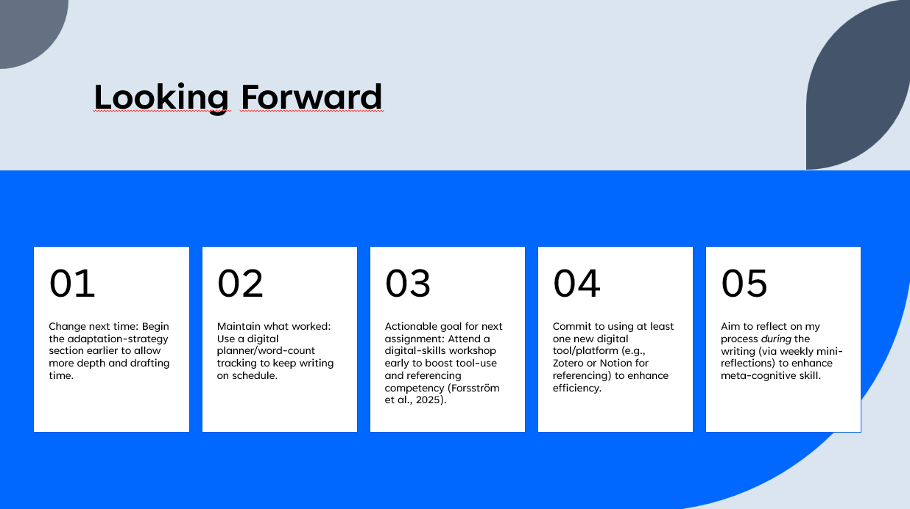

Slide 7: References
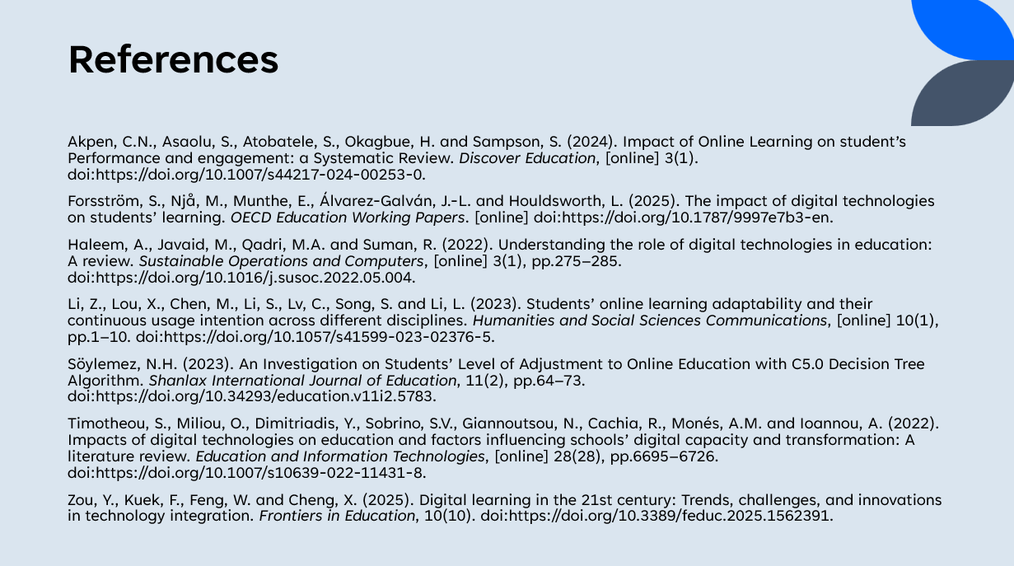

Reference list
Akpen, C.N., Asaolu, S., Atobatele, S., Okagbue, H. and Sampson, S. (2024). Impact of Online Learning on student’s Performance and engagement: a Systematic Review. Discover Education, [online] 3(1). doi:https://doi.org/10.1007/s44217-024-00253-0.
Bogiannidis, N., Southcott, J. and Gindidis, M. (2023). An exploration of the possible educational opportunities and the challenges at the intersection of the physical and digital worlds occupied by 10–14 year-old students. Smart Learning Environments, 10(1). doi:https://doi.org/10.1186/s40561-023-00246-w.
Chen, Z. and Singh, C. (2025). Opportunities and Challenges in Harnessing Digital Technology for Effective Teaching and Learning. Trends in Higher Education, 4(1), p.6. doi:https://doi.org/10.3390/higheredu4010006.
Forsström, S., Njå, M., Munthe, E., Álvarez-Galván, J.-L. and Houldsworth, L. (2025). The impact of digital technologies on students’ learning. OECD Education Working Papers. [online] doi:https://doi.org/10.1787/9997e7b3-en.
Haleem, A., Javaid, M., Qadri, M.A. and Suman, R. (2022). Understanding the role of digital technologies in education: A review. Sustainable Operations and Computers, [online] 3(1), pp.275–285. doi:https://doi.org/10.1016/j.susoc.2022.05.004.
Li, Z., Lou, X., Chen, M., Li, S., Lv, C., Song, S. and Li, L. (2023). Students’ online learning adaptability and their continuous usage intention across different disciplines. Humanities and Social Sciences Communications, [online] 10(1), pp.1–10. doi:https://doi.org/10.1057/s41599-023-02376-5.
Mhlongo, S., Mbatha, K., Ramatsetse, B. and Dlamini, R. (2023). Challenges, opportunities, and prospects of adopting and using smart digital technologies in learning environments: An iterative review. Heliyon, 9(6), pp.1–20. doi:https://doi.org/10.1016/j.heliyon.2023.e16348.
Rueda, M.M., Cerero, J.F., Cerero, D.F. and Meneses, E.L. (2024). Perspectives on online learning: Advantages and challenges in higher education. Contemporary Educational Technology, 16(4), p.ep525. doi:https://doi.org/10.30935/cedtech/15011.
Söylemez, N.H. (2023). An Investigation on Students’ Level of Adjustment to Online Education with C5.0 Decision Tree Algorithm. Shanlax International Journal of Education, 11(2), pp.64–73. doi:https://doi.org/10.34293/education.v11i2.5783.
Timotheou, S., Miliou, O., Dimitriadis, Y., Sobrino, S.V., Giannoutsou, N., Cachia, R., Monés, A.M. and Ioannou, A. (2022). Impacts of digital technologies on education and factors influencing schools’ digital capacity and transformation: A literature review. Education and Information Technologies, [online] 28(28), pp.6695–6726. doi:https://doi.org/10.1007/s10639-022-11431-8.
Wiitavaara, B. and Widar, L. (2025). Challenges and opportunities related to online studies in higher education. Education and Information Technologies. doi:https://doi.org/10.1007/s10639-025-13406-x.
Zou, Y., Kuek, F., Feng, W. and Cheng, X. (2025). Digital learning in the 21st century: Trends, challenges, and innovations in technology integration. Frontiers in Education, 10(10). doi:https://doi.org/10.3389/feduc.2025.1562391.

