Natalie Male 1702161
Learning and collaboration For Global Citizenship
BMSP4003
Contribution to Sustainability

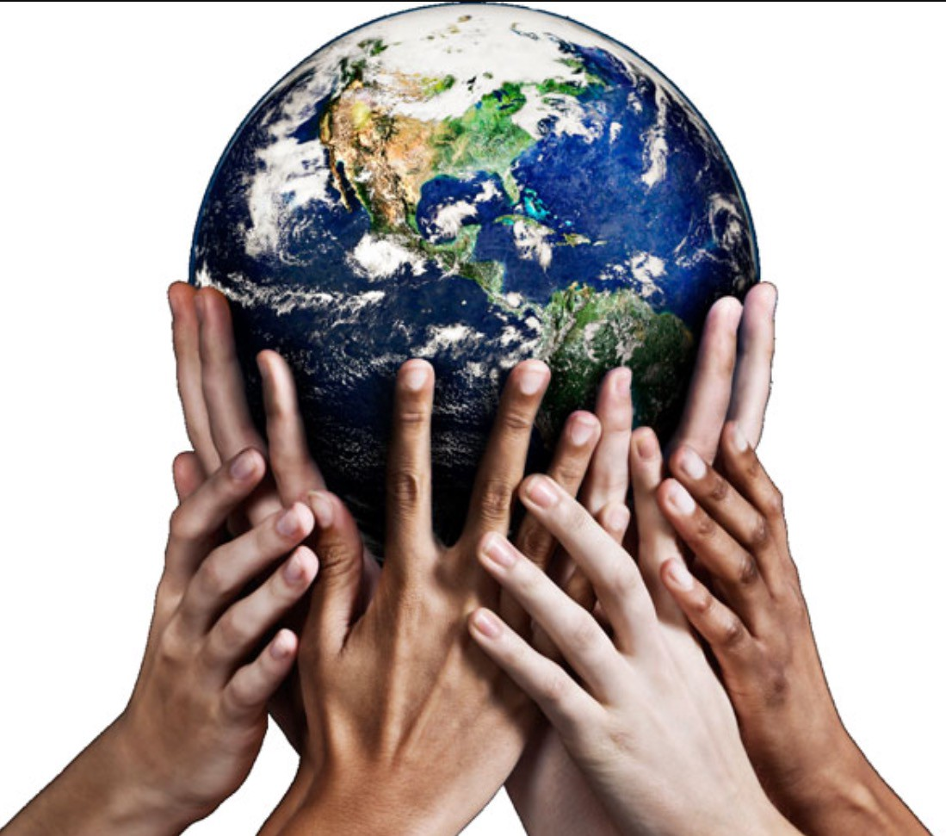
(Himbara, 2017)
Unilever
In the ever-changing business climate there are few market leading companies that are willing to change their business model. With the public concern over consumption, ethics and sustainability, many companies are finding they are needing to change the entire structure of their day to day business. There are a few large companies that have succeeded and are now leading the way for change. Unilever has made an outstanding contribution to sustainability; however, the journey has not been an easy one.
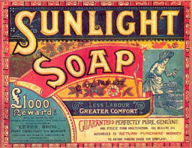
The company formally known as Lever Brothers was founded in the 1890’s. The company started with just one pioneering product, Sunlight Soap, this product revolutionised hygiene in the Victorian era. Their mission statement at that time proposed that “To make cleanliness commonplace; to lessen work for women; to foster health and contribute to personal attractiveness, that life may be more enjoyable and rewarding for the people who use our products”. (Our history, 2018)
Image 1 (Sunlight Soap, n.d.)
William Hesketh Lever who founded the company took a bold step. He had a village built for his workers, which he called Port Sunlight. Lever appeared to value his workforce, possibly contributing to his success. “Lever made a large contribution to the lives of ordinary people. He built Port Sunlight to provide his workforce with good housing. He campaigned for better welfare and a shorter working day, and supported building, education and medical projects”. (The story of Lever - a remarkable man, n.d.). Thirteen architects worked on the development of the village, which has been described by many as an Architectural masterpiece. Lever cut no corners and workers were given the very best accommodation he could provide. Facilities included schools, churches and a post office. Later he was bestowed with the title Lord. Lord lever Hulme campaigned to parliament, he believed that all companies should provide a pension scheme.
Although the company has many achievements, I personally value the organisations commitment to the welfare of girls and women through opportunities, support and sustainable products. One of Unilever’s mission statements for today states that “We want to help create a world in which every woman and girl can create the kind of life she wishes to lead, unconstrained by harmful norms and stereotypes”. (Oppertunities for women, 2018) Interestingly one of their bestselling products Dove started off with one product, a moisturising soap, echoes to lever’s success. The company launched a campaign for real beauty in 2004. Media at the time was beginning to become disheartened with images of women. Models were expected to reach unrealistic weights and this stereotype had never been challenged. A good PR move perhaps on Unilever’s part. Research has suggested that “British women spend on average £70,294 on their appearance in their lifetime”. (Independant, 2017) To the sceptic that is a very large market to have on side.

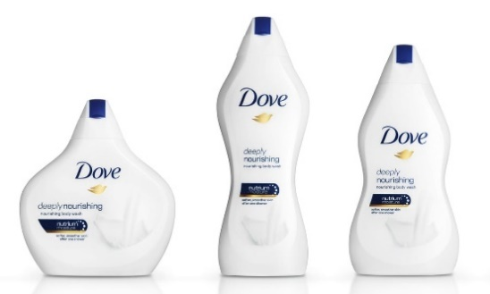
Despite good intentions the company haven’t always got it right. In 2017 they decided to repackage some dove products in 6 differently shaped bottles. Hoping to reflect the diversity of women. This was not well received by the public. People took to social media to express their feelings. (The Guardian, 2017) “The Dove bottle with my body type hurts my feelings. And therein lies the rub: allowing customers to choose a bottle that mirrors their body shape is the opposite of empowering. Suddenly, shower gel is as fraught with body-image dilemmas as their jeans purchase”. The bottles were not put on sale to the general public.
Image 2 (The Guardian, 2017)

A year before this in 2006 Dove has just started a campaign named the Self-Esteem fund. We are now in an ever-changing technological world. The pressures for our young people have changed. Recognising younger generations were plagued with photoshopped images, bombarded with body image and unrealistic expectations. A smart move by Unilever to encourage and support this generation. Ensuring sustainability for the future with a whole new customer base. The mission statement is clear "We’re helping young people all around the world build positive body confidence and self-esteem". (Dove, 2018)
I personally can find no fault in their mission. As a Mother of two daughters any company that is willing to make my daughters feel valued and confident has my vote. The fact that they are prepared to commit resources to provide educational programmes is impressive. Herein lies a wonderful marketing campaign, not only have they ensured sustainability they have potentially gained a new customer, one who appreciates their moral message

What are the benefits for an organisation to empower women. (Mothan-Hill, 2014) states that “It is extremely challenging, if not impossible, for a business to succeed in marketing to women if women are not valued and empowered in the workplace”. Unilever states that “Empowering women will transform individual lives, and it will also transform societies. It’s essential to the United Nations 2030 Sustainable Development Agenda and its Sustainable Development Goals”. (Oppertunities for women, 2018) The company recognizes that women play a large part in its sustainability plan. Just as Lord lever campaigned for the welfare of his workers, Unilever has recognized the inequality between men and women. They are looking at ways to close the gender pay gap and are hoping to lead the way for change. Products for women command a dominant position in the marketplace, this is a marketplace that is growing all the time. A company’s consumers are its biggest asset, it is possible that valuing and empowering it customers has been part of the company’s success.

(Guillen & Ontiveros, 2016) proposes that “The sustainable development of human societies- goes well beyond the concerns about energy, natural resources, and the environment supporting life on the planet to include all aspects of social, economic and political life insofar as present actions may place limitations on future actions”. To conclude a contribution to sustainability is not always better packaging or social and economical issues. It can be recognising the value in the consumers and the workforce. Without either the company will never truly be sustainable.

References
Dove. (2018). Dove self-esteem project. Retrieved from Dove.co.uk: https://www.dove.com/uk/dove-self-esteem-project/our-mission.html
Guillen , M. F., & Ontiveros, E. (2016). Global Turning Points (2nd ed.). Cambridge: Cambridge University Press.
Himbara, D. (2017, September 16). Global Citizenship. Retrieved from Medium.com: https://medium.com/@david.himbara_27884/global-citizenship-gned500-bee46c66eeac
Independant. (2017, march 10). Retrieved from independent.co.uk: https://www.independent.co.uk/life-style/fashion/average-british-woman-spend-70000-appearance-lifetime-cosmetics-beauty-products-groupon-uk-a7623201.html
Mothan-Hill, P. (2014). The Buisness Student's Guide To Sustainable Management. Greenleaf Publishing.
Oppertunities for women. (2018). Retrieved from Unilever.co.uk: https://www.unilever.co.uk/sustainable-living/the-unilever-sustainable-living-plan/opportunities-for-women/
Our history. (2018). Retrieved from Unilever: https://www.unilever.co.uk/about/who-we-are/our-history/
Sunlight Soap. (n.d.). Retrieved from Alamy.com : https://www.alamy.com/stock-photo/sunlight-soap.html
The Guardian. (2017, May 15). Retrieved from The Guardian.com: https://www.theguardian.com/fashion/2017/may/15/beauty-giant-dove-body-shaped-bottles-repair-damage
The story of Lever - a remarkable man. (n.d.). Retrieved from National Museums Liverpool: http://www.liverpoolmuseums.org.uk/ladylever/history/lever.aspx
Unilever. (2016, January 19). Retrieved from You Tube: https://www.youtube.com/watch?v=gnZnBBm2umA

