Cameron Davies – P150422
University of wales trinity saint david
Quality Management in an Operational Environment:
The Impact of Product Recalls on Businesses and Projects
2022
Contents
1.0 Introduction 2
1.1 Product Recall 2
1.2 Wall Colmonoy 2
1.3 Product Issue 2
2.0 Main Body 3
2.1 Process of Product Recalls 3
2.2 Product Recall 3
2.3 Costs of Recall 5
2.4 Consequences of Poor Quality 7
2.5 Restoring Customer Confidence 7
2.6 Need for More Sustainable Practice 9
2.7 Ethical Issues 9
2.8 Supply Chain Complexity 9
2.9 The Current Practice of Powerful Buyers 10
2.10 The Impact of Product Recalls on the Consumer 10
3.0 Conclusion 11
4.0 References 13

Table of Figures
Figure 1: Old Wall Colmonoy Casting Drawing 4
Figure 2: Updated Wall Colmonoy Casting Drawing 5
Figure 3: Individual Casting Order Cost 6
Figure 4: Annual Casting Order Cost 6
Figure 5: ProCast Simulation Image of Re-Designed Part 8

1.0 Introduction
The following report will investigate the process of product recalls; why they happen, and how they can be prevented to ensure they do not occur again. This will be supported using a case study, highlighting an example of a product recall within the company Wall Colmonoy.

1.1 Product Recall
Kalaignanam, (2013) investigated that a product recall can be determined when a product is returned due to it being deemed unsuitable by the customer. Product recalls can be regarded as an indication of the company’s failure to provide a safe/quality assured product to the market.
Mafael, (2022), theorises through secondary research, that companies can often struggle to respond to a product recall and manage the post-process customer satisfaction, this is due to the recall potentially highlighting areas of weakness within the business, that management may not want to accept.

1.2 Wall Colmonoy
Wall Colmonoy is an engineering business engaged in the manufacturing of surfacing and brazing products, as well as castings and engineered components. The company undertakes a considerable amount of work through the process of castings, and manufacture customer products through both investment and sand casting (Wall Colmonoy, 2022).

1.3 Product Issue
Within the investment casting process, a typical customer part would have 1mm overlay added to the component. This is done to ensure that there is enough material post-process, as there is often a need to skim away the excess material so that the finished part is of the best quality possible, (Rome & Young, 2003).
Within Wall Colmonoy, there was a particular case where this practice was not carried out. A tool that was originally designed/manufactured in 2005, had an order placed early in 2022, ready to be processed through the investment casting process. After the parts were manufactured and delivered to the customer, they quickly claimed that insufficient material was on their product. As a result of this, Wall Colmonoy started an internal investigation.

2.0 Main Body

2.1 Process of Product Recalls
A product recall is seen as a process, a practice that will need to be tackled methodically and thoughtfully, with disciplined brainstorming, vetting, testing and double-checking. Companies may wish to thoroughly investigate all product incidents (Wynn, 2011).
A method to approach a product recall, which is implemented within Wall Colmonoy is the methodology of the “Eight Disciplines of Problem Solving (8D’s)”. This is designed to identify the root cause of a problem, plan a quick fix, implement corrective actions and preventive actions to avoid their recurrence (Kumar, 2022). The “8D’s” are as follows, (Kumar, 2022);
- D1 – Appropriate team is assembled, to solve the product issue
- D2 – Problem is fully defined, with all statistics and data collected
- D3 – Immediate action is called, seen as the short-term solution to stop any more losses to the business
- D4 – Root causes of the problem are researched and evaluated.
- D5 – Permanent corrective actions are discussed to ensure that problem never occurs again
- D6 – Permanent corrective action is implemented
- D7 – Change in system/process, so that it will support the prevention of a re-occurrence in the future.
- D8 – Praise team, for the efforts to solve the problem

2.2 Product Recall
Product recalls can occur when an item jeopardises consumer safety or when a product is not fit for purpose. A company may be obligated to remove it from the market or potentially ban it altogether. The process is usually costly and could affect the company’s reputation with a customer. Future sales could decline, while company’s growth projections may also suffer; some of the costs could include the recall process and the replacement of the product. Customer compensation will also signify additional cost (Borah, 2016).
Within Wall Colmonoy, the ”8D’s” method was used to investigate a customer concern, the part was found to have insufficient material overlay resulting in the following steps;
D1 – A team was assembled consisting of the quality engineer, production manager and design engineer of the castings department, as well as a member of the sales team. Each person was selected with the aim that their different knowledge and skillsets would be able to provide a solution to the problem.
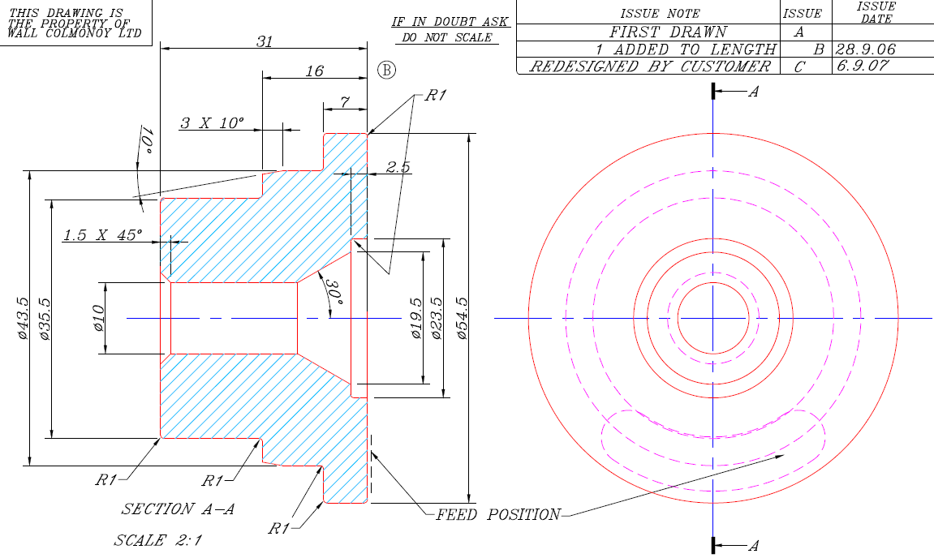
Figure 1: Old Wall Colmonoy Casting Drawing
D2 – Figure 1 is the casting drawing that Wall Colmonoy manufactured. It was found that some dimensions on the part didn’t have enough material (1mm should be added on all investment casting parts), it meant that some dimensions not only didn’t have 1mm, but also were under dimensioned. When the part was skimmed to its final surface finish, extra material was taken off and this meant that the parts were not fit for purpose. The data collected determined that 150 parts were manufactured, meaning a cost of £1,800 was incurred in production costs.
D3 – A product recall was initiated, a process in which a company repossess a product from the market and from consumers who purchase it, due to a defect or error in its production, (Sumukadas, 2021). This was seen as an immediate action from Wall Colmonoy to ensure that no more parts, unfit for purpose were continued to be produced, to stop unnecessary work and extra costs.
D4 – Figure 1, relates to a tool that was originally designed and manufactured in 2005. Through investigation it was found that due to having made the part on several occasions over the last 15+ years, the sales team had failed to confirm if the drawing was suitable with the customer, something that is usually done with any new tools or tool modifications that need to be processed.
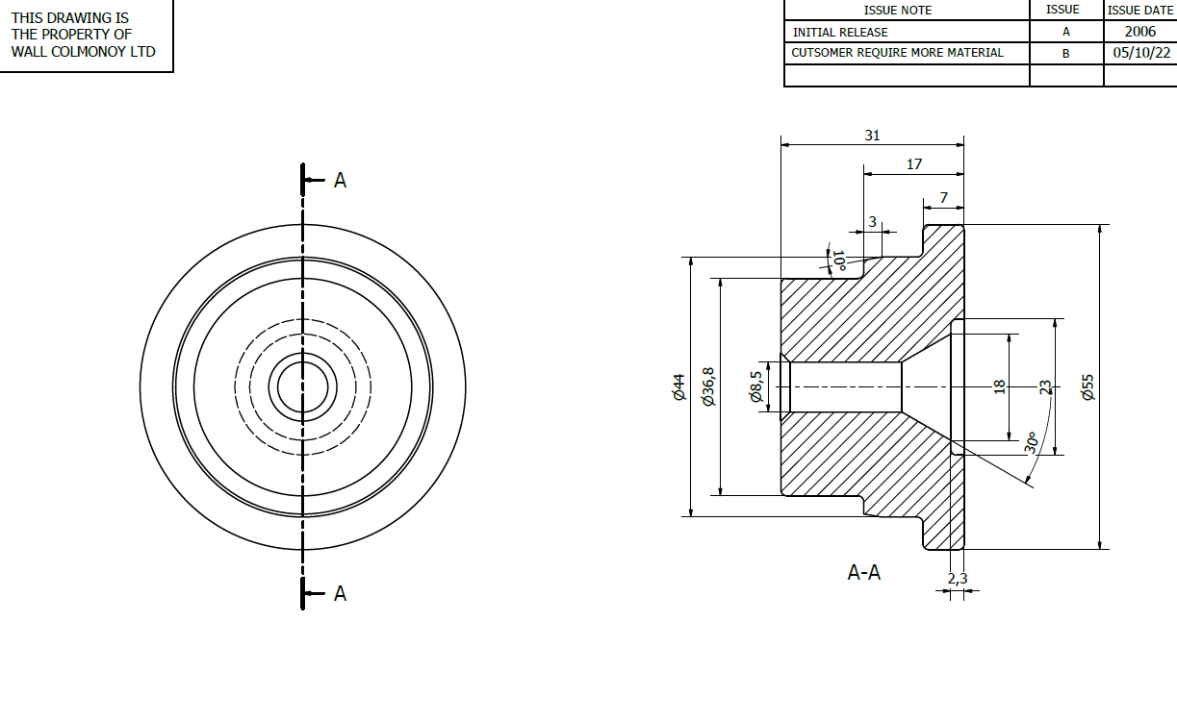
Figure 2: Updated Wall Colmonoy Casting Drawing
D5 – A new design for the tool was completed as shown above in Figure 2, the required 1mm material overlay was added to the part, which was sent off to the customer for approval.
D6 – The tooling cost was covered internally, instead of it being charged to the customer. This was done as an act of goodwill, in order to restore faith to the customer after the product recall. This would mean that the tool/part could now be manufactured and meet the needs of the customer.
D7 – A change in system was implemented driven through sales, that from now on regardless how old/frequent an order was from a customer, it was seen as general practice to always send the drawing off for approval, so that the customer could confirm if it was suitable.
D8 – Finally, praise was given to the team for being able to resolve the issue, and from stopping it from affecting future orders.

2.3 Costs of Recall
Costs are typically incurred for a product recall, and depending on the severity, they can become detrimental to the business. The effect on a company can result in both reputational damage and long-term financial losses to the business, as the product recall affects the relationship with the customer, which could result in a reduction in sales (Liu, 2016).
Chao, (2009) argues that recall costs could be shared between a company and a consumer to encourage quality improvement effort. For example, if there has been a relationship built up between two customers over a long period of time, a plan to ensure the relationship remains strong could be seen as a priority for both, as the company want their continued source of income, and the customer would want its product.

Case Study (Year 2022):

Data |  | Casting Cost per Tree Batch | Tree Batch Quantity | Total Cost per Order
Individual Order |  | £150 | 12 | £1,800

Figure 3: Individual Casting Order Cost
Castings Cost per Tree Batch x Tree Batch Quantity

Data | Casting Cost per Order | Annual Order Quantity | Total Annual Cost
Annual Order | £1,800 | 5 | £9,000

Figure 4: Annual Casting Order Cost
Casting Cost per Order x Annual Order Quantity

The above data represents the costs incurred by Wall Colmonoy in processing the case study order, it cost the business £1,800 due to the product recall, as the money spent to create the parts was wasted, the casting cost per batch takes into consideration all production costs, labour, consumables, energy consumption, parts per tree, etc.) This specific order was from a repeat customer, who has been purchasing from Wall Colmonoy for over fifteen years. Had this issue not been resolved, then a total of £9,000 could have been lost due to the total number of potential orders for that year.
Following the conclusion of a successful response to a product recall, the company can allow themselves to continue production, therefore ensuring income is not affected. There are cases with companies however where costs can have severe effects to a business. For example, pharmaceutical company Pfizer had health and safety issues with one of their products, and due to the size of the organisation and the $1.3 billion dollars’ worth of sales, the product recall cost the company significantly financially, with a total of $3.3 billion dollars lost. This highlights the level of impact a product recall can have on a company from a financial perspective, (Ottawa, 2005).

2.4 Consequences of Poor Quality
Poor quality could have several industry associated consequences. The most widespread are lost customers, lower productivity and increased costs. Poor quality can also initiate product liability claims. In certain cases, it can be a contributing factor to legal action being taken against the company/supplier (Haug, 2011).
Al-Tmeemy, (2015) studied the consequences of poor quality through secondary data. It was concluded that cost overrun is the major consequence of quality failure. Therefore, it can be argued that resolving recalls, and importantly preventing them, is vital to a company. In the current economic environment, any costs that can be saved would greatly benefit the business, as well as maintaining a strong working relationship with a customer.

2.5 Restoring Customer Confidence
Regaining the customer confidence after a product recall can be considered essential, as it ensures that a good working relationship can be maintained and that sales are not lost. Rozembajgier, (2014) wrote an article referring to the best way to regain a customer’s confidence. Initially there is need to establish that there is an issue, provide a solution and keep the customer informed with what is going on. This will give them greater confidence that the issue is not being overlooked, and that the company is offering them support.
The point of accepting the issue can be seen as the first step in trying to regain the confidence of the customer, as very often when a company has an issue, the initial response would be to blame the other party, and not taking ownership for the mistake. This could create even further friction between company and customer.
Wall Colmonoy’s process to regain customer confidence was to accept responsibility that the part should have had 1mm overlay on the design and that it would commit to modifying the part to suit the customer needs. The second way of gaining confidence was to try and prove that there would be no issues with the final part, by running a simulation using the application software ProCast (Lu, 2014). ProCast is a casting simulation software that has been used in Wall Colmonoy for the last 5+ years as a way of supporting the design of new parts and modification of old tools.
The drawback of simulations is that they aren't the real thing. An individual or the process may react differently when faced with situations in the real world, as not all factors can be considered in a simulation due to outside influences (Descantes, 2019).
Wall Colmonoy would try to ease these concerns with a customer by showing real cases within the company where the simulation has demonstrated success; for example, when a part had highlighted issues in the real-world process, the component was re-designed with the support of a simulation. After the re-design change was then implemented in the real world, the part highlighted the positive simulation findings, that there were no defects in the part.
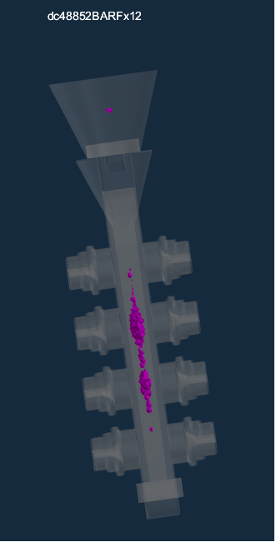
Cone
Filter
Shrinkage
Investment Tree
Customer Part
Figure 5: ProCast Simulation Image of Re-Designed Part
The above simulation image reveals how the re-designed part would progress through the investment casting process, revealing no defects, a key indication that the simulation has worked successfully, is if the shrinkage (purple), is not within the finished part. If the shrinkage is only in the investment tree, it is acceptable, as it’s not seen as important to remove shrinkage, it’s about reducing it, and ensuring it’s targeted to happen in non-vital areas (Liao, 2022).
Companies have different ways of dealing with regaining customer confidence. For example, in 2010 car manufacturing company Toyota, were forced to recall certain ranges of vehicles due to quality issues. Their way of regaining the confidence of the customer was to ensure courtesy cars were given out, all expenses were covered by Toyota, and they were always informed with what the latest updates were. These actions were taken to lessen the inconvenience to the customer, (Fan, 2013). However, there can also be an argument that due to the size of a company like Toyota they can afford to spend money to keep customers happy, smaller businesses may not have that luxury.

2.6 Need for More Sustainable Practice
Bass, (2002) wrote on sustainable development and why it is important to a business, he concludes that sustainability entails fulfilling the needs of current process/market without compromising the needs of the future process/market.
This is important from a product recall perspective, as being sustainable you are adapting to the needs of the current market. While the process improvement a product recall would entail, demonstrates the company’s commitment to adapting to future requirements.

2.7 Ethical Issues
Ethical issues arise when a certain decision, scenario or activity generates a conflict with a society's moral principles. Both individuals and businesses can be involved in these conflicts, since any of their activities might be questioned from an ethical standpoint (Elswick, 2017).
This point could be argued to have been resolved in the case of Wall Colmonoy, due to the failure in following the company’s standard procedure and to check what dimensions the customer wanted. It would be morally wrong if the company didn’t accept a portion of the responsibility.
However, an argument can be made for the opposing side, as if they had changed the design of their part, they had a moral obligation to inform the supplier they would require a design change. To try and keep a good relationship, it can be argued it is important to find a common ground, something Wall Colmonoy tried to do with the customer.

2.8 Supply Chain Complexity
Supply chain complexity is triggered by a variety of factors, frequently the result of rising customer expectations for quicker lead times, expanded products, services, and tailored experiences, (Khan 2018). With the case study from Wall Colmonoy, the supply chain complexity was expanded products and services, as there was a change in the customer part design, resulting in delays with delivery.
With the product being recalled, this naturally impacted the lead time, as the customer wouldn’t have had the part at the initial time they were quoted. This is something that Wall Colmonoy would have to consider for the next time the order would come through, ensuring that the lead time is efficiently and effectively met.

2.9 The Current Practice of Powerful Buyers
A customer has a certain level of power due to a product recall, as they could bargain with a company to reduce their costs, especially if there are plenty of other companies offering the same service cheaper, or if they have had any problems with their current service, (Kirkwood, 2012).
With the product recall in Wall Colmonoy, this would give the customer a position of power, as they could threaten to go elsewhere, or demand lowered costs for the inconvenience of receiving the wrong parts. This would deeply affect Wall Colmonoy if their customers were to start demanding lowered costs, as it would reduce their profit margins. This confirms why it is crucial that restoring customer confidence is met as soon as possible.

2.10 The Impact of Product Recalls on the Consumer
Product recalls can also be damaging to the consumer, as in the instances where the product is not fit for purpose, it will either inconvenience the customers need for the product or could affect lead times, (Marsh, 2004).
However, the most severe effects for when a product is recalled, is directly related to health and safety circumstances. For example, in 2005 the pharmaceutical company Pfizer, were forced to recall their product Bextra which was an arthritis painkiller, this was because research suggested the product increased the number of cases of heart attacks and “life threatening” skin reactions from consumers. This had ethical impacts of endangering the lives of individuals, (Ottawa, 2005).
This highlights the importance of ensuring high quality standards are met by the business, as when product recalls happen, it not only costs the business financially, but it will also affect the reputation, ethics and potentially expose the company to legal proceedings, if the recall has a damaging effect to the consumer/customer (Trumbull, 2018).

3.0 Conclusion
This report has investigated the product recall process; why it can happen, and recommended solutions that can be put in place, to ensure it doesn’t occur again. This was supported through a case study, from an example of a product recall within Wall Colmonoy.
A product recall can be identified as a request to return, exchange, or replace a product after a manufacturer/consumer identify defects or product concerns that could hinder performance, harm consumers or produce legal issues for the producers, (Ni, 2014).
Within Wall Colmonoy there was a product recall at the start of 2022, where a part was sent back, after the customer had addressed the concern that there was not enough material on the part. This meant that the part was not fit for purpose, and unsuitable for the customer.
Through the methodology of using the problem-solving method of “8D’s”, the product recall was reviewed and analysed. The oversight from Wall Colmony’s behalf was traditionally they would send off any casting drawings to the customer so that they could confirm their requirements. This was not done in this instance, due to the customer having had multiple parts produced over the last 15+ years, creating the impression that they didn’t need to.
The issue was resolved by re-designing the part, sending it back for customer approval, while keeping them updated throughout the process. A simulation was also carried out on the new design, to try to regain the customer’s confidence. The simulation showing no issues was a way of giving assurance to the customer that the parts they would be receiving would be of the best quality.
To ensure that this doesn’t happen again, a procedure has been put in place at Wall Colmonoy led through the sales team, that for any future orders, regardless of if the request is for a new tool or a tool modification, a customer should be sent a drawing to approve, to ensure that they know the part they are getting is appropriate and what they require.
Product recalls can be very detrimental to a business, as it can impact the company recalling the products and the consumer. For example, the Wall Colmonoy product recall cost the company £1,800 and if the issue was not resolved it would have cost the company £9,000 annually, due to the repeat order the company would receive, highlighting financial issues.
While for the consumer, there are cases were there can be severe health and safety effects to the customer, as highlighted with the Pfizer instance where the product was not only fit for purpose but had an impact on the health on the customer/consumer.
It is vitally important to investigate a product recall to fully understand the underlying issue and determine how it can be resolved. Using appropriate problem-solving processes is key to achieving this, using methodologies such as the “8D’s”, it builds up a structure that can be followed and repeated, should a similar issue happen again.
Finally, it is important to be fully transparent with the customer, to maintain/regain their confidence, and ensure that is the ultimate priority, as having their confidence could provide a better opportunity for the customer/supplier relationship to both continue and progress.

4.0 References
Kalaignanam, Kushwaha, T., & Eilert, M. (2013). The Impact of Product Recalls on Future Product Reliability and Future Accidents: Evidence from the Automobile Industry. Journal of Marketing, 77(2), 41–57.
Mafael, Raithel, S., & Hock, S. J. (2022). Managing customer satisfaction after a product recall: the joint role of remedy, brand equity, and severity. Journal of the Academy of Marketing Science, 50(1), 174–194.
Wall Colmonoy (2021) ‘Wall Colmonoy - Who are we?’ [Online] Available: https://www.wallcolmonoy.com/company-profile/who-we-are/t
Wynn, Ouyang, C., ter Hofstede, A. H. M., & Fidge, C. J. (2011). Data and process requirements for product recall coordination. Computers in Industry, 62(7), 776–786.
Rome, & Young, H. (2003). Fine art metal casting : an illustrated guide to mould making and lost wax processes. Robert Hale.
Kumar Phanden, Sheokand, A., Kumar Goyal, K., Gahlot, P., & Ibrahim Demir, H. (2022). 8Ds method of problem solving within automotive industry: Tools used and comparison with DMAIC. Materials Today : Proceedings, 65, 3266–3272.
Borah, & Tellis, G. J. (2016). Halo (Spillover) Effects in Social Media: Do Product Recalls of One Brand Hurt or Help Rival Brands? Journal of Marketing Research, 53(2), 143–160.
Sumukadas. (2021). Are you ready for your next product recall crisis? Lessons from operations and supply chain management. Business Horizons, 64(2), 211–221.
Liu, Liu, Y., & Luo, T. (2016). What Drives a Firm’s Choice of Product Recall Remedy? The Impact of Remedy Cost, Product Hazard, and the CEO. Journal of Marketing, 80(3), 79–95.
Chao, Iravani, S. M. R., & Savaskan, R. C. (2009). Quality Improvement Incentives and Product Recall Cost Sharing Contracts. Management Science, 55(7), 1122–1138.
Haug, Zachariassen, F., & Liempd, D. van. (2011). The costs of poor data quality. Journal of Industrial Engineering and Management, 4(2), 168–
The consequences of poor quality on project management success of building projects. (2015). Diyala Journal of Engineering Sciences.
Rozembajgier. (2014). Tracking a Medical Device Recall Is No Easy
Mullins. (2012). RSA Chief Concedes Need To Regain Customer Confidence. Informationweek - Online.
Lu, Xiao, F.-R., Zhang, S.-J., Mao, Y.-W., & Liao, B. (2014). Simulation study on the centrifugal casting wet-type cylinder liner based on ProCAST. Applied Thermal Engineering, 73(1), 512–521.
Zhu, Luo, M., Li, D. Q., Midson, S. P., Qu, W. Y., & Fan, J. Z. (2020). Using ProCAST to Study the Effects of SEED Process Parameters on the Radial Temperature Distribution in Semi-Solid Slugs. Materials Science Forum, 993, 1004–1010.
Descantes, Tricoire, F., & Richard, P. (2019). Classical contact detection algorithms for 3D DEM simulations: Drawbacks and solutions. Computers and Geotechnics, 114, 103134–.
Liao, Ge, P., Lu, G., Song, Y., Ye, W., Gao, J., & Luo, X. (2022). Simulation Study on the Investment Casting Process of a Low-Cost Titanium Alloy Gearbox based on ProCAST. Advances in Materials Science and Engineering, 2022.
Fan, Geddes, D., & Flory, F. (2013). The Toyota Recall Crisis: Media Impact on Toyota’s Corporate Brand Reputation. Corporate Reputation Review, 16(2), 99–117.
Dalal-Clayton, & Bass, S. (2002). Sustainable Development Strategies : A Resource Book. Earthscan LLC.
Elswick. (2017). Data collection : methods, ethical issues and future directions (Elswick, Ed.). Nova Publishers.
Khan. (2018). Supply chain management Motorola’s complexity index. Henry Stewart Talks.
Kirkwood. (2012). Powerful buyers and merger enforcement. Boston University Law Review, 92(5), 1485–.
Marsh, Schroeder, T. C., & Mintert, J. (2004). Impacts of meat product recalls on consumer demand in the USA. Applied Economics, 36(9), 897–909.
Pfizer pulls Bextra. (2005). Canadian Pharmacists Journal, 138(4), 21–.
Trumbull. (2018). Consumer Capitalism: Politics, Product Markets, and Firm Strategy in France and Germany. Cornell University Press.
Ni, Flynn, B. B., & Jacobs, F. R. (2014). Impact of product recall announcements on retailers׳ financial value. International Journal of Production Economics, 153, 309–322.

