11/7/2022
Kathrine Williams-Kirby
L4 LDE Assignment 1

Learning In the Digital Era- Animation and VFX
Kathrine Williams-Kirby 2204818- E Portfolio
Contents
E-Portfolio 2
Summery Task 1 3
Poster- Task 2 4
Task 3- Referencing 5
Task 4 Portfolio created, and review 6

E-Portfolio

Link to Portfolio Homepage
https://22048183.wixsite.com/kathrine-williams-ki

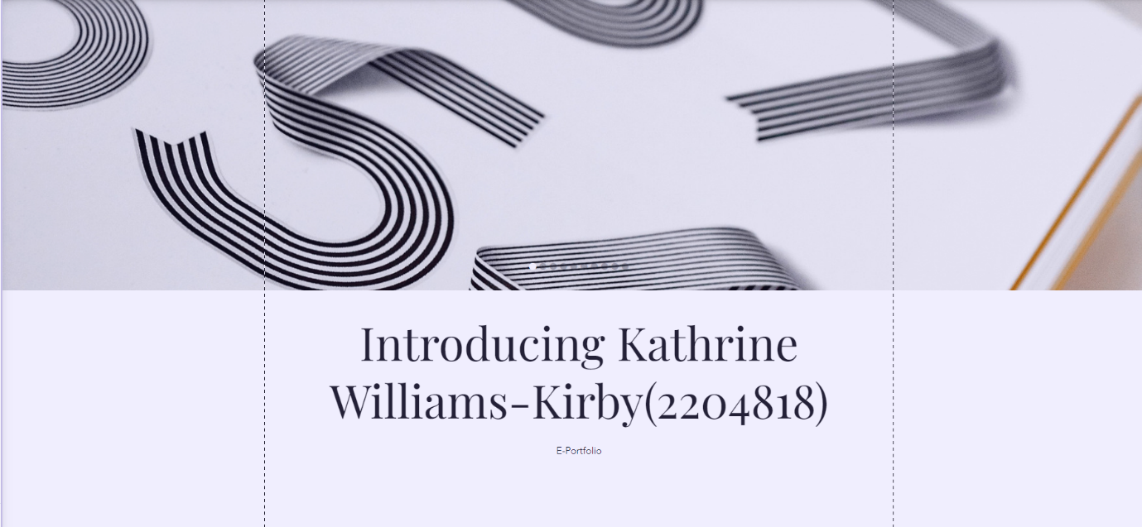
Screenshot of the Portfolio Homepage



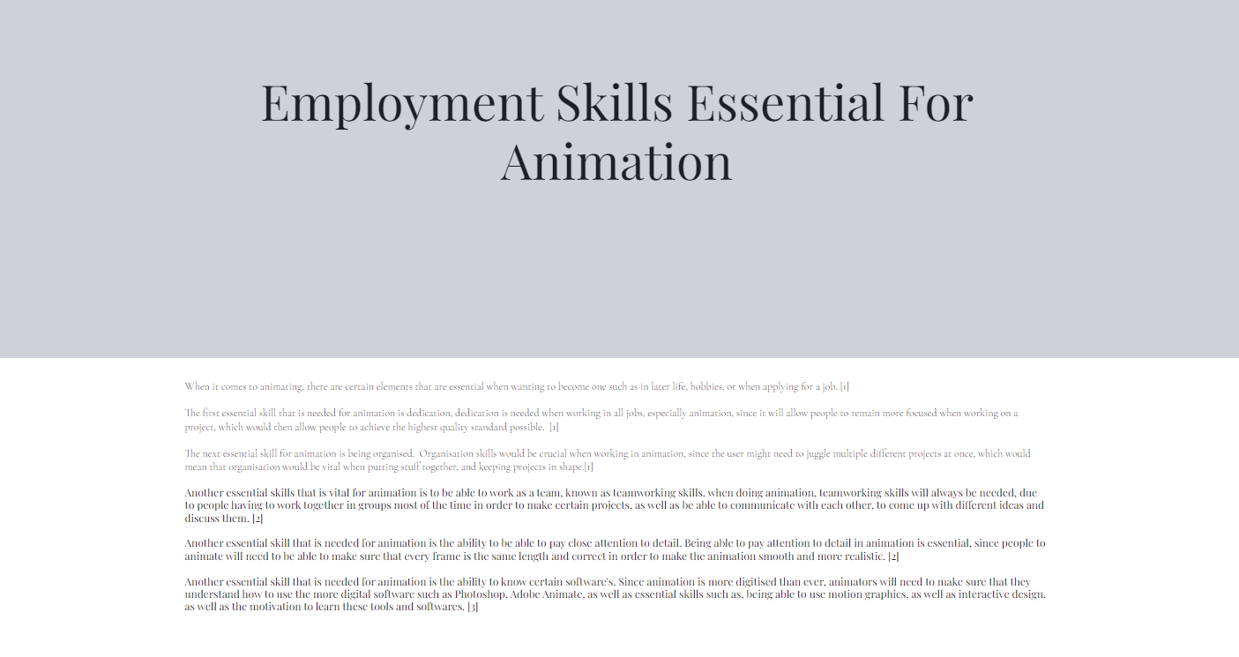
Summery Task 1

Poster- Task 2

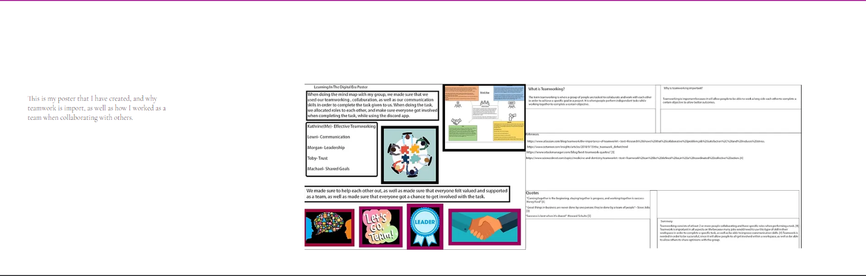
Link to Poster Pages On Onedrive

https://uowtsd-my.sharepoint.com/:i:/g/personal/2204818_student_uwtsd_ac_uk/EfwK3yBG8HFGgy9pVMTyvOwBJY3-RJ7B6ZaWdVaiu6p6Qw?e=aqYI2C

https://uowtsd-my.sharepoint.com/:i:/r/personal/2204818_student_uwtsd_ac_uk/Documents/Learning%20in%20the%20Digital%20Era-%20Adam%20Head(Year%201)/Photoshop%20Projects/Poster%20second%20page.psd?csf=1&web=1&e=elyCPe

Task 3- Referencing

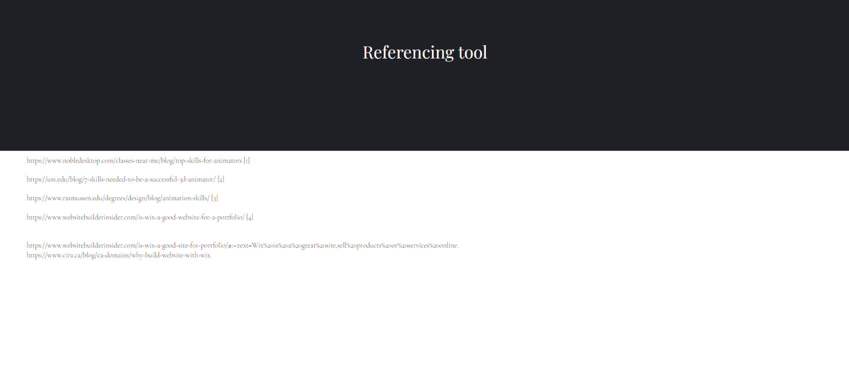
For some of the slides, I have used references to show where I got some of the information from, as well as slides that I haven’t used, but I have had a looked at.

Task 4 Portfolio created, and review

This is all of the slides that I have got on my portfolio, including the portfolio that I have created, as well as the review.



