
Research Proposal:The Impacts of social media on events.
Mrs. Sarah Louise Hillam P137987
HND Events Management
Submitted to Kathryn Flynn
University of Wales Trinity Saint David
Business School

Contents Page

- Introduction………………………………………………………………………… 3
- Aims and Objectives……………………………………………………………… 4
- Background Research..…………………………………………………………....5
- Research Methodology……………………………………………………………..6
- Stragegy Chosen……………………………………………………………………8
- Sampling Framework……………………………………………………………….9
- Data Analysis Tools………………………………………………………………..10
- Research Ethics…………………………………………………………………….11
- Resource Planning………………………………………………………………….11
- Summary……………………………………………………………………………..12
- References……………………………………………………………………………13

1.0 Introduction
The chosen field of study for this research proposal, is going to be based on the impacts of Social Media and how it can affect events.
From the research I have done, I have found quite a few websites, books and online journals with supporting evidence of the impacts of social media and how it can affect events, The article I have found online written by “Blair Potter” is all about social media and how it affects events, “She says that social media is not a trend, it has fundamentaly shifted the way many people in society share their personal and proffessional lives”. Social media has also changed the way our lives are deisgned now and marketed for events as many of us post events on social media. Obviously social media can benefit our lives as well as have significant impacts on them from events we attend as things may get posted on social media sites that you may not want people to see, this can have an impact on you. Mintel Reports (2014) state that “smartphones have made a substantial impression on the mobile phone market with 7 out of 10 adults in the UK owning one”; thus, meaning that wherever someone goes, whatever they do, a mobile phone will always be present. Thomas (2011) explains that an app can benefit both event organisers and attendees as communication can happen in real time with other attendees or information can be shared and updated to friends around the world in seconds for example on facebook or instagram or other social media sites. Often on these social media sites there is close linked groups for an event and they are often posted on facebook so attendes can state if they are going to the event or not and upload pictures of the event and also checkin at the event so people know where they are. The imapct of people checking into an event online is that you don’t know who is watching your facebook profile and it has been proven from online articles on newspapers that people have been burgled whilst out an event due to posting on social media that they are attending an event (Buono, 2013).

2.0 Aims and Objectives

My aims and objectives for this research proposal are to find out from event attendees how they rate social media and how they think it affects events. I am going to conduct this research via questionnaires and online surveys through surveymonkey.com
The objectives are
- To see if attendees think social media affects events and if so how.
- To understand why social media has changed and do they think its for better or worse
- To see if attendees realise how much time social media takes up whilst they are attending an event, this could be from posting on facebook or instagram or even just chatting on messenger to friends or family.

3.0 Background Research
Social media has become such a big part of everyday life and has increasingly become an everyday occurance for people all over the world to use this on a daily basis. Social media is now the new trend on how people communicate with friends and family. The use of social media at events has significantlly increased over the years, according to the “GWI Social Report they interview over 550,000 people per year that are using social media whilst attending an event” These users are aged between 15 and 54 and are a general mix of male and female attendees. The power of social media has changed in the event/tourism field especially as user-generated feeds such as Facebook reveal problems within the event or traffic before the news (Dickinson et al, 2012). More than 1 billion people use Facebook so issues with events are posted online for friends to see before anything is nationwide, thus meaning that in this sense social media is a huge help towards events around the world (Potter, 2017).

4.0 Research Methodology
According to Sekaran (1992) Sekaran (1992) explains that “research is defined as a systematic and organised effort to investigate a specific problem that needs a solution”. Whilst conducting research there is many different way this can be done either through primary research and secondary research methods and also the research onion.
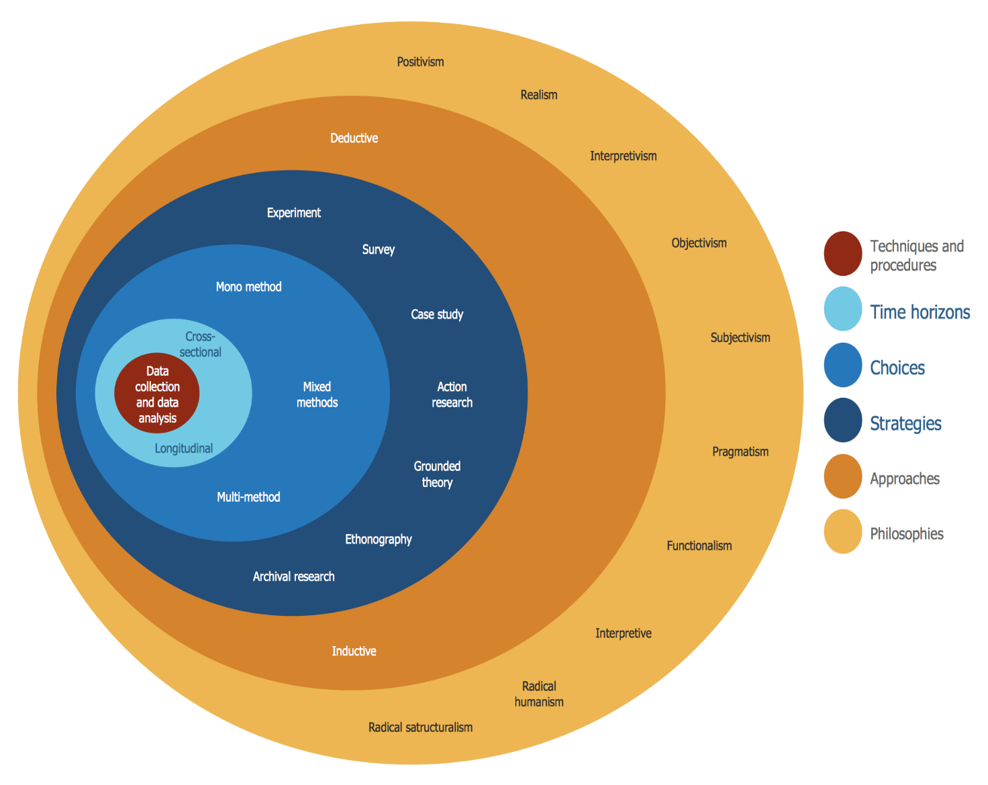Figure 1 Onion research graph (Images, 2018).
For primary research I am going to be conducting interviews with attendees on a one to one basis at local events and also handing out questionnaires to attendees who don’t want to stand around and chat, I will also be conducting surveys through surveymonkey.com. I will also be using secondary research methods such as government departments and organisational records for data analysis.
By using qualitive research methods as well as primary and secondary their will be more indepth detailed results from the interviews, questionnaires and also surveys. “According to Crotty, research methodology is a comprehensive strategy ‘that silhouettes our choice and use of specific methods relating them to the anticipated outcomes, but the choice of research methodology is based upon the type and features of the research problem” Qualiative research can also be unreliable at times as people may answer questions in a bias way.

5.0 Stratagy Chosen
For this research task, the researcher has chosen to do questionnaires and interviews and surveys, this is called mixed methods, This involves both collecting and analysing the data that has been collected from the interviews and questionnaires and surveys. The questionnaires will be handed out to approximatly 300 people attending various events and they will aim to find out what attendees think about social media and the impact it has on events.
By using the research onion, the researcher will be using the inductive approach as they will be aiming to build theory on something where there is not a lot of secondary research. The researcher is now wanting to build a hypothesis into something where there is a lot of secondary research available and this could have been researched by someone else previously.
The questionnaires will include open questions and questions regarding demographics and the main question been social media and the impact it has on events. The questionnaire will be made using spss software as it is a quick and efficent way to make a questionnaire and this can be sent to people via facebook and handed out to attendees at the event.
The online survey will include roughly the same questions but is designed for users who did not want to complete a questionnaire at the event, the survey will be done via surveymonkey.com.
The interviews will be generalised and will be asking the same questions to get the same answers for the data analysis purposes. By using interviews it wil be more likely to gain the truth from the questions so this will be the most positivist way to collect the data, it will also be easier to compare the patterns and trends.
By using these mixed methods of collecting data the hypotesis can be explored in great detail and the results that are collected are going to be more reliable than just conducting questionnaires and surveys.

6.0 Sampling Framework
For this part of the research for this proposal, the researcher will conduct sampling framework on friends and relatives where they will interview around 20 people so many and hand the rest questionnaires or ask them to complete a survey online, by completing a sampling framework this they know the questions will be answered to a high standard. As the questions asked wont have any impact on their lives their will be no need for a larger sampling to be done.

7.0 Data Analysis Tools
The researcher will use spss and excel to gather all the data from the questionnaires and then they will use metrix tables for the interviews. The researcher will use excell to place the data into then use create bar charts and graphs to make it easier for presentation purposes. All the interviews will be typed up by the researcher to have a hard copy to make reviewing easier and make it easier to find a pattern within the answers given, as well as having the tape recordings.

8.0 Research Ethics
Banister et al (1994) says that “ethical concerns must be part of the fundamental design of any research project, and ideally any proposed research”. Although the research methods used should not cause any issues or embarrassment, all persons asked to take part will be asked for their consent which includes telling them the aims of the research, how they were selected and what will happen to the results. The researcher will also offer confidentiality to all participants as to protect them from harm, Mason (1996) explains that “gaining informed consent is quite a complex and difficult business”. This research task does not require children to participate so there is no need for a DBS certificate. The researcher will inform participants that they can do both the questionnaire and interview anonymously if required. The researcher will put on the top of the questionnaire asking if the participant gives their consent, and the participants will be again asked before the interview commences; however, there is no need for the researcher to have written consent from participants as both the questionnaire and interview will not intrude on their lives, only their opinions (Rice, 2018) (Bell, 2012).

8.1 Resource Planning
The reliability will be all about the consistency of the results
To complete this task effectively many different resources will be used; such as the University library and the University’s online library. The researcher will also be using Google Scholar, online articles, journals and hard copy books. The researcher will also need a laptop at home, a printer, Facebook and SurveyMonkey. The researcher will have from October to May to complete this task, there is a Gantt chart attached to show the researchers focus on the months. By using a Gantt chart the researcher can stay focused on the task in hand and see what needs to be completed each month (Rice, 2018) (Bell, 2012). Xx x x x x 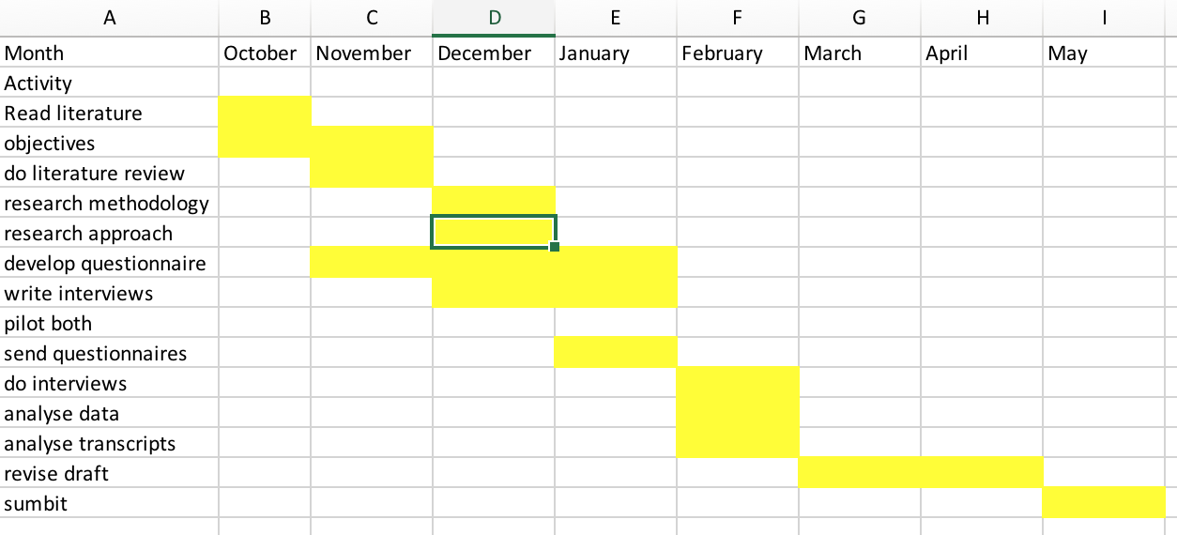x x. xx. X. x x. x. x x. x x x x. x x x x. x. x. x x. x x x. x x x. xx x x x x x. x x. x. x x. xx x. x x x

9.0 Summary
From the research undertaken to complete this research proposal, their have been many articles,books,websites and journals to find information from on the impact of social media and events, I have found that socail media can affect events in different ways such as people using social media too much at events, their has also been reports of problems with attendees getting burgled due to posting images and status updates on social media, these can have serious effects on the people attending the event, As for the impact social media has on events it can have positive and negative affects depending on the event type and location but overall social media has mostly positive impact on events as a lot of attendees share the event so this attracts people to look at the event online and possibly purchase tickets to attend, since facebook started and they introduced the ability to be able to share media through their social media site ticket sales for events have increased by 5% which is a sigificant boost to the events industry.

References
Bell, A. B. a. E., 2012. Research Methods. In: Business Research Methods. London: s.n.
Buono, S., 2013. The affects of social media on attendees. THE AFFECTS OF SOCIAL MEDIA ON ATTENDEES' EXPECTATIONS AND PEERCEPTIONS OF EVENTS.
GWI, 2018. Social Media Trend Report 2018. GWI Social .
Images, G., 2018. Research Onion. [Online]
Available at: https://www.google.com/search?q=research+onion+diagram&client=firefox-b&tbm=isch&source=iu&ictx=1&fir=oyl5Y8FX3G3GcM%253A%252CCXtrXZr8Rsa_HM%252C_&usg=__ls1WLVclZCmqGbIWCiXtC8Y48E0%3D&sa=X&ved=0ahUKEwjdhontoqncAhXPVsAKHU3xAdUQ9QEILTAC#imgrc=oyl5Y8FX3G3GcM
[Accessed 18th July 2018].
Jamshed, S., 2017. Qualative Research Methods. [Online]
Available at: https://www.ncbi.nlm.nih.gov/pmc/articles/PMC4194943/
[Accessed 18th July 2018].
Potter, B., 2017. The impacts of social media on events. [Online]
Available at: https://www.mpiweb.org/blog/article/the-impact-of-social-media-on-meeting-design-event-marketing
[Accessed 18th July 2018].
Rice, R., 2018. An investigation into wheather social media affects events, swansea : s.n.
Tashakkori, C. T. a. A., 2011. Qualitative Research. In: The SAGE Handbook of Qualitative Research. London: Sage Publications.

