

Programme: BA Business Management

Module: ENTREPRENEURSHIP

Module code: LCBB5001

Written Report/ Business Plan

Lecturer’s Name: Vasilios Tavlaridis
Student Name: Veronica Cusciac
Student ID: 2321297

Table of Contents

1. Overview of the Business Idea, Product/s and/or Service/s 3
2. Legal format of the startup company 4
3. Management of the Company 4
4. The Target Market and the Marketing Strategies of the Company 5
5. Use of social media & Website to promote the Company Product/s and/or Service/s 6
6. Evaluation of the Business Idea by using the SWOT Analysis Model 7
7. A cash flow forecast for the first 12 months 7
References 9

Overview of the Business Idea, Product/s and/or Service/s

A pizza business that caters primarily to takeout and delivery clients while additionally providing limited seats for in-store diners are being considered. The pizzeria's menu will include multiple types of pie, all of which will be made with quality ingredients that are fresh and served quickly. The goal of the company is to supply customers with tasty pizzas in a quick and welcoming environment. The pizza business around the world has been expanding significantly in recent years. The increasing need for delivery and takeout services is an immediate consequence of consumers' changing tastes and the ease of use they provide. In 2020, the UK delivery of food market was worth £8.4 billion, and experts predict it will continue to expand at a CAGR of 5.8% between 2021 and 2026. Pizza is now essential for many people all around the world. Families, students in college, people in employment, and people of all ages are all inclined to enjoy it. With such an extensive following, pizza will always be in high demand. Pizza's adaptability to different toppings, sauces, and crusts makes it a versatile food option. By accommodating a broader variety of customers' preferences, one can increase the revenues of the company. The pizza shop would be located in Northfield/ Kings Norton area, West Midlands.
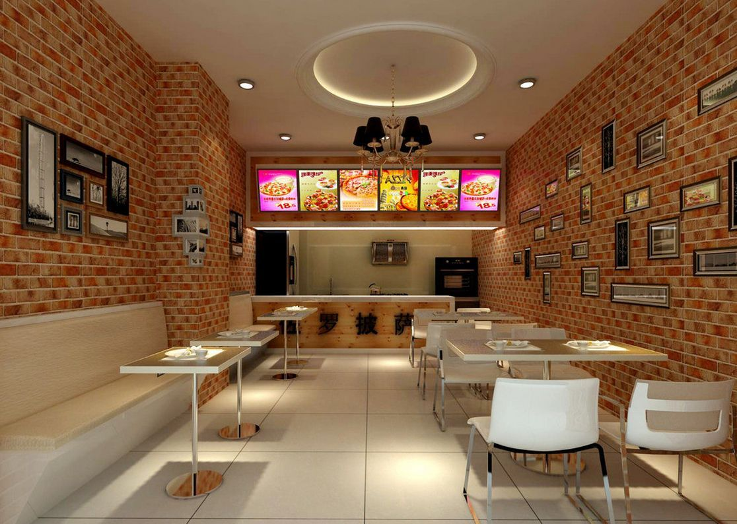
Figure 1 Vision for the Pizza Shop
(Source- https://www.pinterest.com)

2. Legal format of the startup company

For my new pizzeria, I've decided on a limited company as a suitable business structure. Shareholders of a limited company have security from having their private property seized in the event of the firm's financial difficulties or bankruptcy because the company is treated as an independent legal entity from its owners. Shareholders' financial exposure is limited to the value of their shares. With a company with limited liability, shareholders are only responsible for the value of their shareholdings, and the firm itself is responsible for any obligations or debts that exceed that sum of money. Due to the inherent dangers and uncertainties in the restaurant business, this organizational setup offers owners a measure of security and safeguarding from financial loss. Over 4 million firms were listed as being operational in the UK, with many of them being limited companies. The limited company form is frequently utilized by SMEs in the UK because of its many advantages, such as decreased liability, easier access to money, and more fluid share transferability.
The limited company model is ideal for my pizza store because of its numerous advantages. To begin, having the assets of the organization kept separate from the owners shields them from any personal accountability for any debts or litigation that the company may incur. Since accidents, complaints from clients, and other unplanned events happen frequently in a restaurant business, this is essential. The establishment of a limited liability company can add legitimacy to a company. When compared to other legal forms, limited corporations are seen as more reliable and established by prospective vendors, partners, and customers. Having such a perception might help the company win over trustworthy suppliers and cement solid partnerships. The limited company form makes it simple to sell shares to the public to generate funds. This may assist with things like getting funding for growth or shareholder acquisition. Offering stock allows a company to raise money from more types of investors, such as venture capitalists, angel investors, or consumers of crowdfunding sites. The pizza shop would need Licences to play background music (All UK) Public space surveillance (CCTV) licence (All UK). The business would also require a permit for food business registration, a CCTV licence, a premises licence, and permission to place furniture like tables and chairs in the shop. The shop would also require the Pavement or street display licence, and food premises approval license as the pizza shop would use dairy products.

3. Management of the Company

Victor Vutcariov, the owner and head chef of the pizza shop, has the experience of four years. Victor, as the owner, is ultimately responsible for the company's economic health and growth. He is in control of several various duties, including big-picture strategy, accounting, advertising, and interacting with clients. Victor Vutcariov, as the chef would be responsible to take care of the customers with any food allergies and would take all the needed measures. The pizzas on sale would have been of far lower quality and flavour if not for his numerous years of experience in the kitchen (Chaffey, and Smith, 2022). Due to his extensive knowledge of the culinary arts, Victor can create original recipes, choose dishes for the menu, and guarantee that they are always made the same way. A single accountant who can help with every facet of accounting, finance, and reporting. A hardworking and competent staff member will be employed by the pizza joint. One waiter, two delivery people and one maid for cleaning will be on staff. In the company's early stages, Victor will have an essential part as management and chef, heading the charge in both the operations and culinary domains. In the meanwhile, one worker will handle the critical duties of order reception and administration.

4. The Target Market and the Marketing Strategies of the Company

The area of Norfield consists of a total population of 11,852 including families, employees, and students. Family units, students, and professionals with jobs all make up the area's diversified client base. A pizza shop's prospective customer base may grow as a result of this. There is a sizable resident population in the neighbourhood, living in an array of dwellings such as single-family homes and condominiums. This establishes a trustworthy basis for customers in the area. Businesses in the West Midlands may benefit from the current economic expansion in the area. A well-positioned pizzeria can capitalise on the growing amount of disposable income in the region (Office for National Statistics, 2020). Residents within a particular radius of the pizza shop will constitute the majority of the business's target market. People living in the area, students related to universities, and people who work for nearby businesses might all fall into this category. The target demographic is pizza lovers who also care deeply about having a good time when dining out, consequently, we'll be focusing on offering all of those things in abundance. The pizzeria will advertise locally to increase its profile and bring in customers from nearby communities. Some examples of this kind of marketing are handing out menus and brochures in the local area, running ads in nearby newspapers, and constructing attractive signs in public spaces. The messaging will concentrate on selling the pizzeria's best attributes, such as its quality ingredients, customizable menu, and lightning-fast service (Tien, Phu, and Chi, 2019). The pizza shop is going to employ coupons and loyalty schemes to bring in new customers and reward current ones for their continued support. The pizzeria can get involved in community activities by supporting neighbourhood athletic organizations, cuisine festivals, and fundraisers. To attract more customers who prefer to have their pizza delivered, the pizza shop could pair up with one of the many online meal delivery services already available, like Uber Eats, Deliveroo, and Just Eat. Due to this, the company can reach more individuals and keep up with the rising demand for delivery of meals online. Reviews and comments from delighted clients may do wonders for a business's bottom line. Building trust and recruiting fresh clients can be achieved by soliciting feedback from satisfied clients via websites like Google Review, Yelp, and TripAdvisor. The pizza joint will make satisfying its customers a top priority and actively solicit their input to enhance the way they eat (Olson et al, 2021).

5. Use of social media & Website to promote the Company Product/s and/or Service/s

Pizza shop marketing will rely heavily on social networking sites and a well-designed website. We plan to attract our target demographic by posting appetising pizza pictures on social media sites like Twitter, Instagram, and Facebook, where we are also able to communicate with our target demographic in the form of reviews and direct messages. Through the use of social networking sites, we plan to publicise our menu, draw interest in deals, and foster a sense of belonging by hearing from and responding to our customers (Marušić, 2019). In addition, our website will serve as the centre of attention, allowing visitors to easily peruse our menu, place orders, make bookings, and view useful information like hours of operation and contact data. Given the growing number of consumers who like shopping from their smartphones, we will work to improve the mobile shopping experience on our website. Attracting new customers, keeping existing ones up-to-date, and providing a dynamic online experience that mirrors the excellent service and affordability of our pizza store are all goals we hope to accomplish through our use of social media and the internet (Wardani et al, 2019).

Figure 2 Social media Apps used for marketing
(Source- https://hotdogmarketing.net)

6. Evaluation of the Business Idea by using the SWOT Analysis Model

- Strengths- Victor Vutcariov, owner and head chef, has been in the restaurant's kitchen for four years, and his knowledge in making delectable pizzas ensures excellent supplies and service. With my 7 years+ in customer service and lot of experience in restaurant business, we will make our pizzeria to provide the best service, quality, that will make the difference. The pizza may set itself apart from competitors by using unusual pizza recipes that will appeal to those seeking fresh flavours. The pizza shop's ability to bring in regular foot traffic is contingent upon its location, which should be highly apparent and easily approachable (Feld, and Hathaway, 2020).
- Weaknesses- There are quite a lot of established businesses in the pizza market, therefore competition is intense. Gaining a significant share of the market may call for bold marketing strategies and product distinctiveness. There are several hurdles unique to eating establishments that can make regular operations difficult, such as stock control, food safety regulations, and quality control. Successful operations and well-trained personnel are essential for addressing these problems.
- Opportunities- The increasing number of people who choose pizza, because it's quick and cheap to make is a major factor in the business's expansion. By satisfying this need, you can expand your client base. As online ordering and meal delivery become more common, businesses that take advantage of these trends by utilising websites and setting up delivery companies can reach more consumers and grow their business. Opportunities for cross-marketing, enhanced visibility, and involvement within the community might arise through collaborations with other local events, businesses, or businesses.
- Threats- Competition in the pizza sector is fierce due to the abundance of both large pizza chains and smaller and local pizzas and delivery services. Possible danger to attracting and keeping clients from the existence of well-known competitors. To keep up with fluctuating demand, it's important to modify the selections and goods as customers’ tastes and preferences change. Consumers may lose interest if they feel like their needs are not being fulfilled if the business fails to adapt (Walker, 2021).

7. A cash flow forecast for the first 12 months

Several options exist for securing financial backing for the pizza parlour startup. For our Pizzeria we are going to rely on the personal funding and our family/friends. Banks are one example, but other potential sources include business angels and investors. Depending on the company's financial expectations, collateral, and reliability, a bank may extend credit in the form of a loan or a line of credit (Paschen, 2017). If you want to convince a bank to give you a loan, you'll require a well-written business plan that describes your market, your edge over the competition, and your expected financials. Alternative options for funding include venture capitalists and investors. Investors are individuals or organisations who supply funds to a company in return for ownership stakes. Angel financiers can be attracted through networking with other business owners, presenting the pizza shop's idea to prospective investors, and emphasising the company's potential for growth. Crowdfunding sites are another possibility for soliciting contributions from several people who are enthusiastic about the company's potential (Schückes, and Gutmann, 2021).
Description of cost/sale figures | Months
Cash in/out | 1 | 2 | 3 | 4 | 5 | 6 | 7 | 8 | 9 | 10 | 11 | 12
Startup capital | 25000
Sale figures | 12000 | 12500 | 12500 | 13000 | 13000 | 13500 | 14000 | 14000 | 14500 | 14500 | 14000 | 15000
Cost of Renting | 1000 | 1000 | 1000 | 1000 | 1000 | 1000 | 1000 | 1000 | 1000 | 1000 | 1000 | 1000
Cost of Equipment | 12000
Cost of Refurbishment | 5000
Cost of Products | 2000 | 2500 | 3000 | 3500 | 3500 | 4000 | 4000 | 4000 | 4200 | 4200 | 4000 | 4500
Salaries | 6000 | 6000 | 6000 | 6000 | 6000 | 6000 | 6000 | 6000 | 6000 | 6000 | 6000 | 6000
Income per month | 11000 | 3000 | 2500 | 2500 | 2500 | 2500 | 3000 | 3000 | 3300 | 3300 | 3000 | 3500
Total income per year | 43100

References
- Chaffey, D. and Smith, P.R., (2022). Digital marketing excellence: planning, optimizing and integrating online marketing. Taylor & Francis.
- Feld, B. and Hathaway, I., (2020). The startup community way: Evolving an entrepreneurial ecosystem. John Wiley & Sons.
- Marušić, T., (2019). Importance of marketing mix in successful positioning of products and services on the market. Ekonomska misao i praksa, (1), pp.431-446.
- Olson, E.M., Olson, K.M., Czaplewski, A.J. and Key, T.M., (2021). Business strategy and the management of digital marketing. Business Horizons, 64(2), pp.285-293.
- Paschen, J., (2017). Choose wisely: Crowdfunding through the stages of the startup life cycle. Business horizons, 60(2), pp.179-188.
- Schückes, M. and Gutmann, T., (2021). Why do startups pursue initial coin offerings (ICOs)? The role of economic drivers and social identity on funding choice. Small Business Economics, 57(2), pp.1027-1052.
- Tien, N.H., Phu, P.P. and Chi, D.T.P., (2019). The role of international marketing in international business strategy. International journal of research in marketing management and sales, 1(2), pp.134-138.
- Walker, J.R., (2021). The restaurant: from concept to operation. John Wiley & Sons.
- Wardani, P.E., Marroy, D.S.H., Octora, Y. and Setiawan, E.B., (2019). Impact of Social Media Influencer Towards Brand Attitude and Purchase Intention in Airline Industry. Advances in Transportation and Logistics Research, 2, pp.496-503.
- Office for National Statistics (2020) Kings Norton, Birmingham - Ilivehere: Best & worst UK towns reviewed, iLiveHere. Available at: https://www.ilivehere.co.uk/statistics-kings-norton-birmingham-20563.html (Accessed: 17 June 2023).

