Reflective report

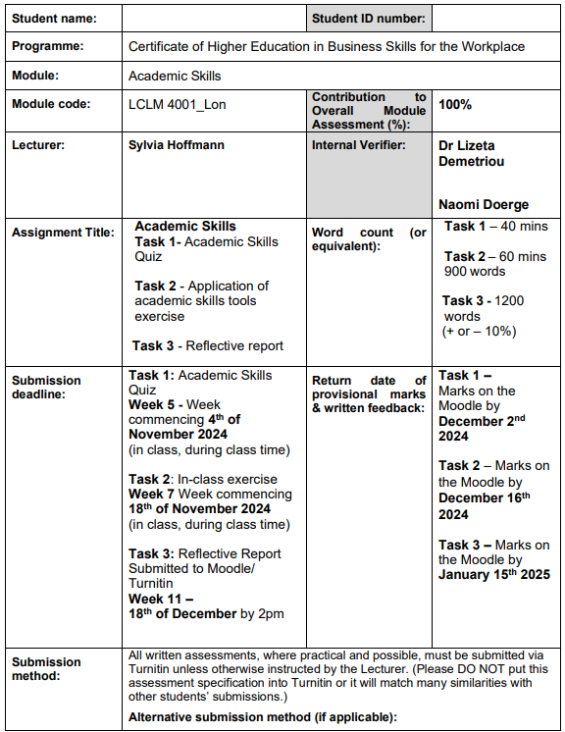
Table of Contents
Introduction 3
Reflective report: Development of academic skills through the help of module learning. 4
Conclusion 9
Reference List 10
Appendices 11
Appendix 1 – Paragraph Writing 11
Appendix 2 – Paraphrasing 12
Appendix 3 – Summarising 13

List of Figures
Figure 1: Gibbs Reflective Cycle 5

Introduction
The reflective report will utilize one of the reflective models for evaluating how the modules learned in the class have been beneficial for developing certain academic skill sets.

Reflective report: Development of academic skills through the help of module learning.
The procedure of academic development is defined to be one of the continuous journeys that mandatorily needs deliberate engagement amongst various activities of learning as well as reflective practises. This report will be incorporating Gibbs's reflective cycle for evaluating and reflecting as to how the activities of the module related to summarising, paragraph writing as well as paraphrasing contributed towards my academic skill set. The Gibbs model involves six stages, namely description, feelings, evaluation, analysis, conclusion, as well as an action plan.

Figure 1: Gibbs Reflective Cycle
Source: Created by Learner
- Description
The module introduced three of the major academic skills, including summarising, paragraph writing as well as paraphrasing. During the session, paraphrasing was taught to be one of the most important skills and it was taught by illustrating its significance in aspect of academic writing (Subandowo and Sárdi, 2023). The emphasis was particularly on demonstrating understanding, clarifying the ideas, and avoiding any plagiarism. Five of the specific techniques were discussed such as utilizing synonyms, altering the forms of the word, changing the order of words, and switching between passive as well as active voice, followed by incorporating positive or negative tones (Verleyen and Beckers, 2023). The mentioned techniques were practiced through various instances, quiz as well, and exercises, which eventually solidified understanding along with its application.
Summarising the activities also included recognizing nature points from the text, involving issues at the workplace involving passive aggression, complexities in communication along the blame game. This particular task required condensing various ideas into defined statements while also retaining their core meaning. Lastly, paragraph writing was particularly explored by dissecting the structure of highly effective paragraphs. We also evaluated certain instances for identified identifying the topic sentences, the supporting details as well as the concluding sentences. The mentioned approach permitted us to practice develop, developing coherent logically structured paragraphs.
- Feelings
In the initial phase, I was very overwhelmed by the technicalities that were involved in the aspect of paraphrasing along summarising. Various techniques seem to be very complex and also need meticulous attention to the slightest of the details. However, the step-by-step instruction along with the practice exercises was beneficial for easing my apprehension. I also began to appreciate the crucial nature of those skill sets in improving the quality along credibility of the academic work.
The summarising tasks, specifically those dealing with the intricate dynamics of the workplace, initially felt very complex due to its dense content. However, as I started progressing, I felt a very strong sense of accomplishment in being capable of distilling, the lengthy text into certain meaningful summaries. Similarly, the paragraph writing exercises also fostered strong confidence as I learned to organize my ideas effectively. By the end of the module, I felt very equipped with all the tools that majorly enhanced my ability in academic writing.
- Evaluation
The design of the module was highly effective in facilitating the development of the skill set. The structured approach towards paraphrasing, which involves theoretical explanation as well as practical application was specifically beneficial and advantageous (Abdel-Reheem Amin and Alammar, 2023). The practice exercises as well as the quiz were quite engaging and also offered prompt feedback that eventually reinforced learning. The incremental introduction of various techniques involving utilizing synonyms and changing the order of the word made the process quite manageable and much less intimidating.
The activities of summarising were insightful, specifically the emphasis on identified major points in highly complex circumstances. This activity was not just beneficial in enhancing my capability for summarising, but also drastically improved my critical reading skill set. The utilization of highly relevant instances, involving communication issues at the workplace, made the tasks very relatable and highly practical.
Paragraph writing was one of the significant areas where the module excelled. Evaluating the instances for understanding the role of various topic sentences, supporting details, as well as conclusions, was an eye-opening practice (Chen and Wang, 2022). It also highlighted the eminent nature of coherence and logical flow in the aspect of academic writing. The potential opportunity for practicing the writing of paragraphs also solidified my understanding.
- Analysis
The activities in this particular module were very instrumental in developing my academic skill set. Paraphrasing is defined to be one of the critical skills for demonstrating immense understanding and preventing plagiarism in the academic landscape (OGUNJIMI, 2022). The techniques that were learned involved the utilization of synonyms and altering the forms of words eventually enhanced my ability to convey ideas in my own set of words. For instance, during one of the practice exercises, I was capable of re-freezing a paragraph regarding the dynamics at the workplace while also preserving its meaning. This particular skill has become very integral to my skill set.
Summarising also required me to recognize and condense key ideas, which improved my capability for processing and synthesizing information. This was specifically evident during the activity regarding the complexities at workplace. A distilled complex set of complexities and issues such as passive aggression along with the blame game in the concise summaries was one of the rewarding exercises that improvised the ability of comprehension and analytics.
Paragraph writing was one of the other areas where the skills improved majorly. The structured approach towards evaluating and writing paragraphs focused on the crucial nature of organization as well as clarity. For instance, deeply understanding the role of a topic sentence in setting the background for a particular paragraph was beneficial for me in writing a more emphasized and coherent piece of content. Similarly, learning to utilize various supportive sentences for elaborating on the significant idea and the concluding sentences for summarising the idea, strengthen my skill of writing.
- Conclusion
The learning activities in this particular module were highly advantageous in developing academic skills. Techniques of paraphrasing enhance my capability for rewriting the content in a specific way that demonstrates immense understanding and also prevents plagiarism. Summarising the activities also improved my skill set of critical reading and information synthesis. Paragraph writing exercises were beneficial for me as they taught me to structure my own set of ideas in a logical and coherent manner which is highly crucial for effective academic writing.
Despite the specified improvements, there is still room for growth. For instance, while I have become highly proficient in utilizing various techniques of paraphrasing, I need to particularly work on applying them in a consistent manner in aspect of longest. Similarly, my skills in summarising can be further refined with the help of practicing with highly complex materials. As for paragraph writing, I emphasize enhancing the depth along with the breadth of my supporting sentences to offer highly substantial arguments.
- Action plan
To continue to develop the specified skill set, I am planning to implement the below-mentioned actions.
- For regular practice, I am aiming to dedicate time each week to practicing summarising, paragraph writing as well as paraphrasing. Utilization of academic texts along with articles will also be one of the factors for ensuring exposure to diversified styles and content of writing (Badilla-Quintana et al., 2020).
- For seeking feedback, I will be sharing my work with friends and instructors for receiving feedback. This step will be beneficial for me in identifying improvement areas so that my skills will be refined.
- I will also be utilizing online resources involving guides on academic writing and tools of paraphrasing for exploring advanced techniques and gaining key insights.
- The skill set that will be learned will be applied in academic assessments to reinforce confidence in learning.

Conclusion
The report concluded by analysing that the modules were beneficial in developing skill sets, including paraphrasing, summarising as well as paragraph writing skillsets.

Reference List
Abdel-Reheem Amin, E. and Alammar, A., (2023). EFL students’ perception of using AI paraphrasing tools in english language research projects. Arab World English Journals, 14(3).
Badilla-Quintana, M.G., Sepulveda-Valenzuela, E. and Salazar Arias, M., (2020). Augmented reality as a sustainable technology to improve academic achievement in students with and without special educational needs. Sustainability, 12(19), p.8116.
Chen, W. and Wang, J., (2022). Understanding source use by undergraduate post-novice EFL writers for the sustainability development of academic literacy: Abilities, challenges, and strategies. Sustainability, 14(4), p.2108.
OGUNJIMI, B.E., (2022) AI Integration in Digital Libraries: A Framework for Promoting Academic Integrity and Originality. AI and Ethics, Academic Integrity and the Future of Quality Assurance in Higher Education.
Subandowo, D. and Sárdi, C., (2023). Academic essay writing in an English medium instruction environment: Indonesian graduate students’ experiences at Hungarian universities. Ampersand, 11, p.100158.
Verleyen, E. and Beckers, K., (2023). European Refugee Crisis or European Migration Crisis? How Words Matter in the News Framing (2015–2020) of Asylum Seekers, Refugees, and Migrants. Journalism and Media, 4(3), pp.727-742.

Appendices

Appendix 1 – Paragraph Writing
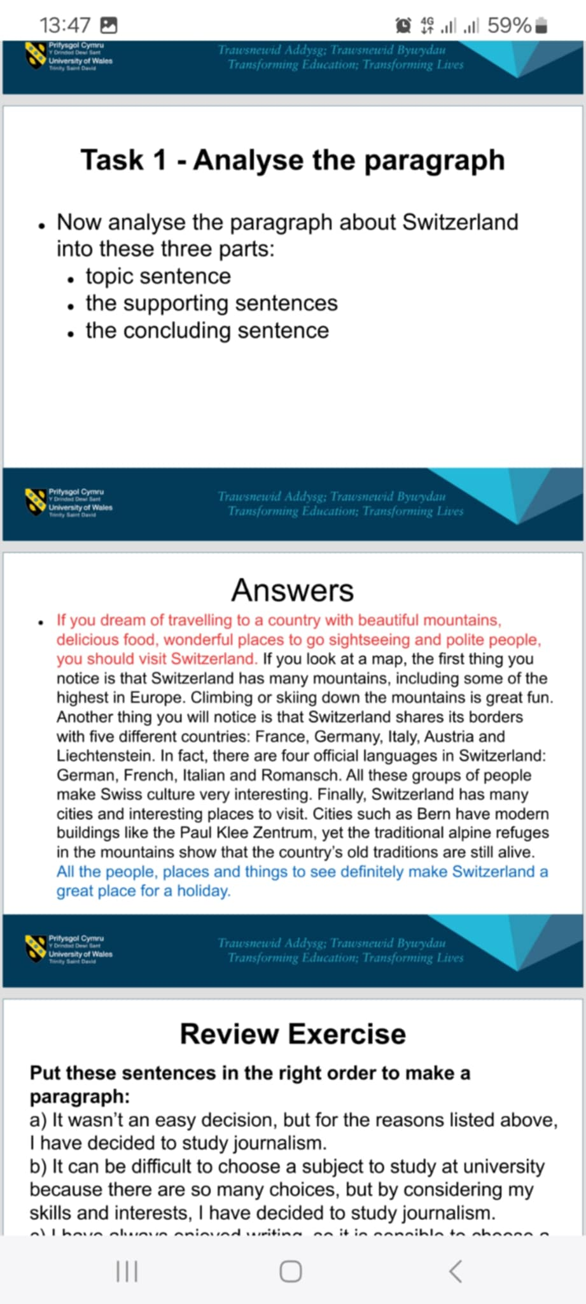

Appendix 2 – Paraphrasing
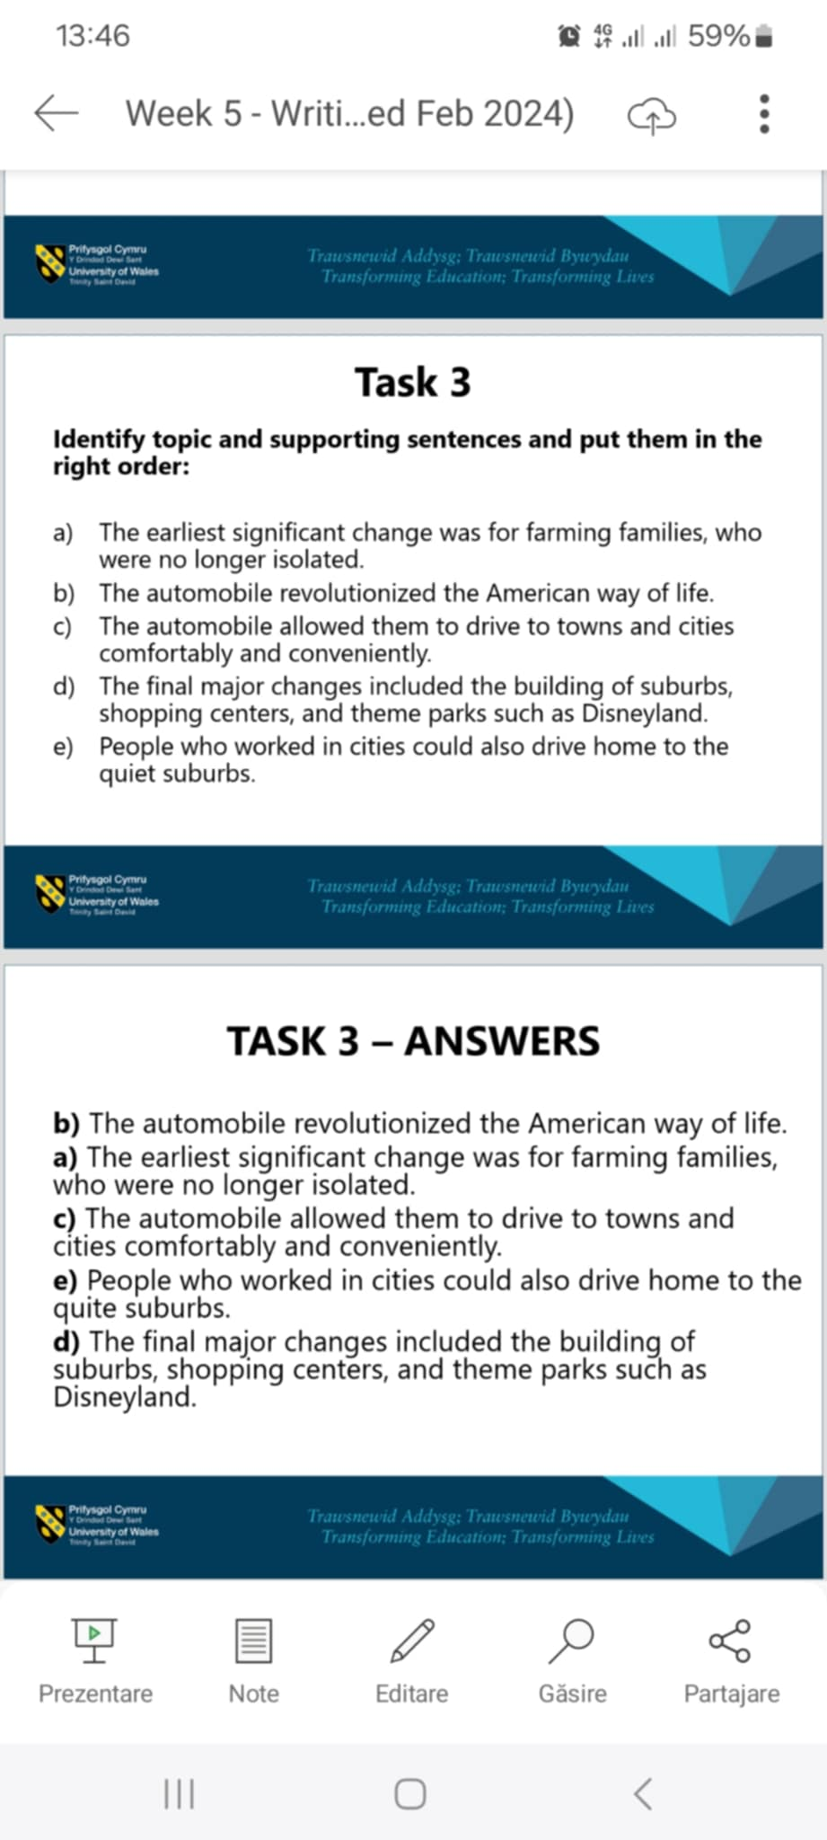

Appendix 3 – Summarising


