MARKETING FUNDAMENTALS
Assignment Component 2
Nour Razvan Vasile
2121444
Lecturer: Efua Adams
LCBB4004

Introduction
According to McKenzie-Jakes, (2021, p. 8), the fundamentals of marketing play an effective role in marketing practice within B2C and B2B. This highlights the marketing fundamentals to be about the description of major marketing principles. They are found to consider the basis of discipline for most common applications specifically in the areas of customer marketing. However, this also involves its core for marketing to revolve across product; promotion; price and place. Channels and approaches are found to get changed but the respective concept revolves around these principles that never change. Nevertheless, some of the models expand the particular principles to 7Ps along with another variation. Hence, the present study highlights the role of marketing with the use of different concepts and theories along with identifying the role of stakeholders within the global marketing environment.

Discussion

Describing the role of Marketing in the creation of values for customers by using adequate theories and frameworks
Role of marketing
As evidenced by Sadchenko and Vorotniuk, (2021), marketing is typically known to be responsible for managing and selecting the vendors and agencies who tend to produce the materials for marketing while providing support. These generally involve print vendors; ad agencies; specialists and PR agencies along with web providers as well. Marketing can be viewed as a set of functions as several activities are traditionally related to the exchange process. For instance, advertising and selling are the only marketing activities; however, for the promotion of a product, marketing requires a broader functional set involving customer service; product development; pricing distribution and packaging as well. Most businesses and organisations are found to assign responsibility for the respective functions of marketing to specific groups of people. The people who make up the department of marketing involve marketing researchers; product and brand managers; pricing specialists; promotion and advertising managers and the personnel of customer service. Hence, these people perform different roles in marketing for different organisations.
Defining and managing the brand
This involves the brand or the organisation; what it stands for and the way the organisation acts. This eventually defines the experiences that the organisation wants its partners and customers to have when they interact with the brand.
Conducting campaign management for the initiatives of marketing
As per the views of Jaenike, (2021), marketing is seen to proactively identify the services and products to focus on over the course of the sales cycle. This includes producing communication and materials which can make the customers aware.
Producing promotional materials and marketing
This denotes that the marketing department creates the materials which describe as well as promote the core services and products. The marketing department needs to keep updated for making the services and products evolve.
Creating content to provide search engine optimisation for the website
The website of an organisation is the main place where the customers find information related to the brand. Hence, the marketing department is responsible for updating the current web content along with ensuring the site comes up quickly when someone is searching for this type of business.
Managing and monitoring social media
The department of marketing needs to contribute to maintaining the pages of social media and also needs to manage the accounts to oversee the online posts.
Producing internal communications
Employees of an organisation need to understand the goals; values and priorities. This allows the marketing department to oversee employee communication through the intranet or newsletter.
Hence, marketing generally aims to meet the needs of humans by creating value. For instance, the marketer is found to choose the services and product features which can deliver value (Business Markets: Definition, Types and Examples, 2022). On the other hand, the marketer also chooses prices which can create value in exchange along with the channels of distribution which can eventually create convenience and accessibility value. This makes marketing to be intrinsically a value-creating discipline.
Different types of marketing functions
Promotion
This is to create awareness about a product with the help of mass communication and encourage the customers to purchase the same. A promotional strategy is responsible for both making and breaking a marketing campaign. Marketers are found to make use of different sets of strategies such as direct outreach; public relations; social media and advertising to let the audience be aware of the new products. The promotion involves content marketing to email and social media as well for building customer awareness. Businesses are known to promote their products in many ways. For instance, the flagship store Nike in London has introduced plus-size mannequins in a marketing campaign for its plus-size line and bespoke personalisation services by celebrating inclusivity and diversity of sports.
Product and service management
This function needs developing; designing and modifying a service or a product to meet the ever-changing needs of the customers. This function includes customer engagement for getting their feedback along with overseeing the changing perceptions of the customers to keep pace with the evolving market (The Role of a Marketing Department in a Business | The Hartford, 2022). Accordingly, these findings help the marketing department to redesign a product while creating new versions for suiting the needs of the customers and discover new opportunities for growth in the competitive market. For example, Coca Cola organisation has experimented with different flavours and also made the Coke flavour close to the original which is loved by people. Nevertheless, its other branding aspects are seen to evolve with time such as changing its contoured bottles over the years.
Management of marketing information
This function is about collecting customer data along with using it to improve other functions of marketing while facilitating critical business discussions. Before launching a product, marketers try to understand the interests and requirements of the customers to fulfil their expectations. This information is obtained through surveys; customer feedback and specifically with the help of social media. This information also helps to create an on-point promotional campaign which hits the mark while bringing returns on investment (ROI). This also deals with competitor research and also follows the trends of the market. For instance, J.Crew organisation is known to collect the zip codes of the customers with every purchase. This helps the marketers to understand the distribution of their customers- where their loyal customers are settled and which regions need most of the attention. This helps the organisation to have an insight into the best locations for opening a new outlet.
Financing
This function involves gaining the required capital to scale the business while deciding about the ways to invest money for maximum ROI. effective management of marketing is known to affect an organisation in many ways (marketing - Roles of marketing, 2022). This includes budgeting for the marketing campaigns. Financial restraints are seen to impact the decisions of marketing involving the marketing channels that can be used by the organisation. Hence, the marketing department in this case is responsible to inform decisions about offering discounts; providing free products and the application of price cuts as well. For example, Bodyform was seen to create a campaign called Womb Stories in 2020 for highlighting unspoken menstrual issues. This advertisement turned out to be a huge success for the customers and reinforced the image of the organisation increasing the traffic source for their website.
Theories and frameworks related to Marketing
Maslow’s Hierarchy of needs
According to Dwivedi, (2021, p. 2450), this theory comprises five stages such as; biological; love and belongingness; safety; esteem and self-actualisation. According to this theory, humans should satisfy their basic needs of survival before considering the higher level of needs. Based on social media marketing, this theory defines the need to understand the hierarchical level of the customers to be likely while they are interacting with a particular brand. The needs that are looked for by people to meet with the usage of social media can be different based on the platform and the organisation needs to tailor the content accordingly. For instance, most people use platforms such as Instagram and Facebook to connect with family and friends fulfilling their needs for belongingness. On the other hand, as evidenced by Xiang, (2021, p. 2779), LinkedIn is used by people for finding jobs along with building their professional networks and checking new solutions for work-related concerns. This can also fit anything from safety to self-actualisation where one can achieve a dream. Hence, organisations need to decide on which one can apply to the target audience for each of the platforms and need to plan the content which can reflect the same.
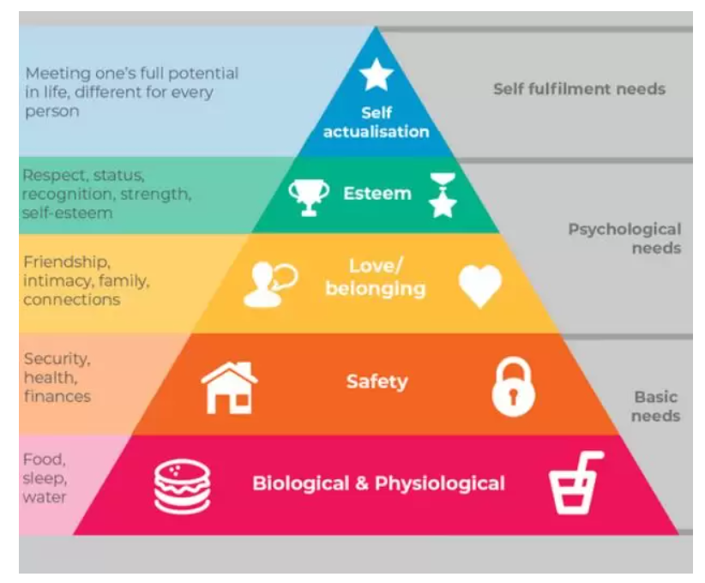
Figure 1: Maslow’s Hierarchy of Needs
Source: (Maslow Hierarchy of Needs Theory for Marketers - Super Heuristics, Super Heuristics. 2022)
Expectancy disconfirmation theory
This theory is popularly used in service marketing to measure customer satisfaction and is introduced by Richard L. Oliver in 1977. According to Lee et al., (2022, p. 20), this defines an individual's expectations to be confirmed when a product is seen to perform as expected. On the other hand, the expectations are negatively disconfirmed when the product is seen to perform more poorly than expected; however, positive disconfirmation arises when the product performs better than expected. Thus, this theory has been applied in different fields to understand customer requirements and expectations in a better way that involves customer behaviour and marketing; psychology; tourism; airline industry and information technology. This theory highlights four primary variables such as perceived performance; expectations; satisfaction and disconfirmation of beliefs.
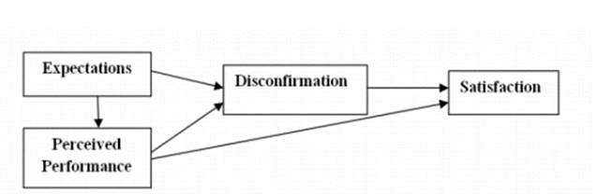
Figure 2: Expectancy Disconfirmation Model
Source: (Wiley Online Library. 2022)
Expectations: The basis for expectations of a product; brand and service is considered feedback through family and friends; marketing material; online reviews and previous experiences. This involves the customers who have an expectation based on their previous experience and the new customers who are known to have first-hand experience.
Perceived performance: After the consumption of the products; customers are known to form perceptions about its performance and these are influenced by their pre-purchase expectations along with affecting the disconfirmation judgement. These perceived performances are also responsible for influencing customer satisfaction indirectly.
Disconfirmation: As stated by Chen et al., (2022), this highlights the evaluations and judgements made by the customers based on the experience; product and service. These are made by the customers in comparison with their original expectations. When the product outperforms their expectations, the disconfirmation is positive and on the contrary, when the product underperforms, the disconfirmation is negative. Hence, it decreases and increases the post-purchase satisfaction of the customers.
Satisfaction: This is the post-purchase satisfaction that shows the extent of being pleased; content or unhappiness of a person after the consumption. Customer disconfirmation regarding the perceived performance of a product directly influences their satisfaction. Hence, their performance expectation is known to influence the respective process.

Identifying the role of stakeholders in the global marketing environment along with the impact on the marketing activities of a company
Within a business context, as opined by Kotabe and Helsen (2020), the Global Marketing Environment is defined to be the forces and factors outside or inside of a business organisation that affects its strategies of marketing in building and maintaining successful relationships with its targeted customers. It allows the companies to sell more products, attracting more customers along with enlarging their market share within different nations with increasing the brand influence and reputation giving them a powerful competitive edge. Thus, within the marketing division of a company, Stakeholder comprises the primary role in helping the company to meet its strategic objective by contributing their experience and knowledge within the marketing or any other project undertaken. Hence, the role of stakeholders within the marketing environment is mentioned below,
Role of stakeholders in the international marketing environment
As stated by Olha, (2022, p. 333), Stakeholders are considered to be that group of people who have stakes and claims within an organisation and are specifically the ones who are indirectly or directly affected by the operations of the business. Hence, within the global context of marketing, the Stakeholder Marketing theory is considered to sensitise global marketers to look beyond the consumer as the significant stakeholder. Thus, such theory argues that marketing must pay attention not only to the customers but to the other stakeholders such as the government, trade unions, suppliers and NGOs, and whosoever is related to a business organisation. Stakeholder Marketing clearly defines the activities happening within a system id social princess and institution that facilitates and maintains the values through exchanges of relationship with multiple stakeholders. Eventually, stakeholders within the international marketing environment mainly focus on co-creating network relationships instead of the dyadic relationship along with acknowledging the perspective of indirectly creating value (Tien et al., 2019, p. 136). Moreover, the stakeholders recognise the customer relationship through the stakeholder marketing theory that might be impacted by the relationship with the other stakeholder along with the diverse stakeholder networks creating the value.
As argued by Pensap and Mekhum, (2020, p. 47), many a time it has been observed that the marketing concept is created to reach only one group of individuals, that is the customers who are considered to be the primary stakeholders, however, in reality, the global business environment is thoroughly supported with the compound web communities as well as different stakeholder groups. The different stakeholder groups have distinctive relationships with the brand as well as with each other which helps the company to connect with the audience authentically. Thus, the approach of stakeholder marketing is now getting introduced to the business companies that are used for engaging and understanding with all the communities supporting the business, assessing the respective needs of the stakeholders along with understanding their relationship with the brand. Hence, within the global context of marketing, such a theory helps in recognising the values of marketing within a company along with minimising the collective harm. Therefore, as opposed to Tretyak et al., (2019, p. 06053), in return this helps in strengthening the relationship with the communities falling under the global marketing environment that leads to the sustenance of relationship and finally success.
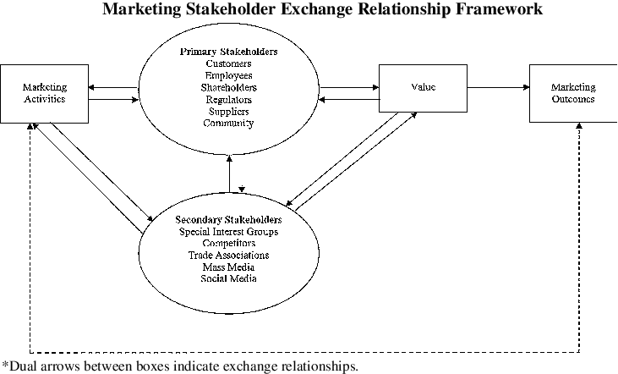
Figure 1: Stakeholder Marketing exchanging the relationship framework
Source: (AMS-Rev_fig1_226037473. 2022)
Eventually, the stakeholders within the international marketing environment mainly practise engaging the communities and recognise their needs, interstate and values regarding the product or services that the business companies are going to launch or have launched in the marketplace. The companies falling under the international marketing environment, are now making no mistakes in engaging the stakeholder marketing theory through mapping their stakeholders, codifying the values of the community along with establishing the valued role within the communities. Thus, as witnessed by Elg and Ghauri, (2021, p. 67), there are three significant transitions that occur involving the interrelationship of the stakeholder within the global marketing environment such are as follows,
Transition 1
The transition from the centralised towards the dispersed control of the brand messaging
Transition 2
The transition from the implicit towards the explicit stakeholder tension wherein the conflicting interest could no longer be ignored as the stakeholder could now easily recognise themselves along make themselves get heard.
Transition 3
The transition that is occurring from the two-people exchange towards the complex exchanges.
Therefore, the above-mentioned transitions encompass one important idea that the marketing relationship does not occur among the brand and one homogeneous personality group or being the one-to-one relationship, rather they occur within the emerging systems of conversations. Therefore, as viewed by Line et al., (2019, p. 50), the stakeholder's theory within the marketing environment mainly focuses on building relationships with the customers, suppliers, employees, shareholders, local communities and government, which helps the business companies on segmenting the customer base and targeting the markets effortlessly after knowing the needs and wants of every stakeholder.
Consequently, to thrive in the complex marketing and business environment, the stakeholders within an organisation help in developing the new capabilities that are the community and system thinking which helps in the ability for understanding the values stream of the business along with the ecosystem. The stakeholders by posing their views, needs, wants, and feedback helps the marketers within the global marketing context to gain information regarding who is influencing whom and the way they are influencing along with who is depending on who along and the reason for their dependence. Thus, only through this, the marketer would be successful in deploying meaningful marketing strategies for companies to attract profitability and business growth.
Impact of the stakeholders on the marketing activities of an organisation
There are 6 kinds of stakeholders who are present within a company and thus, handle the marketing atmosphere as their support becomes crucial for any project undertaken in an organisation such are as follows,
Customers
As stated by Alvarez-Milán et al., (2018, p. 65), customers are considered to be the prime stakeholder within an organisation, as they consist of an entity that is directly linked with the business and its financial success. Within the global business context, customers are considered to be the significant stakeholder as their purchase and buying decisions allow the organisations to continue conducting their business. Thus, within the marketing environment of a company, messages and strategies are made to impress the customers for a successful campaign of any product or service. The offerings are created as per the customer needs which helps the companies to sell them. Thus, the company's marketing environment benefits directly from the customer patronage and tries to serve them as per their requirements which leads to companies gaining profit and business growth.
Employees
The employees in a company are the key stakeholders as they create services and goods issued by the organisation and the quality of their work creates a direct influence upon customer support. Hence, as evidenced by Nart et al., (2019, p. 56), the employees create an atmosphere of confidence, trust and loyalty among the customer by sharing the positive content of the business boost up the business marketing in several ways. Within the marketing environment of an organisation, the employees help in reaching the marketing content that helps in increasing the values of the brand and its product or services in the eyes of the customers along with improving the employer's brand. Moreover, it has also been observed that the customers view the employees as the people who know the truth of the business and are honest about the services and products, thus, the views, contents and feedback shared by the employees are witnessed to be reliable marketing information.
Government
The government of the country where a company is situated is considered to be the secondary or indirectly linked stakeholder of the company. The main responsibility held by the government is the collection of taxes from the workers and organisations in the form of corporate or income tax (Hafezi and Zolfagharinia, 2018, p. 400). Thus, the government provides advisory, financial and other services to the business along with the creation and enforcement of consumer protection, the safety of the workers and similar laws. Eventually, once a company gets marketed as having a good relationship with the government of the country, then the customer and other stakeholders get attracted to making a loyal bond with the company along with making their marketing campaigns successful, leading to higher productivity and profits.
Shareholders and investors
The stockholders, shareholders and investors are considered to be the primary stakeholder of the company who keeps the organisation financially viable. These stakeholders help the companies with finance and provide funds for making their project possible whether it be in the marketing or promotional segment. Moreover, they could also directly impact the outlook of a company when they are dissatisfied with their marketing plans and campaigns along with providing direction to get it corrected.
Local communities
As opined by Kaur et al., (2020, p. 101321), the local communities are considered to be the secondary stakeholder of the company as they benefit from the economic investment through job creation. Thus, they help in building brand reputation along with setting up the brands for resilient growth within the long term. Thus, communities help in creating a strong sense of empathy towards the customers and other stakeholders by creating powerful marketing traditions and communication that solidifies the relationship.
Vendors and suppliers
Though vendors and suppliers exist outside the company, they are still referred to as the primary stakeholders as they along with the organisation sell benefits directly from the revenue generated from the services and its sales. Thus, within the marketing division of the company, they mainly contribute the materials, resources and in several cases, their expertise that helps in improving the ability of the company to innovate their marketing strategies that serves the customer needs and wants, making them attractive towards the brands and its products.

Conclusion
To conclude, the present study focuses on the topic of Marketing Fundamentals with emphasis on the international marketing environment under which companies are operating. Eventually, the present study describes the role of marketing in creating customer value by using adequate frameworks and theories like Maslow's Hierarchy of Needs and Expectancy disconfirmation theory. Moreover, the identification of the role of stakeholders in the international marketing environment along with its impact on the marketing activities of the companies is also thoroughly mentioned by highlighting the Stakeholder Marketing Theory.

References
Alvarez-Milán, A., Felix, R., Rauschnabel, P.A. and Hinsch, C., 2018. Strategic customer engagement marketing: A decision-making framework. Journal of Business Research, 92, pp.61-70. https://www.sciencedirect.com/science/article/abs/pii/S0148296318303308
Business Markets: Definition, Types and Examples (2022). Available at: https://www.indeed.com/career-advice/career-development/business-market (Accessed: 15 July 2022).
Chen, W., Dong, B., Hsieh, C.W., Lee, M.J., Liu, N., Walker, R.M., Wang, Y., Wen, B., Wen, W., Wu, P. and Wu, X., 2022. A Replication of “An Experimental Test of the Expectancy‐Disconfirmation Theory of Citizen Satisfaction”. Public Administration. https://www.researchgate.net/profile/Binzizi-Dong-2/publication/360542577_A_Replication_of_An_Experimental_Test_of_the_Expectancy-Disconfirmation_Theory_of_Citizen_Satisfaction/links/629459106886635d5cae7a5c/A-Replication-of-An-Experimental-Test-of-the-Expectancy-Disconfirmation-Theory-of-Citizen-Satisfaction.pdf
Dwivedi, P., 2021. Maslow Theory Revisited-Covid-19-Lockdown Impact on Consumer Behaviour. Turkish Journal of Computer and Mathematics Education (TURCOMAT), 12(2), pp.2445-2450. https://turcomat.org/index.php/turkbilmat/article/view/2072
Elg, U. and Ghauri, P.N., 2021. A global marketing logic: local stakeholders’ influence in diverse emerging markets. International Marketing Review, pp.45-78. https://www.emerald.com/insight/content/doi/10.1108/IMR-08-2020-0186/full/html
Hafezi, M. and Zolfagharinia, H., 2018. Green product development and environmental performance: Investigating the role of government regulations. International Journal of Production Economics, 204, pp.395-410. https://www.sciencedirect.com/science/article/abs/pii/S092552731830330X
https://www.researchgate.net/figure/Marketing-stakeholder-exchange-relationship-frame-work-AMS-Rev_fig1_226037473. 2022. Marketing stakeholder exchange relationship framework. [online] Available at: <https://www.researchgate.net/figure/Marketing-stakeholder-exchange-relationship-frame-work-AMS-Rev_fig1_226037473> [Accessed 15 July 2022].
Jaenike, K. (2021) The 7 Functions of Marketing Explained with Examples - Wild Idea, Wild Idea. Available at: https://getwildidea.com/functions-of-marketing-explained-with-examples/ (Accessed: 15 July 2022).
Kaur, H., Paruthi, M., Islam, J. and Hollebeek, L.D., 2020. The role of brand community identification and reward on consumer brand engagement and brand loyalty in virtual brand communities. Telematics and Informatics, 46, p.101321. https://www.sciencedirect.com/science/article/abs/pii/S0736585319308135
Kotabe, M.M. and Helsen, K., 2020. Global marketing management. John Wiley & Sons. https://books.google.co.in/books?hl=en&lr=&id=iDLDDwAAQBAJ&oi=fnd&pg=PA1&dq=global+marketing+environment&ots=XJEmZrj1M1&sig=H_WdBoM1fOO94-8TTq_qtedolRw&redir_esc=y#v=onepage&q=global%20marketing%20environment&f=false
Lee, C.P., Hung, M.J. and Chen, D.Y., 2022. Factors affecting citizen satisfaction: Examining from the perspective of the expectancy disconfirmation theory and individual differences. Asian Journal of Political Science, pp.1-26. https://www.tandfonline.com/doi/abs/10.1080/02185377.2022.2047081
Line, N.D., Runyan, R.C. and Gonzalez-Padron, T., 2019. Multiple stakeholder market orientation: a service-dominant logic perspective of the market orientation paradigm. AMS Review, 9(1), pp.42-60. https://link.springer.com/article/10.1007/s13162-018-0125-z
marketing - Roles of marketing (2022). Available at: https://www.britannica.com/topic/marketing/Roles-of-marketing (Accessed: 15 July 2022).
McKenzie-Jakes, A., 2021. Some Fundamentals of Marketing Meat Goats. Professional Agricultural Workers Journal (PAWJ), 6(174-2022-304), pp.1-8. https://ageconsearch.umn.edu/record/319685/
Nart, S., Sututemiz, N., Nart, S. and Karatepe, O.M., 2019. Internal marketing practices, genuine emotions and their effects on hotel employees' customer-oriented behaviours. Journal of Human Resources in Hospitality & Tourism, 18(1), pp.47-70. https://www.tandfonline.com/doi/abs/10.1080/15332845.2019.1526509
Olha, P., 2022. THE INTERNATIONAL MARKETING ENVIRONMENT. In The science of the XXI century: challenges of the contemporaneity [Еlectronic edition]: proceedings of the all-Ukrainian scientific and practical student conference (Kyiv, May 12, 2022)–Kyiv: State University of Trade and Economics, 2022.–406p.–English, German, Czech. (p. 333). https://knute.edu.ua/file/MzEyMQ==/fa2e48a17d17b2b75034aee0500996e6.pdf#page=333
Pandey, K. (2021) Maslow Hierarchy of Needs Theory for Marketers - Super Heuristics, Super Heuristics. Available at: https://www.superheuristics.com/maslow-hierarchy-of-needs-theory-for-marketers/ (Accessed: 15 July 2022).
Pensap, S. and Mekhum, W., 2020. Role of Demographic Factors and Stakeholders in Determining the Marketing Strategies of Pharmaceutical Companies in Thailand. Systematic Reviews in Pharmacy, 11(4), pp.45-51. https://www.sysrevpharm.org/articles/role-of-demographic-factors-and-stakeholders-in-determining-the-marketing-strategies-of-pharmaceutical-companies-in-thai.pdf
Sadchenko, O.V. and Vorotniuk, Y.S., 2021. Fundamentals of marketing in ecological and innovative development of experience economy. http://dspace.onu.edu.ua:8080/handle/123456789/32124
The Role of a Marketing Department in a Business | The Hartford (2022). Available at: https://www.thehartford.com/business-insurance/strategy/creating-marketing-department/role (Accessed: 15 July 2022).
Tien, N.H., Phu, P.P. and Chi, D.T.P., 2019. The role of international marketing in international business strategy. International journal of research in marketing management and sales, 1(2), pp.134-138. https://www.researchgate.net/profile/Nguyen-Tien-32/publication/338752307_The_role_of_international_marketing_in_international_business_strategy/links/6240510457084c718b6d9af9/The-role-of-international-marketing-in-international-business-strategy.pdf
Tretyak, V.P., Rekun, G.P., Andreieva, K.O. and Bieliai, M.S., 2019. The role of stakeholders’ interests management mechanism in the transport services market development. In SHS Web of Conferences (Vol. 67, p. 06053). EDP Sciences. https://www.shs-conferences.org/articles/shsconf/abs/2019/08/shsconf_NTI-UkrSURT2019_06053/shsconf_NTI-UkrSURT2019_06053.html
Wiley Online Library. 2022. The Expectancy-Disconfirmation Model and Citizen Satisfaction with Public Services: A Meta-analysis and an Agenda for Best Practice. Available at: <https://onlinelibrary.wiley.com/doi/full/10.1111/puar.13368#:~:text=The%20expectancy%2Ddisconfirmation%20model%20has,meets%20or%20exceeds%20the%20expectations.> [Accessed 15 July 2022].
Xiang, X., 2021. Factors That Influence Consumers’ Behaviors in Fashion Market. Open journal of business and management, 9(6), pp.2772-2779. https://www.scirp.org/journal/paperinformation.aspx?paperid=112946

