

School of Applied Computing

Student Name: | Peter Davies |  | Student P number: | P079868
Programme: | BSc Web Development
Module: | Web Development | Lecturer: |  | Kemi Ademoye
Assignment Title: | ASP.NET Web Development
Hand Out Date: | February 2018 |  | Submission deadline: | 07/05/2018



Disclosure: | I declare that this assignment is all my own work and that I have acknowledged all materials used from the published or unpublished works of other people. All references have been duly cited.
Student’s Signature: |  | Date: | 24/04/18

Contents

- Introduction……………………………………………………………………………………………………………1

- Implementation……………………………………………………………………………………………………..2

  - Description of Web Application ………………………………………………………………………2
  - Functional & Non-Functional Requirements………………………………………………..….3
  - MoSCow Ranked Requirements of Application……………………………………………….5
  - Entity Relationship Diagram……………………………………………………………………………6
  - Screenshots………………………………………………………………………………………………….…7

- Evaluation…………………………………………………………………………………………………………….15

  - Requirements Implemented…………….…………………………………………………………….15
  - Testing……………………………………………………………………………………………………………16
  - Updated Entity Relationship Diagram…………………………………………………………....18
  - Design, Functionality, Information & Reflection……………………………………………..20

- References……………………………………………………………………………………………………………21

- Bibliography…………………………………………………………………………………………………………22

Introduction

The following report documents the task assigned for the second half of the Web Development module (M5X01058). The task specified requires the creation of a ASP.NET Core web application which integrates an SQL Server Express, 3NF normalised database.

The chosen subject matter for the application was that of worldwide, German car manufacturer Volkswagen. Firstly the report documents the implementation of the web application, considering the requirements using the MoSCow analysis method. An entity relationship diagram is provided to illustrate the structure of the database and their relationships, finally screenshots of the finished application are provided.

The evaluation section provides documentation on the features which have been implemented into the system and testing of these features. An updated MoSCow table is provided to show any requirements proposed which have or have not been implemented. In addition, a new ERD is given to demonstrate an improved database structure. Finally, the web site and application’s design, functionality and information are discussed, inclusive of evaluation.

User & Admin Account Details

Admin

e-mail: admin@volkswagen.co.uk
Password: Main_admin1

User

e-mail: pndavies@icloud.com
Password: 1Volkswagen_

Implementation

2.1 Description of Web Application

The web application produced is based on major vehicle manufacturer, Volkswagen. Its purpose is to serve one the many local franchises trading under the brand’s name, in the case of the produced, the Swansea franchise.

The application’s purpose is to allow customers to register their personal details, along with their VW vehicles, with the main purpose of booking their vehicles in with the VW technicians at the site to maintain or carry out mechanical work. Registered users can create, read, update and delete their personal details, their vehicle details and their bookings. Users can also find information of current staff members, who will be serving them, and the site also includes links to inform about the history of the location of the business. In addition, a protected administrator’s view is provided to allow an admin to perform similar CRUD [1] operations on data relating to staff members and all registered users data.

The system is aimed primarily at Volkswagen owners older than the legal driving limit. However, as Volkswagen Is part of a larger conglomerate, VAG, who produce vehicles under the names of Audi, Skoda, Seat, Porsche, Bentley, Lamborghini, Bugatti, Ducati, MAN & Scania [2] the system could be extended in the future to target and meet the requirements of these customers.

For customer of Volkswagen, the system holds relevance as it will enable them to book their vehicles in 24 hours a day, 7 days a week, with a technician they know and trust. This in turn may elevate some of the worries customers may have when something mechanically fails with their vehicle. The proposed system will also allow users to book in at convenient times, displaying all available drop off dates, further eliminating the stress and time taken when speaking to garages, and eliminating the usual 9 – 5 hours. The web application also offers a ‘members area’ which further enforces the brands ‘club’ like image.

2.2 Functional & Non- Functional Requirements

To begin identifying the requirements of the proposed Volkswagen Garage web application, firstly, the functional & non-functional requirements will be identified.

Functional requirements are those that the system should do, they also define what the system should do, they are declarations of services of which the proposed system should deliver and how the system should react and behave [3], [4].

Non-functional requirements specify how the system should behave, or how it performs a certain function and limitations of the systems functionality, which in turn will guide the development of the system [3]–[5].

Functional Requirements

- Web application must allow users to register for a personal account to use application’s services. *

- Application will contain form validation in terms of password login system and checking of fields in forms. *

- System should automatically send confirmation email when a new account is opened. *

- Application must allow users to view profiles on staff from Swansea branch. *

- System should email a confirmation when a booking is made. *

- Customer should be able to book vehicles in for specifically described jobs and MOT’s. *

- Customers should be able to book test drives. *

- Customers should be able to book meetings with sales personnel. *

- Customers can use services provided by application to book appointments at any one of the Volkswagen dealerships in the network. *

- Customers can use system to remind them of MOT and Service due dates. *

- Customers should be able to add more than one vehicle to their virtual ‘garage’. *

- Application should display service, MOT and complete job history of every vehicle they have registered. *

- Application will allow users to edit, update, delete and add records (crud operations) (delete vehicles, edit their vehicle or personal details, add vehicles to their garage). *

- System should allow users to browse online manuals. *

- System should allow tracking of owners new car orders from factory to the showroom. *

Non-Functional Requirements

- Web application must load quickly. *

- Application must adhere to W3C[6] web standards. *

- System must be able to allow CRUD operations simultaneously to multiple users. *

- Front-end design must be aesthetically pleasing and represent Volkswagen Brand. *

- Application must be easy to navigate. *

- Customers must be able to specify which mechanic works on their vehicle when booking. *

- Customers must be able to specify which sales person they wish to book a test/drive and or sales meeting. *

- System must confirm an appointment of a sales meeting/test drive/technician booking with details of booking and image of chosen staff member. *

- System should remind customers of MOT & Service dates via Confirmation e-mail to either customer or staff member to contact customer by phone, or an SMS message direct to customer. *

- Must work across different platforms. E.g. Desktop & Mobile Devices, Different operating systems and different web browsers. *

2.3 MoSCow Ranked Requirements of Application

MoSCow criteria is a process of prioritising functionality proposed for a system by splitting up the functions recognised into four different areas, ‘Must have, Should have, Could have & Wont have’. All requirements recognised are important to the application being developed, however, it is important to deliver the most immediate system benefits first, meaning the system will be developed to deliver the ‘Must have, Should have & Could have’ requirements foremost, however, should the project timescale be strained, the ‘Should have & Could have’ will be the first to be removed from requirements [7].

In table 1 below it is possible to see the functional and non-functional requirements stated in section 2.2, ranked using the MoSCow criteria.

KEY | MUST HAVE | SHOULD HAVE | COULD HAVE | WONT HAVE

REQUIREMENT | MUST | SHOULD | COULD | WONT
1
2
3
4
5
6
7
8
9
10
11
12
13
14
15
16
17
18
19
20
21
22
23
24
25

Table 1. Showing MoSCow ranked requirements.

2.4 Entity Relationship Diagram

In fig.1, the initial database design is laid out in an entity relationship diagram.

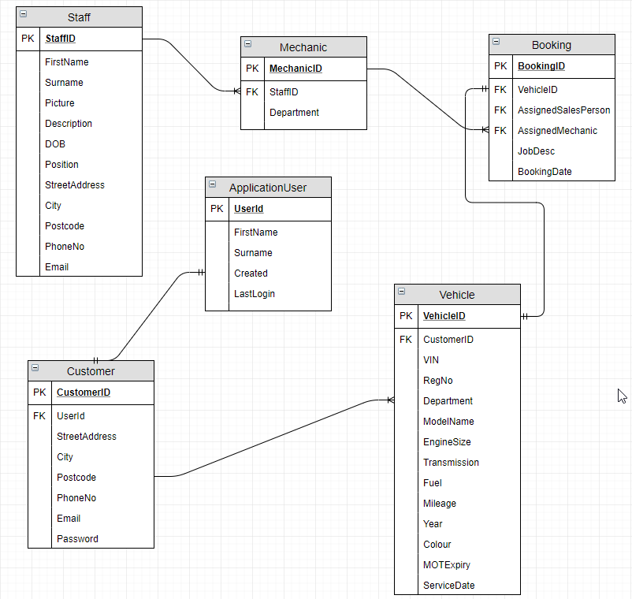

Fig.1 Initial Entity Relationship Diagram

2.5 Screenshots of Web Application

Home Page




About Page

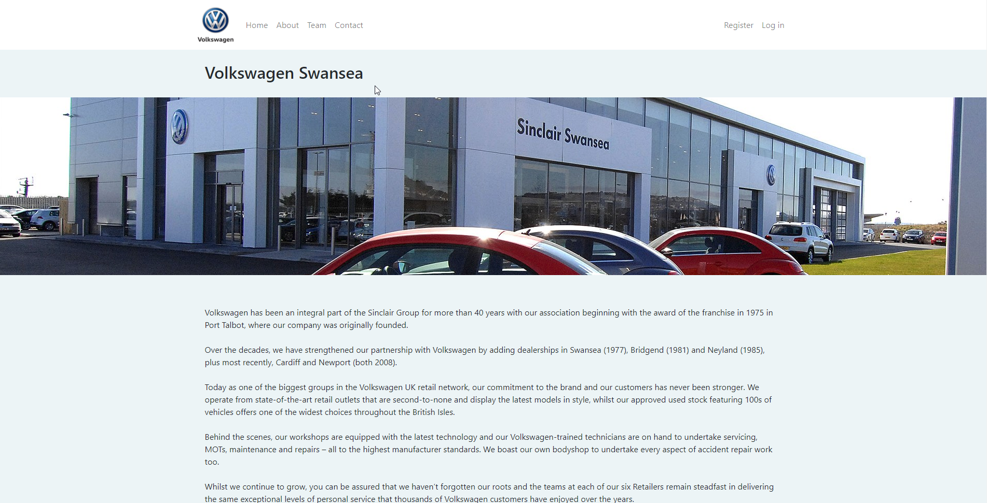

Staff Team Page

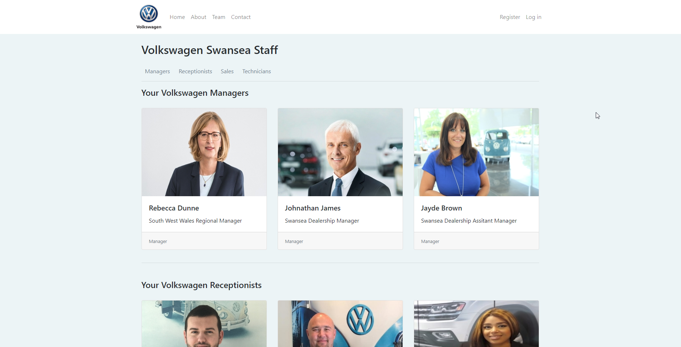
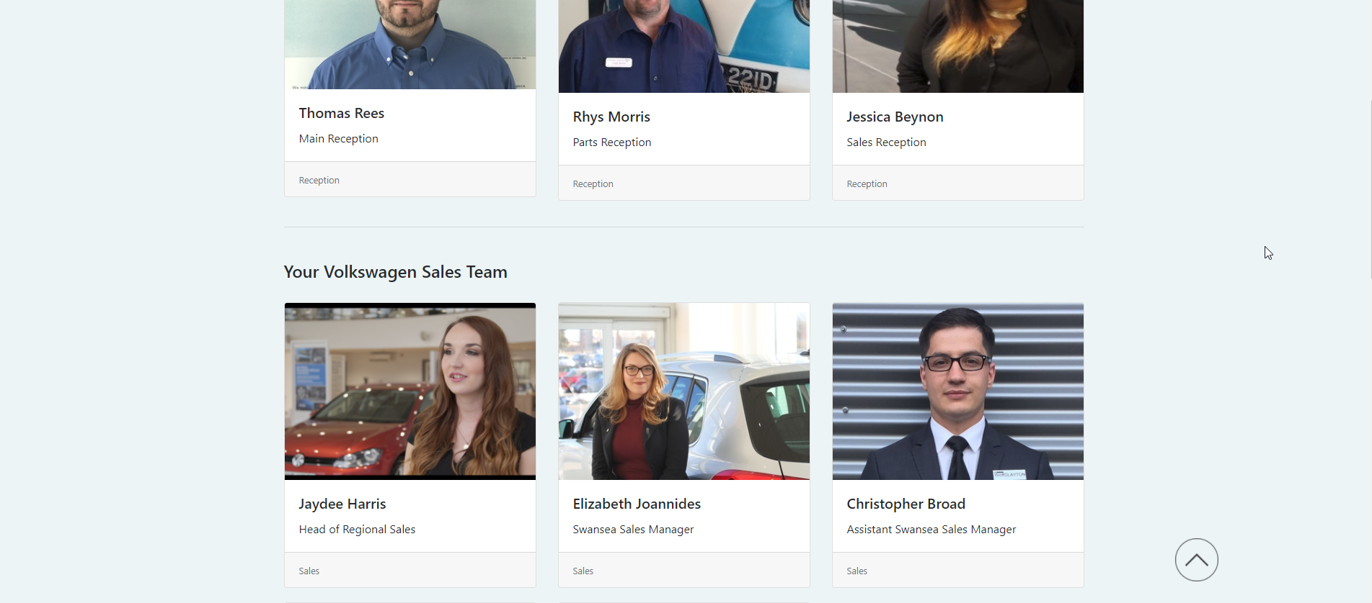


Staff Details

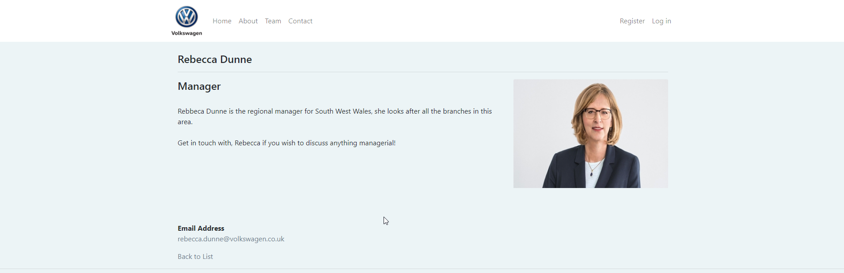

Contact Page

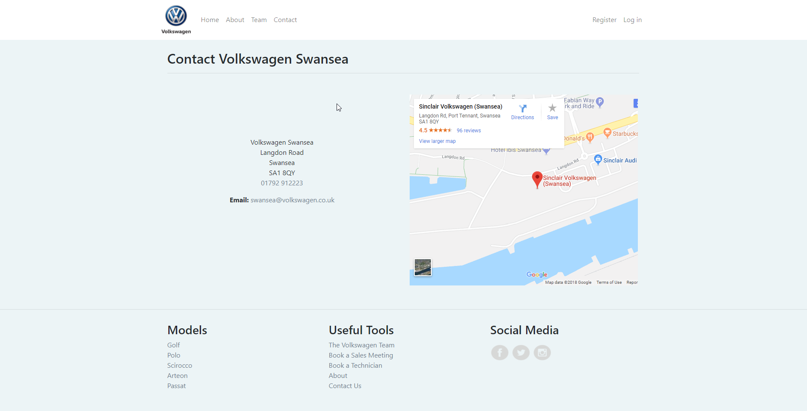

Register

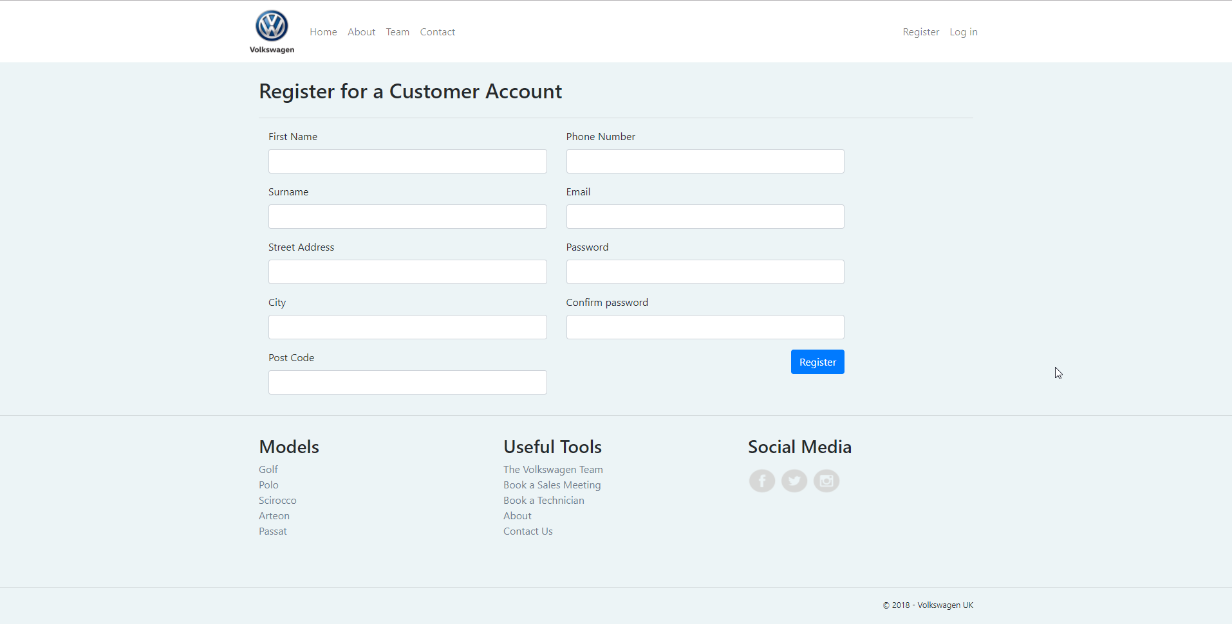
Log In

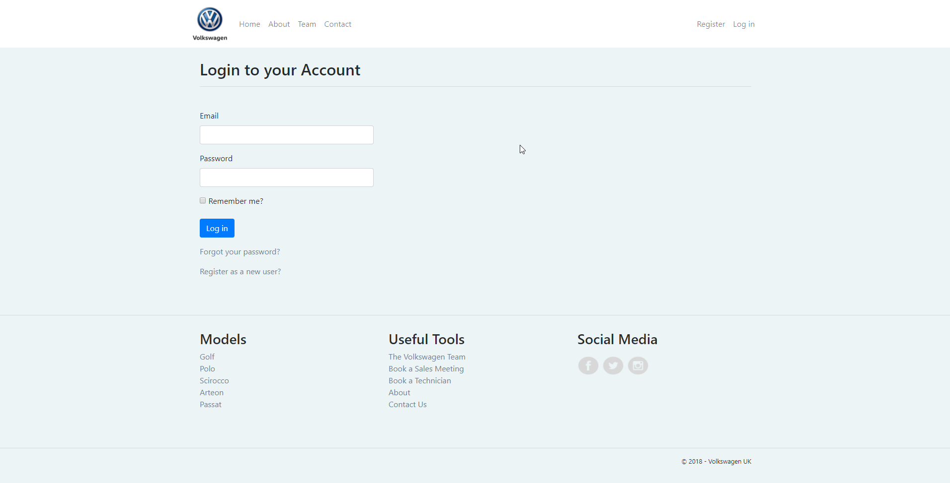

Customer Landing Page

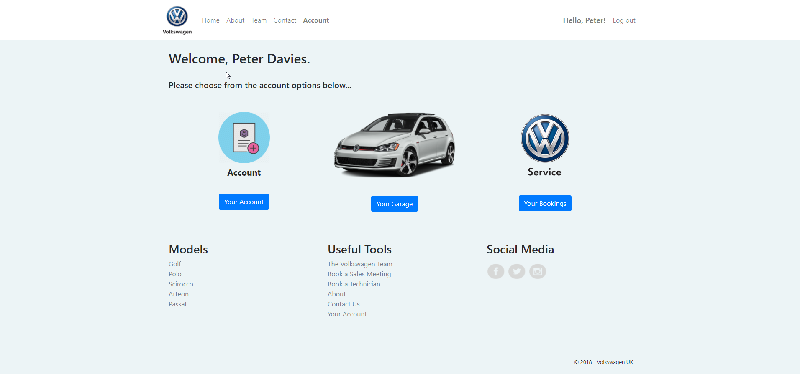

Manage Account

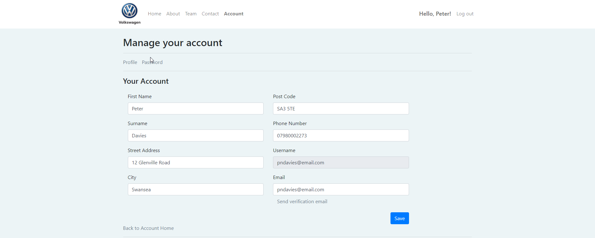
Manage Garage

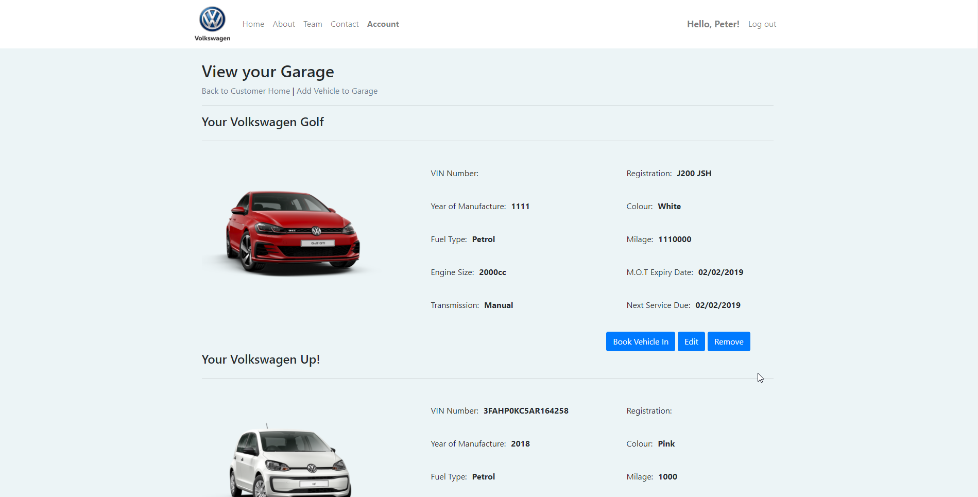

Edit Vehicle

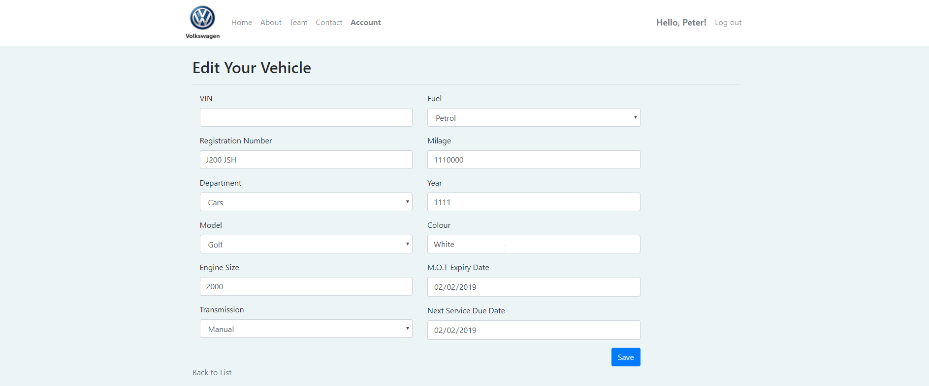

Remove Vehicle

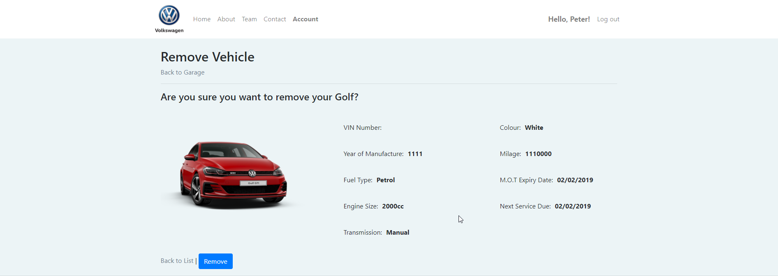

Bookings Page

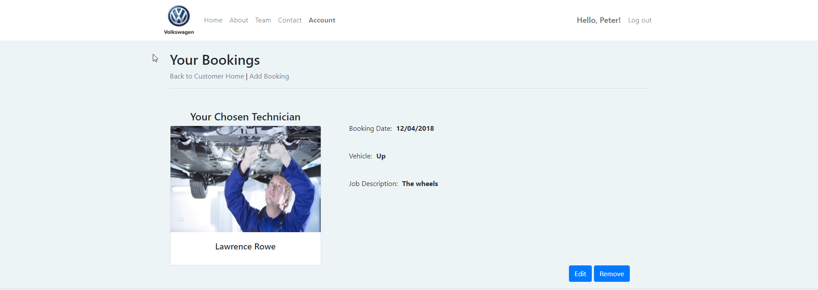

Edit Booking

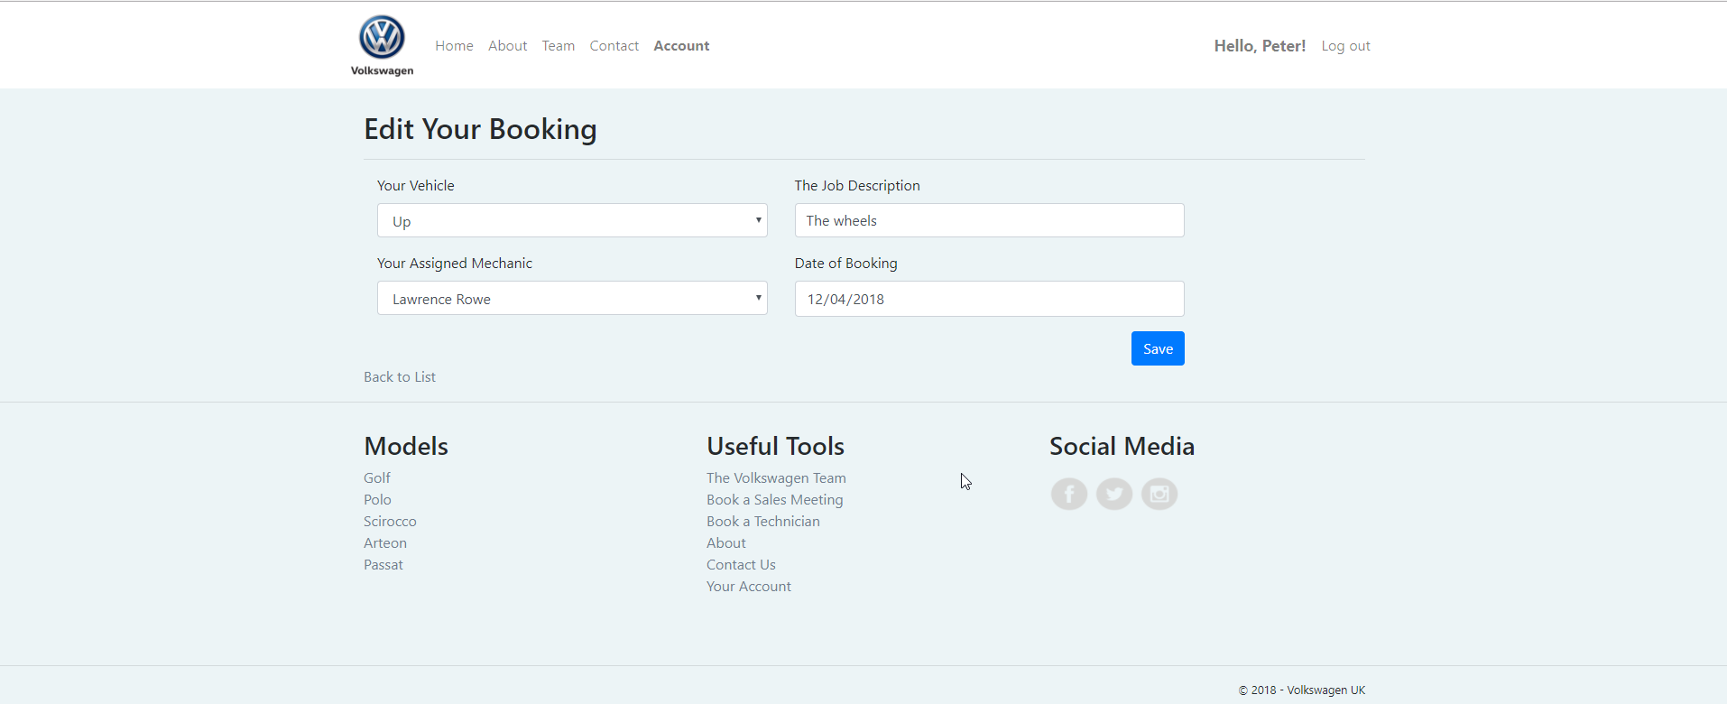

Remove Booking

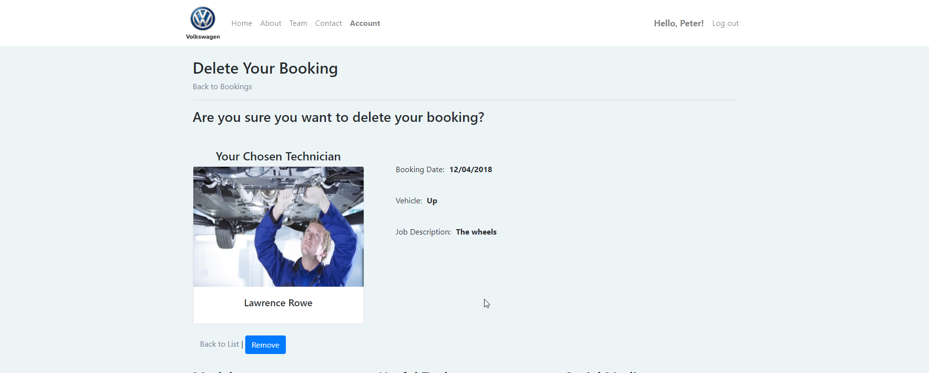

Administrator Home Page

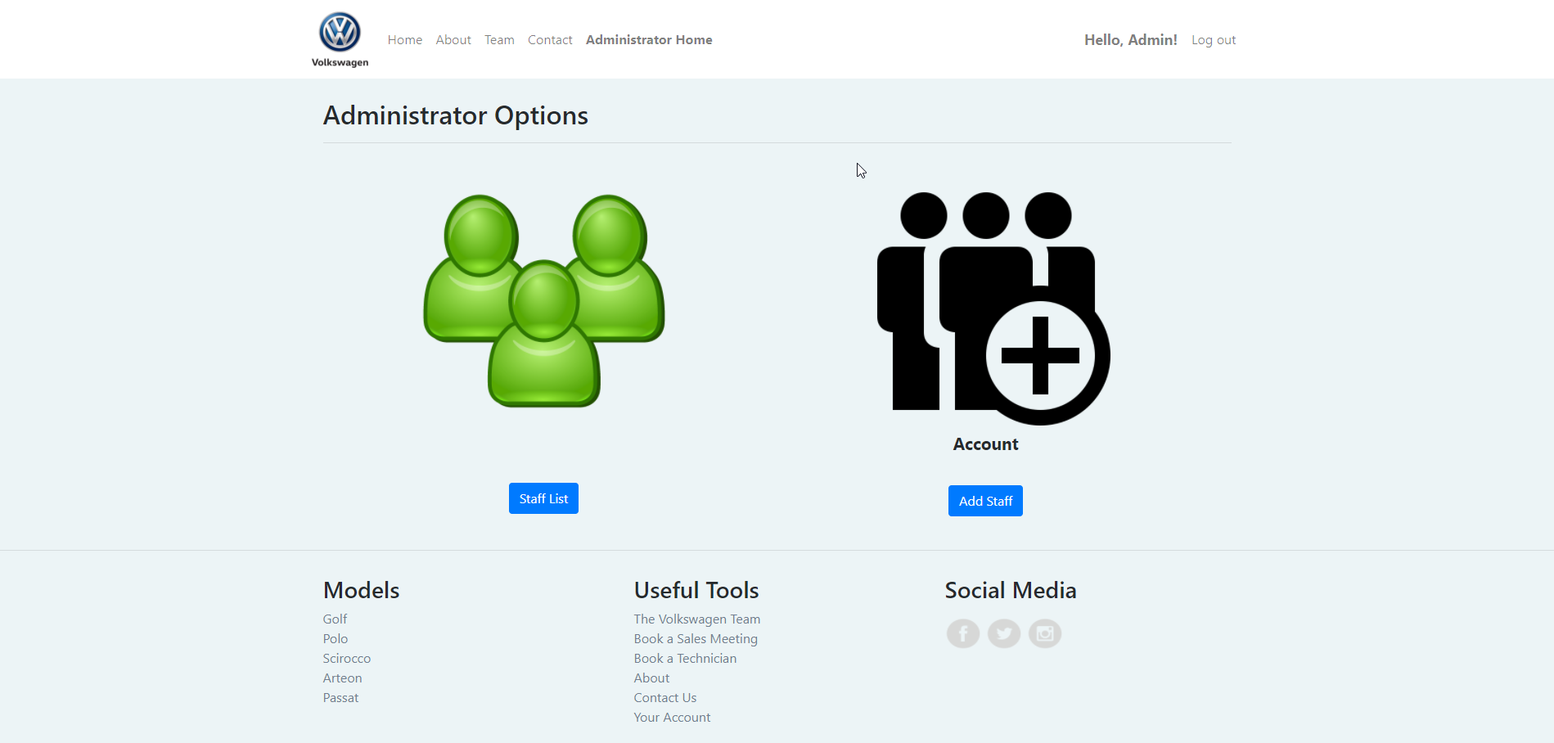

Staff Details Page (Admin)

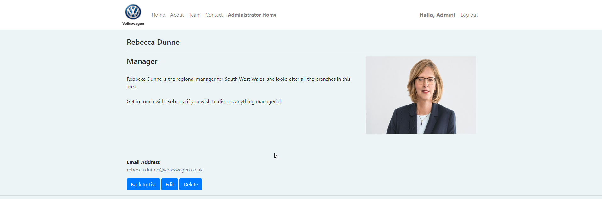

Edit Staff Details (Admin)

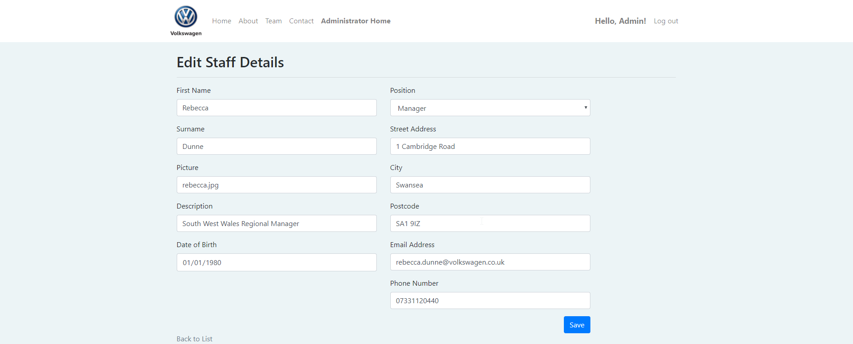

Delete Staff (Admin)

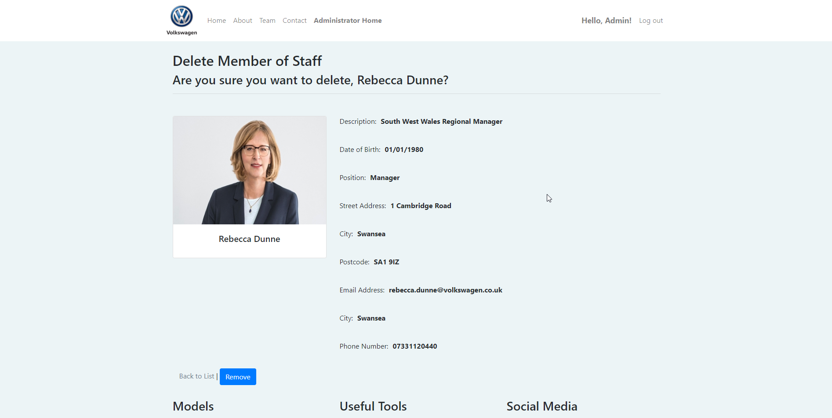

Coming Soon Page

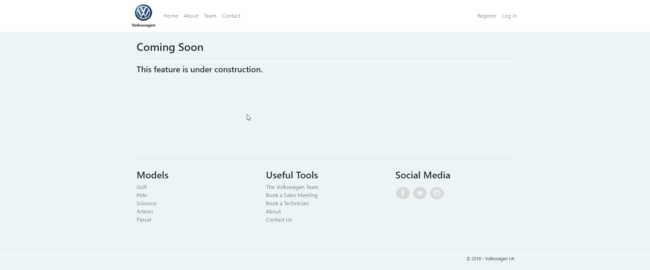

Evaluation

3.1 Requirements Implemented

Table 2 shows an updated version of the MoSCow table produced, indicating which features were implemented. (Implemented features shown with a symbol, not implemented with an symbol).

REQUIREMENT | MUST | SHOULD | COULD | WONT
1
2
3
4
5
6
7
8
9
10
11
12
13
14
15
16
17 |  | /*
18
19
20
21
22
23 |  | (Technician)
24
25

Table 2. Updated MoSCow Ranked Requirements

* Web application does adhere to some W3C [6] web standards, but fails others.

From the MoSCow table, it is evident that many requirements initially identified were not implemented in the web application. The reasons for such will be laid out in the following sections of this report.

3.2 Testing of Web Application

The main feature of the application is the ability to perform CRUD operations on the database. This was extensively tested in both customer role and admin roles. Initial testing yielded some errors;

1. Editing Vehicle in customers garage.

When editing a customer vehicle, any changes saved yielded the following error message.

This error was traced back to the drop-down menu containing the Id’s of all customer registered in the database. At first, to avoid customers selecting another customer’s ID and updating their garage instead, this field was commented out, thus rendering it invisible to the user. However, when commented out, the Customer ID was no longer being passed to the database and the subsequent error being thrown. To overcome this, a class from Bootstrap’s [8] library was used – ‘d-none’ which relates to the CSS property ‘display: none;’ which will render the CustomerID field on the form invisible to the user but the CustomerID data required by the database will still be passed via the query.

2. Migration Update did not update Vehicles Controller.

It was discovered that the Vehicle Registration Field ‘RegNo’ was omitted by mistake when creating the database entities, to remedy this, a new migration called ‘AddRegNo’ was created using the NuGet Package Manager console with the following command.

And subsequently updated using the ‘update-database’ command.

Upon testing the application update, it was found that when editing a vehicle to add the ‘RegNo’ field, no update was being committed to the database. Upon inspection of the query in the Vehicle Controller, it was found that the ‘update-database’ command had not included the new field in the controller query.

‘RegNo’ Added to query.
No ‘RegNo’ field in edit query.

Upon adding the ‘RegNo’ field to the query, the update was successfully committed to the database.

3. Administrator’s Access

Administrators should have access to all areas of the web application, this includes customer records and details, however, this is not the case with the system created. Administrators only have access and can perform CRUD operations only to the staff records in the database. This feature has been omitted purely down to time constraints, with other assignments due in before the end of the academic year, time was not afforded into the research and implementation of this feature.

4. Upon checking if users had been registered to the system, it was discovered that both the built in ‘Application User’ or ‘AspNetUsers’ table and the implemented ‘Customer’ table both contained a field for ‘Email’ address. Although this has no real impact on the system, duplication of fields does not meet 3NF [9] requirements and closer attention would be paid to the existing .NET core tables provided.

3.3 Updated Entity Relationship Diagram

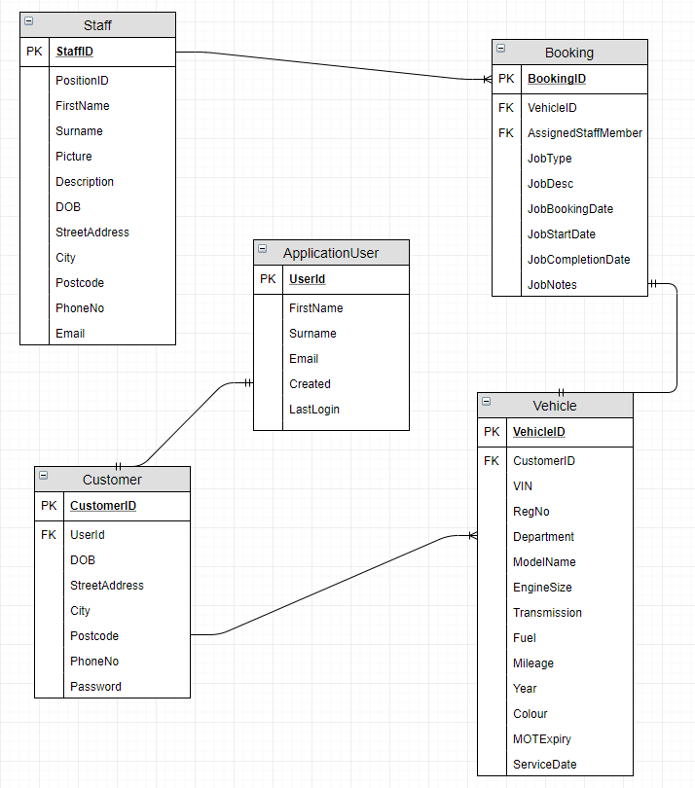

Fig 2. Updated Entity Relationship Diagram

Fig 2 shows an updated entity relationship diagram which demonstrates how the database schema would be designed if the web application was to be produced again.

The diagram shows the removal of the ‘Mechanic’ table, this no longer breaks up the relationship between the ‘Staff’ & ‘Booking’ table, which in turn will allow bookings to be assigned to any staff members in the staff table, not just mechanics, allowing for test drives, and sales appointments to be assigned to respective staff.

In addition, the tables have been updated. The ‘Staff’ table now incorporates a ‘PosistionID’ field to distinguish different staff members roles, and child ‘Booking’ table includes new fields; ‘AssignedStaffMember’, ‘JobType’ (An Enum), ‘JobBookingDate’, ‘JobStartDate’, ‘JobCompletionDate’ & ‘JobNotes’ to allow greater flexibility when bookings are made in relation to different tasks (test-drives, sales meetings etc.). These additions also allow more information to be relayed to customers, improving the user interface.

A ‘DOB’ (Date of Birth) field has been added to the customer table, and Email removed.

3.4 Design, Functionality, Information & Reflection

The Volkswagen web application produced provides a modern and aesthetically pleasing web presence for the company which reflects the brand’s image well. Navigation is simple and intuitive. The colours used across the site are fresh and the font-family utilised is that of Volkswagen’s own logos. However, it is felt that the font colour and background colour of the site and the font colour clash somewhat and would be difficult to read for some visually impaired users.

Although it is felt the overall front-end design is well thought out and presents well, some aspects let the site down. Firstly, the display of data from the ‘Vehicles’ and ‘Bookings’ tables is somewhat untidy and does not reflect the image of the rest of the site. More time is needed to improve these design aspects. However, the display of the ‘Staff’ table data does present well, utilising Bootstrap’s ‘Card’ styles.

Functionality of the application is overall good; however, it would be desirable to implement more of the proposed features in section 2. Most notably requirements, 3, 5, 7, 8 & 10. With a more lenient time constraint these features could be incorporated into the system. In addition to the proposed requirements, from researching the real world Volkswagen Web Application [10] features like booking a service as a guest at any retailer throughout the Volkswagen dealer network would be an advantageous feature of the application.

Information provided on the site is very basic, only offering staff, contact and history information to the user. Should the application be adapted for the real world, more information of Volkswagen’s products would be integrated into the website. It is said by AutoTrader [11] that 59% of car buyers research online before purchasing or visiting a showroom [12] which suggests that displaying Volkswagen’s products across their website would be imperative.

References

[1] J. Martin, Managing the data-base environment, 2nd ed. Prentice-Hall, 1983.
[2] “How many car brands does volkswagen own? - Quora.” [Online]. Available: https://www.quora.com/How-many-car-brands-does-volkswagen-own. [Accessed: 12-Apr-2018].
[3] I. Sommerville, Software Engineering, 9th Edition, 9th ed. Addison-Wesley, 2006.
[4] V. Rainardi, “Functional and Nonfunctional Requirements,” in Building a Data Warehouse, Berkeley, CA: Apress, 2008, pp. 61–70.
[5] “The difference between functional and non-functional requirements | ReQtest.” [Online]. Available: https://reqtest.com/requirements-blog/understanding-the-difference-between-functional-and-non-functional-requirements/. [Accessed: 05-Apr-2018].
[6] “Standards - W3C.” [Online]. Available: https://www.w3.org/standards/. [Accessed: 05-Apr-2018].
[7] K. Brennan, A Guide to the Business Analysis Body of Knowledge. 2009.
[8] “Bootstrap · The most popular HTML, CSS, and JS library in the world.” [Online]. Available: https://getbootstrap.com/. [Accessed: 10-Dec-2017].
[9] “3rd Normal Form (3NF).” [Online]. Available: https://www.sqa.org.uk/e-learning/SoftDevRDS02CD/page_16.htm. [Accessed: 13-Apr-2018].
[10] “The official website for Volkswagen UK.” [Online]. Available: http://www.volkswagen.co.uk/. [Accessed: 13-Apr-2018].
[11] “Auto Trader UK - Find New &amp; Used Cars for Sale.” [Online]. Available: https://www.autotrader.co.uk/. [Accessed: 13-Apr-2018].
[12] “2016 CAR BUYER JOURNEY.”

Bibliography

“c# - Validate uploaded file extension - Stack Overflow.” [Online]. Available: https://stackoverflow.com/questions/25807209/validate-uploaded-file-extension. [Accessed: 12-Apr-2018].
“Checking login user AuthorizePolicy in Razor page on Asp.Net Core - Stack Overflow.” [Online]. Available: https://stackoverflow.com/questions/37509389/checking-login-user-authorizepolicy-in-razor-page-on-asp-net-core. [Accessed: 12-Apr-2018].
“Loading Related Data - EF Core | Microsoft Docs.” [Online]. Available: https://docs.microsoft.com/en-us/ef/core/querying/related-data. [Accessed: 10-Apr-2018].
“Account, add, create, details, document, profile, user icon | Icon search engine.” [Online]. Available: https://www.iconfinder.com/icons/682883/account_add_create_details_document_profile_user_icon#size=512. [Accessed: 10-Apr-2018].
“RandomVIN.com - Random VIN Generator.” [Online]. Available: http://randomvin.com/. [Accessed: 10-Apr-2018].
“asp.net mvc - Multiple models in a view - Stack Overflow.” [Online]. Available: https://stackoverflow.com/questions/4764011/multiple-models-in-a-view. [Accessed: 10-Apr-2018].
“asp.net mvc 3 - Two models in one view in ASP MVC 3 - Stack Overflow.” [Online]. Available: https://stackoverflow.com/questions/5550627/two-models-in-one-view-in-asp-mvc-3/13813476#13813476. [Accessed: 10-Apr-2018].
“c# - How Do I Use A Tuple Properly in ASP.NET MVC 4 - Stack Overflow.” [Online]. Available: https://stackoverflow.com/questions/21105216/how-do-i-use-a-tuple-properly-in-asp-net-mvc-4. [Accessed: 10-Apr-2018].
“asp.net - MVC 5 Multiple Models in a Single View - Stack Overflow.” [Online]. Available: https://stackoverflow.com/questions/23536299/mvc-5-multiple-models-in-a-single-view. [Accessed: 10-Apr-2018].
“How do you display a users full name in the login partial view in ASP.NET Core - Stack Overflow.” [Online]. Available: https://stackoverflow.com/questions/43891589/how-do-you-display-a-users-full-name-in-the-login-partial-view-in-asp-net-core?rq=1. [Accessed: 09-Apr-2018].
“c# - How to create a new .cshtml page in a project that can be seen through a URL - Stack Overflow.” [Online]. Available: https://stackoverflow.com/questions/22029067/how-to-create-a-new-cshtml-page-in-a-project-that-can-be-seen-through-a-url. [Accessed: 09-Apr-2018].
“Role-based authorization in ASP.NET Core | Microsoft Docs.” [Online]. Available: https://docs.microsoft.com/en-us/aspnet/core/security/authorization/roles. [Accessed: 07-Apr-2018].
“c# - SQLException : String or binary data would be truncated - Stack Overflow.” [Online]. Available: https://stackoverflow.com/questions/779082/sqlexception-string-or-binary-data-would-be-truncated. [Accessed: 07-Apr-2018].
“c# 4.0 - ASP.NET Membership, access denied to all roles - Stack Overflow.” [Online]. Available: https://stackoverflow.com/questions/14380574/asp-net-membership-access-denied-to-all-roles. [Accessed: 07-Apr-2018].
“asp.net mvc - MVC Identity wants to insert Null into table when value is not Null - Stack Overflow.” [Online]. Available: https://stackoverflow.com/questions/33223687/mvc-identity-wants-to-insert-null-into-table-when-value-is-not-null. [Accessed: 07-Apr-2018].
“Volkswagen Swansea | South Wales | Sinclair Volkswagen.” [Online]. Available: http://www.sinclairvolkswagen.co.uk/locations/41803/sinclair-volkswagen-
“Quick Start Build a Map | Google Maps Embed API | Google Developers.” [Online]. Available: https://developers.google.com/maps/documentation/embed/start. [Accessed: 07-Apr-2018].
“ControllerBase.ViewBag Property (System.Web.Mvc).” [Online]. Available: https://msdn.microsoft.com/en-us/library/system.web.mvc.controllerbase.viewbag(v=vs.118).aspx. [Accessed: 07-Apr-2018].
“asp.net mvc - How to access Two models data in single view? - Stack Overflow.” [Online]. Available: https://stackoverflow.com/questions/22727376/how-to-access-two-models-data-in-single-view. [Accessed: 07-Apr-2018].
“c# - Operator &amp;&amp; cannot be applied to operands of type ‘bool’ - Stack Overflow.” [Online]. Available: https://stackoverflow.com/questions/18537331/operator-cannot-be-applied-to-operands-of-type-bool. [Accessed: 05-Apr-2018].
K. Grigoryan, “jQuery Scroll Top.” [Online]. Available: https://codepen.io/karencho/pen/KIgur. [Accessed: 05-Apr-2018].
K. E. Wiegers and B. Joy, Software Requirements, Microsoft, 3rd ed. 1999.
“Standards - W3C.” [Online]. Available: https://www.w3.org/standards/. [Accessed: 05-Apr-2018].
“c# - Operator ‘==’ cannot be applied to operands of type ‘int’ and ‘string’ - Stack Overflow.” [Online]. Available: https://stackoverflow.com/questions/15404997/operator-cannot-be-applied-to-operands-of-type-int-and-string. [Accessed: 04-Apr-2018].
“Merge two data in @Html.DisplayFor in ASP.Net MVC - Stack Overflow.” [Online]. Available: https://stackoverflow.com/questions/42809731/merge-two-data-in-html-displayfor-in-asp-net-mvc. [Accessed: 04-Apr-2018].
M. Kahn, “Retrieve images using a file path stored in database in ASP.Net.” [Online]. Available: https://www.aspsnippets.com/Articles/Retrieve-images-using-a-file-path-stored-in-database-in-ASPNet.aspx. [Accessed: 03-Apr-2018].
“asp.net mvc - Introducing FOREIGN KEY constraint on table may cause cycles or multiple cascade paths causing Database.SetInitializer to not work? - Stack Overflow.” [Online]. Available: https://stackoverflow.com/questions/11864704/introducing-foreign-key-constraint-on-table-may-cause-cycles-or-multiple-cascade. [Accessed: 03-Apr-2018].
“.net - EF Core add-migration Build Failed - Stack Overflow.” [Online]. Available: https://stackoverflow.com/questions/44785540/ef-core-add-migration-build-failed. [Accessed: 03-Apr-2018].
“.net - EF Core add-migration Build Failed - Stack Overflow.” [Online]. Available: https://stackoverflow.com/questions/44785540/ef-core-add-migration-build-failed. [Accessed: 03-Apr-2018].
“Resetting Entity Framework Migrations to a clean Slate - Rick Strahl’s Web Log.” [Online]. Available: https://weblog.west-wind.com/posts/2016/Jan/13/Resetting-Entity-Framework-Migrations-to-a-clean-Slate. [Accessed: 03-Apr-2018].
“c# - Identity new table foreign key to AspNetUsers - Stack Overflow.” [Online]. Available: https://stackoverflow.com/questions/37466104/identity-new-table-foreign-key-to-aspnetusers. [Accessed: 03-Apr-2018].
“IdentityUser(TKey, TLogin, TRole, TClaim) Class (Microsoft.AspNet.Identity.EntityFramework).” [Online]. Available: https://msdn.microsoft.com/en-us/library/dn613256(v=vs.108).aspx. [Accessed: 03-Apr-2018].
“c# - Entity Framework rollback and remove bad migration - Stack Overflow.” [Online]. Available: https://stackoverflow.com/questions/22680446/entity-framework-rollback-and-remove-bad-migration. [Accessed: 03-Apr-2018].
“ASP.NET Core MVC with EF Core - Migrations - 4 of 10 | Microsoft Docs.” [Online]. Available: https://docs.microsoft.com/en-us/aspnet/core/data/ef-mvc/migrations. [Accessed: 03-Apr-2018].
“.NET Core CLI - EF Core | Microsoft Docs.” [Online]. Available: https://docs.microsoft.com/en-us/ef/core/miscellaneous/cli/dotnet. [Accessed: 03-Apr-2018].
A. Abel, “EF Migrations Command Reference | Passion for Coding.” [Online]. Available: https://coding.abel.nu/2012/03/ef-migrations-command-reference/. [Accessed: 03-Apr-2018].
“entity framework - EF Data migrations won’t detect changes when adding new migration - Stack Overflow.” [Online]. Available: https://stackoverflow.com/questions/15781968/ef-data-migrations-wont-detect-changes-when-adding-new-migration. [Accessed: 03-Apr-2018].
“c# - EF7 .NET Core 1 RC2 Add-Migration failing - Stack Overflow.” [Online]. Available: https://stackoverflow.com/questions/37468792/ef7-net-core-1-rc2-add-migration-failing. [Accessed: 01-Apr-2018].
“Enable Entity Framework Core Migrations in Visual Studio 2017.” [Online]. Available: https://benjii.me/2017/05/enable-entity-framework-core-migrations-visual-studio-2017/. [Accessed: 01-Apr-2018].
“asp.net - What kind of data Type use to save an image in database - Stack Overflow.” [Online]. Available: https://stackoverflow.com/questions/9649448/what-kind-of-data-type-use-to-save-an-image-in-database. [Accessed: 01-Apr-2018].
“c# - Setting up foreign key in ASP.NET MVC 4 - Stack Overflow.” [Online]. Available: https://stackoverflow.com/questions/19517451/setting-up-foreign-key-in-asp-net-mvc-4. [Accessed: 01-Apr-2018].
“Enumeration types (C# Programming Guide) | Microsoft Docs.” [Online]. Available: https://docs.microsoft.com/en-us/dotnet/csharp/programming-guide/enumeration-types. [Accessed: 01-Apr-2018].
“c# - Inconsistent accessibility: Base class is less accessible than subclass - Stack Overflow.” [Online]. Available: https://stackoverflow.com/questions/29501919/inconsistent-accessibility-base-class-is-less-accessible-than-subclass. [Accessed: 01-Apr-2018].
“9 good reasons to have an online booking system.” [Online]. Available: https://webreserv.eu/news/good_reasons_online_booking_system. [Accessed: 12-Apr-2018].

marking criteria and Student FEEDBACK

This section details the assessment criteria. The extent to which these are demonstrated by you determines your mark. The marks available for each criterion are shown. Lecturers will use the space provided to comment on the achievement of the task(s), including those areas in which you have performed well and areas that would benefit from development/improvement.

Common Assessment Criteria Applied (Assignment 1) | Marks available | Marks  awarded
1. Research-informed Literature
Extent of research and/or own reading, selection of credible sources, application of appropriate referencing conventions.
Excellent evidence of additional research. (Grade mark: 100.00%) | 5 | 5
2. Knowledge and Understanding of Subject
Extent of knowledge and understanding of concepts and underlying principles associated with the discipline.
Demonstrates an excellent understanding of server-side coding with ASP.NET. The database is well designed with a good number of related tables and a proposed solution to improve the design following the evaluation has been provided. A very good range of functionality demonstrating knowledge of different concepts has been included in the implementation. (Grade mark: 83.33%) | 15 | 12.5
3. Analysis
Analysis, evaluation and synthesis; logic, argument and judgement; analytical reflection; organisation of ideas and evidence
The requirements have been well thought out and prioritised using the MoSCoW technique. My only comment is your presentation of the prioritised requirements - see your report. Excellent discussion of the challenges faced and how they were resolved. A very good critical review of the implementation and its current limitations has been provided with relevant suggestions, including an improved database design. (Grade mark: 88.00%) | 25 | 22
4. Practical Application and Deployment
Deployment of methods, materials, tools and techniques; application of concepts; formulation of innovative and creative solutions to solve problems.
An excellent attempt featuring a well-thought-out application. It is evident that you have put in a lot of effort in to the implementation. See your report for some additional minor comments. (Grade mark: 90.00%) | 50 | 45
5. Skills for Professional Practice
Attributes in professional practice: individual and collaborative working; deployment of appropriate media; presentation and organisation.
The report is well-written and presented. See your report for additional comments. (Grade mark: 70.00%) | 5 | 3.5

Assignment Mark (Assessment marks are subject to ratification at the Exam Board. These comments and marks are to give feedback on module work and are for guidance only until they are confirmed. ) | Late Submission Penalties (tick if appropriate) |  | 88%
 | Up to one week late |  | 88%
 | 1st/2nd/3rd attempt? |  | 88%

