TESCO CRM

Valentina Ionela Cergan
1816932
25.02.2022

Executive Summary

The aim of this report will align with the identification of the customer relationship management policies and practices of Tesco Plc. The report will elaborately discuss and identify the processes and areas covered in the CRM initiatives of the company. It will include ethical datasets, practices, and sustainability policies. Segmentation of buyers and the loyalty ladder along with their individual impacts will be located here. Critical analyses of the ethical and sustainable practices would help to find the issues in the system to further understand the gaps of Tesco. These will help to set important recommendations such as direct approach of customers, regular feedback, transparent sourcing information, among several others.
Table of Contents
Executive Summary 1
Introduction 3
Findings 3
CRM Policies and Practices of Tesco 3
Critical Analysis 5
Strategies of Tesco 6
Impacts 7
Conclusion 7
Recommendations to improve standards 7
References 8

Introduction

The need to understand consumers and their marketing tendencies is fundamental in determining the product and service choices of a business. Thus, all companies pursue strong customer relations to generate feedback and improvements constantly. The report will focus on the practices and policies formulated in Tesco to learn the credibility of existing sales and services. It will aim to highlight the importance of different elements like ethics, segmentation, and sustainability in creating good impressions. The report will offer a critical discussion of the practices in light of relevant frameworks and models used by experts to improvise. Relevant inputs on current practices will help to detect the utility of the policies in enhancing customer reviews and relations. It will also elaborate on issues and suggest changes that bear the scopes of improvements.

Findings

CRM Policies and Practices of Tesco

Ethical policies and practices
According to Alshurideh et al., (2019), customer relationship management (CRM) is an insightful practice, businesses pursue to manage a company's interactions with buyers. One of the major misconceptions here is that it refers to merely consumer services. However, it also focuses on technical assistance. Ideally, CRMs are meant to allow companies to collect and maintain huge volumes of data on customers. Ethics is one of the major factors that determine the efficiency of this data collection. Research highlights that Tesco has been addressing a range of ethical issues over the years of expansion internationally. These include climate change, controversial technologies, factory-based farming, political complexities, worker and animal rights, etc. The company issues a strong donations policy for the political stability of the surroundings and the people working within stores. Tesco's Human Rights policies encompasses a range of practices that are acknowledged by the UN and the ILO respectively (Hogan et al., 2019). These include ethical trading and sourcing of ingredients and products from end producers under the Base Code of the ETI (Hughes et al., 2019). Similarly, the company is invested in encrypting data of customers and staff to secure them from cyberattacks or misusage. The use of personal data for consumer research and trend analysis is privatised under the individual cookies policy.

Sustainability policies and practices
Sustainability is another integral aspect of the CRM that ensures collateral alignment of rational resource usage. The Little Helps Plan of Tesco is all about the sustainability of retail businesses through planned actions and decisions. The initiative focuses on long-term approaches of Tesco that demonstrate and administer the four pillars of sustainability: people, product, planet, and places (Chkanikova and Sroufe, 2021). Under the people's policy, the first notable practice is the diversification of the workforce and inclusive work environments. The need has emerged with globalisation as different groups of people aspire for employment across the UK. Ensuring personal and professional safety and workplace sanitation, scheduled working hours are some of the tasks under sustainability. Healthy production and choice of sustainably processed saleable is the first motive under the product scheme. Here, Tesco also attends the issues of food waste and inventory dumping that are major ecological concerns of the UK (Goodman-Smith et al., 2020). Packaging using eco-friendly materials is a practice issued under both product and planet policies. Likewise, engaging in sustainable farming and organic agricultural processes that have the least impacts of contamination or exploitation are validated. Modern customers are keen on the social and environmental welfare practices of the brand. Thus, Tesco partners for several local charity and distribution initiatives for the welfare of underprivileged communities regionally.

Segmentation and the Loyalty Ladder
As an aspiring retail company, Tesco offers a wide range of products and services to the customers internationally. Thus, issuing a regional segmentation approach to market among buyers or potential consumers is indeed challenging and complicated. Thus, the company avoids using demographic, geographical, or even psychological attributes. Here, the main segmentation is based on behaviours of buyers. Tesco's primary target in the market is on cost-conscious buyers, who are willing to bargain on sales with values. The company is also diversified from lower to higher income groups through a range of products under names like 'Tesco Value' and 'Tesco Finest' (Samdani, 2020). However, both value and finest products are all mainstreamed in the stores and digital platforms. The transparency is another tactic in use to ensure all individuals can buy anything from the outlets. Thus, Tesco can easily approach any client group with any preference for purchase without losing acceptances. The segmentation is mainly focused on understanding the area of outlet (rural or urban) and relevant population densities to set product ranges.
Popularly called the branding ladder, the loyalty ladder is deemed essential by marketers to understand customer movements in terms of purchase loyalties. It is in fact notable that Tesco has been successfully thriving in the market among wide customer ranges. One of the major connectors here is the loyalty programme of the brand. The loyalty schemes of Tesco not only add value but also generate good impressions for further references. For example, all customers are sent coupons that relate to the frequency of their product purchases and buying preferences. The most critical technique in use is the Tesco Clubcard. As per Kapooria (2017), the card is scanned for each transaction to grab and record information on purchases. Discount and offer coupons are always offered to customers during their departures to add value experiences. Special cashback and exchange coupons are issued in other subsidiaries of Tesco, such as petrol stations where buyers fill their cars during destination drives (Kotler et al., 2021). These strategies help to acquire acquisitions and build relationships that are tough for rivals to break.

Critical Analysis

Critical analysis of Tesco's ethics
It is clear that Tesco has been holding a strong brand portfolio among customers and staff across the UK. However, there are several instances that experts highlight in the daily practices of the brand. According to Schleper et al., (2017), unfair and unethical trade practices have been claimed by the Friends of the Earth organisation against Tesco. The reason is that local job opportunities that Tesco has built regionally often diminish the scopes for local communities and shops directly selling produced items. The market abuse by Tesco is also an ethical concern for the retail businesses. As per Overland (2019), Sandra Bell has claimed the use of abusive power on smaller traders. Incidents of bullies on suppliers, killing off local high streets, environmental damages through improper waste management are some of the cases highlighted on Tesco's campaigns for cheap food. Even though the internal authorities have retorted these as misleading records to demean the brand, on a regional basis, the problems faced by local supply chains and end producers is undeniable. Holding 27.3 per cent of the UK market, Tesco's processing units for meat and dairy are also questionable on grounds of worst rating for taste and quality. The company has also lost around 1,000,000 pounds annually under the antisocial finance category (Giansanti, 2017). The strategy was issued to work actively against market inhibitors and problems faced by local producers in exchanging good produce for prices. The suppliers have also been reported for slave labouring in a police investigation during 2019 which highlights labour issues.

Critical analysis of Tesco's sustainability
It is evident from expert analyses that Tesco upholds abundant opportunities in the market through its practices and policies. As per Burt et al., (2017), the cultural variant of the brand has evolved with more interactions with worldwide clients and staff. However, one of the major areas affecting the acquisition failures of Tesco is the lack of research on trends and preferences. As per Shavitt and Barnes (2020), the cross-cultural perspectives in regions like Japan and even the US had adversely affected Tesco in terms of fulfilling people's expectations in product ranges. A similar problem is distinct in the product or service launches of Tesco towards sustainable development. Factory production is another concern that is countering the opportunities of CRM sustainability strategies. Cases like the horsemeat scandal are deemed by critics as the biggest hindrance in the growth of processed food sales globally (Ibrahim and Howarth, 2017). However, the plastic free shopping and delivery systems have improved the negative impacts highlighted above. According to Boz et al., (2020), the trials on 10 stores loop scheme was meant to generate customer returns for plastic wastes which were being processed to recyclable plastic bags and soft plastic. Even doorstep deliveries do not use plastic bag packaging or glass bottles that generate excessive carbon emissions during production, damaging the air quality (Siegle, 2018).

Strategies of Tesco

Ways of customer segmentation

It is already clear that Tesco employs the purchasing behaviour analyses as the main criteria to understand market preferences. The form of segmentation is quite appropriate considering the diversity of products and target groups among customers. It also helps to attend a wide range of expectancies among customers which is a major part of ideal CRM practices. Here, geographical segmentation is a secondary analysis to understand purchasing power of and trends among the buyers. Thus, it minimises the problems of product listings and inventory management which impact the product reachability and acquisitions. Furthermore, it reduces the stakes of customer dissatisfaction.

Application of the loyalty ladder in CRM

The idea of every business is to ensure that buyers are always at the apex of the loyalty ladder.
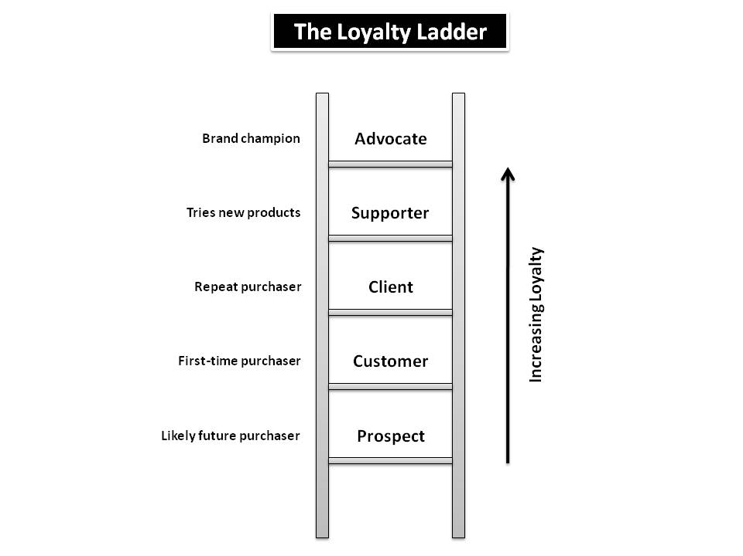
Figure 1: The loyalty ladder
(Source: Eightleaves.com, 2022)

In order to build the wisdom and positive feedback, Tesco must focus on understanding customers at all regions. It should include understanding their purchase preferences, tastes in products, expenses made, and other factors that affect recalls (Eightleaves.com, 2022). Services also play a major role here. Customers receiving good response in grievances or product issues are more likely to come back at Tesco's outlets. Similarly, buyers being assisted in different purchases are more likely to visit Tesco for the agent quality and interactions they have during shopping.

Impacts

Summarising impacts of policies and practices in Tesco's CRM
The process of issuing ideal CRM practices in Tesco or similar businesses is based on large dataset collection and analytics. However, it raises a few notable questions on the ethics of the company and on customers data or system privacies. The first impact is observed in the process of data collection. Originally, Tesco's loyalty scheme is the main tool to acquire data on purchases and product preferences. However, the company also analyses the credit or debit card payments to trace the history of purchases or searches on Google. Such data comprise of people's personal information which need to be handled delicately. Slight mismanagement leads to immense problems making customers prone to cyber threats and digital malware.
Similarly, the sustainability practices have a huge impact on the quality of CRM within Tesco. For example, sustainability initiatives and projects are meant to attract similar customers who are either aware or are actively engaged in the processes. However, the promotions should generate from real-time facts and depictions which can be tested and verified. Using SCRM strategies without implementing them in daily operations can lead to legal constraints for media falsification. It also damages the brand will which is being targeted through CRM practices.

Conclusion
It is clear from the discussed aspects that Tesco has attained global acceptance through its customer-oriented practices. However, some areas identified above need special attention to enhance the consensual brand overview among potential buyers. The recommendations suggested ease the process through research and reporting.

Recommendations to improve standards

Setting up an investment plan for local agents and managers to research on customers and their purchase trends or market values directly is the first recommendation. It would reduce the use of cyber data that is susceptible to malware and spyware threats.
Another recommendation relevant to this approach would be to minimise redirecting of links to different pages. The promotional contents often redirect to subpages that are not existing. Thus, customers might be easily led to pages that are hacking breakthroughs.
The third recommendation is to invest in regular feedback generation on new and old products and services after each purchase. The feedback process must be issued through direct calls or messages over links that are in spams. It would improve customer engagement that in turn affects interrelationships (Brannen et al., 2020).
Clarity of the product sources and updating them over regular intervals is another approach that would enhance ethical standards. For this, direct approach to producers and farmers is necessary to ensure organic farming and aquaculture practices.
Lastly, Tesco must improve the delivery of first-hand contacts. Social media networking should improve to attend queries and complaints. Investing more in recruiting customer care agents can also help to mitigate communal problems of employment immensely.

References

Acar, S. and Yeldan, E. eds., 2019. Handbook of Green Economics. Academic Press.
Alshurideh, M., Alsharari, N.M. and Al Kurdi, B., 2019. Supply chain integration and customer relationship management in the airline logistics. Theoretical Economics Letters, 9(02), p.392.
Bauer, W.A., 2020. Virtuous vs. utilitarian artificial moral agents. AI & SOCIETY, 35(1), pp.263-271.
Boz, Z., Korhonen, V. and Koelsch Sand, C., 2020. Consumer considerations for the implementation of sustainable packaging: A review. Sustainability, 12(6), p.2192.
Brannen, M.Y., Mughan, T. and Moore, F., 2020. The creative use of insider ethnography as a means for organizational self investigation: The “Essence of Tesco” project. In The Routledge companion to anthropology and business (pp. 132-154). Routledge.
Burt, S., Johansson, U. and Dawson, J., 2017. Dissecting embeddedness in international retailing. Journal of Economic Geography, 17(3), pp.685-707.
Chkanikova, O. and Sroufe, R., 2021. Third-party sustainability certifications in food retailing: Certification design from a sustainable supply chain management perspective. Journal of Cleaner Production, 282, p.124344.
Eightleaves.com. 2022. The Loyalty Ladder: A Sideways Look | Eight Leaves | Data Analytics & Software Development. [online] Available at: <https://www.eightleaves.com/2010/04/the-loyalty-ladder-a-sideways-look> [Accessed 2 February 2022].
Giansanti, E., 2017. The precariat: outbursts of crime, such as the 2011 London riots, can be explained through the lens of neoliberalism.
Goodman-Smith, F., Mirosa, M. and Skeaff, S., 2020. A mixed-methods study of retail food waste in New Zealand. Food Policy, 92, p.101845.
Hogan, B.F., Rhodes, M.L., Murphy, S.P. and Lawlor, M., 2019. IRISH BUSINESS & HUMAN RIGHTS.
Hughes, A., Morrison, E. and Ruwanpura, K.N., 2019. Public sector procurement and ethical trade: Governance and social responsibility in some hidden global supply chains. Transactions of the Institute of British Geographers, 44(2), pp.242-255.
Ibrahim, Y. and Howarth, A., 2017. Contamination, deception and ‘othering’: the media framing of the horsemeat scandal. Social identities, 23(2), pp.212-231.
Jones, T.M., Wicks, A.C. and Freeman, R.E., 2017. Stakeholder theory: The state of the art. The Blackwell guide to business ethics, pp.17-37.
Kapoor, P.J., 2017. Customer relationship management: Key to customer sovereignty. Idea Publishing.
Kotler, P., Kartajaya, H. and Setiawan, I., 2021. Marketing 5.0: Technology for humanity. John Wiley & Sons.
Overland, J., 2019. Corporate Liability for Insider Trading. Routledge.
Samdani, T., 2020. Impact of Tesco's Private Label brands on buying behaviour of Millennials in terms of brand preference in Irish market (Doctoral dissertation, Dublin, National College of Ireland).
Schleper, M.C., Blome, C. and Wuttke, D.A., 2017. The dark side of buyer power: Supplier exploitation and the role of ethical climates. Journal of Business Ethics, 140(1), pp.97-114.
Shavitt, S. and Barnes, A.J., 2020. Culture and the consumer journey. Journal of Retailing, 96(1), pp.40-54.
Siegle, L., 2018. Turning the tide on plastic: How humanity (and you) can make our globe clean again. Hachette UK.

