Advanced Web Development
Advanced Web Development Assignment 2
Mike Dacey
Runa Bibi (1702463)
27/04/2020

Table of Contents

1. Introduction 2
2. Black and White box testing 2
3. Behavioural Driven Development 9
4. Test framework 11
5. References 12

Table of Figures

Figure 1 - Decision Table Testing Example 3
Figure 2 - State Transition Diagram Example 4
Figure 3 - Statement Coverage Test Examples 5
Figure 4 - Branch Coverage Testing Example 5
Figure 5 - Branch Coverage Flowchart 6
Figure 6 - Path Coverage Flowchart 7
Figure 7 - Data Flow Test Example 8
Figure 8 - Control Flow Graph for Data Flow Test 8
Figure 9 - Use of variable of Data Flow Test 9
Figure 10 - Sample Feature File 10
Figure 11 - Given-When-Then Approach 10
Figure 12 - Jasmine Test Example 11

1. Introduction
This report will describe black and white box testing with examples and look at the benefits of behavioural driven development. A chosen framework will also be investigated.

2. Black and White box testing
Black box testing is testing software where the tester does not know the internal workings of the application under test (AUT) [1]. It focuses on the outputs given by certain inputs and implementation conditions [2]. It pays attention to the user requirements specification and therefore does not assume any knowledge of the development and tools; it represents real user interactions and scenarios [3]. It looks for errors in the interface, performance or behaviour, external database or data structures, termination and initialisation and missing or incorrect functions [4].
There are several types of black box testing techniques, one of which is equivalence partitioning, also known as equivalence class partitioning [5]. This works by finding test cases from classes of data which have been divided from the input domain of a program [6]. Classes are derived from test inputs that all share similar features and for each class, test cases are chosen so the highest amount of attributes of an equivalence class are used at once [7]. Only one condition per partitioned class needs to be tested as we assume the software will treat all conditions in the class the same way [7]. An example of such a test is a system where only the integers 1-10 are accepted, so invalid integers include: those above 10, below 1 and any 3 digit number [8]. This creates 4 partitions which only requires one test from each e.g. -1, 5, 88 and 121 [8].
Boundary value analysis is another black box testing technique [9]. More errors tend to happen at the “boundaries of the input domain” [10] so this testing technique looks for errors at the boundaries and not the centre of this domain [10]. A real world application of this could be a printer which only allows 1 to 99 copies, wherein the tests would be 1 and 99 which should be valid and 0 and 100 which should be invalid [11]. To test all above and below boundaries, 2 and 98 should be tested.
Another black box testing technique is decision table testing [12]. This is best used for logical relationships and involves all the different combinations and all possible conditions as well as all corresponding responses to all of the various conditions [2]. An example of this is a login page where the only accepted input is a correct username and password with all other combinations giving an error message [13]. This example is illustrated below:
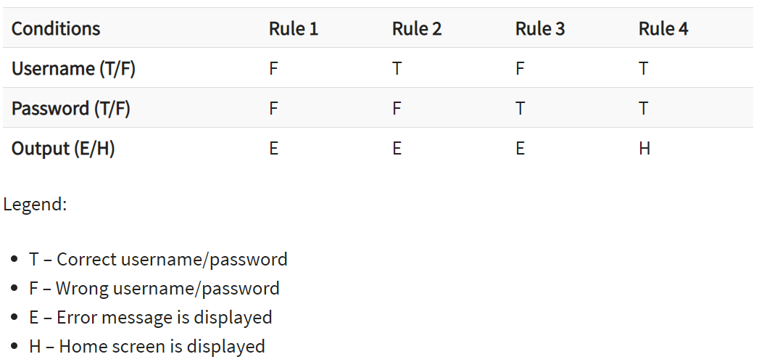
Figure 1 - Decision Table Testing Example [13]

Like decision tables, state transition diagrams document how events are processed in the system and its responses [14]. This can be used in a variety of scenarios such as testing a determinate set of input values, testing a sequence of events that happen in the application under test and when the application has a dependency on the events in the past [15]. The 4 main parts of a state transition model are: the states the software might be in, the transition from each state, the events that source a transition and actions that occur from a transition [15].
Below is an example illustrating a state transition diagram of an ATM system where the user gets three attempts of their pin and if it is invalid three times then the account is blocked [15]. Anytime a correct pin is used then the user will be granted access to their account and in the first or second try if the pin is incorrect, the user is prompted to re-enter their pin [15].
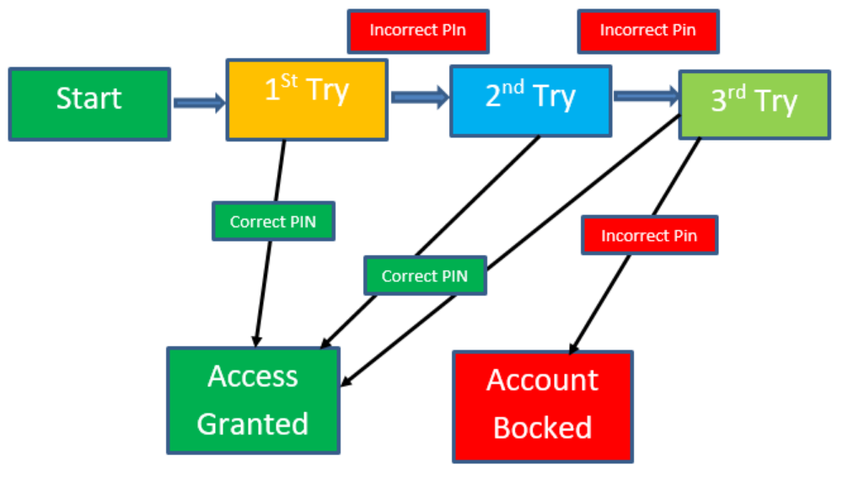
Figure 2 - State Transition Diagram Example [15]

An advantage to black box testing is that the tester does not need any technical knowledge, they only need to know the requirements specification to understand the functionality of the system [16]. Another advantage is the test is unbiased as the tester and designer are independent of each other, also, it helps find any ambiguities in the requirements specification [17]. A disadvantage of black box testing is its incapability to inspect the software by studying the code “statement-by-statement” [18]. Tests can also be redundant if the software designer has already completed them [19].
White box testing, also known as structural testing, needs thorough knowledge of the inner workings of the system [20]. Code is visible in this type of testing to the tester [21]. White box testing is done to ensure that true or false values from logical decisions are verified, all independent paths have been exercised from within a module and to find design errors between the implementation and logical flow of the program [22]. It also helps to find errors in syntax and typographical errors [22].
There are a few white box testing techniques available such as statement coverage, branch coverage and path coverage [23]. Statement coverage is ascertained through evaluating the proportion of statements looked at by the set of planned test cases [24]. The purpose of statement coverage is to process and implement every single line of code, and the following formula gives the statement coverage [25]:
$Statement coverage=\frac{Number Statements Executed}{Total number of Statements}$ x 100% [25]
Statement coverage tests do not test a statement’s false conditions e.g. the following code fragments in a C syntax:
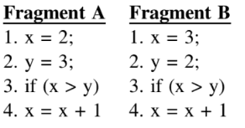
Figure 3 - Statement Coverage Test Examples [25]
In Fragment A, three statements are executed wherein the statement coverage is 75% and in Fragment B, four statements are executed so the statement coverage is 100% [25].
Branch coverage testing intends to execute each decision point’s possible branches at least once so all accessible code is executed [26]. The formula for branch coverage is:
$Branch coverage= \frac{Number of decisions outcomes tested}{Total number of decision outcomes}$ x 100% [26]
An example of this is:
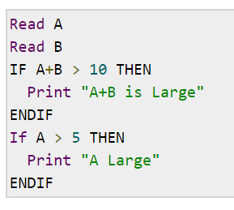
Figure 4 - Branch Coverage Testing Example [26]

This can also be represented in a flowchart form:
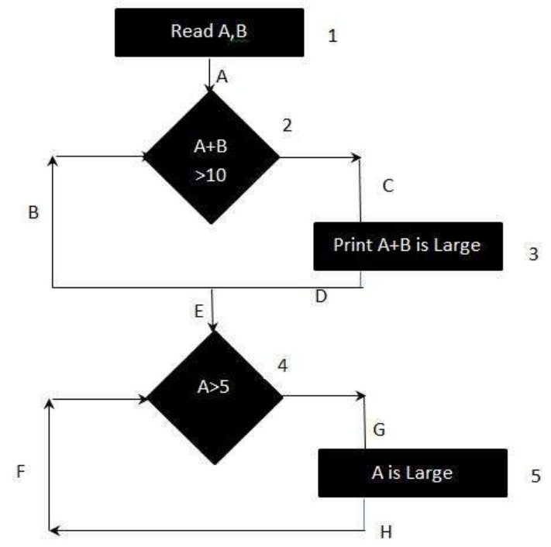
Figure 5 - Branch Coverage Flowchart [26]
In order to find the branch coverage, you need to make sure all the edges are covered with the least amount of paths needed [26]. In this situation, one single path will not cover all edges so all possible true-false decisions need to be covered [26]. The paths are: (1) 1A-2C-3D-E-4G-5H and (2) 1A-2B-E-4F so the branch coverage is 2 [26].
Path coverage works so every path is executed once at a minimum [27]. Similar to branch coverage this can represented through a flowchart [27]:
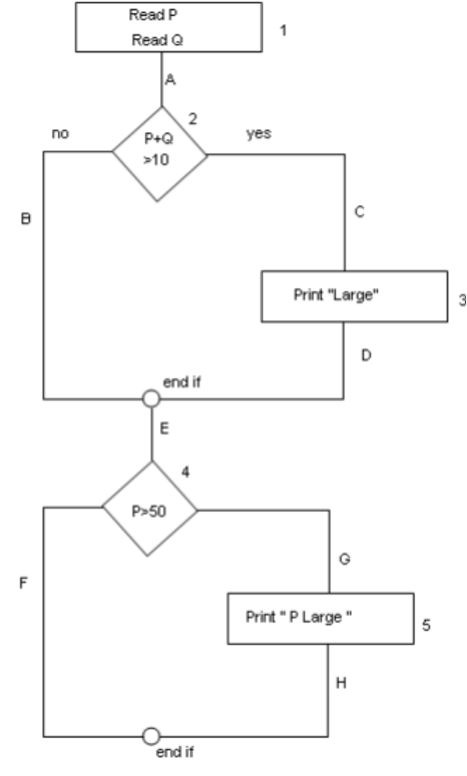
Figure 6 - Path Coverage Flowchart [27]
As all paths need to be covered, every possible path in this example is:
- 1A-2B-E-4F
- 1A-2B-E-4G-5H
- 1A-2C-3D-E-4G-5H
- 1A-2C-3D-E-4F [27]
So, path coverage is 4 [27].
Another white box testing technique is data flow testing which is used to find the test paths of a program conferring to variable use and definition locations in the program [28]. It is in relation to statements where values are received from variables and where the values are referenced [28]. A control flow graph is used to find circumstances where the flow of the program can be interrupted [28]. Define or reference anomalies are found during associations between the variables and values [28]. Such anomalies are where a variable is used but not defined, a variable is defined and not used and a variable has been defined twice before it is used [28]. Below is an example depicting data flow testing:
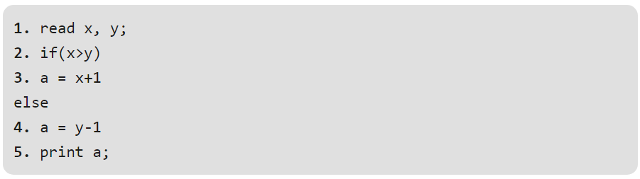
Figure 7 - Data Flow Test Example [28]
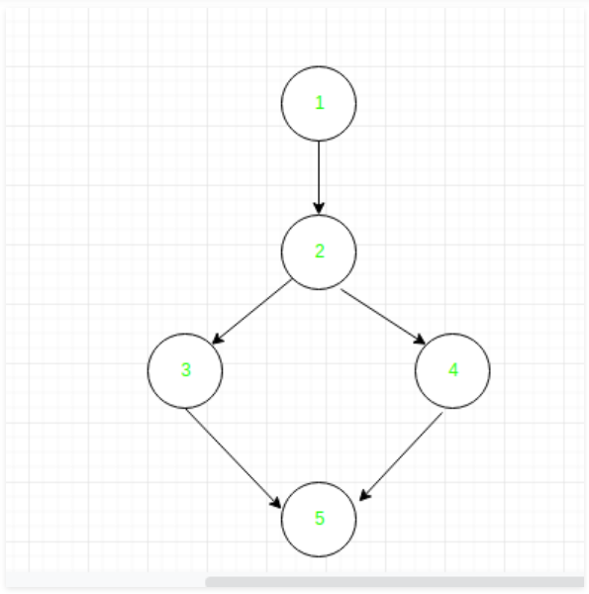
Figure 8 - Control Flow Graph for Data Flow Test [28]
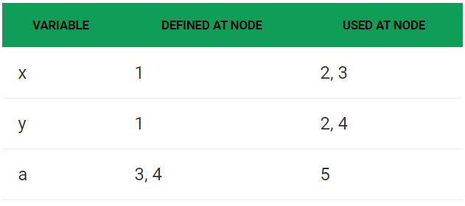
Figure 9 - Use of variable of Data Flow Test [28]
One advantage of white box testing is that it forces the tester to reason judiciously about the implementation [29]. It also allows internal errors to be found as it checks internal functionality [30]. The code can also be modified by the tester for better performance and optimisation [31]. A disadvantage to black box testing is because a skilled tester is required, the costs are hugely increased [32]. There is also the possibility of not finding missing features [33].

3. Behavioural Driven Development
Behavioural Driven Development (BDD) is agile software development that encourages collaboration between everyone involved in the project [34]. It concentrates on the delivery of behaviours on all development activities i.e. what the system should do, explained in a way so that domain experts and developers speak the same language [34]. It works as a test-first approach where only a change in the product allows a new coding task to be created e.g. if there is a new bug or requisite or a change in an existing requisite [35].
BDD enables the business and technical team to reach their goals and communicate what the developer needs to build and understand any technical problems they may face [36]. The focus is on why the code needs to be created rather than the technical details [36]. The big benefit of BDD is the strong collaboration [37]. Everyone involved in the project has a strong understanding and because it is written in plain language, they can all engage in constructive discussions and write behaviour scenarios [37].
Another benefit is that acceptance criteria is defined before development begins [38]. BDD also makes automation easier as its frameworks allow scenarios to be turned into automated tests because scenarios already have the steps needed and the automation engineer is only required to write a method/function to complete each step’s operation [39]. BDD can make code better and easier to make changes to because the scenarios created can become the documentation and after every change you can verify if it is still running acceptably [40]. Furthermore, because the development of the software is done meeting the user’s needs in BDD, users are more likely to be satisfied which leads to good business [41]. BDD is also able to reach a widespread audience as it is non-technical [42].
One BDD framework is called Cucumber and uses a Given-When-Then approach [43]. Given means the preconditions, When means the actions and Then means the outcome [43]. An example of this framework is shown below:
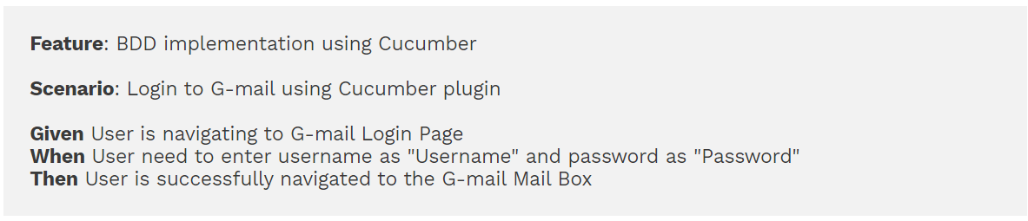
Figure 10 - Sample Feature File [43]
This framework allows testers to reuse steps which saves time for the automation tester [43]. This is demonstrated in the two scenarios below:
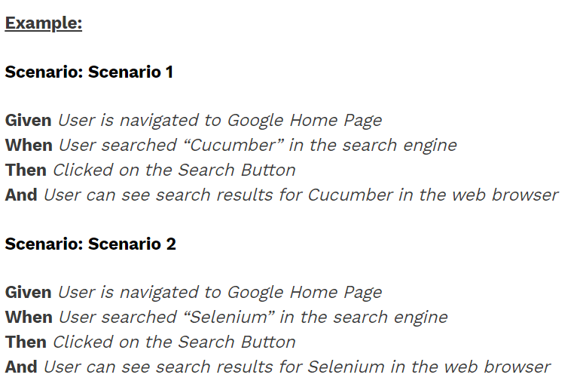
Figure 11 - Given-When-Then Approach [43]
This example shows that Given, When and Then are reusable for the second scenario.
There are also downsides to using BDD. One of them is that if the user is not accessible for communication with the developer, then it will be hard to deal with any questions or uncertainties from the user stories [44]. Structuring the feature files and scenarios incorrectly can create problems for the automation developer, so this needs to be carefully thought up [45]. BDD can lead to higher costs for test maintenance if tests are poorly written [46].

4. Test framework
Jasmine is a BDD framework used to test JavaScript code [47]. A test suite starts by calling the global Jasmine function describe using two parameters i.e. a function and a string [48]. The function being what implements the suite in a block of code and the string being the name for the spec suite [48]. A spec is defined through calling the global Jasmine function it, which also requires a string and a function [48]. A spec has one or more expectations, which are built with the expect function which takes a value, which tests the code state [48].
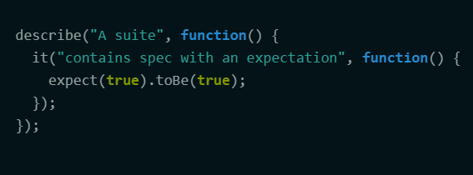
Figure 12 - Jasmine Test Example [48]
Jasmine does not require the DOM (document object model), provides a clean syntax that is easily understandable and has no external dependencies [49]. Jasmine can be used by including the Jasmine core and your test files with a <script> tag, as a CLI tool or library in Node.js or as part of a build system e.g. Grunt.js through grunt-contrib-jasmine [49].
When you first download Jasmine, you will get four folders which are: /src, /lib, /spec and SpecRunner.html [50]. You can reference the source files from where they are currently located in the SpecRunner.html file and delete the /src folder.

5. References

[1] | M. Kumar, S. K. Singh and R. K. Dwivedi, “A Comparative Study of Black Box Testing and White Box,” International Journal of Advance Research in Computer Science and Management Studies, vol. 3, no. 10, pp. 32-44, 2015.
[2] | J. Gao, H.-S. J. Tsao and Y. Wu, “Black-box testing methods for software components,” in Testing and Quality Assurance for Component-based Software, Norwood, Artech House, Inc., 2003, pp. 119-138.
[3] | M. G. Limaye, “Fundamentals of Software Testing,” in Software Testing, New Delhi, Tata McGraw Hill Education Private Limited, 2009, pp. 63-115.
[4] | Y. Irawan, S. Muzid, N. Susanti and R. Setiawan, “System Testing using Black Box Testing Equivalence Partitioning (Case Study at Garbage Bank Management Information System on Karya Sentosa),” in The 1st International Conference on Computer Science and Engineering Technology Universitas Muria Kudus, Kudus, 2018.
[5] | ToolsQA, “Equivalence Partitioning – A Black Box Testing Technique,” [Online]. Available: https://www.toolsqa.com/software-testing/istqb/equivalence-partitioning/. [Accessed 5 February 2020].
[6] | I. Sommerville, “Software Testing,” in Software Engineering, Essex, Pearson Education Limited, 2016, pp. 226-255.
[7] | V. Aksatha and V. Illango, “A Comparative Analysis On Equivalence class partitioning And Boundary value analysis,” International Journal of Recent Trends in Engineering and Research, vol. 4, no. 3, pp. 542-554, 2018.
[8] | Guru99, “Boundary Value Analysis & Equivalence Partitioning with Examples,” [Online]. Available: https://www.guru99.com/equivalence-partitioning-boundary-value-analysis.html#2. [Accessed 5 February 2020].
[9] | K. Rungta, “Testing Types,” in Learn Testing in 1 Day: Definitive Guide to Learn Software Testing for Beginners, Krishna Rungta, 2019.
[10] | Software Testing Help, “What Is Boundary Value Analysis And Equivalence Partitioning?,” [Online]. Available: https://www.softwaretestinghelp.com/what-is-boundary-value-analysis-and-equivalence-partitioning/. [Accessed 5 February 2020].
[11] | D. Graham, E. v. Veenendaal, I. Evans and R. Black, “Categories of test design techniques,” in Foundations of Software Testing: ISTQB Certification, London, Cengage Learning EMEA, 2008, pp. 84-87.
[12] | Olga, “Decision table: How to use it in software testing?,” Merixstudio, 26 November 2019. [Online]. Available: https://www.merixstudio.com/blog/decision-table-software-testing/. [Accessed 5 February 2020].
[13] | Guru99, “Decision Table Testing: Learn with Example,” [Online]. Available: https://www.guru99.com/decision-table-testing.html. [Accessed 5 February 2020].
[14] | L. Copeland, “State-Transition Testing,” in A Practitioner's Guide to Software Test Design, Norwood, Artech House Publishers, 2004, pp. 93-114.
[15] | Guru99, “What is State Transition Testing? Diagram, Technique, Example,” [Online]. Available: https://www.guru99.com/state-transition-testing.html. [Accessed 6 February 2020].
[16] | S. Desai and A. Srivastava, “Black Box Testing,” in Software Testing: A Practical Approach, Delhi, PHI Learning Private Limited, 2016, pp. 116-126.
[17] | ITL Education Solutions Limited, “Black Box Testing,” in Introduction to Computer Science, 2nd Edition, New Delhi, Dorling Kindersley Private Limited, 2011, pp. 249-250.
[18] | D. Galin, Software Quality: Concepts and Practice, Hoboken: John Wiley & Sons, Inc., 2018.
[19] | A. Rongala, “What is Black Box Testing: Advantages and Disadvantages,” 9 March 2015. [Online]. Available: https://www.invensis.net/blog/it/black-box-testing-advantages-disadvantages/. [Accessed 6 February 2020].
[20] | A. Engel, “White Box Testing,” in Verification, Validation, and Testing of Engineered Systems, Hoboken, John Wiley & Sons, Inc., 2010, pp. 356-360.
[21] | Guru99, “What is WHITE Box Testing? Techniques, Example, Types & Tools,” [Online]. Available: https://www.guru99.com/white-box-testing.html. [Accessed 6 February 2020].
[22] | Software Testing Help, “White Box Testing: A Complete Guide With Techniques, Examples, & Tools,” [Online]. Available: https://www.softwaretestinghelp.com/white-box-testing-techniques-with-example/. [Accessed 6 February 2020].
[23] | U. Eriksson, “White Box Testing – Step by Step Guide on Everything you Need to Know,” ReQtest, 28 November 2016. [Online]. Available: https://reqtest.com/testing-blog/white-box-testing-example/. [Accessed 6 February 2020].
[24] | J. J. Malhotra and B. S. Tiple, Software Testing and Quality Assurance, Pune: Nirali Prakashan, 2008.
[25] | G. O'Regan, “Test Case Design Techniques,” in Concise Guide to Software Testing, Cork, Springer Nature Switzerland AG, 2019, pp. 120-127.
[26] | TutorialsPoint, “Branch Testing,” [Online]. Available: https://www.tutorialspoint.com/software_testing_dictionary/branch_testing.htm. [Accessed 7 February 2020].
[27] | SW Testing Concepts, “Statement, Branch and Path coverage,” [Online]. Available: https://sites.google.com/site/swtestingconcepts/home/test-design-techniques/for-white-box/statement-branch-and-path-coverage. [Accessed 7 February 2020].
[28] | GeeksforGeeks, “Data Flow Testing,” [Online]. Available: https://www.geeksforgeeks.org/data-flow-testing/. [Accessed 7 February 2020].
[29] | B. B. Agarwal and S. P. Tayal, Software Engineering, New Delhi: Laxmi Publications Pvt. Ltd., 2009.
[30] | Xenon Stack, “White Box Testing Techniques and Advantages,” 4 December 2018. [Online]. Available: https://www.xenonstack.com/insights/what-is-white-box-testing/. [Accessed 7 February 2020].
[31] | M. Chao, “Difference among Black Box, White Box and Grey Box Testing,” Medium, 2 December 2018. [Online]. Available: https://medium.com/@chaomengting/difference-among-white-box-black-box-and-grey-box-testing-35482292473f. [Accessed 7 February 2020].
[32] | TutorialsPoint, “Software Testing - Methods,” [Online]. Available: https://www.tutorialspoint.com/software_testing/software_testing_methods.htm. [Accessed 7 February 2020].
[33] | Technology Conversations, “Black-box vs White-box Testing,” [Online]. Available: https://technologyconversations.com/2013/12/11/black-box-vs-white-box-testing/. [Accessed 7 February 2020].
[34] | I. Lazar, S. Motogna and B. Parv, “Behaviour-Driven Development of Foundational UML Components,” Electronic Notes in Theoretical Computer Science, vol. 264, pp. 91-105, 2010.
[35] | E. Amodeo, “Welcome to BDD,” in Learning Behavior-driven Development with JavaScript, Birmingham, Packt Publishing, 2015, pp. 7-27.
[36] | L. Karam, “A FEW BENEFITS YOU GET BY DOING BDD,” Apiumhub, 5 September 2017. [Online]. Available: https://apiumhub.com/tech-blog-barcelona/behavior-driven-development/. [Accessed 8 February 2020].
[37] | L. M. Karam, “The Benefits of Behavior-Driven Development,” DevOps Zone, 12 May 2017. [Online]. Available: https://dzone.com/articles/a-few-benefits-you-get-by-doing-bdd. [Accessed 8 February 2020].
[38] | M. M. Moe, “Comparative Study of Test-Driven Development (TDD), Behavior-Driven Development (BDD) and Acceptance Test–Driven Development (ATDD),” International Journal of Trend in Scientific Research and Development, vol. 3, no. 4, pp. 231-234, 2019.
[39] | Automation Panda, “12 AWESOME BENEFITS OF BDD,” [Online]. Available: https://automationpanda.com/2017/02/13/12-awesome-benefits-of-bdd/. [Accessed 8 February 2020].
[40] | P. Soifer, “Why you should consider behavior-driven development,” Belatrix Software, 22 May 2017. [Online]. Available: https://www.belatrixsf.com/blog/behavior-driven-development. [Accessed 8 February 2020].
[41] | K. Kudryashov, A. Stead and D. North, “The beginner's guide to BDD (behaviour-driven development),” Inviqa, 7 October 2015. [Online]. Available: https://inviqa.com/blog/bdd-guide. [Accessed 8 February 2020].
[42] | J. Nair, “What is BDD? An Introduction to Behavioral Driven Development,” TestLodge, 11 September 2018. [Online]. Available: https://blog.testlodge.com/what-is-bdd/. [Accessed 8 February 2020].
[43] | Software Testing Help, “BDD (Behavior Driven Development) Framework: A Complete Tutorial,” [Online]. Available: https://www.softwaretestinghelp.com/bdd-framework/. [Accessed 8 February 2020].
[44] | Agilest, “Behavior Driven Development,” [Online]. Available: https://www.agilest.org/devops/behavior-driven-development/. [Accessed 9 February 2020].
[45] | Automated-Testing, “BDD Pros and Cons,” [Online]. Available: http://www.automated-testing.com/bdd/bdd-pros-and-cons/. [Accessed 9 February 2020].
[46] | Archi Develop, “BDD Advantages and Disadvantages,” [Online]. Available: http://defectracker.com/2017/12/20/bdd-advantages-and-disadvantages/. [Accessed 9 February 2020].
[47] | Jasmine, “Sample Code,” [Online]. Available: https://jasmine.github.io/. [Accessed 9 February 2020].
[48] | Jasmine, “introduction.js,” [Online]. Available: https://jasmine.github.io/2.0/introduction.html. [Accessed 9 February 2020].
[49] | A. Bouchefra, “An Introduction to Jasmine Unit Testing,” freeCodeCamp, 13 December 2018. [Online]. Available: https://www.freecodecamp.org/news/jasmine-unit-testing-tutorial-4e757c2cbf42/. [Accessed 9 February 2020].
[50] | L. Gupta, “Jasmine unit testing tutorial with examples,” HowToDoInJava, [Online]. Available: https://howtodoinjava.com/javascript/jasmine-unit-testing-tutorial/. [Accessed 9 February 2020].

