NAME : ANDREEA EMILIA SMARANDA
STUDENT NUMBER : 2024064
ASSIGMENT TITLE : ACCOUNTING FUNDAMENTALS-ASSIGNMENT -A1
MODULE CODE :LCBB4001
MODULE LECTURER’S NAME : DR WIDIN BONGASU SHA’VEN

Table of Contents
Introduction 3
Question 1 3
a. Presentation of P&L and balance sheet 3
b. Reason behind balancing financial position 5
Question 2 5
a. Ratio analysis 5
b. Comments on the ratio analysis 13
Conclusion 13
References 14

Introduction
Accounting takes part in major activities in a business-like identifying, communicating, and recording accounting activities. It provides quantitative financial information for making a better decision for the business. In this study, the P&L and balance sheet statement has been presented and analyzed according to the Kedison PLC performance. Ratio analysis has also be done on the basis of Chocco plc performance.

Question 1

a. Presentation of P&L and balance sheet
Profit and Loss
The financial health of a business can be measured with the help of a P&L account. The statement helps to summarize all the revenues, expenses, and costs of a business during a period (Ajmi et al. 2019, p.56). The actual amount of money a business earns can be determined by this account.
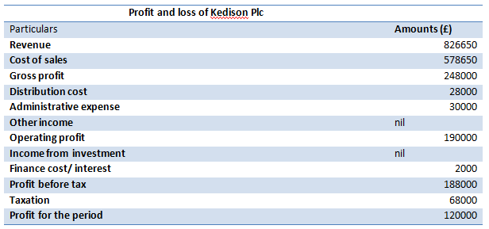
Figure 1: P&L
(Source: self-prepared)
The figure projected above is the P&L statement of Kedison PLC on the date of 31st December 2020. The total amount of revenue recorded by the organization was £826650. They have also paid the cost of sale for that they paid £578650 respectively. After the deduction, the value of GP reflects £248000 respectively. After deducting the administrative and distribution costs the operating profit reflects £190000 respectively. After paying the tax of £68000 the actual net profit earned by the business reflects £120000 respectively.
Balance sheet
One of the most useful and common financial statements that are used for evaluating the liability, equity, and assets amount in the business is the balance sheet. The basic computing rates have been provided by it for evaluating the capital structure (Fleckenstein and Longstaff, 2020, p. 5051). The amount of money a firm owns and owes from its business can be estimated by this statement.
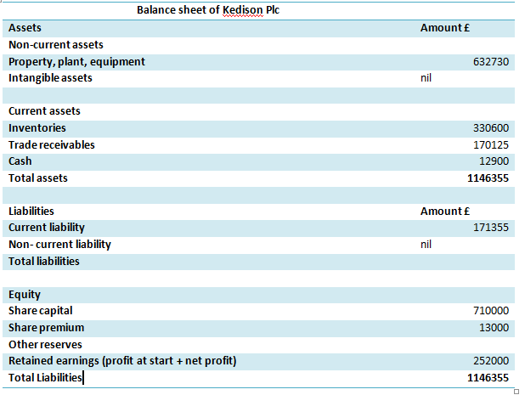
Figure 2: balance sheet
(Source: self-prepared)
The figure projected the balance sheet of the Kedison PLC on dated 31st December 2020. On the assets side of the balance sheet, the total value of non-current assets reflects £632730 respectively. On the section of current assets, the value of inventory shows £330600, the value of trade receivable shows £170125 and the cash amount shows £12900 respectively. Therefore, the total value of the assets reflects £1146355. On the equity and liability portion, the total value of current liability reflects £171355. On the equity head, the share capital and share premium reflect £710000 and £13000 respectively. After adding the retained earnings of £252000 the total value of equity and liability side reflects £11146355 respectively.

b. Reason behind balancing financial position
It becomes necessary to balance the financial position for getting a snapshot regarding the assets as well as the liability position of the business. At a single point, the worth of the business can be estimated by the owners and investors (Bills et al. 2021, p.125). The other reason is as per the accounting principle every double-entry account needs to be balanced for getting a more accurate result.

Question 2

a. Ratio analysis
ROCE
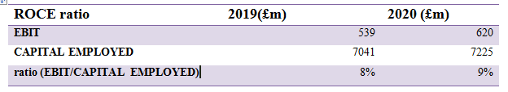
Figure 3: ROCE
(Source: Self-prepared)
Meaning
The profitability of a business in terms of its capital can be measured by the ROCE ratio. It also takes part in improving the profit-making ability of a business.
Changing values
In 2019, the value of EBIT reflects £720m and the value of capital employed reflects £7225m respectively.
In 2020, the value of EBIT increases to £846m, and the value of capital employed decreases to £7041m respectively.
Comparison
The increase and decrease in EBIT and capital employed value increase the ratio from 8percent to 9 percent in 2020. It provides better profit in the organization.
Ways for improvement
Chocco plc needs to sell their old equipment that will help to reduce their capital employed and increase the ratio.
ROE
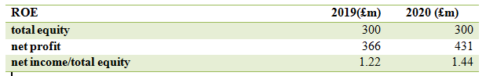
Figure 4: ROE
(Source: Self-prepared)
Meaning
ROE ratio calculates the net income of the shareholders by dividing net profit by shareholders equity amount.
Changing values
In 2019, the value of equity reflects £300m and the value of NP reflects £366m respectively.
In 2020, the value of equity remains the same £300m, and the value of NP increases to £431m respectively.
Comparison
The increasing value of NP helps to increase the ratio from 1.22 percent to 1.44 percent in 2020 as compared to 2019. Therefore, the investors will get a better return on their investment.
Ways for improvement
Increasing the price of the product and reducing the cost of labour can helps to improve the ratio of Chocco plc.
EPS
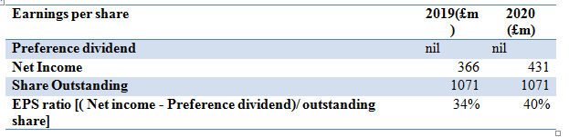
Figure 5: EPS
(Source: Self-prepared)
Meaning
The amount of income inventors get for their single amount of investment is called Earning per share.
Changing values
In 2019, the value of net NP reflects £366m and the value of outstanding share reflects £1071m respectively.
In 2020, the value of net NP increases to £431m, and the value of outstanding shares remains the same £1071m respectively.
Comparison
The increasing value of NP increases the ratio in 2020 from 34 percent to 40 percent. Therefore, the investor’s income will increase per investment.
Ways for improvement
Chocco plc can buy back their share by that it will reduce outstanding stock and the ratio will improve.
NP Margin
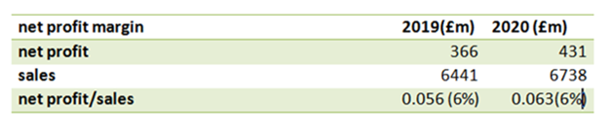
Figure 6: NP margin
(Source: Self-prepared)
Meaning
The actual amount of profit owners get after meeting all expenses and debts is called the net profit and the percentage of return get on sales amount is called NP margin.
Changing values
In 2019, the value of NP reflects £366m, and the value of sales reflects £6441m respectively.
In 2020, the value of NP increases to £431m, and the value of sales increases to £6738m respectively.
Comparison
The increasing value of NP and sales increase the ratio in 2020 from 0.056 percent to 0.063 percent. Therefore the profit percentage will increase in the business.
Ways for improvement
Chocco plc needs to increase their ales volume and can raise their product price to improve this ratio.
Asset turnover
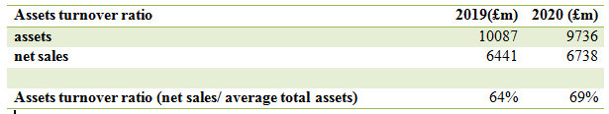
Figure 7: Assets turnover
(Source: Self-prepared)
Meaning
The assets turnover measures the average assets and the net sales of the organization by dividing the value of net sales by average total assets.
Changing values
In 2019, the value of assets reflects £10087m and the value of net sales reflects £6441m respectively.
In 2020, the value of assets decreases to £9736m, and the value of net sales increases to £6738m respectively.
Comparison
Although the assets portion gets to decrease the increasing value of sales increases the ratio in 2020 from 64 percent to 69 percent.
Ways for improvement
Chocco plc needs to increasing their leasing capacity that will help them to hold more cash in the business and improving the ratio.
Stock holding days
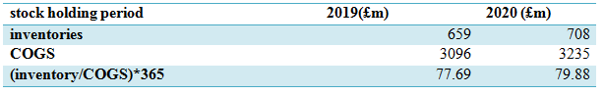
Figure 8: stock holding
(Source: Self-prepared)
Meaning
The time between purchasing a stock and selling the stock is called the stock holding period.
Changing values
In 2019, the value of inventory was £659m, and the value of COGS reflects £3096m respectively.
In 2020, the value of inventory increases to £708m, and the value of COGS increases to £3235m respectively.
Comparison
As per the increase in inventory and COGS value the holding period gets an increase in 2020 (78.79) as compared to 2019 (77.69) respectively.
Ways for improvement
Chocco plc needs to do their demand forecasting on a better note to improve this period.
Debtors collection period
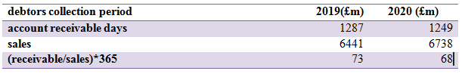
Figure 9: collection period for debtors
(Source: Self-prepared)
Meaning
The number of days taken by a business to collect money from their clients and customers is called the collection period for debtors.
Changing values
In 2019, the value of sales reflects £6441m and the value of receivable amount reflects £1287m respectively.
In 2020, the value of sales increases to £6738m, and the value of the receivable amount decreases by £1249m respectively.
Comparison
The increasing amount of sales helps to reduce the receivable amount and therefore, the number of day’s decreases from 72 days in 2019 to 67 days in 2020.
Ways for improvement
Proper receivable management and the increasing amount of cash sales can improve the period better in Chocco plc.
Current ratio
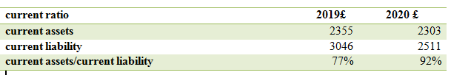
Figure 10: Current ratio
(Source: Self-prepared)
Meaning
The ability to pay short-term debts and the liquidity portion of a business can determine the current ratio.
Changing values
In 2019, the total value of CL reflects £3046m and the total value of CA reflects £2355m respectively.
In 2020, the total value of CL decreases to £2511m and the total value of CA decreases to £2303m respectively.
Comparison
The value of CA and CL both get decrease therefore, the ratio increased in 2020 (92 percent) from 2019 (77 percent). Therefore, Chocco plc efficiently reduces their CL in its business.
Ways for improvement
Chocco plc needs to sell their unusable and old assets to improve their liquidity and improving the ratio.
Gearing ratio
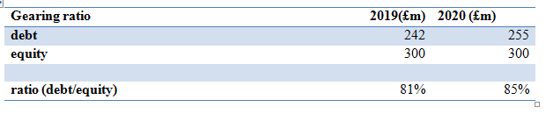
Figure 11: Gearing ratio
(Source: Self-prepared)
Meaning
This is financial matrices which help to compare equity of shareholders as comparison with the debt of the business and helps to determine the financial leverage.
Changing values
In 2019, the value of equity reflects £300m and the value of debts reflects £242m respectively.
In 2020, the value of equity remains the same £300m and the value of debts increases to £255m respectively.
Comparison
As per the increase in debt amount the ratio increase 81 percent (2019) to 85 percent (2020) respectively. Therefore it will help to improve the financial leverage of Chocco plc.
Ways for improvement
Buying back their ordinary can improve the gearing ratio of Chocco plc.
Invertors cover
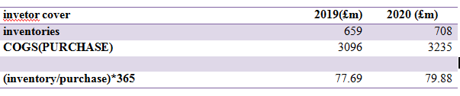
Figure 12: Inventor cover ratio
(Source: Self-prepared)
Meaning
The time between purchasing a stock and selling the stock is called the stock holding period.
Changing values
In 2019, the value of inventory was £659m, and the value of COGS reflects £3096m respectively.
In 2020, the value of inventory increases to £708m, and the value of COGS increase to £3235m respectively.
Comparison
As per the increase in inventory and COGS value the holding period gets an increase in 2020 (78.79) as compared to 2019 (77.69) respectively.
Ways for improvement
Chocco plc needs to do their demand forecasting on a better note to improve this period.

b. Comments on the ratio analysis
With the help of the ROCE and ROE ratio, the financial efficiency of Chocco plc has been evaluated and that ratio shows an increase from the previous year’s business. The profitability ratio has been determined with NP margin ratio and that indicates the firm efficiently increase their profit percentage from the previous year. The efficiency ratio has been determined by the collection period and that shows the collection period of debtors get decreases that is a good indication for the business. Therefore, the inventors can invest in this business risk-free and they will get a valuable return as the performance of the business increasing day by day.

Conclusion
The study can be concluded that financial statements are very useful to determine the efficiency of Kedison plc and Chocco plc. The amount of money a firm owns and owes from its business can be estimated by the balance sheet. The Kedison PLC effectively managing their business operations and maintain good profit percentage in their business. The Chocco plc improves their performer from their previous year of business.

References
Ajmi, H., Abd Aziz, H., Kassim, S. and Mansour, W., 2019. Adverse selection analysis for profit and loss sharing contracts. International Journal of Islamic and Middle Eastern Finance and Management.
Bills, J.R., Nagornov, K.O., Kozhinov, A.N., Williams, T.J., Tsybin, Y.O. and Marcus, R.K., 2021. Improved Uranium Isotope Ratio Analysis in Liquid Sampling–Atmospheric Pressure Glow Discharge/Orbitrap FTMS Coupling through the Use of an External Data Acquisition System. Journal of the American Society for Mass Spectrometry, 32(5), pp.1224-1236.
Cetin, E.I. and Icigen, E.T., 2017. Personnel selection based on step-wise weight assessment ratio analysis and multi-objective optimization on the basis of ratio analysis methods. International Journal of Economics and Management Engineering, 11(11), pp.2718-2722.
Fleckenstein, M. and Longstaff, F.A., 2020. Renting balance sheet space: Intermediary balance sheet rental costs and the valuation of derivatives. The Review of Financial Studies, 33(11), pp.5051-5091.



