Catalin Dragomir - 2327893
Independent Project Part 1

University of wales trinity saint david | London
2026
Contents
Introduction / Background to the Proposed Research 2
Aim: 3
Objectives: 3
Expected Deliverables: 4
Project Design 4
Project Design 4
Outline of Project Design 4
Data Collection Methods Per Objective 4
Development Methods and Tools 4
Risks, Limitations and Ethical Considerations 5
Generalisability, Reliability and Validity 5
Data Analysis 5
Resource and Planning 5
Resource Required 5
Project Planning 6
Conclusion 6
References 6

HoneyWatch : Design and Development of a Low Interaction Honeypot System

Introduction / Background to the Proposed Research
The internet is under constant attack. Automated bots and malicious scripts scan millions of public IP addresses every single day, looking for open ports, weak credentials, and misconfigured services to exploit. According to ENISA, brute force and automated scanning attacks remain among the most frequent and persistent threats targeting internet facing systems [1]. What makes this particularly interesting from a research perspective is that most of these attacks are never seen by the people being targeted. They happen silently, in the background, and leave very little trace unless someone is specifically looking for them.
To study this kind of behaviour, security researchers use a technique called honey potting. A honeypot is a deliberately exposed system that mimics real network services in order to attract attackers and log everything they do, without putting any actual infrastructure at risk. The concept was first introduced by Clifford Stoll in 1989 [2] and later formalised by Lance Spitzner through the Honeynet Project [3], which established honeypots as a legitimate and widely used research methodology in cybersecurity.
Research in this area has shown that even simple honeypot deployments attract real attack traffic almost immediately after being exposed to the internet. Vetterl and Clayton at the University of Cambridge found that low interaction honeypots begin receiving automated connection attempts within minutes of deployment [4]. A separate study published in Computers and Security confirmed that cloud hosted honeypots can collect statistically significant volumes of data within just a few days, with SSH brute force being the most observed attack type [5]. However, most existing implementations rely on heavyweight pre-built frameworks like T-Pot or full ELK stacks, which require significant hardware resources and are not practical for individual researchers or small teams.
This is the gap my project addresses. HoneyWatch is a lightweight, Python based honeypot system built from scratch and deployed on a rented Virtual Private Server. Instead of relying on existing platforms, I will write the scripts myself, collect real-world attack data over a live deployment period, and visualise the findings through a custom web dashboard. This makes the project both original and practically demonstrable.
The field this project sits in is threat intelligence and network security monitoring, which are directly relevant to roles such as SOC Analyst and Junior Penetration Tester. By building and deploying HoneyWatch, I aim to contribute a lightweight, reproducible approach to honeypot research that does not depend on expensive or complex infrastructure.
Aim:
To design, develop, and evaluate a low interaction honeypot system capable of capturing and analysing real world attack patterns in order to generate actionable threat intelligence and demonstrate the nature of automated cyber threats targeting exposed network services.

Objectives:
- To evaluate existing literature and honeypot methodologies in order to identify best practices and justify the technical approach taken in this project.
- To design and deploy a Python based honeypot on a rented VPS, simulating SSH, HTTP, and FTP services to attract and log automated attack traffic.
- To develop an integrated monitoring and visualisation system that captures attacker IP addresses, identifies their geographical location in real time, and displays the findings through an interactive web dashboard.
- To analyse the collected attack data over a minimum seven day deployment period and evaluate the findings against existing research in the field.
Expected Deliverables:
At the end of this project I will submit a fully functional honeypot system with source code, a live or recorded demonstration of the dashboard, and a written report containing the analysis of real attack data collected during deployment, including credential patterns, geographical distribution of attacks, and conclusions drawn from the findings.

Project Design

Project Design
This project follows a product development approach. Rather than analysing existing datasets, I will build a functional system from scratch, deploy it on live infrastructure, and collect real world attack data through it. The project is divided into four stages that map directly to the objectives outlined in section one.

Outline of Project Design
HoneyWatch is a low interaction honeypot system built entirely in Python and deployed inside Docker containers on a rented Virtual Private Server. The system simulates three network services, SSH on port 22, HTTP on port 80, and FTP on port 21, which are among the most frequently targeted services by automated scanners according to the literature reviewed. Each service runs in an isolated container, meaning that even if an attacker connects, they cannot access the host system or any real data. All connection attempts are logged automatically to a local SQLite database, and a web dashboard built with Streamlit displays the collected data in real time.

Data Collection Methods Per Objective
For Objective 1, which involves evaluating existing literature, no primary data is collected. The data gathered here is secondary, consisting of academic papers, governmental reports and industry publications reviewed and synthesised to justify the technical approach taken in this project.
For Objective 2, which involves designing and deploying the honeypot on a VPS, the data collected includes connection logs from the three simulated services, SSH, HTTP and FTP. Specifically, the Python scripts record the source IP address, targeted port, timestamp, and any credentials attempted by the attacker. This data is needed to establish a baseline of attack activity and to confirm that the honeypot is functioning correctly.
For Objective 3, which involves developing the monitoring and visualisation system, the data collected is the geographical enrichment of each IP address. Each captured IP is sent to a public Geo IP API via HTTPS, which returns the country, city and coordinates. This data is needed to populate the interactive world map on the dashboard and to analyse the geographical distribution of attacks.
For Objective 4, which involves analysing the collected data over a seven day deployment period, the full dataset from the SQLite database is used. This includes attack frequency by port, credential patterns, peak attack times and geographical distribution. This data is needed to draw conclusions and compare findings against existing research.

Development Methods and Tools
I chose Python as the primary language because it is widely used in cybersecurity tooling and provides extensive library support for network programming and data visualisation [6]. Docker is used for containerisation because it provides strong isolation between the honeypot services and the host system, which is essential for safety [7]. SQLite was chosen for storage because it is lightweight, requires no additional configuration, and is sufficient for the volume of data expected. Streamlit was selected for the dashboard because it allows rapid development of interactive web interfaces without requiring a full web framework.

Risks, Limitations and Ethical Considerations
The main technical risk is that the VPS could be fully compromised if the containerisation is misconfigured. To mitigate this, each service runs in a separate Docker container with no write access to the host. The project complies fully with the UK Computer Misuse Act 1990 and GDPR, as the system only passively receives inbound connections and does not initiate any attacks. There are no human participants involved. The only personal data collected are public IP addresses, which are stored securely and will be anonymised in the final report.

Generalisability, Reliability and Validity
The data collected will be real but limited to a single IP address over a seven day period. This means the findings cannot be generalised to represent the entire threat landscape, but they are sufficient to identify patterns and compare results against existing literature. Reliability is ensured by the automated and consistent nature of the logging system.

Data Analysis
I will analyse attack frequency by port, geographical distribution of source IPs, most commonly attempted credentials, and peak attack times.

Resource and Planning

Resource Required
For hardware, the project requires a personal laptop or desktop computer for development and testing, and a rented Virtual Private Server with a public IP address for live deployment. The VPS will be sourced from a low cost provider such as DigitalOcean or Vultr, at an estimated cost of around five pounds per month.
For software and programming languages, the project will use Python 3 as the primary development language, Docker for containerisation, SQLite for data storage, and Streamlit for the web dashboard. All of these are free and open source. Development will take place in Visual Studio Code.
For research and literature access, the project will use Google Scholar, the UWTSD library database, IEEE Xplore, and MDPI for accessing academic journals. ENISA publications are freely available on their official website.

Project Planning
The table below outlines the planned timescales for each component of the study:
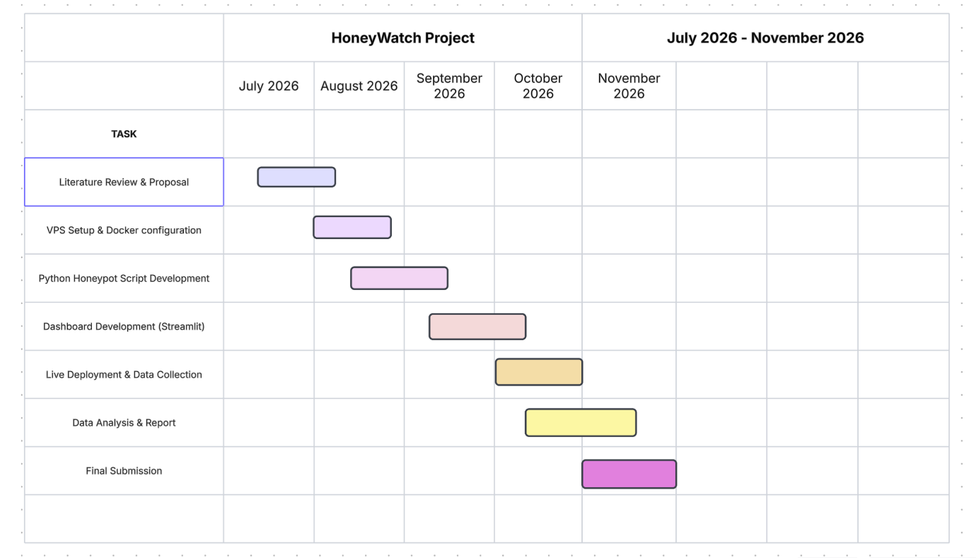

Conclusion
This proposal outlines a practical and technically grounded research project that addresses a real and ongoing cybersecurity threat. By building and deploying HoneyWatch on live infrastructure, I aim to collect genuine attack data and contribute a lightweight, reproducible approach to honeypot research. The project is directly relevant to my degree pathway and provides a strong foundation for a career in cybersecurity, particularly in roles such as SOC Analyst or Security Engineer.

References

[1] | ENISA, “Threat Landscape 2024,” 2024. [Online]. Available: https://www.enisa.europa.eu/topics/cyber-threats/threat-landscape.
[2] | C. Stoll, “ The Cuckoo's Egg: Tracking a Spy Through the Maze of Computer Espionage,” New York, Simon and Schuster, 1989.
[3] | L. Spitzner, “Honeypots: Tracking Hackers,” United States, Addison Wesley Longman Publishing Co, 2002.
[4] | A. V. a. R. Clayton, “Honware: A Virtual Honeypot Framework for Capturing CPE and IoT Zero Days,” 2019.
[5] | C. Kelly, “A Comparative Analysis of Honeypots on Different Cloud Platforms,” vol. 21, no. 7, 2021.
[6] | J. M. Ortega, Python for Security and Network, Packt Publishing, 2023.
[7] | A. M. r. D. P. Theo Combe, “To Docker or Not to Docker: A Security Perspective,” 2016.

