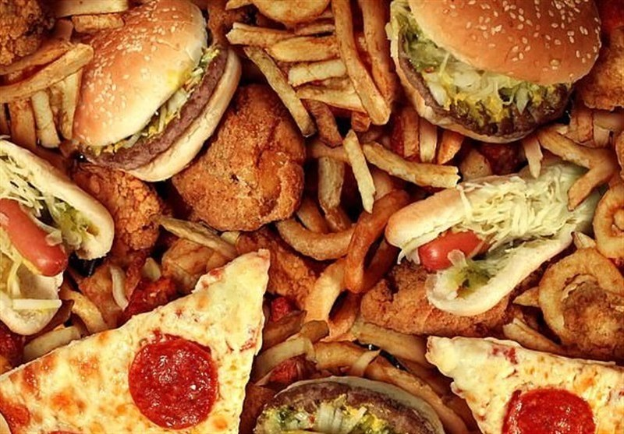
Physical development of a child due to poor nutrition
Poor nutrition also known as malnutrition is a very serious cause for concern as it affects not only the child at the time of experiencing the malnutrition but affects them for the rest of their lives. I find that malnutrition is a very serious problem as it is not the fault of the children who suffer from malnutrition but those before them being unable to make a stable environment for where they can have a healthy amount of food where they don't lack any of the needed nutrients for them to grow properly. in this I will be talking about facts relating to poor nutrition for children which is not limited to just a lack of food, and how it affects the physical development of children. Also giving my opinion among the information that will be used in this blog and then give my overall thoughts at the end of the blog. The information was acquired from unicef.org.uk and agtgenetics.com.
Upon searching the internet, I had found out that almost two in three children between the ages of six months and two years of age are not fed equal to the pace of the development of their bodies and brain which in result would cause there to be many issues for the child to be facing, such as poor brain development which can lead to main health concerns for the child later in life. another issue would be poor immunity and weak learning abilities both of which would set them back far in life as we have compulsory education which in most people's eyes decide what they can do in the future. An example of this is, if one has high marks one can get a high paying job but if someone has low marks then they will more than likely get a low paying job and poor immunity meaning it is easier to get sick and pick up diseases thus jeopardising those around you which would also lower chances of a stable life after graduation of their school. There have also been cases that due to poor nutrition in a body it will eventually absorb itself in order to have some sort of nutrient intake for the body to survive. Unfortunately in the end this would result in the death of the malnutritioned as why, when you see someone starving to death, their body becomes thin and frail, as if they were a skeleton with human skin.
Searching through the same website as the prior paragraph I was able to find statistics on poor nutrition for children and it shows that one hundred and forty nine million children are stunted, or are too short for their age and as you would guess, it is because of a lack of food to support their growth and from this we can tell that these children belong to the poorest of communities or are in very poor conditions and are neglected by those who act as their guardian. Another statistic shows that fifty million are too thin for their height this could be due poor nutrition but it also could be due to the child gaining an eating disorder due to environmental factors such as those who were around them at the time and ridiculed the child for eating too much or insulting them resulting in them to eat as little as possible. Another of these statistics shows that three hundred and forty million or fifty percent of all children in the world under the age of five suffer from deficiencies in essential vitamins and nutrients such as vitamin A and iron, which could be the results of genetics which causes disorder for their vitamins and nutrients intake or it could be a result of poor dietary due to the child disliking the food or drinks containing the vitamins or nutrients. another thing to mention is that on the website it states that one in three children in the UK are now overweight or obese when they leave school with children from poor areas twice as likely to be obese. This is more linked to me as when I left schools I was more chubby and overweight compared to some of my fellow students and using the website's words, the so-called ''food swamps'' are really affect people as junk food and other unhealthy food are cheaper and most cases tastier than the healthy and expensive food which in my opinion if they want people to be less obese and more healthy they should flip things around and make healthy food cheap while make junk food and unhealthy food expensive and that would eventually reduce the obesity rate in the country.
To conclude what I have said, poor nutrition can be caused by environmental causes such as people around you, where you live and the family income which can be changed to some degree for example avoiding hanging around those who make fun of you so no eating disorder develops change where you live while it may take a while it would do the best for both mental and physical health and the family income situation can be improved upon if the parents either take on more jobs or look for better paying jobs. It is also known that obesity is a type of malnourishment and the method to solving obesity which is also known as overweight, is to reduce intake of unhealthy foods and focus more on the healthier dishes, if people around you make fun of you for your weight then leave their side and look for new friends and this will help with solving an eating disorder one may have and finally work out so your body loses weight quicker and helps reduce any mean things people may say towards you due to weight.

The effects of poverty on mental wellbeing

Living in poverty is what many people strive to avoid as when you are in poverty it means you are one step from homelessness if not there already, everything must be calculated so you don't overspend and the things that the average person takes for granted is no different to that of a luxury item worth a lot. In this blog I will be talking about the effects that poverty has on the mental wellbeing of a child to young adult and explaining with factual information that I got from the internet on how this affects these young people and mixing in my opinion in it as to give a bit more of a deeper dive into the topic itself as poverty is having a major effect on children, young adults and everyone after that due to it being such a serious concern. The information was acquired from compassion.com and research.senedd.wales.
Among the information that I have gathered for this topic I have statistics relating to the mental wellbeing/ mental health conditions of children in poverty from around the world, one of said statistic is that mental health conditions account for sixteen percent of the global burden of disease and injury in children aged ten to nineteen. Whilst it may not be a high percentage but one must remember that it is not sixteen percent of a country but the whole world and that would mean that at the very least the lowest number of children in that count would be around several dozen million children that are suffering from disease and injuries that they cannot have taken care of due to being in poverty. From the same website at the previous point it states that childhood and adolescence are crucial times for developing habits important for physical, emotional and mental wellbeing, which in simple terms is that during these times everything that happens around these children will decide for the children such as the future of these children in both a positive and negative sense. This leads to the next point in which it talks about how poverty amplifies the negatives such as the challenges that one would face like the limitation of every little thing, the stress that comes from being in poverty and not being able to get anything that you like, the trauma that may happen due to the child's guardian taking their stress out on them or from something else and goes further to mention that in poverty that children are in great danger as they are unable to defend themselves and are easy outlets for stress in some extreme but realistic cases.
The next website I found has some similarities in which they talk about how people who live in poverty suffer from high levels of stress due to many factors such as struggling to make ends meat, from being overcrowded or because the house is unsafe, also the possibility of crimes that could happen at any time and even due to the poor health that is caused by living in poverty. Among the statistic I have there is one that states that in Wales, that children from the poorest of households are four time more likely to have serious mental health difficulties by the age of eleven compared to children from the wealthiest twenty percent and from my understanding this is because of the environment as the wealthiest children can get pretty much whatever they want as such they are more likely to not have any mental health complications compared to those of the poorest household where they would be happy if they got a bar of chocolate that week. The website mentions that poverty is a two-way street as it can be both the cause and the consequences from your mental health illness and as one would know mental health illness vary widely such as depression, anxiety, schizophrenia and many more, and due to there being so many mental health illnesses the cause and consequences can vary widely but one fact stays the same and that is if one goes into poverty one does not come back out as the same person due to fact that poverty has a huge effect on people without them knowing, like a subconscious desire to avoid all poverty related things or places.
To conclude on what I have previously said about how poverty's effect on the mental wellbeing of children along with my opinion. I believe that poverty affects everyone in some way such as for those in poverty it affects them because they have to live in poverty with all the dangers with it, such as the danger of becoming homeless as that is the next step if one in poverty is unable to make enough money, there is also the worry of crimes occurring such as a robbery, an assault, or even being abducted into trafficking ring or a drugs gang and many others. This is a real worry as if someone is living in poverty the place they live is most commonly an area with a lot of crime and the constant stress does not help as previously mention. It is very likely that one could develop a mental health condition by living in poverty as it is not a place people can comfortably live in and feel secure. In my opinion overall I would say that poverty has a major effect on the mental wellbeing of children as it could shape who they become in the future and the future may be very dark and sad for their future self.

affects the Covid-19 virus pandemic has on mental wellbeing
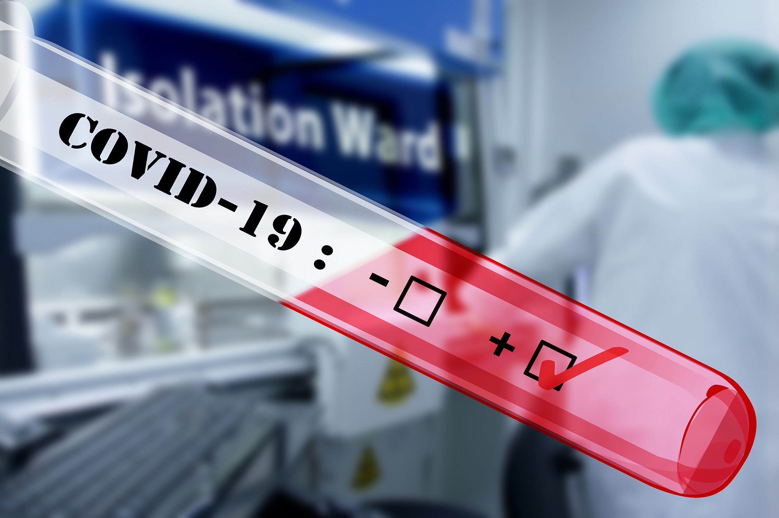
In this blog I will be speaking about the effects that the Covid-19 virus pandemic had on the minds of young people and what was the result of the lockdowns through the two years Covid had claim many of the lives of our friends, loved ones, acquaintances and those we don't but will remember. I will mainly being talking about information I have found on the internet about Covid and how it affected people mentally and adding my own words in to make it easier to understand it. I will also talk about my own opinion as I had experienced the pandemic myself. The information was acquired from research.senedd.wales and benendenhealth.co.uk.
From the data shown on the website, before Covid-19, almost twenty five percent of people in Wales lived in poverty and children were the most likely to end up in poverty than any other age group with thirty one percent living in poverty and while still being calibrated the data showing the effects that Covid had long-term are still in the making, the article in question states that in the last two years, the least well off in our communities were the hardest and same with many others as many small and medium sized companies were forced to be closed and file bankruptcy as in the early time of the pandemic was the most frantic from fighting in the shops and supermarkets toilet rolls and long lasting foods and necessities to the massive strikes throughout the world where many shops were broken into and smashed with little left behind and from what I've said it is clear that for some the mental wellbeing of these people were all over the places and were thrown into a somewhat extreme environment. Another effect Covid had was that low paying workers were quickly being fired due to the difficulty for managers and bosses to pay their employees and had found it easier to fire them whilst the pandemic had not hit the business's economy hard and due to this many workers were in a state of panic and extreme stress worrying about how they will make money so that they don't starve and while small and medium companies took massive hits during the pandemic the big and well-known companies practically had a field day and made lots of money.
From the other website it states that many were struggling with learning due to it being online and for some it was thought the lockdown was a form of holidays as they were not needed to be sent to school in the early mornings. However, due to the lockdown there were many problems facing children such as the missing of normal everyday activities such as going to see their friend to play games inside, going out to play football or even sleepovers and it was not helpful for many when they were constantly reminded on the news and radio how the death toll was increasing, and the infection rate become higher and higher. This was all clear to everyone as from the website it said that one third of parents had seen negative impacts on their children's mental wellbeing and that was only recorded so it could very well be higher than we believe it is. From an NHS Digital survey, they had found that over half of those between the ages of five and twenty two, had found out that lockdown had made their lives harder and the centre of mental health believe that even after the pandemic that around one and a half million children will need ongoing support in the aftermath. It also mentions that students found it difficult to properly study and learn when there was no face-to-face support from teachers and also the social interactions with friend as in the early lockdown it was frowned upon if you went out to meet friend and was told one could go out only if truly necessary which limited most contact between people and later when they did online learning in the 2020/21 autumn term the teachers had learned that the learning and development of students faltered which raised many concerns from teachers and parents alike.
To conclude on what I have previously said, I believe personally that covid-19 had a massive impact on the children's mental wellbeing as I personally believe that everyone who entered the pandemic did not come out as the same person afterward as the whole period of the pandemic was like a rollercoaster. We were in and out of lockdowns and in and out of schools, and stress constantly built up in people resulting in some people being unable to cope with life and resulting many unforeseen incidents. I found the lockdown at the start a fortunate event until after a while I was bored, stressed, angry a lot of the time and there were many cases of people breaking down in my family as me and my brother were in and out of school online and real-life, our mother was a frontline worker and my gran was retired but had a chronic condition that made her vulnerable, so there were many worries and we managed to come out relatively fine and closer than we were before the pandemic.

