The ‘Supporting Opportunity in Schools (SOS)’ project is an Erasmus+ programme co-funded by the European Union. This project is a transnational initiative of nine institutions and is coordinated by the Inspectorate of Education of Catalonia with the aim to empower schools to enhance and to assess school equity. The team is comprised of institutions from Catalonia (Inspectorate and School group), Wales (UWTSD and Pembroke Dock Community School), Romania (Inspectorate and University of Sibiu), Belgium (Go! School Group) and Italy (School group), who are working together to create a framework to assess equity in schools. Universities provide knowledge on equity and draw together the theoretical framework of the project. Educational authorities provide expert knowledge on school evaluation, and schools provide exemplars of effective school practice developing equity in education.

General Project Objectives
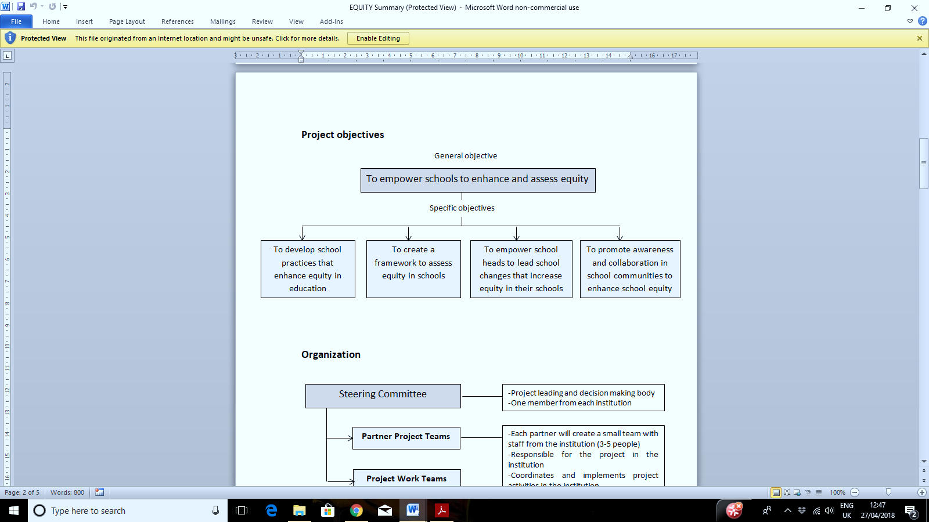
Project Outcomes
Project outcomes will include:
- Practitioner’s Guide
- Framework of Equity Indicators
- Best Practice Examples and Videos
- Digital Tools
- School Leader Training Course
- Project Website (http://euschoolequity.org/)

