University of Wales
Trinity Sain David
LCHS4003

Introduction to Health and Social Care
Title: Portfolio – Two Tasks

Module leader: Dr Patronella Ganza
Submission date: 17 November 2025
Student name: Valentin Atanasov
Student number: 2441144
Word count: 1,480

Contents
Task 1 - poster 2
Task 2 – Essay 7
The Origins and Structure of the National Health Service (NHS) 7
Introduction 7
Conclusion 9
References 10

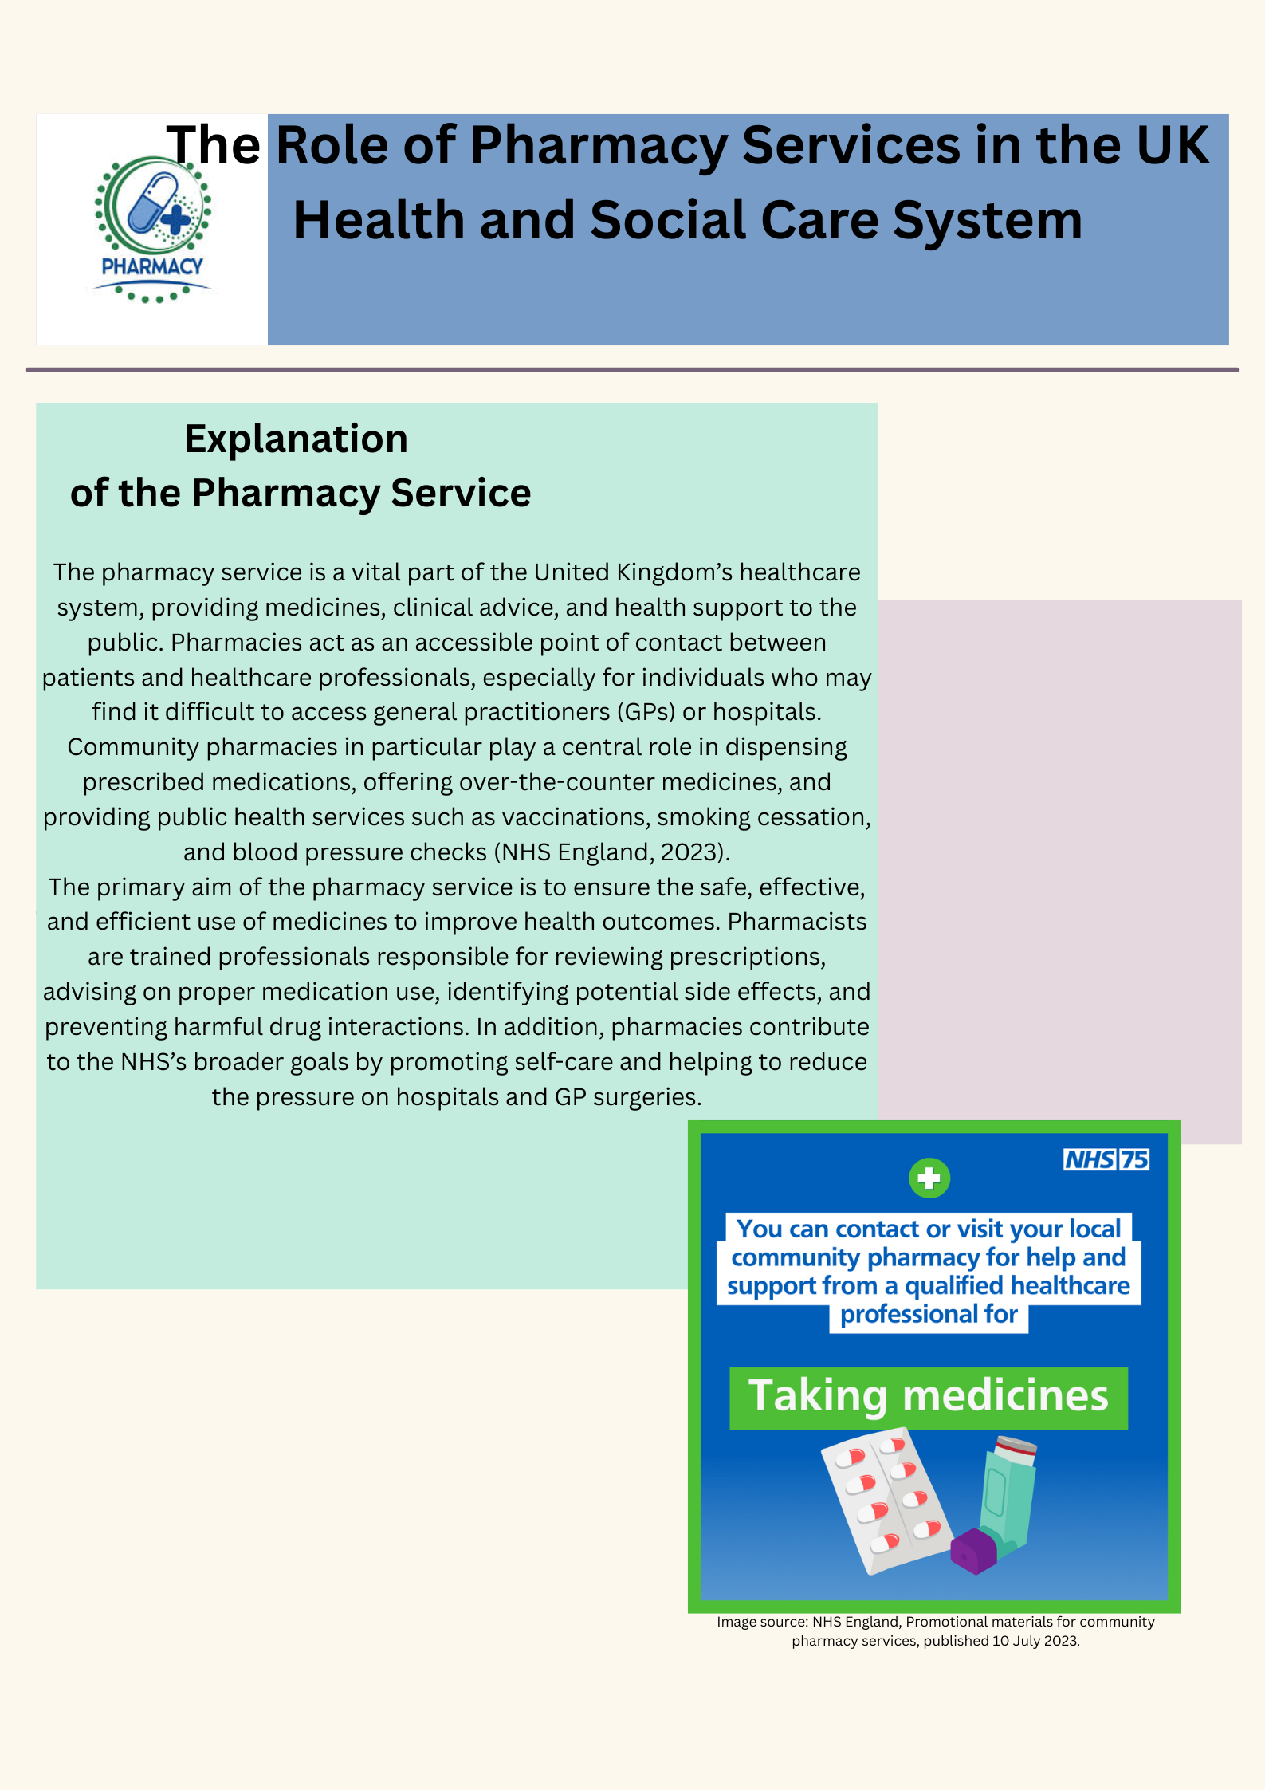
Task 1 - poster

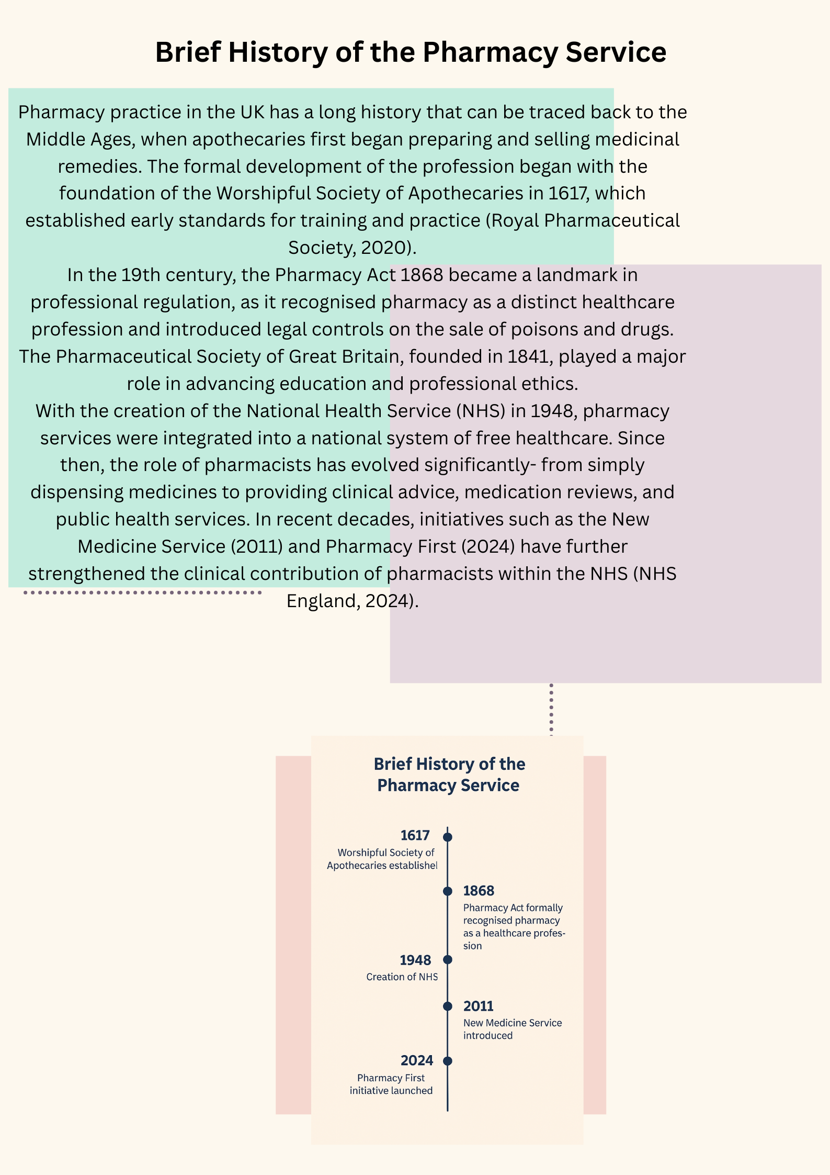

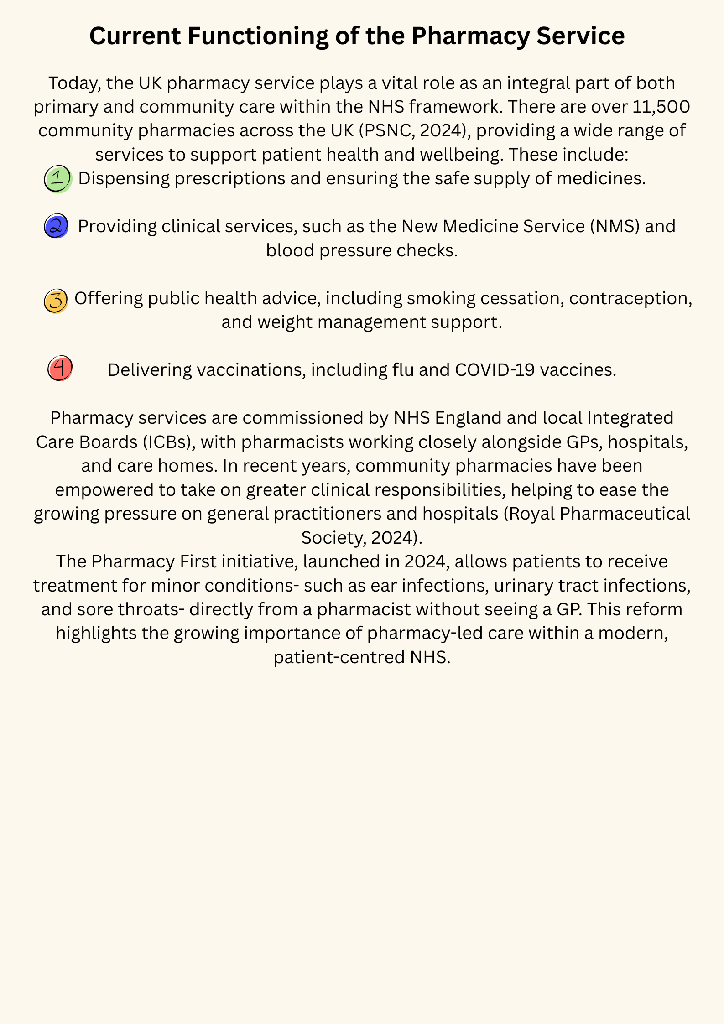

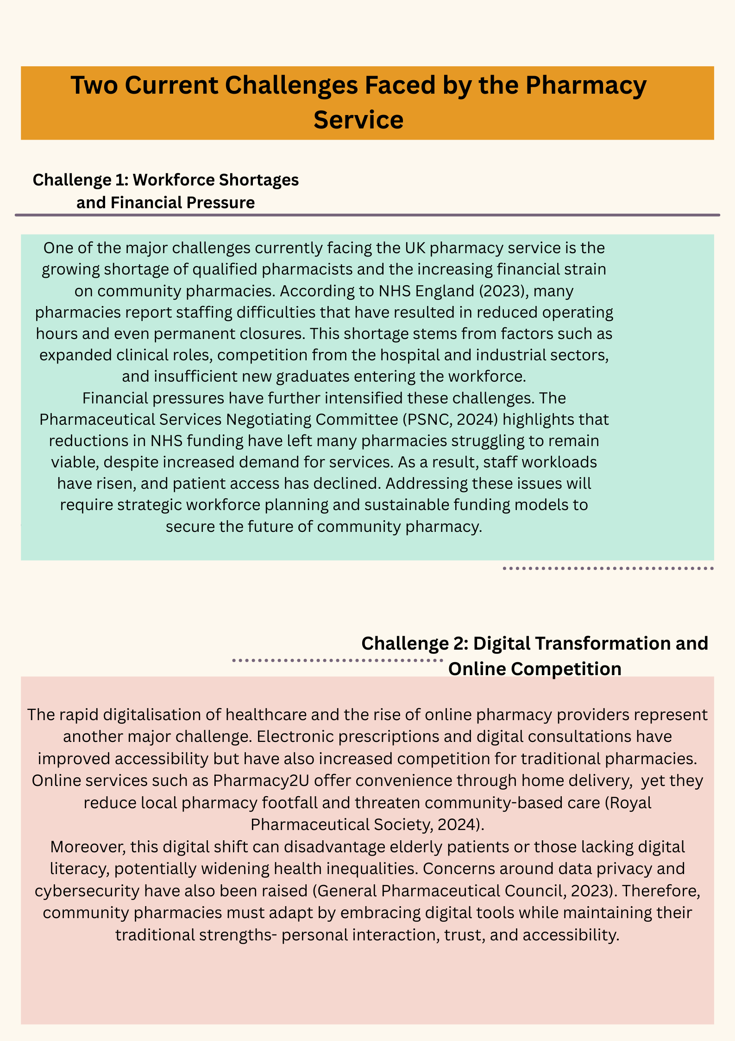

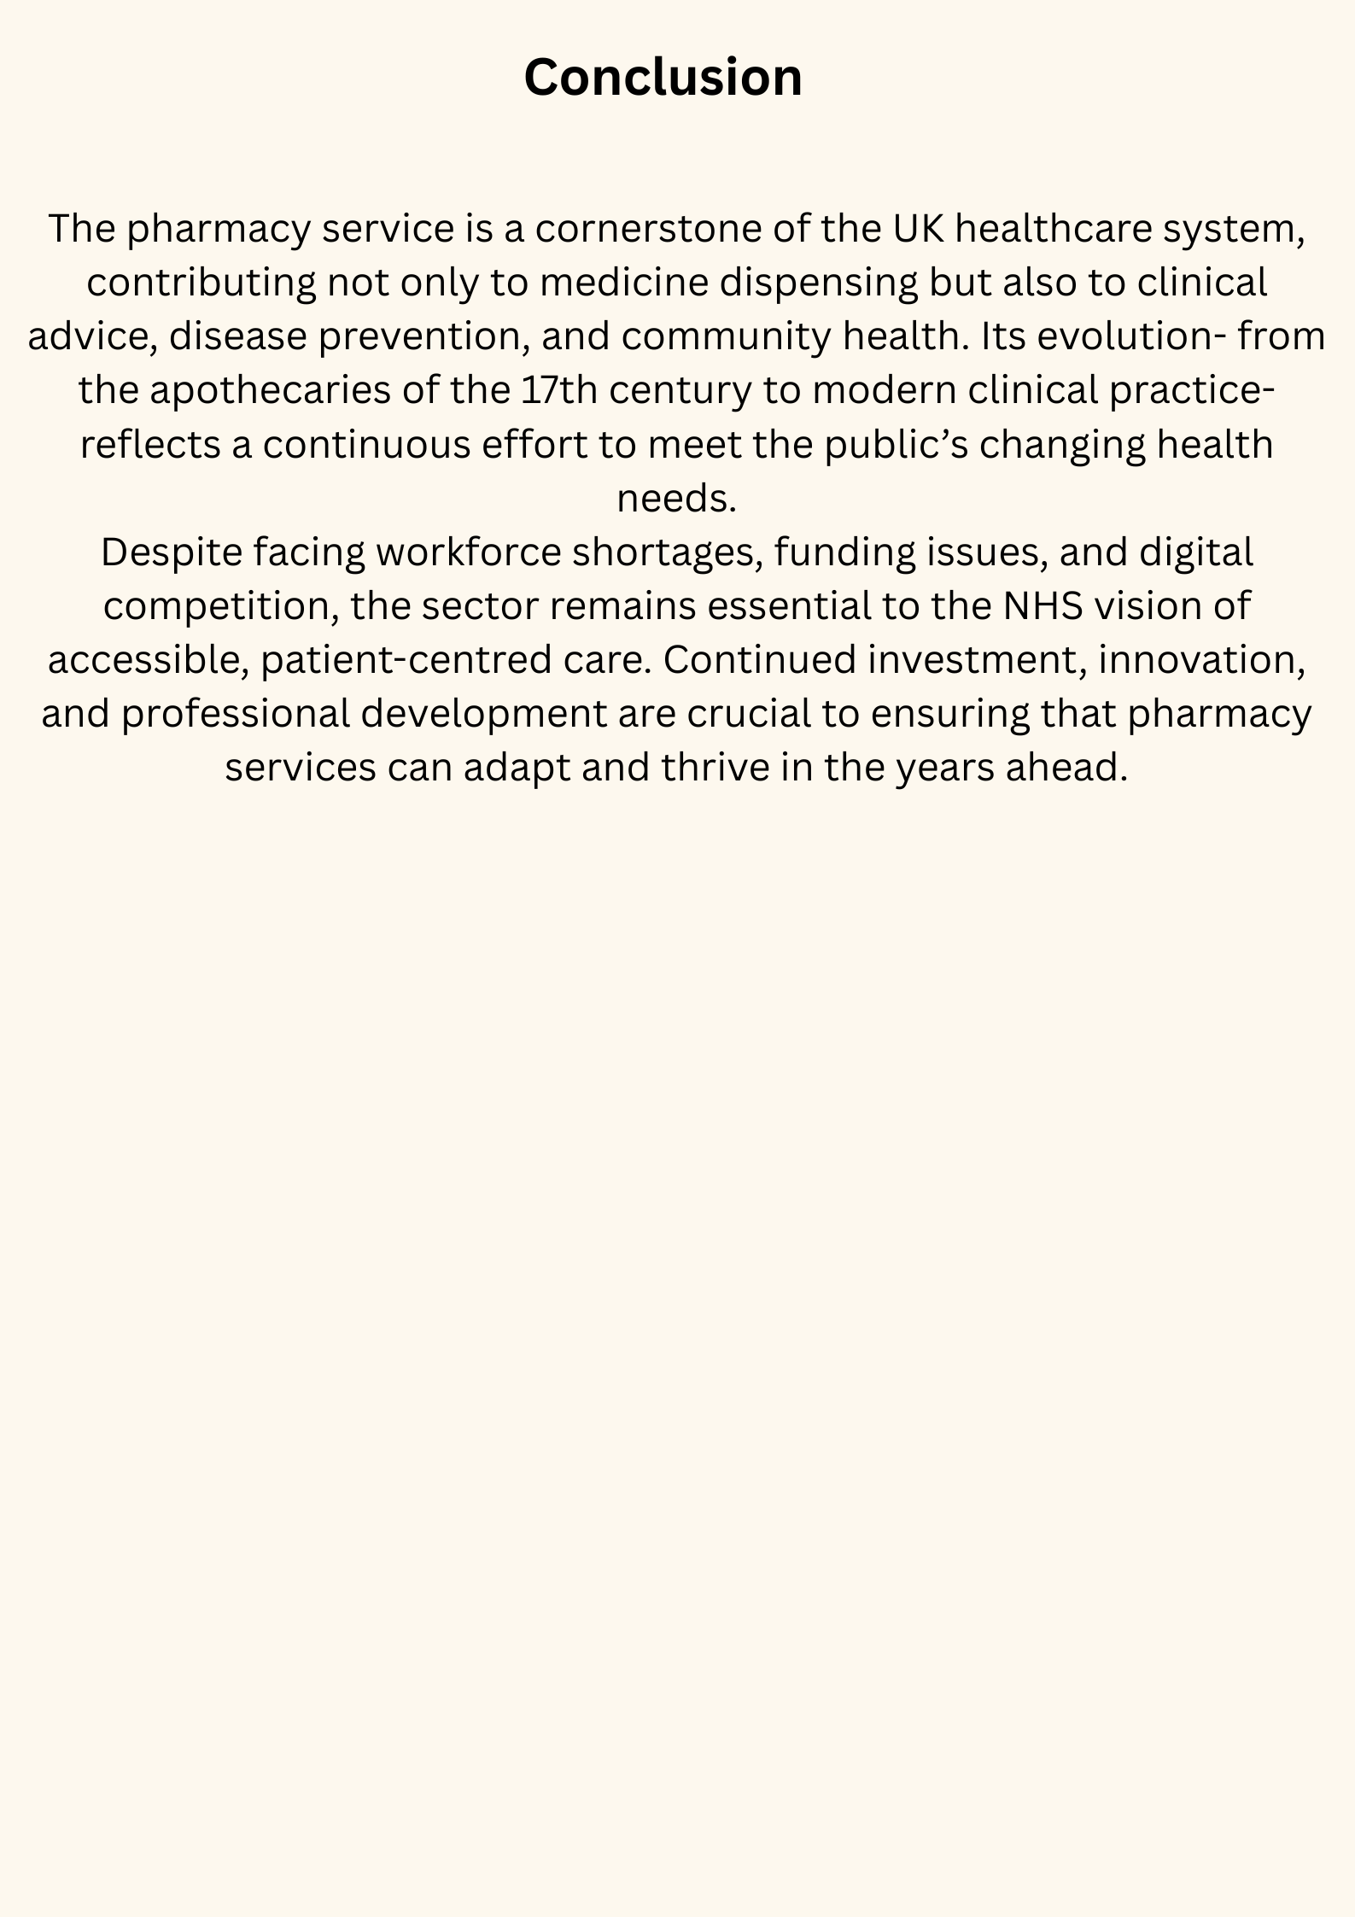

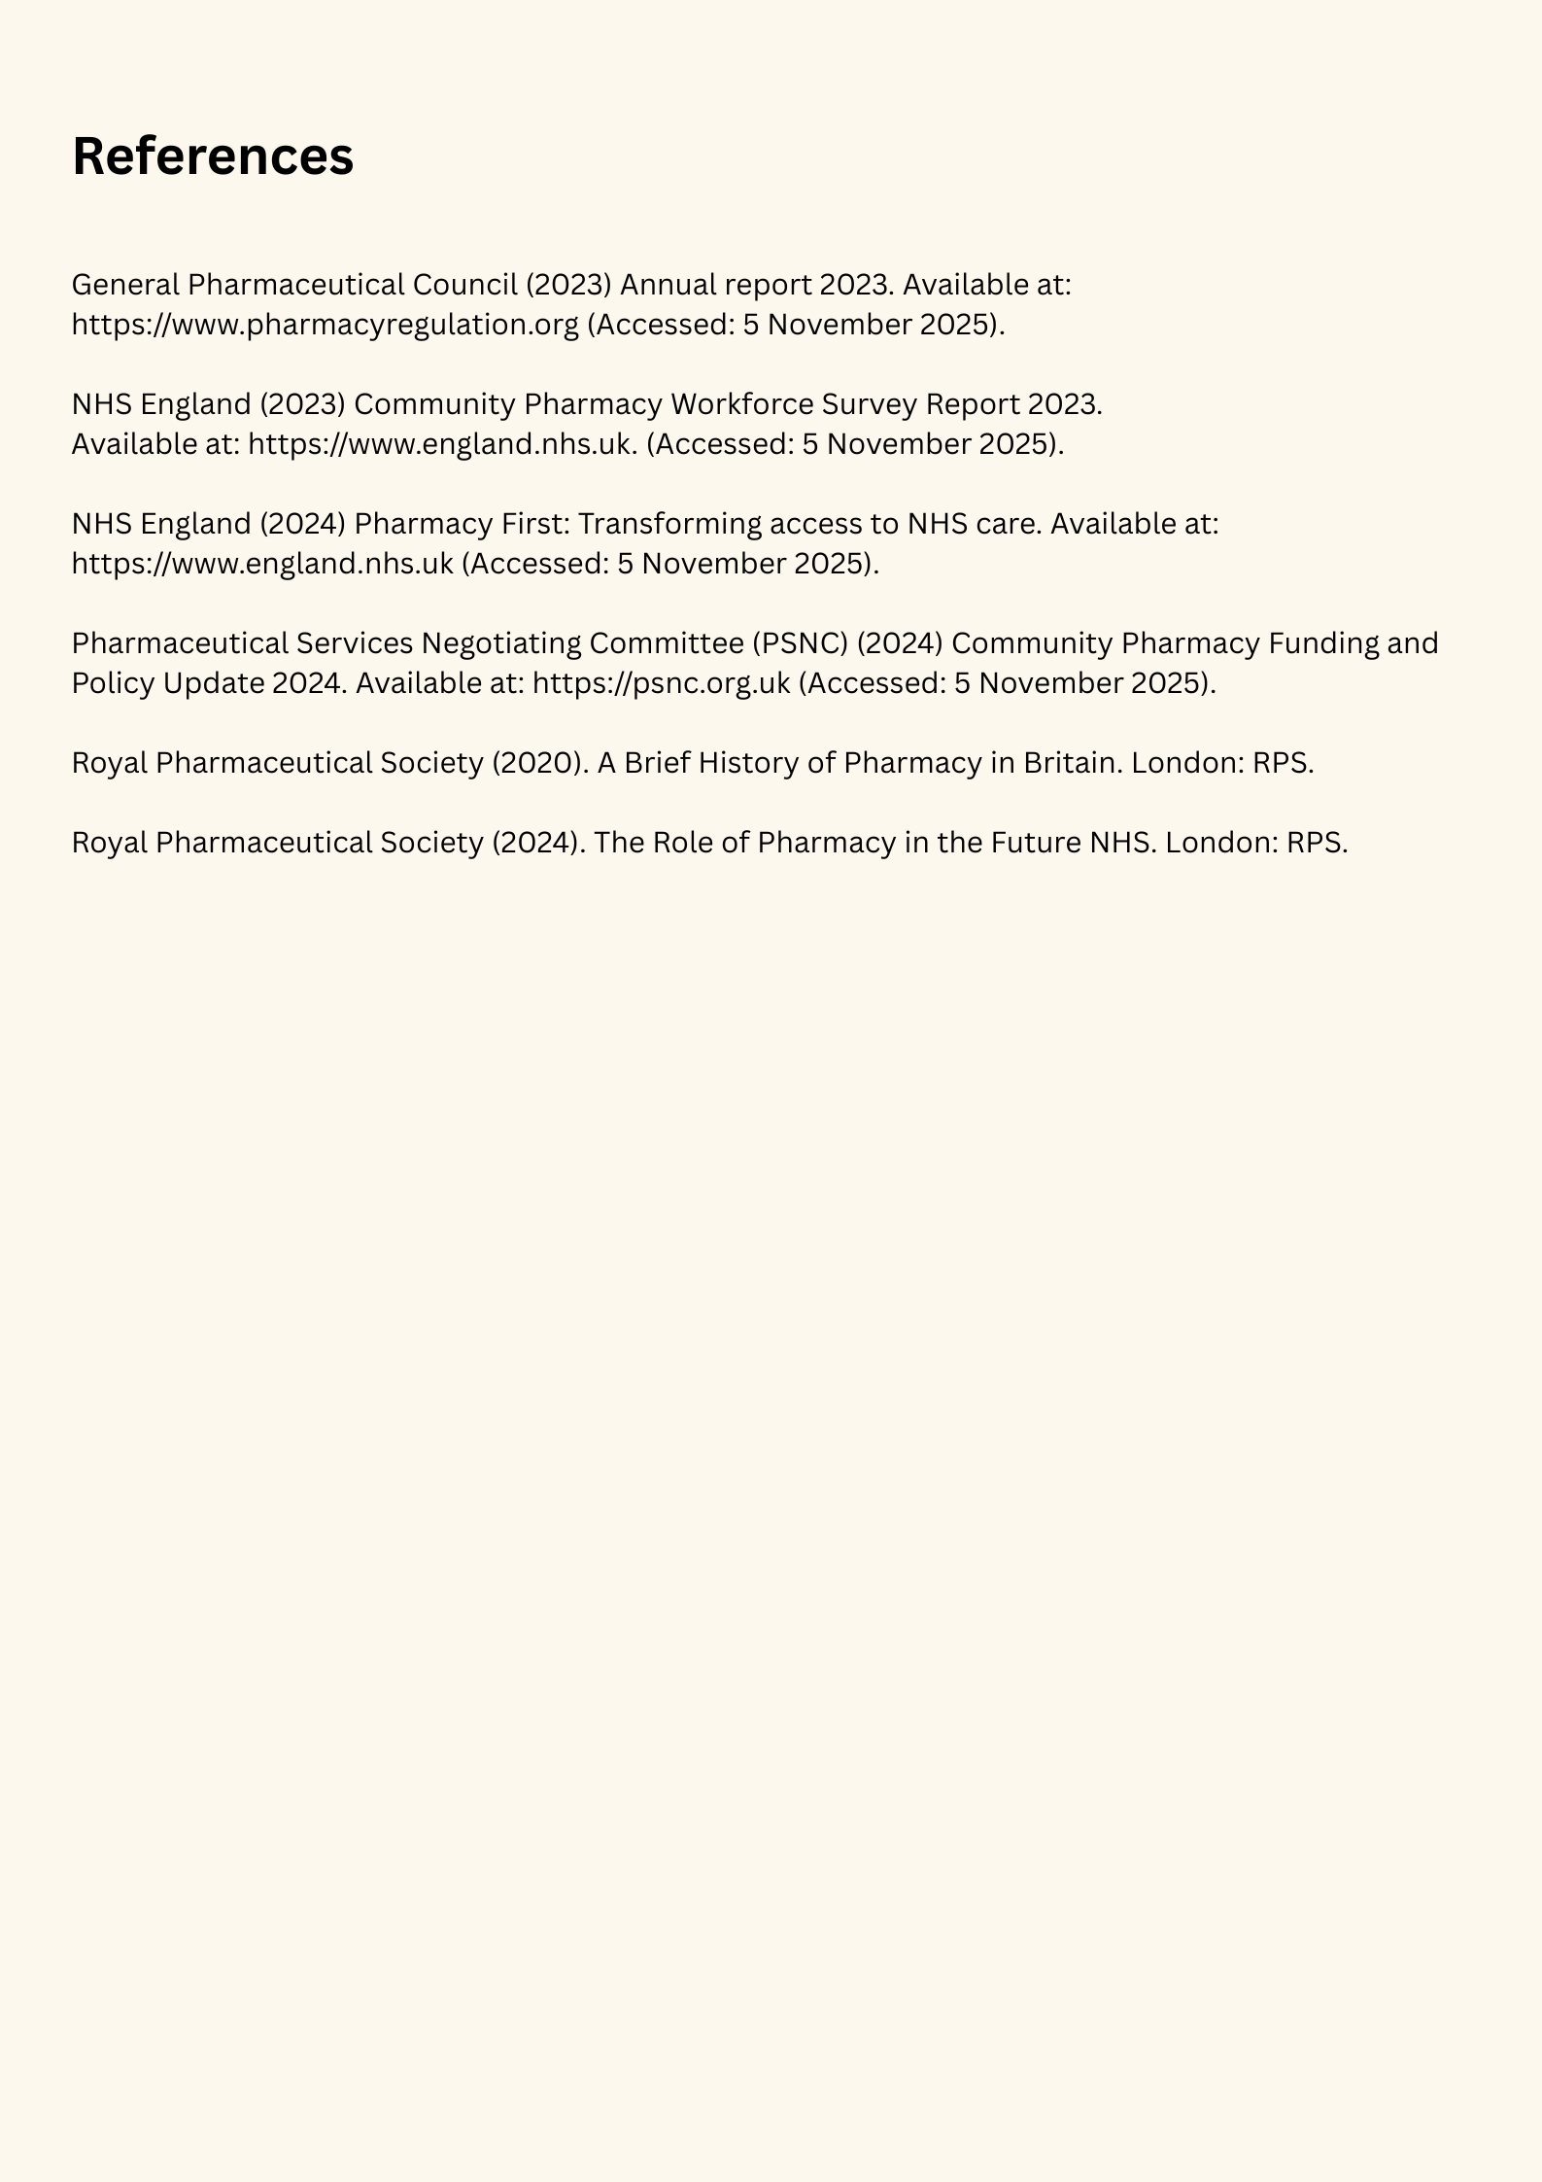

Task Two – Essay

The Origins and Structure of the National Health Service (NHS)

Introduction
The NHS stands as one of the most pivotal social changes in the history of the UK, representing the nation's commitment to providing equal and universal access to healthcare. Established in 1948, it aimed to provide free medical services at the point of delivery to all citizens, regardless of income or social class. This essay explores the origins and guiding principles of the NHS, examining the historical conditions that led to its formation, and critically discusses how its structure and functioning have evolved to meet modern healthcare needs.
Origins and Historical Context
Prior to the founding of the NHS, the provision of healthcare across Britain was characterised by pronounced social and economic inequalities in access. Medical treatment largely depended on a person’s income, with many working-class families relying on charitable hospitals or self-treatment due to unaffordable costs (Baggott, 2019). The turning point came during the Second World War, when a growing sense of social solidarity and shared responsibility encouraged political leaders to rethink the role of the state in providing welfare.
A major influence was the Beveridge Report of 1942, which proposed a comprehensive welfare system to combat “the five giants” of Want, Disease, Ignorance, Squalor, and Idleness (Beveridge, 1942). These ideas laid the foundation for post-war reforms. Following the Labour Party’s election victory in 1945, Health Minister Aneurin Bevan led the development of a national health system, culminating in the official inauguration of the NHS on 5 July 1948. Bevan’s vision was for a system funded through general taxation and available to everyone, stating that the NHS would “universalise the best” in healthcare (Bevan, 1952).

Key Principles of the NHS
The NHS was founded on three enduring principles:
1. Universality – healthcare should be available to all citizens.
2. Accessibility – services should be free at the point of use.
3. Equity – care should be provided based on clinical need, not financial status.
These principles have remained central to the NHS ethos, though applying them consistently has been challenging in practice. Over time, demographic changes, increased life expectancy, and rising treatment costs have placed pressure on the system’s ability to maintain equality and efficiency (The King’s Fund, 2024).
At present, the NHS functions as four distinct healthcare systems across the UK: NHS England, NHS Scotland, NHS Wales and Health and Social Care in Northern Ireland. In the English system, the organisation of services is overseen by NHS England together with Integrated Care Systems (ICSs), which work to coordinate care between hospitals, GP practices and community providers. The overall framework is arranged into several major areas of provision, including primary care (such as GPs, pharmacies and dental services), secondary care (hospital-based and specialist treatment), and wider public health programmes.
While the NHS remains one of the most respected public institutions, it faces significant challenges. Workforce shortages, increasing waiting times, and financial constraints have intensified since the COVID-19 pandemic (BBC, 2023). Moreover, there are ongoing debates about the balance between public provision and private sector involvement. Despite these issues, the NHS continues to adapt through digital innovation, preventive care programmes, and improved integration of services (The King’s Fund, 2024).

Conclusion
The NHS emerged from a post-war vision of fairness and solidarity, designed to guarantee healthcare as a right rather than a privilege. Its founding principles- universality, accessibility, and equity- have guided policy for over seven decades. Although the system now faces complex challenges, it continues to embody the core values of social justice and collective responsibility. To ensure its sustainability, the NHS must evolve with changing demographics, technological progress, and financial realities, while preserving the ideals that have made it a cornerstone of British society.

References
Baggott, R. (2019). Understanding Health Policy. 3rd ed. Bristol: Policy Press.
BBC (2023). History of the NHS. Available at: https://www.bbc.co.uk/news/health
Beveridge, W. (1942). Social Insurance and Allied Services. London: HMSO.
Bevan, A. (1952). In Place of Fear. London: Heinemann.
NHS England (2024). The NHS at 75: Future of Healthcare. Available at: https://www.england.nhs.uk
The King’s Fund (2024). How is the NHS structured? Available at: https://www.kingsfund.org.uk

