

Name: Stefani Petrova
Student’s Number: 1914907
Module Code: BMSW4004
Module Title: Problem Solving and Decision Making
Lecturer’s name: Yajesh Kumar

Table of contents

- Introduction …………………………………………………………………………………………….3
- Matrix Structure ………………………………………………………………………………………3
- Workplace problem and how to solve it ………………………………………….……….4
- Employer vs employee expectations ……………………………………………….……….5
- Problem solving and decision-making techniques ………………………….……6-11
- Conclusion …………………………………………………………………………...…….…….……11
- References ………………………………………………………………………………………….….12
- Appendixes …………………………………………………………………………………………13-14

Introduction
Trevi Home is a three-floor kitchen and bathroom showroom. The organisation was founded in 2004 to specialise in luxury bedroom, bathroom and kitchen design. The company is driven by the vision of creating high design products. It is renowned globally as a luxury brand giant through its small but devoted team. Trevi Home, unlike other brands, supported its clients through the COVID-19 pandemic, which has been a very challenging period. The company offers free design consultations through its skilled and dedicated designers through the use of new technology. Trevi has employed me at a front desk as an administrator, sales and design executive. Despite its reputation and success, the organisation faces a few challenges which may affect its product delivery.

Matrix structure
A matrix organisation refers to one with several managerial responsibilities and accountability. According to Stuckenbruck (1979), the term matrix can have different meanings to different organisations. The matrix structures appreciate that the functional departments are permanent while the project is temporary. While all firms are temporary because they are constantly changing, the matrix structure is designed such that a given organisation lasts for finite project life.
Trevi Home can adopt the matrix structure in its organisation due to its advantages. First, this model outlines clear objectives of a project such that the project objectives are visible through the objectives of the functional organisation and the project office. It is also an important tool for project integration. The matrix organisation sets a workable and clear mechanism for achieving the integration of project subsystems. There is also better coordination across all functional lines. Third, the use of resources with this model is efficient. Since resources are scarce, maximum efficient utilisation is important. Matrix structure gives an effective utilisation of manpower, given that personnel can be shared between projects. Workers, according to this matrix, respond first to the experience of working on a successful project. This builds the morale of such employees. The tool ensures that workers work with their fellow specialists, further building their morale (Egelhoff and Wolf, 2017).
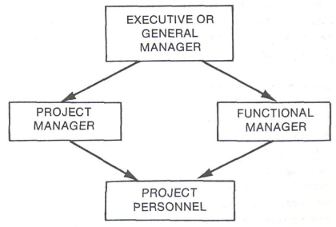
Figure 1: Matrix organisation's basic unit (Stuckenbruck, 1979)
Davis and Lawrence (1978) acknowledge that no organisation method or design of management is perfect. It can have several problems emanating from the matrix structure, especially when an organisation is trying it for the first time. Sometimes when the matrix structure is adopted, it can create complexities in the flow of information because the people involved in the organisational units are so many. The functional and project managers should be sure that they have involved in each other when making decisions.
Workplace problem and how to solve it
My previous job was as a waitress in a restaurant/bar/lounge; with time, I found out that they really do not care about the customer service they provide and there were always complaints. Payments are not refunded to customers and pay for staff is delayed, in some cases, not paid. After this experience, I never wanted to go back to the industry of hospitality.
I decided to change the industry with the recent interest in gaining sales experience. At my new workplace, we are faced with three problems. The first problem is that products in unopened boxes that arrive at our showroom cannot be returned as we write the names of the clients on the box itself and we cannot get a refund. Second, some suppliers have also proved to be problematic. When we are about to place an order, we first confirm with them that whatever we want to order is in stock. We go ahead to place an order for the stock, only for them to suddenly say they do not have the stock. This results in our projects being delayed as we will have to make an order when they have restocked. Besides this problem, we usually hire builders on contract when our permanent builders are overwhelmed with projects. These builders rush on the assigned works, leading to improper finishes. We are forced to come back to fix things that would have been done in the first place. This is consuming a lot of time which leads to delays in our project completion.

Employer vs employee expectations
Employers and organisations have expectations for their employees. Among the expectations is employees' honesty. Honest employees neither cheat nor steal their workplace. They are also expected to understand directions given pertaining to a task, whether written or oral. With that, they are able to complete the assigned work. Organisations, including Trevi Homes, expect employees to be punctual and reliable by completing their assignments on time. An employee who works with others makes a better workplace. It is therefore expected that employees work together for the common good of the organisation (Goffee and Jones, 2013).
According to Goffee and Jones(2013), the motivation and satisfaction of employees are critical for the success of an organisation. Several measures have proved that the satisfaction of employees is a factor in the motivation of employees. If the needs of the employees are not met, they will look elsewhere. Although employees can be unvocal about their expectations, research has shown what employees want from their organisations.
Work Breakdown Schedule
Interior Design
Lighting
Flooring
Colour coordination
Ceiling
Window treatment
Storage
Turn-key installation
Appliances
Furniture
Fabrics
Accessories
Figure 2: Work breakdown schedule

Problem solving and decision-making techniques
- Mind mapping

Tony Buzan developed the mind map tool to solve problems, improve creativity, and organise thoughts. Mind mapping is one tool. Experimenting is a great solution because it helps to avoid the usual instinct of panic when faced with a problem to be solved. The technique not only opens up the possibilities but also allows an individual to remain calm. When this tool is used in solving problems, it gives more clarity to find the solution easily (Erdem, 2017).

As a problem-solving tool, mind mapping prioritises the problem's critical aspects, focusing on the mind of the problem solver. This is because the branches of a map should have short phrases or single keywords instead of countless text lines. The use of images and colour stimulates the brain, which means that a person is ready for problem solving. Mind maps start with a central idea or concept, followed by other ideas that radiate as branches. The brain is able to associate to help to come up with several creative solutions.
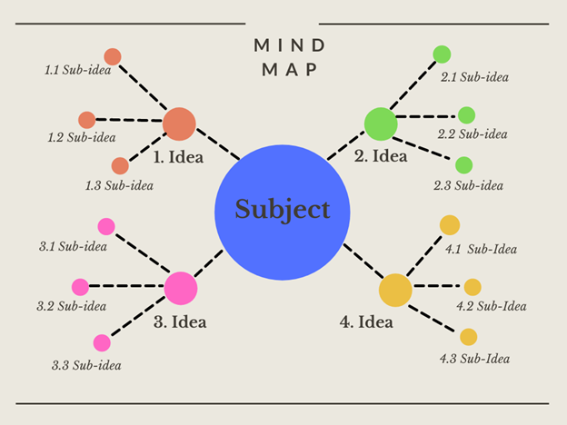
Figure 3: mind map (Erdem, 2017)

- Cause and Effect Analysis
It is a technique that helps in identifying all the possible causes of a problem. It means that the main cause of the problem can be identified, preventing the problem from running on and on. Fishbone diagrams are created for this tool. The generated diagrams resemble a fish skeleton, hence the name. This technique was devised in the 1960s by Professor Ishikawa. As such, the cause-and-effect analysis tool is also called the Ishikawa diagram. The diagram helps teams to recognise the numerous possible causes of issues or problems in a systematic way. It also helps to identify the potential causes of these problems. Ishikawa diagram is drawn as a brainstorming session part, with the main problem identified as a head of a fish. The skeleton is divided into branches that show how the parts the created by the problem (Lapadusi, 2017).
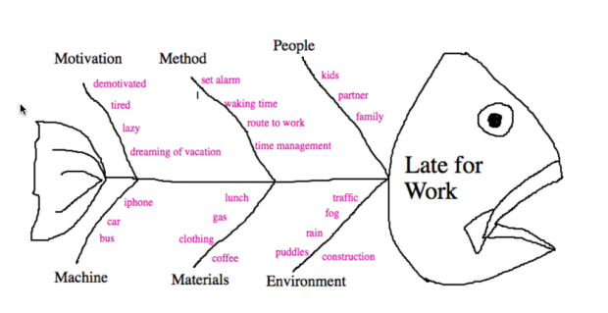
Figure 4: Graphic representation of Fishbone diagram (Lapadusi, 2017)
- SWOT Analysis
An analysis of strengths, weaknesses, opportunities and threats delves into the organisation's internal and external factors that can affect the business. Strengths and weaknesses form the internal factors, while threats and opportunities are external. This tool is critical for strategic planning and brainstorming. There is more value for an organisation in making decisions in the SWOT analysis is conducted with a question in mind or a specific objective (Phadermrod, Crowder and Wills, 2019).
Trevi Home has several strengths and a few weaknesses. It faces great opportunities amidst some threats. The intention is to build on the strengths it has and minimise the weaknesses. For instance, it boasts of competitive prices, qualified experts, and excellent quality of its end products. Some of the weaknesses include that it is not known due to poor marketing. It also suffers from poor communication internally. These weaknesses can be minimised or made strengths. Trevi Homes should also seize the opportunity it has while countering the threats.
SWOT analysis for Trevi Home
Strength | Weakness
- Unbeatable price  - Experts in what we do  - Quality products  - Time efficient | - Not very known  - No marketing  - Poor organisation  - Poor communication
Opportunity | Threats
- Growth during pandemic and support to customers.  - Opened another showroom  - Reduced competitors | - New regulations  - Price increase  - Bad customer service  - Weather

- PESTLE Analysis
PESTLE analysis is key for studying the external factors that affect an organisation. These factors are political, economic, sociological, technological, legal and environmental. It is an important tool in guiding organisational managers in decision making (Fozer et al., 2017).
Political | - Constantly changing government policies.  - Changes in the tax regime over imported house fittings.
Economic | - Economic growth  - Currency exchange as most of our fittings is imported.  - Consumer spending
Social | - Consumer taste which is constantly shifting towards luxurious tastes and preferences
Technological | - Data storage of our completed products in the showroom  - Security levels for imported fixtures, fittings and finishes.  - Changes in design software used to design our products. We have to be on the lookout for new developments.
Legal | - Law  - Change of legislation
Environmental | - Environmental impact  - Recycling  - Corporate social responsibility

- Porter’s five force analysis
Michael Porter coined Porter's five forces to analyse the competitive position of an organisation. The model is based on the idea that there are five forces that determine the attractiveness and competitive intensity of a market (Dessain and Fishman, 2017).
Competitive rivalry | There is no stiff competition from rivalries. Trevi Homes specialise in luxury kitchen, bathroom and bedroom design. Most design companies lack the kind of specialisation that we have. Our past works have left a strong fingerprint in the homes of many people. Our office comprises staff who know the significance of scrupulous design planning rather than people driven by sales and profit. This gives us a competing edge. Our design consultations are free, unlike our competitors.
Supplier power | There are few suppliers for Trevi Homes because we are quality oriented. This has affected our product duration because of our dependence on suppliers who end up failing us.
Buyer power | The number of buyers compared to suppliers is high. It means that buyers are not likely to find new suppliers to switch from our products. This helps to keep our competitive edge intact. Trevi Homes has power because there is minimal competition and a large pool of customers.
Threat of substitution | Trevi Home’s threat of substitution is not high. The organisation has been operation since 2004 and has been relevant throughout that period.
The threat of new entry | The position that this organisation holds is affected by the ability of other design firms to enter the market. It is, however, able to withstand the threat of entry because it has accumulated several loyal customers who bring referrals.

- PMI Retrospective
PMI stands for plus, minus, interesting. It is a brainstorming tool developed by Dr Edward de Bono to aid lateral thinking. This approach helps to solve problems and encourages handling a problem in a non-traditional and creative way. The tool helps to see both sides of the argument before approaching a decision
Plus | Minus | Interesting
Supplier bring top quality products (+5) | Sometimes suppliers delay the delivery (-6) | we can develop another customer base by appealing to our customers (+1)
We specialise in kitchen, bathroom and bedroom (+4) | Some clients approach us over other designs, so we have to outsource (-3)
we boast of qualified engineers and designers (+9) | Some of our outsourced builders take along to finish, delaying project completion time. (-7)
We enjoy many customers who bring referrals (+3) | Labelling of customer’s products using stickers (-3)
Total =+21 | Total = -19 | Total = +1

The results of the PMI decision making tool is as follows:
- 21 (plus)
- -19 (minus)
- 1 (interesting)
- Total= 3 (plus)

Conclusion
After utilising the problem solving and decision-making tools, the problems facing Trevi Homes can finally be ended. First and foremost, a simple solution would be to get stickers to write clients names and if we need to return at any point, the sticker can be taken off for the issues of products in unopened boxes. This will maintain our competitive position in the market and the pool of customers, hence keeping the buyers' power low. Second, we need to cut on the problematic suppliers, as shown by Porter's five forces model and the PMI tool. This will keep their power low as they will be fewer. The company will be dealing with only reliable suppliers who do not interrupt our product delivery. Lastly, we will have to increase the number of builders available in case there are several projects. Those in the contract will have to be thoroughly vetted to ensure quality control. Our customers will not be charged for renovations emanating from improper fittings.

References
Davis, S. M. and Lawrence, P. R. (1978) ‘No Title’, Harvard Business Review. Available at: https://hbr.org/1978/05/problems-of-matrix-organizations.
Dessain, S. and Fishman, S. E. (2017) ‘Porter’s Five Forces and the Market for Angel Capital’, Preserving the Promise, pp. 49–62. DOI: 10.1016/B978-0-12-809216-3.00007-5.
Egelhoff, W. and Wolf, J. (2017) Understanding Matrix Structures and their Alternatives.
Erdem, A. (2017) ‘No Title’, Universal Journal of Educational Research, 5(12), pp. 1–7.
Fozer, D. et al. (2017) ‘Life cycle, PESTLE and Multi-Criteria Decision Analysis of CCS process alternatives’, Journal of Cleaner Production, 147, pp. 75–85. DOI: 10.1016/J.JCLEPRO.2017.01.056.
Goffee, R. and Jones, G. (2013) ‘Creating the Best Workplace on Earth’, Harvard Business Review.
Lapadusi, M. (2017) ‘The Analysis of Causes and Effects of a Phenomenon by Means of The “Fishbone” Diagram’, Economy Series, 5, pp. 97–103.
Phadermrod, B., Crowder, R. M. and Wills, G. B. (2019) ‘Importance-Performance Analysis based SWOT analysis’, International Journal of Information Management, 44, pp. 194–203. DOI: 10.1016/J.IJINFOMGT.2016.03.009.
Stuckenbruck, L. C. (1979) ‘No Title’, Project Management Quarterly, 10(3), pp. 22–33.

Appendixes

Roleplay
Stefani: Hi Alessio, how are you?
Alessio: Hi Stefani, how are you?
Stefani: I am good, thank you
Alessio: So how can I help you today
Stefani: I work for Trevi Homes. Trevi Home is a three-floor kitchen and bathroom showroom. The organisation was founded in 2004 to specialise in luxury bedroom, bathroom and kitchen design. The company is driven by the vision of creating high design products. I work as a front desk administrator, with sales and design executive projects delayed.
Alessio: That is great! Why do you think Trevi Homes is facing this problem?
Stefani: Some suppliers have been very problematic. When we enquire about a fixture or fitting, they will confirm that it is available in stock.
Alessio: Then what happens?
Stefani: When we place the actual order, the stock is not available anymore. We are forced to wait for a longer time which delays our project delivery.
Alessio: I agree that this can delay the delivery of a product and put you on the wrong side of the customer. Is there any other problem apart from the suppliers’ issue?
Stefani: Yeah
Alessio: Go on
Stefani: Sometimes, our projects are overwhelming. We get many projects from referrals and returning clients. We are forced to hire builders on contract. These builders end up doing shoddy work. For example, they will rush on the assigned work, leading to improper finishes. We are forced to come back to fix things.
Alessio: This is a serious issue that can affect the relationship between your company and its customers. Clients want quality work all the time, and that is where you are guaranteed more work.
Stefani: There is still another problem.
Alessio: Go on, please.
Stefani: Products in unopened boxes that arrive at our showroom cannot be returned as we write the clients' names on the box itself and we cannot get a refund.
Alessio: This, too, is a severe problem that can threaten the working relationship with your client. Do you have any possible solutions to the issues that you have raised?
Stefani: To be honest, that is why I reached out to you to know how I am going to address these issues. I will appreciate your advice on how to handle these problems.
Alessio: Great! I will not give you the exact solutions to these problems. Instead, I will share a few tools for problem solving and decision making with you.
Stefani: That is great! Tell me more about these tools.
Alessio: Basically, these tools will help you recognise, investigate and analyse problems. You will have a chance to monitor and review the solutions you will come up with.
Stefani: Are you sure we will bring to a halt the three problems I have just pointed out?
Alessio: You’re right! First, I recommend that you come up with the matrix structure of your organisation.
Stefani: How will this help me?
Alessio: This structure will help you develop the different functional departments of your organisation. With this, you will tell which department is greatly affected by the problems you highlighted.
Stefani: This will certainly help us a lot.
Alessio: It sure will. Besides, develop a work breakdown schedule of your routine activities to determine the activities that are affected the most and which might delay the overall project. After that, I recommend mind mapping, cause and effect analysis, SWOT analysis, PESTLE analysis, Porter's five force analysis and PMI retrospective. These tools work hand in hand in solving organisational problems and making decisions.
Stefani: Thank you for the insightful information. I will be glad to know how each tool works and finally adopt it to solve my organisation’s problem.

