

MARKETING MANAGEMENT – ASSESSMENT 1

Programme : MBA Master of Business Administration
Module name: Marketing Management 1
Module code:LCMB7001
Student name: Arsinbanu Monismiya jadeja
Student ID: 2208899
Lecturer: Tushara Balendran

Table of Contents
Introduction 3
Chosen Organisation for creation of brand management along with customer journey maintenance 3
Customer Journey with an instance 5
Current Scenario in Unilever 6
The Business Model of Unilever 6
Challenges faced by Unilever 8
Market Management 11
5M of Unilever’s Advertisement 13
Innovative Marketing Strategy by Unilever 14
Improving customer journeys 16
References 18

Introduction
Most businesses consider customer touch points distinct interactions by which consumers engage with various aspects of the company and its offerings—when they concentrate on the consumer experience. This makes sense. It displays structure and responsibility and is fairly simple to include throughout procedures. Businesses make an effort to make sure that whenever customers encounter their merchandise, customer support, sales personnel, or promotional materials, they will be satisfied with the experience. However, this compartmentalized attention to specific encounters ignores the bigger—and more significant—picture, which is the customer's whole experience. One can only start to grasp how to meaningfully increase performance by considering the quality of customer service as seen through their personal eye sockets for the duration of the trip taken.
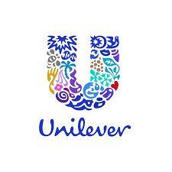
Figure 1: Unilever Logo
(Source: Yachin, 2018)

Chosen Organisation for creation of brand management along with customer journey maintenance
Unilever plc, founded in 1886 and with its headquarters in London, is a British multinational conglomerate in the consumer goods industry. Unilever produces a wide variety of consumer goods, from condiments and stews to frozen yogurt and hygiene products to soaps and cosmetics. About 190 countries offer distribution of Unilever's 400 brands (Yachin, 2018). There are three primary departments within Unilever, and they are the Foods and Beverage, Home Healthcare, and Cosmetics and Personal Care departments. The company has its own research and development throughout the world at prime locations. By 2030, Unilever aims to cut its environmental footprint in half, it will have helped one billion people better their health and well-being and will have sourced all its agricultural ingredients in a sustainable manner.
Vision Statement | To "make sustainable living ubiquitous" is Unilever's stated mission as a company. "This is the ideal strategy for the long-term development of our company."
Mission Statement | To "give vibrancy to life" is Unilever's stated company objective. Brands they carry help people feel better about themselves and improve their quality of life in areas such as nutrition, personal care, and cleanliness.
Table 1: Vision and Mission Statement of Unilever
(Source: self-made)
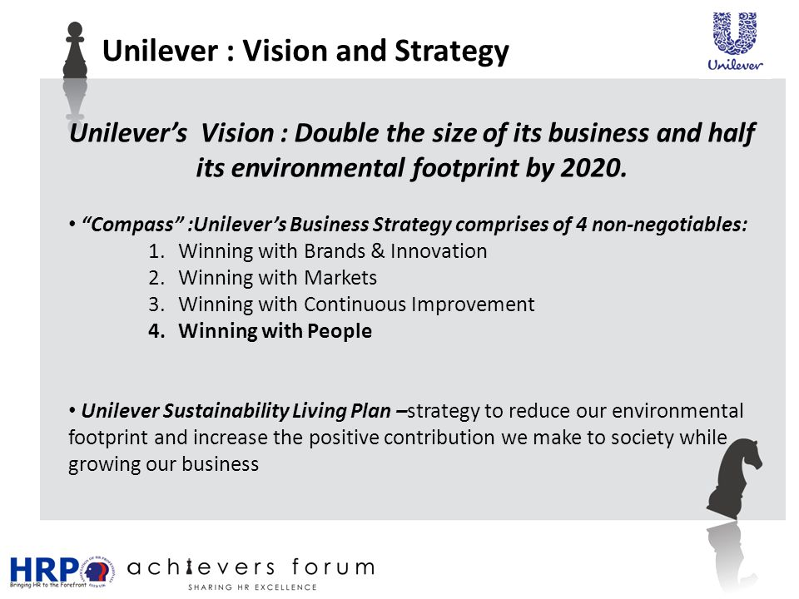
Figure 2: Unilever Vision and Mission
(Source: Yachin, 2018)
Unilever's consumer goods business relies on its purpose and vision statements. Company strategy is reflected in the mission statement. The mission statement affects how Unilever serves its target customers. However, the corporate vision guides organizational development. In its "vision statement," Unilever lays out its plans for the future. Because of its global reach, Unilever's mission and vision statements can be applied to any industry, anywhere in the globe.

Customer Journey with an instance
Client ventures cover many exercises that happen previously, during, and following a collaboration with a decent or administration. Excursions can be extended, spreading over various touchpoints and channels, and as often as possible broadening weeks or even months. A great delineation is adding another client. Another is helping a client to move a business to another area, modernizing assistance, or fixing a specialized issue (Vakulenko et al., 2019). Our examination has shown that organizations that neglect to figure out the edge of reference of these conditions and regulate the scaffold, start to finish encounters that impact the client's view of the organization can have a fountain of troublesome impacts, going from stir expectation and fundamentally higher phone amounts to lost incomes and moderately low representative fulfillment. Then again, organizations that give clients the best experience conceivable all through the whole excursion ought to hope to see expansions in client fulfillment, income, turnover, and worker commitment.
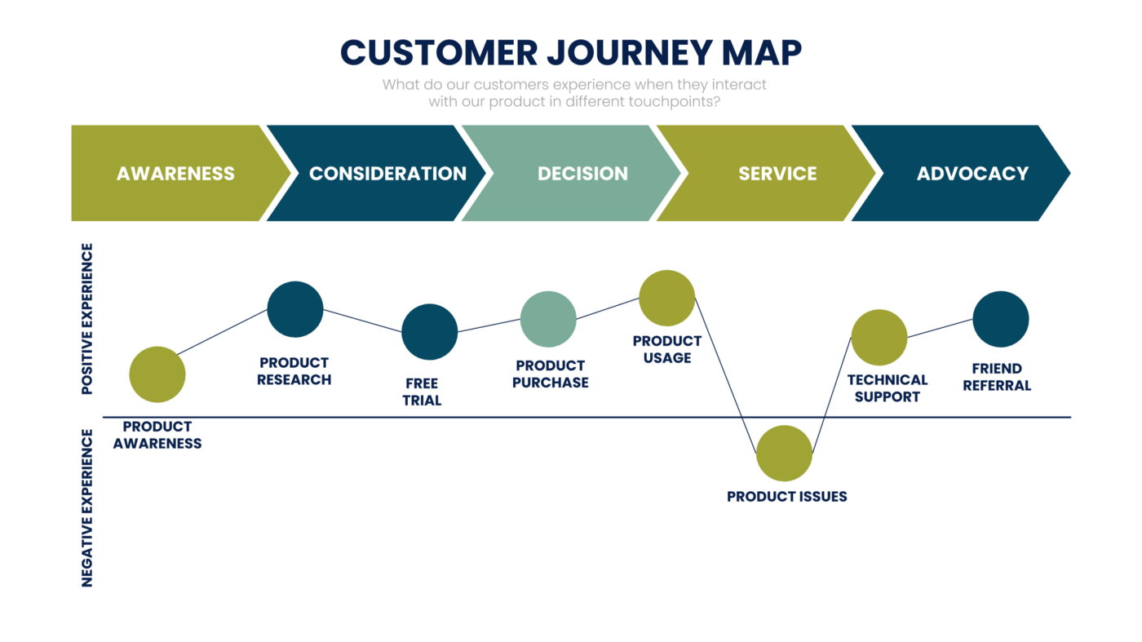
Figure 3: Customer Journey Map
(Source: Tien, 2019)
This is particularly true in the fiercely competitive, inter, multi-channel, every-time distribution channels of today. Reliability of support and satisfaction across platforms is nearly impossible due to the expansion of potential consumer engagement points across digital outlets, smartphones, programs, and more until you manage the journey rather than just particular touchpoints. In fact, studies they performed in 2015 encompassing eight EU telecommunications markets indicated that despite the fact that those encounters were electronic, consumers' perceptions were considerably worse when they undertook journeys spanning several platforms.

Current Scenario in Unilever
As per a new Unilever, research led universally, 33% of customers currently really like to buy merchandise from organizations they see as being socially or naturally mindful. 20,000 grown-ups from five unique countries were surveyed to perceive what their stresses over supportability meant for their shopping and home choices (Tien, 2019). Critically, it then contrasted their declarations with real buying designs, giving a more precise view than ever of what people are really buying — and why.
When asked whether they would deliberately prefer businesses if they made their sustainable attributes more obvious on their container and in their advertising, over one in-fifth (21%) of those questioned answered they did. Out of the €2.5 trillion global markets for sustainable products, this signifies a potential unrealized potential of €966 billion. Unilever's current economic results serve as additional evidence of the size of this possibility. Approximately half of the company's worldwide expansion in 2015 came from its dozens of brands, including Dove, and Ben & Jerry's, which have incorporated sustainability into both their mission and goods. Additionally, they are expanding collectively 30% more quickly than the remainder of the company.

The Business Model of Unilever
The foregoing are aspects of the Unilever business strategy that are informed by customer research and trademark innovation.
Manufacturing | 306 firms have made critical interests in eco-accommodating and productive assembling.
Logistics | To upgrade client care, limit expenses, and lower CO2 outflows, Unilever is uniting its exercises through an organization of overall Ultra Multimodal control focus. Rather than driving out and about, we use rail and half-breed vehicles all the more habitually (Suresh et al., 2021).
Marketing | Unilever utilizes different settings to hang out in a media climate that is very divided. Buying is impacted by powerful web publicizing at all phases of the purchasing system and general media.
Revenue | To accomplish an upper hand, Unilever teams up with vendors, guaranteeing that our items are reliably open and alluringly introduced across all circulation organizations, from food to internet business (Rust, 2020).
Client knowledge | In order to preserve our competitive edge, Unilever has to be able to anticipate trends in addition to having knowledge about them.
Collaboration | To encourage change that is advantageous to society and the company, Unilever collaborates with authorities, NGOs, as well as other partners. We also engage with companies in our distribution chain to develop products and packaging improvements.
Research and development | The objective of Unilever's Research and development is to make brands through benefit-driven improvement that is made conceivable by innovative progressions (Reza, 2020). Its yearly acquisition program, worth €34 billion, horticultural food unrefined fixings, 51% of the all out of whom are provided economically.
Table 2: Business Model of Unilever
(Source: self-made)
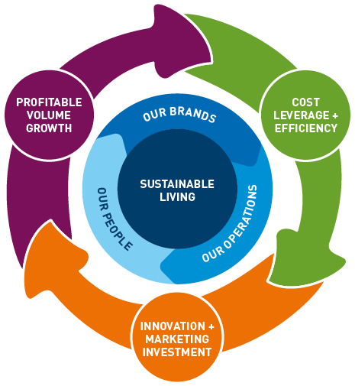
Figure 4: Business Model of Unilever
(Source: Reza, 2020)

Challenges faced by Unilever
Preserving margins as well as prices | FMCG is at present going through a difficult time because of technological changes and cost increments by Unilever, Delegate and Bet, Mondelez, and Nestlé. The choice was made for various significant reasons, including expanded material expenses, despite the fact that purchasers won't begin to see the impacts of cost changes until the accompanying quarter. The brand's solidarity will be scrutinized in light of the fact that earlier cost rises have been slow. Value rises could possibly misfire as organizations battle to keep clients despite Amazon's development and tension from new contenders (Rahimian et al., 2020). Unilever will know about the meaning of showcasing in any imminent evaluating battle, however, it should be mindful so as to abstain from participating in a horrible advancement war. Yet again customers might begin being thriftier with their buys because of Brexit and other looming political vulnerabilities, and Unilever should be wary to find some kind of harmony among both volume and worth buys.
Straightforward disruption | Intuitive showcasing has created a great deal of conversation over its risks. Despite the fact that on occasion it might have appeared to be beyond absurd, the ascent of brands like Harry's and smoother and their effect on notable organizations truly ought not to be put into words (Parsons, and Lepkowska-White, 2018).  In spite of being just four years of age, the magnificence organization Glossier has become clique-like. Notwithstanding having a couple of actual stores notwithstanding its web-based presence, the organization is esteemed at $390 million and is extending. Unilever knows about this and bought Dollar Shave Clubs in 2017 to acquire a superior comprehension of how these enrollment firms work. Notwithstanding, to get pace, it should make its own brand names and change the business procedures of its primary things.
Crowd category navigation | The press has adulated Aldi's in-house skincare and beauty care products line, with Aldi's £3.99 Enchantment Cream — planned to rival Elizabeth Arden's clique 8 Hours Salve out all around the country.  The administration should ensure that Unilever's publicizing attempts to keep clients committed so they do not for a moment even change to more affordable choices (Park, 2020).  It would sound right to leave the food business, where another person's deals are expanding and income development is moderate. In the wake of disposing of its sauce business, different parts of food will without a doubt be examined.
There is a talent war for marketing | Unilever encounters not yet regularly experienced issues finding top capacity by virtue of the scope of brands it conveys and it is brilliant remaining as one of the top chiefs for school graduates. However, in a quick-moving climate, FMCG's effect is decreasing as young money managers slant toward experiential learning over regular procedures.  The business has for the most part been a fantastic spot to study, but individuals wanting to cultivate different gifts could find its tight construction unappealing. Besides, maintaining work for Google or Apple has a higher "jazzy charm" than working for Unilever (Murphy, and Murphy, 2018).  Unilever eventually inclines toward the standard method of making from the inside, as a component of an advancing alumni program. It could need to change as a rising number of additional energetic individuals need a varied CV that integrates both tremendous organizations and little new organizations. To continue to lure the savviest students, Unilever should feature the business as a fiery, quick pioneer in the fields of IT and cash, which have been referred to as two endeavors that are matching FMCG as the top region for graduate students.
The sustainable legacy of Polman | Tragically Polman's standing has been corrupted by the bombed endeavor to redesign the principal office subsequent to filling in as Chief for 10 years (McColl-Kennedy et al., 2019). Numerous people will review Polman for his bungled endeavor to rebuild the business' double proprietorship structure and shift its central command to the Netherlands, and Unilever is sure that this is not the reason for his abdication. His commitment to environmentalism, which was a significant need of Polman's while filling in as Chief, will have a more drawn-out enduring effect. The partnership fostered the Manageable Living Unilever Plan in 2010 under his heading. The applicable viewpoints have consistently contended for kinder business ventures.  The arrangement included testing objectives for work, medical care, and nature, for example, slicing the business' water use down the middle by 2020. Presently, that time is drawing nearer. Unilever as of now has satisfied a portion of its responsibilities, yet others stay unfulfilled. For example, the business' water trouble per client use has truly just diminished by around 2% during 2010 (McColl-Kennedy et al., 2019). The organization's benefits from the reasonable turn of events, notwithstanding its natural security and social, have for some time been advanced by Unilever. In any case, Heinz's 2017 work to procure Unilever shows that the organization has not altogether won in that discussion.  Characteristically persuaded individuals will without a doubt have their very own advantages, yet to prevail upon clients, manageability promises should be kept or surpassed. With just two years left, the organization should apply tension on the organization to ensure that it achieves its responsibilities on the grounds that people, in general, are all examining business choices about manageability like never before.
Table 3: Challenges faced by Unilever
(Source: self-made)
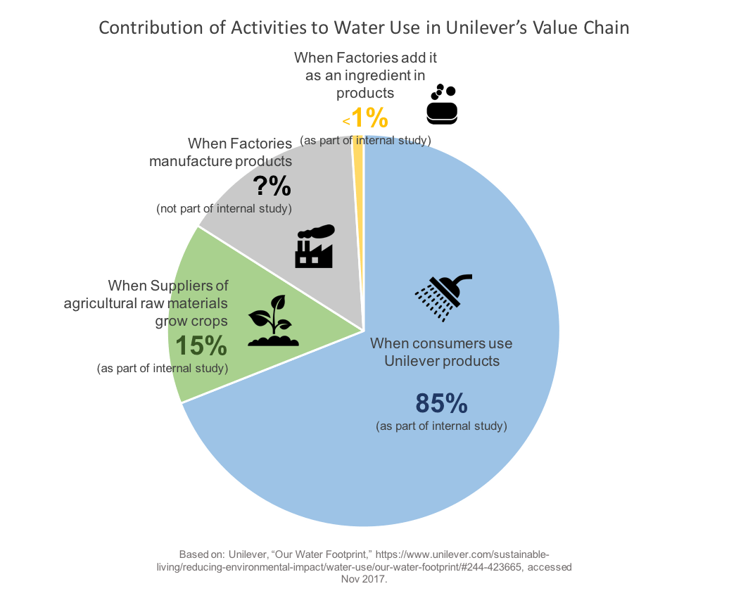
Figure 5: Problem of Water Technology at Unilever
(Source: McColl-Kennedy et al., 2019)

Market Management
This idea promotes starting a company's operation with the client in mind. He needs to focus on the consumer in order to comprehend their needs, wants, needs, and advantages. A manufacturer must carefully consider the wants, preferences, etc. of the client when designing a new item or making improvements to an already existing one. The result must completely satisfy the customer.
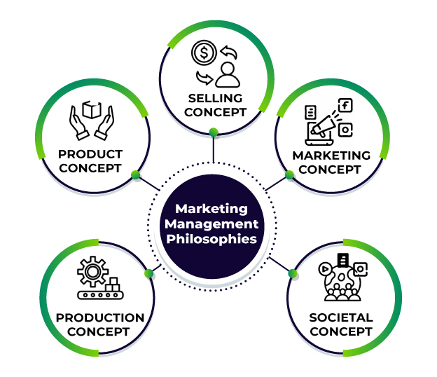
Figure 6: Market Management Philosophies
(Source: Kuehnl et al., 2019)
Consequently, a producer should develop and create a product that the client will embrace rather than just one that he can produce quickly. A consumer is typically picky and unstable. This makes it far more challenging to understand the consumer and create a product that meets their needs, but it is the only way a company can be successful in a market. Customer segmentation, market analysis, and product creation should come before selling. The consumer's interests should be the sole thing that is being considered.
Management Method | A managerial process called marketing administration includes planning, organizing, judgment, predicting, managing, coordinating, and regulating. Management, according to Stanley Vance, is the act of making and enforcing decisions. Planning, judgment, coordinating, and monitoring are necessary for every part of marketing, including determining the requirements of the clients, identifying the intended audience, and developing, pricing, promoting, and distributing products (Kotler et al., 2018).
Consumer-focused | Every advertising endeavor is centered on the consumer. Customers are in charge. The idea behind marketing strategies is to "create what the market wants." The main goals of marketing are to attract new clients and keep existing ones. Crafted by transforming likely clients into genuine clients is taken care of by brand the board.  This is made conceivable by meeting the necessities and wants of the client by furnishing them with legitimate labor and products as per their requirements and wants, at the appropriate time, and utilizing a reasonable channel.
Research Assessment | Understanding consumer demands and wants are the fundamental tasks of marketing. This necessitates the systematic and ongoing gathering of data as well as its analysis and reporting in relation to marketing operations. This aids management in comprehending customer demands, desires, interests, and audience behavior in relation to a company's business mix initiatives. This aids in predicting the future and preparing a strategy for action (Kotabe, and Helsen, 2022).
Development and Planning | Making and planning items and administrations are parts of publicizing. To answer moving client prerequisites, taste, and tendencies, associations continually work to design, make, and advance new items and administrations.
Creating a Framework for Advertising | Promotional strategies extend beyond the simple sale and ownership transfers of services and goods from the manufacturer to the final customer. However, it necessitates a number of tasks like client connections, analysis of the research, manufacturing, innovation, and development; marketing; advertising; marketing; marketing; and transportation (Jansen, 2018).  To get the greatest outcomes, each of these advertising functional departments has to be designed, managed, and created properly. The size of the business, the agency's geographical reach, the number of product offerings, the kind of product, and the size of the client base all influence the marketing strategy.
The organization's goals | All marketing initiatives are founded on the overarching goals of the organization. The marketer fills the gap amongst customers' interests in meeting demands and overarching organizational goals of obtaining high profit as well as maximization of sales.
Interaction and Advertising Process | Enhancing overall sales and revenue is a company's main goal. Marketing and communications of the products and services might help with this. The corporation may notify clients about the goods thanks to this marketing operational management.
Managing Activities | Controlling marketing activities is a task carried out by marketing management (Hoyer et al., 2019). To assess the success of marketing staff and programs, marketing management assesses the efficacy of marketing operations. In this procedure, the actual performance is compared to the standard, deviations are found, and remedial measures are then taken.
Table 4: Market Management
(Source: self-made)

5M of Unilever’s Advertisement
The viability of publicizing might be assessed utilizing various procedures, including crowd brain science, music deals, web streaming, including computerized advertising appraisals. Unilever utilizes a scope of scenes, intermediates, and channels for its advancement and publicizing. Print, broadcast, satellite, POSM, vendors, wholesalers, and so on are instances of regular media. Web content incorporates things like internet business, informal communication locales, site design improvement, and so forth. Unilever is dismissing its consideration from ordinary media and toward contemporary patterns like informal communication locales (Herhausen et al., 2019). Web-based entertainment offers a phenomenal opportunity to interface clients with organizations as a developing number of individuals use them. Unilever's essential objective is to foster an Omnichannel promoting technique for the business so clients might communicate with it from anything that area they need to make a buy.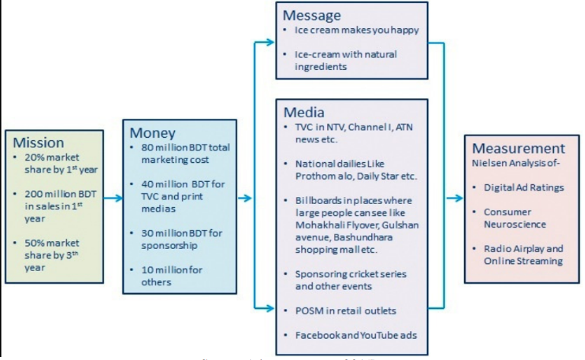
Figure 7: 5M of Unilever’s Advertisement
(Source: Chernev, 2018)
Unilever supports different exercises, crossing games, melodic celebrations, and drives to raise public comprehension of social issues. Unilever likewise makes a lot of occasions. Regularly, numerous Unilever items are connected to sponsorship-explicit occasions. Unilever habitually teams up with different organizations to advance occasions. Unilever's sponsorships should adjust including its all technique for harmless to the ecosystem headway and key standards.

Innovative Marketing Strategy by Unilever
The overall technique is the most critical strategy Unilever has utilized to fight for market predominance in the area. The strategy involves supporting the accessibility of tantamount merchandise here while showcasing brands in nearby environmental elements. This strategy is additionally utilized by the organization to make new brand names for publicizing in different areas of the planet (Grewal, and Roggeveen, 2020). The firm will benefit from this arrangement since it will increment promoting exercises' consistency while improving the worth of the producer's image. Unilever utilizes the cross-market way to deal with win clients from different organizations. This is achieved by offering their merchandise at a market-based sponsored value that is frequently lesser contrasted with other opponent organizations. Since most organizations find it trying to convey these administrations while additionally guaranteeing phenomenal item quality, Unilever's drives are successful.
Advertising and advancement can possibly influence conduct decisively. They help with teaching individuals about the upsides of our creations and merchandise. Also, it permits us to interface with clients on issues that are mean quite a bit to them (Følstad, and Kvale, 2018). For example, Pigeon's Drive advancing Genuine Excellence questions common ideas of magnificence. The Omo/Persil "Soil is Great" promotion urges youths to embrace being dirty as a typical and gainful part of growing up since it adds to their turn of events and learning. The Solace 1 Flush promotion teaches clients about how much water individuals can save by basically utilizing one tub to wash their dresses rather than three.
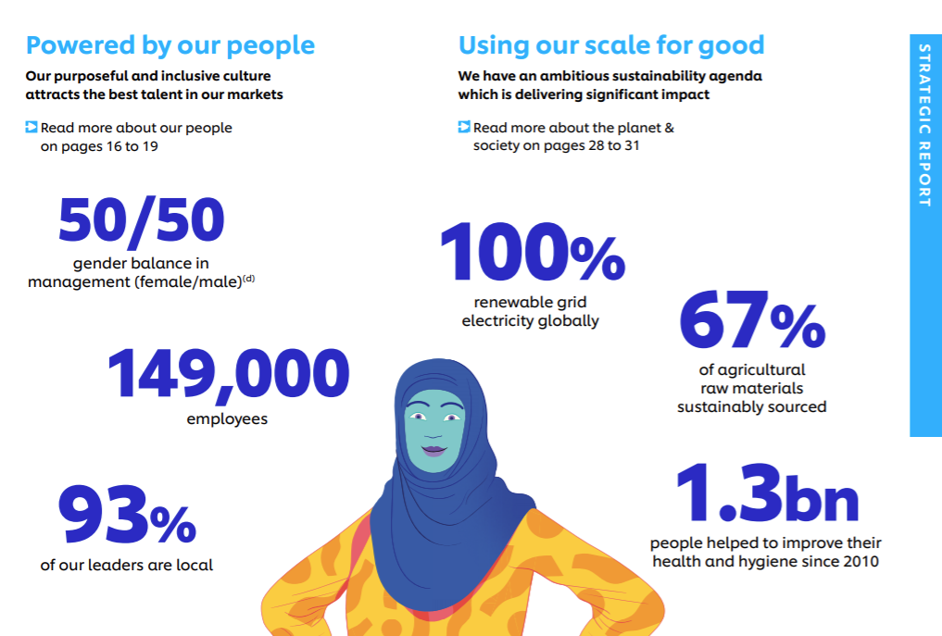
Figure 8: Unilever Marketing Strategy
(Source: Chernev, 2018)
The plan and publicizing areas' utilization of misrepresented magnificence goals in promoting and media is a subject of critical conversation. Unilever brands can choose the sort of supermodel and entertainer that best supplements the brand presence. However, they should constantly comply with Unilever's rules for positive self-perception (Deepak, and Jeyakumar, 2019). To ensure that their promotion does not support "undesirable" slimness, they executed a worldwide strategy restricting the utilization of the "size zero" model or entertainers in 2007. Models and entertainers with a BMI of 18.5 to 25 are the norms for all promoting chiefs and organizations. This is steady with the Worldwide Wellbeing Association's suggestions for the greatest allowable BMI.

Improving customer journeys
Offering what clients desire while paying attention to their needs | Unilever responds to customer feedback to enhance goods and elevate the shopping experience. Giving the example of the TRESemmé brand, getting consumer feedback offers a continuous approach to learning how a service is performing and whether there is potential for development (Chernev, 2018). TRESemmé Collagen Smooth hair product reviews advised using just hair products the following day to preserve effects, however, Unilever did not provide Keratin Smooth dry shampoo. Unilever took use of this realization to market more dry shampoos from its product lines in addition to the Keratin Smooth shampoo.
Increasing the customer's voice | Regardless of how skillfully a business creates its marketing material, it will never be as engaging as user-generated content. For the information they receive on product descriptions pages, consumers truly need a foreign entity to validate it (Becker, and Jaakkola, 2020). They consider product reviews as a reliable resource for learning about other customers' experiences with the product. According to Unilever's own research, more than half of consumers trust subscriber text, audio, and picture material over that produced by brands. Consumers concurred that the commercial for Simple Skincare gained their confidence 38% more when it used a review as a communication tool than if the same information was presented as a corporate assertion.
Expanding the UGC's influence over the bigger industry | In online evaluations, Unilever pays attention to the customer's input and takes aggressive action. All of the consumer input may serve as a continuous panel for notifying R&D, customer relations, quality opponents, and other parties on how an item is working. In one instance, the marketing division discovered a pattern of complaints over a product that had been modified (Bagozzi et al., 2018). All users who had raised issues received replacements from Unilever along with information on the advantages of the reformulation when the quality control division determined that the problem was caused by a poor batch. For more personalization, the business is also linking reviews with CRM.
Table 5: Improving customer journeys
(Source: self-made)
Conclusion
Businesses work hard to ensure that anytime customers interact with their products, customer service, sales representatives, or promotional materials, they will have a positive experience. On its mission and vision statements, Unilever's consumer products division relies. The mission statement conveys the company’s approach. How Unilever serves its target clients is influenced by its mission statement. However, organizational development is guided by the business vision. Businesses that provide customers with the finest experience possible during their whole trip can anticipate increases in customer satisfaction, revenue, turnover, and employee loyalty. According to a recent Unilever study, 33% of consumers today prefer to purchase goods from companies they perceive as being socially or naturally conscious. A customer is often unreliable and finicky. Because of this, it is much harder to comprehend the wants of the customer and develop a product that fits those needs, yet this is the only way for a business to succeed in a market. Prior to selling, market research, product development, and customer segmentation are recommended. The primary factor that should be taken into account is the interests of the customer.

References
Bagozzi, R.P., Rosa, J.A., Celly, K.S. and Coronel, F., 2018. Marketing-Management. Walter de Gruyter GmbH & Co KG.
Becker, L. and Jaakkola, E., 2020. Customer experience: fundamental premises and implications for research. Journal of the Academy of Marketing Science, 48(4), pp.630-648.
Chernev, A., 2018. Strategic marketing management. Cerebellum Press.
Deepak, and Jeyakumar, 2019 . Marketing management. Educreation Publishing.
Følstad, A. and Kvale, K., 2018. Customer journeys: a systematic literature review. Journal of Service Theory and Practice.
Grewal, D. and Roggeveen, A.L., 2020. Understanding retail experiences and customer journey management. Journal of Retailing, 96(1), pp.3-8.
Herhausen, D., Kleinlercher, K., Verhoef, P.C., Emrich, O. and Rudolph, T., 2019. Loyalty formation for different customer journey segments. Journal of Retailing, 95(3), pp.9-29.
Hoyer, W.D., Kroschke, M., Schmitt, B., Kraume, K. and Shankar, V., 2020. Transforming the customer experience through new technologies. Journal of Interactive Marketing, 51(1), pp.57-71.
Jansen, K., 2018. Unilever–javascript:void(0)Sustainable Living Plan. Retrieved May, 2.
Kotabe, M.M. and Helsen, K., 2022. Global marketing management. John Wiley & Sons.
Kotler , P., Keller, K.L., Ang, S.H., Tan, C.T. and Leong, S.M., 2018. Marketing management: an Asian perspective. Harlow: Pearson.
Kuehnl, C., Jozic, D. and Homburg, C., 2019. Effective customer journey design: consumers’ conception, measurement, and consequences. Journal of the Academy of Marketing Science, 47(3), pp.551-568.
McColl-Kennedy, J.R., Zaki, M., Lemon, K.N., Urmetzer, F. and Neely, A., 2019. Gaining customer experience insights that matter. Journal of service research, 22(1), pp.8-26.
Murphy, P.E. and Murphy, C.E., 2018. Sustainable living: unilever. In Progressive Business Models (pp. 263-286). Palgrave Macmillan, Cham.
Park, S., 2020. Marketing management (Vol. 3). Seohee Academy.
Parsons, A.L. and Lepkowska-White, E., 2018. Social media marketing management: A conceptual framework. Journal of Internet Commerce, 17(2), pp.81-95.
Rahimian, S., ShamiZanjani, M., Manian, A. and Esfiddani, M.R., 2020. Developing a Customer Experience Management Framework in Hoteling Industry: A Systematic Review of Theoretical Foundations. Journal of Business Management, 12(3), pp.523-547.
Reza, M.H., 2020. Marketing Strategy and Sustainable Plan of Unilever.
Rust, R.T., 2020. The future of marketing. International Journal of Research in Marketing, 37(1), pp.15-26.
Suresh, R., Rajasekaran, B., Prakash, M.J. and Keerthana, J., 2021. E-Business Model For Rural Market. Ilkogretim Online, 20(1), pp.5144-5154.
Tien, N.H., 2019. Comparative analysis of multidomestic strategy of P&G and Unilever Corporation. International journal of foreign trade and international business, 1(1), pp.5-8.
Vakulenko, Y., Shams, P., Hellström, D. and Hjort, K., 2019. Service innovation in e-commerce last mile delivery: Mapping the e-customer journey. Journal of Business Research, 101, pp.461-468.
Yachin, J.M., 2018. The ‘customer journey’: Learning from customers in tourism experience encounters. Tourism management perspectives, 28, pp.201-210.

