‘Essay based on a Sky Journal’

I have observed the moonset with the direction and its phases for two weeks.
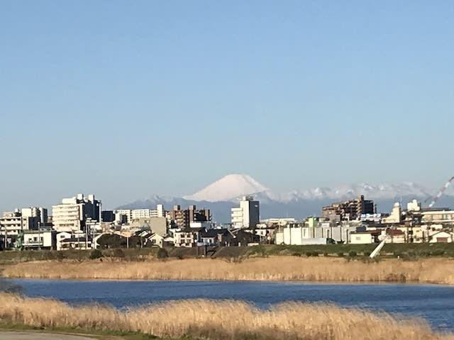
I selected Tamagawa’s river bank where is located in Latitude: 35 degrees 34 minutes 31.85 seconds north; Longitude: 139 degrees 40 minutes 50.09 seconds east as the point to observe the moonset.

Mt. Fuji directly in front is the snowy mountain in the lower left of the aerial image.

【Observation site and direction of moonset in the map】
Observation site（the bank of Tamagawa river in Tokyo） _______ The direction of moonset
Azimuth is that in horizontal coordinate systems used in astronomy, the angular distance measured east wards along the observer’s horizon from the south point or the north point to the intersection of the vertical circle through a celestial body.¹
【Camera used】

Approximately 16 million pixels with 10-layer + 10-layer coating method: The black body is made of aluminum material for durability and excellent design. The high-precision lens reduces light reflections and glare making it ideal for daytime outdoor shooting.

【Moon】 The earth’s only natural satellite, and the only body outside the earth to have been reached by human beings (1969). It is located at a mean distance of 384 400 km and orbits around the common centre of mass that it shares with our planet once every 27.322 days. It has a diameter of 3476 km. Locked by the earth into synchronous rotation, the moon always presents the same face to an earth-based observer. The moon is visible because it reflects light from the sun. As it orbits the earth, increasing and then decreasing portions of its surface are illuminated producing apparent changes of shape called *phases of the moon. On average, the moon completes one lunation (cycle of phases) every 29.530 59 days. Its gravitational influence on the earth plays the main role in the production of *tides. The moon has no atmosphere or surface water. Its surface temperature varies between 80 K (night minimum) and 400 K (noon at the equator). The moon’s surface consists of craters, mountains, and dark lava plains called maria (from the Latin mare, ‘sea’ and is scarred by long channels called rilles. In addition, almost all the surface is covered with a loose layer of soil and dust known as the regolith. Several theories have been proposed for the origin of the moon. The theory that is currently most widely accepted is that the moon was formed about 4.5 billion years ago by a collision between the earth and a body about the size of Mars.²
_____________________________________________________________________________________________________________________________________________________
1 Jonathan Law, A Dictionary of Science (Oxford Quick Reference) (English Edition) 7th Edition, Kindle Edition, p.678
2 Jonathan Law, A Dictionary of Science, p.1821
 Moon age 29.3 days, Moonset time 16:42, 15 November 2020, Azimuth 248degrees
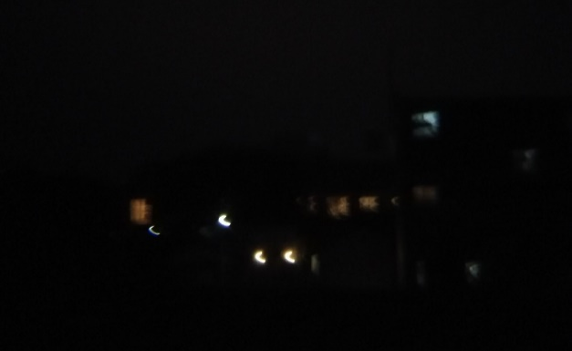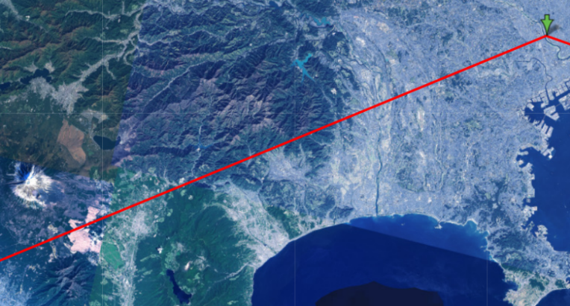
I could not confirm the thinner crescent shadow with naked eyes in this time.
HOW NATIVES THINK  Among the natives of Torres Straits, “soon after a man dies, his mari goes to Kiku, where on his arrival the mari of a previously deceased friend takes the newcomer. At the new moon each of whom takes stoneheaded clubs and hits him on the head and he is a true markai and they teach new markai how they spear fish and so on.”³

 Moon age 0.9 days, Moonset time 17:26, 16 November 2020, Azimuth 243degrees
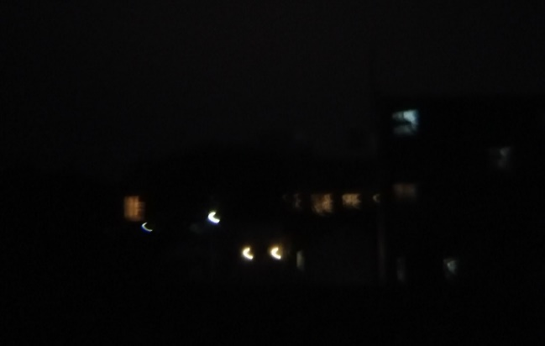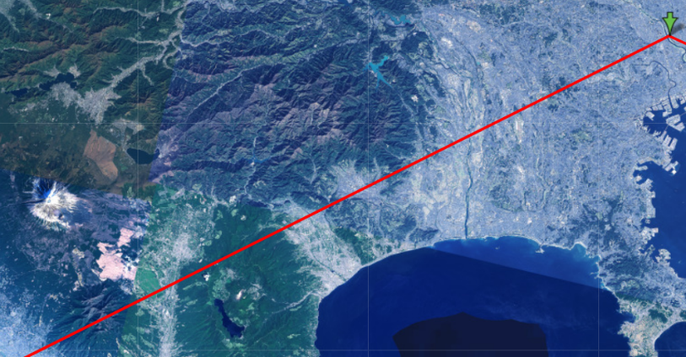
Aged 0.9 day moon could not be appeared in the photography, however, I could see it by my naked eyes.
The moon sank to the south of where it sank yesterday
HOW NATIVES THINK In India, when the new moon falls on Monday, pious Hindus walk one hundred and eight times round the fig-tree. Possibly 108 possesses special virtue as a common multiple of 9 and 12, themselves multiples of 3 and 6.⁴
____________________________________________________________________________________________
3. Lucien Lévy-Bruhl, How Natives Think, Kindle P282
4. Lucien Lévy-Bruhl, How Natives Think, P203
 Moon age 1.9 days, Moonset time 18:18, 17 November 2020, Azimuth 239degrees
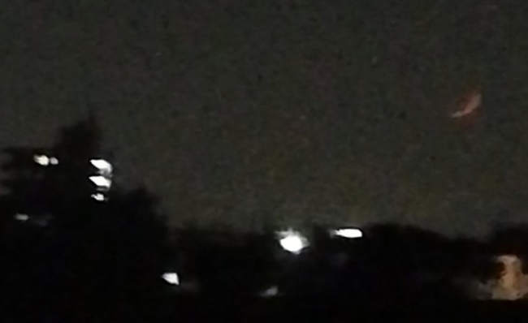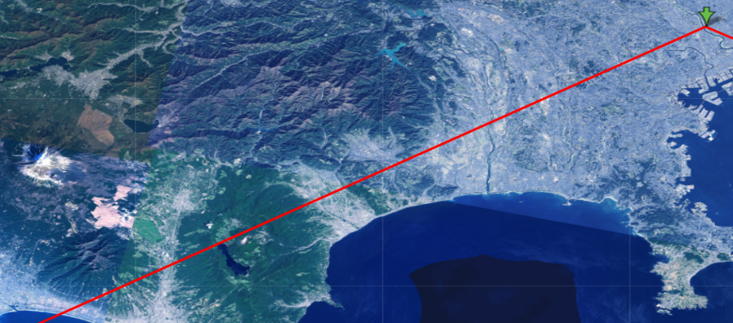
This was first catch by my mobile phone camera with monoscope. However, moon hid in a thick mist near the horizon soon.
 Moon age 2.9 days, Moonset time 19:15, 18 November 2020, Azimuth 238degrees
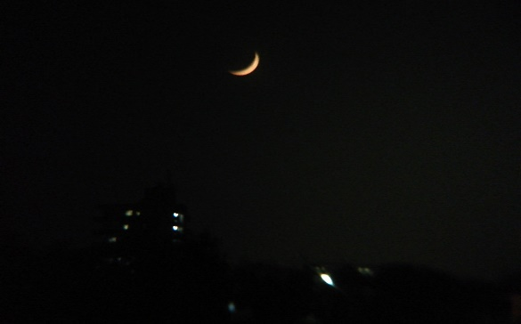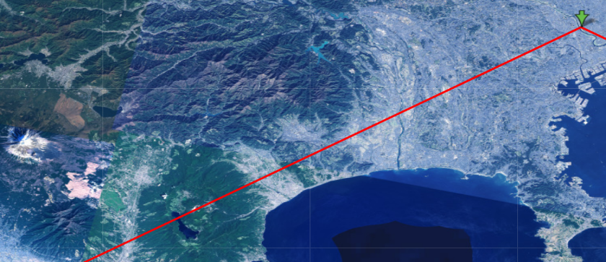
Direction of the moonset was not much different from the point of yesterday.
HOW NATIVE THINK The New Year, Rosh Hashanah, is celebrated on the first two days of Tishri, the seventh month, when the crescent moon rises in the Babylonian zodiac sign Libra.⁵
 Moon age 3.9 days, Moonset time 20:18, 19 November 2020, Azimuth 239degrees
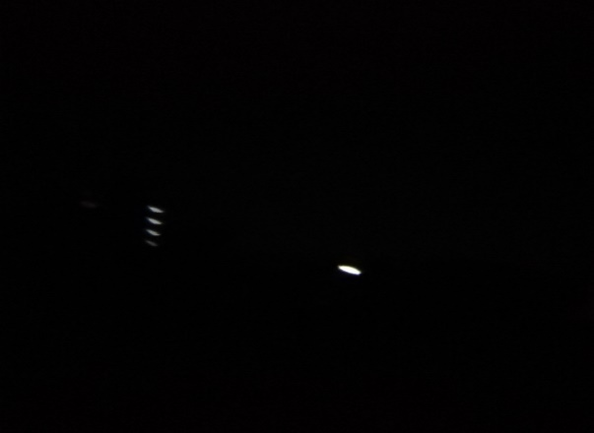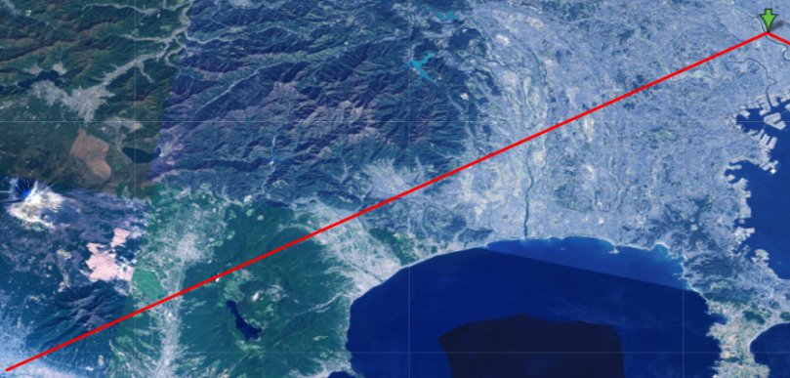
____________________________________________________________________________________________
5 Nicholas Campion, Astrology and Cosmology in the World’s Religions, NYU Press short. Kindle, p.139
The moon cannot be confirmed due to cloudy weather.
The temperature has risen as warm air flows toward the low pressure system that travels from the continent to the Sea of Japan. It reached 20℃ or higher not only in Tokyo region but also in the north region in Japan.
 Moon age 4.9 days, Moonset time 21:21, 20 November 2020, Azimuth 242degrees
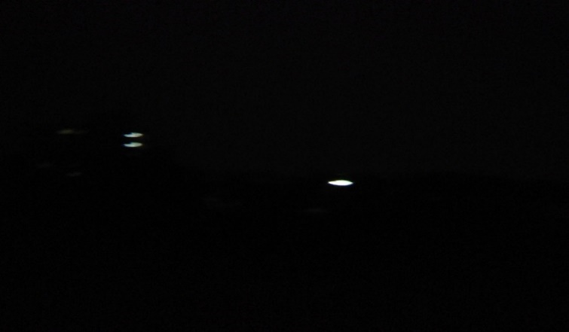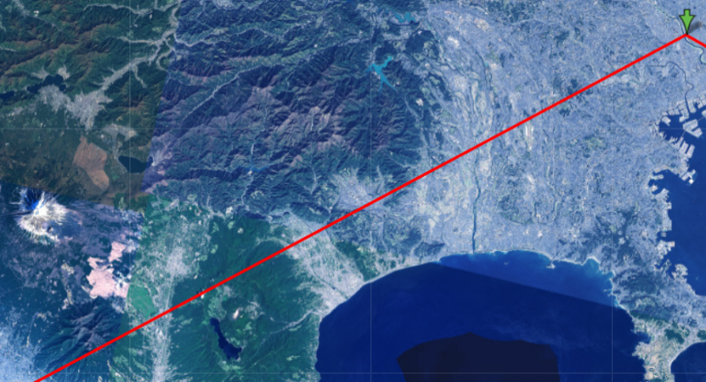
In the eastern and western Japan, there are many places where the temperature exceeds 20ºC. Record high temperatures have continued nationwide these days, and Friday was likely to be nearly 10ºC higher than the original temperature in November. The temperature in Tokyo is 23ºC, therefore, it is warm and humid because of the rain.
 Moon age 5.9 days, Moonset time 22:24, 21 November 2020, Azimuth 246degrees
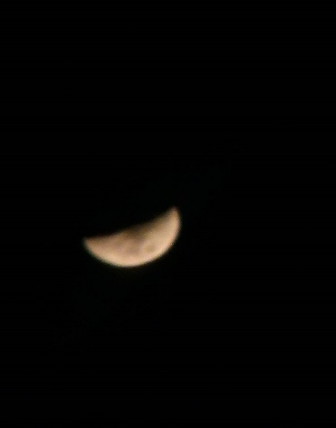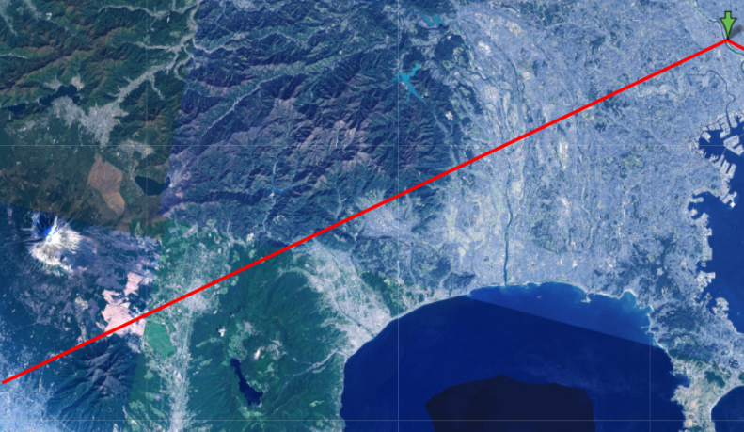
The moon was located much norther than 3 days ago and I could see that the half moon will be tomorrow.
Over the next week, there will be many sunny days covered by high pressure, but it is expected that there will be cloudy and rainy places due to the effects of troughs and moist air.

 Moon age 6.9 days, Moonset time 23:26, 22 November 2020, Azimuth 252degrees
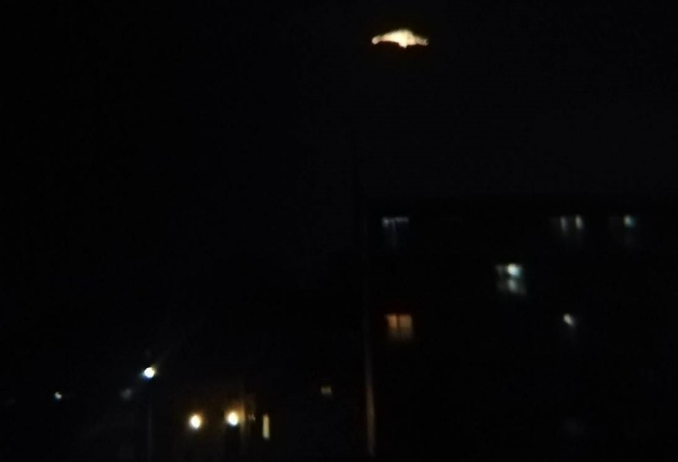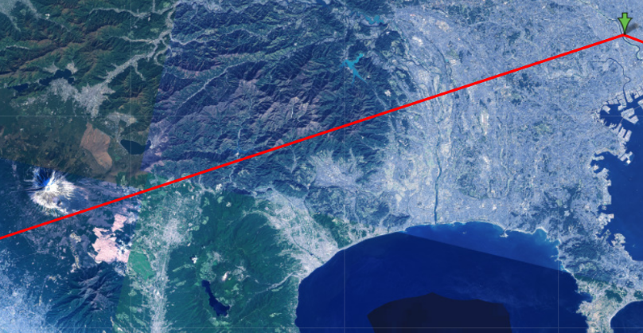
Unfortunately the moon was setting into thick cloud. But I could confirm the crater and contour of the clouds.
 Moon age 7.9 days, Moonset time -- : --, 23 November 2020
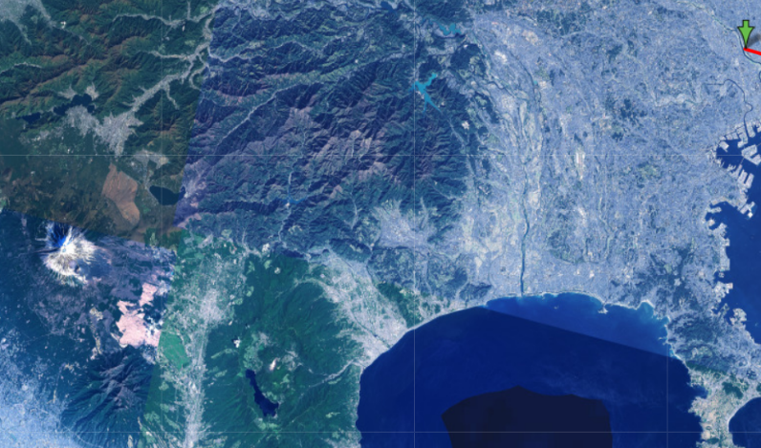
We do not have the moonset time today.
 Moon age 8.9 days, Moonset time 00:25, 24 November 2020, Azimuth 258degrees
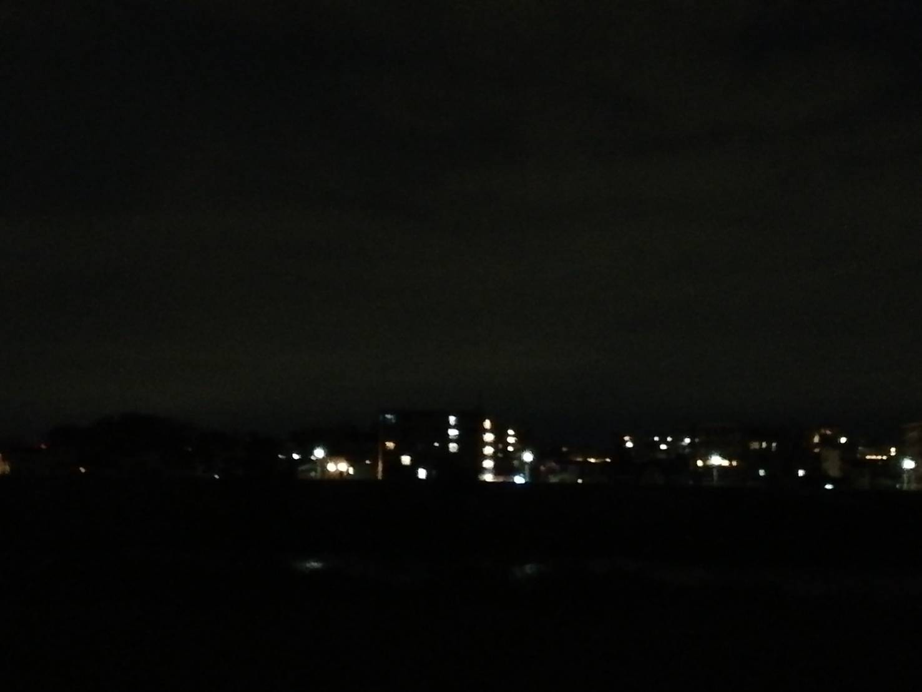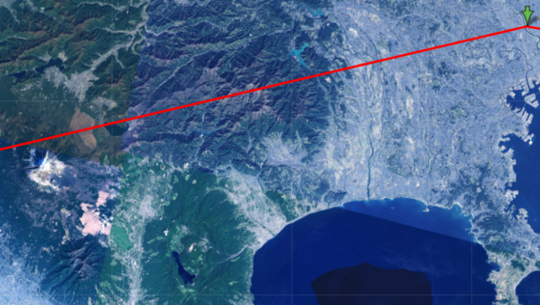
The moon could not been seen behind thick clouds.
 Moon age 9.9 days, Moonset time 01:24, 25 November 2020, Azimuth 264degrees
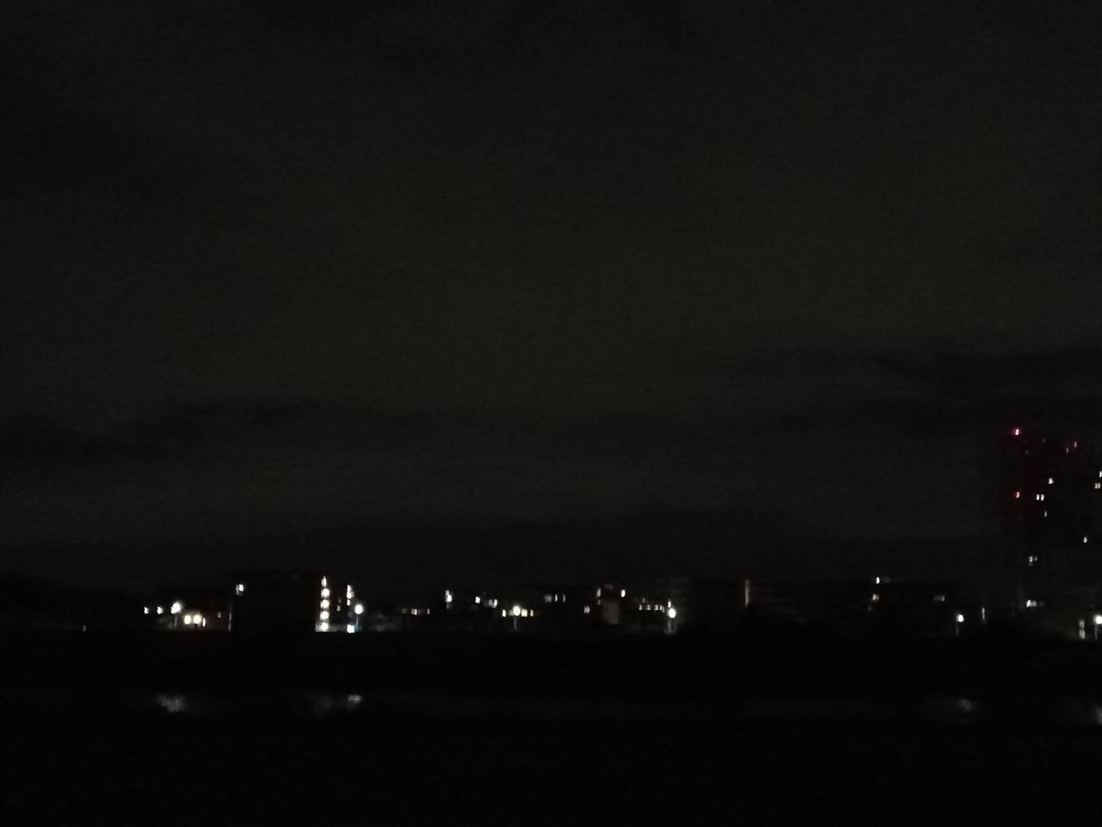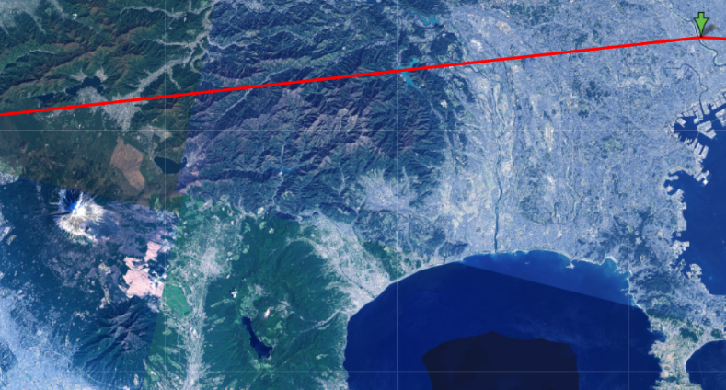
Direction of the moonset is almost due to the west today from the data. Cloudy sky.
 Moon age 10.9 days, Moonset time 02:11, 26 November 2020, Azimuth 270degrees
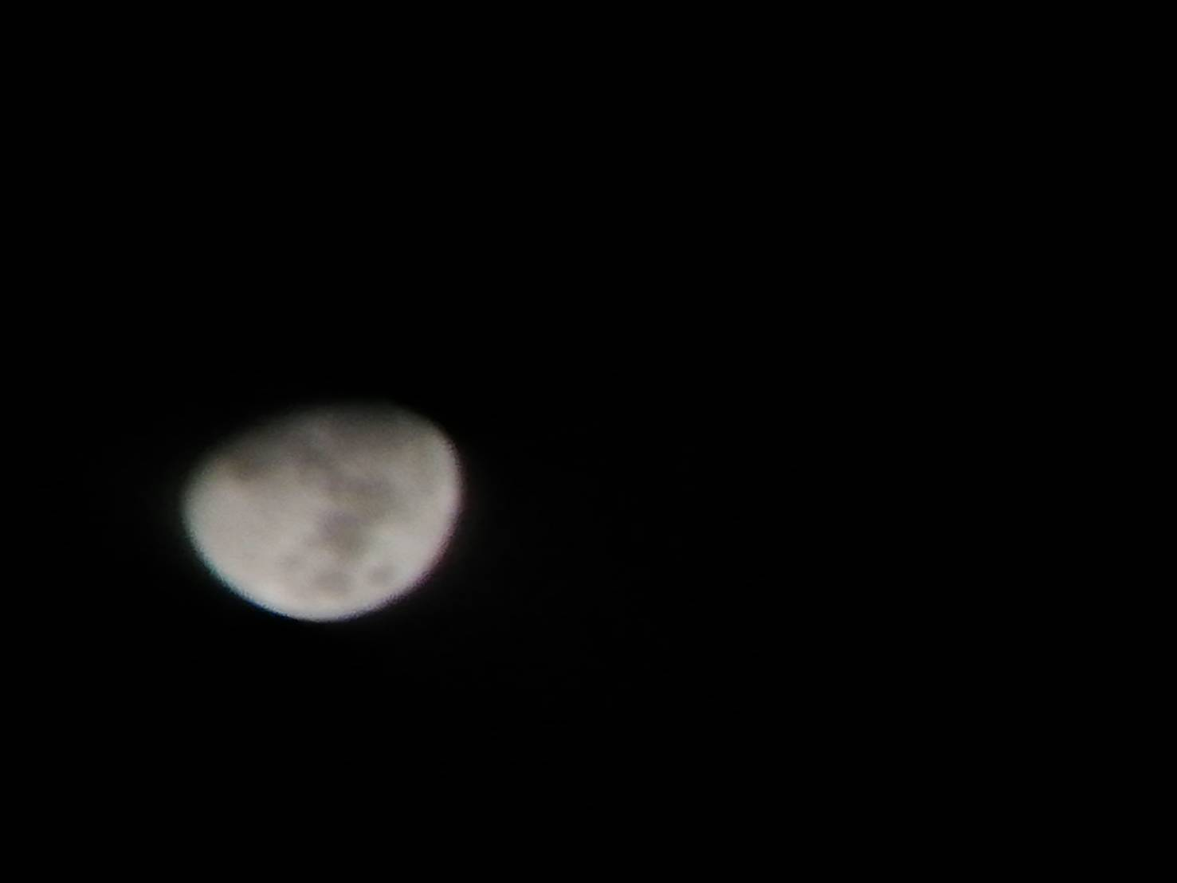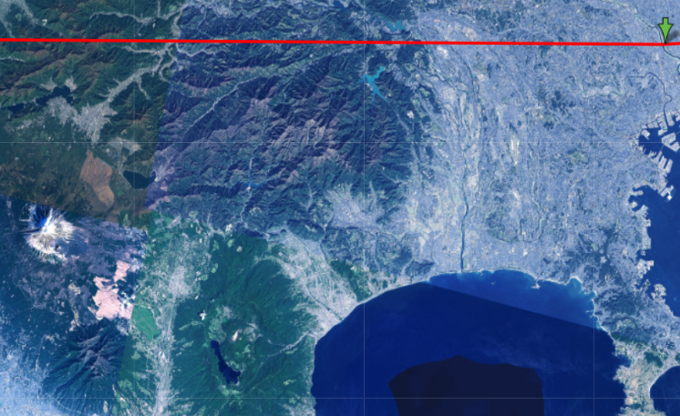
Azimuth 270 degrees tells that moon sinks due to the west. I could identify usual crater pattern.
 Moon age 11.9 days, Moonset time 03:07, 27 November 2020, Azimuth 276degrees
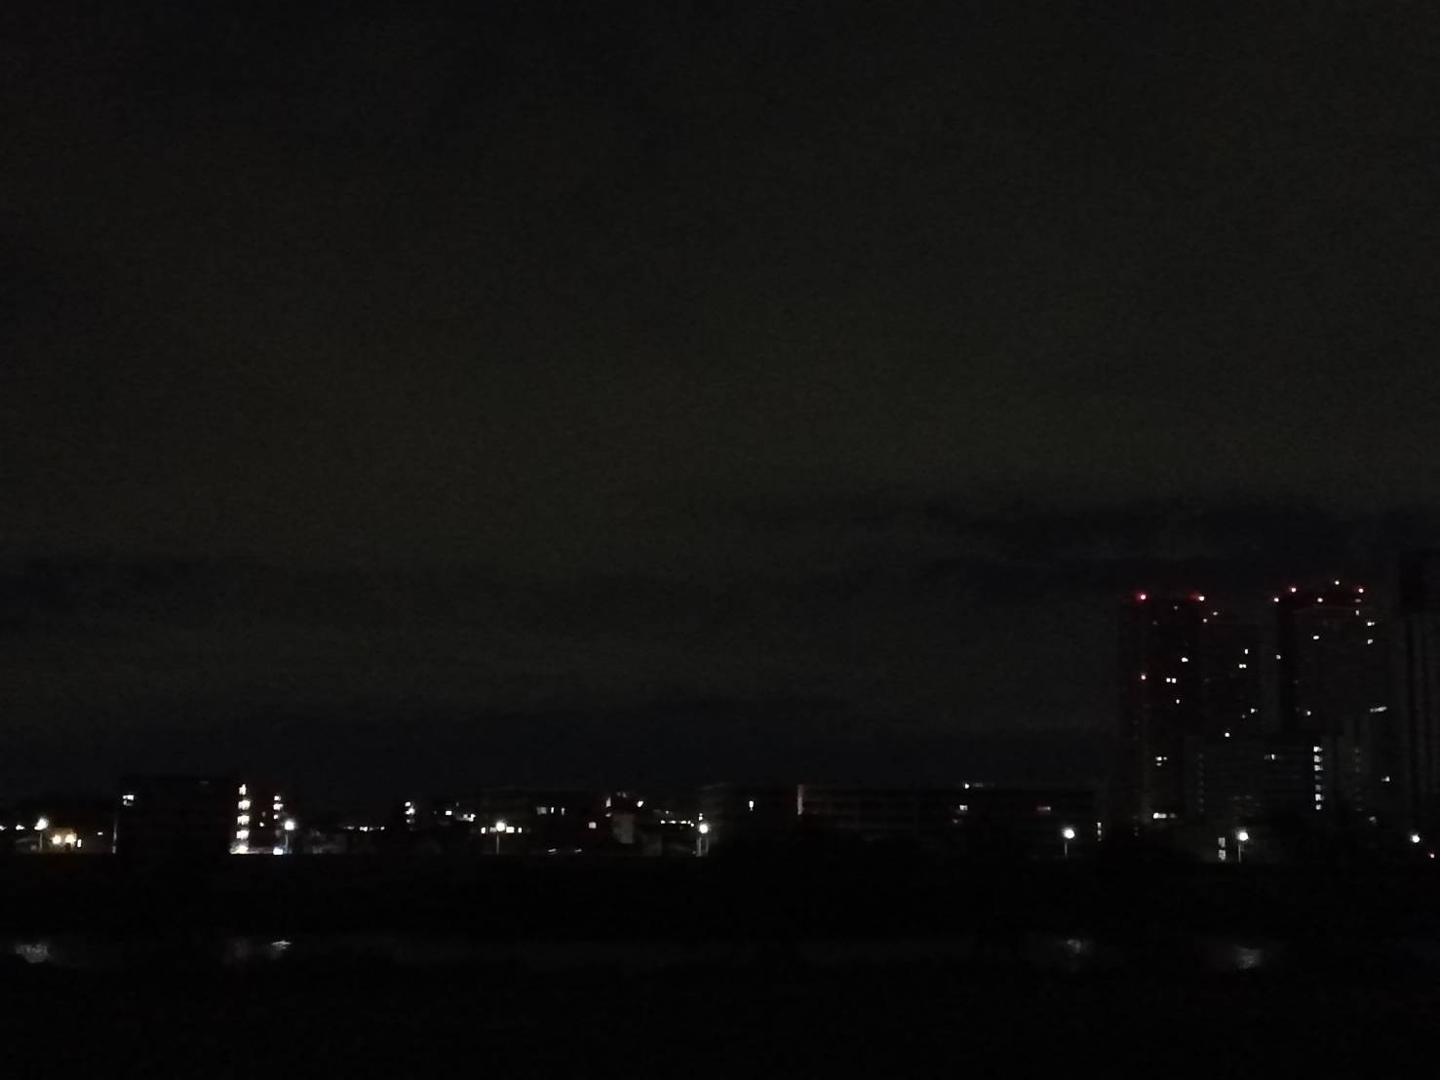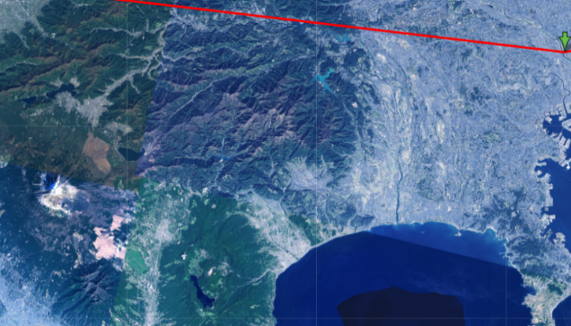
Though I could see the moon last evening from between the clouds, there was thick coulds at moonset time.
Moon age 12.9 days, Moonset time 04:04, 28 November 2020, Azimuth 283degrees
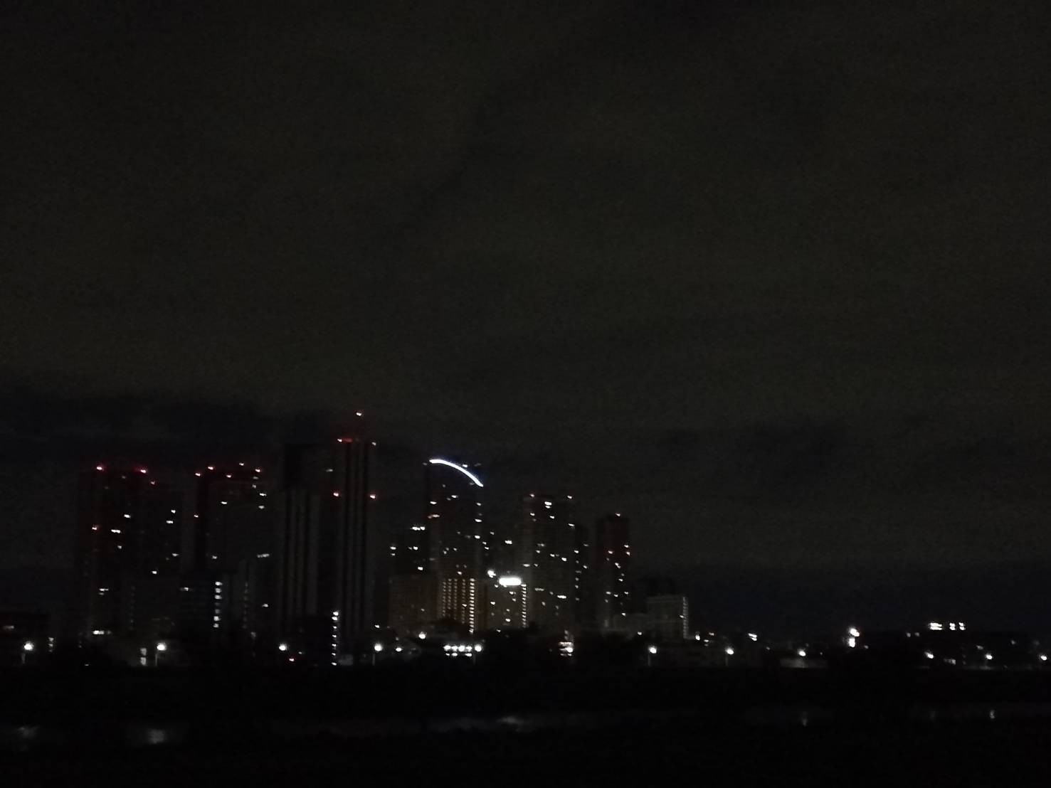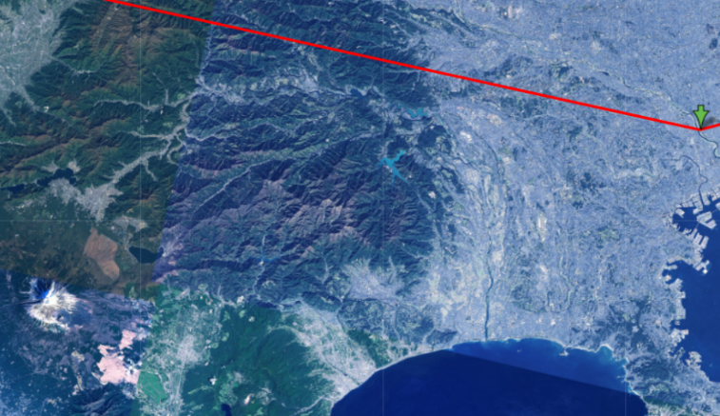
The moon might be behind those building complex.
 Moon age 13.9 days, Moonset time 05:02, 29 November 2020, Azimuth 288degrees
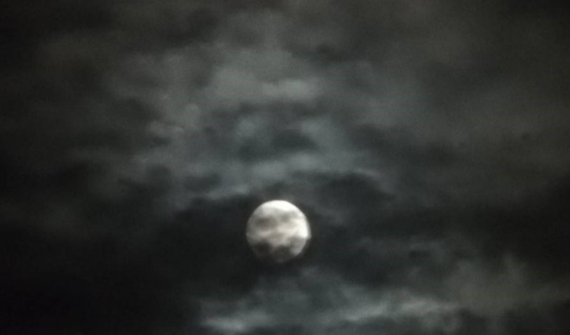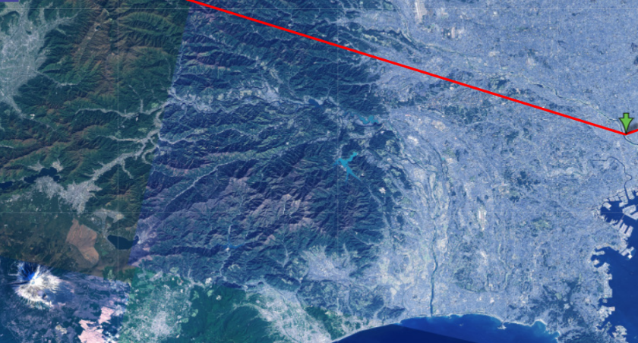
It took time until I could see the moon behind heavy coulds.
 Moon age 14.9 days, Moonset time 6:03, 30 November 2020, Azimuth 293degrees
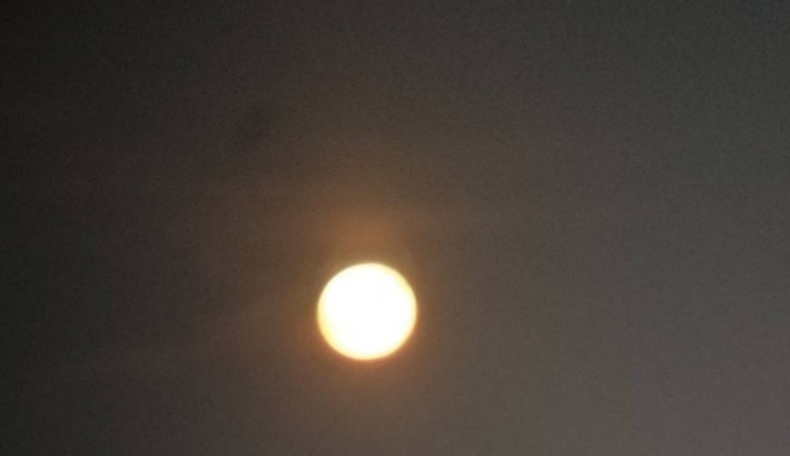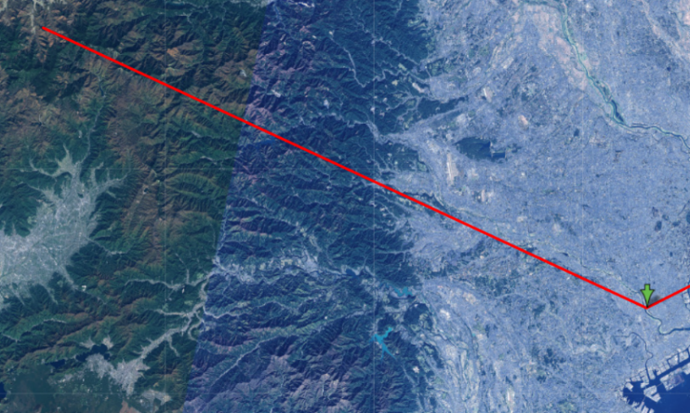
The moon was at its fullest in reddish coloured. I could identify the moon wane slightly in the next day. I was trained to feel subtle changes on the moon.
HOW NATIVE THINK When there is a full moon, people observe in which zone the spots are most outstanding, east, west, south or north and from their position the direction from which the sickness come is deduced.⁶
‘Be clearly aware of the stars and infinity on high. Then life seems almost enchanted after all.’
Discuss this statement from Vincent Van Gogh as it relates to your sky journal observations.

I felt the sense of unity sharing with him beyond space-time besides infinity. Because we can see same Venus and Moon which he has been watching and drawing. I experienced enjoying the sense of unity with the universe and spent. I could understand that he has regretted that he could not share beautiful nature with his brother telling him ‘my only regret is that you cannot see what I see here.’⁷ In his letter.

Identify
A Sky Journal is a piece of research using the sky as the primary document. I observed the sky for two
weeks and focus on the moonset and the setting positions recorded by photographing the changes in these sky features. or sky and landscape features. I observed the moonset from new moon phase to full moon phase for two weeks from 15 November, 2020. I chose the fixed place in bank of Tamagawa river because it was very hard to find horizonal flat geography in Tokyo, Japan.

Locate
Astronomical observation is an old-and-new hobby that gives you a sense of unity with nature, away from the crowded life. Most importantly, I would like to strongly recommend this practice, especially in light of the COVID pandemic of this year. My intended audience are students and general public, etc.
I would like to mention summaries in the next section.

Summarise
I have observed the moonset with the direction and its phases for two weeks.
I selected Tamagawa’s river bank where is located in Latitude: 35 degrees 34 minutes 31.85 seconds north; Longitude: 139 degrees 40 minutes 50.09 seconds east as the point to observe the moonset, because it is almost impossible to find horizon in the big city like Tokyo besides river banks.
The time of moonrise and moonset changes greatly every day. On average, both the moonrise time and the moonset time are delayed by about 50 minutes a day.
Key words: moon; sky; telescope; monoscope; moonrise; moonset; rotation; cycle; phase; crescent; full moon; azimuth; sun; earth; myth; ritual; indigenous; observation;
____________________________________________________________________________________________
6 Nicholas Campion, Astrology and Cosmology in the World’s Religions, p.61
7 Van Gogh, Vincent. The Letters of Vincent Van Gogh, Little, Brown Book Group. Kindle, 645/6776

Analyse
Because the moon changes its location with respect to the stars about 13°to the east every day, the moon rises an average of about 50 minutes later each day than it did the day before. Therefore, when the moon sink at 23:26, there is no the moonset in the next day but around 00:25 in the day after the next day. This happened on 23 November in this observation.⁸ Earth’s gravity has locked the Moon into synchronous rotation. The Moon rotates on its axis every 27.3 days, the same amount of time it takes to travel around Earth. That makes the same side of the Moon face Earth at all times.⁹ When the Moon is near the horizon, it may look red. From that position, moonlight travels a longer path through the atmosphere to our eyes than when the Moon is overhead. Moonlight (reflected sunlight) consists of all visible colors. Short (blue) moonlight rays are scattered out and the long (red) rays, which penetrate the atmosphere more readily, color the moon red.¹⁰ Therefore, we can see a various type of the moon aspect depend on the sky condition.
Furthermore, we can identify in when and from where we can take a best shoot of moon or sun against some characteristic nature by using internet information.

Conclude
The moon is the earth’s only natural satellite, and the only body outside the earth to have been reached by human beings (1969). It is located at a mean distance of 384 400 km and orbits around the common centre of mass that it shares with our planet once every 27.322 days. The theory that is currently most widely accepted is that the moon was formed about 4.5 billion years ago by a collision between the earth and a body about the size of Mars. If you rise up your face toward beautiful moon, you can understand what Van Gogh wanted to tell us about. ‘Be clearly aware of the stars and infinity on high. Then life seems almost enchanted after all.’ Astronomical observation is an old-and-new hobby that gives you a sense of unity with nature, away from the crowded life. I can recommend that astronomical observation is attracting hobby we can avoid from contacting from others under circumstance of the infection of COVID 19.

____________________________________________________________________________________________
8 Moché, Dinah L., Astronomy, Turner Publishing Company, Kindle, p.412
9 Moché, Dinah L., Astronomy, p.413
10 Moché, Dinah L., Astronomy, p.415
Bibliography

1 Law, Jonathan, A Dictionary of Science (Oxford Quick Reference) (English Edition) 7th Edition, Kindle Edition, p.678
2 Law, Jonathan, A Dictionary of Science, p.1821
3. Lévy-Bruhl, Lucien, How Natives Think, Kindle P282
4. Lévy-Bruhl, Lucien, How Natives Think, P203
5 Campion, Nicholas, Astrology and Cosmology in the World’s Religions, NYU Press short. Kindle, p.139
6 Campion, Nicholas, Astrology and Cosmology in the World’s Religions, p.61
7 Van Gogh, Vincent. The Letters of Vincent Van Gogh, Little, Brown Book Group. Kindle, 645/6776
8 Moché, Dinah L., Astronomy, Turner Publishing Company, Kindle, p.412
9 Moché, Dinah L., Astronomy, p.413
10 Moché, Dinah L., Astronomy, p.415

